[Type the company name]
MPLAB Assignment
Micros, Peripherals and Interfaces
Sara Vonk
5/21/2018

[Type the abstract of the document here. The abstract is typically a short summary of the contents of the document. Type the abstract of the document here. The abstract is typically a short summary of the contents of the document.]

Content page

MPLAB Introduction 3
Original Count File 4
HND/BENG PIC16F84 Assignment Board Analysis 8
Coding and Flowchart 10
Appendix 14
Bibliography 47

MPLAB Introduction

MPLAB is a software designed for professional use. It allows and aids the user to write machine code, program PIC microcontrollers and control all the inbuilt features of the PIC. This allows businesses, big or small, and individuals to design, create and make their own products.
MPLAB have many features to assist the code writer so they can take as little time as possible to write a fully working code. One of these is the debugging feature. After writing your code you can run ‘debug’, it will run through your program and give you hints as to why it’s not working and will tell you what line the problem is on.
There are many other features in MPLAB, some of the more basic ones are run, halt, animate, step into, step over, step out, reset and break point list. Some of these are standard such as run, halt and reset. However some are not so standardised such as step into. This lets you step in to a subroutine. Step over lets you step over a subroutine, step out lets you step out of a subroutine, reset lets you go to the beginning of the code, animate runs the code but slower so you can see better what is going on and the break point list lets you put a break point in your code so when running it, it will stop at a pacific point so you can see exactly what is going on. MPLAB also gives access to the inbuilt software of the PIC so the coder can turn on and off different parts of the pic. For example if the watch dog timer is not being used it would be advisory to turn it off so it didn’t over flow its register and cause problems.
In MPLAB the option is given to open multiple windows at one time to help you debug your code. One of these windows is the program memory. This is extremely use-full as it allows you to see what is happening in the PIC’s memory as the code is running allowing you to easily tweak your code with a full understanding of how it is being processed and applied in the micro processor.
When a code has been finished or ready for testing it is time to simulate it. The simulator executes the PIC’s instructions runs through the program and shows the programmer the content of the registers. It lets them use the feature that where mentioned above such as haulting the program, running it, animating it, setting break points etc. Its te most benifisal thing this program allows the user to do as no other program give the user as much information about the workings of the insit of the chip as MPLAB does. The simulator does have a few limitations as it doesn’t have real I/O ports it isn’t too good at performing input and output.

Original Count File

Table of errors found in original count file.
Errors Found | Corrections
Status | status
org 0x000 | org 0x00
get_counnt | get_count
movwf mCont | movwf mCount
en d | end
Below is the original count file. Ever thing highlighted are the errors in the code.

; FILE: count.asm
; AUTHOR: JMY
; DATE: 24th March 2005
; DESCRIPTION: Count to 255 at 1 second intervals and display on a seven
; segment display in binary.
; The pause subroutine takes apx. 0.2 sec.
; Pause is called 5 times

list p=16F84 ; select processor type
radix hex ; define radix as hexadecimal
; #include "p16f84.inc"
;----------------------------------------------------------------------
; cpu equates (memory map)
portB equ 0x06 ;port B address
trisb equ 0x06 ;trisB address in register bank 1

Status equ 0x03 ;status register
RP0 equ 5 ;bit 5 of status register
RP1 equ 6 ;bit 6 of status register

count equ 0x0c ; counter 0 to 255
nCount equ 0x0d ; pause routine inner loop counter
mCount equ 0x0e ; pause routine outer loop counter

;----------------------------------------------------------------------

org 0x000

start
bcf status,RP0 ; clear bank selection bits in the status reg
bcf status,RP1

bsf status,RP0 ; select bank 1
movlw 0x00 ; load w with 0x00
movwf trisb ; load it into trisb to make portb all outputs
bcf status,RP0 ; reselect bank 0

clrf portB ; clear all lines low
clrf count ; initialize counter to 0

get_counnt
movf count, w ; move count to W

movwf portB ; move W to port B to update the display

addlw 1 ; add +1 to W

movwf count ; save W in count

call pause ; delay 200ms by subroutine
call pause
call pause
call pause
call pause ; five pause executions equals ~ 1 second

goto get_count ; repeat forever

;--------------------------------------------------------------------
;subroutine pause: lets waste some time....
;
;inputs: nothing
;outputs: nothing
;
;does: nothing but waste some time
;corrupts: register W
;
;description: two loops using "mCount" and "nCount" register files
; "mCount" is the outer loop counter (255 down to zero)
; "nCount" is the inner loop counter (255 down to zero)
;
;--------------------------------------------------------------------
pause
movlw 0xfff ; set w = 255 decimal
movwf mCont ; mCount = w: outer loop counter
loadN
movlw 0xff ; set w = 255 decimal
movwf nCount ; nCount = w: inner loop counter
decN
decfsz nCount, f ; nCount--
goto decN ; if nCount != 0 then repeat nCount--

decfsz mCount, f ; else decrement Count
goto loadN ; if mCount != 0 then
; reload nCount to 255 and decrement
return ; else exit subroutine

en d
;----------------------------------------------------------------------
; Configuration! Important!
;
; at blast time, select:
; memory uprotected
; watchdog timer disabled
; standard crystal (4 MHz)
; power-up timer on

(D.W.Smith, 2003)

HND/BENG PIC16F84 Assignment Board Analysis
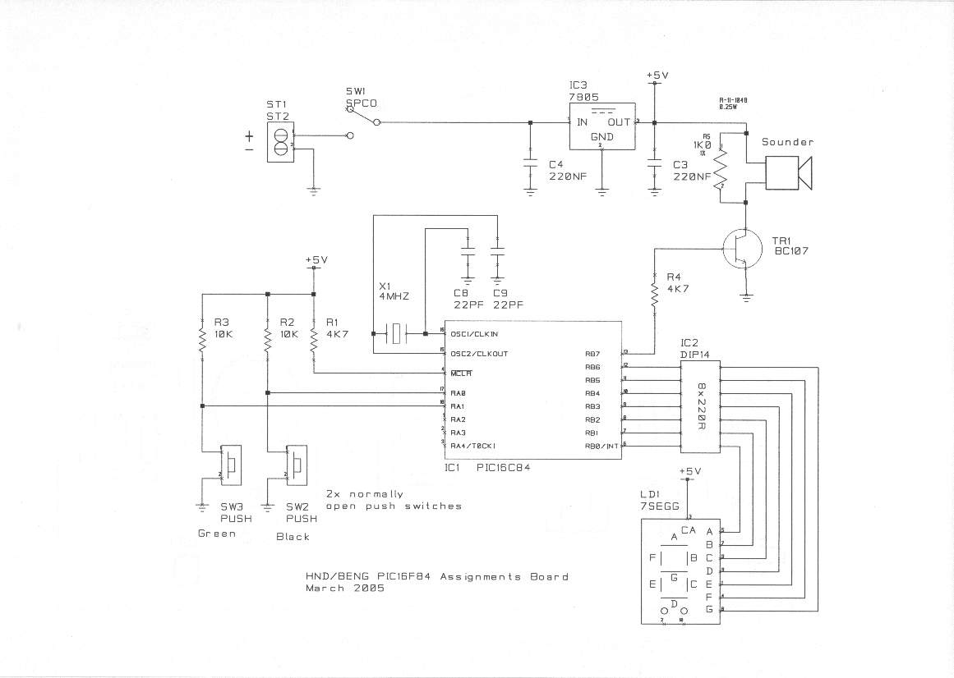
  - Crystal oscillator
The capacitors are out of phase from each other by 180 degrees. This means the loop gain has a net phase off 360 degrees.
This is what makes the oscillator vibrate. The crystal oscillator is in the centre of the two capacitors. Every time one of the capacitors is fully charged the other capacitor is fully uncharged. This constant back and forth current puts a stress current on the crystal and makes it vibrate. The vibration of the crystal is called the piezoelectric effect. The crystal will always vibrate at a set rate depending on the values of the capacitors and there for we can use this in a circuit to measure time. (Walls) (Duncan, 2002, p. 173) (Myke, 2002)
  - AC to DC converter
The capacitor on the left of the converter only lets the positive part of the AC current through. The capacitor on the right side of the converter helps to smooth out the output of the convertor. (Duncan, 2002, p. 367)

  - Speaker
Impedance of speaker is less than the resistance of the resister so current will flow through the speaker until the transistor is turned off. The speaker has similar properties to an inductor so it will hold a voltage in the form of a weak magnetic field like an inductor would. When the transistor is turned off, preventing current from flowing to ground, the resister will let the speaker discharge as it is connected across the speaker’s terminals. (Duncan, 2002, p. 63)
  - Switches
When switches are pressed RA1/RA0 are low as they are connected to ground.
  - Display screen
When RB0-6 are low the display screen is on. When RB0-RB6 are high the display screen is off. The display screen is fed +5v directly, there is no ground directly attached to it so it uses the RB0-6 connections to find ground. When any of the RB0-6 connections are +5v it blocks the currents path to ground so switches the LED’s in the display screen off. There are 220R Resistors in this ground to display screen circuit. They are there to control the current and prevent against an open circuit.
I = V/R
I = 5/220
I = 23mA
The average LED’s 7sgg display needs 20mA but the impedance in the circuit if calculated could total to 30 ohm’s equalling the total circuit impedance to 250 ohm’s.
I = 5/250
I = 20mA
(7 Segment LED Displays, 2018)

Coding and flowcharts

Display ‘STOP’

The program Displays the word ‘stop’. Every second it will display the next letter of the world. When it gets to the end ‘p’ it starts again.
Below is a flow chart of the program.
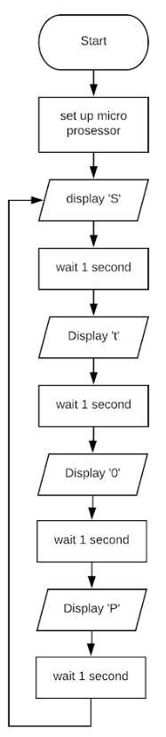

Find the code in the appendix

Count to F in Hex
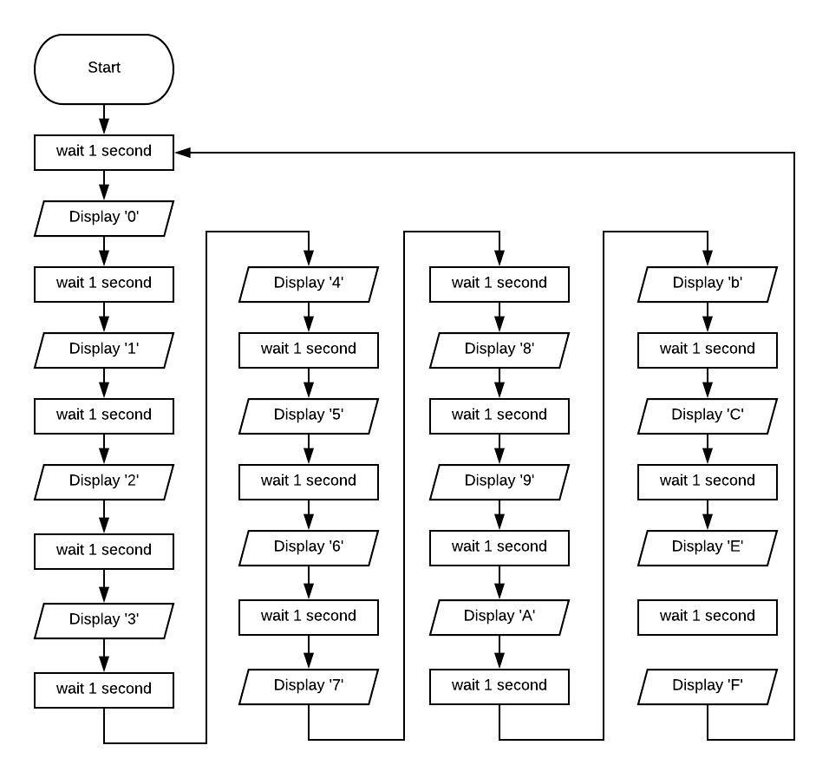
This program counts from 1 to F in hex. The display screen in up dated every second. Once it reaches F it starts again.

Find the code in the appendix.

Count Number of time Green Button is Pressed in Hex
This program counts from 0 to F in hex. Every time the green button is pressed it will increase the number being displayed by 1. When it gets to F it starts again.
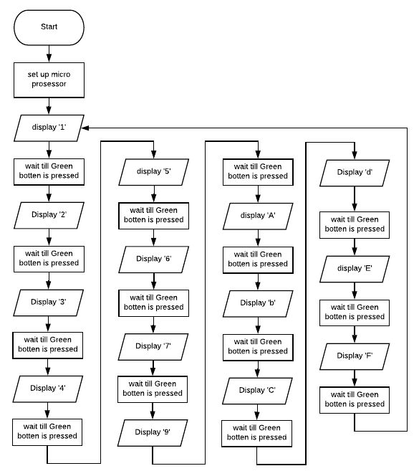
Below is the flowchart.

Find the code in the appendix.

Piezo sounder produces a tone while the Green button is pressed.
This program makes a noise while the green button is pressed.
Below is the flowchart.
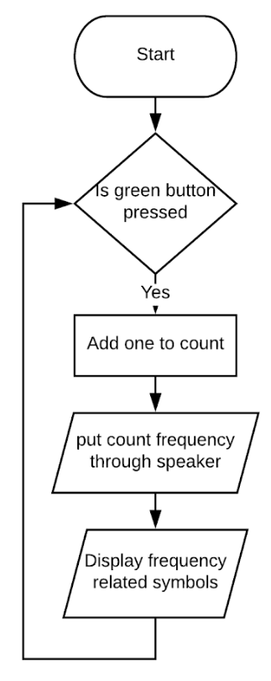

Find the code in the appendix.

Appendix

Display ‘STOP’

; FILE: count.asm
; AUTHOR: JMY
; DATE: 24th March 2005
; DESCRIPTION: Count to 255 at 1 second intervals and display on a seven
; segment display in binary.
; The pause subroutine takes apx. 0.2 sec.
; Pause is called 5 times

list p=16F84 ; select processor type
radix hex ; define radix as hexadecimal
; #include "p16f84.inc"
;----------------------------------------------------------------------
; cpu equates (memory map)
portB equ 0x06 ;port B address
trisb equ 0x06 ;trisB address in register bank 1

status equ 0x03 ;status register
RP0 equ 5 ;bit 5 of status register
RP1 equ 6 ;bit 6 of status register

count equ 0x0c ; counter 0 to 255
nCount equ 0x0d ; pause routine inner loop counter
mCount equ 0x0e ; pause routine outer loop counter

;----------------------------------------------------------------------

org 0x000

start
bcf status,RP1

bsf status,RP0 ; select bank 1
movlw 0x00 ; load w with 0x00
movwf trisb ; load it into trisb to make portb all outputs
bcf status,RP0 ; reselect bank 0

clrf portB ; clear all lines low
clrf count ; initialize counter to 0

;-------------------------------------------------------------------------

get_count

movlw 0x12 ; set w = 18 = s decimal

movwf portB ; move W to port B to update the display

call pause ; delay 200ms by subroutine
call pause
call pause
call pause
call pause ; five pause executions equals ~ 1 second
;---------------------------------------------------------------------------------------
movlw 0x7 ; set w = 7 = t decimal

movwf portB ; move W to port B to update the display

call pause ; delay 200ms by subroutine
call pause
call pause
call pause
call pause ; five pause executions equals ~ 1 second
;--------------------------------------------------------------------------------------

movlw 0x40 ; set w = 64 = o decimal

movwf portB ; move W to port B to update the display

call pause ; delay 200ms by subroutine
call pause
call pause
call pause
call pause ; five pause executions equals ~ 1 second
;-------------------------------------------------------------------------------------
movlw 0xc ; set w = 12= p decimal

movwf portB ; move W to port B to update the display

call pause ; delay 200ms by subroutine
call pause
call pause
call pause
call pause ; five pause executions equals ~ 1 second

goto get_count ; repeat forever

;--------------------------------------------------------------------
;subroutine pause: lets waste some time....
;
;inputs: nothing
;outputs: nothing
;
;does: nothing but waste some time
;corrupts: register W
;
;description: two loops using "mCount" and "nCount" register files
; "mCount" is the outer loop counter (255 down to zero)
; "nCount" is the inner loop counter (255 down to zero)
;
;--------------------------------------------------------------------
pause
movlw 0x3f ; set w = 255 decimal
movwf mCount ; mCount = w: outer loop counter
loadN
movlw 0xff ; set w = 255 decimal
movwf nCount ; nCount = w: inner loop counter
decN
decfsz nCount, f ; nCount--
goto decN ; if nCount != 0 then repeat nCount--

decfsz mCount, f ; else decrement Count
goto loadN ; if mCount != 0 then
; reload nCount to 255 and decrement
return ; else exit subroutine

end
;----------------------------------------------------------------------
; Configuration! Important!
;
; at blast time, select:
; memory uprotected
; watchdog timer disabled
; standard crystal (4 MHz)
; power-up timer on

Count to F in Hex
; FILE: count.asm
; AUTHOR: JMY
; DATE: 24th March 2005
; DESCRIPTION: Count to 255 at 1 second intervals and display on a seven
; segment display in binary.
; The pause subroutine takes apx. 0.2 sec.
; Pause is called 5 times

list p=16F84 ; select processor type
radix hex ; define radix as hexadecimal
; #include "p16f84.inc"
;----------------------------------------------------------------------
; cpu equates (memory map)
portB equ 0x06 ;port B address
trisb equ 0x06 ;trisB address in register bank 1

status equ 0x03 ;status register
RP0 equ 5 ;bit 5 of status register
RP1 equ 6 ;bit 6 of status register

count equ 0x0c ; counter 0 to 255
nCount equ 0x0d ; pause routine inner loop counter
mCount equ 0x0e ; pause routine outer loop counter

;----------------------------------------------------------------------

org 0x000

start
bcf status,RP1

bsf status,RP0 ; select bank 1
movlw 0x00 ; load w with 0x00
movwf trisb ; load it into trisb to make portb all outputs
bcf status,RP0 ; reselect bank 0

clrf portB ; clear all lines low
clrf count ; initialize counter to 0

;-------------------------------------------------------------------------

get_count

movlw 0x40 ; set w = 64 decimal= '0' desplay

movwf portB ; move W to port B to update the display

call pause ; delay 200ms by subroutine
call pause
call pause
call pause
call pause ; five pause executions equals ~ 1 second
;---------------------------------------------------------------------------------------
movlw 0x79 ; set w = 121 decimal= '1' desplay

movwf portB ; move W to port B to update the display

call pause ; delay 200ms by subroutine
call pause
call pause
call pause
call pause ; five pause executions equals ~ 1 second
;--------------------------------------------------------------------------------------
movlw 0x24 ; set w = 36 decimal= ' 2 ' desplay

movwf portB ; move W to port B to update the display

call pause ; delay 200ms by subroutine
call pause
call pause
call pause
call pause ; five pause executions equals ~ 1 second
;-------------------------------------------------------------------------------------
movlw 0x30 ; set w = 48 decimal= ' 3 ' desplay

movwf portB ; move W to port B to update the display

call pause ; delay 200ms by subroutine
call pause
call pause
call pause
call pause ; five pause executions equals ~ 1 second
;-------------------------------------------------------------------------------------
movlw 0x19 ; set w = 25 decimal= ' 4 ' desplay

movwf portB ; move W to port B to update the display

call pause ; delay 200ms by subroutine
call pause
call pause
call pause
call pause ; five pause executions equals ~ 1 second
;-------------------------------------------------------------------------------------
movlw 0x12 ; set w = 18 decimal= ' 5 ' desplay

movwf portB ; move W to port B to update the display

call pause ; delay 200ms by subroutine
call pause
call pause
call pause
call pause ; five pause executions equals ~ 1 second
;-------------------------------------------------------------------------------------
movlw 0x2 ; set w = 2 decimal= ' 6 ' desplay

movwf portB ; move W to port B to update the display

call pause ; delay 200ms by subroutine
call pause
call pause
call pause
call pause ; five pause executions equals ~ 1 second
;-------------------------------------------------------------------------------------
movlw 0x78 ; set w = 120 decimal= ' 7 ' desplay

movwf portB ; move W to port B to update the display

call pause ; delay 200ms by subroutine
call pause
call pause
call pause
call pause ; five pause executions equals ~ 1 second
;-------------------------------------------------------------------------------------
movlw 0x0 ; set w = 0 decimal= ' 8 ' desplay

movwf portB ; move W to port B to update the display

call pause ; delay 200ms by subroutine
call pause
call pause
call pause
call pause ; five pause executions equals ~ 1 second
;-------------------------------------------------------------------------------------
movlw 0x10 ; set w =16 decimal= ' 9 ' desplay

movwf portB ; move W to port B to update the display

call pause ; delay 200ms by subroutine
call pause
call pause
call pause
call pause ; five pause executions equals ~ 1 second
;-------------------------------------------------------------------------------------
movlw 0x8 ; set w = 8 decimal= ' A ' desplay

movwf portB ; move W to port B to update the display

call pause ; delay 200ms by subroutine
call pause
call pause
call pause
call pause ; five pause executions equals ~ 1 second
;-------------------------------------------------------------------------------------
movlw 0x3 ; set w = 3 decimal= ' b ' desplay

movwf portB ; move W to port B to update the display

call pause ; delay 200ms by subroutine
call pause
call pause
call pause
call pause ; five pause executions equals ~ 1 second
;-------------------------------------------------------------------------------------
movlw 0x46 ; set w = 70 decimal= ' C ' desplay

movwf portB ; move W to port B to update the display

call pause ; delay 200ms by subroutine
call pause
call pause
call pause
call pause ; five pause executions equals ~ 1 second
;-------------------------------------------------------------------------------------
movlw 0x21 ; set w = 33 decimal= ' d ' desplay

movwf portB ; move W to port B to update the display

call pause ; delay 200ms by subroutine
call pause
call pause
call pause
call pause ; five pause executions equals ~ 1 second
;-------------------------------------------------------------------------------------
movlw 0x6 ; set w = 6 decimal= ' E ' desplay

movwf portB ; move W to port B to update the display

call pause ; delay 200ms by subroutine
call pause
call pause
call pause
call pause ; five pause executions equals ~ 1 second
;----------------------------------------------------------------------------------
movlw 0xe ; set w = 14 decimal= 'F' desplay

movwf portB ; move W to port B to update the display

call pause ; delay 200ms by subroutine
call pause
call pause
call pause
call pause ; five pause executions equals ~ 1 second

goto get_count ; repeat forever

;--------------------------------------------------------------------
;subroutine pause: lets waste some time....
;
;inputs: nothing
;outputs: nothing
;
;does: nothing but waste some time
;corrupts: register W
;
;description: two loops using "mCount" and "nCount" register files
; "mCount" is the outer loop counter (255 down to zero)
; "nCount" is the inner loop counter (255 down to zero)
;
;--------------------------------------------------------------------
pause
movlw 0x3f ; set w = 255 decimal
movwf mCount ; mCount = w: outer loop counter
loadN
movlw 0xff ; set w = 255 decimal
movwf nCount ; nCount = w: inner loop counter
decN
decfsz nCount, f ; nCount--
goto decN ; if nCount != 0 then repeat nCount--

decfsz mCount, f ; else decrement Count
goto loadN ; if mCount != 0 then
; reload nCount to 255 and decrement
return ; else exit subroutine

end
;----------------------------------------------------------------------
; Configuration! Important!
;
; at blast time, select:
; memory uprotected
; watchdog timer disabled
; standard crystal (4 MHz)
; power-up timer on

Count Number of time Green Button is Pressed in Hex

; FILE: count.asm
; AUTHOR: JMY
; DATE: 24th March 2005
; DESCRIPTION: Count to 255 at 1 second intervals and display on a seven
; segment display in binary.
; The pause subroutine takes apx. 0.2 sec.
; Pause is called 5 times

list p=16F84 ; select processor type
radix hex ; define radix as hexadecimal
; #include "p16f84.inc"
;----------------------------------------------------------------------
; cpu equates (memory map)
portB equ 0x06 ;port B address
trisb equ 0x06 ;trisB address in register bank 1

status equ 0x03 ;status register
RP0 equ 5 ;bit 5 of status register
RP1 equ 6 ;bit 6 of status register

count equ 0x0c ; counter 0 to 255
nCount equ 0x0d ; pause routine inner loop counter
mCount equ 0x0e ; pause routine outer loop counter

;----------------------------------------------------------------------

org 0x000

start
bcf status,RP1

bsf status,RP0 ; select bank 1
movlw 0x00 ; load w with 0x00
movwf trisb ; load it into trisb to make portb all outputs
bcf status,RP0 ; reselect bank 0

clrf portB ; clear all lines low
clrf count ; initialize counter to 0

;-------------------------------------------------------------------------

get_count

movlw 0x40 ; set w = 64 decimal= '0' desplay

movwf portB ; move W to port B to update the display

call pause ; delay 200ms by subroutine
call pause
call pause
call pause
call pause ; five pause executions equals ~ 1 second
;---------------------------------------------------------------------------------------
movlw 0x79 ; set w = 121 decimal= '1' desplay

movwf portB ; move W to port B to update the display

call pause ; delay 200ms by subroutine
call pause
call pause
call pause
call pause ; five pause executions equals ~ 1 second
;--------------------------------------------------------------------------------------
movlw 0x24 ; set w = 36 decimal= ' 2 ' desplay

movwf portB ; move W to port B to update the display

call pause ; delay 200ms by subroutine
call pause
call pause
call pause
call pause ; five pause executions equals ~ 1 second
;-------------------------------------------------------------------------------------
movlw 0x30 ; set w = 48 decimal= ' 3 ' desplay

movwf portB ; move W to port B to update the display

call pause ; delay 200ms by subroutine
call pause
call pause
call pause
call pause ; five pause executions equals ~ 1 second
;-------------------------------------------------------------------------------------
movlw 0x19 ; set w = 25 decimal= ' 4 ' desplay

movwf portB ; move W to port B to update the display

call pause ; delay 200ms by subroutine
call pause
call pause
call pause
call pause ; five pause executions equals ~ 1 second
;-------------------------------------------------------------------------------------
movlw 0x12 ; set w = 18 decimal= ' 5 ' desplay

movwf portB ; move W to port B to update the display

call pause ; delay 200ms by subroutine
call pause
call pause
call pause
call pause ; five pause executions equals ~ 1 second
;-------------------------------------------------------------------------------------
movlw 0x2 ; set w = 2 decimal= ' 6 ' desplay

movwf portB ; move W to port B to update the display

call pause ; delay 200ms by subroutine
call pause
call pause
call pause
call pause ; five pause executions equals ~ 1 second
;-------------------------------------------------------------------------------------
movlw 0x78 ; set w = 120 decimal= ' 7 ' desplay

movwf portB ; move W to port B to update the display

call pause ; delay 200ms by subroutine
call pause
call pause
call pause
call pause ; five pause executions equals ~ 1 second
;-------------------------------------------------------------------------------------
movlw 0x0 ; set w = 0 decimal= ' 8 ' desplay

movwf portB ; move W to port B to update the display

call pause ; delay 200ms by subroutine
call pause
call pause
call pause
call pause ; five pause executions equals ~ 1 second
;-------------------------------------------------------------------------------------
movlw 0x10 ; set w =16 decimal= ' 9 ' desplay

movwf portB ; move W to port B to update the display

call pause ; delay 200ms by subroutine
call pause
call pause
call pause
call pause ; five pause executions equals ~ 1 second
;-------------------------------------------------------------------------------------
movlw 0x8 ; set w = 8 decimal= ' A ' desplay

movwf portB ; move W to port B to update the display

call pause ; delay 200ms by subroutine
call pause
call pause
call pause
call pause ; five pause executions equals ~ 1 second
;-------------------------------------------------------------------------------------
movlw 0x3 ; set w = 3 decimal= ' b ' desplay

movwf portB ; move W to port B to update the display

call pause ; delay 200ms by subroutine
call pause
call pause
call pause
call pause ; five pause executions equals ~ 1 second
;-------------------------------------------------------------------------------------
movlw 0x46 ; set w = 70 decimal= ' C ' desplay

movwf portB ; move W to port B to update the display

call pause ; delay 200ms by subroutine
call pause
call pause
call pause
call pause ; five pause executions equals ~ 1 second
;-------------------------------------------------------------------------------------
movlw 0x21 ; set w = 33 decimal= ' d ' desplay

movwf portB ; move W to port B to update the display

call pause ; delay 200ms by subroutine
call pause
call pause
call pause
call pause ; five pause executions equals ~ 1 second
;-------------------------------------------------------------------------------------
movlw 0x6 ; set w = 6 decimal= ' E ' desplay

movwf portB ; move W to port B to update the display

call pause ; delay 200ms by subroutine
call pause
call pause
call pause
call pause ; five pause executions equals ~ 1 second
;----------------------------------------------------------------------------------
movlw 0xe ; set w = 14 decimal= 'F' desplay

movwf portB ; move W to port B to update the display

call pause ; delay 200ms by subroutine
call pause
call pause
call pause
call pause ; five pause executions equals ~ 1 second

goto get_count ; repeat forever

;--------------------------------------------------------------------
;subroutine pause: lets waste some time....
;
;inputs: nothing
;outputs: nothing
;
;does: nothing but waste some time
;corrupts: register W
;
;description: two loops using "mCount" and "nCount" register files
; "mCount" is the outer loop counter (255 down to zero)
; "nCount" is the inner loop counter (255 down to zero)
;
;--------------------------------------------------------------------
pause
movlw 0x3f ; set w = 255 decimal
movwf mCount ; mCount = w: outer loop counter
loadN
movlw 0xff ; set w = 255 decimal
movwf nCount ; nCount = w: inner loop counter
decN
decfsz nCount, f ; nCount--
goto decN ; if nCount != 0 then repeat nCount--

decfsz mCount, f ; else decrement Count
goto loadN ; if mCount != 0 then
; reload nCount to 255 and decrement
return ; else exit subroutine

end
;----------------------------------------------------------------------
; Configuration! Important!
;
; at blast time, select:
; memory uprotected
; watchdog timer disabled
; standard crystal (4 MHz)
; power-up timer on

Piezo sounder produces a tone while the Green button is pressed.

; FILE: count.asm
; AUTHOR: Sara Vonk
; DATE:
; DESCRIPTION: sounder makes noise; segment display in binary.
; The pause subroutine takes apx. 0.2 sec.
; Pause is called 5 times

list p=16F84 ; select processor type
radix hex ; define radix as hexadecimal
; #include "p16f84.inc"
;----------------------------------------------------------------------
; cpu equates (memory map)
portB equ 0x06 ;port B address
portA equ 0x05
trisb equ 0x06 ;trisB address in register bank 1

status equ 0x03 ;status register
RP0 equ 5 ;bit 5 of status register
RP1 equ 6 ;bit 6 of status register

count equ 0x0c ; counter 0 to 255
nCount equ 0x0d ; pause routine inner loop counter
mCount equ 0x0e ; pause routine outer loop counter

;----------------------------------------------------------------------

org 0x000

start
bcf status,RP1

bsf status,RP0 ; select bank 1
movlw 0x00 ; load w with 0x00
movwf trisb ; load it into trisb to make portb all outputs
bcf status,RP0 ; reselect bank 0

clrf portB ; clear all lines low
clrf count ; initialize counter to 0

get_count

btfsc portA ,1
goto get_count

movf count, w ; move count to W

movwf portB ; move W to port B to update the display

addlw 1 ; add +1 to W

movwf count ; save W in count

call pause ; delay 200ms by subroutine
call pause

goto get_count

call pause
call pause
call pause ; five pause executions equals ~ 1 second

goto get_count ; repeat forever

;--------------------------------------------------------------------
;subroutine pause: lets waste some time....
;
;inputs: nothing
;outputs: nothing
;
;does: nothing but waste some time
;corrupts: register W
;
;description: two loops using "mCount" and "nCount" register files
; "mCount" is the outer loop counter (255 down to zero)
; "nCount" is the inner loop counter (255 down to zero)
;
;--------------------------------------------------------------------
pause
movlw 0xf ; set w = 255 decimal
movwf mCount ; mCount = w: outer loop counter
loadN
movlw 0xf ; set w = 255 decimal
movwf nCount ; nCount = w: inner loop counter
decN
decfsz nCount, f ; nCount--
goto decN ; if nCount != 0 then repeat nCount--

decfsz mCount, f ; else decrement Count
goto loadN ; if mCount != 0 then
; reload nCount to 255 and decrement
return ; else exit subroutine

end
;----------------------------------------------------------------------
; Configuration! Important!
;
; at blast time, select:
; memory uprotected
; watchdog timer disabled
; standard crystal (4 MHz)
; power-up timer on

Bibliography
7 Segment LED Displays. (2018). Retrieved 5 2018, from Fernell: http://uk.farnell.com/c/optoelectronics-displays/displays/led-displays/7-segment-led-displays?CMP=KNC-GUK-GEN-KWL&mckv=PpFlXUmR_dc|pcrid|186409721995|&gclid=Cj0KCQjwre_XBRDVARIsAPf7zZhhik-s9XKnwG4AVqQsbw8GaTpRWbIyTs0WQokydma7cTQFnK-KEcUaAr3rEALw_wcB
D.W.Smith. (2003). PIC n Practice. Burlington.
Duncan, T. (2002). Success in Electronics 2nd Edition. London: John Murray Ltd.
Myke. (2002). Programming and Customizing PICmicro Microcontrollers. New York: R.R.Donelley and Son Company.
Walls, F. L. (n.d.). Environmental Sensitivities of Quartz Crystal. Retrieved 5 21, 2018, from tf.nist.gov: https://tf.nist.gov/general/pdf/906.pdf

