

BSc (Hons) Professional Police Practice

LEVEL 4 - 40 Credits

Workbook title: Competency Based Workbook 1 (PCDA)

(SOUTH WALES POLICE, GWENT POLICE AND UWTSD)

Learner name: Ben Weston

Learner’s University Registration Number:
_______________________________

FACULTY OF BUSINESS AND MANAGEMENT
PUBLIC SERVICE PROGRAMME

Module title: Professional Police Practice 1 (PCDA)

Workbook Guidance

Please read these notes carefully; they provide essential information.

What is the workbook for?

The purpose of this workbook is to enable learners to demonstrate and provide evidence of how they meet the learning outcomes set by the College of Policing, for the BSc programme. Essentially, you are being asked to outline your experiential learning based upon your theoretical understanding in a range of operational situations.

Area of Professional Practice covered, (called elements in your module descriptor):

- Wellbeing and Resilience
- Communication Skills
- Managing Conflict
- Valuing Difference and Inclusion
- Criminal Justice
- Decision making, discretion.
- Conducting Investigations
- Criminal Justice (Managing offenders)

You may wish to use the same incidents as you’ve outlined in the Occupational Competence Portfolio.

How should the workbook be presented?

Blank electronic copies can be found on Moodle of this workbook. You must submit this document electronically therefore it is important that you save your work regularly and upload the final typed version through Turnitin on Moodle.

Word count policy can be found in chapter 7 of the Academic Quality under section 7.7 (this applies to presenting work above and under the specified word count).
(https://www.uwtsd.ac.uk/media/uwtsd-website/content-assets/documents/academic-office/aqh-chapters/chapters---en/Chapter_07_Assessment_Taught_Programmes_Pages_72-79-UPDATED-05-11-2019.pdf)

Reflective practice is a core aspect for your workbooks and although there is a variety of useful resources on Moodle, there is one particular book, that is specifically based on reflective practice in policing, here is a link to one chapter from Selina Copley’s Reflective Practice for Policing Students:
https://moodle.uwtsd.ac.uk/pluginfile.php/298870/mod_resource/content/1/Reflective%20Practice%20for%20Policing%20Students%20-%20Selina%20Copley%20Chapter5.pdf

How is the workbook assessed?

Advice and support about the completion of this workbook will be provided by university staff as part of your initial training day. Your tutor constable and in-force training staff will not be involved in assessing or marking your workbook after it has been submitted.

Dates of workbook submission will be made available during the initial training day and posted on Moodle.

Once submitted your workbook will be assessed and marked independently.

Confidentiality

It is important that no individual can be identified either directly or indirectly from the information in the workbook. Therefore, you must:

- adhere to guidance in the Student Handbook about unfair practice and plagiarism;
- not identify individuals including witnesses, victims or offenders by name;
- not write information that enables any individual to be identified indirectly through the description you provide. This includes references to names, colleagues, places (including hospitals, schools, town, villages, streets) specific incidents which were high profile and could be identified due to past publicity, other professionals or any other personal information including medical or other conditions;
- take personal responsibility for adhering to confidentiality rules.
- not include any dates of any incidents or anything that specifically identifies an actual incident.

Please be aware that any content that is deemed to be inappropriate, disrespectful, or abusive will not be tolerated. Following review of any content of this nature the information will be shared with the employer of the student responsible.

The content of this workbook should be your own work. Do not allow anyone else to see your work or use your work for their own submissions.

Should any health and wellbeing concerns be raised because of disclosures made by the student within this workbook, the employer of the student will be informed.

NOTE

Your workbook will be submitted electronically via Turnitin on Moodle. Guidance on this is in the Student Handbook.

Remember that the workbook is YOUR responsibility you must not rely on the assessor or anyone else to pick up any confidentiality breaches as this is your work and you must accept full responsibility for confidentiality. Meeting all the confidentiality requirements is very important.

Dyslexia and other special circumstances

If you have any condition that you feel may affect your ability to deal with any part of the programme, please see the Student Handbook for further guidance. The University has a Student Services Unit that may be able to help but it is the learner’s individual responsibility to contact them.

Guidance:

- Your workbook must contain the items specified in the table below (clearly identified and in the order given);
- You should use this particular document to insert your text / answer within each section of this workbook;
- You should upload your completed document as a saved pdf of this workbook; if this is not possible then a Worddoc file is acceptable. Do not send a scanned file from a photocopier, an apple.dot file, or a Microsoft publisher file as Turnitin will not be able to assess them despite you being able to upload them.

Contents:

Workbook | Area of Professional Practice | Word count
Task 1 | Wellbeing and Resilience | 1000
Task 2 | Communication Skills, Managing Conflict, Valuing Difference and Inclusion | 1500
Task 3 | Criminal Justice, Valuing difference and inclusion | 1500
Task 4 | Decision making and discretion, Conducting Investigations and Criminal Justice (Managing offenders) | 1500
 | Bibliography
Task 5 | Development Plan | 500
 | Total | 6000
Confirmation of Confidentiality and Plagiarism
This is confirmed by submitting through Turnitin

Task 1

Relevant areas of the National Policing Curriculum:
Wellbeing and Resilience

Guidance:

Focussing on your initial 6 months of learning and since being attested as a Police Constable, outline the coping strategies you have applied to develop resilience and minimise stress.

1000 words (+/- 10%: include your actual word count at the end of each section)

ANSWER:
During this task, I will be focusing on what I did to develop resilience and minimise stress during my initial 6 months of learning, and since being attested as a police constable, I will also try to explain what stress is, the negative affect that stress can have on someone’s mental and physical health, and how my past experiences have helped me to minimise stress and build resilience.

Firstly, I will explain what stress is. According to medical resource sources (Healthline Editorial Team (2020) “Stress is a biological response to a perceived threat. It’s caused by chemicals and hormones surging throughout your body.” Stress can be brought on by many things. It often occurs when a person is placed in a situation where they experience fear, are unaware of the situation, or when they are not able to control what happens during the situation or the final result. A resource produced by Harvard (Harvard Medical School (2024) describes how stress occurs when a person goes through a specific experience that triggers a response from stress hormones, leading to physiological changes within the brain. According to (American Psychological Association (2023), stress can lead to negative physiological effects. Stress affects the musculoskeletal, respiratory, cardiovascular, endocrine, gastrointestinal, nervous, and reproductive systems of the body in a negative way. All though our bodies are capable of dealing with low levels of stress, stimulation to stress over a long period of time can have a serious effect on the body. While discussing stress and stress management, it is important to also understand what resilience is. (Cambridge Dictionary (2019) Resilience is “the ability to be happy, successful, etc. again after something difficult or bad has happened.”.

At the start of my 6-month training, I was fully aware that I would need to develop methods to help build resilience and minimise stress. During my initial training, I saw it as an opportunity to prepare myself for the role of a constable while working every day to develop my understanding of legislation and the job of a police constable. I also developed my resilience and prepared myself for when I would go out on shift. Due to my age, I had limited experience being in a workplace environment, as before I began my training, I was completing my A-levels in college. Similar to my initial six months of training within the police, I dealt with situations that caused stress while I was completing my A levels. During my A levels, I had to balance revisions for three separate subjects, which each required me to understand the topics within the subjects. Like my training, I had to find ways of balancing learning topics in a way that minimise stress and maximised my overall understanding of what I was being taught.

One way that I dealt with stress was through revision. During my college A levels and my police training, I identified that I would experience stress during the lead-up to my exams, and I believe that being prepared and having an understanding of topics would help to minimise stress. When asking students how they dealt with exam stress, the charity's focus on limiting stress (Mind.org.uk. (2019)) identified that being able to plan and prepare for an exam does help to minimise tress. During the lead-up to my exams, I recorded all the relevant legislation that I would need to know. I made mind maps and used post it notes so that I was able to quiz myself during my revision. I planned out my revision using a timetable where I made sure that I revised legislation that I didn’t know first so that I would have longer to gain an understanding of it, and I revised the parts that I knew closer to the exam date.

Another way that I dealt with stress was through exercise. Research developing methods to manage stress (Churchill, R., Riadi, I., Kervin, L., Teo, K., and Cosco, T. (2021)) described how regular physical activity is an evidence-based method of reducing stress. BioMed central looked at how, especially during the pandemic, physical exercise was an effective method of reducing stress. Throughout my life, I have always used exercise as a way of reducing stress. For most of my life, I have always kept a strict training and exercise routine, as from the age of 12 to 17, I represented Wales in the sport of archery, and I had to be physically fit. During my initial 6-month training, I tried to do some form of exercise daily. I believe that being able to be in a disciplined exercise routine helps to reduce stress and helps me to relax. In relation to building resilience, I believe that performing an activity that is unrelated to training or anything academic helps me to take my mind off work and can work as a mental reset, which also helps me to minimise stress.

Finally, another way that I dealt with stress was by listening to music. According to a psychological website (Heshmat, S. (2022), Listening to music is an easy and inexpensive way to reduce stress and anxiety. There are a number of reasons why music does minimise stress. Some of these reasons include listening to music that has a tempo of 60–80 bpm is calm and relaxing; music is a form of escapism; and music is tailored to your personal taste. Overall, the reason why I found that music is a good way of minimizing stress and is a method of building resilience is that it is an activity that requires full attention and is most effective when it is uninterrupted. music is also very effective as it can be paired with other methods of minimising stress, such as exercise and revision.

Overall, throughout my academic studies at A levels and my initial police training, I found that the best way to reduce stress was by doing activities that required my full focus. Being consciously in the moment whilst completing a task is the best method of reducing stress for me. Whether this is revising legislation, doing exercise, or listening to music, being able to do an activity that requires my complete focus is the best way I found of reducing stress, as it helps me to divert my attention from any activity that caused me stress.

Word count 1050

Task 2

Relevant areas of the National Policing Curriculum:
Communication Skills, Managing Conflict, Valuing Difference and Inclusion

You must choose a policing incident involving conflict in which you played a significant role with an offender/service user/victim and reflect on what happened.

Give a brief description of the incident including social and legislative contexts and any relevant cultural, ethnicity and language issues.

Review the fundamental elements of effective communication used (verbal, non-verbal, active listening skills, open and closed questions, building rapport and negotiation skills).

Describe the process for determining whether the use of force was necessary in a conflict situation (including any theories or models underpinning the causes of conflict within policing interventions – e.g. Betari’s Box, The Drama triangle, Emotional versus rational brain) and provide a reflection on the outcome of the incident.

Your reflection must illustrate your understanding and application of core principles of ethics, equality, diversity and human rights, as well as any relevant Code of Practice considerations, culturally sensitive practice and language preference.

1500 words (+/- 10%: include your actual word count at the end of each section)

ANSWER:
During this task, I will be reflecting on a policing incident that involved conflict in which I played a significant role. I will discuss the effective communication skills that I used. I will also demonstrate my understanding of policing principles and how I conducted myself in a manner that adhered to them. To effectively reflect on my actions, I will be using John Driscoll’s 1990 model of reflection (Nursinganswers.net (2018).

What? Describe what happened.

So what? Analyse the event.

Now what? Anticipate future practice based on what you learned.

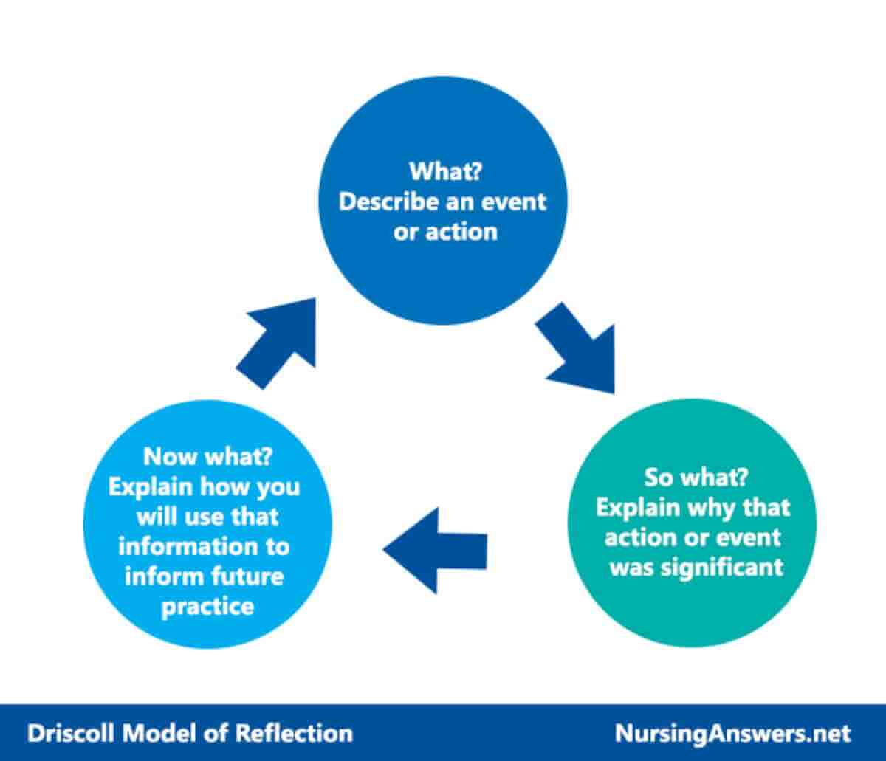

I will assess the incident using Driscoll’s method. I will first describe what happened, then I will analyse the event, looking at all aspects including how affective my communication skills were at mitigating threat and risk; finally, I will look at how I can apply what I learned to future incidents.

To ensure that a decision is accurate and professional an officer should always call back to the National Decision Model (NDM) (College of Policing (2014)

“The NDM has six key elements.

Code of Ethics; Ethical policing principles and Guidance for ethical and professional behaviour in policing.
Gather information and intelligence.
Assess threat and risk and develop a working strategy.
Consider powers and policy.
Identify options and contingencies.
Take action and review what happened.
Each element provides the user with an area for focus and consideration. The element that binds the model together is the Code of Ethics at the centre.”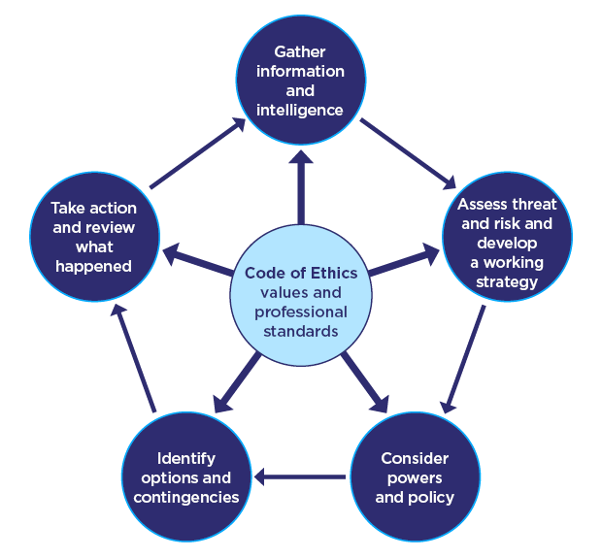

The 2024 Code of Ethics is inclusive and supports everyone in policing.
It has two parts, both of which are non-statutory.
Ethical policing principles.

Guidance for ethical and professional behaviour in policing.
(College of Policing (2024)

During an afternoon shift, I was double crewed in alongside my colleague. During our shift, we were contacted by the Force Control Room (FCR) Where we received an emergency call reporting a male was threatening people in the street outside of a pub. Whilst attending this call I considered the NDM (College of Policing (2013). National Decision Model) as I believe that it is essential to always focus on the policing code of ethics (College of Policing, 2024).

With the NDM in mind, I considered the first principle, “Gather information and intelligence.” I thought about what information we had and what need to be gathered.
From FCR we were given a brief description of the male that had been passed over by a member of the public, this included a description of the males clothing. We were also informed the male had said “Have you got a problem? When I see you next, you can’t believe the stuff I’m going to do." I immediately realised the threatening nature of this and considered possible offence. FCR informed us that the male was highly intoxicated and was being very aggressive and intimidating to members of the public

I thought about the second principle of the NDM “assess threat and risk and develop a working strategy”. I anticipated that due to the male being reported to appear to be intoxicated, aggressive, and intimidating, that he may become a risk to both officers and members of the public. Following this I began to consider methods of communication that would help to calm the male and mitigate risk. Before arriving at the scene I developed the strategy that when we locate the male I would use open questions which would allow him to speak to me and build a positive rapport, due to the male being intoxicated he may not response well to the use of closed questions as he may become frustrated with answering questions with yes or no answers.

On arrival at scene, I identified a male that matched the description and approached him as I did this, I activated my Body Worn Video (BWV) to capture the incident and evidence that may later be exhibited in court. The male was extremely volatile and aggressive, as he had consumed a large amount of alcohol. According to Ackermann, K. (2022): “Research has shown that any amount of alcohol consumption disrupts normal brain function. It weakens our brain mechanisms that normally restrain impulsive behaviours such as aggression and can lead to misjudging situations and overreacting.” To mitigate this I began to use open questions such as “how are you” and “is their anything I can do to help you” I wanted the male to remain calm and keep communicating with me, I also used open and relaxed body language, I did not cross my arms when speaking with the male as he may have perceived this as me being closed off and defensive.

Considering the third principle of the NDM “consider powers and policy” I identified that the male was currently committing the offence being drunk and disorderly.
“Section 91(1) of the Criminal Justice Act 1967: “It is an offence to behave in a disorderly manner in a public place while being drunk." (Legislation.gov.uk, 2023) as the male was currently communicating with me and that we had built a positive rapport all though I had the power to arrest the male for the offence
“Section 24A of the police and criminals evidence act 1984- arrest without a warrant: other persons.
(1) A person other than a constable may arrest without a warrant—
(a) anyone who is in the act of committing an indictable offence;
(b) anyone whom he has reasonable grounds for suspecting to be committing an indictable offence.
(2) Where an indictable offence has been committed, a person other than a constable may arrest without a warrant—
(a) anyone who is guilty of the offence;
(b) anyone whom he has reasonable grounds for suspecting to be guilty of it.”
legislation.gov.uk (2012)

On considering my options I came to the conclusion that if I was able to remove the male from the area this would better mitigate any threat and risk than having to arrest the male which would likely lead to more confrontation.

Considering the fourth principle of the NDM “options and contingencies” I identified that the most suitable option would be to communicate with the male and try and find somewhere that he could stay for the evening as this way we would be fully able to mitigate all threat and risk to ourselves and the public and ensure that the male was safe guarded for the evening. After identifying this option, I once again communicate the male with open questions asking “how would you feel if you sit in the police car whilst we try and find somewhere for you to go for the evening” the male was happy to do this and he entered the vehicle. Following this I asked the male for his details and I ran a PNC check on him as I needed to gather further information and intelligence, with this I identified he had multiple warning markers for suicide, mental health and self-harm, as I had built a positive rapport with him I asked if there were any friends or relative he could go to, however he indicated that he had no one in the area and that he wanted to be alone, at this point the male had a sudden change in mood and began more aggressive. Due to the male's unpredictable behaviour and taking into consideration the duty of care that the police have (The Role and Responsibilities of the Police, 2017), we were not able to leave the male unsupervised, which was done to minimise conflict and safeguard the individual.

We told the male that he could not go home, to which he began swearing at us and became very aggressive. Aggression can be identified in many ways (Anon, n.d.), for example, verbal aggression. “Verbal aggression involves the use of words or tones to harm or control others. Examples include yelling, swearing, insulting, or threatening. Verbal aggression can be used as a tool to intimidate others, assert power or control, or as a form of retaliation.” I continued to use communicate with the male however due to his intoxicated state he began to stop listening to me and my colleague.

Considering the final principle of the NDM “Take action and review” we identified that without the subject offering us with a suitable place to take him for the evening then the best option to mitigate conflict and to safeguard the male was to arrest him for the offence of being drunk and disorderly. As I had been able to communicate with the male throughout the incident I asked him to step out of the police vehicle for me, as I did this the male became extremely aggressive and began to resist arrest, I continued to communicate with the male however realised that I would have to change my method of communication as my initial way of communicating was no longer working, I raised my voice and became more assertive and began to respond to him in one word statement such as “stop” and “listen”, this had a positive impact as he began to listen and look at me as I was talking to him, as he did this me and my colleague placed the male in handcuffs. Following this I sat him down on the pavement so that he could catch his breath, as I did this, I returned to using open questions and showing open body language to make the male aware that the situation had calmed down. Whilst conveying the male to custody I sat in the rear of the police vehicle with him and communicated throughout the journey, this resulted in him being calm for the full remainder of time he was under my supervision.

Considering Driscoll’s second principles of his model of reflection so what? (Analyse the event.) I believe my actions were proportionate and did minimise conflict. Throughout this incident, I was constantly thinking of what the best approach was to managing conflict. I believe that I conducted myself in a calm and professional manner in line with the college of policing (College of Policing, 2023) and the policing code of ethics (College of Policing, 2024). and the ethical policing principles (College of Policing (2024)) and limited conflict to the best of my ability. Also, I believe that all my actions were justifiable and proportionate to the incident and were carried out in a professional manner. My use of different communication methods throughout the incident helped to have a positive impact on mitigating conflict and build a positive rapport with the subject, I believe because I initially was able to create this positive rapport it helped to minimise threat and risk when the subject did become aggressive towards officers.

Considering Driscoll’s final principles of his model of reflection Now what? (Anticipate future practice based on what you learned) for future incidents I will try and identify when there is a break down in communication sooner as a way to minimise conflict for example in this incident I was able to initially calm the male using specific communication methods like open questions, open body language and trying to not use hand gestures however I was unable to properly identify the point where there was a break down in communication between me and the subject such as when he began to stop listening to stop communicating with me when we would not allow him to be left alone, if I am able to identify this break in future incidents then I can sooner changed my method of communication to one that is more appropriate for the new situation and hopefully minimise conflict entirely.

Word count- 1607

Task 3

Relevant areas of the National Policing Curriculum:
Criminal Justice, Valuing difference and inclusion

You must choose a policing incident in which you played a significant role with an offender/service user/victim and reflect on what happened.

Give a brief description of a relevant incident including social and legislative contexts and any relevant cultural, ethnicity and language issues.

Explain and reflect on your responsibilities and procedures in line with the relevant Codes of Practice to support victims and witnesses through the criminal justice system.

Illustrate how policing values were engaged, as well as any other considerations including culturally sensitive practice and language preference.

1500 words (+/- 10%: include your actual word count at the end of each section)

ANSWER:

During this task, I will outline an incident where I played a significant role in supporting a victim who was subjected to a hate crime, I will demonstrate my use of the victim’s code of practice and how I applied them to this incident. Following this I will detail how I dealt with a hate crime and how I applied the policing code of ethics (College of Policing, 2024), and with policing national decision model (College of Policing (2014). To effectively reflect on my actions, I will also use Driscoll’s 1990 what method of reflection (Nursinganswers.net (2018).

What? Describe what happened.

So what? Analyse the event.

Now what? Anticipate future practice based on what you learned.

The victim code of practice is split into 12 rights

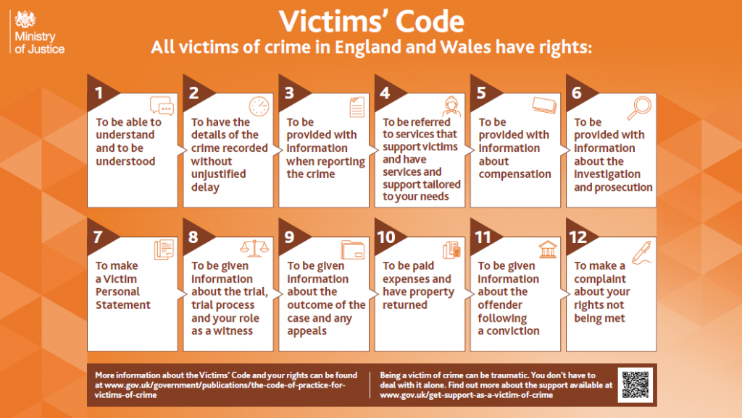

“The Victims’ Code explains the rights that everyone can expect to receive as a victim of crime.
Whoever you are and whatever the crime, you have the right to be informed about the criminal justice process and the support available.”

(OPCC for Avon and Somerset. (n.d.).

Within the nature of the police, a vital aspect is working with victims from many different and diverse backgrounds. The community that police work within can be populated with people with varied ethnic and cultural backgrounds. According to Gov.UK (GOV.UK. (n.d.) “In the year ending March 2022, there were 155,841 hate crimes recorded by the police in England and Wales, a 26 percent increase compared with the previous year.” These figures clearly show that members of our communities are being targeted solely due to their protected characteristics. The College of policing (College of Policing (2020) states that “Hate crimes should be treated as priority incidents and consideration given to the most effective response that balances the needs of the incident, police resources available, and the nature of any risk.”

We received an emergency call from the Force Control Room (FCR) that there were two males fighting in a shop and that staff were asking for assistance. FCR reported that “One white male and one Asian male have entered the shop and have started fighting. One ran in, and the other chased him. Staff have closed the shop down until police arrive." We received no description of the males from FCR; however, we were aware that both males had been fighting and possible offences of assault by acute bodily harm.

Highlighting the first key principle of the NDM “Gather information and intelligence,” through communicating with FCR, we were made aware of a limited description of the individuals, and that there was a possibility that one male had been the aggressor due to the information from FCR that “One ran in and the other chased him.” Although information was still limited, I considered the possibility that due to the time of the evening and the description of one male being white and one male being Asian there was a possibility this incident could be related to hate crime.

Bodily harm (ABH) (Section 47 Offence’s against the Person Act 1861—Whosoever shall be convicted upon an indictment of any assault occasioning actual bodily harm shall be liable) (Legislation.gov.uk (2011)

Considered the second key principle of the NDM (College of Policing) (2014), "Assess threat and risk and develop a working strategy.” Using our professional judgement, which was assisted by the College of Policing (College of Policing (2023) and the NDM, I assessed that the males may be aggressive. Due to there being three officers attending the call the best course of action to limit threat and conflict was to split up the two males who had been fighting, take them away from each other, and place them both in handcuffs, as we were unaware of what had taken place and which male was the aggressor.

We arrived at the scene, and I activated my Body Worn Video (BWV) to capture the incident and evidence that may later be exhibited in court. We entered the shop, and I saw two males appearing to be restraining another male on the floor. My colleague and I separated the males.

Once any further conflict was managed and minimised, I went about speaking to the male. The college of policing (College of Policing (2020) outlines that “effective communication shapes service delivery towards the needs of the public. The various ways in which police communicate should be proportionate to the needs and requirements of the different communities they serve.” The male informed me on what had taken place between him and the other male. The male self-defined himself as Asian British of Pakistan decent and stated that he believed the male was aggressive toward him due to his appearance. Following this I identified that this male was the victim, I then began to go through the stages of the victim’s code, I explained to the victim the police process and what would happen with the offender in line with “Right 1: to be able to understand and to be understood”

After the victim told me what had happened, I considered the third key principle of the NDM “consider powers and policy”. The male identified that he had been targeted due to this skin colour and had been assaulted by way of the offender trying to gouge out his eye.
Following this information I considering two offences, the first being:

“Racial aggravated public order (Section 31 of the Crime and Disorders Act, 1998)
(1) A person is guilty of an offense under this section if he commits—
(a) offence under Section 4 of the [1986 c. 64.] Public Order Act 1986 (fear or provocation of violence);
(b) an offense under Section 4A of that Act (intentional harassment, alarm, or distress); or
(c) an offence under Section 5 of that Act (harassment, alarm, or distress), which is racially aggravated for the purposes of this section.”
(Legislation.gov.uk. (2022).

And the second offence:
“Assault by Acute Bodily Harm (Section 47 Offences Against the Person Act 1861)
Whoever shall be convicted upon an indictment of any assault occasioning actual bodily harm shall be liable.”
(Legislation.gov.uk (2011).

I also considered the fourth key principle of the NDM “Identify options and contingencies”, I tried to identify the best course of action and what the best possible outcome would be, due to the clear assault and the possibility of this being a hate crime or racially aggravated. The crown prosecution (Crown Prosecution Service (2022) states that “any crime can be prosecuted as a hate crime if the offender has either demonstrated hostility based on race, religion, disability, sexual orientation, or transgender identity."

Considering the final element of the NDM “Take action and review what happened,” I identified that the best course of action was to arrest the offender that my colleague was speaking to for assault by ABH and for racially aggravated public order. The male was conveyed to custody, and I stayed with the victim. Whilst with this victim I considered the victim code of practice, I informed the male of his rights, and I identified what he needed to be made aware of now, this included:

- Right 1: To be able to understand and to be understood
- Right 2: To have the details of the crime recorded without unjustified delay
- Right 7: To make a victim personal statement

After I was satisfied that the male was aware of these rights I went through explaining the investigation and what rights would apply to him in the future, I ensured that the male was aware of all the detail in regard to the crime recording (Right 3: To be provided with information when reporting the crime), any possible information and compensation (Right 5: To be provided with information and compensation) and our in-force victim support for victims of offence (Right 4: To be referred to victim support services and have services and support tailored to your needs).

Due to the male’s current health, it was not appropriate to take a statement at that time, I informed him that officers would visit him the next day to take a statement and that following this statement he would be given an opportunity to make a victim personal statement (Right 7: To make a victim personal statement) where he can detail what effects this incident had on him. Finally, as I was aware I would not be the officer in charge of the case I reassured the male that while the offence is being investigated, he will be provided with information relevant to the investigation as he pleases and that he would be informed of the outcome of the case and any appeals. (Right 8: To be given information about the trial, trial process and your role as a witness. Right 9: To be given information about the outcome of the case and any appeals. Right 11: To be given information about the offender following conviction). I then informed the victim that if he was unhappy with the investigation then he would have the right to make a complaint. (Right 12: To make a complaint about rights not being met). For this incident Right 10: To be paid expenses and have property returned did not apply.

Considering Driscoll’s second principles of his model of reflection so what? (Analyse the event.) Throughout this incident, I identified that it was vital for me to take a leading role in dealing with the offender and reassuring the victim. Whilst speaking with the victim, I ensured that that he was safe guarded and that he was informed regarding the code of practice to support victim, I based my safe guarding techniques on the 12 rights, although it is essential to gain all the relevant information in regards to the criminal offence, we as police cannot overlook the impact that the incident has on the victim especially in hate incidents such as this, I gathered all the relevant information and intelligence for the offence however, I also safeguarded the victim and made sure he was aware of the procedures associated with the victims code. I also made him aware of the procedures that we would be following whilst the incident was being investigated.

Considering Driscoll’s final principles of his model of reflection Now what? (Anticipate future practice based on what you learned) In reflection of this incident, I believe that I took positive action in dealing with the victim and offender. It is apparent that within the United Kingdom, many people are still discriminated against and mistreated solely based on their race and skin colour. Many studies have been done to try and identify prejudice in Britain (BBC News, 2014).

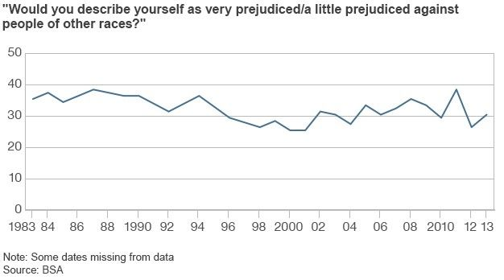

Within this diagram, “the statistics come from the annual British Social Attitudes Survey, which, since 1983, has interviewed one or two thousand people and asked if they are "very prejudiced,” “a little bit prejudiced," or "not prejudiced at all" against people of other races.” This diagram illustrates that even after 30 years, many people openly say that they are, at least in some regards, “prejudiced against people of other races.” It is important to be aware of these statistics as hate incidents often start with someone being prejudice against another person based on their race or other protected characteristics.

During this incident I conducted myself in a professional and proportionate manner, I understand the importance of taking positive action in line with the victim code of practice when dealing with any incident. I believe that my actions reassured the victim and adhered to the police protocol. However, on refection of this incident I need to ensure that I have a better understanding of the victim code of practice so that I have a greater knowledge of the process when dealing with victims and witnesses. In this incident due to the male being intoxicated he would sometimes have difficulty fully understanding the process and what specific aspects meant such as the compensation that he is provided for example “The Criminal Injuries Compensation Scheme is a government funded scheme. It compensates victims with physical or mental injury caused by a violent crime occurring in Great Britain” GOV.UK. (n.d.). I need to improve on this as the first principle is “To be able to understand and be understood” and I must ensure that when speaking with victims and witnesses they fully understand the rights and entitlements that they have.

I believe that all my actions were justified and were made in the interest of the public and the victim. For future incidents that involve a hate crime, I will conduct myself in the manner that I did in this incident; however, to improve in the future, I will ensure that I have a better understanding of all hate crimes and the criteria that must be met to constitute the crime, and I will also further revise the effects that hate crimes have on an individual so that I can better help victims.

Word count- 1647

Task 4

Relevant areas of the National Policing Curriculum:
Decision making and discretion, Conducting Investigations and Criminal Justice (Managing offenders)

You must choose a policing incident in which you played a significant role with an offender/service user/victim and reflect on what happened.

Give a brief description of the situation including social and legislative contexts and any relevant cultural, ethnicity and language issues. Reflect on how you applied the National Decision Model (NDM) to assist in resolving this incident. Consider the role of discretion in the decision-making process.

Explain your responsibilities with regards to the provision of the CPIA when conducting this investigation including when managing the offender and suspects and recording and retaining significant information.

Illustrate how policing values were engaged particularly through an analysis of the potential impact of bias on the decision-making process.

1500 words (+/- 10%: include your actual word count at the end of each section)

ANSWER:

During this task I will be discussing an incident where decision making, discretion, conducting investigations and criminal justice via the managing of an offender played a major role, I will also use John Driscoll’s 1990 model of reflection (Nursinganswers.net (2018) to reflect on my actions and how they can be improved in the future,

I will also reflect upon my use of the National Decision-Making model and how it impacted my decisions, I will be reviewing my responsibilities regarding the CPIA through conducting investigations. According to the college of policing (College of Policing (2013)

“The Code of Practice to the Criminal Procedure and Investigations Act 1996 (CPIA) (opens an external website in the same tab) defines a criminal investigation as:
An investigation conducted by police officers with a view to it being ascertained whether a person should be charged with an offence, or whether a person charged with an offence is guilty of it.”

The CPIA splits an investigation into different phases

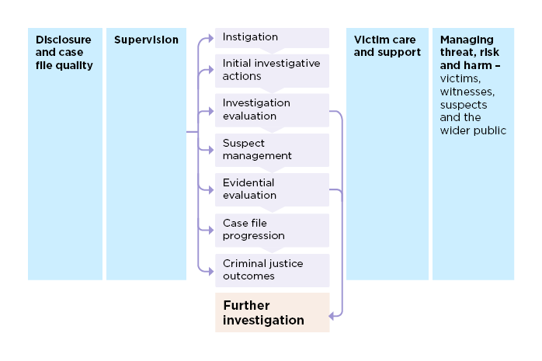

Professional and accurate decision making is one of the most import aspects of policing, as police officers it’s important that we can make decisions that are best suited to the specific situation that we are in. The College of policing (College of Policing (2023) state that all decisions made by officers should be impartial throughout so that an investigation is proportionate and conducted in a professional manner. To ensure that a decision is accurate and professional an officer should always call back to the National Decision Model (College of Policing (2014)
“The NDM has six key elements.

Code of Ethics; Ethical policing principles and Guidance for ethical and professional behaviour in policing.
Gather information and intelligence.
Assess threat and risk and develop a working strategy.
Consider powers and policy.
Identify options and contingencies.
Take action and review what happened.
Each element provides the user with an area for focus and consideration. The element that binds the model together is the Code of Ethics at the centre.”

The 2024 Code of Ethics is inclusive and supports everyone in policing.
It has two parts, both of which are non-statutory.
Ethical policing principles.

Guidance for ethical and professional behaviour in policing.
(College of Policing (2024)

Constables should also use their discretion, according to the definition (Treebold, J. (2018) “Police discretion refers to the authority given to law enforcement officers to make decisions based on their judgment and experience” Officers should use resources such as the National Decision Model to assist their discretion and to help them carry out their duties in a professional way.

Using the first principle of Driscoll model of reflection (What? Describe what happened) I will describe the incident and how the NDM and my professional discretion played a major role. Following this I will also call back to the CPIA

During an afternoon shift I was asked by a colleague to assist in the arrest of a male who was under investigation on the suspicion of stalking his ex-partner, my colleague had extensive prior knowledge of the male and why the allegations had been made.

Using the first key principle of the NDM (College of Policing (2014). “Gather information and intelligence” I spoke to officers prior to leaving the station as I knew that they would have all the relevant details and information. The male had several warning markers including weapons, drugs and an extensive history of assault. The male had also been involved in a few incidents where he was aggressive to both police and members of the public. The male had also in the past evaded police and often runs away when he sees the police. Prior to leaving I made sure that I was aware of the subject’s appearance, to do this I requested that my colleague sent me an image of the male and a 10-point description of him so that I was aware of aspects such as his height, build, complexion, hair colour and any distinguishing features that he may have to better identify him. After gathering all the information and intelligence regarding the male I could better assess the threat and risk the male could potentially pose and was able to develop a working strategy prior to seeing this male. In line with the CPIA I tried to identify
Has a crime been committed?
Who is the victim?
Are there any witnesses?
Where or what is the scene?
Can a suspect be identified?
What material can be gathered?

Following this also in line with the CPIA I established that “As the investigation progresses, these objectives will narrow and focus on key questions potentially about specific people of interest, such as the following.

Description – does the individual fall within the suspect parameters?
Availability – was the individual available to commit the offence within the time parameters?
Physical links – can the individual be linked to the crime through articles removed from or left at the scene?
Forensic links – can the individual be linked to the crime through forensic science techniques, including using digital media?
Passive data links – can the suspect(s) be linked to the crime through CCTV, financial information, computer-based electronic evidence and customer information?
Identification links – can the individual be linked to the crime through victim or witness identification?
Intelligence links – is there intelligence linking the individual to the crime?
Behavioural links – is there anything about the individual’s previous behaviour that may link them to the crime?”

We then began to conduct arrest enquires and I considered the Second key principle of the NDM “Assess threat and risk and develop a working strategy”, this principle allows officers to assess any possible threat and risk and to develop a suitable working strategy. Considering the violent history of the male and the number of times he had been arrested for assaulting police and members of the public I assessed that he may be a risk to myself, my colleagues and members of the public. I considered that the best strategy may be to take immediate action as a way of minimising any threat and risk. Using the NDM and my decision making (College of Policing (2023), I believed that the best course of action was to try and immediately arrest the male as this would minimise the threat and risk massively as trying to communicate with the male for an extended period may lead to him becoming more aggressive.

I considered the third principles of the NDM “Consider powers and policy” and identified that the male had clearly committed the offence of stalking as he had on more than two occasions made his ex-partner fear that unlawful violence would be used against her.
(Section 4A of Protection from Harassment Act 1997:
Stalking involving fear of violence or serious alarm or distress,
(1)A person (“A”) whose course of conduct—
(a)amounts to stalking, and
(b)either—
(i)causes another (“B”) to fear, on at least two occasions, that violence will be used against B, or
(ii)causes B serious alarm or distress which has a substantial adverse effect on B's usual day-to-day activities, is guilty of an offence if A knows or ought to know that A's course of conduct will cause B so to fear on each of those occasions or (as the case may be) will cause such alarm or distress.)
(Legislation.gov.uk. (2012).

The most suitable power that I had was arrest due to the male being suspected of committing the either way offence of stalking involving fear of violence which is arrestable.

“Section 24A of the police and criminals evidence act 1984- arrest without a warrant: other persons.
(1) A person other than a constable may arrest without a warrant —
(a) anyone who is in the act of committing an indictable offence.
(b) anyone whom he has reasonable grounds for suspecting to be committing an indictable offence.
(2) Where an indictable offence has been committed, a person other than a constable may arrest without a warrant —
(a) anyone who is guilty of the offence.
(b) anyone whom he has reasonable grounds for suspecting to be guilty of it.”
legislation.gov.uk (2012)

Considering the fourth principle of the NDM “options and contingencies” I assessed the different ways that the situation may be resolved, I considered my knowledge of the subject including all his violent history, the offence that he had committed and the powers that I had. I identified that when locating the male there may be a short period of time where a positive action may be completed as the male may abscond when he sees police as he has done in the past. Once again, I identified that the best option would be to place the male in handcuffs when I immediately see him as this would limit the threat and risk and the chance of him running, failing this the next best option would be to use multiple police resources so that we can attempt to corner the male so that he cannot evade police.

Whilst travelling in the police vehicle I identified a male that matched the 10-point description of the subject and when I approached him, he matched the image that I was sent by my colleague, I exited the vehicle and activated my Body worn video (BWV) to capture the incident and evidence that may later be exhibited in court in line with the CPIA. The male continued to walk away, and I asked him his name to determine if he was the person in question. The man gave me his name and I ascertained that he was the subject.

Taking into consideration the final key principle of the NDM “Take action and review what happened” and the other previous principles using my decision-making skills, discretion and calling back to college of policing (College of Policing (2023) I took action and placed the male in handcuffs in the rear stack position, I then continued with a Section 32 of PACE search after arrest (Legislation.gov.uk (2013).

During the search the male disclosed to me that he was suffering with arthritis in his wrists and was very uncomfortable in handcuffs. Considering policing guidance (College of Policing (2024) and taking into consideration the idea that we “are conscious of the impact that our behaviour and decisions have on others” I used my discretion to remove the handcuffs from the rear and moved them to a front stack position so the male was more comfortable, but I was still in control, following this the subject remained calm for the full period he was under my supervision.

Following this I went through all the necessary steps of investigation in line with the CPIA, I uploaded both BWV and my arrest statement and then went through completing the golden hour investigation, due to the offence occurring online we seized the male’s phone for evidence, this was then booked into property. Following the arrest I went through the process of speaking with the victim and identifying any possible witnesses to the offence, I made sure that through my investigation all my actions were lawful and professional and in line with the legislation created by the CPIA, the reason why it is essential to follow the CPIA is the main reason why it was originally created, the CPIA was brought in due to there being major miscarriages of justice which resulted in many unlawful investigations.

Using parts 2 and 3 of Driscoll’s 1990 what method of reflection.

• So what? Analyse the event.
• Now what? Anticipate future practice based on what you learned.

Using the resources that I have used from the college of policing and other sources I have been able to reflect on my actions and review the effectiveness of my decision-making skills, my use of my professional discretion and my use of the NDM. On analysis of the event (SO WHAT?) I believe that I used the NDM in the correct method to assist in resolving this incident, as I noted above, I had a good understanding of the offence and knowledge of the subject, so I was able to mitigate threat and risk during the incident. Throughout the incident I thought back to the policing code of ethics especially when interacting with the subject, referring to the guidance for ethical and professional behaviour in policing I applied the idea that we as police “are conscious of the impact that our behaviour and decisions have on others”, I applied this to my professional discretion when interacting with the subject.
On anticipating future practice based on what I learned from the incident (Now What?) I would call back to this incident when dealing with mitigating threat and risk and my application of the NDM, I believe that my decision making did play a part in calming the situation and the subject, I applied the policing code of ethics and the NDM well and will do so in every incident that I go to in my policing career. For future events I will look back at this incident when dealing with a subject. The decision that I made during this incident calmed down the subject and made sure that he was not in any physical pain or discomfort, my behaviour was proportionate in relation to the ethical policing principles (College of Policing (2024). Ethical policing principles) and the principle that we as police must respond to the needs of individuals.
“In ensuring that everyone is treated equally and fairly, regardless of background or circumstance, we recognise the need to tailor our response to ensure that we are being responsive to individual needs and acting with integrity and respect.”

Word count- 1639

Task 5

Personal Development Plan (PDP) / Learning Plan.

As part of your reflective process, please use this table to aid you in identifying the next steps for development. This is equivalent to 500 words. Please note that this not the actual number of words you need to use, the wordcount reflects the thought and research you put into it.

Identified area for development. | How it will be achieved | Who can provide support? | Timeline
Improving my confidence whilst conducting an interview | I will make an effort to conduct as many interviews as possible and during these interviews I will try and remain calm and speak in a slow and controlled manner | My tutor and other experienced colleagues | Within my 10-week tutor ship and throughout my probational period.
Improving my knowledge of legislation and staying up to date with new legislation | I will make sure that I revise legislation and make a conscious effort to be mindful of any new legislation and how this new legislation may impact my decision making | College of policing and ensure that stay updated with changes to current legislation and the creation of new legislation | I will continue to revise during my tutor ship and probation and throughout my policing career
Improving my confidence whilst conducting an arrest. | I will ensure that I watch my colleagues whenever they are conducting an arrest and to also try and take the lead on as many arrests as possible | My tutor and other experienced colleagues | I would like to see a significant improvement with my next arrest especially if it is unassisted by my tutor.
Improve my GOWISELY whilst completing a stop and search | I will ensure that I know all the information that is necessary to give to a person being searched under the police and criminal evidence act 1984 | My tutor and other colleagues who can review my stop search.  Also watching the stop and search back on my BWV | I would like to see a significant improvement with my next stop and search.

Bibliography
The bibliography should only include sources referenced within the workbook using the Harvard referencing system. Information about referencing in written assignments and how to avoid plagiarism can be found on Moodle. It is important that you are aware of the importance of ensuring that the work submitted is your original work.

‌American Psychological Association (2023). Stress Effects on the Body. [online] American Psychological Association. Available at: https://www.apa.org/topics/stress/body.

Ackermann, K. (2022). Drinking Alcohol and The Risk of Violence. [online] Alcohol.org. Available at: https://alcohol.org/health-effects/drinking-and-fighting/.
‌
Anon, (n.d.). Aggression: 10 Signs, Causes, Types, Steps To Control It. [online] Available at: https://mind.help/topic/aggression/#:~:text=How%20To%20Recognize%20Your%20Aggression%20Consider%20the%20following [Accessed 25 May 2024].

Cambridge Dictionary (2019). Resilience. [online] Cambridge.org. Available at: https://dictionary.cambridge.org/dictionary/english/resilience.

College Of Policing (2013). National Decision Model. [online] College of Policing. Available at: https://www.college.police.uk/app/national-decision-model/national-decision-model.
‌‌
College of Policing (2013). Investigation introduction | College of Policing. [online] College of Policing. Available at: https://www.college.police.uk/app/investigation/investigation-introduction?highlight=cpia.

‌College of Policing (2023). Making good decisions. [online] College of Policing. Available at: https://www.college.police.uk/guidance/conducting-effective-investigations/making-good-decisions.

College Of Policing (2024). Guidance for ethical and professional behaviour in policing | College of Policing. [online] www.college.police.uk. Available at: https://www.college.police.uk/ethics/code-of-ethics/guidance.
‌
College of Policing (2024). Code of Ethics. [online] College of Policing. Available at: https://www.college.police.uk/ethics/code-of-ethics.

College of Policing (2024). Ethical policing principles. [online] www.college.police.uk. Available at: https://www.college.police.uk/ethics/code-of-ethics/principles.

College of Policing (2020). Responding to hate crimes. [online] College of Policing. Available at: https://www.college.police.uk/app/major-investigation-and-public-protection/hate-crime/responding-hate-crimes.
‌
College of Policing (2024). Code of Ethics. [online] College of Policing. Available at: https://www.college.police.uk/ethics/code-of-ethics.
‌
College of Policing (2014). National decision model. [online] College of Policing. Available at: https://www.college.police.uk/app/national-decision-model.

College of Policing (2020). Communication. [online] College of Policing. Available at: https://www.college.police.uk/app/engagement-and-communication/communication.

Crown Prosecution Service (2022). Hate Crime. [online] www.cps.gov.uk. Available at: https://www.cps.gov.uk/crime-info/hate-crime.

Churchill, R., Riadi, I., Kervin, L., Teo, K. and Cosco, T. (2021). Deciphering the role of physical activity in stress management during a global pandemic in older adult populations: a systematic review protocol. Systematic Reviews, 10(1). doi:https://doi.org/10.1186/s13643-021-01678-6.

Gladd, J. (2020). John Driscoll’s ‘What?’ Cycle of Reflection. [online] Pressbooks. Available at: https://idaho.pressbooks.pub/write/chapter/john-driscolls-what-cycle-of-reflection/.

GOV.UK. (n.d.). Compensation in the justice system. [online] Available at: https://www.gov.uk/guidance/compensation-in-the-justice-system.

‌
Harvard Medical School (2024). Understanding the stress response . [online] Harvard Health. Available at: https://www.health.harvard.edu/staying-healthy/understanding-the-stress-response.

Healthline Editorial Team (2020). Everything You Need to Know About Stress. [online] Healthline. Available at: https://www.healthline.com/health/stress.
‌
Heshmat, S. (2022). 6 Ways Music Can Reduce Your Stress | Psychology Today. [online] www.psychologytoday.com. Available at: https://www.psychologytoday.com/us/blog/science-choice/202210/6-ways-music-can-reduce-your-stress.

Home Office (2022). PACE Code G 2012 (accessible). [online] GOV.UK. Available at: https://www.gov.uk/government/publications/pace-code-g-2012/pace-code-g-2012-accessible.

Legislation.gov.uk. (2023). Criminal Justice Act 1967. [online] Available at: https://www.legislation.gov.uk/ukpga/1967/80/section/91#:~:text=91%20Drunkenness%20in%20a%20public%20place.%20%281%29%20Any.

Legislation.gov.uk. (2012). Protection from Harassment Act 1997. [online] Available at: https://www.legislation.gov.uk/ukpga/1997/40/section/4A.

legislation.gov.uk (2012). Police and Criminal Evidence Act 1984. [online] Legislation.gov.uk. Available at: https://www.legislation.gov.uk/ukpga/1984/60/section/24A.

‌Legislation.gov.uk. (2022). Crime and Disorder Act 1998. [online] Available at: https://www.legislation.gov.uk/ukpga/1998/37/section/31/enacted.

legislation.gov.uk (2011). Public Order Act 1986. [online] Legislation.gov.uk. Available at: https://www.legislation.gov.uk/ukpga/1986/64/section/3.

‌
Legislation.gov.uk (2013). Police and Criminal Evidence Act 1984 Section 32. [online] Legislation.gov.uk. Available at: https://www.legislation.gov.uk/ukpga/1984/60/section/32.

Legislation.gov.uk. (2022). Crime and Disorder Act 1998. [online] Available at: https://www.legislation.gov.uk/ukpga/1998/37/section/31/enacted.

Legislation.gov.uk (2011). Offences Against the Person Act 1861. [online] Legislation.gov.uk. Available at: https://www.legislation.gov.uk/ukpga/Vict/24-25/100/section/47.

‌Mind.org.uk. (2019). 14 ways to beat exam stress | Mind, the mental health charity - help for mental health problems. [online] Available at: https://www.mind.org.uk/information-support/your-stories/14-ways-to-beat-exam-stress/.

Nursinganswers.net (2018). Driscoll Model of Reflection. [online] Nursing Answers. Available at: https://nursinganswers.net/reflective-guides/driscoll-model-of-reflection.php.

OPCC for Avon and Somerset. (n.d.). Victim Code of Practice. [online] Available at: https://www.avonandsomerset-pcc.gov.uk/working-for-you/victim-support-services/victim-code-practice/.

‌
Treebold, J. (2018). Police Discretion Definition - Encyclopedia.com. [online] Encyclopedia.com. Available at: https://www.encyclopedia.com/articles/police-discretion-definition/.
‌
THE ROLE AND RESPONSIBILITIES OF THE POLICE. (2017). Available at: https://www.police-foundation.org.uk/wp-content/uploads/2017/06/roles_and_resp.pdf.‌

‌

CONFIDENTIALITY and PLAGIARISM – Will be confirmed through Turnitin.

Recognition and Confirmation of the progress on the Occupational Competency Portfolio (OCP).

By signing the section below you are acknowledging your progress on O.C.P. This is recognised by the university as work that is fully supporting this module and is equivalent to 500 words towards the overall wordcount.

I confirm that I am progressing with the Occupational Competency Portfolio (OCP) in accordance to the regulations.

Signed: Ben Weston (Learner - Electronic signature or type name)

Date: 26/05/2024

