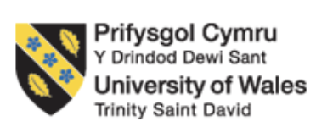

Master of Business Administration
LCMB7023 HUMAN CAPITAL MANAGEMENT
Assessment component 1: Individual report – HR strategy
Topic: Integrated Human Capital Blueprint on Aether innovations
Student Name: Hiraben Devshibhai Modhwadiya
Student ID: 2520086

Table of Contents
Part 1: Building a Culture of Innovation & Future Work Practices 3
1. Current Culture & Work Practices in the Tech Sector 3
Evolution of Work Models in Tech 3
Current HR Challenges in Tech Firms 4
2. Cultural Initiatives to Embed Innovation 6
Building an Innovation-Oriented Culture 6
Structural Reconfiguration: Hub & Spoke + Adhocracy 7
3. Designing a Future of Work Model for Aether 8
Recommended Model: Hybrid 3:2 with Outcome-Based Control 8
Work-Life Balance & Expatriate Considerations 9
4. Motivation & Performance Enablement Framework 10
Part 2: Reflection 12
Learning journey of this module 12
1. Description 12
2. Feelings 12
3. Evaluation 13
4. Analysis 13
5. Conclusion 14
6. Action Plan 14
Staying Relevant in an AI-Driven Workplace 17
References 19

Part 1: Building a Culture of Innovation & Future Work Practices

1. Current Culture & Work Practices in the Tech Sector

Evolution of Work Models in Tech
Organisational structures and work models in the technology industry have experienced a swift change in the last decade, getting rid of old bureaucratic systems and focusing on the vibrant network-oriented models that play with the outcome, expertise, and flexibility. The classical methods based on the bureaucratic control developed by Weber and the Scientific Management developed by Taylor focused on the hierarchical control and efficiency of the process (holistiquetraining.com, 2024). This process is a metamorphosis of work and employee experience, which is becoming less rigid and normative and more flexible and democratised with the environment of the digital age (George, 2024).
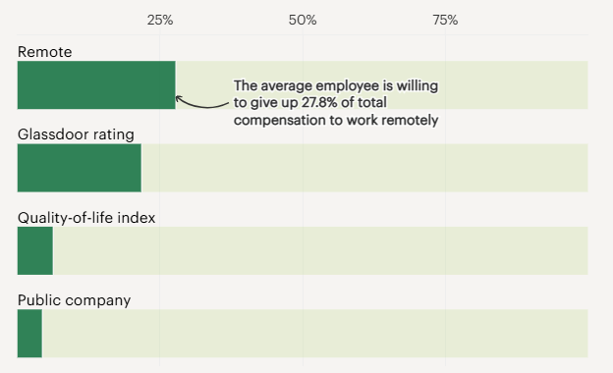
Figure 1: Remote work among tech workers
(Source: Azpúrua, 2025)
Tech companies are taking on the structure of the Spotify Model to create cross-functional teamwork and hasty methods of innovation by increasingly resembling the squads and tribes therein. In the year 2023, 65 out of 100 international technology companies had some form of formal hybrid work structure in place and 25 percent of them had fully remote work setups, as one example of how the nature of flexible work agreements are becoming a common practice in offering balance between collaboration and autonomy (Schmidt, 2026). Hybrid arrangements have a 3- 2 format - typically three workdays in office with alternate deep work, which has become the predominant trend in the opinion of new industry research (Deskbird.com, 2025).

Current HR Challenges in Tech Firms
Although flexible working is widely applied, the technological industry still experiences massive human resources problems, which compromise engagement, retention, and innovation. Employee turnover is one of the recurring issues: according to industry statistics, employee turnover in tech companies often falls between 13% to 21 per year, with the standout problem being the industry competition between companies (simultaneously creating a contest for employee talents), causing frustration in growth, and burnout (Chen, 2025).
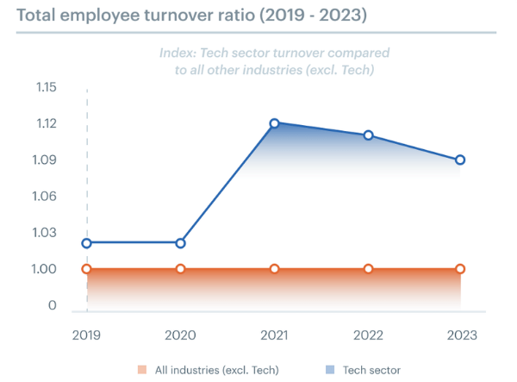
Figure 2: Employee turnover in IT sector
(Source: Chan, 2024)
The result of such churn is usually loss of institutional knowledge which stalls product cycle and team continuity - a notion which matches the Flexible Firm risk concept used by Atkinson in which a high percentage of peripheral labour masses can undermine organisational memory.
The rates of burnout are still high, and according to the surveys, a high percentage of IT professionals feel chronic stress and exhaustion, which is worsened by the work requirements of remote work, blurred roles, and role-overload. A survey conducted by The Upwork Research Institute says that only 71 out of full-time workers claim to be burned out, and merely 65 out of full-time workers claim that they are challenging the demand the employer applies to them (White, 2024).

2. Cultural Initiatives to Embed Innovation

Building an Innovation-Oriented Culture
However, recent indications indicate a culture being one of the primary predictors of innovation performance in technology companies. The McKinsey and Company (2024) point out that those companies that have an inclusive culture in the top quartile are 1.7 times more likely to be a leader in their market (psico-smart.com, 2025). Likewise, according to a Deloitte report, inclusive teams do better on tests of teams by 80 percent as compared to their counterparts (peoplehum.com, 2025).
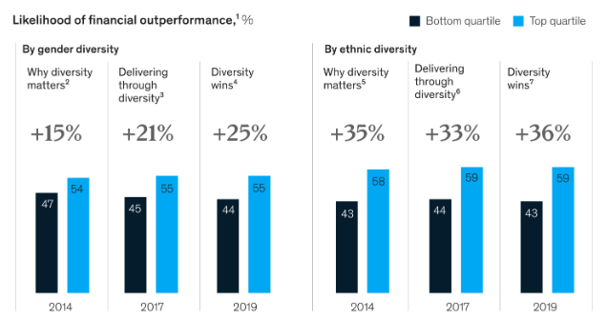
Figure 3: Statistics on gender diversity and ethnic diversity
(Source: ‌Solomon, 2024)
In the case of Aether Innovations, stagnation can be directly overcome by implementing cultural relativism, inclusiveness, and CQ (cultural intelligence). Studies indicate a 27% greater likelihood that the team with a high level of psychological safety will report greater performance, a 50% decrease in the chance to retain top talent, and 76% increased likelihood on the use of strong collaboration practices (nfp.co.uk, 2025).

Structural Reconfiguration: Hub & Spoke + Adhocracy
The probable functional silo structure within Aether inhibits agility and knowledge economy. Recent studies indicate that network-based organisations are more effective in terms of innovation results than the inflexible hierarchies (Post-2023). The study by Celestin et al., (2024) revealed that 70 percent of organisations said their team performance was enhanced once they implemented Agile, and that team collaboration had risen by 35 percent as a consequence of Agile, and the time-to-market had shortened by at least a quarter. Ressler and Thompson state that the introduction of a results-oriented working environment may increase the product of 40 percent of workers and the number of sick days will decrease by 78 percent (Robinson, 2025).
Thus, Aether is recommended to use a Hub and Spoke model:
- Central collaboration Hub- planning, culture-forming, design of innovations.
- Remote teams that were distributed remotely were given the name Digital Spokes.
- Cross-functional Teams Mintzberg Adhocracy innovation pods.
A combination of flexible Firm (core and specialist periphery) as proposed by Atkinson may offer the numerical flexibility with preserving institutional memory by:
- There are central knowledge repositories.
- Organised record keeping systems.
- Mentoring between core and peripheral experts.
Aether can anticipate the following by cutting down on bureaucracy and increasing accountability by outcome:
- Greater agility
- Shorter innovation cycles
- Improved collaboration
- Lower structural friction

3. Designing a Future of Work Model for Aether

Recommended Model: Hybrid 3:2 with Outcome-Based Control
Aether needs to implement a Hybrid 3:2 model with the three days in the central collaboration hub and two days of deep work with the support of the fully remote mode offered to the high-performing teams with outcome-based metrics. Evidence highly supports this structure even after 2023. According to the report by Gallup (2024), the engagement levels of the hybrid employees (35) are the highest relative to fully remote (29) and on-site (27) with flexibility being closely associated with retention (gallup.com, 2026).
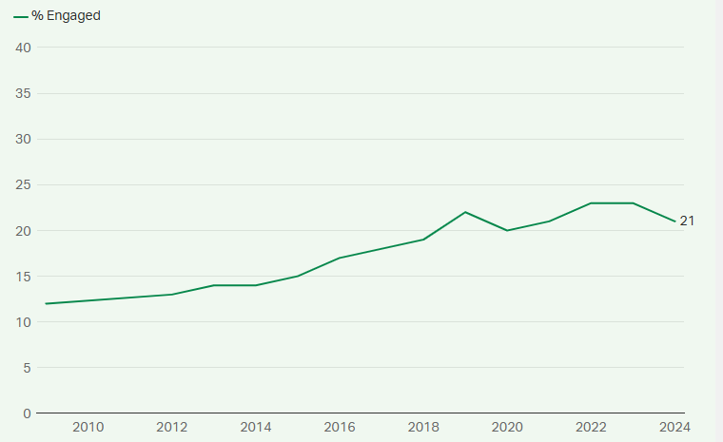
Figure 4: Engagement rate among employees
(Source: gallup.com, 2026)
According to a study by Stanford University economist Nicholas Bloom (2024), hybrid work enhances productivity by 3334 per cent and fewer workers leave because in this model employees have control over the location (Wondrasek, 2026). Also, 66% of managers noted improvement of productivity under hybrid work, and 48.5% of them recorded considerable improvement. On the contrary, 36 percent of hybrid employees are interested in their job, contrasting with 30 percent of fully on-site employees (McBride, 2025).
To be successful, Aether needs to incorporate:
- Specific outcome-based KPIs (ROWE principles).
- Online team work tools (Teams, Slack, Miro)
- Systematic virtual orientation.
- Knowledge diffusion through cross- functional mentoring.

Work-Life Balance & Expatriate Considerations
Hybrid models shall take the initiative in dealing with the risks of work-life spillover. Deloitte Global Human Capital Trends 2024 state that 77 percent of workers claim to have experienced burnout at their present work, which mostly is associated with time-related and strain-related conflicts of the boundaryless working conditions (OMOSE and IKUYINMIU, 2024).
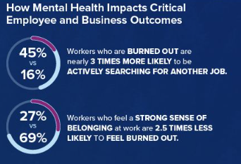
Figure 5: Impact of mental health on employees and business outcomes
(Source: Shrm.org, 2024)
Aether is supposed to incorporate: to solve mobility conflict and expatriate risk:
- Problem oriented coping strategies: packages of family support, structured planning of relocation.
- Emotional support networks: peer networks, mentoring, psychological support.
- Cultural intelligence service: in-country and pre-departure training.
- Repatriation gradients: assured positioning and knowledge repatriation.
Organisations that have formal global mobility systems have a 25 percent increased international retention rates (sig.biz, 2026). Hybrid flexibility will enable Aether to mitigate burnout, reduce assignment failure, and establish a strong global talent pipeline through the alignment of hybrid flexibility with structured expatriate support systems, knowledge captures, and other systems that will consequently enhance engagement and long-term performance.

4. Motivation & Performance Enablement Framework
In the case of Aether Innovations, the only solution to reversing stagnating growth and declining customer satisfaction is to make innovation-motivation systems and performance systems directly interconnected. Rather than quantify an amount of hours dedicated, Aether ought to use OKRs (Objectives and Key Results) based on product innovation, customer experience, and speed-to-market indicators. Most organisations have tended to put a heavy emphasis on individual performance in traditional beliefs that individual accountability is what drives results (Lasa et al., 2024). The last few years have witnessed a tangible change in the approach to the acknowledgment of the necessity of the team in the overall organisational success (Lasa et al., 2024).
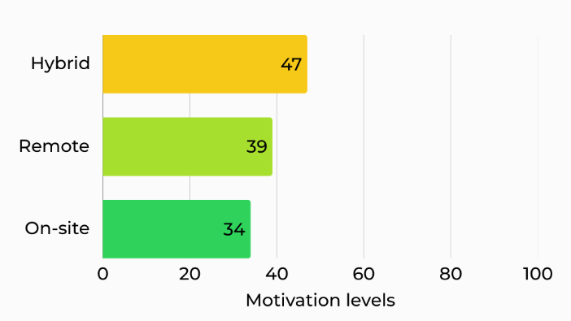
Figure 6: Motivation level in different workplace settings
(Source: high5test.com, 2025)
The psychological contract is enhanced by embedding intrinsic motivators, such as autonomy in executing a project, mastery by sprinting innovation, and purpose, which are associated with customer impact. Gallup (2024) has identified that teams that perceive their organisational contribution as related to the purpose of the organisations are more engaged and rated higher by their customers (gallup.com, 2026).
Recognising the results of innovations (new features, retention rate upgrades, knowledge sharing donations) as opposed to presenteeism emphasises trust and responsibility (Nguyen et al., 2024). Knowledge-intensive industries have high levels of retention in performance systems that are aligned with the growth and recognition of employees (Seidu et al., 2025). To Aether, this combined platform allows innovation to be incorporated into daily performance controls, i.e. make growth purposeful and predictable, not by chance.

Part 2: Reflection

Learning journey of this module

1. Description
It is through this module that I have been introduced to inter-related themes, such as expatriate management, the work life balance theory, organisational structures, the Flexible Firm model, cultural intelligence and the Future of Work. In the beginning, I took these subjects as independent HR functions, including recruitment, compensation, performance management, and mobility. With the growth and development of any business, the labour laws and regulations are also developed. By doing this, HR is aware of such changes to ensure that organisations adhere to payroll laws, employer policies, and employee rights (Oysterhr.com, 2026). Nonetheless, with the case analysis and designed applied strategy (Aether Innovations), I started to think of HRM as a cohesive system that has an impact on the innovation ability, organisational stability, and strategic development.
Major conceptual forces were Mintzbergs adhocracy, the Flexible Firm by Atkinson, the Hybrid 3:2 work model, and the cultural competency models. I also read modern literature by organisations like McKinsey and Company, Deloitte, and Gallup, which enhanced my ideas on the role played by engagement, leadership, and structure on innovations.

2. Feelings
The initial part of the module started with me being stuck about how anyone would see Scientific Management created by Taylor and bureaucracy created by Weber as having a part to play in a contemporary digital company. The quick transition to distributed teams and working remotely seemed to make frameworks used before seem obsolete. The possible minor changes to more distant and offsite employment imply that individual businesses are becoming more explicit in their policies (Pendell, 2025). As the module went on however, I realised that these formational theories and still offered structural logic especially when compared with the more contemporary forms like adhocracy or remote-first systems.
It is the change in my perception of innovation as well. In the past, I perceived innovation as the technological progress. This module has also taught me that innovation is a cultural and behavioural product, which is developed through factors such as psychological safety, inclusive leadership, and enabled knowledge transfer.

3. Evaluation
The best learning experience was the ability to identify that there is a direct relationship between people management and sustainability of performance. Other sources like the World Economic Forum Future of Jobs Report 2024 note that such skills like adaptability, emotional intelligence, and the capacity to think are getting central in the organisational competitiveness (Juniarti et al., 2024). This supported my belief that technical systems will never make growth occur and that human capability and learning culture is vital.
Still another valuable lesson was presented in the Microsoft Work Trend Index 2024 that addresses the limitations of hybrid team work. It emphasised the fact that digital tools can only increase productivity with clear expectations and the leaders being clear (Akinola-Odusola, 2025). This served to explain that behavioural change should be accompanied by structural change.
Nevertheless, a problem I faced was how to balance flexibility and accountability. Hybrid and remote systems facilitate autonomy, however, unless performance alignment systems are implemented like OKRs and psychological contracts, they can become disengaged.

4. Analysis
Theory to practise application helped in realising that innovation is achieved when there is a fit between structural flexibility and cultural support. To take an example, adhocracy introduced by Mintzberg can grant structural freedom required to achieve expertise-based authority, and cultural intelligence will make sure that different teams can work together across boundaries (cfl.dk, 2025). Global or hybrid teams run a risk of fragmentation and decreased knowledge transfer without the inclusion and cross-cultural understanding.
This module has also reinforced my knowledge of the work-life balance theory. These ideas like time based, strain based and mobility-based conflict enabled me to understand how unchecked flexibility affects performance. In response to this, in a study by the Harvard Business Review (2023 and 2024), the authors state that the functioning of a boundary management interferes with creativity performance, which supports the idea that well-being does not exist independently of productive performance but, conversely, facilitates it.
Moreover, the exposure to international mobility systems highlighted the need to have repatriation planning and expatriate mentoring. Unless action is taken to reintegrate them, the tacit knowledge of value can be lost. This is directly connected to the Flexible Firm concern that is expressed by Atkinson with the problem of erosion of institutional memory.

5. Conclusion
This module has given me a good foundation to have my own Learning and Development (L&D) pathway. Today, I realise that an innovation mindset should be developed by:
- Ongoing training of cultural intelligence.
- Effective regulation and flexibility.
- Tactical undoing of personal and organisational interests.
- Flexible work environment Comfort with structural ambiguity.
Most importantly, I understand that contemporary leadership practise implies the establishment of psychological safety and promotion of experimentation, as opposed to strict supervision.

6. Action Plan
Development Area | Objective | Key Actions | Resources / Support | Timeline | Success Indicators
Cultural Intelligence (CQ) | Enhance ability to work effectively in diverse and global teams | Enrol in intercultural communication workshops; participate in global virtual collaboration projects; engage in reflective journaling after cross-cultural interactions | Online CQ certifications; global teamwork simulations; mentorship from internationally experienced professionals | 6–12 months | Improved confidence in multicultural settings; positive peer feedback; stronger collaborative outcomes
Emotional Regulation & Resilience | Strengthen coping strategies under pressure in hybrid and dynamic work environments | Practice structured reflection using Gibbs’ cycle monthly; undertake mindfulness or resilience training; seek feedback during high-pressure tasks | Professional development webinars; coaching sessions | Ongoing | Reduced stress reactivity; improved decision-making under pressure
Strategic HR & Analytics Capability | Build ability to align people strategy with organisational performance | Complete HR analytics short courses; analyse case studies linking HR metrics to business results; practice OKR design in simulations | Online HR analytics platforms; industry reports | 6 months | Ability to design measurable performance frameworks; improved analytical reasoning
Innovation & Growth Mindset | Develop experimentation and continuous learning orientation | Participate in innovation challenges; adopt quarterly personal “learning sprints”; read contemporary HR and innovation research | Professional journals; innovation workshops | Quarterly cycles | Increased idea generation; greater confidence in ambiguity
AI & Digital Literacy | Use AI as augmentation tool rather than replacement | Learn prompt design and AI-assisted research techniques; evaluate ethical implications of AI outputs; integrate AI into academic and strategic analysis tasks | AI literacy courses; industry webinars | 3–6 months and ongoing | Efficient research workflows; improved quality of analysis with human judgment retained

Staying Relevant in an AI-Driven Workplace
Due to the ongoing development of artificial intelligence, its ability to automatize business processes, data analysis, forward-looking statistics, and even some aspects of strategic reporting growth are increasing at a breakneck pace. Instead of seeing this as a threat, I consider it as structural change in the value creation process in organisations. The next generation group of workers will separate more between the work that can be automated and those that cannot be. My impact will thus be based on the development of the high-level cognitive, interpersonal, and ethical skills which will complement AI instead of competing with it.
The human capital management field can be of great assistance to my work as AI can be used to make decisions grounded in data. To illustrate, AI can be used in workforce planning in many different ways, starting with automation of routine processes to predictive workload and enhanced employee engagement, as well as increased retention rates (Bositkhanova and Dadaboyev, 2025). This addition provides more time and efficiency. Nevertheless, AI does not have a sense of context, sensitivity with emotions, and moral reasoning. An unaligned internal strategy will have confusion, and there will be a break in communication and growth is hampered (helloezra.com, 2024). Also, it may cause the decline of employee morale, high rates of employee turnover and the inability to attract high-profile employees.
In order to make sure that AI will not supplant my professional input, I would have to reinforce such distinctly human qualities as imagination, flexibility, leadership quality, and cross-cultural skills. Ethical governance will also grow to be of more significance, especially when organisations are guided by algorithmic decision-making in terms of recruitment or evaluation of performance. By placing myself in the role of a strategic integrator, as the one that considers AI outputs in a human world context, I will be able to provide higher-order input, as opposed to low-level interpretation.

References
Azpúrua, A.E. (2025). Remote Work or More Pay: What Tech Workers Value in One Chart. [online] Harvard Business School. Available at: https://www.library.hbs.edu/working-knowledge/remote-work-or-more-pay-what-tech-workers-value-in-one-chart [Accessed 18 Feb. 2026].
Bayo Akinola-Odusola (2025). Why Clear Leadership Beats Cutting-Edge Tools Every Single Time. [online] Entrepreneur. Available at: https://www.entrepreneur.com/leadership/why-clear-leadership-beats-cutting-edge-productivity-tools/497353 [Accessed 18 Feb. 2026].
Bositkhanova, N. and Dadaboyev, S.M.U., 2025. Revolutionizing workforce planning: the strategic role of AI in HR strategy. Discover Global Society, 3(1), p.100. https://link.springer.com/content/pdf/10.1007/s44282-025-00252-y.pdf
Celestin, M., Sujatha, S., Kumar, A.D. and Vasuki, M., 2024. The rise of agile methodologies in managing complex business projects: Enhancing efficiency, collaboration, and adaptability. Indo American Journal of Multidisciplinary Research and Review, 8(2), pp.69-77. https://www.academia.edu/download/118585749/69_77_1_.pdf
cfl.dk. (2025). Center for Ledelse. [online] Available at: https://www.cfl.dk/en/blog/mintzberg-s-5-organizational-structures-how-your-structure-influences-success [Accessed 18 Feb. 2026].
Chan, M. (2024). Tech Turnover Trends: Insights to Improve Retention. [online] Getaura.ai. Available at: https://blog.getaura.ai/tech-turnover-trends [Accessed 18 Feb. 2026].
Chen, R. (2025). The True Cost of Employee Turnover in Tech: Average Attrition Rate in Tech | Bucketlist. [online] Bucketlist Rewards. Available at: https://bucketlistrewards.com/blog/the-true-cost-of-employee-turnover-in-tech/? [Accessed 18 Feb. 2026].
Deskbird.com. (2025). Hybrid Work Schedule: Types, Benefits & Best Practices. [online] Available at: https://www.deskbird.com/guides/hybrid-work/schedule [Accessed 18 Feb. 2026].
gallup.com (2026). State of the Global Workplace Report. [online] Gallup.com. Available at: https://www.gallup.com/workplace/349484/state-of-the-global-workplace.aspx [Accessed 18 Feb. 2026].
George, A.S., 2024. The metamorphosis of work: how technology is transforming the employee experience from industrial to digital. Partners Universal innovative research publication, 2(1), pp.93-112. http://www.puirp.com/index.php/research/article/download/33/28
helloezra.com. (2024). Building an Effective People Strategy in the Workplace | EZRA. [online] Available at: https://www.helloezra.com/resources/insights/building-effective-people-strategy-workplace [Accessed 18 Feb. 2026].
high5test.com (2025). Employee Motivation Statistics (U.S. & Global, 2024–2025). [online] HIGH5 Strengths Test. Available at: https://high5test.com/employee-motivation-statistics/ [Accessed 18 Feb. 2026].
holistiquetraining.com (2024). Classical Management Theory: Foundations, Concept And Application. [online] Holistique Training. Available at: https://holistiquetraining.com/en/news/classical-management-theory [Accessed 18 Feb. 2026].
Juniarti, A.T., Setia, B.I., Alghifari, E.S., Pangestu, E.S., Onasis, D. and Nuramaliah, A., 2024. Enhancing Sustainable Competitive Advantage: The Role of Emotional Intelligence in Organizational Adaptation within Dynamic Business Environments. In E3S Web of Conferences (Vol. 593, p. 08002). EDP Sciences.
Lasa, A.N., Pedroni, A. and Komm, A. (2024). In the spotlight: Performance management that puts people first. [online] McKinsey & Company. Available at: https://www.mckinsey.com/capabilities/people-and-organizational-performance/our-insights/in-the-spotlight-performance-management-that-puts-people-first [Accessed 18 Feb. 2026].
McBride, A. (2025). Hybrid working: Here are the statistics you need to know in 2025. [online] Amply. Available at: https://news.amply.co/hybrid-working-statistics-2025/ [Accessed 18 Feb. 2026].
nfp.co.uk. (2025). Psychological safety: the foundation of high-performing teams. [online] Available at: https://www.nfp.co.uk/media/insights/psychological-safety-the-foundation-of-high-performing-teams/ [Accessed 18 Feb. 2026].
Nguyen, M., Pontes, N., Malik, A., Gupta, J. and Gugnani, R., 2024. Impact of high involvement work systems in shaping power, knowledge sharing, rewards and knowledge perception of employees. Journal of Knowledge Management, 28(6), pp.1771-1792. https://www.emerald.com/jkm/article-pdf/28/6/1771/9555145/jkm-04-2023-0345.pdf
OMOSE, O. and IKUYINMINU, K.S., 2024. Enhancing employee wellness and mitigating corporate burnout through predictive analytics: A case study of Louvity’s innovative application design and implementation. IRE Journals, 8(6), pp.32-47. https://www.researchgate.net/profile/Kehinde-Ikuyinminu/publication/387322925_Enhancing_Employee_Wellness_and_Mitigating_Corporate_Burnout_Through_Predictive_Analytics_A_Case_Study_of_Louvity's_Innovative_Application_Design_and_Implementation/links/6768ed2e894c552085232ede/Enhancing-Employee-Wellness-and-Mitigating-Corporate-Burnout-Through-Predictive-Analytics-A-Case-Study-of-Louvitys-Innovative-Application-Design-and-Implementation.pdf
Oysterhr.com. (2026). Why is human resource (HR) important? 8 reasons | Oyster®. [online] Available at: https://www.oysterhr.com/library/why-is-hr-important [Accessed 18 Feb. 2026].
Pendell, R. (2025). Hybrid Work in Retreat? Barely. [online] Gallup.com. Available at: https://www.gallup.com/workplace/694361/hybrid-work-retreat-barely.aspx [Accessed 18 Feb. 2026].
peoplehum.com (2025). DEI in the Workplace: Importance and How HR Can Lead the Change. [online] peoplehum. Available at: https://www.peoplehum.com/glossary/dei-diversity-equity-and-inclusion [Accessed 18 Feb. 2026].
psico-smart.com (2025). How can diversity and inclusion initiatives strengthen employer branding efforts? [online] Psico-smart.com. Available at: https://blogs.psico-smart.com/blog-how-can-diversity-and-inclusion-initiatives-strengthen-employer-branding-efforts-82698 [Accessed 18 Feb. 2026].
Robinson, C. (2025). The Future Of Workplace Success Focuses On Results Achieved, Not Hours Worked. [online] Forbes. Available at: https://www.forbes.com/sites/cherylrobinson/2025/02/22/the-future-of-workplace-success-focuses-on-results-achieved-not-hours-worked/ [Accessed 18 Feb. 2026].
Schmidt, A. (2026). Remote And Hybrid Work In The Information Technology Industry Statistics. [online] Gitnux. Available at: https://gitnux.org/remote-and-hybrid-work-in-the-information-technology-industry-statistics/ [Accessed 18 Feb. 2026].
Seidu, F.B., Ocansey, E.O., Yamoah, P.B. and Pepra-Mensah, J., 2025. TALENT MANAGEMENT AND EMPLOYEE RETENTION IN KNOWLEDGE INTENSIVE FIRMS. https://abjournals.org/bjmms/wp-content/uploads/sites/3/journal/published_paper/volume-8/issue-4/BJMMS_U5OIXPKH.pdf
Shrm.org. (2024). Here’s How Bad Burnout Has Become at Work. [online] Available at: https://www.shrm.org/in/topics-tools/news/inclusion-diversity/burnout-shrm-research-2024 [Accessed 18 Feb. 2026].
sig.biz. (2026). How global mobility is shaping the future of work - Explore engaging stories and insightful articles covering everything from career growth to learning opportunities. [online] Available at: https://www.sig.biz/en/careers/life-sig/how-global-mobility-is-shaping-the-future-of-work [Accessed 18 Feb. 2026].
‌Solomon, C. (2024). Unlocking Success: Building a Culture of Diversity & Inclusion through Effective Inclusion Training. [online] Rw-3.com. Available at: https://www.rw-3.com/blog/unlocking-success-building-a-culture-of-diversity-inclusion-through-effective-inclusion-training [Accessed 18 Feb. 2026].
Solomon, C. (2024). Unlocking Success: Building a Culture of Diversity & Inclusion through Effective Inclusion Training. [online] Rw-3.com. Available at: https://www.rw-3.com/blog/unlocking-success-building-a-culture-of-diversity-inclusion-through-effective-inclusion-training [Accessed 18 Feb. 2026].
White, S.. (2024). Burnout: A chronic epidemic in the IT industry. [online] CIO. Available at: https://www.cio.com/article/657960/burnout-an-it-epidemic-in-the-making.html [Accessed 18 Feb. 2026].
Wondrasek, J.A. (2026). Implementing Essential Hybrid Work Policies Based on Research Evidence - SoftwareSeni. [online] SoftwareSeni. Available at: https://www.softwareseni.com/implementing-essential-hybrid-work-policies-based-on-research-evidence/ [Accessed 18 Feb. 2026].

‌

