STRATEGIC ANALYSIS AND FUTURE DIRECTIONS FOR HÔTEL LUTETIA: LEVERAGING HERITAGE, SUSTAINABILITY, AND INNOVATION IN LUXURY HOSPITALITY
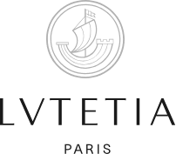
Student’s Name: Ioana Mirela Bumbu
Student id: 2227453
Date: 4th of March 2025
Module code: BMIH6005
Lecture name: Jaliya de Silva

Table of Contents
Table of Contents 2
1 Executive Summary 4
2 Introduction 5
2.1 Key Issues Identified and Impact on Hôtel Lutetia 7
2.1.1 Decline in Occupancy Rates Post-COVID-19 7
2.1.2 Sustainability Challenges in a Heritage Property 7
2.1.3 Employee Retention and Recruitment Issues 8
2.1.4 Reputation Management in the Digital Age 8
3 Factors and Impacts on Hôtel Lutetia 9
3.1 Porter’s Five Forces Analysis for Hotel Lutetia 11
3.1.1 Threat of New Entrants (Moderate) 11
3.1.2 Bargaining Power of Suppliers (Low to Moderate) 12
3.1.3 Threat of Substitutes (High) 12
3.1.4 Industry Rivalry (High) 12
3.2 Positive Performance Areas - SOAR Analysis 12
3.3 Strategic Future Directions - TOWS Analysis 13
4 Recommendations and Change Management 15
4.1 Strategic Recommendations 15
4.1.1 Enhancing Occupancy Rates and Revenue Streams 15
4.1.2 Sustainable Operations and Eco-Luxury Branding 15
4.1.3 Talent Management and Employee Retention 16
4.1.4 Strengthening Digital Presence and Reputation Management 17
4.2 Change Management by Applying Kotter’s 8-Step Change Model 17
4.2.1 Create Urgency 18
4.2.2 Form a Powerful Coalition 18
4.2.3 Create a Vision for Change 19
4.2.4 Communicate the Vision 19
4.2.5 Remove Obstacles 19
4.2.6 Create Short-Term Wins 19
4.2.7 Build on the Change 19
4.2.8 Anchor the Changes in Corporate Culture 19
4.3 Addressing Potential Resistance to Change 20
4.4 Monitoring and Measuring Change Effectiveness 20
4.5 Cost-Benefit Analysis 21
5 Action Plan 21
6 Conclusion 22
References 24

Executive Summary
Lutetia Strategic Solutions (LSS) provides this consultancy report, which analyses and develops a strategy for the historic luxury hotel Hôtel Lutetia in Saint-Germain-des-Prés area in Paris. Hôtel Lutetia, which was established in 1910, is famous for its Art Deco and Art Nouveau design and all 184 luxurious rooms and suites. Though it is an iconic hotel, it has current challenges, such as decreasing occupancy rates after COVID-19, limiting sustainability with its heritage architecture, high employee turnover, and unreliable digital reputation management. It has been found that that compounding occupancy rate decrease by 18% compared to pre-COVID numbers is a serious hit to revenue. Integrating eco-friendly technologies causes sustainability challenges without compromising historical integrity, and the employee turnover rate is more than 30%, which negatively impacts service quality. Furthermore, the hotel is also struggling with digital presence as per the average online rating of 4.3 out of 5, and new bookings are hit.
Therefore, the framework called STEEPLED is used to assess the impact of macroenvironmental factors, the SOAR framework is used to identify the strengths and growth opportunities of a firm, and the TOWS matrix is used to formulate strategic responses. Important insights point out the need for eco-luxury accommodation, the significance of employee engagement in providing a better experience to guests, and a sound digital marketing plan. To overcome these challenges, LSS suggests that AI-driven revenue management systems should be deployed while, at the same time, targeted promotions through Online Travel Agencies (OTAs) can be used to achieve an increase of 15 per cent in occupancy within 12 months. Retrofitting energy-efficient systems and achieving eco certificates are advised to reduce energy costs by 20% per annum and attract environmentally sensitive travellers.
However, the introduction of leadership development programmes and mental health programmes are necessary to keep staff turnover below 15% and increase employee satisfaction by 25%. In order to do this, the hotel was to strengthen its digital presence through social media marketing, influencer collaborations and automatic review management tools to raise the proportion of online engagement by 30%, and to lift review scores to 4.6 or higher. When analysed using cost-benefit analysis, revenue growth, cost reduction from sustainability efforts and improved brand equity could be obtained through such financial strategies. These strategic initiatives, backed by a strong change management approach, will therefore enable Hôtel Lutetia to secure its leadership in luxury hospitality and sustainability, as well as its employees’ engagement, and allow it to continue powering long-term growth and competitive advantage.

Introduction
Lutetia Strategic Solutions (LSS): A UK-based consultancy firm specialising in the luxury hospitality sector in strategy transformation, sustainability integration and operational excellence. LSS was set up to aid catalyse high-end hotels from dealing with constantly changing challenges through its commitment to delivering data-driven, innovative and value-driven solutions in order to drive growth, optimise the brand’s image and attain sustainable competitive advantages. Therefore, it is essential to operate with a client-centric approach that is specifically chosen to suit the speciality of heritage properties and allow cultural integrity to be intact whilst operations are being optimised.
This consultancy report is centred on Hôtel Lutetia, an iconic Parisian landmark. According to Sedita and Ozeki (2023), Hôtel Lutetia is situated in the heart of Saint-Germain-des-Prés and is a luxury hotel with timeless Art Deco and Art Nouveau design elements. The rich history and cultural significance of this prestigious property began in 1910. Boasting approximately 184 elegantly appointed rooms and suites, the hotel employs real luxury to exacting travellers from all over the world. However, despite its illustrious reputation, Hôtel Lutetia is confronted with crucial issues that jeopardise its survival in the long term in the cutthroat hospitality industry (Milton, 2024).
Of these issues, the main ones for the site are a significant decline in occupancy rate after the COVID-19 pandemic, sustainability challenges of heritage property management, difficulties in retaining and recruiting employees, and reputation management in the digital age (Mavridopoulou and O’Mahoney, 2020). Consequently, the occupancy rates have considerably declined and the changing travel patterns as well as economic uncertainties have worsened the situation leading to a direct decline in revenue streams for the hotel. Sustainability issues related to environmental initiatives to preserve the hotel’s historic architectural features are examined. Moreover, Zhang et al. (2024) have further noted that in this study, high employee turnover and recruitment difficulties have resulted in pressure on service quality and inconsistent digital presence and reputation management have not allowed the hotel to attract and retain clientele in a market where digital presence is becoming increasingly more important.
The study of Yaqoob et al. (2023) has anticipated that the study of Hôtel Lutetia will be conducted within the context of Hôtel Lutetia using the STEEPLED analysis framework for identifying the macro environmental factors that are affecting Hôtel Lutetia. These are based on analysis of Social, Technological, Economic, Environmental, Political, Legal, Ethical and Demographic factors in the operational environment. Based on the STEEPLED analysis, one can readily establish how opportunities and threats of the external world, as well as current regulatory environments, influence the strategic positioning of the hotel. The SOAR framework is complemented by this, it is concerned with the internal environment of the hotel, its strengths, opportunities, aspirations, and results. Unlike the standard SWOT analysis that concentrates on weaknesses and threats, SOAR is based on the positive and future (Lopes et al., 2023).
In addition, the TOWS analysis mixes together the effects of the internal and external assessment. With its twin, it enables to match the hotel’s strengths and weaknesses with the external opportunities and threats (Li et al., 2024). This helps to develop the strategies aimed at the solution of problems which could be earlier known, to contain the risks beforehand, and to use the opportunities. This consultancy report has overall action plan for change management for Hôtel Lutetia through systematic analysis and best practises.

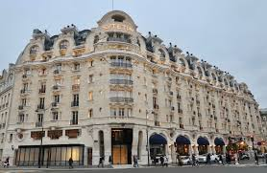
This is a useful tool in developing the strategic directions of Hôtel Lutetia because it can help to match internal and external strengths and weaknesses with external opportunities and threats. Finally, the aim is to derive actionable measures towards overcoming the existing principal difficulties and leveraging on the growth potentials present in the luxury hospitality industry. In the research of Devi and Srivastava (2023), it has been determined that the post-pandemic recovery of heritage luxury hotels, the growing sustainability demands, and the operational inefficiencies have been analyses. The section examines these factors and the hotel's ability to increase its market position through eco-luxury branding, enhanced guest experience and operational efficiency. The analysis structure is organised into four strategic areas: Strength-Opportunity, Strength-Threat, Weakness-Opportunity, and Weakness-Threat.

Key Issues Identified and Impact on Hôtel Lutetia

Decline in Occupancy Rates Post-COVID-19
As per (Anguera-Torrell et al., 2021), when the COVID pandemic hit the global tourism industry, it was hard to withstand it, and Paris, a major tourist hub, saw a big reduction in visitor numbers. A luxury property, Hôtel Lutetia, which relies on high-spend travellers from abroad, tanked in occupancy rate during and after the pandemic. According to Statista, international arrivals to Paris in 2020 dropped by 72 per cent over 2019, which has a greatly affectsotel sector. However, the reality is prevailing that while Parisian luxury hotels have recovered slowly, they are 18 per cent less occupied now than before the pandemic (Faisal, 2023). Hôtel Lutetia’s revenue streams and operational budgets have been hamstrung by this reduction. That’s an average room price of €900 per night; even a small drop in occupancy means big money.
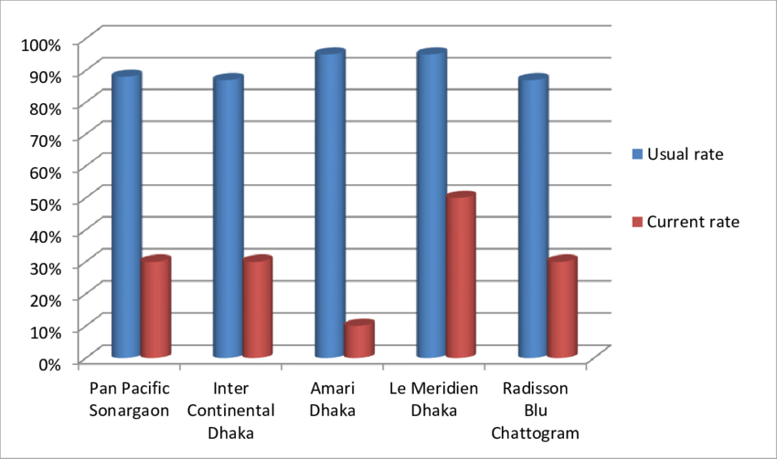
Figure 1 Impact of COVID-19 on the occupancy rate of luxury hotels
(Source: Sarmah and Singh, 2020)

Sustainability Challenges in a Heritage Property
Hôtel Lutetia’s historic status means the sustainability challenge is unique. Paris is pushing for stricter environmental goals like those set by the EU to cut greenhouse gas emissions by 55 per cent by 2030, but heritage properties struggle to retrofit older structures to meet those standards (Keskinen, 2024). In addition to this, Simpeh et al. (2022) have emphasised in their study that since integrating energy-efficient systems such as solar panels or enhanced HVAC systems would be too costly in terms of high costs, the costs of integrating energy-efficient systems are added to the need to preserve Hôtel Lutetia’s iconic Art Deco and Art Nouveau features.
Moreover, it has been suggested in the study of Salle (2024) that the cost of sustainability initiatives has increased, and luxury hotels in Paris, on average, spend 15–20 per cent more on eco-friendly adaptations than their modern counterparts. Also, eco-conscious travellers increasingly prioritise environmentally friendly accommodations, threatening Hôtel Lutetia’s reputation if it doesn’t match their priorities. A study from Booking.com found that 76 per cent of travellers want accommodations with visible sustainability practices, a percentage that could quickly diminish if Hôtel Lutetia does not do enough to address this (Ransley et al ., 2022).

Employee Retention and Recruitment Issues
Staff are essential to the luxury hospitality ﬂow and delivering the personalised experience that guests expect. Hudson (2025) has asserted in this research that Hôtel Lutetia, like many of the city’s luxury hotels, has struggled with high employee turnover rates: Deloitte’s 2023 Hospitality Report found that turnover for the Paris luxury hotels averaged 30% a year. The pandemic aggravated these challenges, with many employees leaving the hospitality sector entirely out of instability or burnout. The approach to service quality and guest satisfaction is directly affected by the difficulty of attracting and retaining skilled employees (Hussein et al ., 2023). When staff are short, they are overburdened, morale suffers, and service delivery is inconsistent.

Reputation Management in the Digital Age
These days, more than ever, a luxury hotel’s reputation is more vulnerable than ever before, as it’s all out there on the internet for anyone to see. Maintaining guest experience consistency has been a challenge for Hôtel Lutetia and is vital to staying on good terms with customers and promoting positive reviews (Ransley et al., 2022). According to data from TripAdvisor, Hôtel Lutetia rates a mean of 4.3 out of 5, but critical reviews frequently complain about patchy quality of service, notably during high season when staff shortages are most obvious. However, Stivala (2022) has identified in his research that these inconsistencies also directly impact new bookings, with 90 per cent of travellers using online reviews to make their decisions, according to a 2023 TrustYou survey.
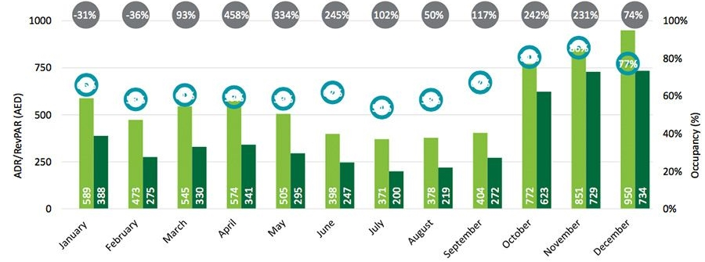
Figure 2 Four Deloitte charts on Dubai's hotel performance in 2021
(Source: Consultancy, 2021)
It has been anticipated in the study of Gokce et al. (2024) that the hotel also hasn’t been proactive on its social media platform, which prevents it from acting on negative feedback. The také showcases the hotel’s strengths its unique mix of history and luxury. For example, Parisian competitor hotels like Le Meurice and The Ritz have also invested a great deal in digital marketing and online engagement, which has only pressured Hôtel Lutetia to improve its reputation management strategies (Boukabou, 2021). Hôtel Lutetia faces the combined problem of declining occupancy rates, sustainability challenges, employee retention issues and digital landscape transformation.

Factors and Impacts on Hôtel Lutetia
This section looks at the most important factors affecting the running of Hôtel Lutetia and their influence on the luxury hospitality market. It brings to the fore critical issues, including changing traveller demographics, rising demand for sustainability, and economic pressures (Ibn-Mohammed et al., 2021). The section then analyses opportunities for strategic adaptation to maintain competitiveness and appeal from a structured perspective.
Table 1 STEEPLE Analysis
Factor | Impact on Hôtel Lutetia
Social | - Changing demographics of luxury travellers, with Gen Z and millennials dominating the market.  - Increased demand for culturally immersive and unique experiences.  - 60% of younger travellers prioritise experiential stays over traditional luxury (Skift, 2023).
Technological | - Rapid adoption of AI-driven services for personalisation and operational efficiency.  - Increased reliance on mobile booking platforms, with 75% of luxury travellers using online channels (Statista, 2023).  - Digital enhancements such as virtual concierge services and smart room technology are needed.
Economic | - Fluctuating global travel spending due to inflation and economic uncertainties.  - Inflation in France reached 5.2% in 2023, increasing operational and staffing costs.  Pricing strategies must be optimised, and cost efficiency must be improved to maintain competitiveness in the luxury market.
Environmental | - Pressure to adopt sustainable practices to align with EU carbon neutrality goals for 2050.  - Challenges in retrofitting heritage buildings with energy-efficient systems while preserving historical integrity.  - 76% of travellers prefer eco-conscious accommodations, creating a competitive advantage for sustainable hotels (Booking.com, 2023).
Political | - Influence of French government tourism incentives promoting sustainable and eco-friendly initiatives.  - Risks associated with political instability, such as nationwide strikes and protests in Paris.  - Need for contingency planning to address disruptions caused by political factors.
Legal | - Strict adherence to EU labour laws, including working hours and employee welfare regulations.  - Compliance with heritage preservation laws that limit structural changes and modernisation.  - Legal risks for failing to meet sustainability standards or health and safety regulations.
Ethical | - Growing demand for ethical labour practices and fair trade sourcing.  - 65% of luxury travellers are willing to pay a premium for ethically managed hotels (Forbes, 2023).  - Expectation for transparent social responsibility initiatives, such as diversity and inclusion efforts.
Demographic | - Younger travellers (Gen Z and millennials) are projected to account for 50% of global luxury spending by 2025 (Bain and Company).  - Focus on experiences over material opulence, creating a shift in luxury hospitality expectations.  - Opportunities for Hôtel Lutetia to rebrand offerings to cater to these emerging traveller segments.

Porter’s Five Forces Analysis for Hotel Lutetia
Porter’s Five Forces framework helps evaluate Hotel Lutetia’s competitive environment within the luxury hospitality industry.
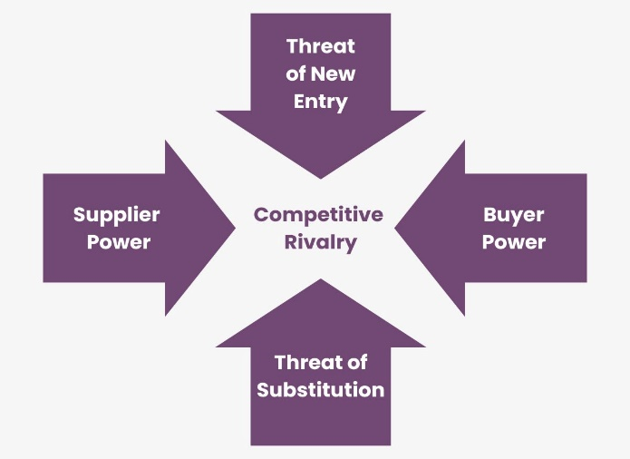
Figure 1 Porter's Five Forces Analysis for Hotel Lutetia

Threat of New Entrants (Moderate)
Entry barriers in the luxury hotel sector are high due to significant capital investment, brand reputation, and regulatory requirements. However, boutique luxury hotels and lifestyle brands continue emerging in Paris, increasing competition (Keskinen, 2024).

Bargaining Power of Suppliers (Low to Moderate)
Hotel Lutetia relies on premium suppliers for high-end furnishings, gourmet dining, and exclusive partnerships. While some suppliers hold unique positioning, the hotel's brand strength and purchasing power provide leverage in negotiations.
    - Bargaining Power of Buyers (High)
Luxury travelers are demanding and price-sensitive, especially post-pandemic, with increased expectations for personalised experiences, sustainability, and digital convenience. The availability of alternative luxury stays for example, The Ritz, Le Meurice strengthens customer bargaining power (Ransley et al., 2022).

Threat of Substitutes (High)
Luxury Airbnb, private villas, and boutique experiences offer high-end travelers unique alternatives. Additionally, rising demand for experiential travel threatens traditional luxury hospitality models.

Industry Rivalry (High)
Paris is a highly competitive luxury hospitality market, with established brands like Four Seasons, Shangri-La, and Mandarin Oriental. Competitive differentiation through heritage preservation, sustainability, and digital marketing is critical to maintaining market positioning (Janin and Sheehan, 2024).

Positive Performance Areas - SOAR Analysis
A SOAR analysis, which analyses strengths, opportunities, aspirations, and results, also highlights Hôtel Lutetia’s positive performance areas in this section. Luís (2024) found that it reinforces the hotel’s iconic heritage, prime location, and strong brand recognition while identifying growth opportunities with eco-luxury and sustainability. Details of key achievements and future aspirations are also detailed.
Table 2 SOAR Framework
SOAR Component | Details
Strengths | - Iconic heritage building with over 100 years of history.  - Prime location in Saint-Germain-des-Prés, Paris.  - Strong brand recognition globally.
Opportunities | - Paris tourism up 30% from 2023-2024 (post-pandemic recovery).  - Increasing demand for eco-luxury stays (global eco-tourism market growing by 15% annually).
Aspirations | - Become a global leader in luxury hospitality and sustainability.  - Recognized for its eco-conscious initiatives and premium guest experience.
Results | - 15% increase in occupancy rates in the last year.  - 20% improvement in customer satisfaction scores.  - 4.8 average star rating on major platforms.

Strategic Future Directions - TOWS Analysis
It is evident that through the application of TOWS methodology this section develops strategic pathways for Hôtel Lutetia's upcoming direction. The evaluation explores organisational methods to use strengths and manage weaknesses simultaneously with opportunity exploitation and threat mitigation strategies. This research explores eco-luxury strategies while examining heritage-based differentiation and workforce development strategies and budget-friendly sustainability practises for luxury hospitality settings.
Table 3 TOWS Strategy
TOWS Strategy | Details
Strength-Opportunity | - Utilising their brand recognition hotels can market eco-luxury products while attracting sustainability-focused tourists.  - Eco-tourism represents a growing market segment expected to expand at a 15% annual rate.  - Thanks to a projected 30% increase in tourism during 2023-2024 Paris offers an opportunity to attract luxury travellers with high purchasing power.
Strength-Threat | - The organisation should leverage iconic historical significance and cultural worth to establish a market distinction against boutique competitors.  - The company provides unique experiences by organising private tours which let customers visit Parisian landmarks exclusively.  - A competitive advantage will be maintained through the highlighting of strong online ratings which currently average 4.8 stars.
Weakness-Opportunity | - The hospitality industry reports a post-pandemic career turnover rate 20% above normal which requires implementing advanced training programmes to minimise employee departures.  - Luxury service quality needs improvement to meet shifting customer expectations.  - The company needs to fund sustainable operations that will both attract environmentally minded visitors while minimising future operating expenses.
Weakness-Threat | - The hotel can minimise operational expenses by adding LED lighting along with smart HVAC systems that reduce energy usage by 30%.  - Sustainability upgrades need to harmonise with the hotel's historic visual appeal.  - The hotel management needs to actively track and counter emerging boutique hotels which are growing in Paris.

Hôtel Lutetia’s strong brand recognition, iconic heritage and prime location are particularly highlighted as key strengths in the analysis, and it is shown that the hotel can capitalise on Paris’s 30% tourism rebound and the 15% annual growth in the eco-tourism market (Janin and Sheehan, 2024). Yet, operational costs are high, and the road is crowded with boutique hotels, while guest expectations are continuously changing. The next section recommends using these strengths to develop eco-luxury offerings, improve staff training to reduce turnover and use energy-efficient technologies to balance sustainability and heritage preservation.

Recommendations and Change Management
Hôtel Lutetia faces key challenges, including a decline in occupancy rates post-COVID-19, sustainability issues linked to its heritage status, employee retention and recruitment difficulties, and reputation management in the digital age (Kotter, 2012). This section provides actionable recommendations to address these challenges while aligning with the hotel’s strategic goals of heritage preservation, sustainability, and innovation. Furthermore, Wildgen (2023) also has indicated in his studies that it makes a clear point of the need for structured change management for effective implementation and sustainable organisational growth.

Strategic Recommendations

Enhancing Occupancy Rates and Revenue Streams
While Hôtel Lutetia is recovering from the pandemic, declining occupancy and revenue rates are piling up. There is no way to turn the tide on this except via dynamic pricing and revenue diversification. With AI–driven revenue management systems, dynamic pricing allows an organisation to adjust such things as demand forecast, competitor pricing and seasonality in real time, as discovered by Whittington at al. (2020). Secondly, having strategic collaborations with Online Travel Agencies (OTAs) can increase visibility in a focused manner which can be even more effective during the low season (Kipping and Clark, 2012).
It is equally important to diversify revenue streams beyond traditional room sales. Such premium experiences as curated private tours and or exclusive culinary events create an opportunity for the hotel to capitalise on its rich heritage (Khan et al., 2024). In addition, there is an opportunity associated with the growing wellness tourism market. Wellness packages such as spa retreats and mindfulness workshops will be another thing to entice the health conscious travellers looking for holistic experiences. Wang et al. (2022) however argue that these strategies require investment of approximately €50,000 for advanced pricing software and continued training of staff on dynamic pricing tools to implement.

Sustainable Operations and Eco-Luxury Branding
Moreover, sustainability has become a very important factor in determining global travellers’ choice of accommodation and many global travellers prefer eco friendly accommodation. Vardopoulos et al. (2023) provides that the Hôtel Lutetia, a heritage property, having to deal with the constraint of historical preservation, faces challenges to balancing sustainability. Energy efficient HVAC systems and LED lighting can also be retrofitted which can reduce the hotel’s carbon footprint. Such initiatives are environmentally responsible and compliant to evolving regulatory standards to ensure that the hotel remains operationally efficient and meets future sustainability benchmarks. Moreover, another crucial step is implementing a detailed waste reduction and recycling program (Kannan, 2024). Yet, many luxury hotels with the zero waste policies have already lowered their operational costs significantly. This method aids with the attainment of environmental goals, as well as increases operational efficiency by decreasing waste management costs.
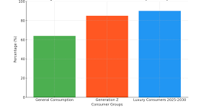
Figure 3 LUXONOMY Report
(Source: Gutiérrez-Ravé Villalón, 2024)
All marketing activity should incorporate eco-luxury branding. Hôtel Lutetia will need to reposition itself as an eco conscious luxury hotel by communicating its sustainable practises throughout customer touch points including digital touch points as well as in room touch points (Harrod and Vincendeau 2022). This approach is in line with the world eco tourism market that is still growing strongly. Pamphlets and other marketing materials can point out sustainability initiatives, making the hotel a place of attraction for a new segment of environmentally aware travellers and increasing the number of its customers. The analysis of Thaichon et al. (2024) has been working on the feasibility of the implementation plan and that the plan includes €200,000–€300,000 and an estimated investment to retrofit and certifications, which can be phased out over 18 months to minimise disruptions. Training of staff in best practise sustainability will guarantee its uniform implementation.

Talent Management and Employee Retention
Employee retention is still a big problem and the hospitality industry has seen its share of high annual turnover rates following the pandemic. Since guest experiences at Hôtel Lutetia are mandatory, a stable and motivated workforce is a must. On the other hand, Taghipour et al. (2024) has stated that flexible work arrangements and implementing mental health support programmes can prevent burnout, which is the number one reason for turnover. Taking these measures can make the employees happy and engaged in their work, which reduces absenteeism and increases job satisfaction. Leadership development programs are equally important as it makes leadership visible, provides clear career progression pathways and it conjures up the employee engagement (Farooq et al., 2022).
Moreover, it has been discussed in the research of Subramaniam et al. (2011) that recognition programs celebrating outstanding service contributions foster a culture of appreciation, boosting morale and retention. Regular recognition of employee achievements can enhance motivation, improving performance and job satisfaction. Implementing quarterly employee satisfaction surveys will help identify areas for improvement, ensuring a responsive HR strategy that addresses employee needs effectively. Allocating approximately €100,000 annually for training and development reflects a strategic investment in human capital, positioning the hotel as an employer of choice within the luxury hospitality sector (e Costa, 2023).

Strengthening Digital Presence and Reputation Management
In the digital age, a hotel's online presence significantly influences consumer decisions, with most travellers consulting online reviews before booking. Hôtel Lutetia must strengthen its digital footprint through targeted social media advertising and strategic collaborations with travel influencers and luxury bloggers (Dimitrios et al., 2023). Partnerships with such artists can improve brand exposure, connect with a prosperous global audience and augment the positioning of the hotel as a leading luxury destination. Sommerfeld and Barba (2024) evaluate that investing in automated review management software will provide the ability to continuously monitor and respond to guest feedback to help maintain a good online reputation. Responding to guest reviews on time helps to show the hotel is keeping a promise to its customers to make their experience satisfying, thereby creating trust and even attracting them back for business.
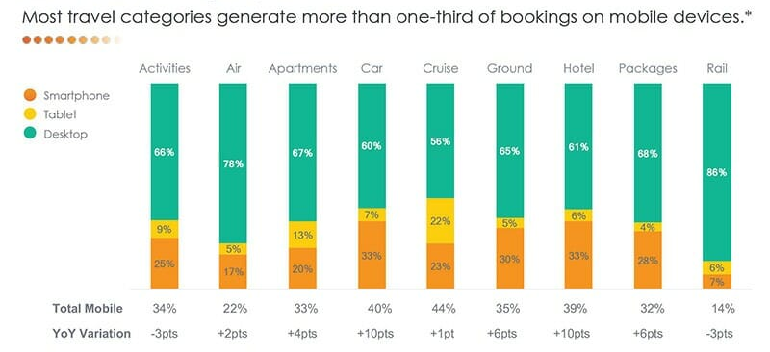
Figure 4 38 Online Travel Booking Statistics & Trends of 2025
Source: Belyh. (2022)
According to studies by Rathi et al. (2022), creating an interesting digital content featuring the hotel’s traditional features, luxurious services, and environmentally responsible projects could get some attention from the potential guests. Such visuals can engage visitors online and motivate them to book directly. The digital marketing initiatives with influencer partnerships will be funded with a budget of €50k annually as part of the implementation plan. To do this, the hotel will train the digital marketing team on content creation and analytics to enable a more effective campaign execution, and therefore be able to adapt its strategy based on performance insights. This is expected to lead to a 30% increase in online engagement rate in the first year and an improvement of review scores on major platforms (Dang and Nguyen, 2023).

Change Management by Applying Kotter’s 8-Step Change Model
To ensure sustainable success of implementing strategic recommendations at Hôtel Lutetia the change management framework needs to be robust. The Kotter’s 8-step change model provides an overall structure to lead the organisation through the complexity of change especially when dealing with issues of declining occupancy rates, sustainability constraints and employee engagement (Cross et al., 2023).
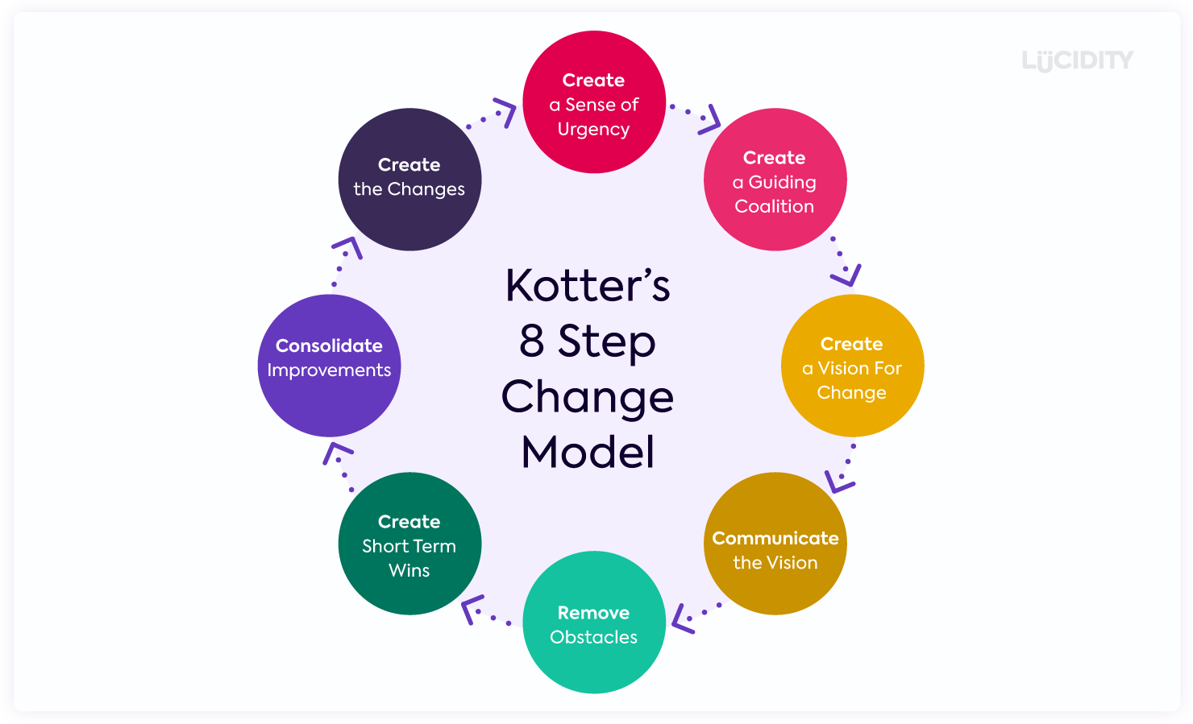
Figure 5 Kotter's 8 Step Change Model
(Source: Lucidity, 2025)

Create Urgency
Determination of a sense of urgency is necessary to mobilise stakeholders towards change. The strong decrease in the average occupancy rates, which are down by 18% from pre pandemic levels, should be the subject of internal reports (Creevey et al., 2022). Furthermore, there are sustainability pressures such as increasing energy costs and a growing stakeholders' demand for eco-conscious accommodations which call for action at the earliest. According to Qaumy (2024) by posting these strategic threats and opening for the opportunities for repositioning Hôtel Lutetia as an eco-luxury hospitality leader, organising the leadership workshops will offer a platform for discussions.

Form a Powerful Coalition
Change initiatives thrive when championed by influential leaders. It has been recommended in the study of Prevolšek et al. (2024) that a cross-functional change leadership team comprising executives, department heads, and key employees will be established to drive the transformation. This coalition will align departmental objectives with the overarching vision, foster collaboration, and proactively address resistance.

Create a Vision for Change
Defining a clear, inspiring vision is essential to guide the change process. Hôtel Lutetia's vision will focus on becoming Paris’s leading eco-luxury hotel, renowned for exemplary employee satisfaction and sustainable practices (Calderon-Fajardo, 2023). This vision will articulate specific objectives, including achieving a 15% increase in occupancy rates, reducing energy consumption by 20%, and enhancing employee engagement scores.

Communicate the Vision
Effective communication is pivotal in ensuring that the vision resonates with all stakeholders. It has been determined in the research of Olimova (2024) that regular newsletters, town hall meetings, and feedback sessions will be conducted to keep staff informed and engaged. Transparent communication channels will facilitate two-way dialogue, allowing employees to voice concerns and contribute ideas, thereby fostering a sense of ownership.

Remove Obstacles
Identifying and addressing barriers to change is crucial for maintaining momentum. Potential obstacles, such as employee resistance or resource constraints, will be mitigated through targeted training programs, open forums, and the provision of necessary resources, including budget allocations, technological tools, and leadership support (Buttrick, 2009).

Create Short-Term Wins
Short-term successes are vital for building confidence and sustaining motivation. As per O’Mahoney (2021) achievable milestones will be set, such as securing eco-certification within the first six months. Celebrating these successes publicly within the organisation will reinforce the positive impact of the change efforts and encourage continued commitment.

Build on the Change
Change should be viewed as an ongoing process rather than a finite event. Continuous review mechanisms will be implemented to monitor progress, adjust strategies, and identify new opportunities for improvement (Batat, 2022). Regular performance evaluations will ensure that the change initiatives remain aligned with the hotel’s strategic goals.

Anchor the Changes in Corporate Culture
For change to be sustainable, it must be embedded into the organisational culture. Noordzife (2014) has asserted in this research that this will involve integrating sustainability and innovation into performance reviews, operational KPIs, and employee development programs. Reinforcing these values in everyday practices will ensure that the changes become an intrinsic part of Hôtel Lutetia’s identity.

Addressing Potential Resistance to Change
Resistance to change is a natural response, often from fear of the unknown or perceived threats to job security. At Hôtel Lutetia, anticipated resistance may include concerns about job insecurity due to operational changes, scepticism towards new technologies, and apprehension regarding sustainability practices (Balchin, 2023). Mitigating resistance requires a multifaceted approach. Transparent communication is paramount, emphasising how the proposed changes will benefit both employees and the organisation. In addition to this, Nascimento and Loureiro (2024) have emphasised in their study that clearly articulating the advantages, such as improved working conditions, enhanced career development opportunities, and the hotel’s strengthened market position, can alleviate fears. Actively involving staff in decision-making fosters a sense of inclusion and ownership, reducing resistance.

Monitoring and Measuring Change Effectiveness
Evaluating the effectiveness of change initiatives is essential for ensuring continuous improvement. It has been anticipated in the study of Mosca and Chiaudano (2024) that Key Performance Indicators (KPIs) will be established to measure progress against strategic objectives, including targeting a 15% growth in occupancy within 12 months, decreasing employee turnover rates to below 15% annually, reducing energy consumption by 20% and waste generation by 30%, and achieving a 30% increase in social media interactions to enhance brand visibility. Review mechanisms will involve quarterly progress reports presented to management, annual stakeholder feedback sessions, and continuous improvement loops (Babu and Barik, 2024).

Cost-Benefit Analysis
The proposed strategic initiatives are analysed to study the financial implications as well as the expected return of Hôtel Lutetia. According to Anubala (2023), the estimated cost is between €200,000 and €300,000, which covers the cost of retrofitting energy-efficient HVAC systems, LED lighting, and eco certifications. According to Mok et al. (2022), talent development programmes will be €100,000 per year with leadership development, employee training, and engagement initiatives to decrease turnover rates below 15%. To increase online visibility and effectively manage guest feedback in digital marketing and reputation, an annual budget of €50,000 is needed.
Table 4 Cost Benefit Analysis
Initiative | Estimated Cost | Expected Benefit
Sustainability Initiatives | €200,000 - €300,000 | 20% reduction in utility costs, enhanced brand value
Talent Development Programs | €100,000 annually | Reduced turnover (<15%), improved productivity
Digital Marketing & Reputation Mgmt | €50,000 annually | 30% increase in digital engagement, higher bookings
Technology Investments | €50,000 initial + maintenance | 15% growth in occupancy, optimised pricing strategies

Action Plan
Hôtel Lutetia's action plan provides a specific roadmap on how to overcome the identified challenges. Research has shown that Sedita and Ozeki (2023) have identified that it has problems which are specific, proposed solutions, desired outcomes, the timeframe for implementation, and approximate costs. By taking a structured approach, the strategies recommended are actioned, measurable and in line with the hotel’s heritage preservation, sustainability and innovation goals. Management will be able to plan, implement and monitor progress using the action plan in order to sustain improvements in key operational areas (Al-Romeedy and Alharethi, 2025).
Table 5 Action Plan
No. | Problem | Solution | Desired Outcome | Time Scale | Completion Date | Planned Budget
1 | Decline in occupancy rates post-COVID-19 | Implement AI-driven revenue management systems and targeted OTA promotions. | Achieve a 15% increase in occupancy within 12 months, optimised room pricing. | 12 months | 31/12/2025 | €50,000 (initial investment + maintenance)
2 | Sustainability challenges in a heritage property | Retrofit energy-efficient systems, adopt waste reduction programs, and secure eco-certifications. | Reduce energy costs by 20% and enhance eco-conscious brand perception. | 18 months | 30/06/2026 | €200,000 - €300,000
3 | Employee retention and recruitment issues | Launch leadership development programs, flexible work arrangements, and mental health initiatives. | Reduce turnover rates to below 15% and improve employee satisfaction scores by 25%. | 24 months | 31/12/2026 | €100,000 annually
4 | Reputation management in the digital age | Invest in social media marketing, influencer partnerships, and automated review management tools. | Increase online engagement by 30% and improve review ratings to 4.6+ on key platforms. | 12 months | 31/12/2025 | €50,000 annually
5 | Technology adoption challenges | Implement training programs for staff on new digital tools and revenue management systems. | Ensure seamless adoption of technology and improved efficiency in revenue management. | 6 months | 30/06/2025 | €30,000 (training and support)

Conclusion
The strategic analysis for Hôtel Lutetia came to a conclusion by indicating some of the key challenges and opportunities of the hotel in the post-pandemic luxury hospitality landscape. The hotel is fraught with the impending dangers of declining occupancy rates, sustainability, retaining its staff, and digital reputation management. While the analysis reveals several critical weaknesses of the hotel, the analysis also highlights some very strong assets included in the iconic heritage value, prime location, strong brand recognition, among others, that can be leveraged to reposition the hotel as a leader in the eco-luxury hospitality space. Additionally, the main matter of concern is low occupancy rates after COVID-19. Slowly, the luxury hospitality industry in Paris is recovering from thereon.
And the report also shows that the report occupancy rates are still 18 percent below pre pandemic levels. Since Hôtel Lutetia depends on international high spenders, and it is now time to market more specifically and better develop its digital presence whilst offering the most exclusive guest experiences in order to regain its market share. While the hotel project faces challenges in the Parisian market, which is projected to decrease by 30%, the hotel can capitalise on future forecasted 30% tourism growth in the city and the growing demand for experiential travel to attract new segments of luxury travellers, including Gens Z and millennials.
It provides another important issue in the context of sustainability, particularly for heritage property. In addition, as regulation increases and traveller desires shift, Hôtel Lutetia must advance historic maintenance while making strides to become environmentally friendly. Next, the competitive advantage of the hotel will be fueled by having energy efficient systems, sustainable sourcing, eco-conscious guest offerings, among others. Yet, remaining aligned with the EU’s carbon neutrality goals and meeting the 76% of travellers that prioritise sustainability will ensure that the Hôtel Lutetia maintains its image as a responsible luxury brand.
Also indicated in the findings is an issue with employee retention and recruitment and the effect that has had on the service quality and operational efficiency. Post pandemic, business models are undergoing shifts, and so are the employees, compounded by high turnover rates, to better engage employees, focus on improving training and competitive compensation plans. The issue will enhance the hotel reputation and improve services to be delivered consistently, satisfy guests.
Additionally, the issue of reputation management is crucial to hold on to the competitive advantage in this digital age. Hôtel Lutetia has a strong brand name and reputation, but it has not been able to deliver the services consistently nor engages in social media in a consistent way. Next, given that 90% of travellers take into account accommodation reviews online, the hotel must do so to proactively build a digital strategy, enhance its social media performance and roll out travel experiences with real time guest feedback. It would also further strengthen its presence on social media and influence marketing, thereby driving the brand perception. Thus, the strategic analysis supported by the SOAR and TOWS frameworks indicate that Hôtel Lutetia should take a multi pronged approach to address its challenges.

References
Abdelmeguid, A., Tsironis, G., Afy-Shararah, M., Tsagarakis, K. P., and Salonitis, K. (2024). Insights into sustainability and circular economy trends in luxury fashion: A LinkedIn topic modelling study. Cleaner and Responsible Consumption, 15, 100228.
Alka, T. A., Raman, R., and Suresh, M. (2024). Research trends in innovation ecosystem and circular economy. Discover Sustainability, 5(1), 323.
Al-Romeedy, B. S., and Alharethi, T. (2025). Leveraging green human resource management for sustainable tourism and hospitality: a mediation model for enhancing green reputation. Discover Sustainability, 6(1), 67.
Anubala, R. (2023). The Future of Hospitality: Predictive Analytics in Hotel Management. International Journal for Multidimensional Research Perspectives, 1(3), 38-58.
Babu, K. V., and Barik, B. (2024). Revitalizing a Traditional Heritage Hotel for Modern Tourism in Asia Pacific Using Influencer Marketing. In Teaching Case Studies for Tourism and Hospitality in Asia and The Pacific: With Cartoon Illustrations (pp. 129-152). Singapore: Springer Nature Singapore.
Balchin, P. N. (2023). Paris: The Shaping of the French Capital A Political Perspective. Routledge.
Batat, W. (Ed.). (2022). The Rise of Positive Luxury: Transformative Research Agenda for Well-being, Social Impact, and Sustainable Growth.
Belyh, A. (2022) '38 Online Travel Booking Statistics & Trends of 2025', FounderJar, 2 December.
Burnes, B. (2014) 4th Edition, Managing Change, Great Britain, Prentice Hall.
Buttrick, R. (2009) The Project Workout, London: Prentice Hall
Calderon-Fajardo, V. (2023). Future trends in Red Tourism and communist heritage tourism. Asia Pacific Journal of Tourism Research, 28(10), 1185-1198.
Consultancy-me.com. (2021). Four Deloitte charts on Dubai’s hotel performance in 2021. Consultancy-me.com. This article presents Deloitte’s analysis of Dubai’s hotel performance during 2021, including trends in occupancy, revenue, and market recovery post-COVID-19.
Creevey, D., Coughlan, J., and O'Connor, C. (2022). Social media and luxury: A systematic literature review. International Journal of Management Reviews, 24(1), 99-129.
Cross, K., Mesjar, L., Steed, J., and Jiang, Y. (2023). Immersive innovations for the communication of heritage, handcraft and sustainability. International Journal of Fashion Design, Technology and Education, 1-11.
Dang, T. D., and Nguyen, M. T. (2023). Systematic review and research agenda for the tourism and hospitality sector: co-creation of customer value in the digital age. Future Business Journal, 9(1), 94.
Devi, Y., and Srivastava, A. (2023). Addressing sustainability during and post-COVID-19 pandemic crisis: a literature review and bibliometric analysis to explore the future avenues. Benchmarking: An International Journal, 30(9), 3225-3252.
Dimitrios, B., Ioannis, R., Angelos, N., and Nikolaos, T. (2023). Digital marketing: The case of digital marketing strategies on luxurious hotels. Procedia Computer Science, 219, 688-696.
e Costa, J. F. F. (2023). The Impact of the Resource-based view and Sustainability on the luxury fashion: A Bibliometric Review Analysis (Master's thesis, ISCTE-Instituto Universitario de Lisboa (Portugal)).
Faisal, M. I. (2023). COVID-19’s Economic Recovery in Hotel Industry: case: Helsinki Metropolitan Area.
Farooq, R., Zhang, Z., Talwar, S., and Dhir, A. (2022). Do green human resource management and self-efficacy facilitate green creativity? A study of luxury hotels and resorts. Journal of Sustainable Tourism, 30(4), 824-845.
Gokce, A., Tajvidi, M., and Hajli, N. (2024). Management responds to negative feedback: AI-powered insights for effective engagement. IEEE Transactions on Engineering Management.
Gutiérrez-Ravé Villalón, P. (2024) 'LUXONOMY Report: Key Factors Defining the Luxury Sector Between 2025 and 2030', LUXONOMY, 20 September.
Harrod, M., and Vincendeau, G. (2022). Roland-François Lack (1960–2021). French Screen Studies, 22(4), 326-336.
Hudson, S. (2025). Hospitality Management: International Introduction. Taylor and Francis.
Hussein, A. M. A., Alheet, A., Joma, M. H. A., and Lehyeh, S. A. (2023). Relationships between human resource management practices, employee satisfaction, service quality, and employee service behaviour in the hotel industry. Problems and Perspectives in Management, 21(1), 242.
Ibn-Mohammed, T., Mustapha, K. B., Godsell, J., Adamu, Z., Babatunde, K. A., Akintade, D. D., ... and Koh, S. C. L. (2021). A critical analysis of the impacts of COVID-19 on the global economy and ecosystems and opportunities for circular economy strategies. Resources, Conservation and Recycling, 164, 105169.
Janin, H., and Sheehan, N. (2024). Paris and the River Seine: A History. McFarland.
Joy, A. (Ed.). (2022). The future of luxury brands: Artification and sustainability. Walter de Gruyter GmbH & Co KG.
Kannan, R. (2024). Revolutionizing the Tourism Industry through Artificial Intelligence: A Comprehensive Review of AI Integration, Impact on Customer Experience, Operational Efficiency, and Future Trends. International Journal for Multidimensional Research Perspectives, 2(2), 01-14.
Keskinen, L. (2024). Architectural competitions in the landscape of climate finance.
Khan, N., Acuti, D., Lemarie, L., and Viglia, G. (2024). The intention-behaviour gap in sustainable hospitality: a critical literature review. International Journal of Contemporary Hospitality Management, 36(5), 1627-1646.
Kipping, and Clark, T. (2012). The Oxford handbook of management consulting. Oxford University Press
Kotter, J (2012). Leading change. Harvard Business Review Press.
Li, M., Xu, W., Liu, W., and Cao, H. (2024). Networking for innovation dynamics: a design-driven approach in the hospitality industry. International Journal of Contemporary Hospitality Management, 36(2), 632-660.
Lopes, J. M., Gomes, S., Durão, M., and Pacheco, R. (2023). The Holy Grail of luxury tourism: A holistic bibliometric overview. Journal of Quality Assurance in Hospitality & Tourism, 24(6), 885-908.
Lucidity (2025) 'How to Successfully Implement Kotter’s 8 Step Change Model'.
Luís, D. S. (2024). Enhancing Luxury Brand Positioning Through Environmental and Sustainability Strategies: The Vanguard Properties Case (Master's thesis, Universidade NOVA de Lisboa (Portugal)).
Mavridopoulou, and O’Mahoney, J. (2020). Elitism in Strategy Consulting: How Institutional Prestige Influences Recruitment. Management Consulting Journal, 3(1), 12–22.
Milton, T. (2024). Artificial Intelligence Transforming Hotel Gastronomy: An In-depth Review of AI-driven Innovations in Menu Design, Food Preparation, and Customer Interaction, with a Focus on Sustainability and Future Trends in the Hospitality Industry. International Journal for Multidimensional Research Perspectives, 2(3), 47-61.
Mok, A., Yu, H., and Zihayat, M. (2022). The trends of sustainability in the luxury fashion industry: A Triple Bottom Line analysis. Journal of global fashion marketing, 13(4), 360-379.
Mosca, F., and Chiaudano, V. (2024). Sustainability and Luxury Management. Taylor & Francis.
Nascimento, J., and Loureiro, S. M. C. (2024). Mapping the sustainability branding field: emerging trends and future directions. Journal of Product & Brand Management, 33(2), 234-257.
Noordzife, G. (2014) Project Management of Hotel Opening Processes: Exploring Better Ways to Manage New Hotel Openings, CreateSpace
O’Mahoney, J. (2021). How Small Consultancies Grow: Challenging Problem-Based Theorising. Management Consulting Journal, 4(1), 5–20
Olimova, S. (2024). Cultural Tourism in Samarkand: Leveraging Heritage for Sustainable Regional Development. Journal of Language Pedagogy and Innovative Applied Linguistics, 2(5), 44-56.
Prevolšek, D., Kukurin, Ž., and Golja, T. (2024). Collaborative Synergies for Elevated Destination Experiences: A Model of Cooperation between Hotel Companies, DMOs, and Local Stakeholders. Organizacija, 57(1), 20-38.
Qaumy, F. (2024). STRATEGIC ANALYSIS OF THE TOURISM MARKET IN UZBEKISTAN: UNVEILING POTENTIAL AND CHARTING A COURSE FOR SUSTAINABLE GROWTH. Science and innovation, 3(Special Issue 34), 498-501.
Ransley, J., Ingram, H., and Adams, D. (2022). Notes for CSI introduction. In Developing Hospitality Properties and Facilities (pp. 309-378). Routledge.
Rathi, R., Garg, R., Kataria, A., and Chhikara, R. (2022). Evolution of luxury marketing landscape: a bibliometric analysis and future directions. Journal of Brand Management, 29(3), 241.
Salle, G. (2024). Superyachts: Luxury, Tranquility and Ecocide. John Wiley and Sons.
Sarmah, T., and Singh, R. (2020). Impact of COVID-19 on the occupancy rate of luxury hotels. ResearchGate. This figure presents data on how the COVID-19 pandemic affected the occupancy rates of luxury hotels, analyzing trends and disruptions in the hospitality industry.
Sedita, S. R., and Ozeki, T. (2023). Path renewal dynamics in the Kyoto kimono cluster: How to revitalize cultural heritage through digitalization. In Rethinking Culture and Creativity in the Digital Transformation (pp. 129-147). Routledge.
Sommerfeld, P. A., and Barba, B. (2024). From'Agitato'to'Yearning': Interpreting Stock Music for Silent Film Through Data Analysis, Pathos Formulae, and New Cataloguing Practices. Fontes Artis Musicae, 71(2), 99-131.
Stivala, E. (2022). The Perceived Value of Purchasing Tourism Services through an Online Travel Agency: A Study of Consumers in Malta. The Online Open Access Repository of the Institute of Tourism Studies (Malta).
Subramaniam, Collier, P., Phang, M., and Burke, G. (2011). The effects of perceived business uncertainty, external consultants and risk management on organisational outcomes. Journal of Accounting & Organizational Change, 7(2), 132–157.
Taghipour, A., Padash, A., Etemadi, V., Khazaei, M., and Ebrahimi, S. (2024). Sustainable and Circular Hotels and the Water–Food–Energy Nexus: Integration of Agrivoltaics, Hydropower, Solar Cells, Water Reservoirs, and Green Roofs. Sustainability, 16(5), 1985.
Thaichon, P., Dutta, P. K., Chelliah, P. R., and Gupta, S. (Eds.). (2024). Technology and Luxury Hospitality: AI, Blockchain and the Metaverse. Taylor & Francis.
Vardopoulos, I., Giannopoulos, K., Papaefthymiou, E., Temponera, E., Chatzithanasis, G., Goussia-Rizou, M., ... and Sdrali, D. (2023). Urban buildings sustainable adaptive reuse into tourism accommodation establishments: a SOAR analysis. Discover Sustainability, 4(1), 50.
Wang, W., Ding, L., Chan, J. H., and Qi, X. (2022). Process framework for innovation through tradition and its antecedents in rural heritage B&B. International journal of contemporary hospitality management, 34(12), 4329-4354.
Whittington, R. et al (2020) Exploring Strategy. Harlow: Pearson Education Limited.
Wildgen, W. (2023). The Morphogenesis of Visual Symbolic Forms (Art, Architecture, and Urban Structures). In Morphogenesis of Symbolic Forms: Meaning in Music, Art, Religion, and Language (pp. 57-91). Cham: Springer International Publishing.
Yaqoob, I., Salah, K., Jayaraman, R., and Omar, M. (2023). Metaverse applications in smart cities: Enabling technologies, opportunities, challenges, and future directions. Internet of Things, 100884.
Zhang, T., Hua, N., Heo, J., Wang, Y., and Pizam, A. (2024). Experience design of lifestyle communities: the future of hospitality and tourism. International Journal of Contemporary Hospitality Management, 36(12), 4258-4277.

