PROFESSIONAL CAREER DEVELOPMENT
BMSW4005
TASK 2 REPORT 2000 WORDS
LECTURER MRS RITA
STUDENT ID 2027887

TABLE OF CONTENT

- INTRODUCTION

- MAIN BODY

- COCLUSION

- REFERENCES

- APPENDICES JOB APPLICATION AND MY FIVE QUESTIONS

INTRODUCTION

PEERSONNEL REFLECTION AND CAREER PLANNING

This is a report on the personnel reflection and my career development plan I will be applying reflective cycle of Gibbs module, I will be writing about my personal strengths and my development plans furthermore what my employment goals are, furthermore, write a personal development plan, SWOT analysis. I will be writing about my learning experience in the University, I have learnt new skills and tools from the modules this can help me in my future employment, I have a plan now and very confident and have acknowledgement to what I need to do,

Where am I today? Janet’s lifeline shows the stages of life the high points and low points
My stage now on the lifeline is I am studying at the University of Wales Trinity Saint David’s
Certificate of Higher Education in Health and Social Care, I have chosen this course because I would like to work in a health and social care related job. My dream career would have to be to become Children’s Nurse.

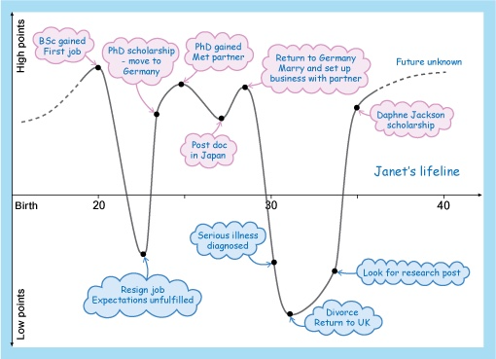

Janet’s lifeline

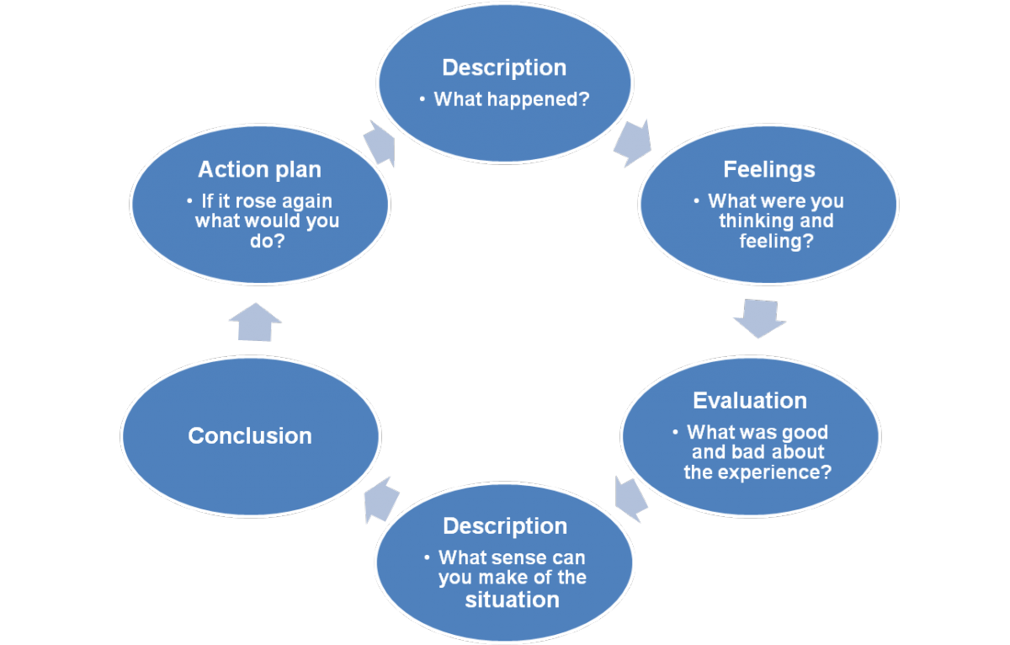

experiential learning, to Gibbs (1988) reflective model (Hussien,2022)

For my report, I'll use Gibbs' reflective cycle.

Based on Gibbs' reflecting cycle, reflection
(1988)

What occurred, in a nutshell?

What was nice and what was negative about the event?

experience? What worked well and what didn't?

Observation – What do you think the situation means?

What more could you have done, in the end?

What would you do if the situation occurred again?

MAIN BODY

The most common path to becoming a children's nurse is to complete a university degree programme. It's vital to verify with colleges about the entry requirements for these courses because they can differ depending on where and how you want to study. Child nursing courses can be found at the bottom of this page.

For an undergraduate degree, you'll typically require a minimum of five GCSEs with a grade of 4/C or higher, maybe in English language or literature and a science subject, as well as two A levels or comparable level 3 certificates. Some universities may require three A levels or equivalent qualifications. If you already hold a bachelor's degree, you might be able to pursue a postgraduate degree.

Job role for children’s nurse is to respect, compassion, and empathy are other desirable qualities in a child nurse. Respect, compassion, and empathy are other desirable qualities in a child nurse. You'll oversee patients with a variety of needs, so you'll need to be well-organized, adaptable, and able to prioritise well.

TRAINING AND ENTRY REQUIREMENTS TO BECOME CHILDREN’S NURSE

Specialist Community Public Health Nursing – School Nursing is the name of the school nurse training programme (SCPHN - SN). It is available as a bachelor's or master's degree programme. To apply, you must be a licenced midwife, adult, child, mental health, or learning disability nurse.

Although the full-time programme lasts 52 weeks, you may be able to train part-time for a longer amount of time. In rare cases, apprenticeships at the master's level may be available.

You must apply to be sponsored or seconded by a health-care organisation, which will provide you with a clinical placement as well as a community practise assessor and supervisor. The course is split into two parts: 50 percent theory and 50 percent practise on placement with a healthcare provider.

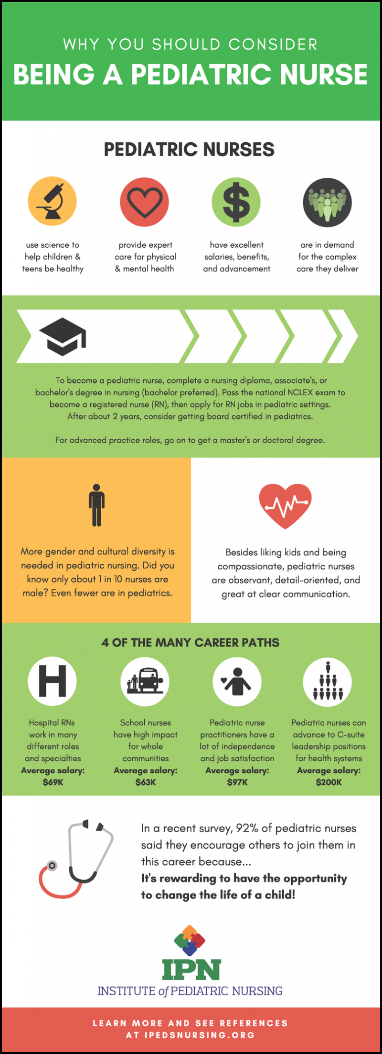 google image

WORKING EFFECTIVELY

The capacity to operate well in a group is a crucial skill for all professionals. Teamwork will be included into the field on some level, and in many cases, it will be a mandatory skill, regardless of the professional career one chooses.

Because of the different backgrounds that many people bring to educational programmes and the workplace, they often approach collaboration with a sense of fear, bewilderment, or even hostility due to their lack of experience working with teams or a lack of comprehension of the term. Teamwork and effective team-learning are characterised by collectively framing and reframing ideas, experimenting, bridging boundaries, and integrating perspectives into multiple tasks. Here's how to evaluate ideas from many perspectives. (Jones,2022)

THERE ARE SEVEN TECHNIQUES TO EFFECTIVELY MANAGE YOUR TIME.

Everyone has the same twenty-four hours each day, thus time is the great equaliser. Making good use of that time might mean the difference between getting things done and scrambling to stay on top of things. These time management suggestions can help you organise your day and operate more efficiently. (Hertzberg,2022)

1 Carry out a time audit.

2 Remove all sources of distraction.

3 Make a schedule for yourself

4 Stay away from multitasking.

5 Make it clear that others must respect your time.

6 Keep in mind your "call to action."

7 Make sure you get enough rest and down time.

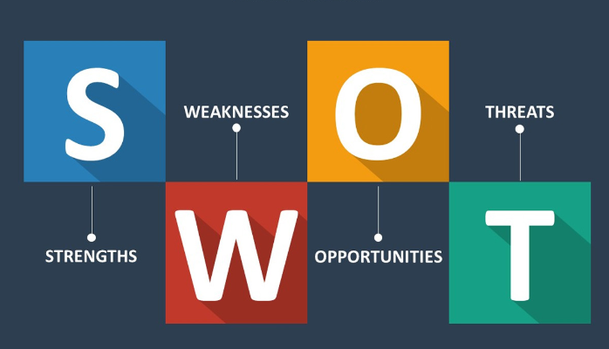

STRENGTHS

My qualifications CERTIFICATE OF HIGHER EDUCATION IN HEALTH AND SOCIAL CARE
I have good communication skill that I can use at work
I have excellent problem-solving skills I have learnt several problem-solving tools that I can apply
my strengths are I work better as a team and can work independently when required, my main strengths are I am always looking ways to improve at work, I also have been taking IT skills to improve my computer skill I am happy to say I have completed the course and there have been major improvements

WEAKNESS

I do sometimes get irritated when other workers delay their task that makes us all fall behind because it is teamwork and effects all in the workplace, I can support and help if the person needs help, I expect others to perform high standards because I give high standards to all my work at like to set goals and complete.

OPPORTUNITY

I'll have to do some more research. Following my A levels, I will need to apply for a nursing degree apprenticeship or attend university to complete a full-time nursing degree.
For full-time degrees, some universities may require three A levels and specific subject requirements, so check with the university directly.
Nursing degree apprenticeships are offered in some parts of the country, and you'll often need the same level of GCSEs, A levels, or equivalent degrees.

THREATS

Expand on what I have learned and not Lose drive application to practise due to complacency in inquiry/reflection techniques
Being discouraged if grades fall short of expectations

RECRUITMENT AND SELECTION (500 word)

I feel I am ready to get work in any employment in the health and social care

In class we did a role play on job interview me and my partner I feel the interview went great I asked my questions and received really good answer from my partner also my reverse role play went very well , I did feel nervous during the job interview and I forgot to smile here and there , so this is what I need to remember during an actual interview , I was confident to give my answer in the interview role play , and so did my partner. My lecture said we did well and we both where calm throughout the role play.

Interview tips (Twenty tips for interview,2022)
If you have a poor interview for a job that you honestly believe would be a good fit for you rather than merely something you want badly, don't give up. To let the interviewer know you think you did a bad job of articulating why you think this position is a good fit, write a letter, send an email, or phone him or her. Reiterate what you have to offer the company and convey a desire to help. Whether or not this strategy will result in a job offer will be determined by both the employer and you. However, one thing is certain: if you don't attempt, you won't succeed.

Do your homework on the industry and the firm.

2. Be clear about your "selling points" and why you want the job.

3. Anticipate the interviewer's reservations and concerns.

4. Get ready for the most common interview questions.

5. Prepare a list of questions to ask the interviewer.

6. Rehearse, rehearse, rehearse.

7. Complete the task within the first five minutes.

8. Sit on the same side of the interviewer as the interviewer.

9. Be forceful and take charge of your interview.

10. Be prepared to answer inquiries that are illegal or inappropriate.

11. Clearly state your selling points.

12. Keep an optimistic attitude.

13. Finish on a high note.

14. Take a copy of your CV with you to each interview.

15. Don't be concerned with sounding "canned."

16. Use the question "Tell me about yourself" to your advantage.

17. Use appropriate language

18. stay ready for questions

19. when finish send thank you message

20. never give up.

TOOLS FOR IMPROVING WORK PERFORMANCE

When you have an infinite list of activities to complete, having the correct tools can make all the difference. Take, for example, automation tools. Automating processes that don't require human intervention can save you a lot of time and provide you the flexibility you need to excel in other aspects of your business.

Here's what you need to do to get started:
Determine which parts of your workflow can be automated.
Consult with a third party who specialises in simplifying company processes and building workflows.
Contact a co-worker or superior who may have greater knowledge with automation technologies. (Ross,2021)

After I complete level four in Health and Social Care I can get in many jobs, I did some research and there are many jobs available with these qualifications, or I can do further to level six where I will have a better chance of getting a better job.

CONCLUSION
My learning experience PROFFESSIONAL CAREER DEVELOPMENT has been great
Based on Gibbs' reflecting cycle, reflection (1988)

I have learned a lot and honestly looking back and now I can perform better in my job interview, I understand the further training I will need for my dream job, furthermore I have effective personal development plan and I know what to do for my future workplace.

My main strengths are that I work better as part of a team and can work independently when necessary. I am also always looking for ways to improve my skills, and I have been taking IT skills to improve my computer skills.

I will practice and implement the skills and tools I have learned through-out the whole term in this university I understand there always will be room for improvement and I am willing to learn all the way, the different modules I have learned are Academic and Employment skills
Effective Team Working and Communication, Problem Solving and Decision Making, Psychology for Health and Social care, all these modules have given me new skills and tools to use in the workplace.

REFERENCES

Hertzberg, K. 2022. 7 Essential Time Management Skills That Will Improve Your Life. Available at: https://www.grammarly.com/blog/essential-time-management-skills/ (Accessed: 4 May 2022).

Hussien, H. 2022. Available at: https://iafor.org/archives/journals/iafor-journal-of-education/10.22492.ije.6.2.pdf (Accessed: 27 April 2022).

Job application
https://www.tes.com/jobs/apply/1602380

jones, P. 2022. Available at: http://jehdnet.com/journals/jehd/Vol_8_No_2_June_2019/1.pdf (Accessed: 4 May 2022).

Ross, H. 2021. 21 Ways to Improve Work Performance and Continuously Grow | Fellow.app. Available at: https://fellow.app/blog/productivity/improve-work-performance-and-continuously-grow/ (Accessed: 4 May 2022).

20 tips for great job interviews
https://www.experis.com/en/insights/articles/2021/05/25/20-tips-for-great-job-interviews

APPENDIX
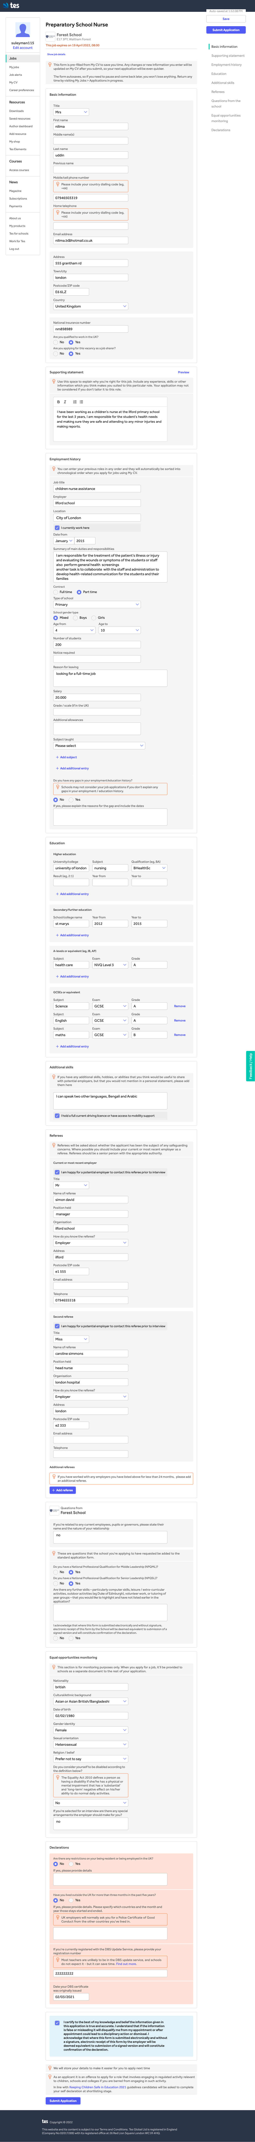
MY FIVE QUESTIONS

1. Tell me about yourself?
2. What experiences and skills do you have that make you a good fit for this position?
3. Describe a major workplace problem you have encountered and how you handled it.
4. How do you work within a team?

5. What are your career goals, and how do you plan to achieve them?

