Managing Enterprise in the 21st Century
BMSK4006

Student Name - Dimitrina Zheleva
Student Number: 1806472
Lecturer’s Name – Mushfiqur Rahman

Glam Studio - Business Plan Reflective Report

Table of Contents
Introduction 3
Descriptions 4
Feelings 5
Evaluation 6
Analysis 7
Conclusion 8
Action Plan 8
Conclusion 8
Reference List 10
Appendix1 11

Introduction

The aim of this reflective report is to describe the path I have been through since the beginning of this course.
Studding in University of Wales Trinity Saint David we were given the task of dividing 4 - 5 people into groups and each group to draw up a business plan and make a presentation at the end of the term. We had 10 weeks to prepare everything, and the group presentations take place the last week of the term in front of two lecturers.
As a part of my learning Assessment for one of the modules Managing Enterprise in the 21st Century for the second term is write a reflective report describing my role in teamwork, what I learned, what would change if I started it again. Looking back, seeing the weaknesses and strengths of assessing and analysing the situation to learn from the experience. Putting together at the past and present knowledge, thinking carefully and analysing the all process research, writing business plan presentation work in team and the result to improve performers.
I will use the Gibbs method to get there here is Gibbs’ cycle of reflection: Description, Feelings, Evaluation, Analysis, Conclusion, Action Plan.

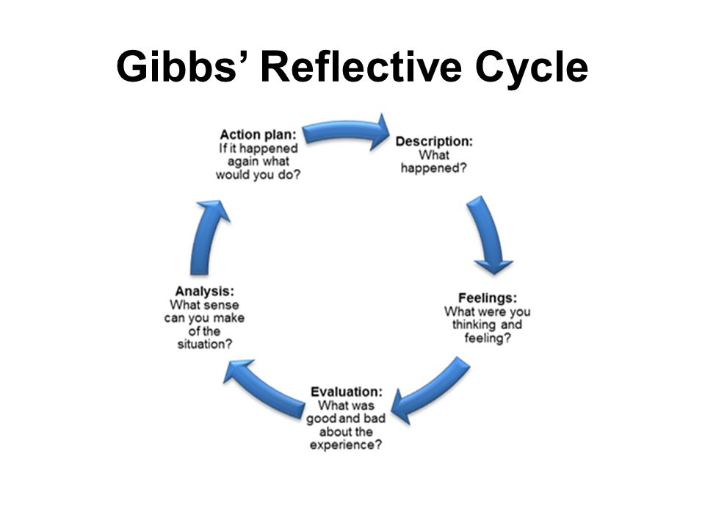

Descriptions

All the class had to be divided into groups of 4 to 5 people. Exceptionally our group was of six people Daniela, Catalina, Pavlin, Samuel, Michel and me - Dimitrina. We had to choose business idea and create business plan. The whole group discussed this, and our leader offered to work on a beauty studio. Because she already had such a business and was aware of what is needed, as well as the positive and negative sides. We all agreed because it sounds easy and everyone knows something in this area, or maybe because our leader said, "I know only that, it must be this!’’ She made our WhatsApp Group, and everyone shared their ideas and found interesting information. Several times we met before school and discussed the work done and future strategies. Many suggestions were dropped, others were upgraded, we had some disagreements but finally we found solutions for them too. I suppose this happens whenever a few people are doing business together, and everyone has their own opinion and vision of things.
For the name of our business, we chose "Glam studio" as an activity to be a modern beauty salon with new fashion services. The presentation starts the leader of the Daniela group. She introduced the group, our business, aim and objectives mission and vision.
Introduce the essence of the business idea, what services we will offer, what clients we plan to have and how we think of it.
For a plan to be well accepted, it is important to be enthusiastic, and that is part of the success.
Then Samuel talk for Legal Compliances. It is important foe the business to ensure that their company competition practices follow current legislation. Is vital to be updated all licences and insurance.
Michael spoke for Management Process Marketing The market needs to be well-researched, who will be the potential customers, what they need, how to keep them and develop the strategies they need.
Pavlin had Management Process Finance - Planning of investments, revenues, income, losses, profits. Who are the originators of revenue, how much money will be invested, equipment and materials investments, rental costs, bills and fees, advertising salaries, and other costs? Monthly forecast of cash flows.
My part was Work Scheduling, Payroll and Staff training. There are many business support programs to manage work scheduling and Payroll. So, when it comes to workers, it is easy to plan the working days of all staff and even send the weekly Rota to everyone with an email. These prognoses can automatically calculate wages, taxes, overtime, pensions, holydays or maternity and paternity pay. Other important part is training. When customers visit beauty salon, they want to know that the one who takes care of them has the necessary knowledge and qualifications. Therefore, the completion of professional courses is important. It is also important to have monthly training sessions Health and Safety, Hazard spotting, Security and Fire training, to ensure that all staff and customers are safe.
Catalina talk for SWOT Analysis and PESTLE Analysis This is a strategic planning tool that shows the clear goal of the business. Describes strengths, weaknesses opportunities and threats. And a risk analysis that contains a risk plan.
And Daniela finished with the conclusion.
.

Feelings

Firstly, it sounded an easy task as perhaps everyone has an idea in his head for a
business and whit some research can create plan for it. But for a business to be successful it must be thoughtful and well planned. This is the role of the business plan and to be a good it is very important.
At the outset, I imagined that I could think of the idea and make the presentation slides of a power point, and someone else who speaks well to present everything and speak to the audience. I quickly conceded that this was impossible because everyone had to participate as a presenter of a part. For me it was scary. I did not know how to stand up and speak in front of that many people. And after all the group will be evaluate.
According Cottrell (2008) Every member is responsible for the group. If is any problem, еeveryone need help to sort out and then the group will work effective. I did not want my fear of talking to harm the whole group and ruin the whole presentation. I thought I could not get involved and hinder them, but they told me to try and offer while I'm talking about looking at the window or something that will not overwhelm me.
What frightened me was the presentation itself. The thought of going out and coming out and talking to everyone was terrible. I was afraid to go out and talk to the whole class, and if the lecturers do not understand me, I will be felt. At the rehearsal for the presentation, when I was out of order, I went out to speak and could not, I knew the words, but I could not tell them. I even thought it would be better not to go on the day of the exam would be best for everyone. And maybe I would, if the lecturer did not give me courage, told me that if I did my best I could do it.
Thanks to this subject and to the lecturer who helped me by showing me a way to learn and correct my speech. I felt a little more relaxed. Using this method of learning helps me to improve my speech and showed me the way how I can learn alone.
This benefits me not only to this subject and the doctrine, but also to my work and my life. And now I know that I need practice to achieve everything.

Evaluation

Typically, the reasons for starting a business are financial or personal. Whether or
not the goal is to earn more money or simply work for yourself without having to keep
up with the superiors, any business has any purpose. In order to survive the
business, we need to work hard, and the goals must be realistic.
Before somebody start will have to know who will need the services the business will offer. It is important to offer something different, better than others that offer the same products or services.
For example, Bulgaria is the largest producer of rose oil, importing it directly from
there, the price will not be further expensive, and the quality will be unchanged. It
should also be borne in mind that people are increasingly looking for natural
products, and by using them, we would have an edge over a well-established beauty
studio that uses only traditional products.
How each decision is important, because it can lead to the success or failure of a busyness.
Everywhere there are beauty salons, some are successful than others, some are engaged in many activities and others are specialized only with a few.
As a starting point, it's a good idea to explore already existing businesses to figure out what can lead to success and how to survive and beat the competition. We had to decide exactly what we would do, where it would be best, how much money would be spent.
We live in a time when people are increasingly paying attention to health and beauty. Everywhere we talk about this, advertise natural products and explain how nature should be protected. On the other hand, it is fashionable for people to have a different hairstyle and manicure and take pictures every day on social networks. Considering all of this, we decided that our efforts in this business will be successful. If we work with natural products that do not harm our health and nature and have not been tested on animals, we will have success.
Location is important because it determines customers to a large extent. we chose for our business we chose Stratford Westfield. it is like the border different types of people attended by everyone.
We all wanted our business plan to be the best and we were looking for information on how to achieve it.

Analysis

Looking at the past and present knowledge to improve performers.
To be a good business plan, everything must be explored, calculated, and well-built strategy.
Although it was discussed a few times, changing the text and distributing the roles, we somehow failed to mention the allergies that some of the products might cause. In a real business, if it does not take care of it can lead to serious consequences.
Business Plan According to Lane Michael (2018), it is a strategic document that must be well-shuffled, and everything must be verified and planned. The type of product or service, the competition, the market, who will be offered, the location, how many people are involved, the necessary licenses, trainings and legal compliances will be very precisely defined, and the financial part will be very detailed planned - what money will be spent costs, losses, profits for at least a year ahead.

Conclusion
I suppose it is better to show why customers must choose our business, with what our business will be better than others. Something that makes us unique and competing companies do not have it.
When several people work together, there are always different views and views and in the process each one changes a lot. For these moments and the changes that occurred to me, how I felt, what I learned and what I would change.

Action Plan
In my opinion the financial part was not very well done, and this is one of the important parts. It was time to spend more time and to better calculate investment and profits. Another thing that was not mentioned is about allergies. Thinker that we have been talking about natural products in the process of preparation, those that have not been tested on animals and those that can cause allergies, we finally missed them a bit. In a real business, if it does not take care of it can lead to serious consequences. This should be changed if we start doing it now. Speaking to an audience is a skill that makes a presentation successful. I have a lot of preparation and if I must do it better to do it. This can be done with lots of practice and exercises.
How Connor Neel say, to being public speaker is not talent, but if somebody practice and put effort on it can develop this skill. And to be one presentation successful, the most significant think is how is presented.

Conclusion
Overall, I can say that it was challenging for me to work with a group of strangers from different cultures and different characters. I learned a lot of new things. We all worked with enthusiasm and did our best for the success of a job. I was lucky to fall into a group of very nice people who understand and accept me. By sharing opinions and exchanging ideas with each other, we sought the right path. I think we finally made the right decisions and we have come to a successful end. And it is said that "Everything is good when it ends Well!"

Reference List

Maund, A. Schriek, M. and Tinkler, P. (2017). Certificate in Higher Education: Skills for the Workplace Student Yearbook. Sage Publications

Lane, M. (2018) A Guide to Creating an Effective Business Plan The Easyway. Revised ed. Straightfoward Publishing

Cottrell, S. (2008) The Study Skills Handbook 3rd edition. Hampshire: Palgrave MacMillan.

https://www.youtube.com/watch?v=c8_BIamLESg (Accessed: 12 April 2019)
https://www.youtube.com/watch?v=Q5WT2vweFRY (Accessed: 12 April 2019)
https://www.youtube.com/watch?v=-FOCpMAww28(Accessed: 28 April 2019)
https://www.youtube.com/watch?v=3I2mx9Pj-s8(Accessed: 29 April 2019)
Toerien, M and Kitzinger, C. (2007) Emotional Labour in Action: Navigating Multiple Involvements in the Beauty Salon SAGE Journals BSA Publications Ltd
https://journals.sagepub.com/doi/abs/10.1177/0038038507078918 (Accessed: 12 April 2019)

Appendix1



