
Student Name -Aemanben Anwarbhai Dhanani
Student id -2525496

Module Name: Strategic Management
Module Code: LCMB7003

Lecturer name – Ghulam Mujtaba

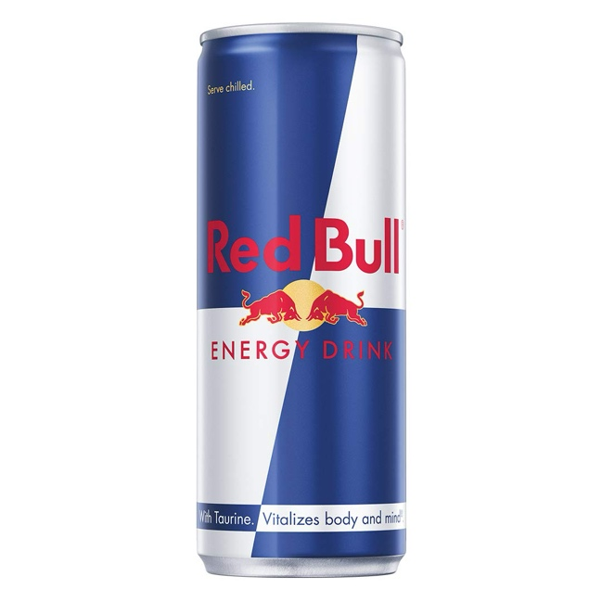

Table of Contents
Section 1 3
1. Organizational Context and Overview 3
2. External and Internal Analysis 6
2.1 PESTLE Analysis 6
2.2 Internal analysis using VRIO framework 8
2.3 SWOT Analysis 9
3. Comprehensive and Holistic View of the Organization 11
3.1 Current CSR strategy 11
3.2 Balanced Scorecard 13
4. Strategic Choices and Implementation 14
Section 2 18
Reflection 18
References 21

Section 1

1. Organizational Context and Overview
Strategic management helps organizations to achieve its goals by evaluating its competitive environment and resources. It starts with setting a goal, and then a strategic analysis is performed to formulate strategies. An organization should be flexible to adapt to the changes to take full advantage of strategic management (Kenton, et. al., 2026). Red Bull GmbH is an Austrian private multination conglomerate that dominates the global energy drink market. The company needs to maintain its competitiveness in the energy drink market. It was launched on April 1, 1987, by Dietrich Mateschitz who innovated a new category energy drink. The founder got inspired by the functional drinks from East Asia. The company currently has 21924 employees and sold 13.969 billion cans sold in year 2025 (Redbull, 2026). The drink is appreciated around the globe by top athletes, professionals, travelers and students. The company has become a marketing giant that is famous for its marketing events.
Mission and Vision
Mission: The company’s mission is encapsulated in the phrase “Giving Wings to People and Ideas.” Their mission is focused on inspiring people and their ideas. It operates in 178 countries as a leader of energy drinks. Moreover, the company inspires performance and a boundary-pushing lifestyle.
Vision: Their vision is centered on upholding rigorous Red Bull standards by delivering superior value. It has translated the firm into a lifestyle brand rather than a traditional beverage company. They envision to keep high standards to lead the energy drink market (Nell, 2026).
Business Model
The business model of the company is the driving force behind its overall success. Following are the key components of Red Bull’s business model:
Product Differentiation: The products have a unique blend of ingredients and packaging that are associated with extreme adventure sports. This is what sets it apart from the rivals in the energy drink industry (Larsen, 2024). The product's flavoring is done in Bangkok which is then exported around the globe into different manufacturing plants (Dudovsky, 2016).
Lifestyle Marketing: A clever positioning is used by the brand in alignment with the aspirations and lifestyle of the target customers. It sponsors sports events strategically to make a connection which goes beyond the product. When Dietrich discovered a local truck driver in Thailand in the 1980s, he came up with an idea of energy drinks. This product was associated with an energetic and bold lifestyle, which helped them to reach a large customer group (Bosanskom, 2025).
Experiential Marketing: it does not rely on traditional marketing but creates immersive experiences. They know that adrenaline-fueled events make consumers feel the taste of thrilling lifestyle as part of brand association.
Effective Distribution Network: the distribution network is highly extensive, which makes their products readily available globally (Larsen, 2024). This is one of the major success factors behind the lasting growth of the company. The company uses a non-open distributorship model in India with margins around 5% in this volume-driven business. They manage their distribution through regional partners, internal sales teams, and logistic networks. They only enter a market when a territory needs expansion or the existing distributors are underperforming (Tradologie, 2025).
Overall, the company uses Story Performing Marketing instead of only storytelling like other brands. Your ability to connect with the customers through sponsorship of sports events makes their approach unconventional. They use a vertical integration strategy, which adds value to its supply chain as well as business. The company spends most of the profits on marketing to maintain high awareness (Pereira, 2025). Their value proposition is to give exposure to non-competing businesses through advertisement. It has its own channels of marketing, which provide value to the customers. One example is its YouTube channel that has over 29 million subscribers, which is a great platform for its content creation.
Industry, Competitors and Market Position
In India, Red Bull made an entry in 2009 that was previously dominated by tea, coffee and traditional refreshments. The brand then positioned itself as a premium product by targeting urban youth and lifestyle-oriented individuals. India’s energy drinks market is values at $0.82 billion which will reach 0.94 billion by 2031 with a CAGR of 2.25% (Mordorintelligence, 2026).

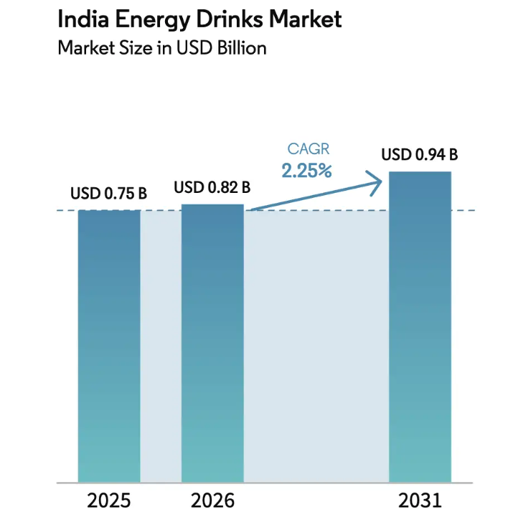
India Energy Drinks Market
Source: [Mordorintelligence, 2026]
Major driving factors are urbanization and rising disposable income among the youth. Even the gaming and sports culture has expanded significantly in recent years which creates acceptance of on-the-go functional products. This is a price-sensitive market that is polarized between a large-volume segment and a small premium segment. The major competitors are PepsiCo, Sting, Monster Beverage, and Coca Cola's energy offerings. There are many other local, regional players who also create a high dominance.
Red Bull’s market position is undisputed despite the rivalry because it leads the premium segment. Its volume shares have sharply declined from its early dominance of 70% market share to 7% as mass-market alternatives like Sting Energy emerged (Bhosle, 2023). It costs around 125 INR for a 250 ml can with a selective distribution in modern trade. It has now become a status and performance brand in India instead of a mass volume player.

2. External and Internal Analysis
This section assesses both the environments using PESTLE and VRIO framework. They're highly popular in most industries to understand how companies can create sustained competitive advantage. The strategic recommendations are provided on the basis of a SWOT analysis.

2.1 PESTLE Analysis
Political: The politics of India is usually stable for multinational beverage companies. It provides favorable policies of foreign direct investment in the consumer goods industry. The regulatory intensity has increased recently by FSSAI (Food Safety and Standards Authority of India) that classifies products above a caffeine threshold as a caffeinated beverage instead of energy drinks. Any brand that makes health claims directed at young customers is subject to closer scrutiny (Kalra, 2026).
Economic: A young population provides a structural growth potential because they have rising disposable incomes in metropolitical cities. Recently, Red Bull achieved a high-volume growth with expanded premium demand. The parliament has created 40% tax on energy drinks under the reformed ‘sin goods’ classification (Whiteandbrief, 2025). It compressed the margins for these high-costing products and created advantages for low-priced alternatives.
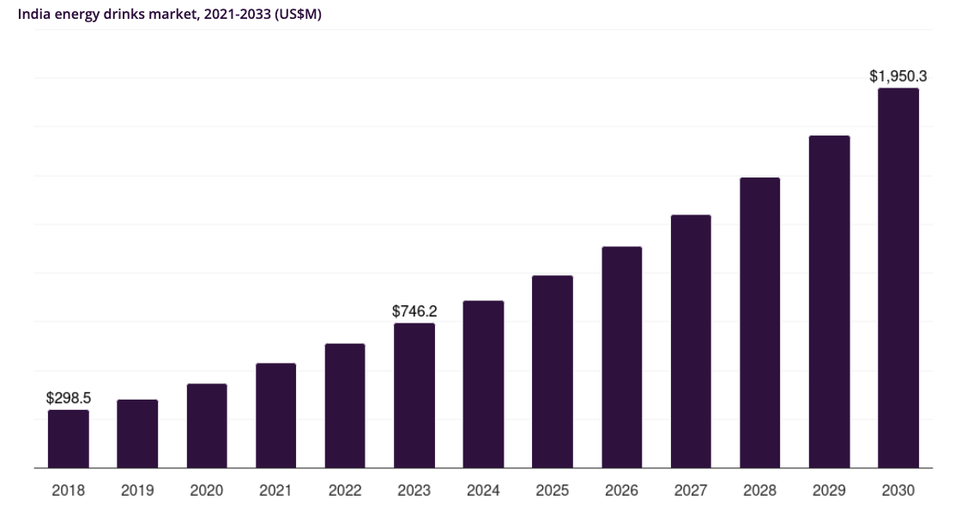
India’s Energy Drinks Market Economic Growth
Source: [Grandviewresearch, 2025]
Social: 65% of the nation’s population is under the age of 35 (Kumar, 2025). It gives the company a large addressable base of aspiring customers. The urban lifestyle is characterized by long working hours where people live in competitive professional environment. However, there are rising concerns over high sugar and artificial ingredients that shift their preference for sugar free alternatives. The social media gives both brand building opportunities and reputation risks. It is crucial to carefully manage these trends by introducing sugar free products as well.
Technological: The digital infrastructure and commerce platforms are changing the route-to-market possibilities. In Indian market, the quick commerce platforms like Zepto and Blinkit are helping premium brands to reach customers without relying on wholesale networks (Mordorintelligence, 2025).
The social media algorithms and data driven personalization also favor firms investing highly in owned media. Moreover, the science-based formulation of product is also crucial to make sugar free variants without compromising the quality.
Environmental: India’s climate has extreme heat in many regions where people demand functional refreshment. The extended producer responsibility rules and plastic reduction policies have increased compliance costs for the company. Here, Red Bull has advantage as its cans have high recyclability. They emphasize aluminum stewardship through using ASI-certified aluminum in many markets (Banarjee, 2026). Their national distribution can get affected due to climate related logistics disruption and extreme weather events.
Legal: Brands often make many claims but now advertising codes are restricting them beyond FSSAI and labelling. The competition law and packaging regulations also puts a legal exposure for high-caffeine products. Moreover, the high GST classification shapes the competitive dynamics by raising the absolute price of premium products (Jagwani and Savani, 2026).

2.2 Internal analysis using VRIO framework
The VRIO framework helps to determine the nature of competitive advantage in the chosen market.
Valuable: Red Bull’s brand conveys energy, adventure and status. Very few rivals have achieved this kind of cultural resonance. The firm has built itself over decades that makes it difficult to imitate. A consistent global storytelling with ‘gives you wings’ identify has proved to be a major success factor.
The company invested significantly in adventure sports from its early days. They sponsor athletes across different disciplines like BMX, motocross, surfing, cliff diving and many more (Ayles, 2020).
Rare: The dept of brand association with extreme adventures and lifestyle is rare element. Indian firms does not organized events on the scale similar to Red Bull. They constantly use their revenue in brand-building that makes it distinctive. Its rivals like PepsiCo has a strong traditional trad reach but not in premium segment (Racoma, 2019). A massive following on YouTube is a rare asset that the company possesses and other brands cannot replicate easily. They post all the videos of their adventurous events on the platform with 29.2 million subscribers who regularly watch their videos and convert into customers.
Inimitable: The fanbase of the firm is worldwide due to its consistent marketing efforts over decades. This long-term creative investment is difficult to replicate quickly even with high spending. The company spends 30% of its revenue in marketing which is approximately $3.7 billion (Korfiatis, 2026). The financial scale is be matched which reduces the inimitability on pure resources alone. Other factors like the product formulation and aluminum packaging are easy to copy but still they have first-mover credibility which raises the bar.
Organization: In India, Red Bull has local activation teams and dedicated media structure for the lifestyle positioning. Even the quality systems as well as formulation expertise are institutionalized. The firm does not go for short-term volume chasing but plan for capturing the marketing over next upcoming years. Its distribution is organized around selective premium channels to protect brand equity even if this limits the mass reach.

2.3 SWOT Analysis
Strengths  Iconic global brand equity  Content, events and media ecosystem  Premium positioning and pricing power  Strong financial resources | Weaknesses  High price point limiting volume  Narrower mass-market distribution  Limited product localization  Perception risks around sugar and caffeine
Opportunities  Premium and functional segment growth  Sugar-free and cleaner-label variants  Sports, esports and campus engagement  Quick-commerce and digital channels | Threats  40% GST sin tax burden  Aggressive low-priced competition  Rising health and regulatory scrutiny  Economic pressure on discretionary spend

Strengths
The best-selling energy brand is a category leader with majority share. This is giving them an unfair advantage over rivals. As a result, Red Bull not only have more buyers but have loyal ones. It finances its growth initiative from operating cash flow so it can create strong business plans for the future (Giles, 2026). Most of its branding is aligned with work deal customers enjoy such as extreme sports. They are not pushing the product but building a lifestyle which inspires the customers. Many famous celebrities in different parts of the world are the supporters and ambassadors of the brand which gives them access to a multitude of loyal customer base.
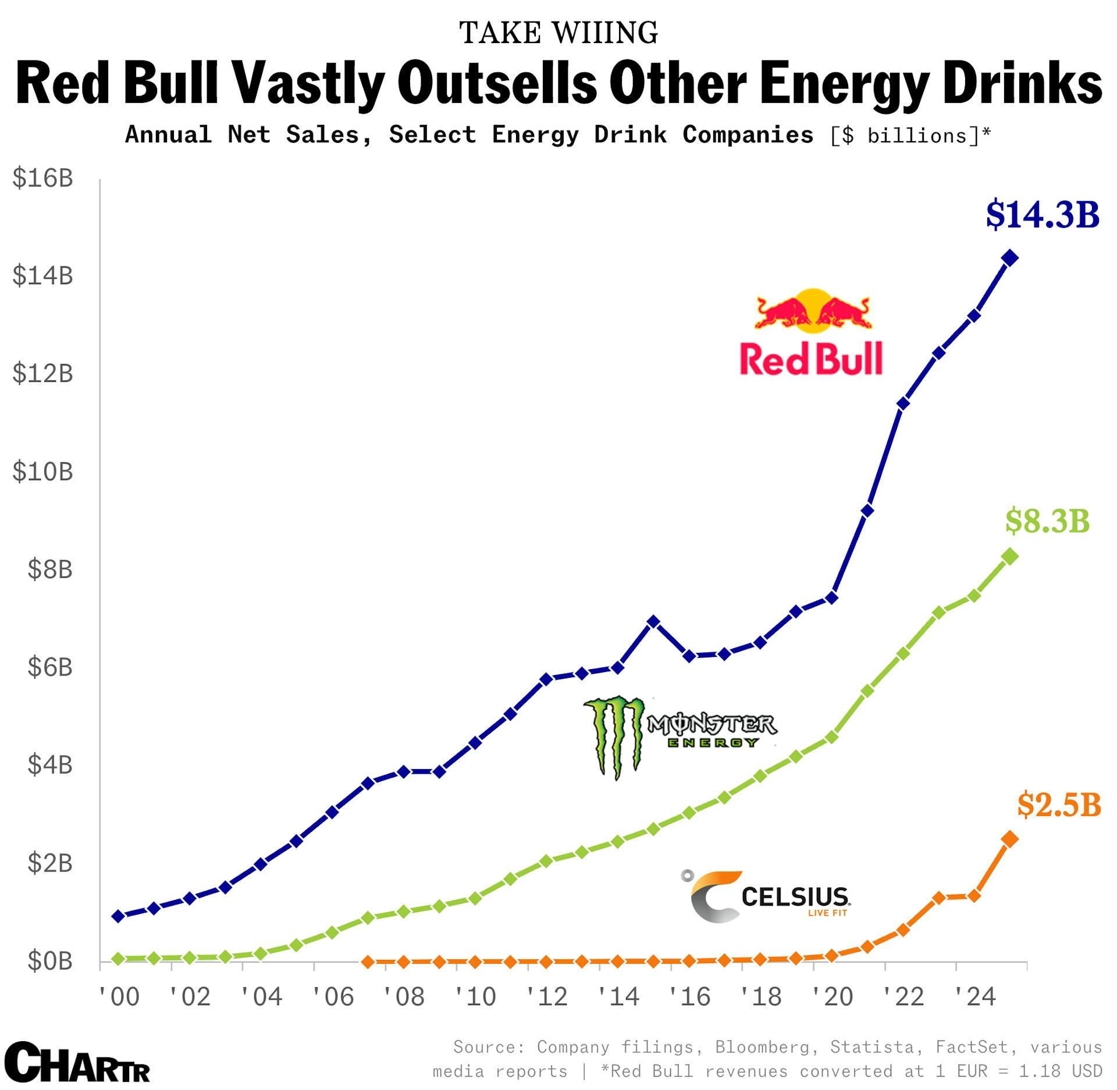
Red Bull Financial Strengths
Source: [Giles, 2026]
Red Bull has its in-house media department working hard to generate rich content. For example, their YouTube channel has 28.9 million subscribers and Instagram account has 33 million followers (Jurevicius, 2025).
Weaknesses
A small product portfolio makes it limited in comparison to rivals like Monster that gives double variety. Indian customers have so many other alternatives in cheap cost that prevents them from going to premium segments. One major concern is the high price of INR 125 excludes most of the customers. They are not able to make this expensive energy drink part of a regular routine (Kalra, 2026). Moreover, these drinks are not very healthy for people to consume on daily basis due to its high caffeine content (Chavoustie and McGrane, 2025). The brand has a narrow variant range tailored for Indian taste preferences as compared with rivals. There is also perception risks linked to sugar content among the health-conscious client base.
Opportunities
Lifestyle of India’s young demographic is changing with time. Here, Red Bull needs to respond by introducing new product lines with localized taste. An improvement in health credentials is also crucial for better differentiation. Some probable options include plant-based, natural caffeine and nootropic variants. Many critics have shared concern on the environmental impact of the firm. There is a massive opportunity to use recycled materials to minimize the use of virgin aluminum. Their communications should be made more transparent for its initiatives (Holt, 2021). For example, it is not clear whether they currently use recycled aluminum in making their cans.
Threats
People often become cautious about their spending when living expenses rise. Currently. India is facing the same situation due to global inflation caused by Middle East conflicts and other factors. Here, the premium positioning can become a threat as customers will shift to cheaper alternatives. This highly competitive market is becoming saturated very fast. Small brands are taking niche spaces with their high-quality products, which can affect Red Bull’s growth opportunities.
The 40% GST classification increases prices, which results in compressed margins. The intensified regular scrutiny of caffeine and sugar claims can cause reputational risks for the company (Sushmit, 2026). All these elements must be considered by the company to avoid any issues in the business.

3. Comprehensive and Holistic View of the Organization
The mission of ‘Giving Wings to People and Ideas’ shows its commercial strategy as well as CSR approach. This identity shapes its CSR strategy along with brand building activities.

3.1 Current CSR strategy
Red Bull is highly aware of its sustainability aspect which reflect in their circular packaging. It helps then in saving 95% energy through recycling. In comparison to plastic bottles, the cans save 20% space in transport (Redbull, 2026). Following is how the company uses circular packaging in their production:
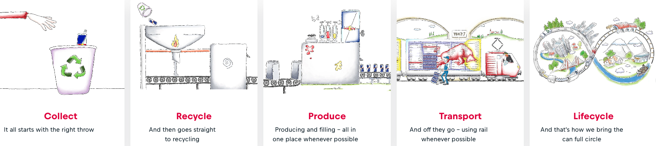
Circular Packaging at Red Bull
Source: [Redbull, 2026]
The firm uses ECO coolers for their products which contribute to a low environmental impact. These are natural refrigerants with energy-efficient fans, smart temperature and requires 35% less energy. This is how the company reduce greenhouse gases.
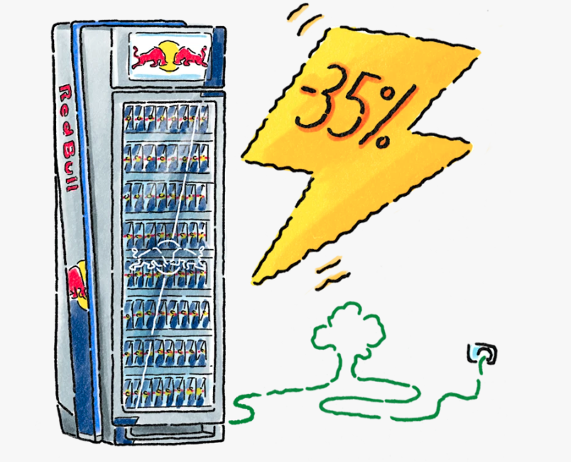
CEO Coolers consumes 35% less energy
Source: [Redbull, 2026]
There are programs like Red Bull Basement that empower the young innovators for technology projects. Another program is Amaphiko that supports social entrepreneurs (Aziz, 2020). They also organize sports, music, and gaming events to engage youth in India. Their approach aligns with the objectives of their business because environmental credibility protects them from scrutiny. A focus on youth reinforces the core target demographics to make their marketing more efficient.
Limitations: The skew of their efforts is towards commercial branding that gives low priority to health-related initiatives. The product itself is high in caffeine and has high sugar. The volume share is constrained in India by a high pricing with low visibility of the CSR. This portfolio is instrumental instead of purely philanthropic. It might give them a cultural relevance but leaves scope for a less brand-centric social impact.

3.2 Balanced Scorecard
Organizations use Balanced Scorecard (BSC) to grade their performance from different perspectives. It gives a comprehensive view of the overall company health and implements long-term strategies. It is so popular that even Fortune 500 corporations like Apple and Volkswagen use it (Hayes and Velasquez, 2025). Following is the BSC for Red Bull covering different perspectives:
Financial: India’s market has intense competition and high GST. Hence, the firm focus on profits within the premium segment to protect their margins. The key aim of the company is to improve their contribution margins so the returns can be maximized. Other target is to sustain double digit revenue growth in metro and tier-2 cities.
The company is present on modern trade and quick commerce with strong cost control in distribution (Quintero, 2026). Their discipline for continuous premium price helps them to activate highest returns. Some of the standard tools includes consist of net profit margin, return on capital employed and cash flow benchmarks. The core objective is to create tangible financial outcomes instead of giving abstract targets.
Customer: Red Bull wants to have brand leadership among the 18 to 35 urban consumers. These are the segments that get highly engaged on the digital platforms and events. The areas help them grow through repeat purchases. The goal is to be the most aspirational energy brand in the target segments. The basement-style innovation programs and expansion sugar-free variants show their commitment towards their consumers. The organization can also evaluate their product through net promoter scores and customer lifetime value to understand if they are successfully connecting with the target consumers (Hayes and Velasquez, 2025).
Internal Business Processes: the quality of the event production and product availability are major KPIs for the business. A strong partnership with modern trade forms helps them to promote their new product range. This perspective also involves the implementation of closed-loop aluminum and energy programs across the supply chain. The matrix of these processes can help to identify any bottlenecks in the process. This is the best way to optimize operations as well as innovative solutions.
Learning and Growth: This dimension determines if a company is capable to innovate with its learnings. It includes training hours, skill development, technology investment etc. Red Bull needs local market insights and creative digital skills to match their high-performance brand ethos (Medium, 2025). Here, data analytics can be used for knowledge sharing and sustainability.
Overall, The BSC showed a link between investment, learning, and superior internal processes. They give a distinct customer experience as compared to other rivals. The scorecard reinforces a strategy of defending profitable premium in India instead of going for mass volume share. This holistic view supports coherent decisions for responsible business practices.

4. Strategic Choices and Implementation
Companies usually choose the Porter’s generic strategies like cost leadership, differentiation or focus. These choices decide how Reb Bull can remain the top player in the industry.
Examination of Strategic Choices
Cost leadership is a practice approach to win in a crowded market by being a low-cost producer without compromising quality valued by customers. It helps to provide the Customers' product at a low price and expand market share. It is achieved by making smart use of resources and optimizing the value chain so the advantage lasts long (Ailani and Vaidya, 2025). The market of energy drinks in India would require competing on pricing and extensive traditional trade distribution. The rival product like Sting by PepsiCo uses the same approach with aggressive pricing and wide reach.
Red Bull can differentiate on basis of product features as well as customer experience. It can be based on the content, brand image or through lifestyle association. The firm has a history of creating its brand aspiration by linking it to youth culture. For this, they heavily invest in events and owned media (Kopp, et. al., 2026).
The customer segment of the company is quite narrow due to the premium positioning. The cost-focused strategies would target a low-price niche whereas differentiation-focused strategies would serve a premium segment.
Recommended Strategy and Validation
A focused differentiation is best strategy for Red Bill to reach urban youth. However, the execution should be adapted to local conditions. For example, they can provide health-aligned variants with culturally relevant marketing.
Validation using Porter’s Five Forces
Threat of New Entrants (Low): A brand can easily enter the low-price market in India due to low barriers. The only issue they face is high rivalry with thin margins. These barriers become substantially higher in the premium range because it requires sustained investment over many years. Red Bull is a credible brand with global media capabilities. The structural requirements protect the advantages of the company which is challenging for newcomers (Gibson, 2024).
Bargaining Power of Suppliers (Low): the materials, like caffeine, taurine, and other inputs like aluminum, are available to plenty of suppliers that give them moderate power. Aluminum is a commodity that has many sources. Other ingredients are unlikely to capture value from a brand that differentiates through intangible assets. The cost pressure still remains manageable as compared to the price sustained by the company.
Bargaining Power of Buyers (Low): Indian customers are price-sensitive, which gives them negligible switching cost. However, the specific segment targeted by Red Bull gives low power to buyers because no other brand stands there. The content and events of the company have provided them with a brand image valued by consumers (Edwards, 2023). It somehow minimizes its sensitivity towards price and makes them willing to pay.

Threat of Substitutes (Medium): this threat is real across the broader market, where people like traditional beverages, tea, coffee and other functional drinks. The niche segment is less intense within the premium lifestyle choices. The company's differentiation relies more on emotional as well as cultural meaning. Someone who wants status and performance will not go for some other substitute than Red Bull itself.
Intensity of Competitive Rivalry (Medium): There are many players with aggressive low-priced products like Sting. Their domination is very high in the market but Reb Bull’s premium tier is not just price based. Moreover, rivals like Monster compete more on lifestyle where Red Bull retains strong equity (Malodia, 2025). The firm deliberately avoids the high-volume approach to compete on dimensions where its resources are strongest.
Delivering Optimum Performance and Sustaining Advantage
The average company takes intelligent decisions by focusing on segments where it has the strongest assets to generate high returns. The resource-based view theory supports this by conveying that sustainable advantage arises from valuable resources. This entire event ecosystem meets these criteria very well. This is how they constantly monetize these assets through stronger loyalty instead of participating in price competition.
It's been decades that the organization is maintaining its category leadership, where content is core to its business model. It has continued its success in other emerging markets by giving priority to brand building instead of rapid volume expansion (Larsen, 2024). It might have a low volume share in India but its brand leadership gives it pricing power.
There is a reinforcing power that helps to achieve optimum performance as given below:
High Perceived Value
Premium Pricing and Loyalty
Resources and Investment
Continued Differentiation
All these elements are consistent with the balanced scorecard where learning processes support customer preferences.
Implementation Challenges and Mitigation
The first challenge is 40% GST which can significantly compress margins. The best solution is to implement a cost discipline in non-brand areas with high-ROI experiential marketing (Pandian, 2025). They can slowly gradually shift their portfolio towards variants that support better value perception.
The competitors who give the product at an extremely low price are creating a perception that energy drinks are cheap. It is an issue that should be solved as a high priority. Otherwise, people might think that Red Bull charges high without providing them value. Hence the distribution must be improved with premium positioning through modern trade, e-commerce, gyms, etc. The communication about lifestyle and performance should be consistently maintained.
Red Bull's reputation can get at risk due to rising health consciousness as well as regular scrutiny around caffeine and sugar. They have already started its sugar-free options which is a step in the right direction. However, it should keep its communication transparent to make sure all claims are compliant with FSSAI requirements (Livemint, 2026).

Section 2

Reflection
Gibbs made a six-stage system to help individuals to learn from their experiences and explore underlying causes. This reflection model helps to get better by identifying opportunities of improvement.
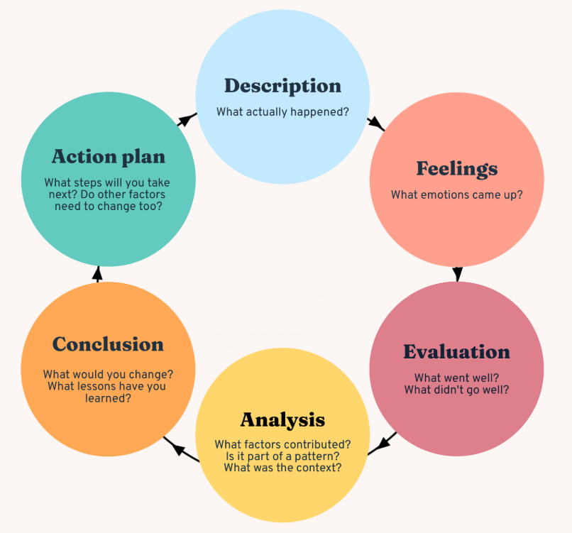
Gibbs Reflective Cycle
Source: [Bitsizelearning, 2025]
Description
It was a strategic analysis of Red Bull in the Indian market where I was tasked to analyze the company's internal and external environment and its strategic choices. I started this work with secondary research on the company's history and business model. I further proceeded to collect data on industry dynamics as well as regulatory dynamics. The process included many stages of research and drafting to critically evaluate the subject.
Feelings
I was very curious and had mild anxiety at the start. I'm familiar with this energy drink but its analysis required moving beyond surface-level knowledge. I had some concerns about locating reliable data and companies' local operations. Some moments were challenging and made me feel frustrated when the market size figures were conflicting. I kept on researching and felt satisfied when the framework started to make sense and explained why focus differentiation was by far much better than cost leadership (Martin, 2021). The entire process shifted my uncertainty towards growing confidence.
Evaluation
Most of my experience was positive as my understanding became deeper by applying multiple strategic frameworks. The work was iterative and I had to return to earlier sections as later analysis developed. It helped me to make a more consistent and logical report. The current data on GST changes and aluminum stewardship made this entire work feel more practical (Jagwani and Savani, 2026).
I often collected more data and went through multiple drafts many times. Some early versions of the report were overly descriptive but it shifted to critical evaluation as I further progressed. I learned that secondary sources cannot be relied on completely because it is important to balance practical applications as well.
Analysis
The strongest part of the work emerged when I allowed the frameworks to guide me. It was through the PESTLE that I got to know about the tension between demographic opportunity and regulatory pressure. The true advantages of Red Bull lie in its intangible assets instead of distribution. Porter’s model confirmed that focus differentiation is the best way to protect these advantages (Gratton, et. al., 2025). The gaps in the data forced me to show transparency about the limitations. I linked these frameworks and identified that external threats interact with internal weaknesses.

Conclusion
An effective strategic analysis not only needs breadth of information but a disciplined selectivity as well. The real effort is about prioritizing what matters for the company's competitive position. There is a significant relationship between resources and strategic choices. I could have planned the research phases better by knowing the key information and the key data requirements in advance. It would be better to give more time earlier to critical evaluation to save a lot of time in the next phases. This entire process made me better at creating a strategic narrative.
Action Plan
In future I would map the required frameworks and take notes on the relationship I expect to explore. A research brief would be developed that lists main data points and a list of resources. It will help me to reduce an information overload during the study. Moreover, secondary data has a lot of limitations that would be reflected in further works to enrich the analysis. These steps will provide a robust result that makes the assessment valuable for my learning. This plan has the potential to help me in my future professional endeavors.

References
Ailani, G. and Vaidya, D. (2025) Cost Leadership. [Online] wallstreetmojo. Available at https://www.wallstreetmojo.com/cost-leadership/
Ayles, J. (2021) From Cliff Diving To Formula One and Football: How Red Bull Built A World-Class Sporting Empire. [Online] forbes. Available at https://www.forbes.com/sites/jamesayles/2020/01/14/from-cliff-diving-to-formula-one-and-football-how-red-bull-built-a-world-class-sporting-empire/
Aziz, A. (2020) The Power Of Purpose: How Further Is Expanding Its Quest To Help Social Entrepreneurs. [Online] forbes. Available at https://www.forbes.com/sites/afdhelaziz/2020/03/05/the-power-of-purpose-how-further-is-expanding-its-quest-to-help-social-entrepreneurs/
Banerjee, N. (2026) One can, many lives: How aluminium is powering Red Bull’s circular future. [Online] alcircle. Available at https://www.alcircle.com/news/one-can-many-lives-how-aluminium-is-powering-red-bulls-circular-future-119816?srsltid=AfmBOopcCBojMsa9Qe27V7vi4bJmA3S_vL-BB2DGWUZblunf5VGzNUKc
Bhosale, H. (2023) How Sting Stung India’s Energy Drink Market. [Online] medium. Available at https://medium.com/@bhosaleharshwardhan07/how-sting-stung-indias-energy-drink-market-7818260fd3b8
Bitesizelearning. (2025) The Gibbs Reflective Cycle, explained. [Online] bitesizelearning. Available at https://www.bitesizelearning.co.uk/resources/gibbs-reflective-cycle-explained-diagram-examples
Bosanskom, P. C. (2025). Timeless Marketing Lessons from Red Bull. [Online] media-marketing. Available at https://www.media-marketing.com/en/news/timeless-marketing-lessons-from-red-bull/
Chavoustie, C. and McGrane, K. (2025) What Are the Side Effects of Drinking Red Bull? [Online] healthline. Available at https://www.healthline.com/nutrition/red-bull-side-effects
Dudovsky, J. (2016). Red Bull Business Strategy and Competitive Advantage. [Online] research-methodology. Available at https://research-methodology.net/red-bull-business-strategy-and-competitive-advantage/
Edwards, C. (2023) Red Bull Links Its Brand to the Sports We Love. [Online] theharrispoll. Available at https://theharrispoll.com/articles/marketing-win-red-bull-connects-their-brand-name-with-the-sports-we-love/
Gibson, K. (2024) How to Compete Effectively with Your Industry's Emerging Brands. [Online] hbs. Available at https://online.hbs.edu/blog/post/brand-competition
Giles, M. (2026) Energy drink sales are soaring — but Red Bull’s still fly the highest. [Online] sherwood. Available at https://sherwood.news/business/energy-drink-sales-are-soaring-but-red-bulls-still-fly-the-highest/
Grandviewresearch. (2026). India Energy Drinks Market Size & Outlook, 2026-2033. [Online] grandviewresearch. Available at https://www.grandviewresearch.com/horizon/outlook/energy-drinks-market/india
Gratton, P., Scott, G. and Petrick, B. (2025) Porter's Five Forces Explained and How to Use the Model. [Online] investopedia. Available at https://www.investopedia.com/terms/p/porter.asp
Hayes, A. and Velasquez, V. (2025) Balanced Scorecard (BSC): What It Is, Examples, and Uses. [Online] investopedia. Available at https://www.investopedia.com/terms/b/balancedscorecard.asp
Hayes, A., James, M. and Petrick, B. (2026) Return on Capital Employed (ROCE): Ratio, Interpretation, and Example. [Online] investopedia. Available at https://www.investopedia.com/terms/r/roce.asp
Holt, K. (2021) WHAT I LEARNED ABOUT BRAND COMMUNICATIONS FROM MY TEN YEARS AT RED BULL. [Online] medium. Available at https://kerri-l-holt.medium.com/what-i-learned-about-brand-communications-from-my-ten-years-at-red-bull-2eced8eb9d83
Jagwani, M. and Savani, A. (2026) GST Rate for Beverage: What Changed from May 1, 2026? [Online] themunim. Available at https://themunim.com/blog/gst-rate-for-beverages/
Jurevicius, O. (2025) SWOT Analysis of Red Bull 2025. [Online] strategicmanagementinsight. Available at https://strategicmanagementinsight.com/swot-analyses/red-bull-swot-analysis/
Kalra, A. (2026) India firm on 'energy drink' crackdown despite Pepsi, Red Bull, Monster protest. [Online] reuters. Available at https://www.reuters.com/world/india/india-firm-energy-drink-crackdown-despite-pepsi-red-bull-monster-protest-2026-07-27/
Kenton, W., Mansa, J. and Perez, Y. (2026). Strategic Management: Organizing Resources to Achieve Business Goals. [Online] Investopedia. Available at https://www.investopedia.com/terms/s/strategic-management.asp
Kopp, C., Drury, A. and Munichiello, K. (2026) How Product Differentiation Boosts Brand Loyalty and Competitive Edge. [Online] investopedia. Available at https://www.investopedia.com/terms/p/product_differentiation.asp
Korfiatis, J. (2026) You're Ignoring the $3.7B Marketing Secret Fuelling Red Bull's Global Domination. [Online] apolcs. Available at https://www.apolcs.com.au/advice/red-bull-spends-37b-in-marketing
Kumar, S. (2025) The population paradox in India. [Online] orfonline. Available at https://www.orfonline.org/research/the-population-paradox-in-india
Larsen, R. (2024) The Business Model and Revenue Streams of Red Bull Explained. [Online] untaylored. Available at https://www.untaylored.com/post/the-business-model-and-revenue-streams-of-red-bull-explained
Larson, R. (2024) The Business Model and Revenue Streams of Red Bull Explained. [Online] untaylored. Available at https://www.untaylored.com/post/the-business-model-and-revenue-streams-of-red-bull-explained
livemint. (2026) FSSAI orders Pepsi, Red Bull, Monster to drop ‘energy drink’ label from high-caffeine products. [Online] livemint. Available at https://www.livemint.com/companies/news/fssai-orders-pepsi-red-bull-monster-to-drop-energy-drink-label-from-high-caffeine-products-11785155926050.html
Livemint. (2026) FSSAI orders Pepsi, Red Bull, Monster to drop ‘energy drink’ label from high-caffeine products. [Online] livemint. Available at https://www.livemint.com/companies/news/fssai-orders-pepsi-red-bull-monster-to-drop-energy-drink-label-from-high-caffeine-products-11785155926050.html
Malodia, R. (2025) Red Bull vs Monster: The Real War You Never Heard About. [Online] rahulmalodia. Available at https://rahulmalodia.com/blog/red-bull-vs-monster
Markhub24. (2026) Red Bull: Lifestyle and Energy Positioning Strategy. [Online] markhub24. Available at https://www.markhub24.com/post/red-bull-lifestyle-and-energy-positioning-strategy
Martin, R. (2021) Can You Be Both Cost Leader & Differentiator? [Online] medium. Available at https://rogermartin.medium.com/can-you-be-both-cost-leader-differentiator-1774d5c7ff86
medium. (2025) What Red Bull Teaches About Brand Strategy That No MBA Ever Will. [Online] medium. Available at https://medium.com/@thebrandcult.lab/wings-of-myth-how-red-bull-built-a-9b-brand-from-nothing-but-energy-4ce0f3a25842
Mordorintelligence. (2025) TOP INDIA Q-COMMERCE COMPANIES, LEADERS & MAJOR PLAYERS. Available at https://www.mordorintelligence.com/industry-reports/q-commerce-industry-in-india/companies
Mordorintelligence. (2026) INDIA ENERGY DRINKS MARKET SIZE & SHARE ANALYSIS - GROWTH TRENDS AND FORECAST (2026 - 2031) [Online] mordorintelligence. Available at https://www.mordorintelligence.com/industry-reports/india-energy-drink-market
Nell, V. H. (2026). Red Bull Mission and Vision Statement Explained (2026 Guide). [Online] newswirejet. Available at https://newswirejet.com/red-bull-mission-and-vision-statement/
Pandian, I. (2025) The Secret Playbook Red Bull Wrote for Experiential Marketing in the Age of AI. [Online] medium. Available at https://medium.com/@iswarya.skp/the-secret-playbook-red-bull-wrote-for-experiential-marketing-in-the-age-of-ai-24eb2fc09318
Pereira, D. (2025). Red Bull Business Model. [Online] businessmodelanalyst. Available at https://businessmodelanalyst.com/red-bull-business-model/?srsltid=AfmBOopSuoEn3b0WyAriM3ZMnWeniUg56MIGuI_MtIWaUWK7tvUNmI7Q
Quintero, D. (2026). [Online] newswirejet. Available at https://newswirejet.com/red-bull-pricing-strategy/
Racoma, B. (2019) How Red Bull Adapts to Different Markets. [Online] daytranslations. Available at https://www.daytranslations.com/blog/how-red-bull-adapts-to-new-markets/
Redbull. (2025) Giving Wings to People and Ideas. [Online] redbull. Available at https://www.redbull.com/int-en/energydrink/company-profile
Redbull. (2025) Sustainability at Red Bull: A can has more than one life. [Online] redbull. Available at https://www.redbull.com/in-en/energydrink/red-bull-can-lifecycle
Sushmit. (2026) FSSAI Beverage Compliance India: Founder's Guide 2026. [Online] flavorcatalyst. Available at https://www.flavorcatalyst.com/insights/fssai-beverage-compliance/
Tradologie. (2025). How to Get Red Bull Distributorship in India: Application Process, Investment, Margin & Requirements. [Online] tradologie. Available at https://www.tradologie.com/blogs/how-to-get-red-bull-distributorship-in-india/
Whiteandbrief. (2025) India’s Sin Goods Taxation Overhaul: Central Excise Amendment Bill 2025. [Online] whiteandbrief. Available at https://whiteandbrief.com/indias-sin-goods-taxation-overhaul-central-excise-amendment-bill-2025/
Wright, K. (2026) Riding backwards on one wheel down a ski jump? Mission accomplished. [Online] redbull. Available at https://www.redbull.com/in-en/tomomi-nishikubo-trials-biking-world-records

