Software Solutions for Business
ACCA4026
Component 1- Coursework: Portfolio

Submitted by
Fernando Bruno Peternella Moreira
Student number:
2523396
Date: 25 March 2026
UWSTD – Birmingham University
Table of contents
Contents
Introduction 3
Task 1. e-Commerce Website builders/software solutions 4
Task 2. Mind-map of Contemporary Software Applications 5
Task 3. Office Applications for creating, storing, presenting, and analysing information/data 8
Task 4. Communication and Collaboration Applications 14
Conclusion 19
References 20

Introduction
Today, digital tools are very important in business. Companies use different applications to sell products, organise ideas, manage information, and work with other people. These tools help save time, improve communication, and complete tasks more easily.

In this assignment, I will look at some modern digital applications used on business. I will discuss e-commerce platforms, mind mapping, office applications, and communication and collaboration tools. The aim is to show how these applications support everyday operations and why they are useful in the workplace.

Task 1. e-Commerce Website builders/software solutions

Amazon and eBay as Contemporary E-Commerce Platforms

Amazon and eBay are two very common examples of contemporary e-commerce platforms. Today, many people use these websites because they make online shopping simple, fast, and convenient. They also help businesses and individual sellers reach more customers through the internet. Even though both platforms are used for buying and selling, they work in slightly different ways [1], [3].
Amazon is one of the biggest e-commerce websites in the world. One reason for its success is the large number of products available on the platform. Customers can buy many different items in one place, such as clothes, electronics, books, beauty products, and home items [1]. This makes shopping easier because people do not need to visit many different websites. Amazon is also helpful for businesses. The company explains that many independent sellers use the platform to grow their sales and reach more people online [2]. Because of this, Amazon is not only a shopping website, but also an important platform for small and medium-sized businesses. In general, Amazon is a strong example of modern e-commerce because it offers convenience, variety, and business support [1], [2].
eBay is also a popular e-commerce platform, but it has a different style from Amazon. On eBay, customers can buy products at a fixed price, or they can join an auction and bid for an item [3]. This makes the website feel more flexible and interesting, especially for people who are looking for rare, second-hand, or special products. eBay is often a good choice for customers who want to compare prices or find something unusual. It is also still a very large online marketplace. According to the company’s 2025 results, eBay had 135 million active buyers and $79.6 billion in gross merchandise volume [4]. This shows that eBay continues to be an important part of global online business. It is a modern e-commerce platform because it gives sellers an easy way to list products and gives buyers more options when shopping [3], [4].
Overall, Amazon and eBay are both good examples of contemporary e-commerce websites. Amazon is more focused on convenience, wide product choice, and support for independent sellers [1], [2]. eBay is more flexible because it includes auctions as well as fixed-price buying [3]. Both platforms show how online shopping has become an important part of modern life and modern business. They make it easier for people to buy, sell, and connect in the digital world [1]–[4].

Task 2. Mind-map of Contemporary Software Applications
1. Description of mind mapping and its benefits in business operations
Mind mapping is a simple visual way to organise ideas around one main topic. A mind map usually starts with a central subject in the middle, and then related ideas branch out from it. This makes information easier to see, understand, and connect [5].
In business operations, mind mapping can be very useful because it helps people organise their thoughts in a clear way. For example, a team can use a mind map when planning a project, preparing a meeting, solving a problem, or discussing how different departments work together. Instead of writing long notes in a straight line, a mind map shows the links between ideas. This can help staff see the bigger picture more quickly [5].
Another benefit is that mind maps can improve memory and understanding. The use of short words, colours, symbols, and branches can make important points easier to remember [5]. This is helpful in business because employees often need to deal with a lot of information at the same time. A visual format can save time and make communication more effective.
Mind mapping is also useful for decision-making. In an organisation, managers often need to compare options, identify priorities, and look at possible solutions. A mind map can help them break a large topic into smaller parts. This makes it easier to focus on each area and understand how everything is connected [5].
Overall, mind mapping is a practical tool for modern business. It supports brainstorming, planning, teamwork, and problem-solving. Because it is clear and flexible, it can be used by both individuals and teams in day-to-day business activities [5].

1-1. Mind map of contemporary software applications used in day-to-day business operations
Below a simple mind map show contemporary software applications that support everyday business and organisation. Many businesses use integrated systems, such as ERP and related applications, to manage areas like accounting, procurement, project management, HR, supply chain, and customer information [6].

Mind Map: Contemporary Software Applications
Contemporary Software Applications
→ Finance and Accounting
→ budgeting
→ invoices
→ payroll
→ financial reports
→ Procurement Software
→ supplier records
→ purchase orders
→ cost control
→ Project Management Tools
→ task planning
→ deadlines
→ team progress
→ Human Resources Software
→ employee records
→ attendance
→ recruitment
→ Supply Chain and Inventory Systems
→ stock control
→ logistics
→ delivery tracking
→ Customer Relationship Management (CRM)
→ customer details
→ sales follow-up
→ service support
→ Reporting and Analytics Tools
→ dashboards
→ performance tracking
→ business insights

This mind map shows that contemporary software applications are important in almost every part of a business. They help organisations work faster, store information more accurately, and improve communication between departments [6]. In modern business, these applications are often connected, which means information can move more easily across the organisation. As a result, daily operations become more efficient and better organised [6].

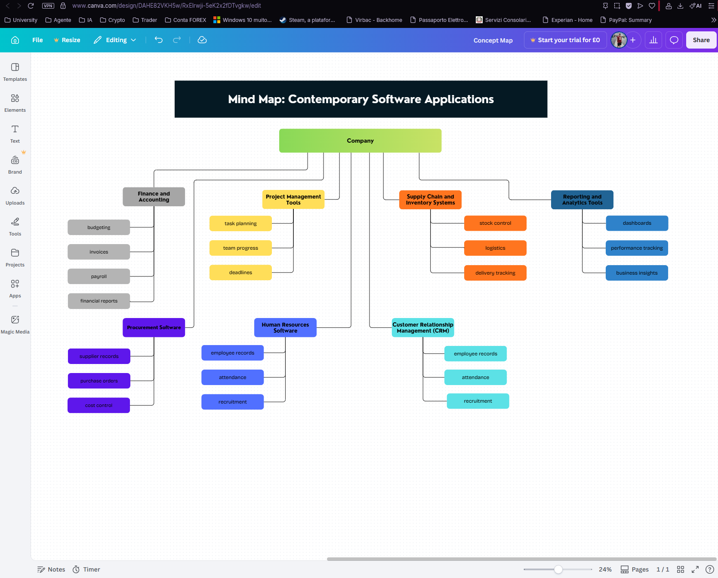
Fig. 1 Example of Mind Map create with Canvas [16].

Task 3. Office Applications for creating, storing, presenting, and analysing information/data
Each application has its own role. Word is mainly used for writing documents. PowerPoint is used for presenting ideas and results. Excel is used for numbers, tables, calculations, and charts. Access is used for storing data in a more organised database system [8]–[11]. For example, a company can records in Access, analyse in Excel, write a report in Word, and present the final results in PowerPoint [7]–[11].
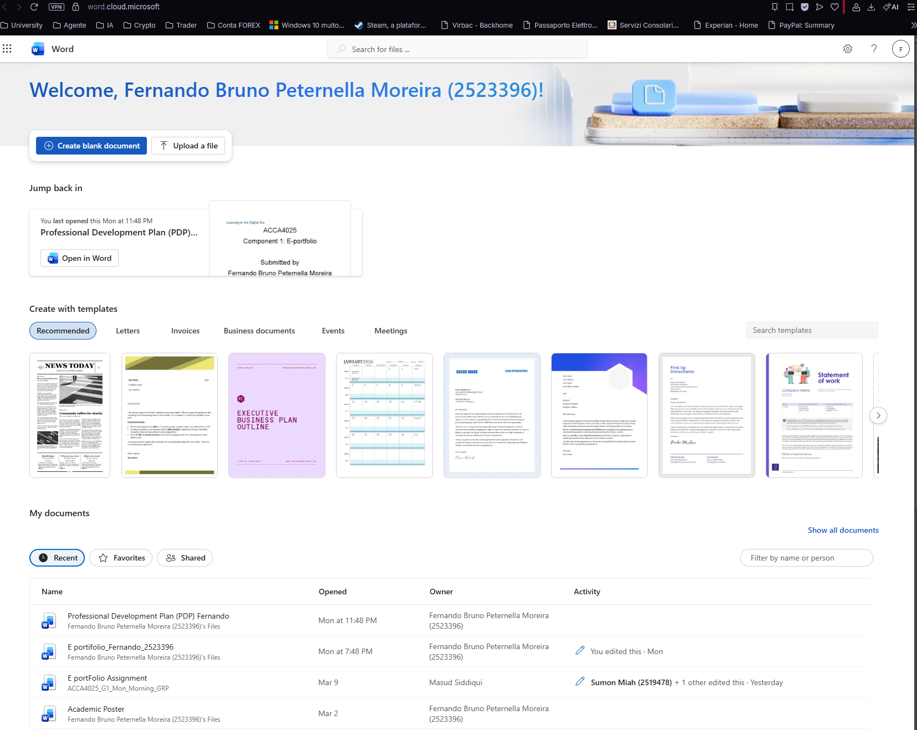
Fig. 2 Example of documents can be create with Word [8].

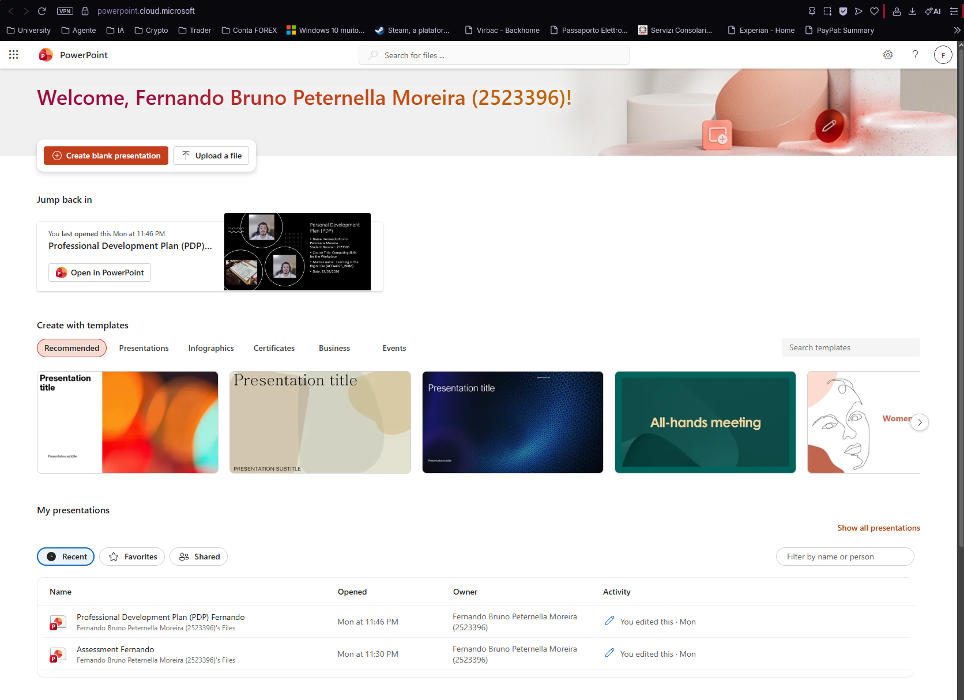
Fig. 3 Example of documents can be create with Power Point [9].

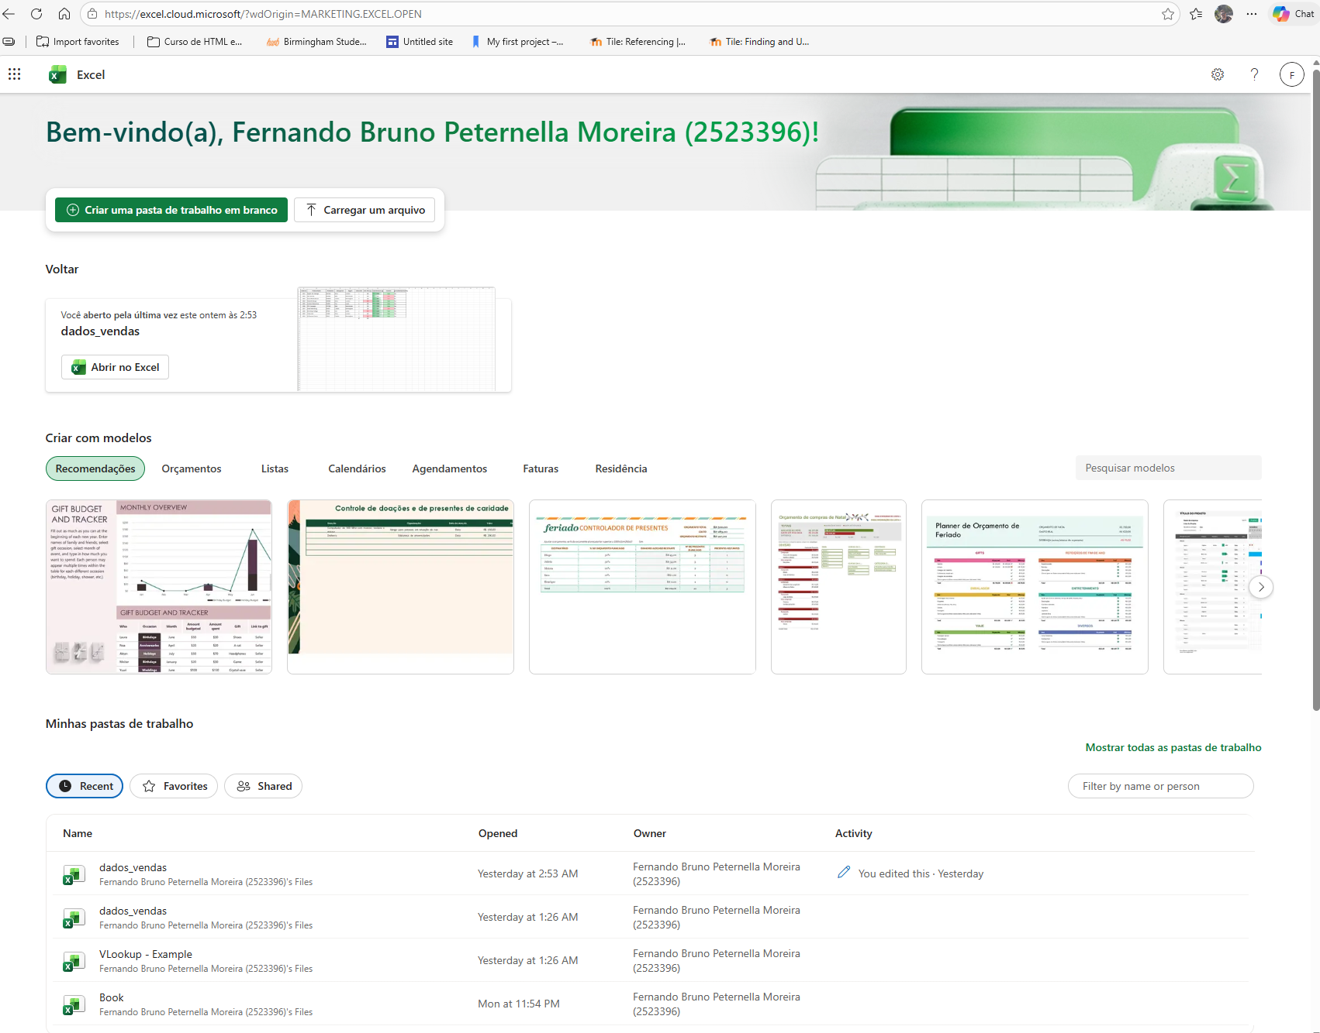
Fig. 4 Example of documents can be create with Power Point [10] .

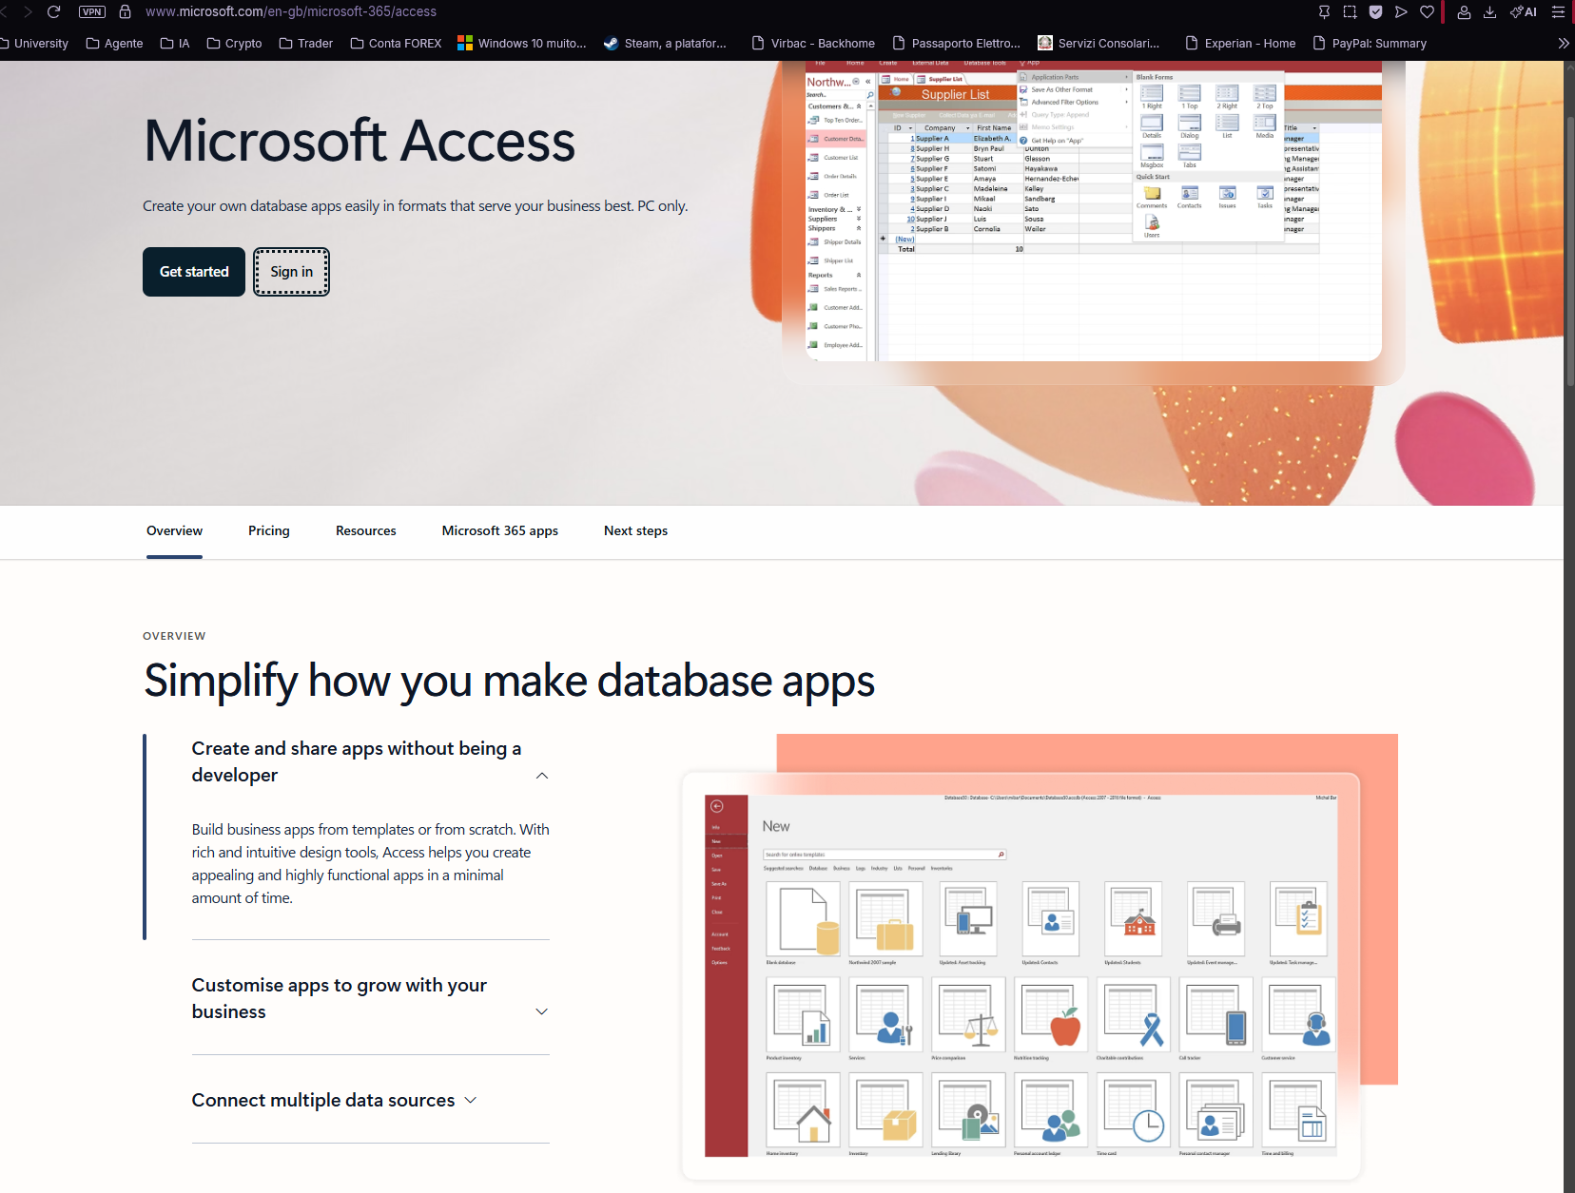
Fig. 5 Example of documents can be create with Access [11].

Finance and Accounting
In Finance and Accounting, Excel is usually the most useful application. Finance teams work with numbers every day, so Excel is helpful for budgets, income and expense tables, payroll support, and financial summaries [10]. It allows staff to organise figures, use formulas, and create charts. This makes daily finance work faster and easier.
Word is also useful in this area. Finance departments often need written reports, payment letters, internal policies, and procedure documents. Word helps staff prepare these documents in a clear and professional way [8]. So, Word supports the written side of finance work, while Excel supports the numerical side.
PowerPoint can be used when financial information needs to be presented in meetings. For example, managers may present the budget, monthly performance, or cost-saving plans using slides [9]. Access can also help if the business wants to store structured records such as supplier payments, invoice histories, or account details in a database [11].

Procurement Software
In Procurement, businesses need to deal with suppliers, prices, orders, and records. Excel is very useful here because it can compare prices, track orders, and record quantities [10].
Word is also important in Procurement. It can be used for supplier letters, purchase requests, contract drafts, and procurement procedures [8].
Access is helpful when the business wants to keep supplier names, contact details, product categories, and order history in one organised database [11].
PowerPoint is less central, but it can still be used for supplier review meetings or cost comparison presentations [9].

Project Management Tools
Project Management is an area where all four applications can be useful. Word can be used for project plans, meeting notes, and progress documents [8]. It is a good tool for writing down project goals, responsibilities, and next steps.
Excel is useful for task lists, timelines, cost tracking, and progress monitoring [10]. Many teams use spreadsheets to check deadlines and responsibilities. PowerPoint is very useful for project updates because project managers often need to explain progress to teams or senior managers [9]. Slides make the update easier to understand.
Access can support project work when the business wants to store project records in a more organised way. For example, it can hold project names, team members, deadlines, and status information [11]. This means the four applications can all support project management, but in different ways.

Human Resources Software
In Human Resources, Word is very important because HR teams create many written documents. These include job descriptions, contracts, policies, warning letters, and training notes [8]. Word helps make these documents clear and professional.
Excel is useful for attendance records, leave tracking, interview schedules, training lists, and payroll support data [10]. Many HR teams use Excel because it is simple and flexible for everyday administration. Access is also helpful when the business wants to store employee records in a structured database. This may include names, job roles, departments, phone numbers, and contract details [11].
PowerPoint is useful for staff training and induction. HR teams can prepare slides for new employees, training sessions, and internal presentations [9]. In this area, Word and Excel are often used daily, while Access stores records and PowerPoint supports communication.

Supply Chain and Inventory Systems
In Supply Chain and Inventory work, Excel is often the easiest tool for daily control. It can be used to record stock levels, product quantities, order dates, delivery dates, and reorder points [10]. This helps staff check what is available and what needs to be ordered again.
Access is very useful when stock data becomes larger and more detailed. A company can use it to store product codes, supplier details, warehouse locations, and movement records in one database [11]. This gives the business a more organised system for inventory information.
Word can be used for delivery instructions, warehouse procedures, and supplier agreements [8]. PowerPoint can support meetings where the business needs to explain stock problems, delivery performance, or logistics plans [9]. So, Excel and Access are the main tools here, while Word and PowerPoint provide extra support.

Customer Relationship Management (CRM)
In Customer Relationship Management, Access is very useful because customer information often needs to be stored in a structured and searchable way. A business can use Access for names, email addresses, phone numbers, customer history, and follow-up notes [11]. This helps staff find information more quickly.
Excel is also useful in CRM. Sales teams can use it to track leads, customer contact dates, sales activity, and monthly performance [10]. It is a practical tool for quick customer-related analysis. Word supports CRM by helping staff write quotations, service letters, and follow-up messages [8].
PowerPoint is helpful when the business needs to present products or services to clients. It is often used in sales pitches and customer meetings [9]. This means CRM can use all four applications, depending on the type of task.

Reporting and Analytics Tools
For Reporting and Analytics, Excel is usually the main tool. It is very useful for tables, calculations, charts, and simple trend analysis [10]. Managers often use Excel to review sales, costs, stock data, and staff performance.
After that, PowerPoint can be used to present the results in a meeting [9]. This is helpful because charts and short slide points are easier to explain than large spreadsheets. Word is useful when the final report needs to be written in full sentences and stored as a formal business document [8].
Access can support reporting when the data comes from a structured database [11]. In that case, the business can store records in Access first, then use the information for reports and analysis. This shows how the four applications can support the same business process step by step.

Task 4. Communication and Collaboration Applications
Communication and collaboration tools are very important in modern business. Companies use them to speak with staff, organise meetings, share files, and work together more easily. Digital connectivity is now a normal part of the workplace and it supports productivity and flexible working [14].
For this task, Microsoft Teams can be used as a communication application, and OneDrive can be used as an online collaboration application. Teams is useful for meetings and chat, while OneDrive is useful for storing, sharing, and working on files with other people [12], [13].

1. Analysis of one communication and one online collaboration application
Microsoft Teams is a communication tool used for online meetings, calls, chat, and file sharing [12]. It is useful in business because it allows people to communicate in real time, even when they are in different places. This is helpful for team meetings, manager updates, and communication with clients [12].
One important feature of Teams is online meetings. Staff can join a meeting and communicate by audio or video [12]. Another useful feature is screen sharing. This helps the user show a document, slide, or webpage during a meeting, which makes communication clearer [12]. Because of this, Teams is often a practical tool for daily business communication.
The main benefit of Teams is that it brings communication into one place. People can chat, meet, and share information in the same app [12]. A limitation is that Teams is mainly for communication, so it is not the main tool for storing large numbers of files in an organised way [12].

Fig 6: Microsoft Teams meeting screen [12].

OneDrive is an online collaboration tool because it allows users to store files in the cloud, share them with others, and work together on them [13]. In modern business, this is useful because teams often need access to files from different locations [14].
One important feature of OneDrive is file sharing. Files are private until they are shared, and users can share them by link or by giving access to specific people [15]. Users can also manage permissions and choose whether other people can edit the file or only view it [15]. This is very useful in business because teams often need to send files safely and control who can make changes.

The main benefit of OneDrive is that it helps teams keep files in one place and share them more easily [13], [15]. It also supports collaboration because people can work on shared files instead of sending many different versions by email [15]. A limitation is that OneDrive is more focused on file storage and sharing, so it is not mainly used for live meetings like Teams [13].
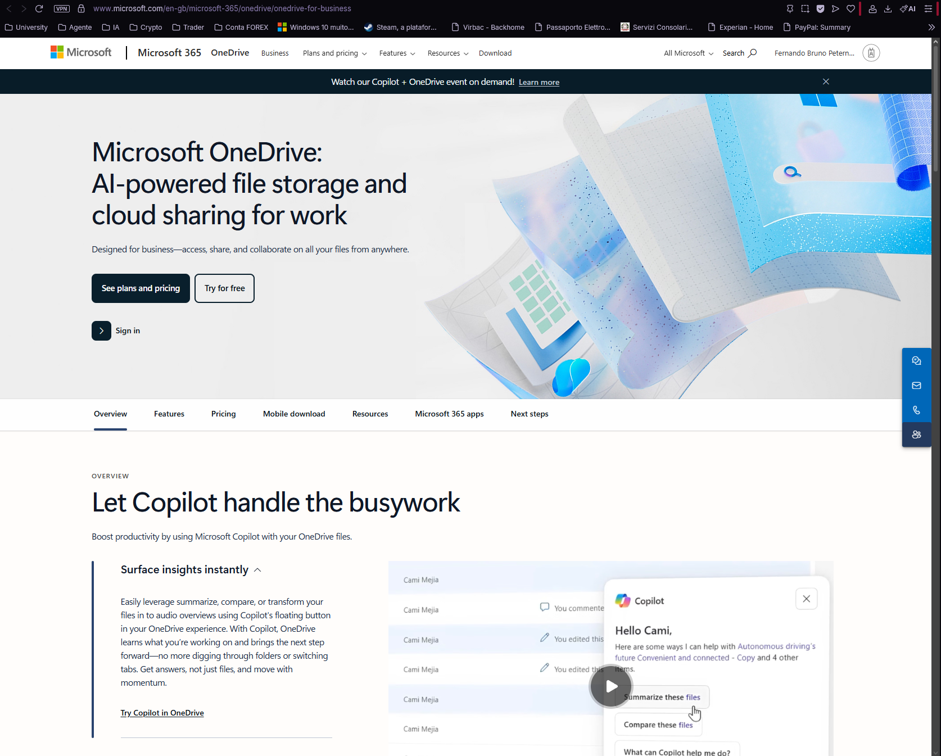
Fig 7: Microsoft Onedrive storage and cloud Sharing [13].

1.1. Practical test of one feature from each application
For the practical part, one feature from each tool can be tested. For Microsoft Teams, the feature can be screen sharing. For OneDrive, the feature can be sharing a file with edit permission. These are both simple and useful for daily.
Example screenshots for Microsoft Teams
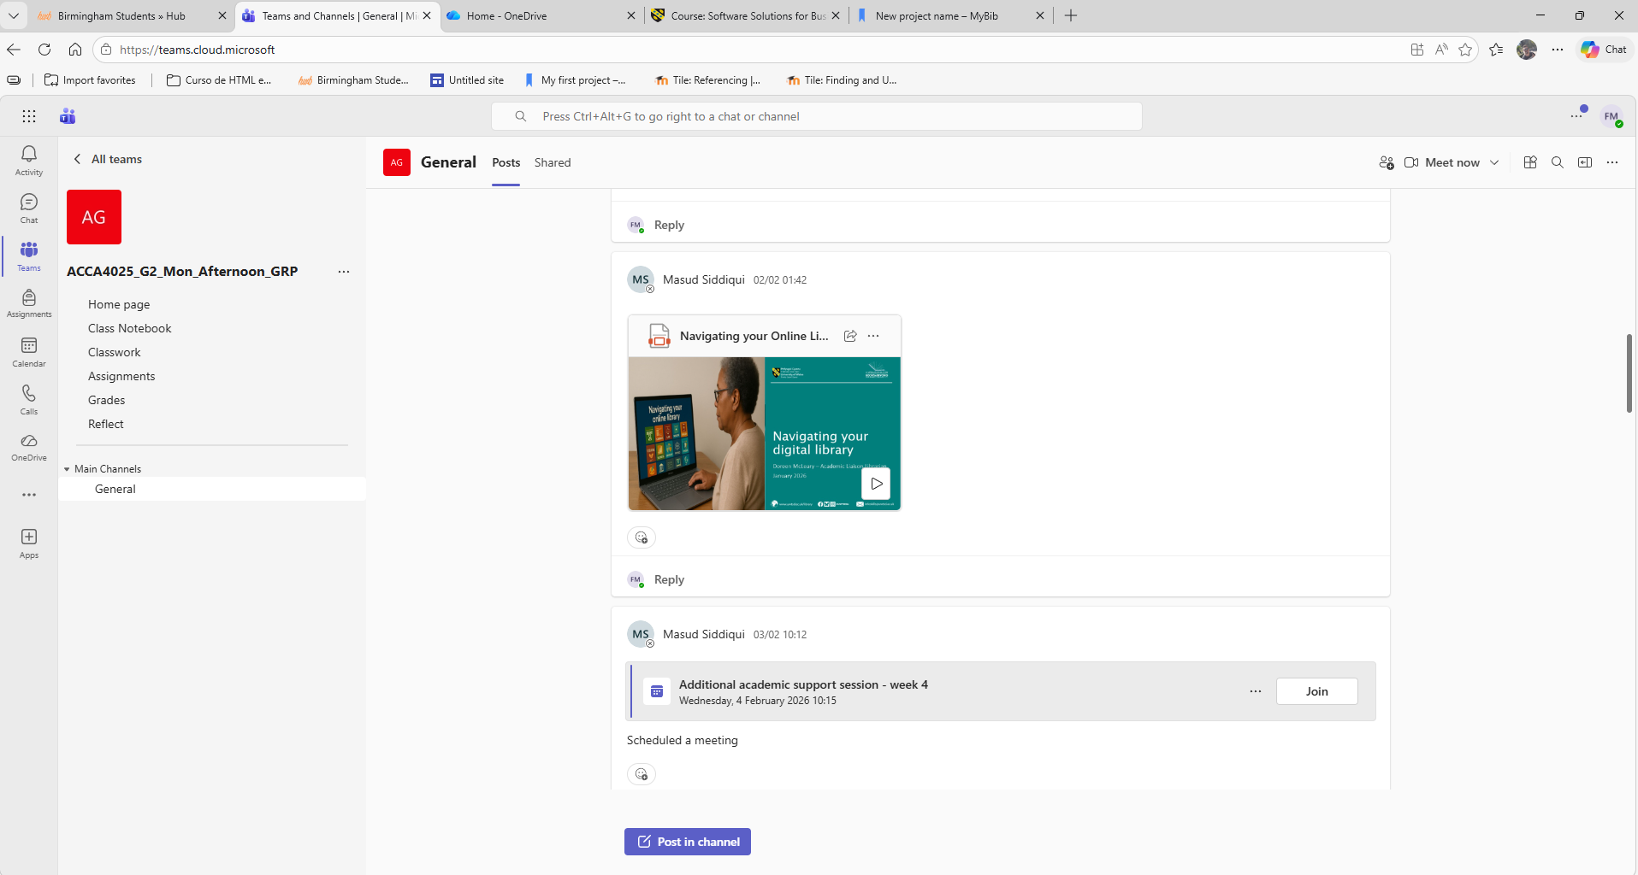
Screenshot 1: Teams home screen, This shows the Microsoft Teams interface.

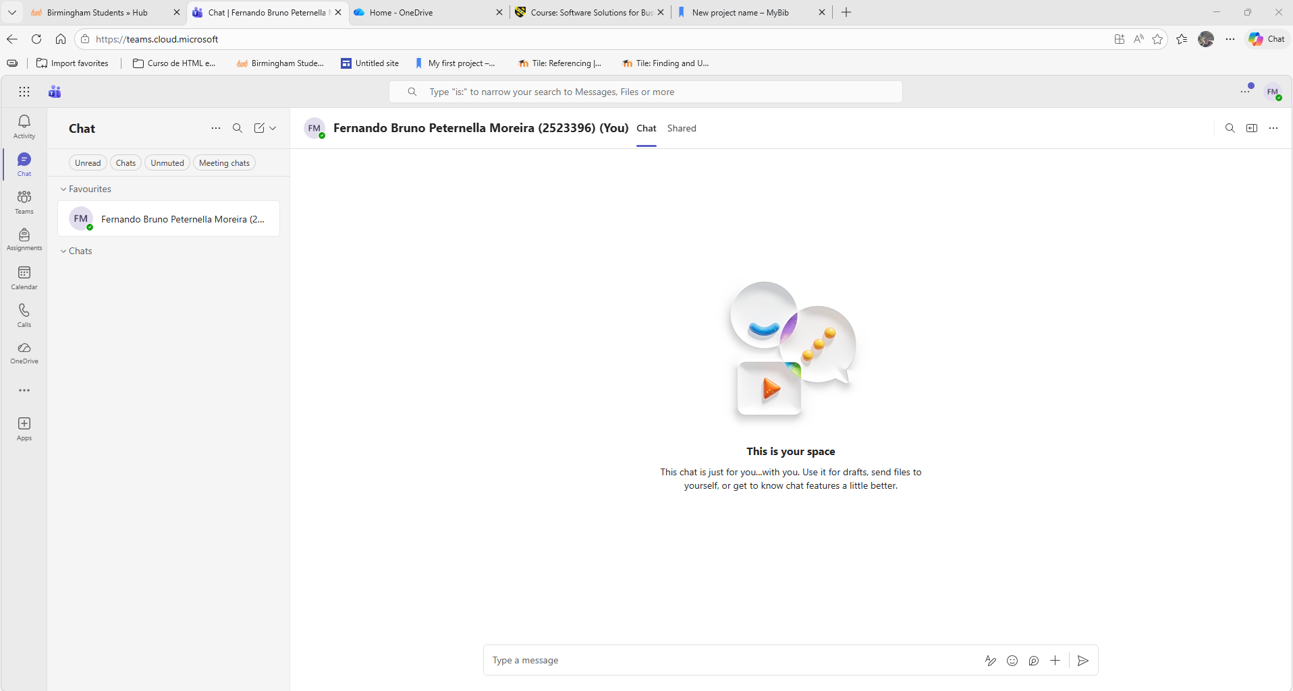
Screenshot 2: Chat Start, This shows the Chat started successfully.
Example screenshots for OneDrive
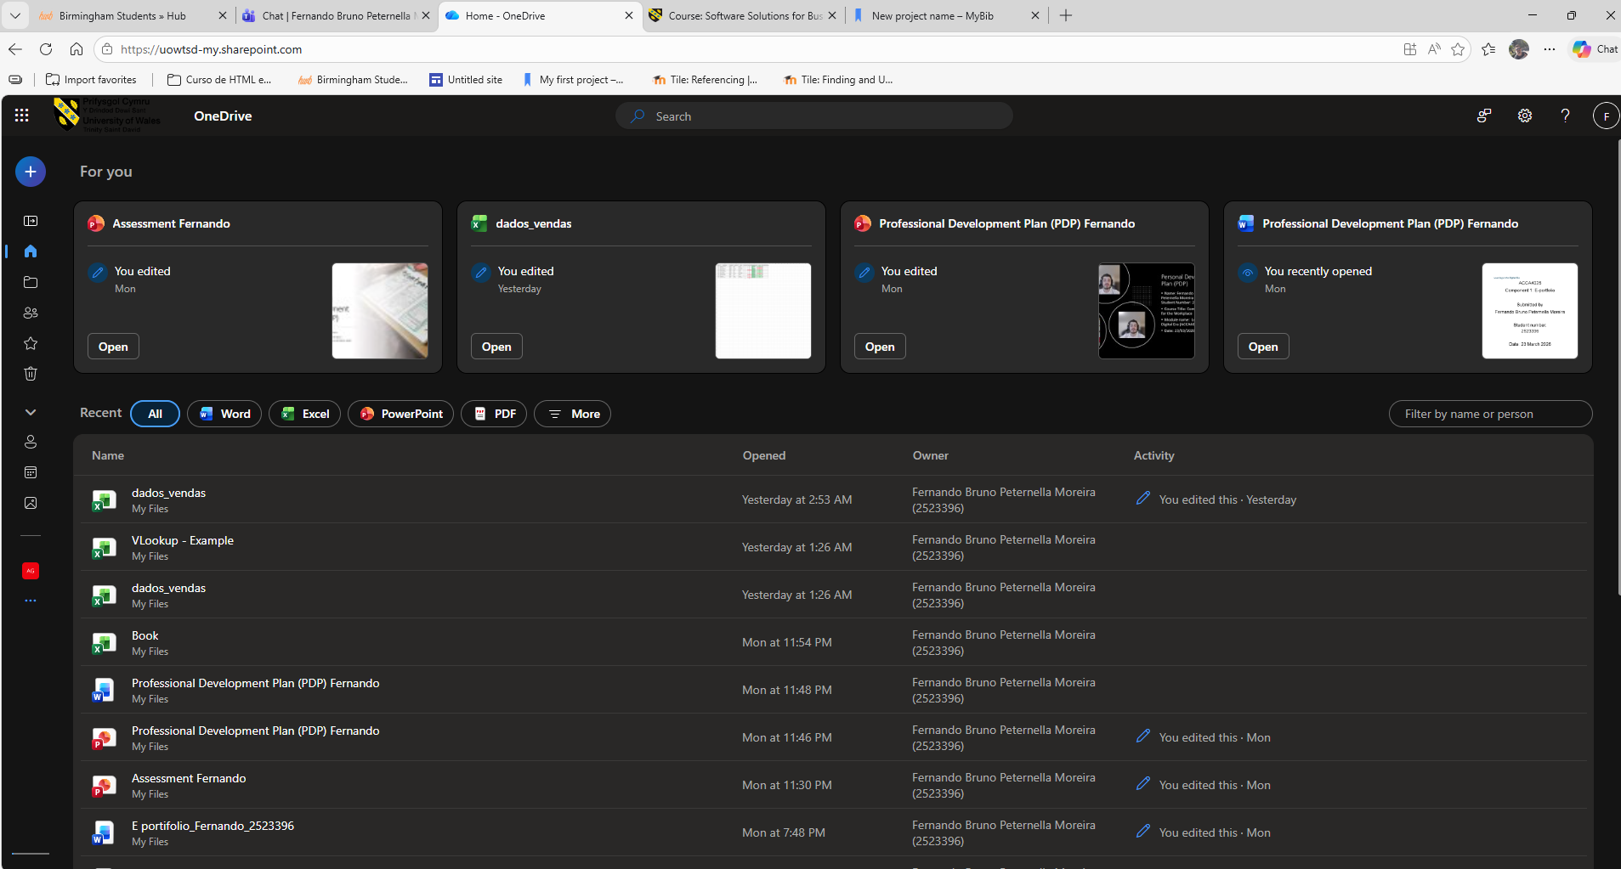
Screenshot 3: OneDrive home page with file visible, This shows the file ready to be shared in OneDrive.
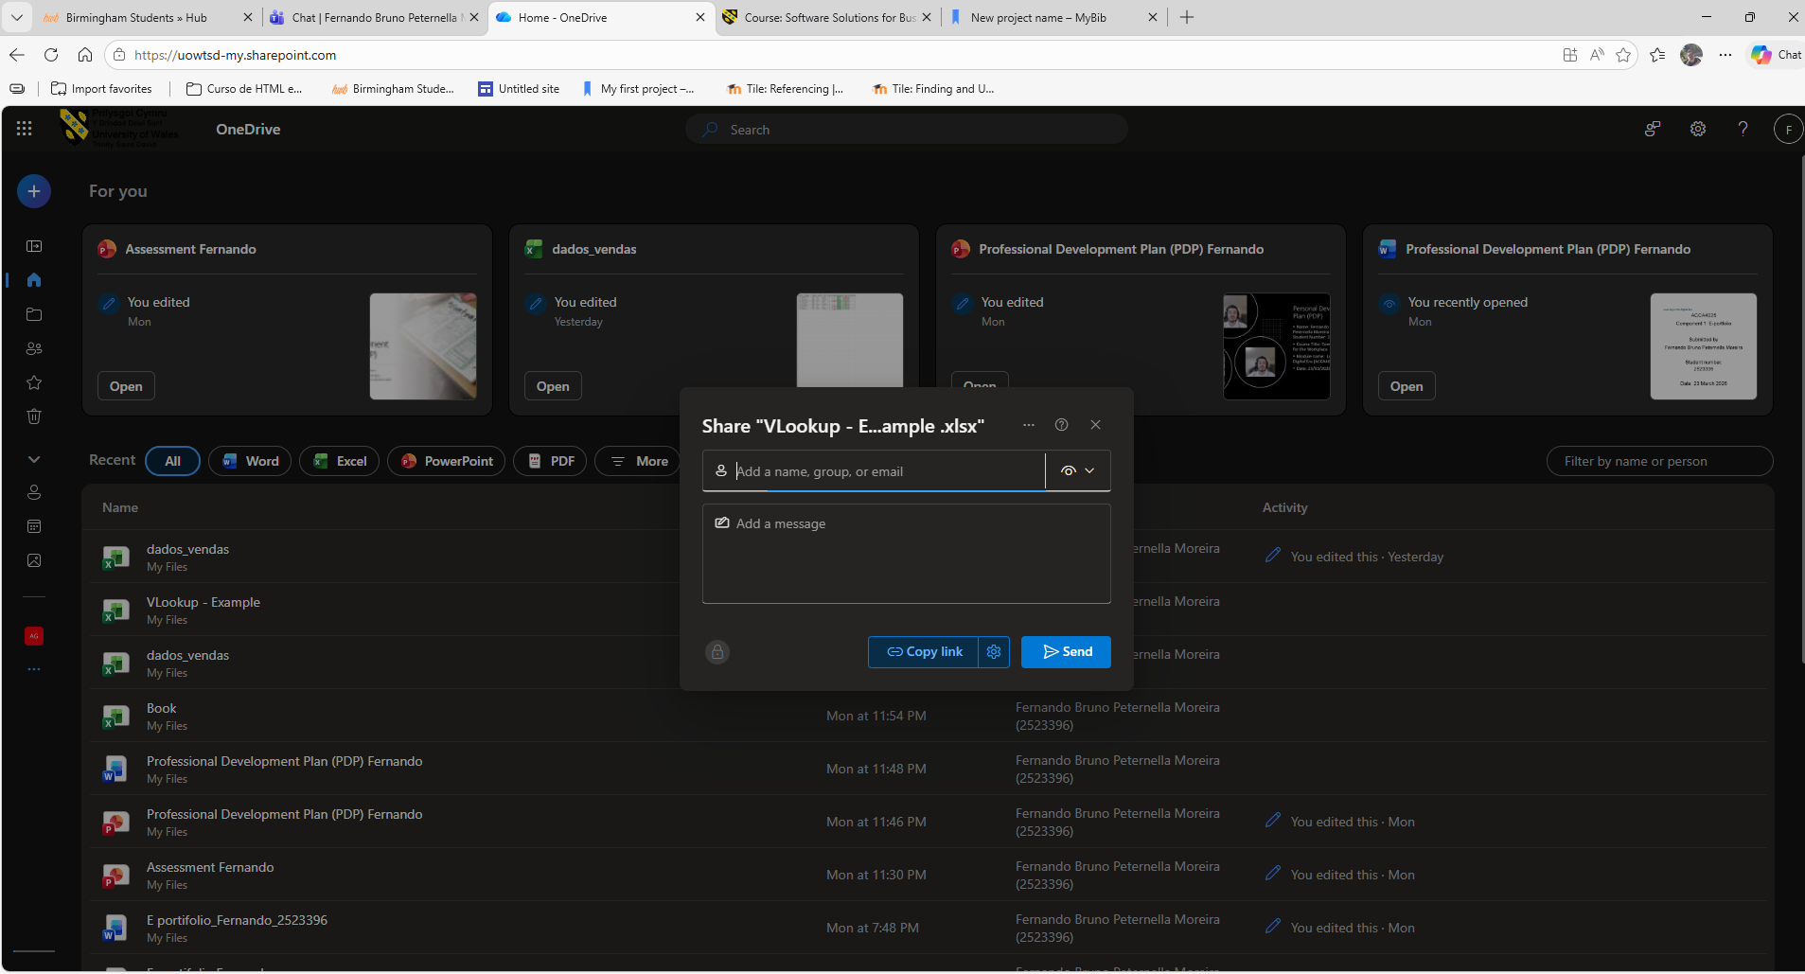
Screenshot 4: File selected and Share button, This shows the step before sharing the file.

Conclusion
To conclude, this assignment has shown that digital applications are a very important part of business. Different tools are used for different tasks, such as selling products online, organising ideas, creating documents, analysing data, and working with other people.

Overall, these applications help businesses work in a more organised, fast, and effective way. This is why digital tools are now an important part of daily business operations.

References
[1] Amazon, “Amazon Store,” About Amazon. [Online]. Available: https://www.aboutamazon.com/what-we-do/amazon-store. [Accessed: Mar. 25, 2026].
[2] Amazon, “Small Businesses,” About Amazon. [Online]. Available: https://www.aboutamazon.com/impact/small-businesses. [Accessed: Mar. 25, 2026].
[3] eBay, “How buying works on eBay,” eBay Help. [Online]. Available: https://www.ebay.com/help/buying/buy-now/buying-works?id=4002. [Accessed: Mar. 25, 2026].
[4] eBay Inc., “eBay Inc. Reports Fourth Quarter and Full Year 2025 Results,” Feb. 18, 2026. [Online]. Available: https://investors.ebayinc.com/investor-news/press-release-details/2026/eBay-Inc--Reports-Fourth-Quarter-and-Full-Year-2025-Results/default.aspx. [Accessed: Mar. 25, 2026].
[5] University of Portsmouth Library, “Mind maps,” University of Portsmouth Library. [Online]. Available: https://library.port.ac.uk/using-resources/guides-to-using-resources/information-library/choosing-keywords/mind-maps. [Accessed: Mar. 25, 2026].
[6] Oracle, “What Is ERP?,” Oracle United Kingdom. [Online]. Available: https://www.oracle.com/uk/erp/what-is-erp/. [Accessed: Mar. 25, 2026].
[7] K. T. Hanna, “Productivity software,” TechTarget, Aug. 12, 2022. [Online]. Available: https://www.techtarget.com/whatis/definition/productivity-software. [Accessed: Mar. 25, 2026].
[8] Microsoft, “Microsoft Word,” Microsoft 365. [Online]. Available: https://www.microsoft.com/en-gb/microsoft-365/word. [Accessed: Mar. 25, 2026].
[9] Microsoft, “Microsoft PowerPoint,” Microsoft 365. [Online]. Available: https://www.microsoft.com/en-gb/microsoft-365/powerpoint. [Accessed: Mar. 25, 2026].
[10] Microsoft, “Microsoft Excel,” Microsoft 365. [Online]. Available: https://www.microsoft.com/en-gb/microsoft-365/excel. [Accessed: Mar. 25, 2026].
[11] Microsoft, “Microsoft Access,” Microsoft 365. [Online]. Available: https://www.microsoft.com/en-gb/microsoft-365/access. [Accessed: Mar. 25, 2026].
[12] Microsoft, “Free Microsoft Teams,” Microsoft Teams. [Online]. Available: https://www.microsoft.com/en-gb/microsoft-teams/free. [Accessed: Mar. 25, 2026].
[13] Microsoft, “Microsoft OneDrive: AI-powered file storage and cloud sharing for work,” Microsoft 365. [Online]. Available: https://www.microsoft.com/en-gb/microsoft-365/onedrive/onedrive-for-business. [Accessed: Mar. 25, 2026].
[14] G. Bondanini, C. Giovanelli, N. Mucci, and G. Giorgi, “The Dual Impact of Digital Connectivity: Balancing Productivity and Well-Being in the Modern Workplace,” International Journal of Environmental Research and Public Health, vol. 22, no. 6, p. 845, 2025. [Online]. Available: https://www.mdpi.com/1660-4601/22/6/845. [Accessed: Mar. 25, 2026].
[15] Microsoft Support, “Collaborate in OneDrive,” Microsoft Support. [Online]. Available: https://support.microsoft.com/en-gb/office/collaborate-in-onedrive-d8a2a19a-e306-4ca5-9b00-19b0e96890d6. [Accessed: Mar. 25, 2026].
[16] Canvas, [Online]. Available. https://www.canva.com/graphs/mind-maps. [Accessed: Mar. 25, 2026].

