Building evaluation
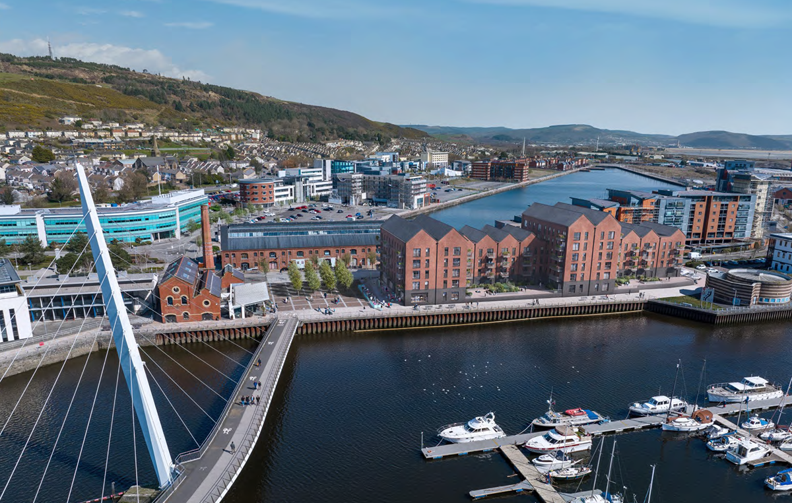
Daniel Griffiths ACBA5019
Contents
1. Introduction 2
2. Foundations 2
3. Frame 4
1. Cast in situ Reinforced Concrete Frame 4
2. Steel Frame and Precast Hollow Core Floor Planks 5
3. Location and Building envelope. 7
1. Location 7
2. Building Envelope 8
4.Prefabrication or off-site construction 9
5.Conclusion 10
References 11

Figure 1 BH208 (British Geological Survey, 1999) 3
Figure 2 steel framed building. 5
Figure 3 Precast hollow core planks 6
Figure 4 cavity wall construction for a steel framed building. 8
Figure 5 Volumetric construction 10

Introduction
This report will give the design of a medium to high rise building for student accommodation with a basement carpark, ground floor commercial unit and student union facility. The building’s exterior will be well matched to existing buildings in the area. The location of the proposed building is at Plot B3, Kings Road, Swansea, SA1.
The selection of the building’s foundation will be based upon the ground conditions from borehole logs and location of the building. The choice of the buildings frame will be based on fire safety, ease of assembly, the use of the commercial ground floor units and weather conditions.
The report will also look at on site construction and off-site construction, show the advantages and disadvantages for both options.
Finally, a conclusion will be given about the buildings design and material choices.

Foundations
Past ground investigations from sites near to Plot B3 Kings Road, show that the land was previously used as a rail yard and had a small warehouse built there. The land was once part of the Fabians Bay mud flats.
Research of borehole logs from the local area and historical research show the surface is of made ground, consisting of compacted stones, bricks, and ash. It also shows that the underlying strata consist of Sand, Clay, Peat, Sandy gravel and Boulders.
Due to a lack of bed rock and the proposed buildings hight of nine stories and basement car park, Friction pile foundations would be best suited for this building. Friction piles transfer the buildings load down, and then out to the sides of the piles and then into the surrounding strata making it an effective choice where there is no suitable bed rock.
Pile foundations are also a good choice due to the site’s location next to the River Tawe, as the depth of the piles should lower the Bulb of pressure on the river wall and surrounding buildings.
(Asbri Planning Ltd, 2023) (British Geological Survey, 1999) (designingbuildings.co.uk, 2022)

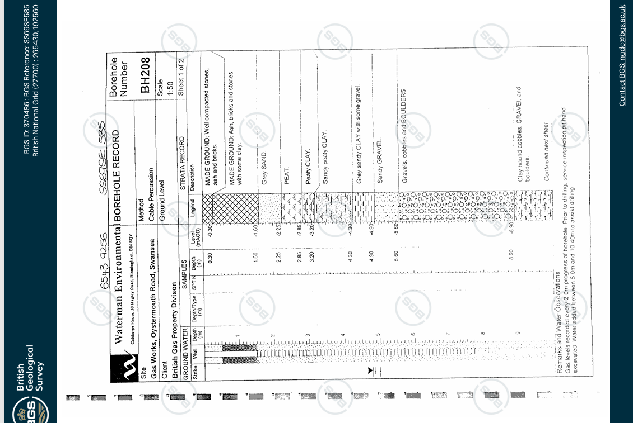
Figure 1 BH208 (British Geological Survey, 1999)

Frame
The design that has been selected for this building is a hybrid system consisting of a cast in situ Reinforced Concrete frame for the underground car park and a steel frame superstructure with precast hollow core floor planks, clad with hand laid bricks and then a timber pitched roof clad with slate.

Cast in situ Reinforced Concrete Frame
I have selected a cast in situ reinforced concrete frame for the underground car park for several reasons.
Due to the site’s proximity to the River Tawe, there is a high chance of ground water ingress into the underground car park. Cast in situ reinforced concrete offers good protection against ground water ingress into the underground car park, when combined with cast in situ mass concrete walls. There are also several tanking options to further aid in the prevention of ground water ingress. Some of the tanking options would be post applied membrane, liquid applied membrane and fully applied bonded systems to name a few. The selection of tanking system will be based upon ground conditions, water table levels and calculations from engineers.
Reinforced concrete Frames offer good protection against fire and are given the highest fire rating of A1 under EN 13501-1-1:2007 and A1:2009. Protection against fire is a major consideration when constructing any building. In this case there is an additional fire risk to the building, due to the underground carpark. Maintaining the building structural strength during a fire is a key reason why reinforced concrete has been chosen for the frame in this area of the building. A reinforced concrete building combine with mass concrete walls will also contain a fire within the underground carpark. This will stop it spreading to other parts of the building, if any openings between floors are sealed in the correct way to prevent fire traveling between floors.
The high compressive strength of concrete makes it a great choice to support the superstructure above the underground carpark. The compressive strength of the reinforced concrete frame will allow the transfer of the buildings mass down to the friction pile foundations with a low chance of failure.

(The Institution of Structural Engineers, 2002) (The Concrete Centre., n.d.) (Tevema, 2024) (NHBC-Standards , 2025)

Steel Frame and Precast Hollow Core Floor Planks
A steel frame has been selected for the superstructure of this building for several reasons.
The site only has a small amount of room to store materials and has poor access for HGVs. I have proposed a just-in-time delivery strategy for the steel frame components and the precast hollow core planks to be delivered to site. Using this method of delivery, materials only get delivered when they are required on site. Deliveries can be scheduled to avoid the busiest parts of the day; this will help prevent any traffic issues near the site.
(Lean Construction Institute , 2024)
The construction of steel framed buildings can be done efficiently and quickly. Steel frames can be manufactured to any shape, size and have predrilled holes within the web to allow any services to pass through without effecting the strength of the component. these attributes help reduce the cost of the build and cut down on wastage.
Steel frames can span greater distances between columns when compared with reinforced concrete framed buildings. The greater spans allow for more usable floor space and more flexibility for internal layouts. This will be a great advantage for commercial units on the ground floor of the building.
Steel framed buildings need to have additional Insulation and fireproofing. Insulation around the steel frame is essential, as steel conducts heat and cold very well. Poor insulation around the steel frame will lead to heat loss from the building. When insulating around the steel frame it is critical that the insulation is a non-combustible product. Non-combustible insulation such as mineral wool will help to protect the steel frame in the event of a fire. The steel frame can also be coated in intumescent paint that reacts to very high temperatures and expands, insulating the steel from the fire and will help prevent failure. Fire lining the steel frame with mineral boards that are made from calcium silicate offer good protection in the event of a fire.
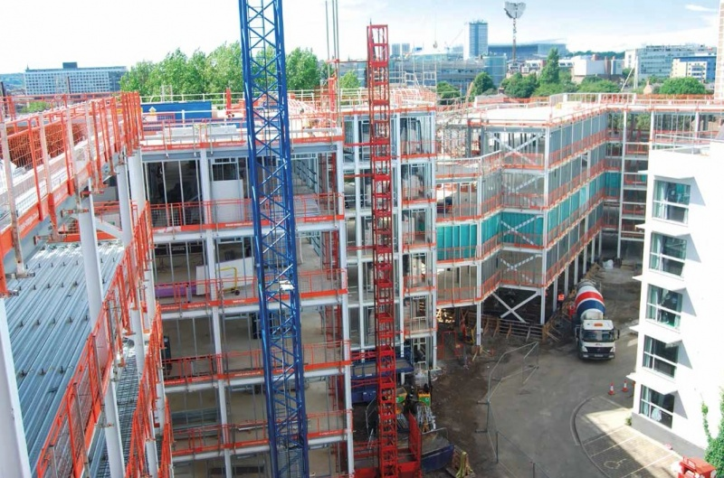
The buildings’ location near the sea will influence the specification and design of the steel frame. High winds coming from the sea will add additional load on to the building. Cross bracing within the steel frame will help the building resist the additional wind loading. The sea air can speed up the corrosion process due to a higher salt content. It would be advised that the steel frame is galvanised to help prevent against corrosion and all the steel frames be clad to offer an additional barrier against the weather.
Figure 2 steel framed building.

Precast, prestressed hollow core concrete floor planks or (Hollow core planks) are a fast and effective method of constructing floors within a steel framed building. The hollow core floor planks can either be installed within the steel frame or sit on top of the steel beams. The hollow core planks can span long distances with out the need for additional supports. There are lifting points installed within them to allow for easy and safe installation. The fire rating of up to two hours makes this a good choice for fire prevention.
Hollow core planks can help the thermal properties of the building as concrete can regulate temperatures. Additionally, insulation can be added to the hollow core planks during manufacturing. Another benefit of the hollow core planks are their acoustic properties, as they help absorb sound due to their density and air gaps. The hollow core of the precast planks can also function as service channels, saving time and money during construction as additional service trays will not be needed.
Once installed hollow core plans provide a safe working platform. This allows for the next level of the building to be added.

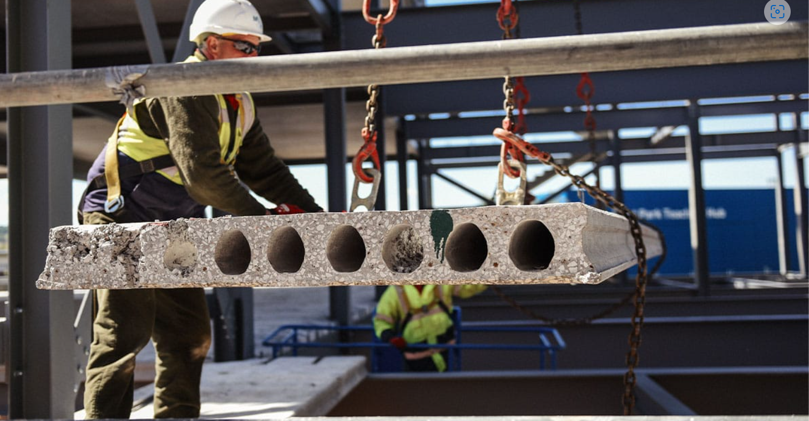
Figure 3 Precast hollow core planks

(SteelConstruction.info, n.d.) (HPD Consult, 2024) (Promat, 2018) (Rodriguez, 2022) (FLOORING, 2024)

Location and Building envelope.

Location
The site of the proposed building is in an historically important area of Swansea. The River Tawe and Swansea docks have played a major role in the development of Swansea into a City.
It is important that the building fits in with the original buildings that were once a part of Swansea Docks and the surrounding area. Many of the buildings near to this site are of red brick construction such as the J Shed opposite to the site. The J Shed was once formally part of Swansea docks.
I feel that the external facade should be constructed using red bricks like the ones used in the surrounding buildings.
The roofs of many of the former dock buildings have pitched roofs with a slate finish, such as the J shed opposite. Pitched roofs are more aesthetically pleasing than flat roofs and will also perform better during heavy rainfall, especially in an area such as Swansea witch has some of the highest rainfall in the UK.
The window openings can add character to the building. The arched brickwork lintels on the J Shed offer good character when coupled with the small individual pains of glass within the window.
The brick finish for the building will not only be aesthetically pleasing but will also be a good material to offer protection from the weather.
(Asbri Planning Ltd, 2023)

Building Envelope
The outer skin of facing brickwork will form the external part of the building’s cavity wall. The cavity would be around 50mm wide (assume) to stop any moisture penetrating the internal skin of the building. The external brick skin would be tied to the internal Metsec wall, via wall ties and tied to the steel frame head above and below on every floor. The wall ties will be manufactured from stainless steel to prevent corrosion. The wall ties connecting the external skin to the internal skin will have a drip bend to help prevent water tracking across to the inner skin.
The inner skin of the building will be constructed from a Metsec stud wall. The Metsec stud wall will be insulated with a mineral fibre batt insulation. The Metsec wall will be mechanically fixed to the steel frame.
The external face of the Metsec wall will be clad with a breather membrane and then clad with an A1 fire rated Calcium silicate board. The internal face will be clad with plaster board and then pattresed to create a 25mm service channel and then clad with plasterboard.
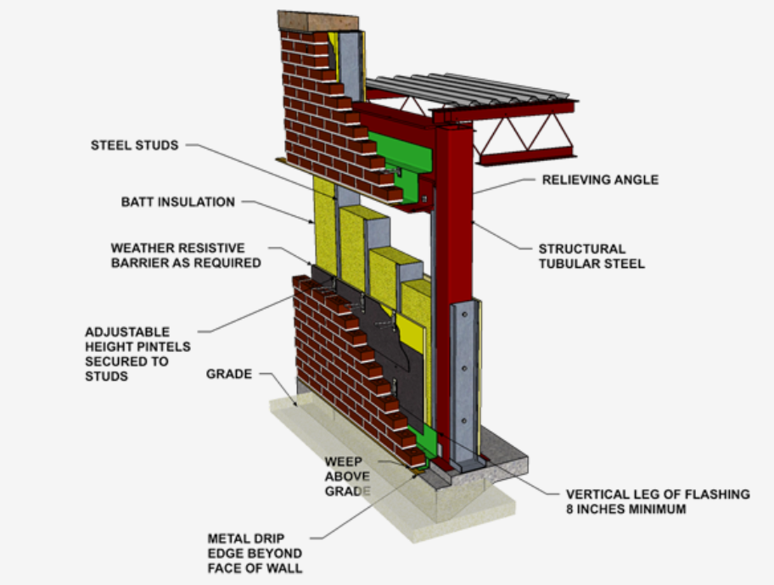
Cavity trays will be installed above and below every window and door along with weep vents to allow any moisture to be released from the cavity.
Figure 4 cavity wall construction for a steel framed building.

The roof chosen for the building will be pitched. The frame of the roof will be of timber construction and then clad with breathable membrane and slate covering. Timber has been chosen as the roof trusses can be manufactured off site and will be ready to be installed directly on to the building via crane. Timber roof trusses are strong and light weight and can be manufactured in many different forms to suit the buildings use. Internally the roof trusses will be insulated with a mineral wool, as this has good fireproof properties and then fire lined with plasterboard.
Slate has been selected so that roof will match many buildings with the area, its weatherproof properties, and its lifespan.
(Sps Enviro wall , 2025) (Mason contractors association of America, 2025) (NHBC Standards 2020 6.1.17 DPCs and Cavity trays, 2020) (Rockwool, 2023)

4.Prefabrication or off-site construction
As previously mentioned, the steel frame of the building will be manufactured off site to the required dimensions and shapes. The steel frame can have precut holes to allow services to pass through the web of the steel.
The hollow core floor planks will be manufactured off site ready to be directly installed within the buildings steel frame.
Another option for this build could have been Volumetric construction. Volumetric construction is a three-dimensional unit that have either timber, steel or concrete frames and are constructed within a factory. Volumetric units can either be structural or non-structural. These units can come with external cladding, windows, doors, and internal linings preinstalled in the factory. There is also the possibility of having bathrooms and kitchens preinstalled.
Volumetric construction can have many advantages such as reduced site labour requirements, less material wastage, and speed of construction. These advantages combine to improve the quality of the building and save money.
Some of the disadvantages could be transportation to site, the volumetric units can be quite large and need to have specialist transport or must be delivered outside of normal site working hours. Weather conditions can have an effect as increased wind speed could prevent the volumetric units being lifted into position.
The reasons why this method was not chosen are limited site access, limited designs, and a dependency on technology.

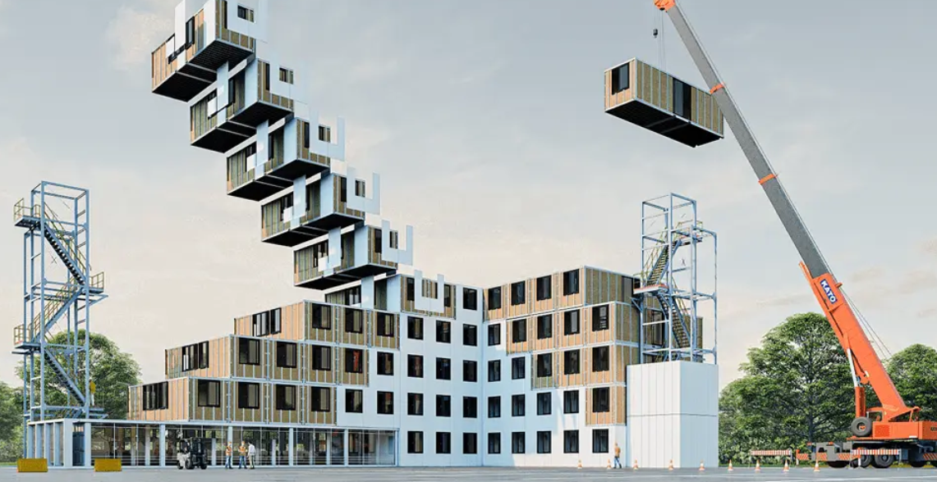
Figure 5 Volumetric construction
(The Constructor, 2021) (Volumetric, 2024)

5.Conclusion
In conclusion, the red brick façade and traditional slate pitched roof makes this building a fitting traditional design to blend in with the surrounding area making it an inviting place to live.
The friction pile foundations, will ensure the stability of the building in the poor ground conditions combined with the hybrid design of a reinforced concrete basement and steel framed superstructure, give this building a robust high strength and flexible design that is well suited for the environmental challenges it faces.
Furthermore, the choice and combination of materials used for this building will help contain fires within an area of a building, making it a safe place for the occupants.

References
Asbri Planning Ltd. (2023). Plot B3, Kings Road, Swansea. DESIGN AND ACCESS STATEMENT. Swansea: Asbri Planning Ltd. Retrieved from file:///C:/Users/dangr/OneDrive/Documents/Construction%20Technolgy%202/2023_2018_RES-PART_1_-_DESIGN___ACCESS_STATEMENT-1579106.pdf
British Geological Survey. (1999). BGD ID: 370486 : BGS Reference: SS69SE585. Swansea.
designingbuildings.co.uk. (2022, November 23). Friction Piles . Retrieved from designingbuildings.co.uk: https://www.designingbuildings.co.uk/wiki/Friction_piles
FLOORING. (2024). Retrieved from fpmccann.co.uk: https://fpmccann.co.uk/uk/flooring/
HPD Consult. (2024, September 12). What is Steel Frame Construction? Retrieved from www.hpdconsult.com: https://www.hpdconsult.com/what-is-steel-frame-construction/#:~:text=Steel%20frame%20construction%20refers%20to%20the%20use%20of,wood%20or%20concrete%20as%20the%20primary%20structural%20material.
Lean Construction Institute . (2024). Lean topics - Just-in- time . Retrieved from leanconstruction.org: https://leanconstruction.org/lean-topics/just-in-time/
Mason contractors association of America. (2025). Cavity Wall: Brick Veneer/Steel Stud. Retrieved from masoncontractors.org: https://masoncontractors.org/systems/cavity-wall-brick-veneer-steel-stud/#newsletter
NHBC Standards 2020 6.1.17 DPCs and Cavity trays. (2020). Retrieved from https://nhbc-standards.co.uk/2020/: https://nhbc-standards.co.uk/2020/6-superstructure-excluding-roofs/6-1-external-masonry-walls/6-1-17-dpcs-and-cavity-trays/
Promat. (2018, 7 26). Deciding what type of fire protection to use with steel structures. Retrieved from www.promat.com: https://www.promat.com/en/construction/your-project/expert-area/39721/deciding-what-type-of-fire-protection-to-use-with-steel-structures/#:~:text=Fire%20protection%20of%20steel%20structures%20is%20best%20considered,paint%2C%20fire%20stopping%20boards%20or
Rockwool. (2023, September 1). twin roll. Retrieved from rockwool.com: https://www.rockwool.com/uk/products-and-applications/product-overview/roll-products/twin-roll-en-gb/
Rodriguez, B. (2022, March 24). The Effects Of Saltwater On Metals. Retrieved from sciencing.com: https://www.sciencing.com/effects-saltwater-metals-8632636/#:~:text=Saltwater%20corrodes%20metal%20five%20times%20faster%20than%20fresh,consumes%20iron%20and%20their%20excretions%20turn%20to%20rust.
Sps Enviro wall . (2025). Shop -Y wal. Retrieved from spsenvirowall.co.uk: https://spsenvirowall.co.uk/product/y-wall-building-board/
SteelConstruction.info. (n.d.). Framing schematics. Retrieved from SteelConstruction.info: https://steelconstruction.info/Framing_schematics
Tevema. (2024, May 6). Is concrete good in tension or compression. Retrieved from www.tevema.com: https://www.tevema.com/is-concrete-good-in-tension-or-compression/#:~:text=Concrete%20is%20widely%20recognized%20for,acting%20upon%20it%20are%20compressive.
The Concrete Centre. (n.d.). What is concrete -Fire . Retrieved from sustainableconcrete.org.uk: https://sustainableconcrete.org.uk/Sustainable-Concrete/Sustainable-Concrete/Fire#:~:text=Concrete%20performs%20very%20well%20in%20a%20fire.%20It,of%20fire%20and%20protecting%20both%20lives%20and%20property.
The Constructor. (2021). What is off site construction? Retrieved from theconstructor.org/: https://theconstructor.org/building/offsite-construction-features-methods/38319/#:~:text=In%20volumetric%20construction,%20three-dimensional
The Institution of Structural Engineers. (2002). Design recommendations for multi-storey and underground car parks THIRD EDITION. London: The Institution of Structural Engineers.
Volumetric. (2024). Projects . Retrieved from www.volumetric.co.uk: https://www.volumetric.co.uk/projects

