

BMHP6021 | Health Wellbeing and Sustainable Development




Name | Aidah Becky Namuli
Student Number | 1912621
Lecturer | Diola Bijlhout
Submission Date | 08-SEPTEMBER-2022


Table of Contents
BMHP6021 1
Health Wellbeing and Sustainable Development 1
Introduction 3
1.0 Briefly discuss of the 17 Sustainable Development Goals 4
1.1 A detailed discussion of the 3 SDGs: Goal 3, Goal 4, and Goal 17 5
1.2 Introduction of identified city: London and its difference and current situation. 6
1:2.0 UN Sustainable Development Goals and London's progress 7
1:2.1 Mental Health Issue 7
1:2.2 Education in Greater London 8
UK policies and initiatives identified to meet the 3 SDGs 10
REFERENCE 11

Introduction

This assignment critically explores the current health, well-being, and sustainable development situation within the present health care sectors in the UK.
This assignment’s main aim is briefly to discuss the 17 sustainable development goals (SDGs) and outline the three goals: Goal 3, Good health, and well-being; Goal 4, Quality Education and Goal 17, Global Partnership (SDGs) to accomplish the goals of the selected city of London. Furthermore, the UK policies and initiatives have been lightened to meet the three identified SDGs.
The local policies of London have been considered to meet the three identified SDGs to narrow down the research. Once the policies are identified, current city (London) status is evaluated for the implementation of SDGs and their benefits. It also presents the extent to which these policies’ implementation progress. In the concluding part of the assignment, recommendations are given for the improvement of policies in meeting the SDGs.

1.0 Briefly discuss of the 17 Sustainable Development Goals
Sustainable Development: is a universal call to action to end poverty and protect the planet by 2030. They are also known as the Global Goals since they were adopted by the UN in 2015. As actions in one area influence outcomes in others, the 17 SDGs balance social, economic, and environmental sustainability. Besides, progress for the poorest has been focused on in several countries. SDGs will eliminate poverty, hunger, AIDS, and gender discrimination. Therefore, to achieve the Sustainable Development Goals, society must contribute creativity, knowledge, technology, and financial resources (UNDP, 2015).
The Sustainable Development Goals aim to promote prosperity while protecting the environment and should be achieved by all countries - rich, poor, and middle-income (United Nations, 2018). In total, there are 17 sustainable development goals (SDGs), and they are as follows:
- All forms of poverty must be eradicated worldwide.
- It is imperative to eradicate hunger, improve nutrition, achieve food security, and encourage sustainable agriculture.
- Having sound health and well-being are encouraged
- Promoting long-term learning and providing fair and quality education.
- Achieve gender equality and eliminate gender biases.
- Ensure that sanitation and water are available to all as well as sustainable management
- Eliminate gender biases and provide equal rights and leave no one behind.
- Assuring a clean and safe water supply and sanitation system. Ensure sanitation and water are accessible to all through sustainable management.
- Ensure that all people have access to affordable, reliable, and sustainable energy.
- The creation of decent jobs and the growth of the economy
- Develop robust infrastructure, promote sustainable industrialization, and encourage innovation.
- Reduction in inequalities among and within all countries
- Ensure the sustainability, resilience, and safety of the communities and cities.
- By controlling emissions and managing renewable energy, we can combat climate change and its effects.
- Utilize resources sustainably to improve and save life below water.
- Responsible management and production of consumption and production are essential.
- Establish institutions that are inclusive and accountable as well as provide justice and peace for society.

1.1 A detailed discussion of the 3 SDGs: Goal 3, Goal 4, and Goal 17

The 3SDG Goals 3, 4, and 17 combined are part of the transformation 2030 Agenda.
At the core of what UN resolves, SDG Goal 3 was established by the organization to ensure that every individual, no matter what their age, is healthy and happy, additionally to reduce maternal mortality rates, the associated targets aim to end preventable deaths in new-borns and children, end epidemics of AIDS, tuberculosis, malaria, and other communicable diseases; halt the spread of noncommunicable diseases; combat substance abuse; halve road traffic accident deaths and injuries; achieve universal health coverage, reduce deaths and illnesses caused by hazardous chemicals and pollution, and ensure universal access to reproductive health care services (United Nations, 2015).
Additionally, fourth goal is quality education, which emphasizes equity, inclusion, and long-term learning. Using specific targets can help measure sustainable development in education (Webb et al., 2017).
SDG Goal 4 aims to provide lifelong learning opportunities for all with equitable primary and secondary education to all children, resulting in significant learning gains. Furthermore, it encourages all countries to enhance and improve their education systems, reversing previous universal educational goals; besides, self-respect begins with education which liberates the intellect and unlocks the imagination. We can all contribute to a progressive, prosperous society by learning this key (Global Goals, 2022).

According to United Nations (2021), SDG Goal 17 aims to “Strengthen the means of implementation and revitalize the Global Partnership for Sustainable Development”. As part of the 2030 agenda, SDG17 can be achieved by collaboration between stakeholders is crucial to achieving this objective since it allows stakeholders to share their expertise, technology, and funds. Developing global partnerships for sustainable development is essential if developing countries are assisted in achieving their sustainable development targets in the long run (Desai et al., 2018).
According to UNDP (2020), $5 trillion in investments are required annually to achieve the Sustainable Development Goals. The amount of development assistance provided in 2017 was estimated to be 147.2 billion dollars. In the same year, international remittances contributed approximately US 613 billion to developing countries but on the map of global progress, there are still some significant challenges to be addressed.

1.2 Introduction of identified city: London and its difference and current situation.
According to Carroll, (2018) defines the difference between the City of London and Greater London, as London being the capital of the United Kingdom, it occupies an area of 607 square miles, making it the largest city in the country. He states that besides the City of London, there are 32 other boroughs that are included in this area. Therefore, the governing body for London, the Greater London Authority (GLA) is responsible for overseeing the city of currently nine million and a half people; this includes the City of London being part of this body, and it is based at City Hall in London. There is a leadership team that is led by Sadiq Khan, the Mayor of London. Meanwhile the City of London has its own government, mayor, and police force independent of Greater London and the Greater London Authority.
London has the highest population among all United Kingdom cities due to the higher number of workers, local inhabitants, visitors, and students. Residents of central London also differ demographically from those of the rest of the city. There are significantly more single-person households, short-term residents, and people in their 20s and 30s living in the Central Activities Zone (the CAZ – roughly the West End, City of London, South Bank and Canary Wharf – and their immediate surroundings) than the London average in the Central Activities Zone (Gidda, 2020).
Although, cities tend to have a better health care system, a better job market, and a better education system, they additionally face a variety of factors that contribute to mental health problems; this may pose a particularly stressful situation to some people living in London, as well as being exposed to risk aspects such as poverty, social isolation, reduced leisure time, noise pollution, overcrowding, and traffic congestion, which may add to their vulnerability (Leppänen, 2019).
Heaviside et al. (2017) discuss chronic illness as closely associated with various physical and mental disorders that are more prevalent in densely populated and urbanized areas. The Health and Social Care Act of (2012) was enacted to improve the health care system and the lives of the people. Its main purpose is to determine the health and well-being of the inhabitants and then provide a strategy for improvement. However, the increasing population surges the complexities
According to Johnsen and Jones (2015), the number of rough sleepers in London is the sixth highest in the whole of the country. There is a higher rate of crime, drug abuse, and substance abuse among the homeless population. In addition to addressing the problems caused by these individuals, it is the responsibility of the locals as well. The number of health issues such as depression has been on the rise over the last few years.

1:2.0 UN Sustainable Development Goals and London's progress
The London Sustainable Development Corporation (LSDC) measures London's progress towards the Sustainable Development Goals (SDGs) by gaining an understanding of the city's social, economic, and environmental health. As a first step towards defining the methods by which London can quantify its state of wellbeing as well as reducing inequality, work in partnership, and include local communities in local decision-making processes with the Younger Londoners at the forefront (Greater London Authority, 2018a).
In accordance with the Sustainable Development Goals, London should recover in a fair and sustainable manner whereby health care, housing, jobs, the environment, and many other issues can be addressed collaboratively by decision-makers and Younger Londoners
after opinions gathered and a report was made (Greater London Authority, 2018b).
According to a survey conducted by 2002 participants between the ages of 16 and 24 in London, Young Londoners identified amongst concerns such as pollution, knife crimes, most relevant social and environmental issues (Greater London Authority, 2018c).

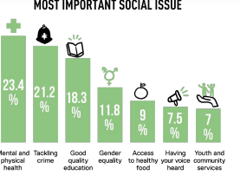
(table 1- most important social issue)

1:2.1 Mental Health Issue
It is the mayor’s goal to end the stigma surrounding mental illness by making Londoners feel comfortable discussing mental health concerns. Schools should support children's mental health and wellbeing. For them to be successful in the future, they need to be prepared to reduce suicide rates in the city and hopes to work with people and organizations throughout the city. The mayor has also set a goal of training more young people in mental health first aid informed approaches, (Greater London Authority, 2018d). Tackling crimes in London is another agenda the Mayor of London has implement as London saw 25 teenage deaths in the first nine months of 2021. In last year's homicide statistics, there were two fewer teenage murders in year 2020, which is almost double the number of 2008's homicides (Greater London Authority, 2021).

1:2.2 Education in Greater London
Education is one of the SDG goals 4 of 2030 agenda which is promoted by United Nations. Its main aim is to maximise the provision of quality education that is inclusive and equitable to all and the promotion of lifelong learning opportunities (United Nations, 2021a).
There are four parts to the UK educational system: primary education, secondary education, further education, and higher education. Primary and secondary schools are required in the UK for children between the ages of five and 16 (Bright World, 2019).
A total of 471,659 15–19-year-olds lived in London in 2011 - 5.8% of the nation's population. 10–19-year-olds make up 6.3 percent of the nation's population. By 2032, London's 16-18-year-old population will increase from 283,100 to 323,600 as shown in figures 1 and 2 respectively. 16 and 17-year-olds are concentrated in certain wards in specific boroughs, including Havering, Enfield, Croydon, Sutton, and Hillingdon (London Councils, 2014)
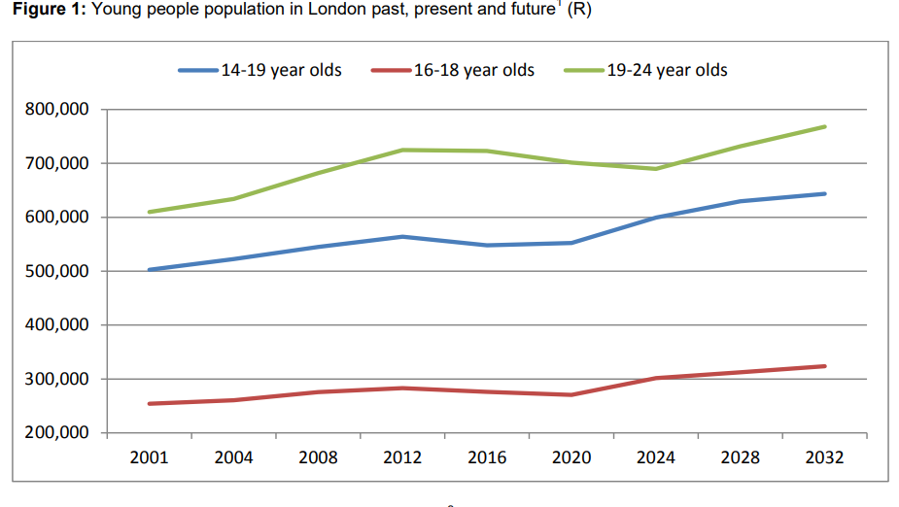
(Table 1-young people population in London)
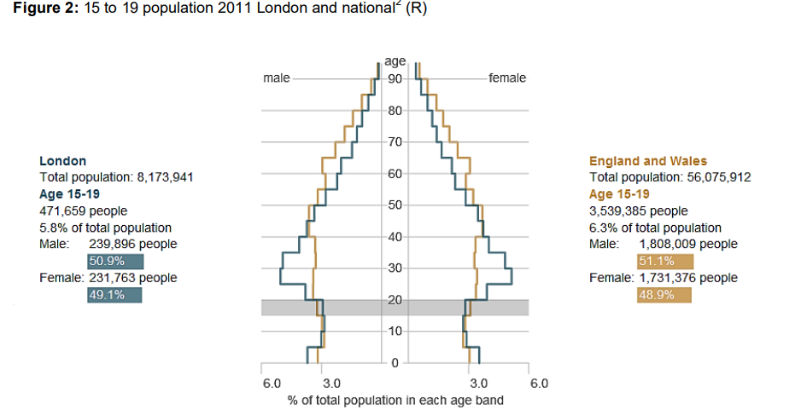
(Table 2: 15-19 population 2011
1:2.3 Rising inequality in education among Younger Londoners

The Mayor of London, Sadiq Khan, has been asked by the London Assembly's Education Committee to support and promote the development of an educational system which is more inclusive. This will address the disparity between those who have access to education and those who do not (Greater London Authority, 2020b).
Students from low-income backgrounds do not have access to free school meals because of their circumstances. This educational inequality also has an impact on the economic and societal advantage of a country. It is well known that families of low income have a higher risk of poverty and social mobility due to a lack of access to primary early education (Ainscow, 2016)
Free school meals (FSM) can be used as an indicator of poverty for around one fifth of the students in London. Those eligible for FSM do slightly better than their non-eligible counterparts, according to research. To close the gap between underprivileged students and those from privileged backgrounds, it is urgent to reduce the disparity between them (Greater London Authority, 2020a)

UK policies and initiatives identified to meet the 3 SDGs

The United Kingdom is highly committed to achieving the 17 Sustainable Development Goals as it ensures that these goals into the systems and planning of all the departments working with the UK government.

REFERENCE
Ainscow, M. (2016). Collaboration as a Strategy for Promoting Equity in education: Possibilities and Barriers. Journal of Professional Capital and Community, 1(2), pp.159–172. doi:10.1108/jpcc-12-2015-0013.
Barker, K. (2016). Why are some boroughs missing out from London’s education success story? Trust for London. Available at: https://www.trustforlondon.org.uk/news/londons-education-success-story-why-some-boroughs-are-missing-out/ (Accessed 17 Jul. 2022).
Bright World (2019). The British Education System | Bright World. www.brightworldguardianships.com. Available at: https://www.brightworldguardianships.com/en/guardianship/british-education-system/ (Accessed 21 Aug. 2022).
Carroll, R. (2018). What’s the Difference between London and the City of London? Culture Trip. Available at: https://theculturetrip.com/europe/united-kingdom/england/london/articles/whats-the-difference-between-london-and-the-city-of-london/ (Accessed 11 Aug. 2022).
Children's Commissioner (2019). Almost One in Five Children Left Education at 18 Last Year without Basic Qualifications. The Children’s Commissioner’s Office. Available at: https://www.childrenscommissioner.gov.uk/2019/09/20/almost-one-in-five-children-left-education-at-18-last-year-without-basic-qualifications (Accessed 21 Aug. 2022).
Desai, R.M., Hiroshi Katō, (Researcher, Kharas, H.J., Mcarthur, J.W. and Brookings Institution (2018). From summits to solutions: innovations in implementing the Sustainable Development Goals. Washington, D.C.: Brookings Institution Press.
Gidda (2020). Seven challenges facing central London. (online) www.centreforlondon.org. Available at: https://www.centreforlondon.org/blog/challenges-facing-central-london/ (Accessed 23 Jul. 2022).
Global Goals (2022). Goal 4: Quality education. (online) The Global Goals. Available at: https://www.globalgoals.org/goals/4-quality-education/(Accessed 13 Aug. 2022).
Greater London Authority (2018a). Our current work and priorities. [online] London City Hall. Available at: https://www.london.gov.uk/about-us/organisations-we-work/london-sustainable-development-commission/our-current-work-and-priorities (Accessed 18 Aug. 2022).
Greater London Authority (2018b). Our Work on the UN Sustainable Development Goals. [online] London City Hall. Available at: https://www.london.gov.uk/about-us/organisations-we-work/london-sustainable-development-commission/our-current-work-and-priorities/our-work-un-sustainable-development-goals (Accessed 12 Aug. 2022).
Greater London Authority (2018c). Our Work on the UN Sustainable Development Goals. [online] London City Hall. Available at: https://www.london.gov.uk/about-us/organisations-we-work/london-sustainable-development-commission/our-current-work-and-priorities/our-work-un-sustainable-development-goals (Accessed 12 Aug. 2022).
Greater London Authority (2018d). The London Health Inequalities Strategy. [online] The London Health Inequalities Strategy. Available at: https://www.london.gov.uk/sites/default/files/health_strategy_2018_low_ [Accessed 19 Aug. 2022].
Greater London Authority (2020a). Mind the Gap: Rising Educational Inequality for Young Londoners. (online) London City Hall. Available at: https://www.london.gov.uk/about-us/london-assembly/london-assembly-publications/mind-gap-rising-educational-inequality-young-londoners (Accessed 22 Aug. 2022).
Greater London Authority (2020b). Mind the Gap: Rising Educational Inequality for Young Londoners. [online] London City Hall. Available at: https://www.london.gov.uk/about-us/london-assembly/london-assembly-publications/mind-gap-rising-educational-inequality-young-londoners (Accessed 22 Aug. 2022).
Greater London Authority (2021). Approaches to Tackling Violent Crime in London. [online] London City Hall. Available at: https://www.london.gov.uk/press-releases/assembly/approaches-to-tackling-violent-crime-in-london [Accessed 20 Aug. 2022].
Hák, T., Janoušková, S. and Moldan, B. (2016). Sustainable Development Goals: A need for relevant indicators. Ecological Indicators, 60, pp.565–573. doi:10.1016/j.ecolind.2015.08.003.
Johnsen, S. and Jones, A. (2015). The Reconnection of Rough Sleepers within the UK: an Evaluation. (online) Available at: https://www.crisis.org.uk/media/237144/the_reconnection_of_rough_sleepers_within_the_uk_an-_evaluation_2015.pdf (Accessed 2 Aug. 2022).
Leppänen, A. (2019). Poor mental health is more likely to hit Londoners. What is being done about it? [online] www.centreforlondon.org. Available at: https://www.centreforlondon.org/blog/mental-health/ [Accessed 4 Aug. 2022].
London Councils (2014). Young People in London: an Evidence Base. [online] p.6. Available at: https://www.londoncouncils.gov.uk/node/3917 [Accessed 21 Aug. 2022].
Melvin, A. (2016). Journal of Professional Capital and Community. Collaboration as a strategy for promoting equity in education: possibilities and barriers, [online] 1(2), pp.159–175. doi:https://doi.org/10.1108/JPCC-12-2015-0013.
UNDP (2015a). Sustainable Development Goals. [online] Sustainable Development Goals. Available at: https://www.undp.org/sustainable-development-goals [Accessed 30 Jul. 2022].
UNDP (2015b). Sustainable Development Goals. [online] Sustainable Development Goals. Available at: https://www.undp.org/sustainable-development-goals [Accessed 30 Jul. 2022].
United Nations (2015a). Health and population | Department of Economic and Social Affairs. [online] sdgs.un.org. Available at: https://sdgs.un.org/topics/health-and-population.
United Nations (2015b). Transforming Our World: the 2030 Agenda for Sustainable Development | Department of Economic and Social Affairs. [online] United Nations. Available at: https://sdgs.un.org/2030agenda [Accessed 9 Aug. 2022].
United Nations (2015c). Transforming Our World: the 2030 Agenda for Sustainable Development | Department of Economic and Social Affairs. [online] United Nations. Available at: https://sdgs.un.org/2030agenda [Accessed 9 Aug. 2022].
United Nations (2021a). Goal 4 | Department of Economic and Social Affairs. [online] sdgs.un.org. Available at: https://sdgs.un.org/goals/goal4 [Accessed 19 Aug. 2022].
United Nations (2021b). Goal 17 | Department of Economic and Social Affairs. [online] sdgs.un.org. Available at: https://sdgs.un.org/goals/goal17 [Accessed 12 Aug. 2022].
United Nations (2022). Sustainable Development Goals-3 Good Health and Well-being. [online] United Nations. Available at: https://unric.org/en/sdg-3/ [Accessed 10 Aug. 2022].
United Nations Western Europe. (2022). Sustainable Development Goals (SDG 3). [online] Available at: https://unric.org/en/sdg-3/ [Accessed 11 Aug. 2022].
Webb, S., Holford, J., Hodge, S., Milana, M. and Waller, R. (2017). Lifelong learning for quality education: exploring the neglected aspect of sustainable development goal 4. International Journal of Lifelong Education, 36(5), pp.509–511. doi:10.1080/02601370.2017.1398489.

