How employment relations have been affected at my organisation as a result of the recent global pandemic of COVID 19.

Like other NHS organisations, Hywel Dda Health University Health Board has been through rapid change during the last two years as a result of the pandemic (Marlow et al, 2020). With the NHS already experiencing a shortage of staff prior to the pandemic, staff have been working in an intense and high-pressured environment over the last two years (King’s Fund, 2021).

Understanding staff experiences
In 2021, Hywel Dda University Health Board commissioned a Discovery report to capture staff experiences of working during the pandemic (Hywel Dda Health Board, 2021). The report highlighted a number of key areas that could potentially impact on employment relations:

- A major change for many employees has been the move to work from home. Whilst the ability to work from home has been transformational in many respects, one of the themes highlighted in the Discovery Report was the impact of this in terms of the sense of isolation, frustration and vulnerability that staff experienced. Engagement between management and employees is critical to fostering good employee relations (CIPD, 2021). In the report, it was acknowledged that,

‘attention may need to be given to building up teams to develop a trusting and compassionate environment’ (p5) and ‘the relationship between management and frontline staff could also do with some TLC so that there is an understanding and appreciation of all roles’ (p8).

One of the key actions that the Health Board needs to take to address this is to ensure that leaders must role model expected behaviours to help develop a positive working environment for staff (p12).

- The report acknowledges that staff have demonstrated their commitment, often going above and beyond to the detriment of their own health and personal life, to ensure that patients received the care that they needed (p1). The Good Work Index (CIPD, 2021, p5) shows that employees are experiencing stress, poor wellbeing and heavy workloads, all of which will impact on positive employee relations.

The Health Board is committed to supporting employees to rest, recover and recuperate. One of the aims of the Discovery Report was to understand what is important to employees to inform a ‘thank you offering’ (p1).

- The results of the European Company Survey led researchers to conclude that encouraging trust and freedom to act were highly important for the employee – employer relationship (Webber, 2021).

In the Discovery report, the Health Board has considered feedback from staff in terms of the enhanced trust the pandemic afforded them in terms of decision-making (p13):

‘Staff equally valued the fact that they were trusted to get on with their jobs and decisions were made quickly.’

‘The Health Board may wish to consider how we build on the command structure to inform autonomy and trust going forward which enables immediate decision-making and empowers people to make collective decisions in a safe space.’

‘If you can trust us during a pandemic, in the highest risk environment, then continue to trust us when things are ‘normal’.

Communication
One of the key factors to securing positive employment relations is clear and transparent communication (Management Study Guide, n.d.).

Very early on in the pandemic, the Health Board issued guidance to staff regarding COVID-19, including a list of Frequently Asked Questions (Evidence 1). This has continued throughout the pandemic, ensuring that all staff have access to consistent information at the same time.

In addition, the Chief Executive of the Health Board has published numerous and regular video updates, always thanking staff for their efforts and sharing upcoming plans for any changes in service delivery (Evidence 2).

Sickness
Some symptoms of COVID-19 can last for weeks or months after infection, known as Long-COVID. Whilst employers must apply the usual sickness rules to individuals with Long-COVID (Acas, n.d.), The NHS have agreed a temporary extension of sick pay paid at full pay for a maximum of one year, regardless of length of service or previous absences (NHS Confederation (November 2021).

Whilst this may benefit employment relationships, there is also a potential risk that these arrangements may also create feelings of unfairness amongst those with other long-term illnesses or conditions, such as cancer, who do not receive the same discretion.

Recruitment
Following the WHO announcement that COVID-19 had been declared a global pandemic, the Health Board initiated a mass recruitment exercise for Nursing and Facilities staff to ensure that the Health Board could meet the additional anticipated service demand.

As a result of this exercise, an additional 929 staff were employed on fixed term contracts (Hywel Dda University Health Board, 2020, p1) to cover what was initially perceived to be on a short-term basis. As we approach two years since their initial appointment, the Health Board will need to consider how these contracts are managed as if employed for more than two years, these employees will have the right to make an unfair dismissal claim when their employment ends (CIPD, 2021b).

Evidence List
Evidence 1 – screenshot of Global Email, March 2020.
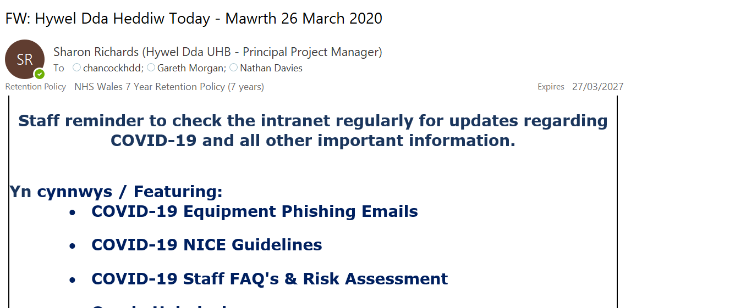

Evidence 2 – Screenshot of Global Email, September 2021

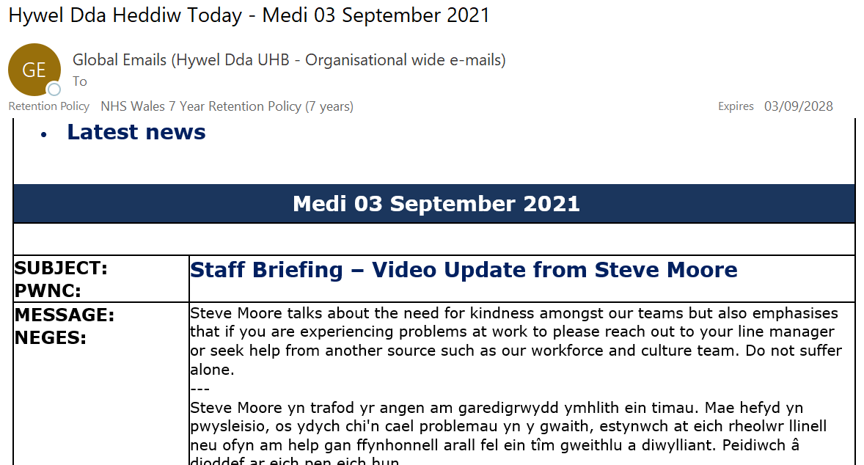

Reference List
Acas (n.d.) Long COVID – advice for employees and employers. Available at Sickness and absence because of long COVID: Long COVID – advice for employers and employees - Acas. (Accessed: 7th January 2022)

CIPD (2021) Employee Relations: an introduction. Available at Employee Relations | Factsheets | CIPD. (Accessed: 6th January 2022)

CIPD (2021b) Fixed-term contracts: Understanding the Law. Available at Fixed-term contracts: understanding the law (cipd.co.uk) (Accessed: 7th January 2022)

Hywel Dda University Health Board (2020) Report of the Chair. Bundle Public Board 28 May 2020 (nhs.wales) (Accessed: 7th January 2022)

Hywel Dda University Health Board (2021b) Understanding the staff experience in Hywel Dda University Health Board during the 2020-2021 COVID 19 Pandemic. Available at https://hduhb.nhs.wales/about-us/your-health-board/board-meetings-2021/board-agenda-and-papers-30th-september-2021/agenda-and-papers-30th-september-2021/item-3-1-3-discovery-report-understanding-the-staff-experience-in-hdduhb-during-the-2020-21-pandemic/. (Accessed: 6th January 2022)

King’s Fund (2021) NHS Workforce: Our position. Available at NHS workforce: our position | The King's Fund (kingsfund.org.uk). (Accessed: 6th January 2022)

Management Study Guide (n.d.) Role of Communication in Employee Relationships. Available at Role of Communication in Employee Relationship (managementstudyguide.com). (Accessed: 7th January 2022)

Marlow, J, O’Shaughnessy, J, Keogh, B and Chaturvedi, N (2020) ‘Learning from a pandemic: how the post-covid NHS can reach its full potential’ in BMJ 2020;371:m3867. Available at Learning from a pandemic: how the post-covid NHS can reach its full potential | The BMJ. (Accessed: 6th January 2022)

NHS Confederation (2021) COVID sickness absence - transition from enhanced provisions to application of regular sickness absence arrangements
COVID sickness absence - transition from enhanced provisions to application of regular sickness absence arrangements with effect from 1st April 2022.pdf (nhsconfed.org). (Accessed: 7th January 2022)

Webber, A (2021) ‘Mutual trust between managers and staff boosts performance’ in Personnel Today. Available at Mutual trust between managers and staff boosts performance - Personnel Today. (Accessed: 7th January 2022)

