Lecture 7: 26 April 2024.

Taken from University College London (UCL) https://library-guides.ucl.ac.uk/systematic-reviews/what#:~:text=Systematic

What are systematic reviews?

Systematic reviews are a type of literature review of research which require equivalent standards of rigour as primary research. They have a clear, logical rationale that is reported to the reader of the review. They are used in research and policymaking to inform evidence-based decisions and practice. They differ from traditional literature reviews particularly in the following elements of conduct and reporting.
Systematic reviews:
- use explicit and transparent methods
- are a piece of research following a standard set of stages
- are accountable, replicable and updateable
- involve users to ensure a review is relevant and useful.
For example, systematic reviews (like all research) should have a clear research question, and the perspective of the authors in their approach to addressing the question is described. There are clearly described methods on how each study in a review was identified, how that study was appraised for quality and relevance and how it is combined with other studies in order to address the review question. A systematic review usually involves more than one person in order to increase the objectivity and trustworthiness of the reviews methods and findings.
Research protocols for systematic reviews may be peer-reviewed and published or registered in a suitable repository to help avoid duplication of reviews and for comparisons to be made with the final review and the planned review.
- History of systematic reviews to inform policy (EPPI-Centre)
- Six reasons why it is important to be systematic (EPPI-Centre)
- Evidence Synthesis International (ESI): Position Statement
Describes the issues, principles and goals in synthesising research evidence to inform policy, practice and decisions

Should all literature reviews be 'systematic reviews'
Literature reviews provide a more complete picture of research knowledge than is possible from individual pieces of research. This can be used to: clarify what is known from research, provide new perspectives, build theory, test theory, identify research gaps or inform research agendas.
A systematic review requires a considerable amount of time and resources, and is one type of literature review.
If the purpose of a review is to make justifiable evidence claims, then it should be systematic, as a systematic review uses rigorous explicit methods. The methods used can depend on the purpose of the review, and the time and resources available.
A 'non-systematic review' might use some of the same methods as systematic reviews, such as systematic approaches to identify studies or quality appraise the literature. There may be times when this approach can be useful. In a student dissertation, for example, there may not be the time to be fully systematic in a review of the literature if this is only one small part of the thesis. In other types of research, there may also be a need to obtain a quick and not necessarily thorough overview of a literature to inform some other work (including a systematic review). Another example, is where policymakers, or other people using research findings, want to make quick decisions and there is no systematic review available to help them. They have a choice of gaining a rapid overview of the research literature or not having any research evidence to help their decision-making.
Just like any other piece of research, the methods used to undertake any literature review should be carefully planned to justify the conclusions made.

Different methods for systematic reviews
Finding out about different types of systematic reviews and the methods used for systematic reviews, and reading both systematic and other types of review will help to understand some of the differences.
Typically, a systematic review addresses a focussed, structured research question in order to inform understanding and decisions on an area. (see the Formulating a research question section for examples).
Sometimes systematic reviews ask a broad research question, and one strategy to achieve this is the use of several focussed sub-questions each addressed by sub-components of the review.
Another strategy is to develop a map to describe the type of research that has been undertaken in relation to a research question. Some maps even describe over 2,000 papers, while others are much smaller. One purpose of a map is to help choose a sub-set of studies to explore more fully in a synthesis. There are also other purposes of maps: see the box on systematic evidence maps for further information.

Reporting standards for systematic reviews
Reporting standards specify minimum elements that need to go into the reporting of a review. The reporting standards refer mainly to methodological issues but they are not as detailed or specific as critical appraisal for the methodological standards of conduct of a review.
A number of organisations have developed specific guidelines and standards for both the conducting and reporting on systematic reviews in different topic areas.
- PRISMA
PRISMA is a reporting standard and is an acronym for Preferred Reporting Items for Systematic Reviews and Meta-Analyses. The Key Documents section of the PRISMA website links to a checklist, flow diagram and explanatory notes.
PRISMA is less useful for certain types of reviews, including those that are iterative.
- eMERGe
eMERGe is a reporting standard that has been developed for meta-ethnographies, a qualitative synthesis method.
- ROSES: RepOrting standards for Systematic Evidence Syntheses
Reporting standards, including forms and flow diagram, designed specifically for systematic reviews and maps in the field of conservation and environmental management.

Types of systematic reviews
There are many types of systematic reviews. They may ask different kinds of questions and use a variety of methods, just like primary research. As with primary research, they vary in terms of perspective, purpose, approach, methods, and the time and resources used to conduct them.
Some reviews may ask broad questions (over a wide topic area) and examine them in little detail whilst others may ask narrow questions that are examined in great detail. Some reviews ask such broad questions that these are split into sub-questions that are addressed by different sub-components in the review each with different review methods considering different types of primary studies (multi-component reviews).

Dimensions of difference in systematic reviews
- EPPI Centre: Dimensions of Difference in Systematic Reviews
This video (22 mins) describes the Dimensions of Difference in Systematic Reviews by David Gough of the UCL IOE EPPI-Centre.
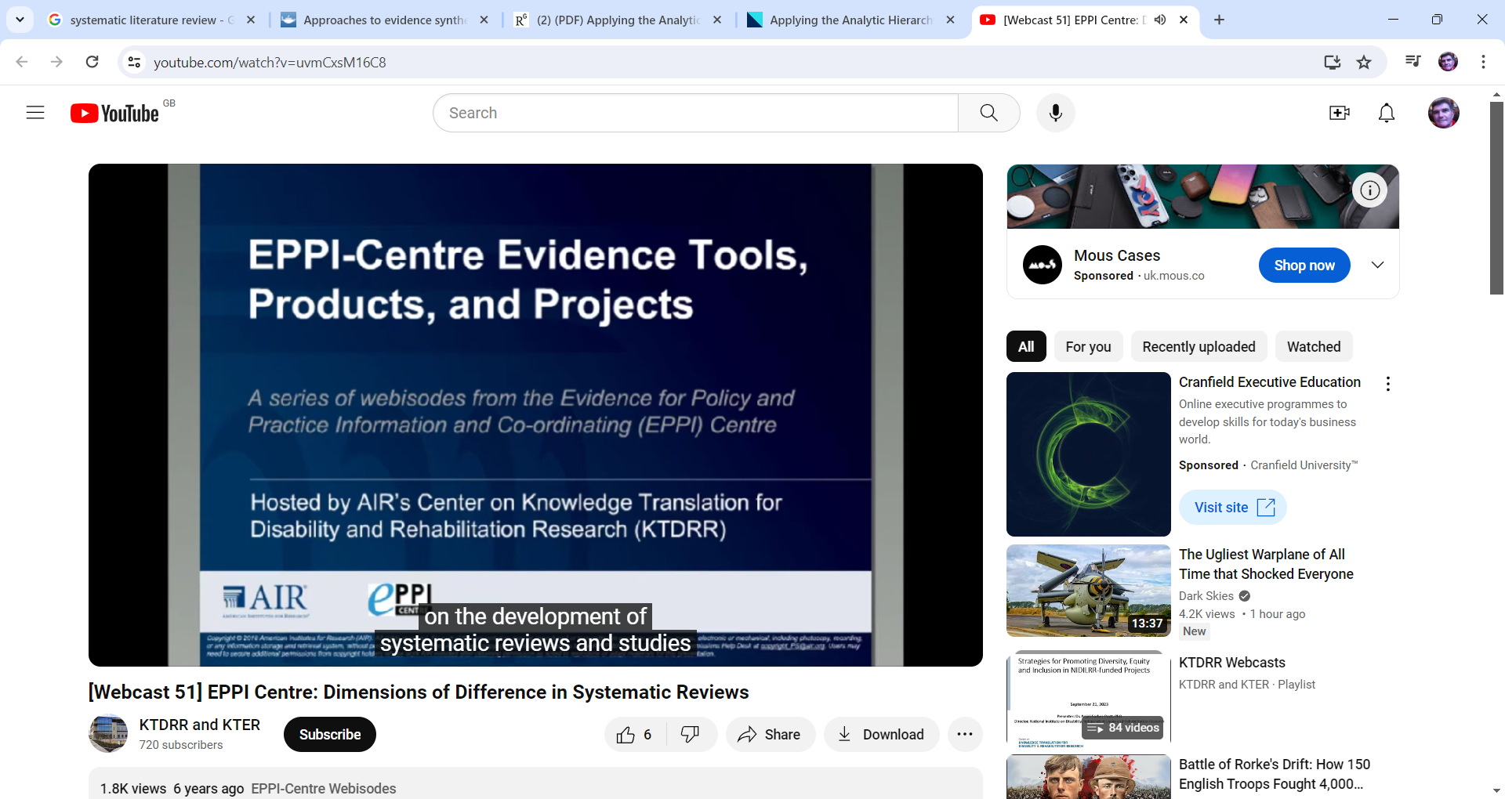

Further reading
- Clarifying differences between review designs and methods / Gough et al. 2012
This paper clarifies differences between review designs and methods.
- Approaches to evidence synthesis in international development: a research agenda / Oliver et al. 2018
International development is an area where systematic review methods have been applied to complex situations for a variety of purposes. This paper details some of these different approaches and synthesis methods,
- Perspectives on the methods of a large systematic mapping of maternal health interventions / Chersich et al. 2016
One large systematic map describes maternal health interventions in 2292 full text articles. The perspectives of 15 researchers from the review team provide insights into some of the challenges in systematically identifying and describing studies, and in being part of a large review team.

