Crypto wall Trojan
Contents
Abstract 1
History 1
How do Systems Become Affected? 1
What Files are affected? 2
Impact/Effect 3
Preventative Measures 3
Summary 3

Abstract
CryptoWall is a type of ransomware, currently favoured method used by criminals to extort end-users, and businesses alike for money. Criminals deploy software to an affected machine, which will seek out all data file extensions, then encrypt them and demand payment in return for their release. The latest version of CryptoWall that is affecting users is version 5.1, which uses AES- 256 encryption. This is essentially impossible to break without a key, held only by the owner of the malicious code.
https://www.datamagicinc.com/august-2018-ransomware-update/

History

Cryptolocker Clone
Cryptolocker Clone was the first version of the Cryptowall family. Cryptolocker clone first affected victims in November 2013. This version of the virus accepted many different types of payment, as opposed to just Bitcoin which is common in newer versions. Cryptolocker used RSA 2048 bit encryption according to anti-virus company Avast [1]. Eventually this version was replaced as “keys were generally locally” according to CryptoWall Tracker [2].

Crypto Defence
Crypto Defence replaced Cryptolocker Clone in January 2014. The only real change related to the ransom notes users would receive following infections. Eventually superseded with Cryptowall due to a “huge cryptography flaw in CryptoDefense” [2]

Cryptowall 1.0
Cryptowall 1.0 was the “This was the first 'official' version of CryptoWall where they gave it their own name they stuck with.” [2] it came about in March 2014. This versions was removed as “Instead of overwriting the original files with the encrypted version a new file would be written to disk with the encrypted content.” [2].This meant a simple process to be able to recover files.

Cryptowall 2.0
First introduced in October 2014. This version of ransomware used connections to Tor, although this was dropped was later versions “Tor traffic was easily visible from a networking perspective but this is unconfirmed” [2]. In this version the c2 (otherwise known as Command and Control) protocol was used, and developed further.

Cryptowall 3.0
Version 3.0 of the virus was introduced in January 2015, in place of the previous version 2. This again further developed the c2 protocol. This time however “the I2P network was used to transport the data from the victim to the C2 controller.” [2]. Developers did change “back to their old setup with an extra proxy layer in-between was deemed very successful”, due to instabilities with the I2P transport method. Jeff Petters [3] advises that version 3.0 has been “by far the most lucrative version so far”.

Cryptowall 4.0
In November 2015 version 4.0 was developed and released. The main change from version 3.0 was that
“CryptoWall v4 introduced a new feature to encrypt both the files and the filenames, meaning that you can’t simply look at the filename to check (and restore) if you have a backup.”
This feature change meant that IT administrators would have great difficulty in restoring files. As well as files names being encrypted to, ransom notes displayed much more confidence in the system.

Cryptowall 5.1
Cryptowall 5.1 is the latest version, although it does not share features with the previous Cryptowall viruses, and is instead based upon HiddenTear malware. Cryptowall 5.1 used AES 256 bit encryption, which is extremely secure.

How do Systems Become Affected?

Systems are infected through the usual means, as advised by cfoc.org [4] Crypto Wall; “often employs aggressive spam and phishing campaigns in order to affect as many users as possible over a short time. Such emails usually contain luring subject lines that trick users into opening the email. Users should note that an infection may be triggered just by opening the email. Sometimes no further interaction is needed. In other cases, the email body contains a malicious attachment or URL that may redirect the user to an exploit kit”. McAfee [5] advise that the “Ransom Cryptowall usually installs itself into the Application Data folder.” and also that “The malware uses an AES algorithm to encrypt the files. The malware first generates a 256-bit AES key which will be used to encrypt the files. In order to be able to decrypt the files, the malware author needs to know that key. To avoid transmitting the key in clear text, the malware will encrypt it using an asymmetric key algorithm, namely the RSA public/private key pair.”

What Files are affected?
The below graphic advises which file types are affected, provided by Jeff Petters [6]:
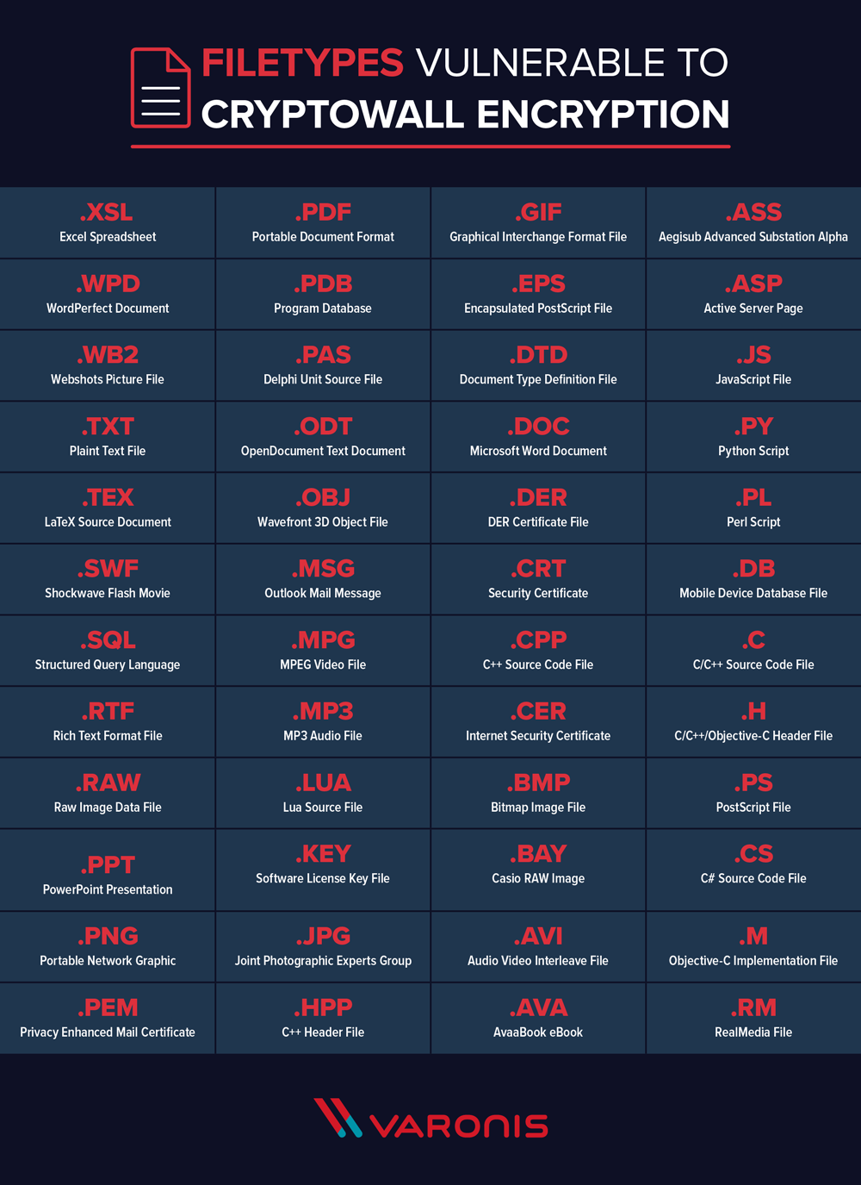
From the image it is clear that the virus aims to affect all common file types for maximum disruption. Files range from media files like mp3, through to document files such .txt or .doc.

Impact/Effect
As can be drawn from the above, most files types are affected by the Cryptowall Virus, a type of ransomware. “The ransomware is a kind of malware that encrypts important personal files, like documents, spreadsheets etc. Decryption key (or a tool) is provided to the victim after paying ransom to attacker” advises Krzysztof Cabaj et al. for companies paying such ransoms will result in loss of money and potentially still the files if the cyber-criminals do still not provide the key; “only 19% of users that pay the ransom get their files back.” [3]. Criminals usually request payment in a cryptocurrency as they are able to remain anonymous.

Preventative Measures
With the potential impact being so significant, it is important to ensure that the users are doing the utmost to ensure security and prevent infection where possible.
Firewall rules can be put in place to stop the virus contacting servers which contain malicious code, Audrey [3] advises that the following domains are known to be compromised “pastimefoods.com, 19bee88.com, adrive62.com, httthanglong.com” of course this list will need to evolve as the CrytpoWall virus will adapt and find new methods of infection.
It is also possible to block certain files from having the rights to execute. Audrey [3]also advises that two such files are attempted to execute from the domains previously mentioned: “http://46.30.43.183/syria.exe http://46.30.45.110/analitics.exe”.
Other preventative measure to minimise risk would be too ensure backups are regular and up-to-date. This means if files are compromised, they can be deleted as soon as possible, to prevent the spread of the virus and then a backup is restored in place of the infected file.
As well as this, staff in businesses can be trained to be more aware of such viruses therefore stopping the initial breach into the network via phishing emails or other methods.

https://www.securitycolony.com/2018/01/cryptowall-analysis-and-behaviours/

Summary
”According to malware security firm Barkly, a company is hit with a ransomware attack every 40 seconds” [7] therefore is is vital that measures are in place to prevent attacks. Such measures include; firewalls blocking known sources of servers relating to the ransomware, stopping associated file types from having permission to run, training staff to be aware of suspicious emails and also IT ensuring back-ups are in place to mitigate risk.
Even with such measures in place attacks can still happen, however being cautious and able to restore from backup provides the best chance of minimising impact.

References

[1] | Avast, “CryptoLocker,” Avast, [Online]. Available: https://www.cryptowalltracker.org/. [Accessed 7 January 2019].
[2] | @. PGP:0x7e6d96d628493171, “CryptoWall Tracker,” 2013. [Online]. Available: https://www.cryptowalltracker.org/. [Accessed 7 January 2019].
[3] | Audrey, “Cryptowall Analysis and Beahviors,” 9 January 2018. [Online]. Available: https://www.securitycolony.com/2018/01/cryptowall-analysis-and-behaviours/. [Accessed 1 7 2019].
[4] | “CRYPTOWALL 5.1 USES AES-256 AND IS BASED ON HIDDENTEAR RANSOMWARE,” [Online]. Available: https://cfoc.org/cryptowall-5-1-uses-aes-256-and-is-based-on-hiddentear-ransomware/. [Accessed 19 11 2018].
[5] | McAfee, “McAfee Labs Threat Advisory,” 2019. [Online]. Available: https://kc.mcafee.com/resources/sites/MCAFEE/content/live/PRODUCT_DOCUMENTATION/25000/PD25480/en_US/McAfee_Labs_Threat_Advisory-Ransom_Cryptowall.pdf. [Accessed 2019 January 7].
[6] | J. Petters, 6 January 2018. [Online]. Available: https://www.varonis.com/blog/cryptowall/. [Accessed 7 January 2019].
[7] | S. Kimbrel, “August 2018 Ransomware Report,” 10 August 2018. [Online]. Available: https://www.datamagicinc.com/august-2018-ransomware-update/. [Accessed 7 January 2019].
[8] | P. G. K. G. D. O. Krzysztof CABAJ, Warsaw University of Technology, 2015. [Online]. Available: http://red.pe.org.pl/articles/2015/11/48.pdf. [Accessed 7 January 2019].

