SAMINA BASHIR
1816450
BMSW 4005
PROFESSIONAL AND CAREER DEVELOPMENT
YOHAN MENDIS
REFLECTIVE PORTFOLIO

Page 1

CONTENTS

Title page……………………………………………………………………………………..page 1
Content page………………………………………………………………………………...page 2
Reflection of self awareness tool that I have used and its relevance to my future employment…………………………………………………………………………………..page 3 , 4 ,5
Reflection based on my mock interview and the feedback I received………………….page 6 , 7,
Career development plan with SMART objectives strategies and detailed actions…...page 8,9
References…………………………………………………………………………………….page 10

Page 2
Reflection of self awareness tool that I have used and its relevance to my future employment
INTRODUCTION

Self awareness has been identified as an important aspect of emotional intelligence. Self awareness is important it helps people identify their identity and belief in themselves. There are different ways and methods individuals can use to build their self-esteem.
According to Tjan.T, 2015 these are some of the ways of becoming more self aware of yourself such as; Meditation which helps you focus your mind on a particular thought and also helps you to have a clear mind mentally and emotionally and it also focuses on your breathing. Write a journal about your plans what you want to do and how you are going to reach your goal and keep a track of you progress. Getting feedback from your work friends and from your loved ones this will give you time to reflect on yourself and also take psychometric tests

MAIN BODY
According to Ackerman, 2020 there are benefits of being self aware such as;
- It can benefit us in our workplace make us better at our jobs by enhancing our confidence and well being.
- It can lead to us making better decisions
- Encourage ourr own self development by being positive and accepting things around us.
- Self awareness gives you a chance to see yourself from someone else’s perspective
- It gives you the opportunity to experience pride in your work as well as in yourself and general well being.
- Self awareness is a tool that you can use anywhere, anytime it gives you the chance to evaluate yourself when you are in a situation.
During this module I have used various self awareness tools to probe into my ability and identity. This report will examine one of such tools. I have decided to use the johari windows as a tool for reflection on myself awareness. This is a tool which you can use in different environments and situations a tool which I use on different occasions. According to johari windows there are four aspects of self awareness;
- Open self – This is something you and others know about yourself and something you’re willing to share about yourself which is the open self e.g. gender, age, ethnicity group etc. This area will build trust among people when they disclose information page 3
- Hidden self – This is something that you are aware of, but wouldn’t want to share the information with anyone else e.g.it could be something your ashamed of , hidden agendas etc.

- Blind self – This is something that you’re not aware of yourself, but others are with their feedback this will help you by being aware of you positive and negative actions around people and in the environment.
- Unknown self – This is a area that is unknown to yourself and others this can be factors that you are not aware of such as a conditioned behavior from childhood, an illness , fear , an ability that you have due to lack of self esteem or opportunity you’re not having a chance to achieve or show your ability etc.

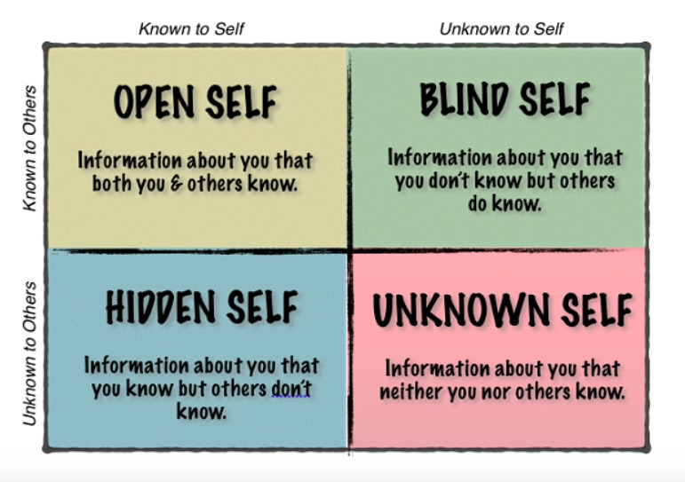
Page 4
The Johari window is a tool that individuals apply to get to know and understand themselves better. I have used my open self to build relationships with my tutors and fellow students this enabled me to communicate well with the information we shared amongst ourselves. This area of the johari windows helped me with my personal development as I progressed through my first year in the university. I benefited with the information I shared and what others knew about me this changed group dynamics and it benefited me when I did group tasks and presentations. I progressed in team development and inter group relationships with using my open area e.g. my fellow students realized with the information I shared with them that I come across with leadership qualities due to my past experiences and im a confident out spoken person who has good communication skills so I was chosen as a class REP this was all based on the open area I showed and shared. In the future when I seek employment my open area plays a big part for me to achieve my goal as it depends on my open area if I get the job or not because it all depends on what I share and present to the employers. In the process of being employed the johari window will benefit me when its being applied by employers and other members of team as we will be building trust and forming a relationship at the workplace.

CONCLUSION
This report has studied the importance of self awareness. I have used johari windows as my tool and applied it to myself even though I’m aware of my open self I realize that I’m a open person and this seen by everyone else I’m in the process to study myself further and get to know the unknown self and my hidden self.
I hope to do so by using the feedback strategy this will enable me to get to know the unknown area about myself and I will be in the process to learn new information about myself which I never knew before. This will increase my self- awareness and give me a chance to deal with any issues or areas that I have to work on to become a more effective individual to succeed in the near future. It will be a learning process to learn about different emotions, actions, behaviours which I never knew about myself. My hidden self is something I’m only aware of myself that I don’t want to share this could a variety of things or behaviours with the right support and help I can overcome some of my hidden area and transfer it to my open area eventually with time such as I have fears and suffer from anxiety which I can use mediation to help me overcome by using different breathing techniques etc.

Page 5
REFLECTION ON MY INTERVIEW AND THE FEEDBACK I RECEIVED
INTRODUCTION
This Report is about a mock interview conducted on the 26/2/20 at university of Wales trinity saint David. According to Trull,(1964). Interview is an effective way of hiring a position in a organization specification an interview is a formal meeting between a employer and employees it enables the employer to ask questions to get to know the person applying for the position better and to understand their understanding of the job role they are applying for their knowledge about the organization and to see if they meet the requirements for the position. Your aim is to show the employer that you have effective interview skills for the job role and that you will fit in their company. An employee has to put a lot of effort when attending a interview and be well prepared before attending.

MAIN BODY

I received the following feedback from my interview I had some positive and negative feedback which I will take in account when I attend interviews for future employment. I received feedback that I could have done more research on the organization I was applying for. According to Huhman (2018) researching about your employers and their organization is one of the best ways for you to stand out from other candidates applying for the same position. It gives you an advantage over them by researching you are learning more about the company you will find out what they are looking for in a candidate and prepare yourself to answer questions tailored to the role and position yourself as as a better candidate.
Some of the things that you research and learn about a company is the skills and the companies culture , mission and values , the main key players of the organization, research about any news or most recent events about the company , the products and services they offer etc.
In my interview one of my negative feedback was that I wasn’t prepared to ask questions from the panel which I forgot to do. According to Robert, (2019) An interview is a two way process it allows the organization to find out about their candidates , but its also is an opportunity for the candidates to ask what they would like to know about the company this shows your interested in the job role and if you don’t ask questions you miss the opportunity to gather more information about the company and this will be a downfall as you miss the chance to impress the hiring managers before they can offer you a job in their company. Depending on the questions you ask such as salary, shift work , pension scheme , management expectations , benefits to work in this company etc. The panel shows you have done research on the company. This reveals a candidate can think independently and about their thoughts process regarding the position

The positive feedback I received at my interview was that I demonstrated confidence and experience for the job role. Demonstrating confidence builds your strength to overcome situations it is a quality that you gain from experiences and you have to believe in yourself to accomplish this. Confidence will better yourself as you progress in your chosen career and apply for employment. According to indeed career guide/career development (2020) demonstrating confidence has a positive impact at your workplace, this could be coworkers, supervisors, interviewer people who you come face to face with in your professional setting. There are different ways to develop your confidence this reflects on developing a positive self image about yourself e.g. focus on yourself , prioritize , rethink about rejection , construct a positive image etc
Experience always is a benefit when you apply for a job that shows you have worked in this field before and you can bring your experience forward to a company and progress further. When you are being interviewed and asked questions this shows the hiring position your knowledge and expertise e.g. I demonstrated the strategies I used with challenging behavior children which I used in my previous job role and which I benefited from voluntary work. Experience shows your awareness of general business. Experience includes transferable skills that you had from a previous job from school as you progressed in life that you will be using in your new workplace know such as good communication skills, team building, problem solving, critical thinking etc. These are skills that you already have and will establish more as you move forward in life.

CONCLUSION
In the future I want to bring my experience from my previous year advancing my career as I move forward to better myself as an individual and prepare myself for employment. The interview process has helped me to be more aware of what to expect and also how I should present myself in front of a panel. This has been a learning process for me the past year and I want to take my positive and negative feedback and work on my weaknesses so I can improve my chances of gaining employment. This report has examined how my feedback from my mock interview has emphasized the importance of asking questions back to the panel , being prepared for the interview by doing research about the organization you want to apply for etc.I hope to enhance these skills in the near future when I apply for jobs.

Page 7
Career development plan with SMART objectives strategies and detailed actions
INTRODUCTION
Career development is when an individual enables them self to move forward in their employment and progress further. This gives them the opportunity to learn and develop new skills in their chosen career. This can include them moving to a higher position having more responsibilities, managing a new team or even starting up their own business. This all depends on the job they are currently in they need to find out is there a opportunity for them to develop their career. There are always factors that can affect career development e.g. job performance , company situation , personality of the employer etc. you have to take in consideration everything before you begin to develop your career.
MAIN BODY
These are some of the following strategies and objectives used in career development;
- Set up your goals – knowing what you want in your career than identifying your goals and decide how you are going to reach it.
- Network - This is a skill that is very valuable and very effective and it’s a important part of professional career development you will be benefiting from this as you progress in your career. Network enables you to access new jobs find out about what they are offering about different industries , new information etc. Using the right network can develop your career position.

- Embrace new challenges – This will help you advance your career by taking part in new tasks and challenges that fits with your career plan with this objective . This can also benefit the organization your already working in.

- Creating a portfolio of your accomplishments – This shows what you have achieved in life this can be a collection of things with the best work you have done s far and this is a great asset for career advancement.
- Create an open feedback loop – Feedback will always provide you with information about yourself weather this is positive or negative. This can help you work towards your goals and help you better yourself in your chosen career. According to Karrera(2017) feedback is an essential tool it makes your goals more realistic when you receive feedback it shows the qualities about yourself that you were not aware of.
- Conduct regular self assessment - Self-assessing yourself can help you to improve on your goals. You can do this by setting yourself small goals and reflect on them over a period of time. This will tell you if you have reached your target or are still working towards it.
Page 8
By making sure we achieve our goals and progress in our career development we need to use the SMART objectives which are;
- S –Specific
- M- Measurable
- A-Attainable
- R-Relevant
- T-Time bound

This is a tool used by businesses to achieve their best performance. By having a clear vision of their goal implementing it and then achieving it within the time limit the goal was set up for.

CONCLUSION

I will like to progress further in my studies and gain a higher qualification and gain employment by using the following strategies I will keep a record of my goals such as in 10 weeks time – finish my assignments so I can keep a track record of my work. I will use the feedback strategy to know things about myself and my work that I wasn’t aware of and than I can learn from that to move forward and do better. Keeping a portfolio will benefit me with my career development it highlights my qualifications , experiences , voluntary work etc.
One of my goals is to do voluntary work beside my studying to gain experience and be aware of the latest rules and legislations in the workplace industry and also to build up my portfolio. I hope to do the following by also using the SMART objective to progress in my professional career development.

Page 9
REFERENCES

- Trull, SG (1964) strategies of effective interviewing. Harvard Business Review.
- Courtney E Ackerman, MSc (2020) what is self awareness and why it is important. Positivepsychology.com.
- Anthony K.Tjan, (2015) 5 ways to become more self aware. Harvard Business Review.
- Self awareness.org.uk (2013) Understanding the Johari window model.
- Heather Human,(2018), glass door, 7 things to Research Before Any job interview.
- Michael Roberts (2019),the balance careers, why you should Ask Questions in a job interview.
- Indeed career gide/career Development,(2020).
- Mariliza Karrera,(2017)CareerAddict,career Development.10 Most Effective Career Planning Strategies

Page 10

