

Report on HVO fuels at Tata Steel Colors
By
Graham Jones
2313935

Degree Apprenticeship in Logistics and Supply Chain Management
24th July2026
Sustainable supply chains (ACMA 5021)


APPENDIX GA36a

LEVEL 5 ASSESSMENT SPECIFICATION
Student name: | Graham Jones | Student ID number: | 2313935
Programme: | DA Program in Logistics and Supply Chain Management
Module: | Sustainable Supply Chains
Module code: | ACMA5021 | Contribution to Overall Module Assessment (%): | 100%
Lecturer: | Dr Irina Neaga | Internal Verifier:
Assignment Title: | Developing Sustainable Supply Chain Strategies to Support the Circular Economy and Net Zero | Word count (or equivalent): | 2000words(+/- 10%)
Submission deadline: |  | Return date of provisional marks & written feedback:
Submission method: | All written assessments, where practical and possible, must be submitted via Turnitin unless otherwise instructed by the Lecturer. (Please DO NOT put this assessment specification into Turnitin or it will match many similarities with other students’ submissions.)  Alternative submission method (if applicable):  Late submission of the assessment will result in a late penalty mark. Penalties for late submission: Up to one week late, maximum mark of 40%. Over one week late, 0%. Only the Extenuating Circumstances Panel may approve a change to submission dates.
Academic honesty / referencing: | Academic honesty is required. In the main body of your submission, you must give credit to authors on whose research and ideas your work is based. Append to your submission a reference list that indicates the books, articles, etc. that you have used, cited or quoted in order to complete this assessment.

TASK DESCRIPTION
You are required to produce a 2,000-word report that presents a project proposal addressing significant sustainability issues within an organisation/company of your choice (preferably your own workplace or a well-known organisation).
Your report must critically analyse the organisation’s current supply chain practices and evaluate how these can be transformed and improve to better align with:
- Sustainability principles (environmental, social, and economic)
- Circular economy concepts and practices
- Decarbonisation and Net Zero targets
It is expected to develop a well-justified and evidence-based proposal that outlines practical and innovative strategies for improving the sustainability performance of the organisation’s supply chain.
The analysis should:
- Demonstrate critical evaluation, not just description
- Apply relevant theories, models, and frameworks
- Consider real-world feasibility, risks, and organisational constraints
- Incorporate current academic and industry sources
The final proposal should provide clear, actionable recommendations supported by evidence, and reflect Level 5 expectations of analytical thinking, application, and synthesis.

Use of Generative AI in Assessment
RESEARCH | For this assessment, you can use Generative AI to support you in research, including searching for bibliography, using tools to summarise, compare and interrogate materials. | Yes ​☒​  No ​☐​
STRUCTURE | For this assessment, you can use Generative AI to support you in structuring your submission, including creating a draft argument structure, identifying parts and headings, etc. | Yes ​☒​  No ​☐​
PROOFREADING | For this assessment, you can use Generative AI to check your own text/creation for grammatical and syntactical mistakes, including rephrasing of your own work within specific standards. | Yes ​☒​  No ​☐​
WRITING | For this assessment, you can use Generative AI to create text for submission. | Yes ​☐​  No ​☒​
CREATIVE | For this assessment, you can use Generative AI to create creative materials, such as images. | Yes ​☐​  No ​☒​
PROGRAMING | For this assessment, you can use Generative AI to create and check code. | Yes ​☐​  No ​☒​
NONE | For this assessment, you are not allowed to use any type of Generative AI support. This includes research support, structure support, writing/proofreading support and creative support. | Yes ​☐​  No ​☒​

AI Acknowledgement

I confirm that I have not present any AI-generated materials as my own work in this portfolio.
However, I acknowledge that I have used or may have used the AI in the research and proofreading of my portfolio.
Name:........Graham Jones
Student ID.........2313935

Table of contents
1 – Introduction………………………………………………………………………………………6
2 – What is HVO………………………………………………………………………………….…6
2.1 - HVO Vs Euro 6 Diesel……………………………………………………………….8
3 – Feasibility study; Transitioning a Ten-Truck Fleet from Euro 6 Diesel to HVO………...10
3.1 - Environmental Sustainability……………………………………………………….11
3.2 - Financial Implications and Cost Analysis…………………………………………12
3.3 - Strategic Risk and Sustainability Verification…………………………………….12
3.4 - Implementation Plan………………………………………………………………...13
4 – Why not electric?............................................................................................................13
5 – Conclusion………………………………………………………………………………..…….14
References………………………………………………………………………………………….15

List of figures and tables
Figure 1 – Hydrotreated Vegetable Oil (Crown Oil, N.D)………………………………8
Table 1 – Euro6 vs HVO Evaluation……………………………………………………..9
Figure 2 – Comparing HVO to Standard Diesel……………………………………….10
Table 2 – Carbon emissions comparison………………………………………………11
Table 3 – Fuel cost comparison…………………………………………………………12

- – Introduction
Tata Steel Colors (TSC) is a Downstream Operation (DSO) of Tata Steel UK (TSUK), the Shoton site is located in Flintshire, North Wales operates 24/7 and produces six thousand tonnes of painted finished steel for the construction sector per week. To support this the site operates a fleet of ten internal vehicles which move three thousand tonnes of material between operational warehouses, manufacturing bays and finished goods storage areas per day. These vehicles are Euro 6 heavy goods trucks which travel on average forty miles each per day or 13,200 miles per year, meaning the entire fleet will travel 132,000 miles per year. As Euro 6 trucks produce on average 1.4kg of CO2 per mile this means the fleet of vehicles are producing 184,800Kg of CO2 per year.
This report will be looking at the possibility and feasibility of converting the fleet of vehicles to run on Hydrotreated Vegetable Oil (HVO) which could drastically reduce the fleet emissions and contribute towards TSUK corporate sustainability goals, which has targeted a 30% reduction in total CO₂ emissions by 2030 as an interim step toward 2045 net-zero goals.
The information and data has been sourced from the TSC on site Warehouse and transport team and from my own research into industry standards for HVO and Euro6 Diesel fules.
- – What is HVO?
Hydrotreated Vegetable Oil (HVO) is a premium, fossil-free diesel alternative made from 100% renewable waste materials. These materials include used cooking oil, animal fats, and agricultural residues. Unlike first-generation biodiesels, HVO undergoes a specialized hydrotreatment process. This chemical treatment removes impurities and adds hydrogen, resulting in a pure, stable hydrocarbon that mirrors the molecular structure of regular fossil diesel (Mårtensson, 2025).
For heavy-duty trucking, HVO offers an immediate and dramatic reduction in greenhouse gas emissions. Switching from standard diesel to HVO lowers net carbon dioxide (CO₂) emissions by up to 90% over the fuel’s lifecycle. It also enhances local air quality by reducing particulate matter by up to 30% and nitrogen oxide emissions by roughly 10% (Crown oil, 2026).
From an operational standpoint, HVO performs exceptionally well in demanding commercial transport environments. It boasts a high cetane number, typically between 70 and 90, which ensures cleaner, more efficient combustion, smoother engine idling, and excellent cold-start performance down to -22°C. Because it lacks the oxygen molecules found in traditional biodiesel HVO does not absorb water, resist bacterial growth, or degrade during long periods of storage.
The single greatest advantage of HVO-fuelled trucks is their logistical simplicity. HVO is a true “drop-in” fuel. Heavy-duty truck engines require absolutely zero modifications to run on it. Fleet operators can fill up their existing diesel trucks with 100% pure HVO (known as HVO100), mix it with standard pump diesel in any ratio, or switch back and forth between the two depending on fuel availability. Almost all major commercial vehicle manufacturers, including Scania, Volvo, DAF, MAN, and Mercedes-Benz fully approve HVO for use across their standard Euro 6 diesel engine lineups without voiding manufacturer warranties (Van Gestel, 2026).
While HVO provides an excellent immediate pathway to greener transport, fleets face two primary challenges;
- Cost Premiums: HVO is consistently more expensive per litre than fossil diesel due to complex processing methods and limited raw material supply.
- Supply Constraints: Global quantities of certified, sustainable waste fats are limited, meaning HVO cannot entirely replace global diesel demand on its own.
HVO-fuelled trucks serve as a vital bridging technology in the logistics sector. While long-term targets point toward hydrogen fuel cells and battery-electric heavy goods vehicles (HGVs), those technologies require massive infrastructure overhauls and high upfront vehicle investments. HVO allows logistics companies to slash their scope1 transport emissions today using their existing vehicles, fuel tanks, and depots.
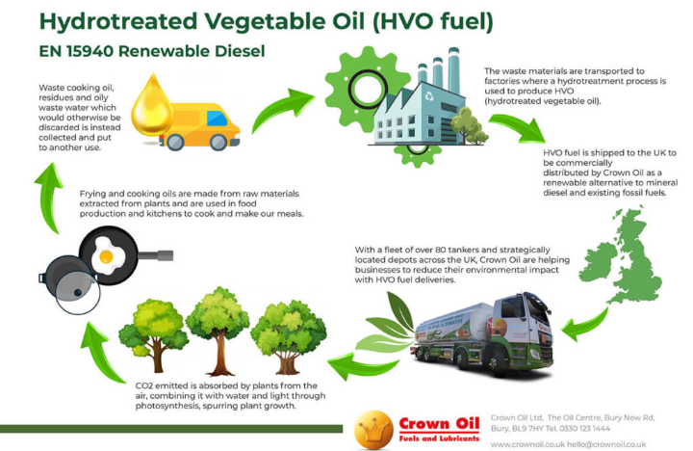Figure 1 – Hydrotreated Vegetable Oil (Crown Oil, N.D)
  - – HVO Vs Euro 6 Diesel
The transition to net-zero logistics requires a critical examination of HVO versus standard Euro 6 fossil diesel. While both fuels satisfy strict regional air quality regulations, they represent entirely distinct concepts regarding corporate sustainability and carbon reduction.
The fundamental difference between these two fuels lies in their carbon lifecycle accounting. Standard Euro 6 diesel relies on crude oil extraction. Burning it releases fossilised carbon into the active carbon cycle, directly expanding atmospheric greenhouse gas volumes. In contrast, HVO is a renewable, paraffinic fuel derived from biogenic waste materials, including used cooking oil and animal fats. This biological origin radically alters greenhouse gas reporting in the following sectors (SupplyChain School, 2026):
- Scope 1 (Direct Emissions): Under global greenhouse gas protocols, HVO combustion is treated as carbon-neutral at the tailpipe because it releases biogenic carbon that was recently absorbed by organic matter.
- Lifecycle Reductions: Evaluating the full well-to-wheel lifecycle, HVO delivers a net carbon footprint reduction of up to 90% compared to Euro 6 fossil diesel. This allows fleet operators to immediately shrink their Scope 1 footprints without purchasing carbon offsets.
Lifecycle Reductions: Evaluating the full well-to-wheel lifecycle, HVO delivers a net carbon footprint reduction of up to 90% compared to Euro 6 fossil diesel. This allows fleet operators to immediately shrink their Scope 1 footprints without purchasing carbon offsets. HVO possesses a higher cetane number (70–90) and contains zero aromatic hydrocarbons or sulphur. This chemical purity results in cleaner combustion, fewer DPF regeneration cycles, and lower engine wear than fossil diesel .
Evaluation Metric | Euro 6 Fossil Diesel | HVO
Lifecycle Greenhouse Gas Impact | Base baseline emissions | Up to 90% reduction
Particulate Matter | Complies with Euro 6 limits | Decreases by 30% to 65% beyond Euro 6 baseline
Nitrogen Oxides | Complies via intensive SCR use | Slightly lower (pprox.. 10%) due to cooler combustion
Fuel Stability & Storage | Prone to degradation within 1 year | Highly stable (up to 10 years); resists microbial growth
Table 1 – Euro6 vs HVO Evaluation
While HVO outperforms standard diesel on paper, a critical sustainability analysis highlights significant structural vulnerabilities regarding long-term net-zero goals (Allen, 2025):
- Feedstock Integrity and Fraud Risk: The sustainability value of HVO depends entirely on transparent supply chains. Illicit blending of virgin palm oil—which drives tropical deforestation—can completely negate the fuel’s environmental benefits. Fleets must utilize verified certification systems to guarantee that feedstocks are strictly derived from waste.
- Supply Scale Limitations: The global supply of authentic waste oils is highly constrained. Total availability cannot scale to replace global diesel demand, creating severe competition with the aviation sector for sustainable feedstocks.
- Economic Strain: HVO carries a consistent price premium over fossil diesel, driving up operating margins for low-margin logistics providers.
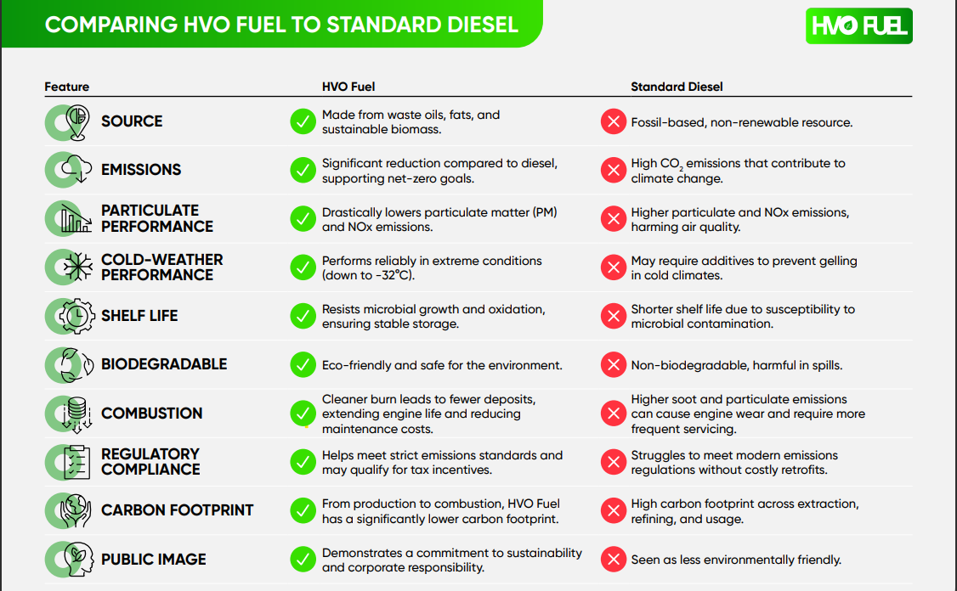 Figure 2 – Comparing HVO to Standard Diesel
Standard Euro 6 diesel is an unsustainable, fossil-dependent fuel that cannot align with long-term net-zero milestones. HVO offers an ideal, immediate transition technology. It bypasses the massive capital costs and grid constraints of implementing charging networks for fully electrified fleet by functioning as a drop-in replacement for existing infrastructure. However, because of global feedstock limits, HVO is a temporary asset for heavy transport rather than a permanent net-zero solution. True long-term decarbonisation will still require a broader transition toward battery-electric and hydrogen fuel-cell commercial transport when technologies advance.
3 - Feasibility Study: Transitioning a Ten-Truck Fleet from Euro 6 Diesel to HVO
This study evaluates the operational, financial, and environmental impacts of transitioning a fleet of ten Euro 6 heavy goods vehicles (HGVs) from standard fossil diesel to 100% Hydrotreated Vegetable Oil (HVO100). Each vehicle operates an average of 13,200 miles annually, resulting in a collective fleet mileage of 132,000 miles per year.
Because HVO is a chemical "drop-in" replacement fuel, this transition requires zero capital expenditure (CapEx) for vehicle modifications. The study demonstrates that while the fleet can achieve an immediate 88.5% reduction in lifecycle greenhouse gas (GHG) emissions, it will face an estimated 17.5% increase in annual fuel expenditure. This analysis weighs these competing factors to determine the viability of the transition.
3.1 - Environmental Sustainability
The fleet consists of ten Euro 6 diesel trucks. Modern Euro 6 engines from major manufacturers are fully approved to run on paraffinic fuels meeting the BS EN 15940 specification, which covers HVO. HVO can be mixed with fossil diesel in any ratio without adverse effects. The transition can occur immediately using existing on-site bunkering infrastructure or commercial fuel cards. Unlike traditional biodiesel (FAME), HVO does not attract water, suffers no microbial growth ("diesel bug"), and maintains a long storage life (up to 10 years), reducing the risk of fuel degradation (Hardwick, 2023).
To quantify the environmental impact, a standard Euro 6 fleet fuel efficiency baseline of 8.0 miles per gallon (mpg) is applied. HVO has a slightly lower volumetric energy density than fossil diesel (approx. 4–5% less), which can occasionally result in a minor increase in fuel consumption. However, its high cetane number (70–90) optimizes combustion efficiency, typically neutralizing this discrepancy in real-world driving. This model assumes a conservative, identical fuel efficiency of 8.0 mpg for both fuels.
Annual Fuel Volume Calculation;
- Single Truck Annual Distance: 13,200 miles
- Total Fleet Annual Distance (10 Trucks): 132,000 miles
- Annual Fuel Consumption: 16,500 gallons (75,010 litres)
The environmental value of HVO depends heavily on its feedstock source. Certified 100% waste-derived HVO delivers up to a 90% reduction in greenhouse gas emissions over its full life cycle compared to fossil diesel.
 | Euro6 (Fossil Diesel) | HVO (HVO100)
Emission Factor | 2.512 kg CO₂ per litre | 0.289 kg CO₂ per litre
Annual Fleet Emissions | 188.43 tonnes of CO₂ | 21.68 tonnes of CO₂
Net Annual Carbon Savings | 166.75 tonnes of CO₂ (88.5% Reduction)
Table 2 – Carbon emissions comparison
On top of this operating on HVO further cleans tailpipe emissions beyond standard Euro 6 requirements:
- Particulate Matter: Reductions of 30% to 50%, resulting in fewer Diesel Particulate Filter regeneration cycles.
- Nitrogen Oxides: Reductions of up to 10% due to more efficient combustion temperatures.
3.2 - Financial Implications and Cost Analysis
Because HVO is a direct drop-in fuel, the upfront cost to convert the fleet is £0. No mechanical retrofits, tank cleanouts, or specialized driver trainings are required. The primary financial hurdle is the price premium of HVO over standard commercial white diesel. Market conditions indicate an average HVO premium of £0.15 per litre (excluding VAT) due to feedstock scarcity and refining costs.
Financial Metric | Euro6 (Fossil Diesel) | HVO (HVO100) | Variance
Annual Fuel Required | 75,010 Litres | 75,010 Litres | 0 Litres
Estimated Price per Litre | £1.12 | £1.27 | £0.15
Total Annual Fleet Fuel Cost | £84,011 | £95,263 | +£11,252
Average Fuel Cost per Truck | £8,401 | £9,526 | +£1,125
Table 3 – Fuel cost comparison
Although while fuel costs increase, HVO delivers minor operational cost offsets such as reduced AdBlue consumption because cleaner combustion can lower AdBlue usage by up to 10% and lower component wear as reduced soot production extends DPF life expectancies and decreases engine oil contamination, potentially lengthening service intervals.
3.3 - Strategic Risk and Sustainability Verification
Before deploying HVO, the organization must account for two major supply chain risks;
- Feedstock Traceability; To claim these carbon reductions in corporate ESG or Scope 1 reporting, the fuel must not be linked to deforestation (such as virgin palm oil markets). The fleet must mandate that suppliers provide proof of sustainability through recognised verification schemes, such as the International Sustainability and Carbon Certification (ISSC) or the Renewable Fuel Assurance Scheme.
- Price Volatility; The premium for HVO is tied to regional mandates and global waste fat availability. For example if aviation sectors scale up their use of Sustainable Aviation Fuel, which competes for the exact same waste feedstocks, the cost premium for road-going HVO could widen, increasing financial risk.
3.4 - Implementation Plan
The transition can be safely phased over a brief four-week period to protect operations:
- Week 1: Supplier Audit & Compliance: Source an ISCC-certified HVO broker. Establish a transparent auditing trail for Scope 1 reporting data.
- Week 2: Infrastructure Readiness: Verify whether fuel cards or existing on-site storage tanks require configuration adjustments with the vendor.
- Week 3: Phase-In Pilot: Introduce HVO into the existing diesel tanks at a 50/50 blend. Monitor truck diagnostics, fuel consumption, and driver feedback for performance anomalies.
- Week 4: Complete Transition: Fill the remaining tank capacity with 100% HVO. Begin documenting emissions reductions for monthly corporate sustainability metrics.
4 – Why not electric?
Whilst electric trucks offer much lower running costs, as electric is up to 50% cheaper per mile than diesel, and also have zero tailpipe emissions for sustainability goals there are two major drawbacks to this being a viable alternative for TCS.
- Cost; As the current fleet could not be converted in any way to run with electric motors brand new units would need to be sourced. Current cost of an electric truck capable of hauling the payloads at TCS would be £300,000 per truck, £3million to replace the entire fleet. An expenditure that is not viable in the current financial climate.
- Refuelling Vs Recharging; Currently the technology available for electric trucks means that to recharge a vehicle fully once the battery range has been depleted would mean the vehicle out of service for many hours. When this is compared to how diesel or HVO vehicles can be refuelled in a matter of minutes, this would make an electric fleet in-efficient as multiple vehicles would be off the road or the fleet would have to be expanded to counter this which would be an increase in purchase cost.
5 – Conclusion
The transition of this ten-truck fleet to HVO is technically seamless and operationally low-risk, requiring no capital expenditure or vehicle downtime and is highly feasible with budgetary approval.
A positive for the sustainability case is that there is unrivalled immediate impact. The fleet will eliminate an estimated 166.75 tonnes of CO₂ per year, offering a rapid mechanism to hit corporate sustainability targets and go a long way to achieving net-zero. The project will however require an adjustment in the dedicated operational budget to increase by £11,252 annually for the fleet operations. This investment though will protect existing assets while instantly transforming the fleet into a low-carbon transit operation.

References
Lynx Fuels (2026), “Everything you Need To Know About HVO”, https://www.lynxfuels.co.uk/news/everything-you-need-to-know-about-hvo (Accessed 24th July 2026)
Crown Oil (2026), “HVO fuel vs Biodiesel – Which Fuel is Right for Your Business?”, https://www.crownoil.co.uk/resources/hvo-vs-biodiesel-which-fuel-is-right-for-your-business/ (Accessed 24th July 2026)
Van Gestel, B (2026), “HVO Fuel: What Is It and Is It a Smart Choice for Your Truck?”, https://www.basworld.com/content/what-is-hvo-fuel-and-is-it-a-smart-alternative-to-diesel (Accessed 24th July 2026)
Mårtensson, L (2025), “What can HVO offer heavy-duty trucking?”, https://www.volvotrucks.co.uk/en-gb/news/insights/articles/2025/may/what-is-hvo-fuel.html (Accessed 24th July 2026)
YourNRG (2026), “Comparing HVO fuel to standard diesel”, https://yournrg.co.uk/media/5bfhqez2/hvo-comparison-table-final.pdf (Accessed 24th July 2026)
SupplyChainSchool (2026), “The pros and cons of HVO”, https://www.supplychainschool.co.uk/wp-content/uploads/2023/05/Collaboration-Group-on-HVO-Sponsorship-opportunity.pdf (Accessed 24th July 2026)
Allen, S (2025), “HVO is a critical bridge in the transport industry’s race to net zero” (Opinion report), https://fueloilnews.co.uk/2025/12/hvo-is-a-critical-bridge-in-the-transport-industrys-race-to-net-zero/ (Accessed 24th July 2026)
Hardwick, B (2023) “Can You Mix HVO And Diesel?” https://lubiq.uk/can-you-mix-hvo-and-diesel/ (Accessed 24th July 2026)

