Effective Team Work and Communication

BMSW4002

Table of Contents

1. Introduction 3
2. Models of Communication 3
2.1 Shannon and Weaver (1948/49) 3
2.2 Schramm (1954) 5
2.3 Berlo (1964) 6
3.0 COMMUNICATION SKILLS 9
3.1 Verbal 9
3.2 Non-Verbal 9
3.3 Listening - 9
4.0 The Advantages And Disadvantages Of Technology In Communication 10
5.0 CONCLUSION 11
6.0 REFERENCES 12

1. Introduction
Every aspect of daily life relies on effective communication, and that includes businesses. Communication is the sharing of knowledge and ideas amongst a group of individuals. Words, gestures, pictures, and sounds are all forms of communication. Effective communication requires knowledge of the various communication models, their benefits and drawbacks, and the necessary communication skills. Furthermore, technology plays a significant part in communication, and it is helpful to be aware of both its benefits and drawbacks. Some of the models of communication covered in this paper are the sender-receiver model, the transactional model, the interactive model, and the noise model. Active listening, questioning, body language, and non-verbal communication will also be covered as necessary communication skills. In addition, both the benefits and drawbacks of using technology for communication will be highlighted.

2. Models of Communication

2.1 Shannon and Weaver (1948/49)
Description
There are five main parts to the linear model of communication proposed by Shannon and Weaver (1948/49): the sender, the message, the channel, the receiver, and feedback. The essential premise is that messages need to travel from source to receiver via some sort of intermediary channel (Cargill, 2019).
The sender creates the message, which consists of signs, words, and pictures with the goal of being understood by the recipient. The information is then transmitted through a medium, which might be anything from a phone line to a printed document, depending on the nature of the message. Someone who gets a communication processes it, and responds to the sender is the receiver (Lavalle, 2020).
The feedback loop is crucial to good communication because it enables the sender to gauge the message's reception and make any necessary adjustments. The model highlights the value of feedback in ensuring that the intended meaning of a message has been conveyed.
Interpersonal, organisational, and mass communication are only some of the settings where the Shannon and Weaver model finds widespread application. It is also a source of information for scholars and researchers in the study of communication.

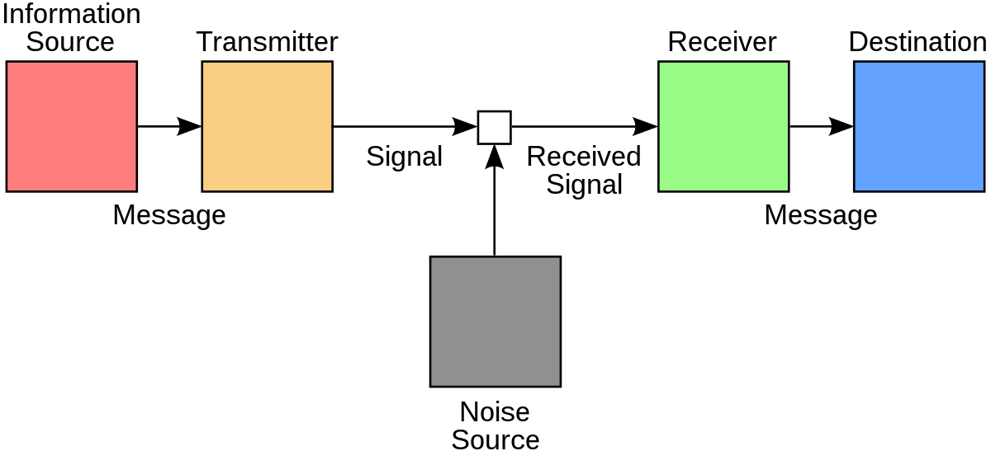
Figure: Shannon and Weaver Model of Communication
(Source: CMT, 2022)

Case Study
In the case of Maria and Pedro, there was an issue of misunderstanding observed between the couple that has become a classic example of misunderstanding and communication gap. Maria asked Pedro to bring chicken for dinner and Pedro heard, Kitchen instead of Chicken. Therefore Pedro analysed the conversation as if Maria called him to tell him that she would meet him in the Kitchen as soon as he reaches home. Thus, when Pedro reached home he became aware of the issue and misunderstanding. If Pedro could have asked Maria a second time about why exactly she called just to be sure, the whole misunderstanding could be avoided.
A Similar Experience in the Workplace
Yes, I have faced a similar example at my workplace. One day, My co-worker asked me to bring an important file to the office. She called me an early morning to remind me about the file. I was sleepy and I could not concentrate on what exactly she was saying. I thought she was asking me for a most recent file. I had it on my table. Therefore after getting ready I rushed to my office while taking the file that was in front of me. After reaching the office when I offered her the file she said I had been mistaken and brought the wrong file. Then I had to go back home, look out for the file and brought it to the office. If I could have just given her a call before leaving the whole situation could be avoided.

2.2 Schramm (1954)
Description
The Schramm (1954) model is an influential communication model that is used to analyze the process of communication. It is a linear model that explains the flow of information from a sender to a receiver. It is also known as the linear communication model or the transmission model (CMT, 2021).
The model was first proposed by Wilbur Schramm in 1954 and is based on the idea that communication is a linear process, with a sender encoding a message, sending it through a channel, and a receiver decoding it. The model has three components: sender, receiver and message. The sender is the person sending the message, the receiver is the person receiving the message, and the message is the content of the communication. The Schramm (1954) model differs from the Shannon and Weaver (1949) model in that it is more focused on the interpersonal communication process, while the Shannon and Weaver (1949) model is a more technical model focusing mainly on the transmission of information. The Schramm (1954) model also includes feedback, which the Shannon and Weaver (1949) model does not (Lin and Lin, 2020). Feedback is the process by which receivers respond to the sender's message, and this response is used by the sender to modify the message and send it again. The Schramm (1954) model also takes into account the context in which the communication is taking place, such as the relationship between the sender and receiver, the environment, and the culture in which the communication occurs.
In summary, the Schramm (1954) model is an influential communication model that is used to analyze the process of communication. It is a linear model that explains the flow of information from a sender to a receiver and differs from the Shannon and Weaver (1949) model in that it is more focused on the interpersonal communication process and includes feedback (Kalogiannidis and Papaevangelou, 2020).
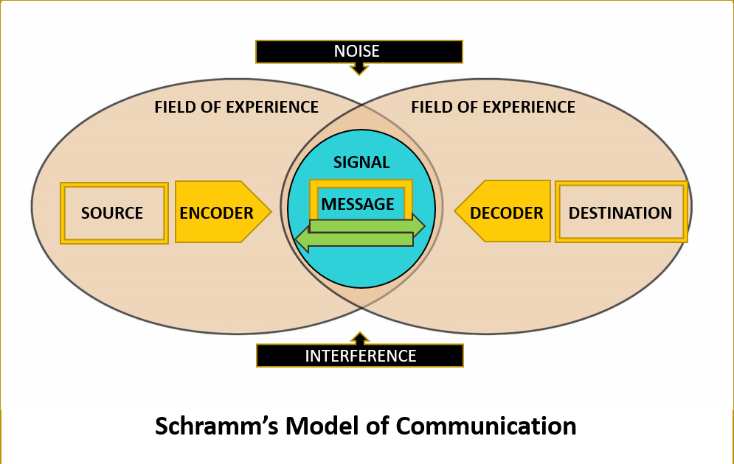
Figure: Schramm's (1954) model
(Source: CMT, 2021)

Case Study
Pedro could have asked Maria twice about her requirement. Even Pedro could even request Maria to write him a list of requirements over a text message. In this way, the situation could easily be avoided.
A Similar Experience in the Workplace
As it has been explained earlier, there was a miscommunication at the workplace with the file I brought to the office. In order to avoid such kind of situations nowadays I prefer to ask people to send me a text of their requirements so that I can not make a mistake out of miscommunication.

2.3 Berlo (1964)
Description
A linear, interactive model of communication, Berlo's model was created by David Berlo in the 1960s. It describes the sender, the recipient, the message, and the channel as four interconnected parts of a whole. The sender is the one who creates the message and transmits it to the recipient using an encoding method. A message's receiver is the one who gets it, deciphers it, and replies to the sender (CMT, 2021). The channel is the way by which the information is sent from the sender to the recipient, and the message is the information itself.
Unlike competing models of communication, Berlo's approach places primary emphasis on the receiver. Since both the transmitter and the receiver are participating in the model developed by Berlo, the process of communication is considered to be interactive. Additionally, this model considers the attitudes of both the sender and the receiver, as well as contextual and medium-specific elements, all of which can have an impact on the efficacy of the communication process (Hagiu and Bortoș, 2021).
Whereas Shannon and Weaver's linear model of communication focuses solely on the message's transmission, Berlo's model emphasises both the message's transmission and the receiver's comprehension. It recognises that the message's efficacy depends on the recipient's interpretation and understanding of the sender's intended meaning. Berlo's model also highlights the significance of receiving feedback from the recipient to confirm that the message was received and processed correctly.
Schramm's model of communication differs from Berlo's in that it is more all-encompassing, considering not just the technical components of communication but also its social and psychological contexts. Schramm's model also stresses the significance of the medium of communication and the importance of knowing the context of the communication.
Berlo's model of communication, in conclusion, is an interactive model that places a premium on the role of the receiver. It considers the sender's and receiver's mentalities as well as contextual and environmental aspects as well as the channel of communication itself. This model is distinct from the linear model proposed by Shannon and Weaver and the more complete model proposed by Schramm because it emphasises the receiver's comprehension of the sent information.
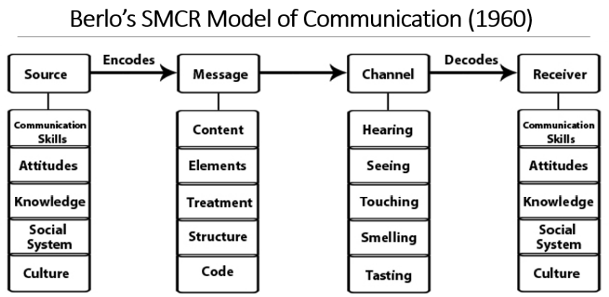
Figure: Berlo's communication model
(Source: CMT, 2021)
Case Study
The English professor and home fire anecdote illustrate the power of words. When his house caught fire, the professor, a distinguished linguist, was able to vividly describe the scenario. He stated it was a huge fire engulfing the structure. His account of the fire's destruction helped others understand its severity. This study shows how words may create vivid mental images. The Berlo method may help the English instructor and villagers communicate well.
A Similar Experience in the Workplace
In my workplace, I had a similar experience. Once a pigeon came inside the office and it was roaming around vigorously. Many of the employees became scared of the situation and started panicking. The HR saw the situation, took the matter in hand, used her positive attitude, communication and people-handling skills at work and was fi]nally able to calm everyone down, call a bird catcher and finally the pigeon was out of the workplace.

3.0 COMMUNICATION SKILLS

3.1 Verbal
Words and language are used in verbal communication to communicate ideas and information. Words and language are used to convey concepts, ideas, and emotions, and this is the most common method of communication (ML, 2022). The term "verbal communication" is broad enough to encompass both spoken and written language. Speech, writing, and reading are all forms of verbal communication.

3.2 Non-Verbal
Communicating without using words or language is called nonverbal communication. Facial expressions, body language, and other types of nonverbal communication are all part of this mode of communication (Koegel et al., 2020). Facial expressions, body language, gestures, eye contact, and posture are all forms of nonverbal communication.
CASE STUDIES
In the case study situation of a day with the chief, Mark was really scared and nervous about her meeting with Mrs Brown. Mrs Btrown has a great personality and people-handling skills that made Mark comfortable. Therefore by the end of the meeting, Mark was able to finish up the given task of communicating with Mrs Brown appropriately. Here, Mark should have been calmer and more composed. In this way, he would not have been providing Mrs Brown with his company’s confidential information. Mrs Brown’s strong utilisation of verbal and non-verbal communication processes helped her gather the required information she needed before getting into direct business with Mark’s company precisely.

3.3 Listening -
To engage in active listening is to pay close attention to what the other person is saying and then reply appropriately. Listening actively means not only hearing what the speaker says, but also interpreting what they mean by what they say and how they say it (Manusov et al., 2020). Active listening also entails responding to the speaker with questions and comments to demonstrate comprehension. Asking questions, giving comments, and paraphrasing back what the speaker has said are all examples of active listening.
It is a style of communication known as "empathetic listening" where the listener takes the speaker's sentiments into account and provides a supportive response. Listening with empathy means taking the other person's feelings and point of view into account and reacting in a way that demonstrates one has heard and comprehended their words (Jonsdottir and Fridriksdottir, 2020). A few characteristics of an empathic listener are exhibiting comprehension, expressing sympathy, and offering encouragement.
CASE STUDY
In the case of Max the Mul6titasker, Tamara was observed to be sad and angry with Max as he failed to provide her with her party on the decided date. Therefore she had to cancel the whole invitation and other plans she made. Here both the characters needed to be in each other’s shoes and assess the situation. Possibly Max assessed the situation better. That is why they as seen to be offering Tamara an offer of arranging the Party at half cost. Tamara should have also done the same, she should have been a bit more understanding and could have agreed to Max’s offer. This way they both could have maintained a good relationship with each other precisely.

4.0 The Advantages And Disadvantages Of Technology In Communication
Advantages:
1. Technology has made it easier to communicate with people from all over the world. Through the use of email, video conferencing, and social media, people can send messages and share ideas quickly and easily.
2. Technology has enabled businesses to increase productivity and efficiency by streamlining communication processes. Through the use of online platforms, companies can send emails, create shared documents, and collaborate on projects with colleagues from different departments and locations in real-time (LMS, 2022).
3. Technology has made it easier to share information and resources. People can access information from all over the world via the internet, and share their own knowledge and experiences with others.
4. Technology has allowed people to stay connected with their friends and family. Social media platforms such as Facebook, Twitter, and Instagram make it easy to stay in touch with people from all over the world.
Disadvantages:
1. Technology can be distracting and lead to decreased productivity. People can become too focused on their devices and may forget to take breaks or concentrate on their work.
2. Technology can lead to a feeling of disconnection from the people around us. Spending too much time on our devices can make us feel isolated and disconnected from those living around communities (Chakraborty and Rodrigues, 2020).
3. Technology can lead to an increased feeling of stress and anxiety. People can become overwhelmed by the amount of information and notifications they receive, and can feel pressured to constantly stay connected and updated.
4. Technology can be expensive and complicated to use. Companies may need to invest in technology infrastructure and hire specialists to help them use the technology correctly.

5.0 CONCLUSION
In conclusion, communication has evolved over the years and is now a vital part of our daily lives. The various models of communication help us to understand the different types of communication that occur in our lives. Communication skills are important in order to effectively communicate with others. Technology has both advantages and disadvantages when it comes to communication. It can be a great tool for connecting people from all over the world, but it can also be a distraction from real-world communication. Communication is an important part of our lives and it is important to understand the different types of communication, the communication skills needed to effectively communicate, and the advantages and disadvantages of technology in communication.

6.0 REFERENCES
Cargill, S.S., 2019. How do we really communicate? Challenging the assumptions behind informed consent interventions. Ethics & human research, 41(4), pp.23-30.
Chakraborty, C. and Rodrigues, J.J., 2020. A comprehensive review on device-to-device communication paradigm: trends, challenges and applications. Wireless Personal Communications, 114(1), pp.185-207.
CMT, 2021, “BERLO’S SMCR MODEL OF COMMUNICATION”, Available at https://www.communicationtheory.org/berlos-smcr-model-of-communication/ [Accessed on 31st December 2022]
CMT, 2021, “OSGOOD- SCHRAMM MODEL OF COMMUNICATION”, Available at https://www.communicationtheory.org/osgood-schramm-model-of-communication/ [Accessed on 31st December 2022]
Hagiu, A. and Bortoș, S., 2021. Towards an Applied Ethics in Digital Communication: A Transdisciplinary Perspective on Responsibility. Analele Universității din Craiova, Seria Filosofie/Annals of the University of Craiova, Series: Philosophy, 48(2), pp.110-123.
Jonsdottir, I.J. and Fridriksdottir, K., 2020. Active listening: Is it the forgotten dimension in managerial communication?. International Journal of Listening, 34(3), pp.178-188.
Koegel, L.K., Bryan, K.M., Su, P.L., Vaidya, M. and Camarata, S., 2020. Definitions of nonverbal and minimally verbal in research for autism: A systematic review of the literature. Journal of autism and developmental disorders, 50(8), pp.2957-2972.
Lavalle, 2020, “Beyond Shannon-Weaver communication”, Available at http://lavalle.pl/vr/node332.html [Accessed on 31st December 2022]
Lin, X. and Lin, C., 2020, March. Communication theories applied in mentimeter to improve educational communication and teaching effectiveness. In 4th International Conference on Culture, Education and Economic Development of Modern Society (ICCESE 2020) (pp. 870-875). Atlantis Press.
LMS, 2022, “David Berlo's Model of Communication (Strength and Weeknesses)”, Available at https://lms.su.edu.pk/lesson/2492/david-berlos-model-of-communication-strength-and-weeknesses [Accessed on 31st December 2022]
Manusov, V., Stofleth, D., Harvey, J.A. and Crowley, J.P., 2020. Conditions and consequences of listening well for interpersonal relationships: Modeling active-empathic listening, social-emotional skills, trait mindfulness, and relational quality. International Journal of Listening, 34(2), pp.110-126.
ML, 2022, “Chapter 3: Verbal Communication”, Available at https://open.lib.umn.edu/communication/part/chapter-3-verbal-communication/ [Accessed on 31st December 2022]

