DS 1 Template

My Screenshots/Photos
- Please add 4–6 screenshots or photos of your digital life.
- You can use your phone or laptop.
- For each screenshot, write one or two sentences explaining what it shows.

Screenshot/Photo 1
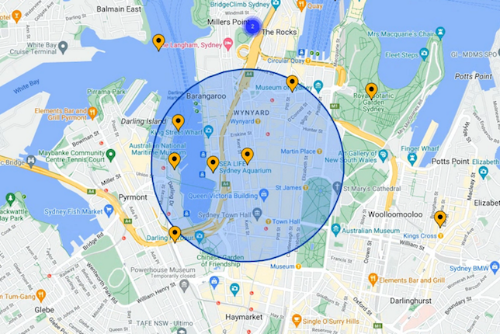
Google maps
I use google maps for my digital life because it helps me find directions and helps me get to where I need to go quick, it makes my journeys more efficient, and it is so quick and easy to do. As well as this Google map is so good that its cam tell u all the different transportation that there is and how long it will take for u to get there depending on your location and the transportation that u want.

Screenshot/Photo 2

Snapchat
I use snapchat for my digital life because it teaches me how to edit my videos that I want to post on Snapchat such as putting on a filter and choosing a sound of a little emoji that I want to add to my snapchat. In addition, another good thing that snapchat has that helps my digital skills is that I can crop videos just incase I do not like some of the video

Screenshot/Photo 3
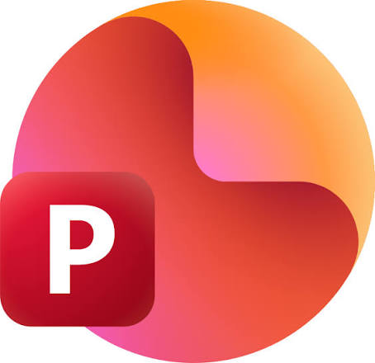
Powerpoint
I use powerpoint for my digital life because it helps me make really good presentations and how to add big box so I can write all the information I need to and also the effects so when I am presenting it looks very nice and not so basic and also the different backgrounds. As well as this powerpoint is good for digital life because u can add pictures from your gallery.

Screenshot/Photo 4

TikTok
I use TikTok for my digital life because this shows me how to make videos and to also go live so that they can comment on my videos and another good thing that TikTok has is that you can repost a video so if u like a video on TikTok you can repost u and other people can like the video because u reposted it. In addition to this TikTok is really good for digital life because u can do battles for gifts and speak to ur fans and they would send u roses.

Screenshot/Photo 5

Uber eats
I use uber-eats for digital life because it is such a officiant app all your favourite stores are on there for example, Asda, Morrisons and much more and the app is so quick pick all your items and then u can pay straight away using apple pay and u can also message the driver to see how far they are and it also tells you how many minutes they are from you. In addition to these uber-eats is really helps if u do not want to travel to get your groceries

Screenshot/Photo 6
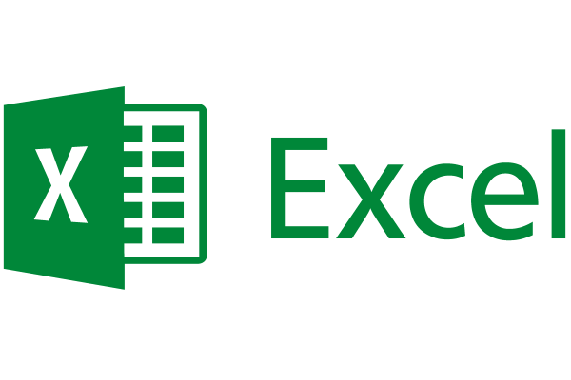
Excel
I use excel for digital life because if u are a banker or someone who really loves saving money excel is the app for you because you can put it all your categories if it is groceries, electric bill and calculate and total on excel and it will give you ur estimated-number and it is good if your someone that really loves to write down how much money u have and how much you are trying to save. It is useful and helpful for bog families or a budgeter.

My Short Reflection
- Write 5–8 simple sentences about your digital life.
- You can use the sentence starters below if helpful.
- I use digital skills to help improve the way I take my photos and how I can improve my photos by using funny filters and adding little emojis and posting funny videos.
- I want to improve my creative skills and I want to be able to make videos look nice and make two videos look like one video sp that it looks nice and be able to make my videos that I post nice so that people can like and comment.
- I feel confident when I do presentations such as using powerpoint because I know how to make my presentations nice and know how to insert a text box and add all the special effects so when I am presenting it looks good.
- I sometimes feel nervous about learning about new apps that u can use for digital skills because it is a lot and there would be a lot of new settings and new things to make a video or a presentation 10x better and I also feel nervous about messing up that i feel like its pointless.
- Digital skills are important for me because when I’m older I wanna have mu own clothing business so learning all about digital skills and so much more skills I feel can have a advantage for me.

Sentence starters
- I use digital tools to …
- I feel confident when I …
- I want to improve …
- I often use these tools: …
- I sometimes feel nervous about …
- I hope this module will help me …
- Digital skills are important for me because …
You can write more if you want.

Submission Checklist
Before you submit, please check:
​​​ ☐ I added 4–6 screenshots
☐ I wrote short sentences for each screenshot
☐ I wrote my short reflection
☐ My work is my own
☐ My file opens correctly
​​☐ My file opens correctly

