Name: Gabriel Blagrove
Student Number: 2519498
Course title: BA Religion, Philosophy and Ethics
Date: 19th October 2025

My reflective response to the Carmarthenshire Museum trip, from the perspective of religion.
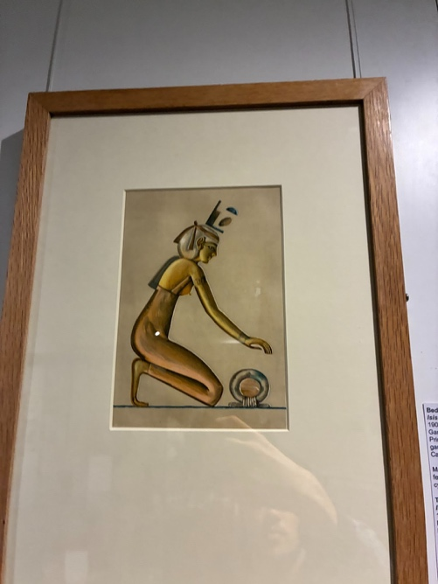
Fig. 1
During our visit to the Carmarthenshire Museum in Abergwili, I learned how deeply religion, especially Christianity, has shaped the history and identity of Carmarthen. The museum, once a Bishop’s Palace, offered a glimpse into how faith influenced daily life, culture, and community in this area. Although the museum also displayed other religions, such as the polytheistic Egyptian religion through a depiction of the goddess Isis (Fig 1), it was the Christian artifacts that stood out the most and made me reflect on how important Christianity has been to Wales.
Through this visit to a museum, I have realised that our culture - both tangible through physical artefacts, and intangible through stories, songs and myths - is all around us and quite literally we are living in it. It is how we interact with our histories, art, music, and faith that shapes our communities. Raymond Williams in his book Keywords, says that from the 20th century that this is the most widespread use of the term culture. He lists, “music, literature, painting, and sculpture, theatre and film” as forming the most recognised understanding of culture.
During my visit to the Carmarthenshire Museum, I saw this clearly through the museum building itself which is 700 years old. However, the part that stood out to me the most was the chapel room, which is why I chose to focus on Christianity's effects on our lives. One of the main reasons for the creation of these buildings was to bring glory to God. The book shown in the display and photo (Fig 2) was a Welsh Bible, reminding me of how deeply Christianity is connected to both our language and our culture.

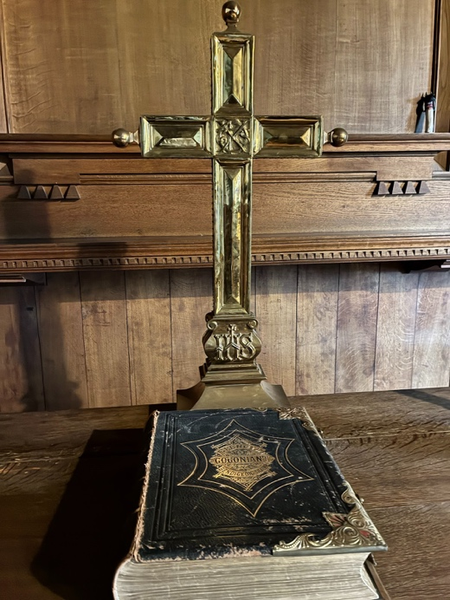
Fig 2.
Across Wales, we mainly see churches such as Baptist, Methodist, and Congregationalist chapels. This is because, during the 18th and 19th centuries, these free churches became the heart of many Welsh communities, shaping their traditions, language, and music. During the 18th century, Carmarthenshire was full of chapels in villages and towns; for instance, in Blaenavon, chapels were integral to the community, offering not just religious services but also acting as venues for lifelong learning, entertainment, politics, and culture. By the late 19th century, they became one of the few places in industrial South Wales where the Welsh language was actively used. Additionally, in Aberdare, chapels like Siloa Chapel, established in 1841, were central to community life. They hosted services in Welsh and were known for their long-serving ministers, reflecting the deep-rooted connection between religion and community activities. These chapels were more than just places of worship; they were vital hubs that preserved Welsh language and culture while fostering a strong sense of community across Carmarthenshire and beyond.

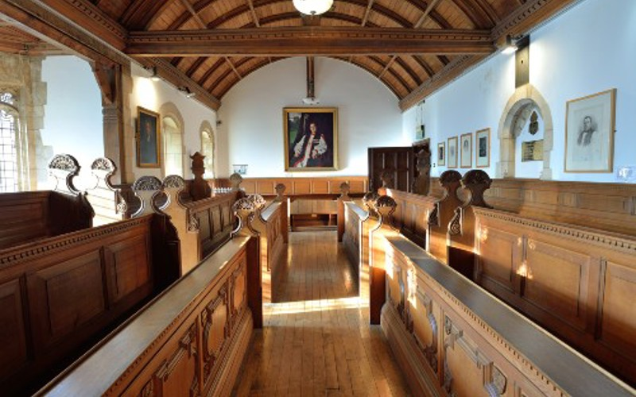
Fig 3.
During my research and visit to Carmarthenshire Museum, it made me think about Christianity not only being influenced by faith and worship in Wales, but also education. Many early schools in Wales were founded by churches and chapels and the Sunday school movement in Carmarthenshire helped shape literacy and the use of Welsh language. This meant that Christianity directly impacted education and Welsh language literacy. Furthermore, the religious instruction offered in these schools was conducted in Welsh, which contributed to the preservation and promotion of the language during a period when English was becoming more dominant in public life. This bilingual education model ensured that Welsh remained a vital part of community identity and communication.
One thing that really caught my attention in the museum was the gold cross placed above the Bible (Fig 2). Seeing cultural objects like this makes me think about the past and how incredible it is that people with so few tools and resources could create such detailed and meaningful works of art. In the photo of the Chapel (Fig 3), there was a portrait of William Dobson, which also impressed me with its beauty and skill. What stood out to me throughout this whole trip was how these objects reflected both faith and skill. The gold cross symbolised devotion to Christianity; during the time it was created, gold would have been rare and costly, yet people were willing to invest in such materials to honour their beliefs. This showed how powerful faith can be in inspiring creativity and sacrifice. The craftsmanship and care put into each detail revealed not just artistic ability, but a deep spiritual purpose behind the work. Standing before these pieces, I felt a sense of connection to the people who created them centuries ago, realising how faith and creativity have always worked together to shape culture and identity.
Personally, I am not a Christian; however, I deeply appreciate the importance of community, unity, and shared belief in society. This is why I attend church every week and value the messages the Bible offers. Christian values have played a significant role in shaping our country, and I recognize how fortunate we are to benefit from them. Although church attendance has declined over the years, according to Emma Lawson, “in 2018, only 4 per cent of 18 to 24-year-olds reported attending church at least monthly. Today, that number has risen to 16 per cent, with young men increasing from 4 per cent to 21 per cent, and young women from 3 per cent to 12 per cent”. Many of our Welsh cultural events—Christmas, Easter, Harvest Festival, and St David’s Day —are deeply rooted in Christianity, highlighting the profound and lasting impact the religion continues to have on our society. As fewer people attend church for strictly religious reasons, churches have adapted by generating income through other means, such as becoming community centres or museums. For example, Carmarthenshire Museum, originally a bishop’s palace, demonstrates how churches still shape and preserve our local identity.
Overall, Christianity’s influence on Carmarthenshire and Wales reaches far beyond religion, and it has helped me understand how deeply Christianity has shaped not only the history of Carmarthenshire but also the identity of Wales itself. Although I am not religious, I can appreciate how religion has helped preserve our language, inspire us in our understanding of art and strengthen our unity as communities. I felt that Carmarthenshire Museum stands as a strong message about how the past cultures and traditions live within us, connecting our current generation with past generations. Understanding how faith shaped Carmarthenshire helps us value the cultural foundations that continue to influence modern Wales. By learning from the past, we can appreciate how belief, identity, and community remain connected in shaping who we are today.

List of Figures:
Figure 1: Isis (1907) by E. H. Jones. Print of a Watercolour in the Carmarthenshire Museum. Image taken by the author.
Figure 2: Gold Cross and Bible. Photograph taken in The Chapel Room in Carmarthenshire Museum. Image taken by the author.
Figure 3: The Chapel Room in Carmarthenshire Museum, Carmarthenshire County Council, accessed October 19, 2025, https://www.carmarthenshire.gov.wales/business/filming-opportunities/locations/carmarthenshire-museum/.

Carmarthenshire County Council, “Carmarthenshire Museum,” accessed October 19, 2025, https://www.carmarthenshire.gov.wales/business/filming-opportunities/locations/carmarthenshire-museum/.
Raymond Williams Keywords. 1983.p 90.
Parc yr Esgob, “Carmarthenshire Museum,” accessed October 19, 2025, https://parcyresgob.org.uk/visit/carmarthenshire-museum/?utm_source=chatgpt.com.
“The Glory of God: The Right Purpose in Building,” Proclaim & Defend, February 13 2018, accessed October 19 2025, https://www.proclaimanddefend.org/2018/02/13/the-glory-of-god-the-right-purpose-in-building/.
Faith in Wales: Counting for Communities, (Welsh Government / Gweini & WCVA), accessed October 19, 2025, https://www.gov.wales/sites/default/files/statistics-and-research/2019-07/080331-faith-wales-counting-communities-en.pdf
Visit Blaenavon, “Non-Conformist Chapels of Blaenavon,” accessed October 19, 2025, https://www.visitblaenavon.co.uk/assets/documents/world-heritage-site/The-Blaenavon-Story/Non-Conformist-Chapels-of-Blaenavon.pdf?utm_source=chatgpt.com.
Welsh Government, The Big Chapel Handbook, accessed October 19, 2025, https://hwb.gov.wales/api/storage/8b8f4a86-d669-48e4-b11c-82045759ee6f/English%20The%20Big%20Chapel%20Handbook%20FINAL.pdf.
Visit Blaenavon, “Chapels and Religion,” accessed October 19, 2025, https://www.visitblaenavon.co.uk/en/learning/the-blaenavon-townscape/chapels-and-religion?utm_source=chatgpt.com.
Wikipedia contributors, “Siloa Chapel, Aberdare,” Wikipedia, last modified October 5, 2025, https://en.wikipedia.org/wiki/Siloa_Chapel%2C_Aberdare?utm_source=chatgpt.com.
“Schools,” AGOR – Cwm, University of Wales Swansea, accessed October 19 2025, https://www.agor.org.uk/cwm/themes/Life/education/schools.asp
“The Sunday School in Wales in the 19th Century,” Pembrey and Burry Port Heritage, accessed October 19, 2025, https://pembreyburryportheritage.co.uk/the-sunday-school-in-wales-in-the-19th-century.
“William Dobson,” Encyclopaedia Britannica, accessed October 19, 2025, https://www.britannica.com/biography/William-Dobson
Emma Lawson, “The Quiet Revival: A New Generation Leads Growth in Church Attendance,” Tearfund, April 16, 2025, https://www.tearfund.org/stories/2025/04/the-quiet-revival-a-new-generation-leads-growth-in-church-attendance
"St David," Encyclopaedia Britannica, accessed October 19, 2025, https://www.britannica.com/biography/Saint-David.
Swansea & Brecon Diocese, "Gorseinon Church Hall to be Transformed into Heart of the Community," accessed October 19, 2025, https://swanseaandbrecon.churchinwales.org.uk/en/news/gorseinon-church-hall-to-be-transformed-into-heart-of-the-community/.

