Can Graphic Design really save your life? Explore the association of wellbeing and personal growth in Design in your discussion.

Student Number: 2004590

Course Title: BA Graphic Design Year 2

Word Count:

Lecturer: Donna Williams

Graphic design is an extremely powerful outlet in provoking feeling, thought and emotion in others, and often in changing perspectives (Montogomery, 2014). It is said that our human response to visuals and images around us is emotional rather than intellectual. It is immediate, something we learn to do even before reading and speaking (Schrauwen, Roberts and Wright, 2017, p.028). Nick Bell once stated, “you save lives by making life worth living” (Schrauwen, Roberts and Wright, 2017, p.080), and so, from this, we can take the knowledge that graphic design is an influential tool that can be used to paint a better future. It can open eyes to so many matters of the world with just one look. Many designers have certainly had a strong influence on our behaviours, attitudes, and outlooks in life. Therefore, we ask ourselves, can graphic design really save the world?

The packaging a company chooses to implement is often considered in relation to sustainability, as climate change continues to threaten the futures of all life on Earth. For example, FRAHM (D&AD Awards, 2021) is a company who avoids waste and resources with its pre-order model in place. In addition, climate change and greener thinking has been promoted by many designers, such as High Mountain Creative. They not only have their own environmental campaigns such as ‘Cool Effect’ and ‘Leave No Trace’ (High Mountain Creative, 2021) which promote sustainability, but also recognise the significance of designers on the wellbeing of our Earth by their campaign ‘I am a Climate Designer’. This is an initiative to reach out to designers to make a difference to the world’s global warming crisis through design. Similarly in the sense that it’s a campaign to motivate other designers to inspire change, is the LIFE poster, awarded by D&AD Awards (2021). These graphic examples are essentially inspiring designers to inspire change, yet another way that could save lives, by giving designers the means and motivation to inspire change in the world, particularly in times of difficulty such as quarantine, as the LIFE poster addresses. Climate change Causes such as Extinction Rebellion utilise graphic design to spread awareness of the urgency of the world’s state in public stands like protests, with graphics as in fig. 1. There is a lot they set out to communicate to the public via their designs, which are carefully thought out to communicate the peaceful nature of their cause, but also the urgency to the world and humanity, with the ‘extinct’ skulls in the background depicting the fate of humanity if change is not made (Dawood, 2019). Therefore, an abundance of graphic designers are working to spread this sense of urgency, so that we might save our world from the threats of global warming in the future.
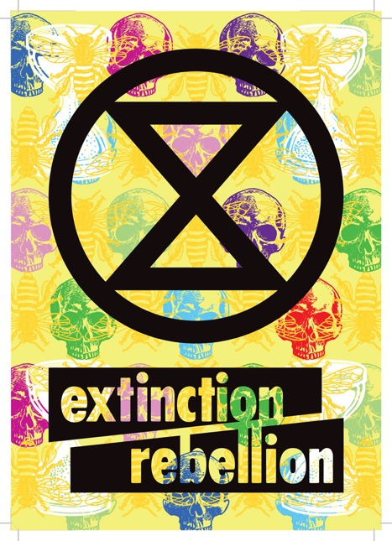

Figure. 1.
Graphic design has a vital role to play in displaying medical data to the public. It is stated by Wiswede et al (2006) that the human brain recognises pattern well, and that the eye is drawn to shapes and something that stands out with ‘distinctiveness’, known as the Von Restoroff effect. This supports why graphic design within the industry of public health is so important in terms of the public having clear understanding of significant things issues like medical conditions. A leaflet containing information of a medical condition needs to be designed well for maximum understanding with significant data easily distinguished by the reader (Duke et al, 2015), which could make the difference of a person’s life in recognising something like a medical condition. This is again the vital power of graphic design in actively saving lives.
A visit to hospital or to A&E is something most of us are unacquainted with, yet this is something everyone will experience in their life at some point. Therefore, when this experience comes by it does not help the stress of the situation that many hospital surroundings are not designed for the easiest understanding or for a welcoming feeling. The implementation of graphic design including “pictograms, diagrams, colour and clear typography” has been shown to decrease stress levels of patients and staff (Schrauwen, Roberts and Wright, 2017, p.096-097). Dani Rubio Arauna made an incredible difference to children’s hospital Sant Joan de Déu by designing the hospital with a focus on colour, animals, and pattern to engage the children and make the environment less clinical with the installations as in fig. 3. The project also implements a way-finder system as in fig.2, making hospital visits easier to navigate, and so less stressful for both parents and children, and in turn, for staff, allowing them to provide better services (Arauna, 2012-2018).
Adding to this, Elif (2019) is a useful source in describing just how significant it is to us, as people, that we can effectively communicate with others and our surroundings, and likewise, the environment around us needs to communicate, too, with its own “spacial language”. The urban world is forever growing and becoming more difficult to interpret, and the source argues that best method in easing this and creating a global language that everyone can understand, is the practice of graphic design and all the visuals that come with it. As, after all, good designers know how to visually communicate to people in the best and most comprehensible way.

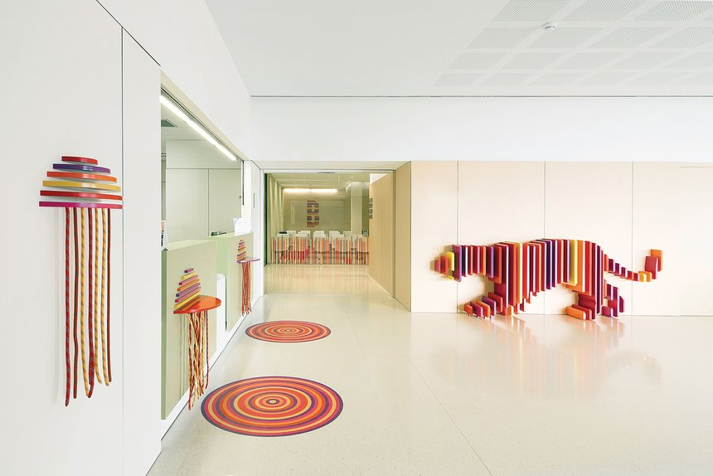
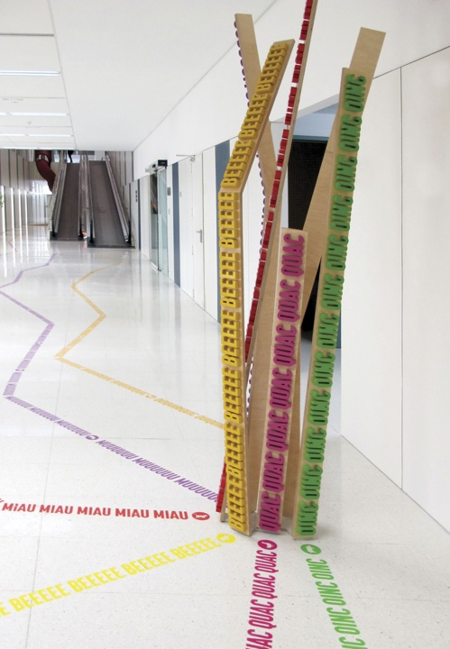
Figure. 2. Figure. 3.

To tackle Zika, a disease mainly spread by mosquito bites, NBS and Posterscope derived a genius idea to attract mosquitoes to billboards that resemble the way mammals breathe by releasing an airborne solution. This attracts the mosquitoes to the sticky surface from as far as 4km distance and traps them. These billboards save many lives by being placed in areas of high zika outbreak, as well as spread awareness of the disease (Dentsu, 2021). BBC NEWS (2016) commented that "It's impressive how… many lives you can save with this idea”, demonstrating how powerfully life-changing graphic design can be to countries tackling disease, particularly those less developed and struggling with poverty who might not afford the treatments for the disease. However, it is important to ensure designs such as these do not have potential dangers to the public despite their good purpose, as there has been concern of bus billboards being placed where people gather, exposing them to the risk of mosquito bites (Moscatello, 2016). These are considerations that must be made for the safety of the people.
Pandemics are something our modern world is all too familiar with today. Dating back as far as 1854, graphic design played a significant part in saving lives even then (Pinion, 2017). John Snow’s cholera map saved lives by mapping the locations of the cholera cases, identifying where the cases were most prolific, and connected it’s spreading to water pumps. This changed the way data visualisations and microbes were seen forever (Rogers, 2013).
In more recent years, COVID-19 has struck humanity, but brings with it many life-saving graphics. These graphics have informed people of government rules, reminding people to wear masks, and reminding people to self-isolate. Designers have given the public the incredible gift of clear communication and understanding in these times of fear, confusion, and uncertainty (HydraCreative, 2021) as shown by example in fig. 4. Therefore, it is argued that graphic design has played a huge role “in the prevention of the COVID-19 epidemic” (Atasoy, 2021). The source also outlines that graphic design is one of the most effective ways of communicating the government’s guidelines with the public, due to the clear and visual messages it has the power to convey. However, Creative Review calls much of the government’s mismatched and wildly varying COVID-19 graphics “very confusing”, arguing that many of their brochures were poor communicators to the public (Moore, 2020).

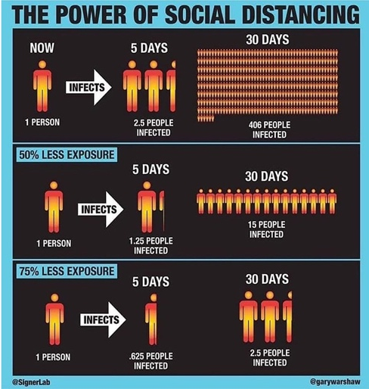

Figure. 4.

Human emotion is being increasingly considered as a vital focus of design within the health industry. (Medley, 2009) The source argues that the conservative nature of designs within the pharmaceutical industry are derived from the 1950s Swiss design. Swiss graphics are very uniform in terms of typefaces, layouts and forms, critics even describing it as “cold”. However, Schrauwen, Roberts and Wright, pp.138-143. (2017) argues that the Swiss graphic language of Geigy played a massive part in connecting hospital staff to pharmaceuticals. It has been seen to be “saving some lives”. Therefore, Geigy’s Swiss design style certainly seems to have had an impact on lives in the health and pharmaceutical industry. But it is also being questioned by Medley (2009) whether this Swiss style is as impactful as it could be in this industry, or whether a different design angle might be more impactful. However, the Swiss style is one that does not seem to become outdated. Even 60 years on, it remains extremely popular, clean, and contemporary, and acts as the international style of Graphic Design even up to today (Robinson, 2019).
Mental health awareness week circulates self-care and positivity graphics such as that of Flow (2020) via platforms such as Instagram, encouraging openness surrounding mental health, and a feeling that it is okay to not be okay. Often these graphics are shared via social media platforms and have vast influence as they spread, with a different theme each year to tackle different issues (Mental Health Foundation, 2021), accompanied by related graphics. These visual graphics spread each mental health awareness week, making a difference to someone who needs to hear positive perspectives, and perhaps even prevent suicide. Pentagram’s Mental Health Coalition (see fig.5.) utilises a square peg in a round hole to send the message that everyone experiences differing mental health and there is nothing wrong with that. The project encourages people to talk about how they are feeling, via motion graphics seen in Pentagram (2020). Leah Batchelor (2020) stated that their use of a varied colour palette and photography of many different types of people (see fig. 4) is used to reinforce this idea that everyone struggles and in different ways, normalising that “there is no normal” when it comes to mental health. These little design decisions can affect our thinking even without our knowledge.

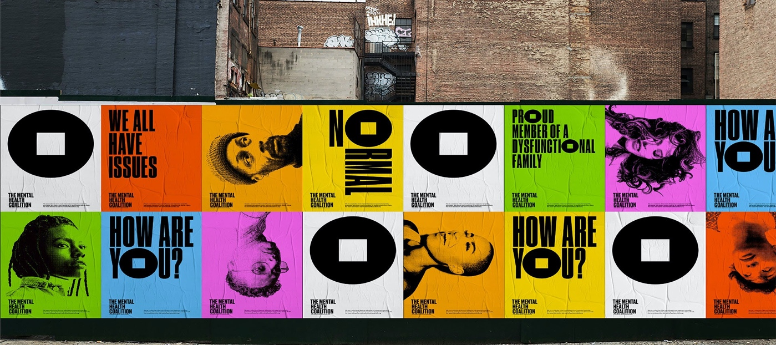
Figure. 5.

Graphic Design has so often been a tool for educational purposes, which is vitally important as every job in the world must be learnt, and people cannot provide services without learning the relevant knowledge. Gaining insight into the psychology of learning has shown the importance of graphic design to visual learners, who absorb information best by visual aids such as infographics and posters (Regional Assessment and Resource Centre, 2019). Educating those in the public health and medicine sector in particular is something graphic design has tackled in so many ways, providing visualisations of conditions that we cannot readily see by eye, such as anxiety (see fig. 6). Fig.6 is derived from a book called ‘Nobrium’, presenting a new drug for anxiety, with vivid colour and illustration yet extremely “educative and delectable” (Schrauwen, Roberts and Wright, 2017, p.144). This sort of graphic design shows the power it can have in the education sector, making the people of today more knowledgeable, and, more importantly, making this learning easier to absorb with vivid visualisations.

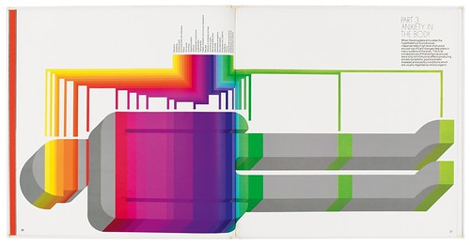

Figure. 6.

Silk Cut cigarette company’s packaging designs are shown in an exhibition by Wellcome Collection (2017) (see fig. 7) ‘Can Graphic Design Save Your Life?’ (Brewer, 2017) next to packaging for tobacco that we have today with their warning messages and disturbing photography, showing the comparison between how the packaging has developed over the years to be less appealing to buyers. During the 1980s, Silk Cut became the best-selling cigarette brand in the UK (Blum, 2019), when the smoking population in the UK was approximately 34% of the adult population. Tobacco Tactics (2020) tells us that standardised packaging has come into law in the UK on 20th May 2016, with statistics showing that 13.9% of adults in the UK smoked in 2019 (GOV.UK, 2021). Therefore, there has been an approximate 20.1% decrease in smokers since the 1980s. A strong factor in this decrease could be down to the changes in graphic design, in which case the preventative danger warnings featured on today’s packaging could be saving lives, by making smoking less appealing, an incredibly powerful effect on public health. However, there has been evidence to show that the negative graphic warnings on packaging do not implicitly affect smokers’ outlooks to smoking over text-only warmings (Van Dessel et al, 2018).
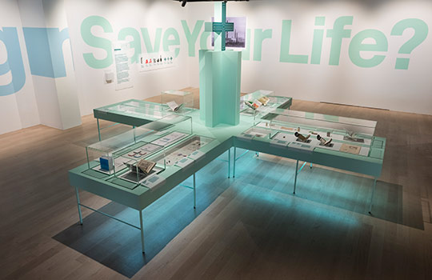

Figure. 7

The expression of opposition by designers to prejudice in the world could be seen as a way that Graphic Design could save lives in the future, by spreading awareness of these discriminations that exist. The visual power of the Black Lives Movement following the murder of George Floyd was profound, and graphics in relation to the tragedy spread around social media, a platform that gets people talking and, in turn, can lead to changes in opinion and feeling (Freelon, D., Mcllwain, C.D. and Clark, M., 2016). Greg Bunbury, a designer prolific in this movement, once said “graphic design should be a tool for social change” (Wong, 2020), an ideal he utilised in his ‘I can’t Breathe’ campaign in fig. 7. In addition, graffiti artist Banksy’s work shines light on the deep feelings held by society. Banksy’s very own support of the BLM movement shows this with his most recent artwork (Banksy, 2020). Gilbert Baker is another designer who seeks to change the world through his work. For example, his Gay Pride flag design, bringing this in for the LGBTQ+ community to embrace as their identity. Baker envisioned replacing the Pride design with a “symbol of gay visibility and diversity” (Kirkus Reviews, 2019), not one that functions as a “tool of Nazi oppression” as it historically had. (Gilbert Baker Foundation, 2019).

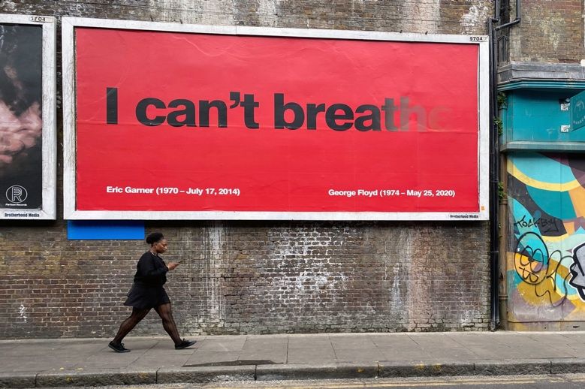

Figure. 8.

The significance of graphic design historically and in our modern world is profound and has a massive influence on so many areas of everyday life. Due to this influential power it holds, it is extremely important that a specific piece of graphic design really considers its impact and its purpose and has the intended effect on people. So, if graphic design really can save lives, graphic designers hold a lot of responsible to make the right impact on the world rather than the wrong one. These risks are clear after looking into the mosquito-killing billboard that was argued to put people more at risk. However, it is said that great design “cannot save the world, but it can make the world worth saving” (Montgomery, 2014), demonstrating its power as a tool in shaping the future and making the world a better place. After all, graphic design, by a literal means, is visual communication, and so what a designer communicates can be anything they see fit to tell the world, namely “life ideas” (Roberts, 2019). Everyone has been impacted by graphic design, and whether that is negative or positive is in the eye of the beholder, and up to the designer behind the designs. One thing that can be said about graphic design for certain is that it has the incredible power of impacting the views, opinions, and feelings of the people of world, and, in countless instances, in saving lives.

Bibliography

Arauna (2012-2018) Hospital Sant Joan de Déu. Available at: http://arauna.studio/project/hospital-sant-joan-de-deu/ (Accessed 7 December 2021).

Atasoy, S. (2021) ‘The role of graphic design in the COVID-19 global outbreak’ New Trends and Issues Proceedings on Humanities and Social Sciences, 8(1), p.3. Available at: https://un-pub.eu/ojs/index.php/pntsbs/article/view/5791 (Accessed 6 December 2021).

Banksy (2020) Black Lives Matter artwork. Available at: https://www.theguardian.com/artanddesign/2020/jun/06/banksy-black-lives-matter-latest-artwork (Accessed 3 December 2021).

Batchelor, L. (2020) ‘Pentagram Uplifting brand for Mental Health’, Leah Batchelor [blog]. 25th May. Available at: https://leahbatchelor.wordpress.com/2020/05/25/pentagram-uplifting-brand-for-mental-health/ (Accessed 3 December 2021).

BBC NEWS (2016) Can ‘sweaty billboard’ help fight Zika virus? Available at: https://www.bbc.co.uk/news/technology-36094565 (Accessed 10 November 2021).

Blum, A. (2019) ‘Silk Cut: Surrealism as Subversion’, The University of Alabama: College of Community Health Sciences, 25th July. Available at: https://csts.ua.edu/silk-cut/ (Accessed 3 December 2021).

Brewer, J. (2017) ‘Can Graphic Design Save Your Life? Explores “widespread and subliminal” impact of design on health’, It’s Nice That, 5th September. Available at: https://www.itsnicethat.com/news/can-graphic-design-save-your-life-wellcome-trust-exhibition-lucienne-roberts-rebecca-wright-050917 (Accessed 1 December 2021).

Montgomery, A. (2014) ‘Can Design Save the World?’, Design Week, 30th June. Available at: https://www.designweek.co.uk/issues/june-2014/can-design-save-the-world/

Schrauwen, S. Roberts, L. and Wright, R. (2017) Can Graphic Design Really Save Your Life? London: GraphicDesign&.

D&AD Awards (2021) FRAHM – Tough and Beautiful. Available at: https://www.dandad.org/awards/professional/2021/234858/frahm-tough-beautiful/ (Accessed 21 November 2021).

D&AD Awards (2021) LIFE poster. Available at: https://www.dandad.org/awards/professional/2021/234858/frahm-tough-beautiful/ (Accessed 21 November 2021).

Dawood, S. (2019) How Extincition Rebellion Designed “angry but peaceful” protest graphics. Available at: https://www.designweek.co.uk/issues/15-21-april-2019/how-extinction-rebellion-protest-graphics/ (Accessed 4 December 2021).

Dentsu (2021) NBS & Posterscope: The Mosquito Killer Billboard. Available at: https://www.dentsu.com/br/en/social-impact/mosquito-killer-billboard#top (Accessed 18 November 2021).

Duke, S.P. et al (2015) ‘Seeing is believing: good graphic design principles for medical research’, Wiley Online Library, 25th June. Available at: https://onlinelibrary-wiley-com.ezproxy.uwtsd.ac.uk/doi/full/10.1002/sim.6549 (Accessed 29 November 2021).

Elif, A. (2019) ‘Environmental graphic design for building information systems’, EurAsian Journal of BioSciences. Available at: https://www.proquest.com/docview/2339039761/fulltext/7A1687D5A8E74B89PQ/1?accountid=130472 (Accessed 5 December 2021).

Flow (2020), Mental Health Awareness Week Graphics [social media graphics], Mental Health Foundation’s Instagram Page. Available at: https://weareflow.uk/work/mental-health-awareness-week-2020/ (Accessed 1 December 2021).

Freelon, D., Mcllwain, C.D. and Clark, M. (2016) Beyond the Hashtags: #Ferguson, #Blacklivesmatter, and the Online Struggle for Offline Justice. Center for Media & Social Impact, American University, Forthcoming. Available at: https://papers.ssrn.com/sol3/papers.cfm?abstract_id=2747066 (Accesssed: 7 December 2021).

Gilbert Baker Foundation (2019) Rainbow Flag: Origin History. Available at: https://gilbertbaker.com/rainbow-flag-origin-story/ (Accessed 3 December 2021).

GOV.UK (2021) Cigarette Smoking Among Adults. Available at: https://www.ethnicity-facts-figures.service.gov.uk/health/alcohol-smoking-and-drug-use/adult-smokers/latest (Accessed 2 November 2021).

High Mountain Creative (2021) Saving the Planet with Green Graphic Design: My graphic design career is dedicated to protecting the planet. Available at: https://highmountaincreative.com/design-for-the-planet (Accessed 21 November 2021).

HydraCreative (2021) 5 Ways Graphic Design is Being Utilised Effectively During Covid-19. Available at: https://www.hydracreative.com/news/design-covid-19 (Accessed 18th November 2021).

Kirkus Reviews (2019) Review of ‘Rainbow Warrior: My Life in Color’ by Gilbert Baker. Published by Chicago Review Press. Available at https://www-proquest-com.ezproxy.uwtsd.ac.uk/docview/2207854056/abstract/1310407DF224EAEPQ/2?accountid=130472 (Accessed: 3 December 2021).

Medley, S. (2009). ‘The feeling’s neutral for pharmaceutical packaging: how the pharmaceutical aesthetic equals the Modernist aesthetic’, Australasian Medical Journal, 1st December. Available at: https://www.researchgate.net/profile/Stuart-Medley/publication/38109372_The_feeling's_neutral_for_pharmaceutical_packaging_how_the_pharmaceutical_aesthetic_equals_the_Modernist_aesthetic/links/569dbb4608ae950bd7a6aec8/The-feelings-neutral-for-pharmaceutical-packaging-how-the-pharmaceutical-aesthetic-equals-the-Modernist-aesthetic.pdf (Accessed 6 November 2021).

Mental Health Foundation (2021) Mental Health Awareness Week. Available at: https://www.mentalhealth.org.uk/campaigns/mental-health-awareness-week (Accessed 4 December 2021).

Moore, R. (2020) The UK government’s coronavirus strategy: shoddy by design? Available at: https://www.theguardian.com/artanddesign/2020/jun/14/the-uks-government-coronavirus-strategy-shoddy-by-design (Accessed 8th December 2021).

Moscatello, C. (2016) ‘Brazil Fights Zika with ‘Sweaty’ Mosquito-Killing Billboard’, Conde Nast Traveler, 26th April. Available at: https://www.cntraveler.com/stories/2016-04-26/brazil-fights-zika-with-sweaty-mosquito-killing-billboard (Accessed 3 December 2021).

Pentagram (2020) How Are You Really? [motion graphics] Available at: https://www.pentagram.com/work/the-mental-health-coalition/story#29615 (Accessed 14 November 2021).

Pinion, S. (2017) ‘Design for Life’, Proquest, 30th September. Available at: https://www.proquest.com/docview/2339039761/fulltext/7A1687D5A8E74B89PQ/1?accountid=130472 (Accessed 5 December 2021).

Regional Assessment and Resource Centre (2019). STEPS: Visual Learners! [video]. Available at: https://www.youtube.com/watch?v=K327aAlJkHg (Acessed 18th November 2021).

Roberts, L. (2019) Good: An Introduction to Ethics in Graphic Design. P.13. Bloomsbury Publishing. Available at: https://books.google.co.uk/books?hl=en&lr=&id=PKtpvxDCTzcC&oi=fnd&pg=PP2&dq=graphic+design+saving+life&ots=X_LZnpMK93&sig=Zwxc9pf7-ACCCjXC_r8TqoUxuJw&redir_esc=y#v=onepage&q=graphic%20design%20saving%20life&f=false (Accessed 7 December 2021).

Robinson, D. (2019) ‘How Pharmaceutical Packaging Inspired Generations of designers’, David Robinson Design [blog]. 18th April. Available at: https://www.davidrobinsondesign.co.uk/blog-1/how-pharmaceutical-packaging-inspired-generations-of-designers (Accessed 8 December 2021).

Rogers, S. (2013) ‘John Snow’s data journalism: the cholera map that changed the world’, The Guardian, 15th March. Available at: https://www.theguardian.com/news/datablog/2013/mar/15/john-snow-cholera-map (Accessed 3 November 2021).

Van Dessel, P. et al. (2018) ‘Graphic cigarette pack warnings do not produce more negative implicit evaluations of smoking compared to text-only warnings’, ProQuest, March 2018, Available at: https://www.proquest.com/docview/2014445987?accountid=130472&pq-origsite=primo (Accessed December 3 2021).

Wellcome Collection: Can Graphic Design Really Save Your Life? (2017) [Exhibition]. Euston Road, London. 7 September 2017 – 14 January 2018.

Tobacco Tactics (2020) Plain Packaging in the UK. Available at: https://tobaccotactics.org/wiki/plain-packaging-in-the-uk/ (Accessed 9 November 2021).

Wiswede et al (2006) ‘Memory recall in arousing situations – an emotional Von Restorff effect?’, Springer Link, 24th July 2006. Available at: https://link.springer.com/article/10.1186/1471-2202-7-57#citeas (Accessed 19 November 2021).

Wong, H. (2020) ‘Black Lives Matter: graphic design’s role in the protest movement’, Design Week, 3rd June. Available at: https://www.designweek.co.uk/issues/1-7-june-2020/black-lives-matter-graphic-designs-role-in-the-protest-movement/ (Accessed: 12 January)

Figures

Figure. 1.

Dawood, S. (2019) How Extincition Rebellion Designed “angry but peaceful” protest graphics. Available at: https://www.designweek.co.uk/issues/15-21-april-2019/how-extinction-rebellion-protest-graphics/ (Accessed 4 December 2021).

Figure. 2.
Arauna (2012-2018) Hospital Sant Joan de Déu. Available at: http://arauna.studio/project/hospital-sant-joan-de-deu/ (Accessed 7 December 2021).

Figure. 3.
Arauna (2012-2018) Hospital Sant Joan de Déu. Available at: http://arauna.studio/project/hospital-sant-joan-de-deu/ (Accessed 7 December 2021).

Figure. 4.
HydraCreative (2021) 5 Ways Graphic Design is Being Utilised Effectively During Covid-19. Available at: https://www.hydracreative.com/news/design-covid-19 (Accessed 18th November 2021).

Figure. 5.
Batchelor, L. (2020) ‘Pentagram Uplifting brand for Mental Health’, Leah Batchelor [blog]. 25th May. Available at: https://leahbatchelor.wordpress.com/2020/05/25/pentagram-uplifting-brand-for-mental-health/ (Accessed 3 December 2021).

Figure. 6.
Kurlanksy, M. (1971). Nobrium: Towards True Precision in the Control of Excessive Anxiety Book. [Infographic book] Available at: https://www.eyemagazine.com/feature/article/head-trip (Accessed 8th December 2021).

Figure. 7.

Wellcome Collection: Can Graphic Design Really Save Your Life? (2017) [Exhibition]. Euston Road, London. 7 September 2017 – 14 January 2018. Available at: https://blogs.bmj.com/bmj/2017/10/06/will-stahl-timmins-can-graphic-design-save-your-life/ (Accessed 4 December 2021).

Figure. 8.
Bunbury, G. (2020) I Can’t Breathe [graphic] Brixton, London. Available at:
https://bunbury.co/portfolio/i-cant-breathe-george-floyd-poster (Accessed 8 December 2021).

