

Assignment (ACCA7028)

Securing NatureGreen: A Governance and Compliance Approach for Cloud, Wireless, and BYOD Risks

Student Name: Rasithabanu Abdhul Rahim
Student ID: 2415470
Course Name: Data Security, Governance and Compliance (ACCA7028)

Table of Contents
1. Abstract 3
2. Introduction 3
3. Case Scenario Overview – NatureGreen (NG) 3
4. Analysis of Information Security Frameworks and Models 4
4.1 Overview of Security Frameworks 4
4.2 ISO 27001 4
4.3 Information Technology Infrastructure Library (ITIL) 5
4.4 The NIST Cybersecurity Framework: Structure and Functions 5
4.5 Comparison of Security Frameworks 6
4.6 Summary of Research 7
5. Proposed Approach to Security, Governance, and Compliance for NatureGreen 7
5.1 Security Governance and Strategic Planning Approach 7
5.2 Security Policies 7
5.3 Risk Management 8
5.4 Compliance (Laws and Ethics) 8
5.5 Protection Mechanisms (Technical Controls) 8
5.6 Incident Response and Contingency Planning 8
5.7 Service Level Agreements (SLAs) 9
6. Importance of Updated Regulations and Standards 9
7. Assumptions 9
8. Conclusion 10
9. References 10

1. Abstract
The rapid growth of digital technologies and internet-based services has increased the need for strong data security, governance, and compliance in modern organisations. NatureGreen (NG), a global health and wellness organisation, relies on cloud computing, extensive wireless networks, and faces growing pressure to adopt Bring Your Own Device (BYOD) practices. While these technologies improve operational efficiency and global access, they also expose NG to serious information security risks, including unauthorised access, data leakage, intellectual property theft, and regulatory non-compliance. This study analyses the primary information security challenges encountered by NG and reviews recognised governance and security frameworks such as the ISO/IEC 27000 series, ITIL practices, and the NIST Cybersecurity Framework [1]. Based on this evaluation, a structured approach to security, governance, and compliance is proposed to strengthen risk management, policy enforcement, and protection of sensitive data and multi-billion-dollar intellectual property. The report also highlights the need for continuously evolving regulations and standards to address emerging technologies, changing legal requirements, and an evolving cyber threat landscape.

2.Introduction
NatureGreen (NG) is a major global brand that sells products to support healthy living. The company depends heavily on cloud services, wireless networks, and online platforms to help its staff work and to serve customers around the world. Almost all internal connections are wireless, and NG has a strong website and social media presence to promote its brand and interact with customers.
NG is under growing pressure to let both employees and customers use their own personal devices (BYOD) to connect to company systems and resources. This creates higher risks for staff data, customer information, and valuable intellectual property, which are all critical to the business. At the same time, there is no clear, companywide security policy or framework in place, so current security practices are inconsistent and uncoordinated [2].
Because of this, NG needs a recognised cybersecurity framework to organise and improve how it identifies, manages, and reduces cyber risks related to its cloud use, wireless networks, and BYOD access. Such a framework will guide the development of clear security policies and controls that can be applied across all locations. This report recommends a cybersecurity framework for NatureGreen that supports information asset protection, stakeholder trust, and long-term organisational reputation.

3. Case Scenario Overview – NatureGreen (NG)
NatureGreen (NG) is a leading global organisation in the health and wellness sector, offering products that promote healthy living. As a well-established international brand, NG operates across multiple regions and supports a large global workforce and customer base. To maintain its market position, the organisation relies on a highly scalable and accessible operational model. NG’s technology environment depends heavily on modern digital infrastructure. The organisation uses cloud-based services to support core IT operations for employees and customers worldwide. Around 95% of its network infrastructure is wireless, reducing reliance on traditional wired systems. As NG leverages digital and social media platforms for customer engagement, ensuring reliable connectivity and continuous system operations becomes a key operational requirement.
Due to its global operations, NatureGreen faces growing pressure to adopt Bring Your Own Device (BYOD) practices. Employees and customers increasingly expect to access organisational systems using personal devices such as smartphones, tablets, and laptops. While BYOD improves flexibility and remote access, it also increases security risks, as personal devices may not meet organisational security standards, raising the risk of unauthorised access and data exposure. Although information security is considered important at NatureGreen, the organisation lacks formal security policies and structured governance frameworks. This fragmented approach creates significant risks to employee data, customer information, and regulatory compliance. Furthermore, NG’s multi-billion-dollar intellectual property remains vulnerable. Without clear oversight and control, the organisation faces an increased risk of data breaches, intellectual property theft, and regulatory non-compliance.

4. Analysis of Information Security Frameworks and Models

4.1 Overview of Security Frameworks
Security frameworks give organizations a clear set of guidelines to handle information security in a consistent and organized way. They support risk identification, policy development, role assignment, and the implementation of technical and organisational controls. Using recognised frameworks ensures security practices align with business objectives while supporting governance, accountability, and regulatory compliance. For NatureGreen (NG), which operates globally and relies on cloud services, wireless networks, and personal devices, security frameworks are essential for managing complex risks, protecting sensitive data, and maintaining trust with stakeholders.

4.2 ISO 27001
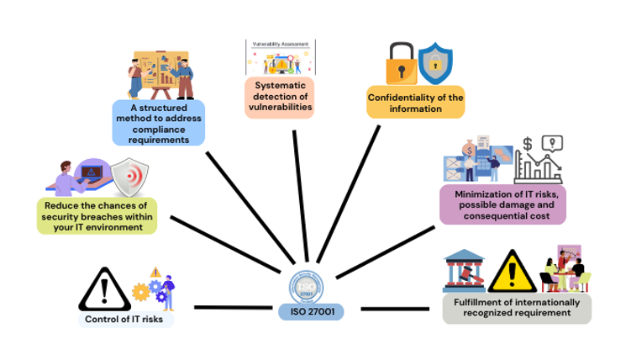
Fig 1. ISO 27001
ISO/IEC 27001 is an internationally recognised standard that establishes a formal Information Security Management System (ISMS) to manage information security in a structured and consistent manner [3]. It provides a systematic, repeatable framework rather than ad-hoc measures, helping organisations understand their context, identify information assets, assess risks, and apply appropriate controls, while regularly reviewing and improving their security posture.
For NatureGreen, adopting ISO 27001 would mean defining the ISMS scope around its cloud services, largely wireless network, BYOD environment, online platforms, and key information assets such as customer data, employee data, and high-value intellectual property, then performing focused risk assessments and selecting relevant Annex A controls like access control, encryption, network security, and supplier management. By establishing policies, clear roles, awareness training, incident management, and asset management, and embedding these into daily operations (HR, procurement, IT, product development), NatureGreen can better protect data, strengthen cloud and wireless security, manage BYOD risks, support legal and regulatory compliance, and build greater trust and confidence among customers, partners, and regulators.

4.3 Information Technology Infrastructure Library (ITIL)
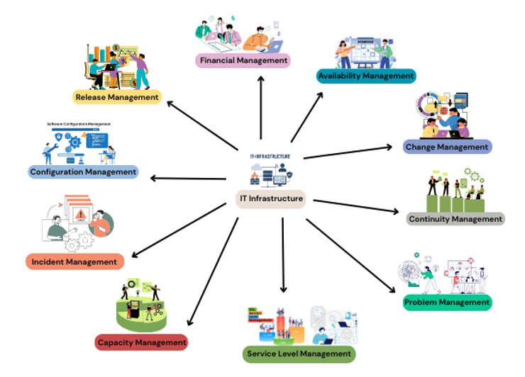
Fig 2. IT Infrastructure
The Information Technology Infrastructure Library (ITIL) is a widely adopted set of best-practice guidelines for managing IT services in a way that consistently supports business goals. At its core, ITIL covers the entire lifecycle of IT services from planning and design to implementation, operation, and continuous improvement ensuring that IT delivers reliable, efficient, and valuable services to both the organization and its customers. It emphasizes clear processes, well-defined roles, standardized workflows (like incident, problem, and change management), and ongoing monitoring to continually improve service performance.
Implementing ITIL at NatureGreen would allow the organisation to take a more structured and service-focused approach to managing its IT and security operations. By aligning service management practices with its cloud services, wireless infrastructure, BYOD environment, and digital platforms, NG could formally define critical services such as corporate Wi-Fi, cloud applications, customer portals, and IT support. Clear ownership could be assigned, and standardised processes introduced for incident management, change management, and service availability, all prioritised according to business needs. This would reduce downtime, improve responses to security and IT incidents, and enhance coordination between IT, security, and business stakeholders. For the report writer, ITIL provides a recognised framework and shared language to clearly articulate how NG can operationalise and sustain cybersecurity and IT controls in a consistent, repeatable way that supports long-term business goals [4].

4.4 The NIST Cybersecurity Framework: Structure and Functions
The NIST Cybersecurity Framework (CSF) is a high-level, risk-based framework that helps organisations understand, manage, and reduce cybersecurity risk in a structured and consistent way. It is built around five core functions Identify, Protect, Detect, Respond, and Recover which together provide a lifecycle approach to cybersecurity that aligns technical controls with business objectives. Rather than prescribing specific technologies, The CSF provides a shared framework and clear objectives that organizations can adapt to their size, industry, and level of risk.
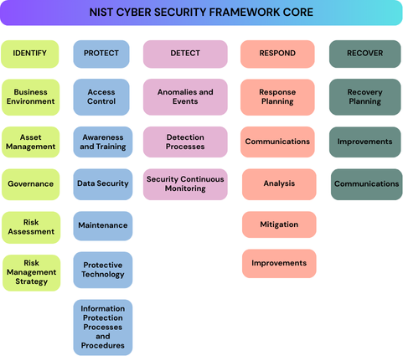
Fig 3. NIST Cyber Security Framework Core
The NIST Cybersecurity Framework adds value to NatureGreen by giving the organisation a practical, business-focused way to manage cybersecurity risk across its cloud services, wireless networks, BYOD environment, and online platforms. By structuring security activities around the framework’s five core functions Identify, Protect, Detect, Respond, and Recover NG can consistently assess risks, implement effective safeguards, detect threats in a timely manner, and respond to and recover from incidents with minimal business impact. This approach strengthens NG’s overall security posture, increases transparency of cyber risk at a management level, and supports informed, risk-based decision-making. For reporting purposes, the NIST CSF provides a widely recognised structure to clearly articulate how NG’s cybersecurity controls align with best practice, integrate with operational frameworks such as ITIL, and support long-term resilience, governance, and business objectives [5].

4.5 Comparison of Security Frameworks
Together, ISO/IEC 27001, ITIL, and the NIST Cybersecurity Framework (CSF) offer more extensive and comprehensive coverage than single-purpose frameworks like COBIT, which primarily focuses on governance, or PCI DSS, which targets payment card security. ISO 27001 provides a formal framework for managing information security through an Information Security Management System (ISMS), ensuring robust governance, risk management, and control practices. ITIL focuses on IT service management, ensuring that IT (including security) is delivered and operated in a consistent, process-driven way across incidents, changes, and service levels. CSF adds a practical, high-level security lifecycle (Identify–Protect–Detect–Respond–Recover) that is easy to map to business capabilities and communicate to executives. Choosing these three together makes sense because they are widely recognised, complementary rather than overlapping, and can be tailored to different organisation sizes and sectors, making them suitable for a complex, global, cloud-heavy company like NatureGreen.
Using ISO 27001, ITIL, and CSF in combination helps uplift a company’s security posture by addressing both structural causes and day-to-day problems. ISO 27001 tackles root issues like lack of clear policies, missing risk assessments, weak control ownership, and poor compliance evidence. ITIL operationalises security by embedding it into service design, change, incident, and problem management, reducing outages, misconfigurations, and slow responses to security events. CSF provides a clear, business-friendly view of capabilities and gaps across the security lifecycle, helping leadership prioritise investments and track improvement over time. Together, these three frameworks help transform security from ad-hoc and reactive into a coherent, risk-based, process-driven function that better protects data, supports cloud and BYOD use, and aligns tightly with business goals.

4.6 Summary of Research
This research demonstrates that no single security framework can fully address all aspects of information security, governance, and compliance within a complex organisation. ISO/IEC 27001 lays a solid foundation for managing security risks and ensuring compliance, ITIL promotes effective service management and governance, and the NIST Cybersecurity Framework enhances operational cybersecurity and organizational resilience. Adopting a combined framework approach represents industry best practice and provides a robust foundation for addressing the security challenges faced by NatureGreen, forming the basis for the proposed security, governance, and compliance approach discussed in the next section.

5. Proposed Approach to Security, Governance, and Compliance for NatureGreen

5.1 Security Governance and Strategic Planning Approach
- Business-aligned security governance: Implement security governance that views cybersecurity as a core business risk. This approach ensures the protection of NatureGreen’s cloud services, wireless networks, BYOD environment, and online platforms, while aligning with organizational objectives and the company’s risk appetite.
- Clear roles and accountability: Define executive oversight, security leadership, and service ownership to ensure accountability for cybersecurity decisions, risk management, and incident escalation across IT, security, and business teams.
- Framework-driven strategic planning: Use recognised frameworks such as the NIST Cybersecurity Framework for risk-based security planning and ITIL to embed security controls into day-to-day service management and operational processes [6].
- Continuous improvement and assurance: Implement regular risk assessments, policy reviews, and performance monitoring to adapt the security strategy to emerging threats, technology changes, and evolving business requirements.

5.2 Security Policies
- Policy framework and alignment: Develop a comprehensive set of security policies based on recognized standards, such as the NIST Cybersecurity Framework, to clearly guide the protection of NatureGreen’s information assets, systems, and services.
- Coverage of key risk areas: Develop policies addressing critical areas including cloud security, wireless networks, BYOD usage, access control, data protection, and incident response to ensure consistent and organisation-wide security practices.
- Clear communication and enforcement: Ensure security policies are formally approved, communicated to all staff and contractors, and supported by defined responsibilities and enforcement mechanisms to promote compliance and accountability.
- Regular review and updates: Regular review and updates: Continuously review and update security policies to account for changes in business operations, regulatory requirements, technology, and the evolving threat landscape [7].

5.3 Risk Management
- Risk-based approach: Implement a structured risk management process to identify, assess, and prioritise cybersecurity risks affecting NatureGreen’s cloud services, wireless infrastructure, BYOD environment, and online platforms.
- Framework alignment: Align risk management activities with the NIST Cybersecurity Framework to ensure risks are consistently evaluated, treated, and tracked in a manner that supports business objectives and risk tolerance [8].
- Ownership and accountability: Assign clear ownership for identified risks, ensuring accountability for risk treatment decisions, mitigation actions, and acceptance of residual risk at appropriate management levels.
- Ongoing monitoring and review: Continuously monitor risks and regularly reassess them to address emerging threats, system changes, and business growth, supporting informed decision-making and continuous improvement.

5.4 Compliance (Laws and Ethics)
- Regulatory and legal compliance: Ensure cybersecurity practices comply with applicable laws, regulations, and contractual obligations related to data protection, privacy, and information security, particularly for cloud services and customer-facing platforms [9].
- Ethical handling of information: Promote ethical use, storage, and protection of organisational and customer data, ensuring confidentiality, integrity, and appropriate access in line with organisational values.
- Policy and control alignment: Align security policies, procedures, and controls with legal and ethical requirements to reduce compliance risk and support consistent, defensible security practices.
- Awareness and accountability: Provide regular training and guidance to staff on legal obligations and ethical responsibilities, reinforcing a culture of compliance and responsible information handling.

5.5 Protection Mechanisms (Technical Controls)
- Layered security controls: Implement a defence-in-depth approach using multiple technical controls to protect NatureGreen’s cloud services, wireless networks, BYOD environment, and online platforms from cyber threats.
- Access and identity protection: Implement robust access controls including authentication, authorization, and role-based permissions to ensure that only authorized users and devices can access NatureGreen’s systems and data.
- Network and system security: Deploy technical safeguards including network segmentation, firewalls, secure wireless configurations, endpoint protection, and system hardening to reduce attack surfaces.
- Data protection and monitoring: Protect sensitive data through encryption, secure storage, and continuous monitoring to detect unauthorised access, misuse, or potential security incidents [10].

5.6 Incident Response and Contingency Planning
- Structured incident response capability: Establish a formal incident response process to detect, report, assess, and respond to cybersecurity incidents affecting NatureGreen’s cloud services, wireless networks, BYOD environment, and online platforms.
- Clear roles and escalation procedures: Define incident response roles, responsibilities, and escalation paths to ensure timely decision-making, coordination, and communication during security events.
- Business continuity and recovery planning: Develop contingency plans, including backup and recovery procedures, to maintain critical services and minimise operational impact following security incidents or system failures.
- Testing and continuous improvement: Regularly test incident response and recovery plans through exercises and reviews, using lessons learned to improve readiness and resilience over time [11].

5.7 Service Level Agreements (SLAs)
- Defined service expectations: Establish SLAs that clearly define availability, performance, and security expectations for critical IT and cloud services supporting NatureGreen’s business operations.
- Security and incident metrics: Include security-related metrics such as incident response times, resolution targets, and service recovery objectives to ensure accountability and consistent service delivery.
- Alignment with business priorities: Ensure SLAs reflect business impact and risk, prioritising services such as customer-facing platforms, corporate wireless access, and cloud applications.
- Monitoring and review: Regularly monitor SLA performance and review agreements to ensure they remain aligned with evolving business needs, risk levels, and service requirements [12].

6. Importance of Updated Regulations and Standards
Security regulations and standards exist to protect organisational and personal data, safeguard privacy, and ensure accountability in how information is handled. They provide legal and ethical frameworks that guide organisations in managing security risks responsibly, particularly within globally connected digital environments. For international organisations, regulations also promote consistency, transparency, and trust across different jurisdictions.
It is increasingly important that regulations and standards are regularly updated due to the evolving threat landscape and the rapid adoption of emerging technologies. Cloud computing, wireless networks, BYOD, and artificial intelligence significantly increase the attack surface and introduce new vulnerabilities. As cyber threats evolve faster than legislation, outdated laws often become ineffective, creating gaps in protection and enforcement [13].
Outdated regulations can lead to weak data protection, legal loopholes, and a higher likelihood of data breaches. Organisations may unintentionally become non-compliant, resulting in financial penalties, reputational damage, and loss of stakeholder trust. Ineffective regulation also reduces confidence in digital services and undermines organisational credibility.
Security standards such as ISO/IEC 27001 and the NIST Cybersecurity Framework evolve more rapidly than legislation, enabling organisations to adopt best practices and support continuous improvement. For NatureGreen, compliance with updated regulations and standards is critically important to managing cloud, wireless, and BYOD risks while meeting global legal and ethical responsibilities.

7. Assumptions
To support the proposed security, governance, and compliance approach for NatureGreen, the following assumptions have been made regarding the organisation’s operational context:
Global Jurisdiction:
NatureGreen operates in multiple regions and must comply with data protection regulations, including the EU’s General Data Protection Regulation (GDPR) and the UK Data Protection Act.
Third-Party Reliance:
Cloud services are provided by third-party vendors operating under a shared responsibility model.
Device Access:
Employees and customers use a variety of unmanaged personal devices under BYOD practices.
Data Sensitivity:
NatureGreen processes both personal data relating to customers and staff, as well as highly sensitive intellectual property.
Connectivity:
The organisation’s infrastructure is predominantly wireless based, with a strong dependence on continuous internet connectivity for business operations.

8. Conclusion
NatureGreen operates in a complex digital environment where the use of cloud computing, wireless networks, and BYOD introduces significant information security risks, which are further heightened by the lack of formal governance, policies, and coordinated security processes. This report addresses these challenges by proposing a structured security approach based on recognized frameworks ISO/IEC 27001, ITIL, and the NIST Cybersecurity Framework which together enhance governance, improve risk management, integrate security into service delivery, and strengthen incident response and organizational resilience [14]. While this framework-based approach provides a practical and effective foundation for improving NatureGreen’s security posture, its success depends on sustained management commitment, adequate resources, and organisation-wide adoption, and it must be continually reviewed and improved to address evolving threats, regulatory changes, and long-term business objectives.

9. References
[1] | Nickson M., et al. Karie, ""A review of security standards and frameworks for IoT-based smart environments."," IEEe Access, no. IEEE, 2021.
[2] | José Antonio, et al. Gómez-Hernández, ""ARANAC: a bring-your-own-permissions network access control methodology for android devices."," IEEE Access, no. IEEE, 2021.
[3] | Fatiha, and Kim Nordström. Djebbar, ""A comparative analysis of industrial cybersecurity standards."," IEEE Access, no. IEEE.
[4] | Jia, Alexey V. Shvetsov, and Saeed Hamood Alsamhi. Yu, ""Leveraging machine learning for cybersecurity resilience in industry 4.0: Challenges and future directions."," IEEE Access, no. IEEE, 2024.
[5] | Fernando Rocha, et al. Moreira, ""Evaluating the performance of NIST’s framework cybersecurity controls through a constructivist multicriteria methodology."," IEEE Access, no. IEEE, 2021.
[6] | Patrick, and Stefan Rass. Kubiak, ""An overview of data-driven techniques for IT-service-management."," IEEE Access, no. IEEE, 2018.
[7] | Razan, et al. Alajlan, ""A literature review on cybersecurity risks and challenges assessments in virtual power plants: Current landscape and future research directions."," IEEE Access, no. IEEE, 2024.
[8] | Mengmeng, Honghui Chen, and Aimin Luo. Zhang, ""A systematic review of business-IT alignment research with enterprise architecture."," IEEE Access, no. IEEE, 2018.
[9] | Pan Jun. Sun, ""Privacy protection and data security in cloud computing: a survey, challenges, and solutions." ," IEEE Access, no. IEEE, 2019.
[10] | Ishu, et al. Gupta, ""Secure data storage and sharing techniques for data protection in cloud environments: A systematic review, analysis, and future directions."," IEEE Access, no. IEEE, 2022.
[11] | Jia, Alexey V. Shvetsov, and Saeed Hamood Alsamhi. Yu, ""Leveraging machine learning for cybersecurity resilience in industry 4.0: Challenges and future directions."," IEEE Access, no. IEEE, 2024.
[12] | Haneya Naeem, et al. Qureshi, ""Service level agreements for 5G and beyond: overview, challenges and enablers of 5G-healthcare systems."," IEEE Access, no. IEEE, 2020.
[13] | Deafallah. Alsadie, ""Artificial intelligence techniques for securing fog computing environments: trends, challenges, and future directions."," IEEE Access, no. IEEE, 2024.
[14] | Chang, and Junho Choi. Choi, ""Ontology-based security context reasoning for power IoT-cloud security service."," IEEE Access, no. IEEE, 2019.

