

Changemakers: Creativity and Value Creation
Professions (BMHP5014)

Student name: Amina Mustapha
Student number:2418937
Lecturer’s name: Brian Mashumba

Introduction
Mind Connect UK: An AI-Enabled Mental Health Support Platform for Young Adults
Mental health has become a growing public health concern in the United Kingdom, particularly among young adults. Increasing numbers of people aged 18–25 experience anxiety, depression, stress and loneliness, yet many encounter barriers to accessing timely support. These barriers include long waiting times, stigma, limited awareness of available services and shortages of mental health professionals. Delays in accessing care can lead to poorer health outcomes, reduced educational attainment and wider social and economic impacts.
Mind Connect UK is proposed as an innovative digital platform designed to complement existing mental health services. By combining artificial intelligence with professional support and clear pathways into NHS and community services, the platform aims to improve early access to appropriate care while encouraging individuals to engage with support before their mental health deteriorates.
Identifying the Need for Innovation:
Mental health services in the UK continue to face significant demand. Young adults are particularly affected by academic pressures, financial challenges, social isolation and the influence of social media. Although NHS services provide essential care, many people experience delays before receiving treatment. Early intervention is recognised as one of the most effective ways to improve outcomes, yet existing services often struggle to meet demand.
Digital technology offers opportunities to improve access to information and support. Many young adults are already comfortable using smartphones to manage aspects of their daily lives, making digital health platforms a practical way to encourage engagement. However, technology should complement rather than replace qualified healthcare professionals. An AI-supported platform can help users understand their symptoms, access evidence-based wellbeing resources and identify appropriate services, while directing individuals experiencing severe symptoms to urgent professional care.
Mind Connect UK seeks to bridge this gap by providing a secure and accessible digital entry point into mental health support. It combines self-management tools with clear links to NHS and voluntary-sector services, helping users receive guidance sooner while supporting more efficient use of existing health resources.
How the Innovation Creates Value:
Mind Connect UK is designed to create value for individuals, health services and the wider community. For users, it offers convenient access to trustworthy mental health information, mood-tracking tools and signposting to appropriate services. Earlier engagement with support may contribute to improved wellbeing and help prevent mental health problems from escalating. For health and social care organisations, the platform may support more efficient use of resources by helping users access the right level of care. It can also strengthen collaboration between NHS services, universities, local authorities and mental health charities through shared signposting and referral pathways. The innovation also reflects wider developments in digital health. Artificial intelligence can provide immediate responses to general wellbeing questions, but clinical decision-making remains the responsibility of qualified professionals. This balance supports innovation while maintaining patient safety and public confidence. Great. The next part of your model written pitch focuses on implementation, stakeholder engagement, legislation, technology, and evaluation. Use this as a foundation and adapt it to reflect your own understanding and any additional evidence you research.
Implementation Strategy: The successful implementation of Mind Connect UK will require a phased approach involving collaboration between healthcare providers, educational institutions, technology developers and community organisations. The first stage will involve conducting user research with young adults, mental health professionals and university wellbeing teams to ensure that the platform addresses genuine needs. Feedback gathered during this phase will inform the design and functionality of the application.
The second phase will involve developing and testing the platform in partnership with NHS mental health services and selected universities. During the pilot, users will evaluate features such as the AI chatbot, mood tracker and appointment booking system. Healthcare professionals will also assess whether the platform provides accurate information and appropriate signposting to services. Any technical or usability issues identified during the pilot will be addressed before wider implementation.
Following successful evaluation, the platform will be introduced more widely across England through collaboration with NHS organisations, local authorities and voluntary-sector mental health charities. Public awareness campaigns using social media, universities, GP surgeries and community centres will promote the service and encourage early engagement. Ongoing monitoring will ensure that the innovation continues to meet users' needs while maintaining high standards of safety, accessibility and effectiveness.
Stakeholder Engagement: The success of Mind Connect UK depends on effective collaboration between a range of stakeholders. Young adults are the primary users of the platform and should be actively involved in its design, implementation and evaluation. Their feedback will ensure that the application is accessible, user-friendly and responsive to their experiences.
Healthcare professionals, including GPs, mental health nurses, psychologists and psychiatrists, play a vital role by providing clinical expertise and ensuring that the information available through the platform is evidence-based. Universities and colleges can promote the service through student wellbeing teams, while local authorities and voluntary organisations such as Mind and Young Minds can contribute resources, awareness campaigns and specialist support.
Technology developers are responsible for maintaining the platform, protecting user data and improving AI functionality. Policymakers and NHS England also have an important role in supporting funding, regulation and integration with existing healthcare systems. Collaborative working between these stakeholders increases the likelihood that the innovation will achieve sustainable improvements in mental health outcomes.
Relevant Legislation and Policy: Mind Connect UK must operate within the legal and professional framework governing health and social care in the United Kingdom. Compliance with the Care Act 2014 supports the principle of promoting individual wellbeing and providing person-centred care. The Equality Act 2010 requires the platform to be accessible to all users regardless of disability, age, gender or other protected characteristics, reducing inequalities in access to mental health support. As the platform processes personal health information, it must comply with the UK General Data Protection Regulation (UK GDPR) and the Data Protection Act 2018. These laws require organisations to process personal data lawfully, maintain confidentiality an implement appropriate cybersecurity measure. The proposal also supports the objectives of the NHS Long Term Plan, which emphasises expanding access to mental health services and increasing the use of digital technology to improve patient care. By complementing existing NHS services rather than replacing them, Mind Connect UK aligns with national priorities to improve early intervention and deliver more integrated, accessible healthcare.
Technology Integration: Technology is central to the proposed innovation. Artificial intelligence will provide users with immediate responses to general wellbeing questions, personalised self-care recommendations and signposting to appropriate services based on the information they provide. However, the AI system is not intended to diagnose mental health conditions or replace professional clinical judgement. Individuals reporting severe symptoms or risk of harm will be directed immediately to emergency services, NHS crisis teams or qualified healthcare professionals. The platform will also include secure appointment booking, mood monitoring, wellbeing resources and optional reminders to encourage continued engagement with treatment plans. Data encryption, secure authentication and regular cybersecurity reviews will protect users' information and maintain public trust. As digital technologies continue to develop, ongoing evaluation and updates will be necessary to ensure that the platform remains accurate, inclusive and aligned with evolving healthcare standards.
Expected Outcomes and Evaluation: The introduction of Mind Connect UK is expected to improve access to early mental health support among young adults while promoting greater awareness of available health and social care services. Earlier intervention may reduce the severity of mental health problems, improve educational outcomes and enhance quality of life for individuals experiencing anxiety, depression or stress. From an organisational perspective, the innovation may contribute to more efficient use of NHS resources by directing users to appropriate levels of care and reducing unnecessary demand on overstretched services. The platform may also strengthen collaboration between healthcare providers, educational institutions and community organisations. Evaluation will be undertaken through user satisfaction surveys, service usage data, referral rates and feedback from healthcare professionals. These findings will support continuous improvement and demonstrate whether the innovation achieves its intended outcomes while maintaining high standards of safety, effectiveness and accessibility. The platform will incorporate artificial intelligence (AI) to conduct daily wellbeing check-ins, monitor mood patterns, and recommend evidence-based self-help resources tailored to individual users' needs. While the AI provides guidance and signposts appropriate services, it does not replace professional clinical judgement. Users identified as being at higher risk will be encouraged to contact NHS mental health services or crisis support immediately.
Mind Connect UK will also include digital Cognitive Behavioural Therapy (CBT) modules, guided mindfulness exercises, stress management techniques, sleep improvement programmes, and mood tracking tools. These features empower users to manage their mental wellbeing while waiting for or alongside professional treatment.
To ensure continuity of care, the platform will integrate with NHS digital systems, allowing secure referrals to NHS Talking Therapies, GP services, and local community mental health teams where appropriate. Appointment reminders and personalised care plans will help improve treatment adherence and reduce missed appointments.
Protecting users' personal information is a key priority. The platform will use end-to-end encryption, multi-factor authentication, secure cloud storage, and comply fully with the UK GDPR and the Data Protection Act 2018. Access controls and regular cybersecurity monitoring will safeguard sensitive health information and maintain public trust.
The platform will also use anonymous data analytics to evaluate user engagement, identify trends in mental health needs, and support service improvement without compromising individual privacy. These insights can help healthcare organisations allocate resources more effectively and develop targeted public health interventions.
Overall, integrating AI, digital CBT, secure NHS connectivity, and robust data protection makes Mind Connect UK an accessible, innovative, and scalable solution. It enhances early intervention, promotes self-management, improves communication between service users and healthcare professionals, and contributes to better mental health outcomes while helping reduce pressure on NHS mental health services.

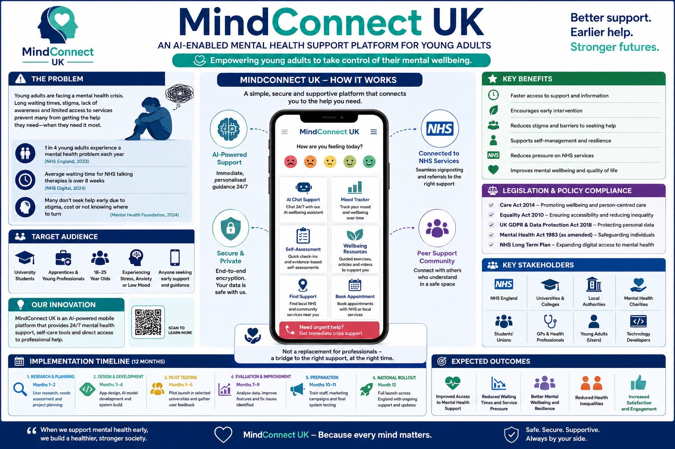

Conclusion:
Mental health remains one of the most significant public health challenges affecting young adults in the United Kingdom. Although existing NHS mental health services provide valuable support, increasing demand and workforce pressures mean that many individuals experience delays in accessing appropriate care. This highlights the need for innovative approaches that improve access to support while complementing, rather than replacing, professional healthcare services. Mind Connect UK presents a practical and evidence-informed innovation that combines artificial intelligence with person-centred healthcare principles to encourage earlier intervention and improve access to mental health services. By offering 24-hour wellbeing guidance, mood tracking, self-management resources and direct links to NHS and community services, the platform has the potential to reduce barriers to care and empower young adults to take a more active role in managing their mental wellbeing. The proposal also aligns with key UK legislation and national health priorities, including the NHS Long Term Plan, the Care Act 2014, the Equality Act 2010 and UK data protection legislation. Through collaboration between healthcare providers, educational institutions, technology developers and the voluntary sector, Mind Connect UK could contribute to improved health outcomes, reduced inequalities and more sustainable mental health services. As digital health continues to evolve, innovations such as Mind Connect UK demonstrate how technology can responsibly support high-quality, accessible and person-centred care.

Reference List
NHS England (2025) Principles for using digital technologies in mental health inpatient treatment and care. Available at: NHS England digital technologies guidance⁠ (Accessed: 2 August 2026).
Medicines and Healthcare products Regulatory Agency (MHRA) (2026) Digital mental health technology. Available at: Digital mental health technology collection⁠ (Accessed: 2 August 2026).
MHRA (2026) MHRA issues new guidance for people using mental health apps and technologies. Available at: MHRA mental health apps guidance⁠ (Accessed: 2 August 2026).
MHRA (2025) Digital mental health technologies guidance launched to help manufacturers and safeguard users. Available at: MHRA digital mental health technologies guidance⁠ (Accessed: 2 August 2026).
National Institute for Health and Care Excellence (NICE) (2022, current guidance) Depression in adults: treatment and management (NG222). Available at: NICE Guideline NG222⁠ (Accessed: 2 August 2026).
UK Government (2018, current legislation) Data Protection Act 2018. Available at: Data Protection Act 2018⁠ (Accessed: 2 August 2026).
NHS England (2024) Digital mental health. Available at: https://www.england.nhs.uk/mental-health/adults/digital-therapy/⁠ (Accessed: 2 August 2026).
National Institute for Health and Care Excellence (2022) Depression in adults: treatment and management (NG222). Available at: https://www.nice.org.uk/guidance/ng222⁠� (Accessed: 2 August 2026).

