

route

final year project
by
Neil A O’Mahoney

Supervisor: Dr Carlene Campbell

Project submitted as part of the requirements for the award of BSc (Hons) Computer Networks

July 2023

Declaration of Originality

I, Neil O’Mahoney declare that I am the sole author of this Project; that all references cited have been consulted; that I have conducted all work of which this is a record, and that the finished work lies within the prescribed word limits.

This work has not previously been accepted as part of any other degree submission.

Signed : Electronically signed

Date : ..24/07/2023

FORM OF CONSENT

I, Neil O’Mahoney hereby consent that my Project, submitted in candidature for the B.Sc.(Hons) Computer Networks degree, if successful, may be made available for inter-library loan or photocopying (subject to the law of copyright), and that the title and abstract may be made available to outside organisations.

Signed : Electronically signed

Date : ..24/07/2023

Copyright Acknowledgement

I acknowledge that the copyright of this project report, and any product developed as part of the project, belong to University of Wales Trinity Saint David, Swansea.

ABSTRACT/SYNPOSIS

This project is the work of a student of University of Wales Trinity St David. Its is designed to compare the networking technologies of MPLS and IP VPN and whether the latter can be optimised to improve on the more expensive MPLS for differing file types through different techniques and methods.

This document is for reference guide only. You may wish to have a slightly different structure for your report. This template will help you to automatically generate a Content page, List of Tables and List Of Figures, but only if you correctly use Styles.

Table of Contents
Copyright Acknowledgement iii
Chapter 1 1
1.1 Introduction 1
1.2 Aim 3
1.3 Objectives 3
1.4 Structure Of The Project 3
Chapter 2 - RESEARCH & REVIEW OF LITERATURE 5
2.1 Introduction 5
Related Work 6
2.2 Conclusion 8
Chapter 3 - RESEARCH METHODOLOGY 9
3.1 Introduction 9
3.2 Research Overview 9
3.3 Research Onion 10
3.3.1 Research Process 11
3.3.2 Research Philosophy 11
3.2.5 APPROACH 12
Methodology 13
3.2.8 TIME HORIZONS 14
3.2.9 TECHNIQUES AND PROCEDURES 15
3.4 Conclusion 15
Chapter 4 - DESIGN & IMPLEMENTATION 16
4.1 Introduction 16
4.2 problem formulation 16
4.3 Design 18
4.4 Implementation 19
4.5 Conclusion 19
Chapter 5 – Testing and Evaluation 21
Design and Implementation of Variables 22
Overview of the test Environment 23
Testing 24
Chapter 6 - CONCLUSIONS AND RECOMMENDATIONS 31
6.1 Summary 31
6.2 Conclusion 31
6.3 Recomendations for Further Research 33
Chapter 7 – Reflections 34
chapter 8 - REFERENCES 35
APPENDICES 38
Appendix A 38
Appendx B 43
TABLE OF FIGURES 43

ACKNOWLEDGEMENTS
.
I would like to thank my Wife and Son, the past 12 months have been so difficult but we came out of the other side.

I would also like to thank Dr. Campbell for directing me and helping me all that she can during this most difficult of times.

Chapter 1

Introduction

This chapter is used to present background information to the research topic. It describes the research aims, which will help to deliver a solution to the problem scenario. It sets out the structure of the project and the methodologies or approaches that are applied in the execution of the literature review and fieldwork.

The internet relies on information reaching its destination in a timely manner with a minimal possible delay. Multiple devices maybe used inbetween destinations to deliver the packets of data required. A secure connection would ideally be laid with a single cable between two points. In reality this would rarely happen and a technology called a Virtual Private Network (VPN) is required. VPN’s use encryption technology to encrypt at one end and decrypt at the other. Inevitably there is a cost to encrypting and that cost adds an increase to the size of the data flowing between the two sites.

A VPN is typically client or site to site based. It is a joining between two networks to act as one. It is a cost-effective method of securing connections between two physically separated sites. VPNS can function on layer 2 and layer 3 secure point-to-point and links to use one another resources.

The size of the networks secure point-to-point can be represented as n(n-1). The cost of which L2 links is increased exponentially when ‘n’ is smaller. MPLS can be used to create Site-to-site, Layer 2, layer 3 and Virtual Private LAN’s. Generally used by service providers MPLS VPNS are used to deliver VPN services. MPLS achieves this by one method using Label distributed Protocol using label edge routers (LER’s) and Label Switching Routers (LSR’s) the paths established between them are called Label Switching Paths (LSP). Layer 2 VPN’s types are Border Gateway based (BGP) using a cloud connection. Layer 3 MPLS VPN’s operate oat the network layer of the OSI sharing common routing information and connectivity is controlled by policies on the service provider’s routers. It requests more extensive routing and forwarding configuration information than a layer 2 VPN.

For an IP based VPN protects data by encrypting it. Within the VPN tunnel data is encapsulated and tunnelled which disconnects it from other internet traffic. These are all virtual of course. It is coded at the source and decoded at the destination. If there is a compromise then the data will remain encrypted until decoded. It is meaningless to the hacker. IP VPN can operate up to layer 7 of the OSI common methods include: IKeV2 Internet Key Exchange (1 or 2) and a diffie –Hellman key exchange is setup from which the crypto keys are created. Phase 1 negotiation creates a secure authenticated channel Phase 2 the IPSec security associations and key materials.

Using open SSL encryption Open VPN is another method of VPN that is designed to create secure point to point connections across remote facilities. As well as using OpenSSL it also utilises the TLS protocol for key exchange. Using HMAC <insert description here> packet authentication to add extra security. It boasts methods such as pre-shared secret keys, certificate based or username/ password. OpenVPN can use UDP or TCP transport methods and can support IPv6 as a protocol.

Aim
The aim of my report is to determine the differences in speed between MPLS and IP Sec based VPN’s and the reasons behind it and optimisation of.

Objectives
- Carry out a critical literature review of VPN’s targeting MPLS and IPsec in particular
- Develop a detailed project plan for the project
- Simulate analyse and evaluate MPLS and IP VPN’s against each other using 3rd party tools.
- Analyse and document the process of creating the MPLS and IPSec VPN comparing and contrasting the effect different policies and QoS has on the variance of traffic streams between the two.
- Document and construct a report that compares and contrasts the results from the above experiments. Make suggestions and recommendations for future works and profiles and policies which detail the optimisation of each VPN type.

Structure Of The Project
This project will be split into 3 main parts. The first part will outline the project aims and objectives. It will include the theory behind decisions made. Essentially it will seek to investigate and explain the workings of VPNs, best practices and policies that will be applied to allow a QoS optimising each type of traffic.
The second section of the project outlines the design elements of the project and how it will go out being implemented. Best practices will be followed as well as what control and variables will be set. Data will be moved from one point to another in various formats in varying methods of encryption. Control software will record the timings of movement between the two sites.
The third and final section will outline the findings of part 2. The data recorded of type, size and speed along with the encryption methods used. A conclusion summary will be drawn on the best methods of setting up the VPN(s) as well final conclusion and outline of any recommendations or development.

Chapter one Aims and Objectives are stated here and a brief overview of what will be undertaken and how this is to be achieved.

Chapter two Sets out how the project will be achieved. By selecting a methodology and an approach a measurement of the set of goals is achievable.

Chapter Three To justify the research design the objectives are related to the aims.

Chapter Four This chapter outlines how the researcher will go about resolving the problem & refers back to the literature review to validate the design decisions.

Chapter Five The results are the subject are inputted into data format & comments on control and variables within the test.

Chapter Six The summary of what the project is trying to achieve, a conclusion followed by any recommendations for future experiments is set out here.

Chapter 2 - RESEARCH & REVIEW OF LITERATURE

Introduction

“A Virtual Private Network, or VPN is an encrypted connection over the internet from a device to a network. The encrypted connection helps ensure that sensitive data is safely transmitted. It prevents unauthorized people from eavesdropping on the traffic and allows the user to conduct work remotely.” [1]

As show in the image below this will be a virtual connection of two points. The configuration is carried out on router A and then router B. A set of encryption standards are agreed along with things like passwords and key lifetime. Quality of Service (QoS) is added at a later time.

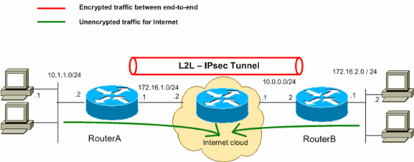
Figure 1 Depciting an IP VPN L2 Tunnel encrypted and unencrypted between two sites

Multiprotocol Label Switching MPLS VPN is a method of routing and transporting traffic using an MPLS backbone. There are 3 distinct types; Layer 3 Virtual Private Routed Network (VPRN), Layer2 Virtual Private LAN Service (VPLS) and point-to-point.
Layer 3 VPRN this utilises Virtual Routing and Forwarding (VRF) to disseminate and segment routing tables for each area of business. Clients peer with the Internet Service Provider (ISP) and the routes are put onto the clients router specifically to the clients.

Layer 2 Virtual Private LAN services or VPLS is a cloud based switch service and offers the ability to have VLANs spanning more than one site. Typically used to route voice, data and video traffic data centres and sub locations.

Point-To-Point This method of VPN operates a Virtual Leased Line (VLL) P2P connectivity between sites. Typically these can include Async Transfer Mode (ATM), Time Division Multiplexing and ethernet frames are encapsulated.

Label switched routers are at the core of the MPLS network and edge LSR’s which apply labels to packets. Once received the LSR will check against the forwarding table (in the below case the Cisco Express Forwarding table CEF) and if it does not already have an entry it will add one. The Label Distribution Protocol advertises the bindings between routes and protocols.
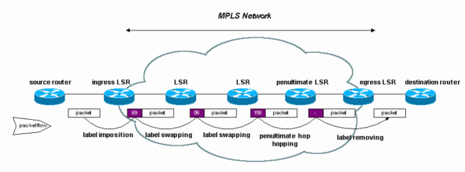
Figure 2 Depicting an MPLS network with ingress and egress LSR’s
[1]

IP VPN
IPSec VPN protocol is an authenticated and encrypted method of sending and receiving of data. It is a mutual method of authentication between (usually but not always) two firewalls. It is established in the form of a session of which it has crypto graphical keys to encrypt and decrypt during the session.
There are two basic protocols used within IPSec, Authentication Header (AH) and Encapsulation Security Payload (ESP). the Authentication Header provides an ‘…Origin of authentication, data integrity and replay protection.’ [2]. Within the CIA triangle Confidentiality is not provided by AH so all of the data is sent in plaintext. The job of the AH is to make sure that it all arrives safely and it achieves this by way of a checksum (a simple calculation achieved by an algorithm). In short the AH ensures that no additional data has been added or removed from the message on the way to its destination. There are two modes; transport and tunnel for the purposes of this however we will be looking at tunnel mode which creates a new IP header and it is used outside the original IP datagram.

ESP does not provide the integrity of the message but provides the encryption so that the data cannot be seen in plain text. When sending messages across two sites a key is used and agreed by the two parties. If used with authentication the first packet is sent and if successful is decrypted reducing processing overhead as well as vulnerability to Denial of Service (DoS) attacks.

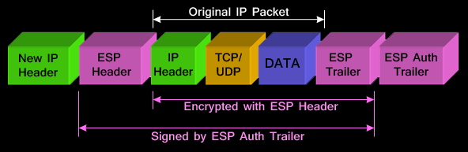
Figure 3 Image of the encapsulation of the IP Packet by ESP https://www.firewall.cx/networking-topics/protocols/870-ipsec-modes.html

Hiding plaintext by a process is known as encryption. It is hidden by the sender and decoded by the destination back to its original format. To intercept the message and read would be meaningless without a key. There are two kinds of keys that will decrypt the original message Symmetric whereby the encryption and decryption are one and the same key. Public key is where a message is encrypted by the sender and unreadable. The receiver has their own key and can decrypt the message.

For the purposes of the Authors project the context in which IP VPN will be used is in an encrypted stream, it will have the same number of hops as the MPLS (Multi Packet Layer Switching) so that an accurate and direct comparison can be drawn between the two.

PRIME
For optimum encryption during transmission of data between the two sites there are multiple settings that can be changed. To keep to current levels of encryption between two sites it is important that there is a set standard to follow. Advice from the National Cyber Security Centre recommends the following:

For configuring IKE, the Recommended Profile (2022) uses the following parameters:
Parameter | Selection | RFCs
IKE Version | IKEv2 | RFC7296
Encryption Algorithm | AES with 128-bit key using GCM with 16-octet (128-bit) tags | RFC5282
Pseudo-Random Function | PRF-HMAC-SHA-256 | RFC4868
Diffie-Hellman Group | 256-bit random ECP Group 19 or 2048-bit MODP Group 14 | RFC5903, RFC3526
Authentication Method | X.509 certificates using ECDSA or RSA | RFC4945, RFC4754, RFC4055
For configuring Encapsulating Security Payload (ESP), the Recommended Profile (2022) uses the following parameters:
Parameter | Selection | RFCs
Encryption Algorithm | AES with 128-bit key using GCM with 16-octet (128-bit) tags

For configuring key lifetimes, the Recommended Profile (2022) uses the following lifetimes:
Key Type | Lifetime
IKE SA | 86400 seconds (1 day)
Child SA | 28800 seconds (8 hours)
[1]

By keeping the same encryption for the MPLS as well as the IP VPN it will mean that a direct comparison will be drawn between the two comparison technologies with high levels of encryption. It would be expected that a lower speed would be achieved and it may be relevant that encryption plays a part in this reasoning. The reason that the advice has been issued is so that an achievable level of security is maintained against current known threats by saying that ‘…Issued advisories for organizations working remotely using tools like VPNs, based on a significant uptick in a number of cyber-attacks that exploit publicly known vulnerabilities in remote working tools and software like VPNs…digital workspace solutions that are consumer simple but enterprise secure.’ [3]

SD WAN

Software Defined Wide Area Network (SD-WAN) is a Wide Area Network which utilise internet technology to create a kind of encrypted tunnel for internal or joined networks. In simpler terms it is designed to centralises the network by changing the forwarding process. It achieves this by changing the forwarding process of the data plane to the control plane. The data plane which is a process of forwarding packets and the control plane which includes such elements as the routing table or the protocols that the control plane uses to forward messages. This is best summarized as ‘…SDN controllers dynamically route flows based on network status by managing underlying switches’ [4] The same article does go on to say ‘…Controller failures could result in serious network performance degradation due to the decrease of network programmability in SD-WAN’s’ [4]

This is in contrast to what Cisco claim are the features and benefits of SD WAN claiming that the features include:
- ‘High availability, with predictable service, for all critical enterprise applications
- Multiple hybrid active-active links for all network scenarios
- Dynamically routed application traffic with application-aware routing, for efficient delivery and improved user experience
- Improved OpEx, replacing expensive Multiprotocol Label Switching (MPLS) services with more economical and flexible broadband (including secure VPN connections)’ [5]

Furthermore, there is supporting evidence that states SD WAN improves the overall experience for the users by providing bandwidth management ‘SD-WAN improves bandwidth and latency by connecting SD-WAN to the cloud, leveraging the best of the cloud's features to consume less bandwidth, and utilizing policy-based routing (dynamic route selection) to reduce delay and keep the network running smoothly.’ [6]

Autonomous Systems

‘An Autonomous System (AS) is a network controlled by a single technical administration entity. Autonomous systems divide global external networks into individual routing domains, where local routing policies are applied.’ [7] Put diffrently the AS is an IP prefix policy which depicts how routing information is exchanged with other AS. This can be a University, commercial venture or an Internet Service Providor. The AS numbers are controlled by Internet Assigned Numbers Authority (IANA) co-ordinates these details so that there is no confusion between systems.

Exterior Gateway Protocol

Inorder to exchange data within the AS a routing protocol is required. There are two types; internal and external. An internal routing protocol would focus on fast convergence of the network so perhaps locally connected routers in a server room or Network Expansion Room NER would be a good example of this. If there was a power cut the depending on the interior protocol would focus on rapidly getting back to operational functionality if for example it had a link-state focused protocol. An Exterior Gateway Protocol (EGP) such as Boarder Gateway Protocol (BGP) is a method of exchanging such information as routing tables, known networks and updates between items in the same AS. There are of course other external routing protocols such as Open shortest Path First (OSPF). This is more focused on path choice and convergence speed as the author previously mentioned, therefore unsuited to traversing a large network with multiple paths.

Network Simulation Tools

A “Network simulator is simply a discrete event-driven network simulation tool for studying the dynamic nature of communication networks”. [8] The network simulation tool is to be used to predict the nature of 1 a control network, 2 an MPLS configured network & 3 a VPN configured network to measure such elements as speed, throughput, errors & discards, metrics and links to name but a few.

Emulation allows the input of real-life devices to the network which will allow real-world events to take place. From jitters to pauses in the network this will give the author a more realistic idea how MPLS and VPN technology can function.

A selection of network simulators the Author has decided to look at and evaluate are:

GNS 3

This is an open-source simulator tool which can be used as a VM or installed onto the users machine. It allows the download and use of real software in order to manipulate and test real-world software. It supports the use of MPLS technologies. Downsides are it can be quite bulky and slow the user’s machine down considerably. Results from tests are less than intuitive.

OPNET
OPNET is a Graphical represented simulator which can be used to ‘…Build network topology and entities from the application layer to the physical layer’ Having viewed the product it is a market leader in terms of it’s a ability, manipulation of the OSI layer model. It employs djifferent simulation technoogues, an event simulation engine and a debugging analysis (GUI) It is limited by its complexity of GUI, limited number of nodes per sim and inefficiency if standing for long periods of no data.

Cisco Packet Tracer
The Author has previously used this simulator tool to model networks, although it is capable of simulating a network with MPLS on it, it is ineffective as a tool to record results from this. It has been commented by several that Packet Tracer is ‘The ability of Packet Tracer in comparing various routing protocols tells that this simulator is effective as a learning tool for computer network’. [9]

Related Work

There has been a number of comparisons of MPLS and IPSec VPN’s with their speed monitored and QoS applied with various methods. It is the intention of the Author to encompass both high security encryption as well as applying QoS to maintain a minimum speed.

‘…MPLS pushes the size of the MPLS frame past the MTU of the MPLS edge switches, the switches will drop it.’ [10]. Networld makes the valid point that 4 bytes are added to each label. The standard MTU size of packets being 1518 bytes.

As defined by Hassan H. Elkarash Et Al There are 3 different QoS models ‘best effort, integrated Service and INDiff service’ [11] defining best effort as no QoS required, integrated service which reserves bandwidth to minimise jitter and loss and finally indiff which stores different traffic types according to their classification scheduling their release.

They go on to further describe:

‘1) Priority Queuing (PQ): In PQ, each queue has a priority level and these queues are served based on its priority level starting from the highest priority.

2) Weighted Fair Queuing (WFQ): In WFQ, a cost function is applied on each queue to compute its bandwidth weight and then the queues are served based on this weight in descending order.

3) Weighted Round Robin (WRR): It is also named Class Based Queuing (CBQ). It allocates the bandwidth for each queue based on its required data rate then serves the queues in round robin order.’ [11]

The above report goes onto on to say ‘The results verified that in VoIP, PQ outperforms the other two algorithms in all performance metrics except jitter. In video conferencing, WFQ also outperforms the other two algorithms except the received traffic. MWRR has the lowest VPN and WiMAX delays.’ [11]

Therefore, it is dependent on what type of traffic is being transmitted as to what type of QoS should be given a priority. It is intended that this study will

Billy Susanto Panca in their study into QoS mentions that the International Telecommunications Union – Telephony (ITU-T) ‘…Had released a standard unit of communication quality knowns as Mean Opinion Score (MOS).’ Which he goes on to describe as .’…Subjective judgements of some individuals.’ [13]

It is important to highlight here that Billy Panca is focusing their work solely on voice transmission and not that of video and data.
A methodology can be defined as a logic that studies why something is done. ‘It is a set of procedures, methods & techniques that are put together by the researchers to obtain a solution to the problems they control during the collection of data.’ [1]

The Problem
A lot of research has been conducted to promote the benefits of MPLS networks and how they outperform traditional VPN’s. There are varying in their results and their tests, some with security some measuring voice, data and not video. A study was conducted in 2014 by Information Management & Business Review. 2014 which focused its study on obtaining performance metrics of end-to-end delay, voice packet delay and Rx and Tx voice packets to evaluate IP and MPLS networks. It demonstrated that MPLS outperformed the IP based network, this did not cover VPN’s and therefore was not a direct comparison of what the Author is trying to demonstrate in their work.
A journal conducted called ‘Mechanism of Multiprotocol Label Switching for Forwarding Packets & Performance in Virtual Private Network. Middle-East Journal of Scientific Research. 2014’ study manipulating QoS parameters (packet Loss), route trip delays and fault tolerant paths. Again MPLS demonstrated that it out performed IP networks. Security was not implemented on this study however.
Finally a study carried out in 2018 Applied Mechanics and Materials conducted a study which did incorporate security into VPN’s however it used frame relay as a performance metric demonstrating that MPLS-VPNs perform better than IP based networks.
It is the Authors intention to link these studies together, using security and consistent metrics across, voice, data and video as well as manipulating policies of the IP Sec VPN in order to obtain the richest set of results that I can.
However Okokpujie et al argue that although performance metrics of end to end delay, voice packet delay Tx and Rx and voice jitter prove that MPLS is a better performing medium. A second study was conducted using QoS parameters such as packet loss, trip delays and fault tolerant paths -again MPLS the better performing method. Finally a study had been conducted using a frame relay as a performance metric demonstrated that MPLS-VPN’s are again better performing than IP Sec networks.

Conclusion

MPLS, IP VPN and SD WAN are 3 varying methods fo joining networks together securely It is the authors intention that IP VPN and MPLS will be compared along with recommendations for SD WAN optimal performance based on best practices from the former.
There are several interesting studies on speed and throughput of data between 2 points on a proposed network but thus far no study linking voice, video and data into an optimum fast and secure transfer method.

The aim of this study is to focus on balancing current recommended encryption against which PQ WQ and WRR as to which the best QoS is to support it guiding an engineer should they be debating cost/ benefit analysis of each product.

Okokpujie et al states that MPLS is faster than IP VPN, however, when these studies are conducted. The Author believes that they fail to consider the considerable security risks that exist. It is the Authors objected to prove or disprove this practical test and will consider the impact additional security has on transfers..

Chapter 3 - RESEARCH METHODOLOGY

Introduction
Car
The research methodology is designed to outline exactly how the author intends to conduct the research of how to deal with the data collection method and analysis of data collected. In short, it is designed to take the speed and quality comparison of MPLS and IP VPN’s.

Research Overview
The data that will aim to be collected will be time taken to receive data from point A to point B via the network. The first control viable on the data being collected will be MPLS and IP VPN left alone with no encryption or QoS. The second control variable will be standard encryption according to PRIME across the MPLS and IP VPN network. The QoS variables available which will be applied are Priority Queuing, Weighted Fair Queuing and Weighted Round Robin. This will be achieved by research of coding for the cisco devices. It will be applied across all 3 types of data (voice, data and video) to give both methods of VPN the best chance of success.

Research Onion
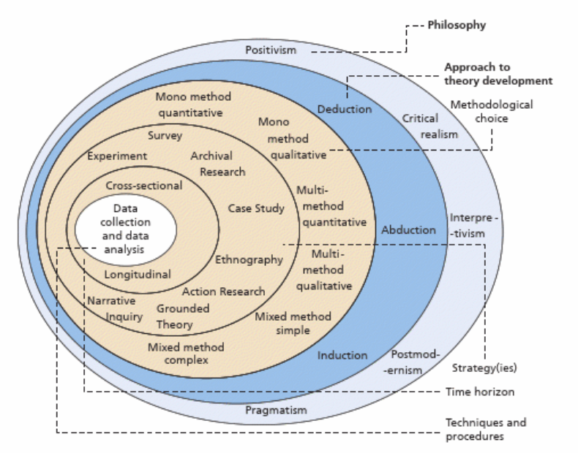
Figure 4 The Research Onion

Pictured above is the ‘Research Onion’ [13] a concept which is designed to break down into logical steps the layers of a research project through a logical process. As seen above these processes are broken down into:

- Philosophy
- Approach
- Methodology
- Strategy
- Time Horizon
- Techniques.

This chapter aims to put forth the view of the entire research process proposed for the achievement of the aim and objectives stated in the previous chapter. According to Saunders, Lewis and Thornhill (2007) research design provides an overall view of the method selected and the reason for that choice. In essence it details an action plan to aid the researcher execute the research from its inception to its conclusion. It does this by providing the researcher with initial questions to be addressed.
Figure 3 below provides a top-down view of the four phases of the Research Process. The four-phase segregation: Research Process; Research Philosophy; Methodologies and Data Collection, collectively helps to provide a better understanding of the research design.

Research Process
This chapter is dedicated to intoduction of the hypothesis and how the Author will go about testing it. It will go on to describe what is being used and why this it is being tested in this way.

Research Philosophy
Data will be collected from whichever tool is selected. This data will then be subject to such things as speed, time taken to transfer data, jitters etc. It is a factual collection of data that the Author is researching from the data.
“As a philosophy, positivism is in accordance with the empiricist view that knowledge stems from human experience. It has an atomistic, ontological view of the world as comprising discrete, observable elements and events that interact in an observable, determined and regular manner” [14]
The philosophy will determine which is quicker and more reliable at transferring data between two points with the best outcome.
Inorder to select meaningful data the method of collection influences the data. ‘The methodology should impact which method(s) for a research endeavour are selected in order to generate the compelling data.’ [13]
A research philosophy is a belief of which data collected can be analysed and used. There is an emphasis on ideas, data that has been selected and methods of assessing and processing that data. There are two distinct philosophies that are available to measure the research elements which are: ‘Positivism and phenomenology are two conceptual frameworks that are generally considered and applied while carrying out a research activity.’ [17]

Positivism is related to figures/ numbers and scientific knowledge to name but a few, it is quantitative rather than a qualitative method of philosophy summed up well by Ma (et al) describe positivism as the application of ‘…Scientific knowledge, understanding and numerical norms to investigate a research phenomenon….a researcher does not rely on personal knowledge and understanding; instead, he is required to apply the basic standards of Positivism to know how he or she can avail or extract findings.’ [17]

The advocates of Phenomenology support a different agenda and say of the Pro-Positivists perspective ‘…Supporters of the latter philosophy undermine the importance of personal knowledge of researchers’ [17] By encouraging a researchers professional judgement and opinion it is a better method of critically evaluating a project.

For the purpose of this project, it is proposed that positivism approach is used to gather data. This wouldn’t be the whole approach however, as there are statistics that will be gathered if, for example there are higher speeds but voice or video suffers as a result then the reader will need to know about this. In addition there would be few applicable scientific laws and rules that would govern the nature of software in such a manner.

3.2.5 APPROACH
The analytical approach to research the project will take the form of one of three methods; Inductive, Abductive and deductive research. According to Joanne Neale in Interpreting Qualitative Data, Inductive method is when ‘A researcher reviews their descriptive themes and categories to identify more abstract concepts, constructs or theory or even to develop a tentative topology or framework.’ [16]
Abductive research method is when a researcher ‘..Generates their descriptive themes and categories but simultaneously reads around the topic and wider literature to identify a concept, construct, theory, typology or framework that seems to fit their data best.’ [16]
Deductive approach assesses their descriptive themes categories for evidence to support, refute or amend a concept, construct theory, typology or programme working. It tends to be used by researchers who choose to bring an explicit world view, standpoint, perspective or heuristic to their research. [16]
For this project the Author will be using a deductive and mixed research approach. The main reason for this is that there is not as much research into this topic and they are looking to refute or prove whether one product is better placed to suit their needs than another. There will be a formulated hypothesis and subjection to tests. The system is not yet live and would need to be ran in a parallel with the current system and only after a period of time (say testing of upwards of a year) would the data prove whether one is better than another (or not). This timeframe would be unacceptable in the current climate of a live system duplicating effort and workload for the various Service Desk/ Server and Network teams involved.

Methodology
‘A well-thought-out consistent set of assumptions will constitute a credible research philosophy, which will underpin your methodical choice, research strategy and data collection techniques and analysis procedure.’ [15]
To achieve the above it is necessary to breakdown the research method into smaller sub-sections
As data is likely to be collected as numbers (time taken) errors and other data of that nature, it is of a qualitative methodology. It will be collected as a standard method (seconds, errors etc) and the data that will be used could potentially be used to draw a diagram of time taken to data transferred (start to finish).
While ‘number depends on meaning…it is not always the case that meaning is dependent on number’ [15] If the statistics collected can be opened to much wider interpretation then they mean less ‘‘the more ambiguous and elastic our concepts, the less possible it is to quantify our data in a meaningful way’’. [15]

3.2.6 STRATEGIES

The method of strategy that will be conducted is Experimental. The reason this has been chosen is because ‘The purpose of an experiment is to study causal links: Whether a change in one independent variable produces a change in another dependent variable’ [16] The independent variable will be what type of method of transferring the data (IP or MPLS) and the dependent variable will be the QoS & encryption method applied to each.

The plan is that there will be 4 sets of routers in two separate types. One will be setup for MPLS VPN and one to be setup for IP VPN. Each will have the same encryption applied to it and will run the first control test. The second test will have QoS of Priority Queue, Third: Weighted Fair Queue and Fourth: Weighted Round Robin. The type of data being transferred will be controlled and mirrored between the independent variables, they are to be: Voice, Video and textfiles/ images data.

There will be a standards check that the data has moved in its entirety between point A and B so a checksum of the data will be taken before and after the transfer to qualify it for the results.

When considering time taken, this must be above 0 seconds for it to qualify and the amount of data to be transferred should be approx. 2 gig of data to give the routers enough data to draw a comparison. This may change later on if the transfer of data is too quick.

3.2.8 TIME HORIZONS
As with transferring files can take several hours to several days depending on multiple differing factors it would be preferred to take a longitudinal approach for this project. Transferring several gigs of data over a period of perhaps 24 hours then comparing the results with similar other transfers of data. The equipment being used is going to be a simulation due to its cost & setup. The type of time horizon that has been selected is cross sectional.

It would not be feasible to use a diary approach to this, it would take far too long and after transferring a certain size of file it would be presumed that it would be clear which method of data transfer is quicker and more reliable (along with the QoS)

3.2.9 TECHNIQUES AND PROCEDURES
Files will be complied with differing types of data, word documents, images, videos, voice etc all with equal sizes amongst them. Initially the data will be transferred over in a controlled environment and a time frame will be recorded. This is to happen on both the MPLS and IPSec VPN’s.
Part 2 of the data movements will involve data with a policy with a voice priority applied to it.
Part 3 of the data movements will involve data with a video priority applied to it
Part 4 of the data movements will involve data with a priority applied to it relating to .doc files.
Consideration will be given to the network usage and timings will be sought that will not be effecting the main operating times or scheduled outages.

Conclusion

The methodology chosen will be an experimental one. The environment will be created in GNS3. There will be two separate networks independent of one another. One which is MPLS and the second which is IP VPN.

The control elements due to their size will only be changed on the IP VPN and have their variables added to the network. The two control PC servers for the FTP will exist in the cloud and will move data between the two. The files created are dummy files which will be moved manually via FTP.

Depending on the speeds of the data link it would be best to move each file within around 10 minutes. This would allow multiple attempts if needed to gather more data.

There should be 4 separate sets of switches within the file transfer if able to.

Chapter 4 - DESIGN & IMPLEMENTATION

Introduction

This chapter discusses the design of the systems that are being involved which will include the reasons for such decisions. It will outline the dependent and independent variables of each.

problem formulation

From the Authors research in the literature review it has been found that there is no direct comparison between MPLS and IP VPN’s with same security and with QoS applied. Although some investigation has already been conducted with regards to different types of QoS, it has not had security settings applied to it and it has also not a mixture of voice, video and data being transferred.

The speed difference and whether there are enough manipulating factors on the IP VPN to compare with the MPLS VPN if there are policies which can best match that. If it is possible to manipulate or exceed the MPLS VPN then this could be considered a positive result.

During the setup there will be 2 sets of routers. The two end point routers and intermediate routing. The two end point routers will be setup as IP VPN or MPLS depending on which scenario we will be depicting and the intermediate with will be setup using fast and slower links. This will give both type of VPN’s an alternative route which will seek to mimic a real-world scenario where there is more than one route.

For the IPSec VPN there will be a variance of settings depending on which type of data is being sent across the network. There will be 3 types of data being sent across the NW; voice video and data (files).

The purpose of testing with MPLS VPN and IP VPN is to tie together different types of studies which have previously not done a “complete picture” of testing VPN speeds nor have they prioritised types of data being sent down.

Further Work
A lot of information exists to trumpet the benefits of MPLS networks and how they out perform traditional VPN’s, these are varying in their results and their tests, some with security some measuring voice, data and not video. A study was conducted in 2014 by Information Management & Business Review. 2014 which focused its study on obtaining performance metrics of end-to-end delay, voice packet delay and Rx and Tx voice packets to evaluate IP and MPLS networks. It showed that MPLS outperformed the IP based network, this did not cover VPN’s

A journal conducted called ‘Mechanism of Multiprotocol Label Switching for Forwarding Packets & Performance in Virtual Private Network. Middle-East Journal of Scientific Research. 2014’ study manipulating QoS parameters (packet Loss), route trip delays and fault tolerant paths. MPLS demonstrated that it out performed IP networks. Security was not implemented on this study however.
Finally a study carried out in 2018 Applied Mechanics and Materials conducted a study which did incorporate security into VPN’s however it used frame relay as a performance metric demonstrating that MPLS-VPNs perform better than IP based networks.

It is the authors to tie all of these studies together, using security and consistent metrics across, voice, data and video as well as manipulating policies of the IP Sec VPN in order to obtain the richest set of results that the author can.

Okokpujie et al argue that although performance metrics of end-to-end delay, voice packet delay Tx and Rx and voice jitter prove that MPLS is a better performing medium. A second study was conducted using QoS parameters such as packet loss, trip delays and fault tolerant paths - again MPLS the better performing method. Finally a study had been conducted using a frame relay as a performance metric demonstrated that MPLS-VPN’s are again better performing than IP Sec networks.

Tools

Design
As the internet is a ‘..Collection of Interconnected Autonomous Systems (ASEes), which are networks or sets of networks under a single and clearly define external routing policy.’ [1] It is important that the interior and exterior routing protocols for IP and MPLS match one another. As the internet is a series of interconnections with some quicker and slower connections this will be reflected in the design of the test.

There will need to be Internet Exchange Points, this is a point of data to be exchanged with other networks this is for the establishment of internet traffic peering agreements to take place the external WAN protocol selected will be Border Gateway Protocol which is a path vector routing protocol. The reason that this has been selected is because it is a common routing protocol, it is standardised and it is designed to exchange routing and reachability data. It makes decisions based on policy, rules or paths. It is also designed to carry MPLS Label Switched Paths

A network simulator will be used such as GNS3 or Opnet Modeller. The basic design will be 2 alternative paths with varying speeds 1Gig and 0.5Gig.

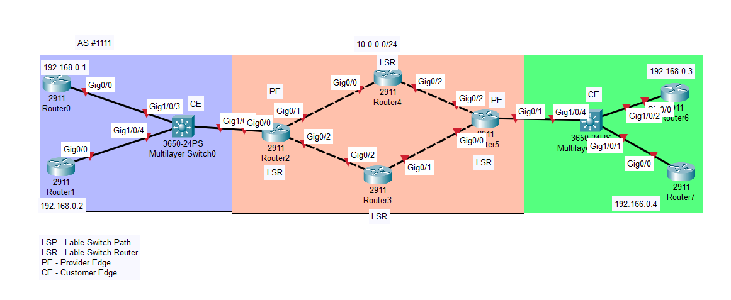
Figure 5 Depicture of an MPLS network

Implementation
Please see Appendix A

Conclusion
This project has been carried out on the Authors home PC using GNS3 simulated software. It would be entirely possible to also do this on another type of simulating software however it would not have had the ‘real-world’ manipulation of software that is GNS3 (the real world operating system) or ’Ostinato’.
The author has argued from the outset of this dissertation project that the aim of their report is to “determine the differences in speed between MPLS and IP Sec based VPN’s and the reasons behind it and optimisation of.”. In particular there are plenty of studies depicting differing types of data moving through a network incorporating security and using manipulations of QoS to gain the maximum possible throughput for the VPN.
By manipulating the traffic for TCP and UDP traffic I have demonstrated that it is possible to get video, voice and data traversing the network at a quicker rate than less priority.
In the example below priority has been given to voice over a 10Mmps link of which 60% is utilised for voice data.
ip access-list extended VOICE_ACL
permit ip any any dscp ef
policy-map VOICE10Mb
class VOICE_CLASS
bandwidth 6000
class class-default
fair-queue
class-map match-any VOICE_CLASS
match access-group name VOICE_ACL
interface GigabitEthernet0/0/0
service-policy output VOICE10Mb

On the VPN there is Weighted Fair Queuing (WFQ) and Class Based Fair Queuing (CBWFQ).
On the VPN there is also QoS which has been applied. This means that there is an inspection of traffic before it goes over the VPN and is unable to be changed prior. It is done as soon as it leaves the NIC to the Data Path (DP) it is classed as useful when using limited bandwidth but not supported at high level ASA models. It may also starve other types of traffic such as video etc.
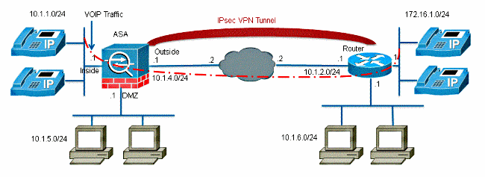
Figure 6 Above is an example of Voice data traversing a VPN with QoS in place.

Chapter 5 – Testing and Evaluation

The MPLS and IP VPN’s have been set up in a simulated environment on a homebased PC. Tests have been ran to investigate the Authors hypothesis.

Two virtual machines have been created, running Windows 10 x64, 2048Mb RAM with 1xCPU AMD A10 processor in each with 50Gig HDD each. Each of these devices will be connected via GNS 3 on virtual interfaces and IP’d the same.

When the simulators have been set up the MPLS has acted as a control on its service test and there is a control IP VPN and finally an amended version which will carry the rules which will change the behaviour of the IP VPN.

When amending the variables care and consideration has been taken to be sympathetic to the type of data that is travelling across the network to optimise its transfer speed within the scope of this project. It has been ensured that the same file types that are moved are transmitted and received by control items.

Testing has taken the form of 3 different file types across a variance of connectivity method in a best effort to simulate 3 differing types of media. Text, video and a sound file all 10Mb in size. This was FTP transferred across the network with the routers in between all being on the same version of software with the independent variables being the method of getting them from one side to the other and the restrictions, priorities applied to them.

Design and Implementation of Variables
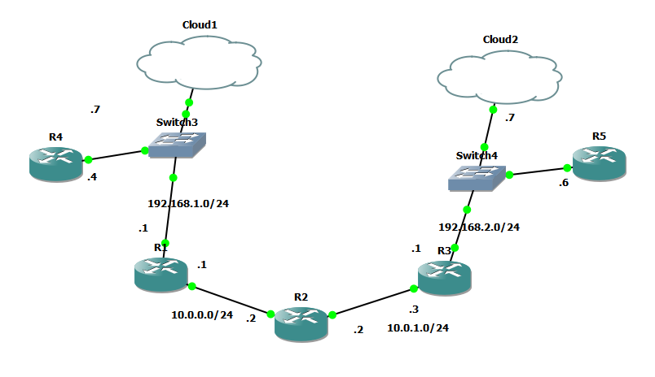
Figure 7 Image of setup of MPLS and IP VPN setup.

The above image depicts how the network will be setup. Routing tables will be set on R1,2&3Cloud 1 and Cloud 2 are where the Virtual Machines reside, Cloud 1 is where the FTP server is sat and Cloud 2 is where the receiver is sat. all devices are connected via cables.

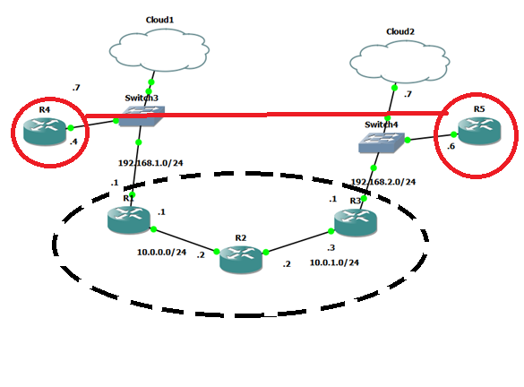
Figure 8 VPN/MPLS Tunnel and Internet Framework.

The above image depicts the MPLS/ IP VPN tunnel which exists between the two sites. Within the dotted area would be the ISP’s routers which would exist in a more real life scenario rather than just directly connecting the two routers together & testing.

Overview of the test Environment

All switches within the network are running the same software (version 14.0) and hardware (cisco 7200) to reduce bottlenecks and other potential variables as well as making it easier to amend the switches if necessary. In a real-world environment, there would be a great many more resources available particularly for the two Windows 10 devices however due to the great number of switches being ran at a single time this would impact on the performance.

The transfer of the data took place via ftp on the windows client via command line. It had been considered to use FileZilla as a potential for transferring the data however it was decided by the Author that this would potentially use up too many extra resources during the transfer of data.

Monitoring of the traffic of data would be via the time taken on the FTP transfer and from Wireshark.

To ensure that the data travelling from one side to the other captured the correct traffic, the IP VPN modifications would be applied on the outbound interface of R1 interface 10.0.0.1.

All devices are connected with the same ethernet cabling in the environment and all interrace speeds are the same (speed auto-duplex auto).

Testing

Testing was conducted via the cli transferring the files one after the other in separate connections within the same FTP session:

 | .Txt File 1 | .Txt File 2 | .Txt File 3 | .Txt File 4 | Total time taken
Control IP VPN | 212.18 | 218 | 211 | 217 | 858.18
Control MPLS | 217 | 217 | 202 | 222 | 858
IP VPN Bandwidth Mod | 243 | 237 | 247 | 241 | 968
Policing | 239 | 236 | 215 | 218 | 908
IP VPN Video Modification | 255.87 | 262 | 261 | 257 | 1035.87
 | Video File | Video File | Video File | Video File | Total time taken
Control IP VPN | 265.7 | 249 | 291 | 291 | 1096.7
Control MPLS | 298.75 | 281 | 275 | 266 | 1120.75
IP VPN Bandwidth Mod | 245 | 249 | 238 | 247 | 979
Policing | 243 | 239 | 207 | 240 | 929
IP VPN Video Modification | 246.36 | 251 | 241 | 245 | 983.36
 | Sound File | Sound File | Sound File | Sound File | Total time taken
Control IP VPN | 250.225 | 257 | 251 | 255 | 1013.225
Control MPLS | 223 | 215 | 214 | 218 | 870
IP VPN Bandwidth Mod | 242 | 245 | 223 | 246 | 956
Policing | 718 | 712 | 624 | 697 | 2751
IP VPN Video Modification | 755.48 | 771 | 720 | 753 | 2999.48
 | Total transfer time taken | Total transfer time taken | Total transfer time taken | Total transfer time taken | Total time taken
Control IP VPN | 728.105 | 724 | 753 | 763 | 2968.105
Control MPLS | 738.75 | 713 | 691 | 706 | 2848.75
IP VPN Bandwidth Mod | 730 | 731 | 708 | 734 | 2903
Policing | 718 | 712 | 624 | 697 | 2751
IP VPN Video Modification | 755.48 | 771 | 720 | 753 | 2999.48

Figure 9 Data tables of transfer times per file type by method of priority

Figure 10 Individual and combined text file transfer via differing methods
The results for the above experiment demonstrated that not all modifications made to the VPN were positive ones. The Control IPVPN and MPLS networks were near enough neck and neck for transfer times for the 10Mb text file.of the IP VPN modifications the ‘Policing method’ referring to the capping of its top speed to 10Mbp in an effort to shape the traffic appeared to have a positive outcome. This was not as the author had expect the expieriment to go and anticipated instead that the QoS on the video or prioritising the bandwidth would have had a more positive effect on the total transfer of the text file.

Figure 11 individual and combined video file transfer via differing methods

In the above diagram of the results it is the MPLS method of transferring data which was the slowest by nearly 5% more than the IP VPN. The quickest being the Policing method again followed by bandwidth modification and the QoS video modification. This is more what the Author would have expected to see of the data results (that the IP VPN) modifications would have had a quicker speed than the two control experiments. As previously alluded to in the Literature Review section it was expected that the IP VPN would have a slower speed and response time the reason for this is explained that the overhead for the encryption is larger than the MPLS overhead.

Figure 12 individual and combined audio file transfer via differing methods

The results for the audio .wav file demonstrate that the quickest method is MPLS probably because of the lower overhead but the quickest modified was the bandwidth capping model. This was a little unexpected as the previous two files were text and video and although it was transferred via FTP then it should have produced similar results to the other two. The Policing and Video modifications produced almost 3x higher transfer times. On inspection of the Wireshark packets, it was due to higher retransmissions of the same packets in both. It is possible that the file type affected the algorithm used to calculate how the Policing and Video QoS modification worked as this has been repeated 4x across the sound file experiment. When linking this back to my literature review the reason for the selection of the different file types is exactly because results this this may affect them so drastically. This was an unexpected result and the composition of the sound file not being a similar speed to the others.

Figure 13 Combined file types via individual methods and combined via different methods of file transfer

The line of best fit demonstrates that the quickest method of transfer of files is the IP VPN with Policing and the slowest being the IP VPN Control Model. It should be noted that this is not a real-life network however and resources were limited on the host machine. The Author anticipated that the IP VPN would either equal or mimic a similar transfer speed than the MPLS network. Bettering the speed of the MPLS proves that it is possible to get a better speed than the MPLS. This was not anticipated due to the larger overhead particularly in relation to the encryption used.

All experiments support the MPLS is a faster method of transport on its own which was anticipated. It is suspected that the Authors computer that it was tested on might have slowed the transfer down between the nodes. It is further suspected that GNS3 software is a software which is more for simulation of code rather than for scaling networks. The sound file transfer was not expected to have been so slow so a different type of file to transfer for audio should have been selected the Author believes.

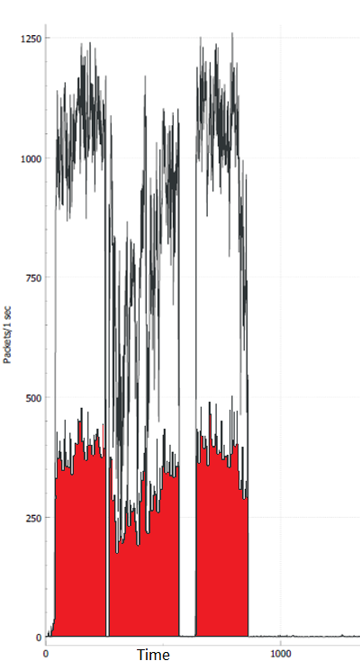
Figure 14 Wireshark Graph of MPLS transfer of data (speed in black) against the errors (in red).

On closer inspection of the data and with assistance from Wireshark it has been possible to look closer at the data available. For example, when transferring data, the MPLS had a higher packet per second, it is obvious from the graph, that the errors during transmission were greater also, on occasion reaching nearly half the total transmissions. This is a strange characteristic as the transportation method is TCP. The method of transmission was FTP and this is also a TCP protocol. it is possible that this is because of user misconfiguration or the order that they are arriving at the destination. A closer inspection of packet tracer confirms that this is a resend.

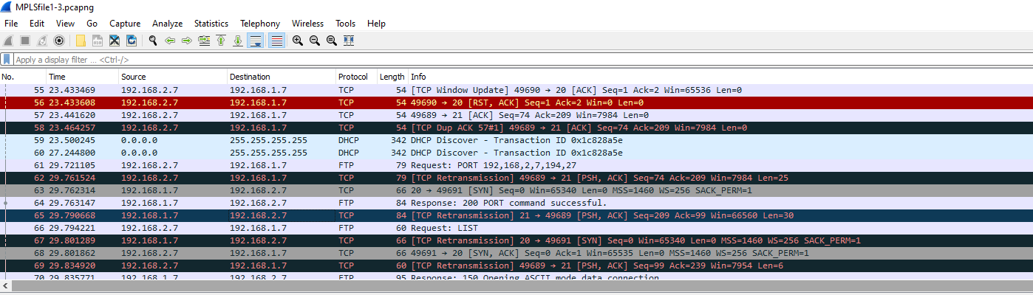
Figure 15 Image of a Wireshark capture of data being transmitted from one side of the MPLS network against the other.

Transfer of 3 file types across an MPLS network

Type | .Txt File | Video File | Sound File | Total transfer time taken
Control IP VPN | 212.18 | 265.7 | 250.225 | 728.105
Control MPLS | 217 | 298.75 | 223 | 738.75
IP VPN Voice, FTP and Video Mod with bandwidth 75 Policy | 243 | 245 | 242 | 730
Policing 100000 mod | 239 | 243 | 236 | 718
IP VPN Priority Mod | 255.87 | 246.36 | 253.25 | 755.48

Chapter 6 - CONCLUSIONS AND RECOMMENDATIONS

Summary

The MPLS data movement was quicker than the IP VPN data connectivity method however with adjustments made to specific types of traffic on the IP VPN along with appropriate security methods something which had never been done before it is more real world to test in an environment.

IPVPN has proven to be just 27% slower in voice, 13% slower in data movement and 19% slower in Priority 1000 CBWFQ; when moving data from two points. When security is also considered

The main aim of the project has been for the Author to determine differences in speed between MPLS and IP Sec VPN’s, the reasons for and the optimisation behind it. Largely this has been achieved within the GNS3 environment although there are still some question marks behind some of the file types selected ie between text file and Video file QoS why there are such vast differences (nearly 3 times greater).

Conclusion

Resources were constrained on the Authors home machine. It would be advisable to use more specialist software (if the budget allowed) or increase resources as potentially the use of the Authors HDD slowed down the process considerably taking around 3-4 minutes to move quite a small file. This is understandable though given when looking at the Wireshark logs that considerable retransmissions were a root symptom of this. The cause is so far unidentified, as it was a TCP protocol transferring the files between the two cloud computers lost data caused its retransmission. The Author suggests that the switch being present may have caused some errors and perhaps should have separated into separate VLAN’s instead on the same router.

In the selection of IP VPN variables, Bandwidth priority (75%), Policing (of no more than 10Mbps) and Priority 1000 CBWFQ; the Author believes that at the time they were sensible methods of queue priority in relation to real world data traffic and this has been proven in the test results.

The literature review targeted differences between MPLS and IP VPN, it made good and reasonable references to the security header. By use of GNS3 and Wireshark it was possible to view the retransmissions that occurred. It appeared that the higher the transmission the greater the retransmissions. As high as 50% during some periods of MPLS.

The author of the project had created 2 separate networks, one with IP VPN connectivity and one with MPLS connectivity. Both are configured on a WAN and have the same routing protocols between them.

Both MPLS and IP VPN have been optimally configured to move specific traffic between source to destination. Links have been downgraded in-between the network to account for a more “real-world” example of an IT network between 2 areas.

Significant difficulties experienced with licencing agreements for add on Software for GNS3 partner Ostinato. Expired licencing agreements and software repository movements have hampered the testing to a point of time-consuming trial and error to get the software working. Trials on Bosun NetSIM and NetSIM ™ were found not to have the same level of support or any support for MPLS simulation again time was wasted going back and forth with their tech support trying to get these products working.

Data movement for MPLS has been quicker through the network than IP VPN however by traffic shaping and prioritising targeted data it was achieved that IP VPN could effectively be optimised.

Recomendations for Further Research

- Further investigation into Priority IP VPN’s if they can be further optimised.

- Understanding of the retransmission errors & position of placement of rules being applied.

- Further Research into SD WAN as the future.

Chapter 7 – Reflections

The aim of this project has been to assist a network manager make the decision whether to implement an MPLS or IP VPN based solution linking networks together. It covered both of these and identified a possible best fit solution to this in implementing a traffic shaping. To a large extent this has been achieved and a viable outcome has been identified.

When completing the project significant time was given to creating of the program, various the coding was hampered by the software being used. It went from GNS 3, to Boson NetSim to Ostinatos and eventually back to GNS3 again. This wasted significant time when the write up should have been completed instead.

Hardware had been problematic and possibly contributed to slowness in transfer of data. Due to space limitations on the Authors own PC it was not possible to run at a quicker speed with multiple cores and RAM to access. This it is suspected contributed to limiting factors such as retransmissions of data.

A range of new skills had been acquired by the Author during the programming period of the project. In-depth programming of network policies according to traffic types is usually a CCIE (expert level) of Cisco learning academy.

The Author began this project back in 2021 since then SD WAN has been more widely adopted. Through no fault of their own MPLS and IP VPN technology has become a little more dated. It is their wish that they focused on this area a little more when drawing a comparison particularly in the Literature review.

chapter 8 - REFERENCES

[1] | “Configuring Basic MPLS Using OSPF,” Cisco, 01 March 2023. [Online]. Available: https://www.cisco.com/c/en/us/support/docs/multiprotocol-label-switching-mpls/mpls/13736-mplsospf.html. [Accessed 10 mar 2023].
[2] | I. Corp, “Authentication Header,” IBM, 31 Aug 2021. [Online]. Available: https://www.ibm.com/docs/en/i/7.1?topic=protocols-authentication-header. [Accessed 24 March 2022].
[3] | B. S. Nagarajan, “When VPN Is Not Enough To Protect Apps,” 2 June 2020. [Online]. Available: https://www.proquest.com/magazines/when-vpn-is-not-enough-protect-apps/docview/2408511721/se-2. [Accessed 28 Feb 2023].
[4] | G. M. b. Z. G. a. C. Y. c. W. W. a. Y. X. a. Songshi Dou a, “Matchmaker: Maintaining network programmability for Software-Defined WANs under multiple controller failures,” Computer Networks, vol. 192, p. 1, 2021.
[5] | “What Is SD-WAN?,” Cisco, [Online]. Available: https://www.cisco.com/c/en_uk/solutions/enterprise-networks/sd-wan/what-is-sd-wan.html#~benefits. [Accessed 28 Feb 2023].
[6] | Z. Qin1, “SD-WAN for Bandwidth and Delay Improvements on the Internet,” in SHS Web of Conferences, Selangor, Malaysia, 2022.
[7] | Cisco, “Cisco Nexus 3000 Series Switches,” Cisco, 2022 05 01. [Online]. Available: https://www.cisco.com/c/en/us/td/docs/switches/datacenter/nexus3000/sw/unicast/503_u1_2/nexus3000_unicast_config_gd_503_u1_2/l3_overview.html#wp1114179. [Accessed 31 05 2022].
[8] | I. E. B. M. S. O. F. Z. W. M. Salima Samaoui, “Modeling and Simulation of Computer Networks and Systems,” Science Direct, pp. 3-33, 2015.
[9] | I. B. I. P. 2020, “Role of packet tracer in simulating server services,” in International Conference on Science Education and Technology, Bali, 2020.
[10] | S. Hogg, “MTU size issues, fragmentation, and jumbo frames: The maximum transmission unit (MTU) for a protocol sets the top limit on how big its packets can be, but the network devices they pass through, encapsulation and other factors can complicate things.,” 20 Oct 2021. [Online]. Available: https://www.proquest.com/trade-journals/mtu-size-issues-fragmentation-jumbo-frames/docview/2584046643/se-2.. [Accessed 14 Feb 2023].
[11] | H. H. Elkarash, N. M. Elshennawy and E. A. Saliam, “Evaluating QoS using Scheduling Algorithms in MPLS/VPN/WiMAX Networks,” in 2017 13th International Computer Engineering Conference (ICENCO), Tanta, Egypt, 2017.
[12] | N. M. E. E. A. S. Hassan H. Elkarash, “Evaluating QoS using Scheduling Algorithms in MPLS/VPN/WiMAX Networks,” in IEEE; 2017 13th International Computer Engineering Conference (ICENCO, Tanta, Egypt, 2017.
[13] | B. S. Panca, “QoS Measurement of VoIP Codec Usage on Limited Bandwidth Network over UDP-based VPN,” Telfor Journal, vol. 12, no. 1, p. 13, 2020. .
[14] | Cisco, “What Is a VPN? - Virtual Private Network,” 11 03 2022. [Online]. Available: https://www.cisco.com/c/en/us/products/security/vpn-endpoint-security-clients/what-is-vpn.html#~related-topics. [Accessed 11 Mar 2022].
[15] | IPL, “Three Types Of Research Methodology,” IPL, [Online]. Available: https://www.ipl.org/essay/Qualitative-And-Quantitative-Research-Methodology-FK7TEJ36JED6. [Accessed 25 Mar 2022].
[16] | NCSC, “Using IPsec to protect data,” NCSC, 09 03 2022. [Online]. Available: https://www.ncsc.gov.uk/guidance/using-ipsec-protect-data. [Accessed 08 04 2022].
[17] | C. Mayr, C. Risso and E. E. B. Grampín, “Crafting optimal and resilient iBGP-IP/MPLS overlays for transit backbone networks,” Optical switching and networking, vol. 42, no. 1, p. 100635, 2021.
[18] | S. I. M. J. H. S. H. Mohammed Humayun Kabir, “Detail Comparison of Network Simulators,” International Journal of Scientific & Engineering Research, vol. 5, no. 10, p. 208, 2014.

APPENDICES

Appendix A
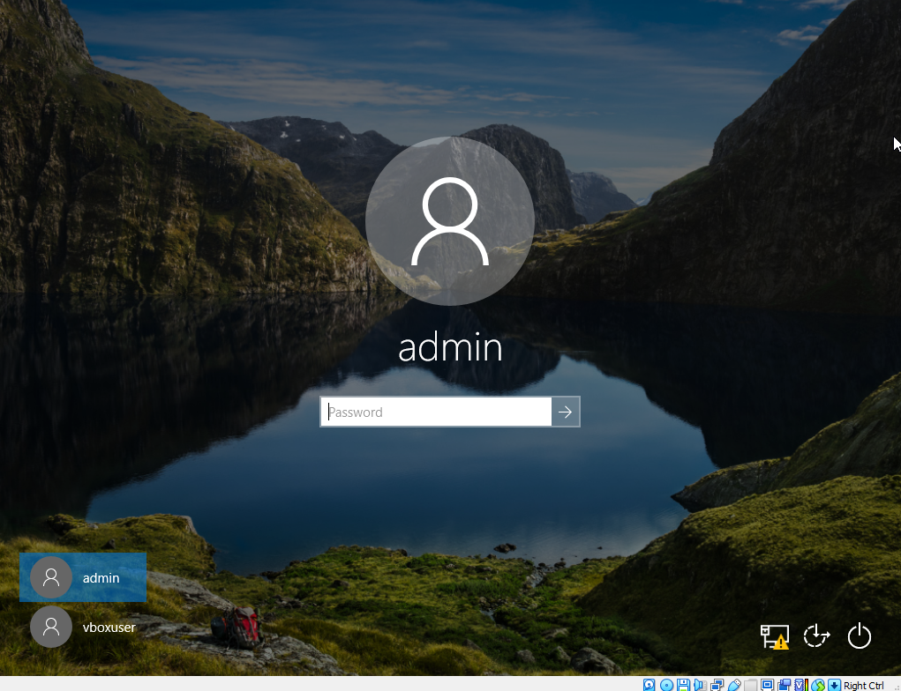
Login with admin account password: admin do this on Win10_1 and Win10_4 machines
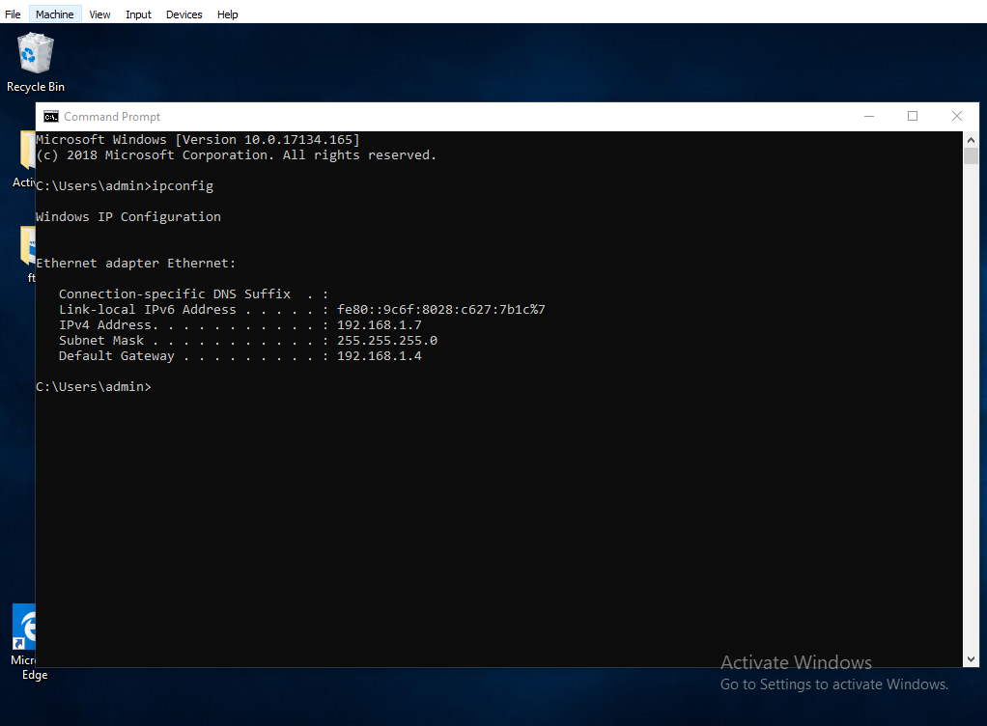Start > command promopt > ipconfig
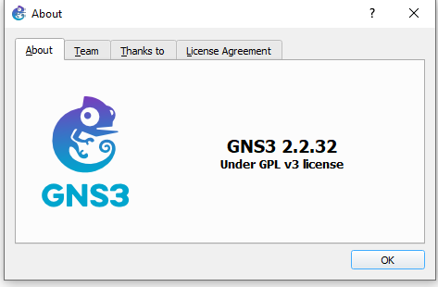
Please open GNS 3 (it must be version2.2.32 downloaded)

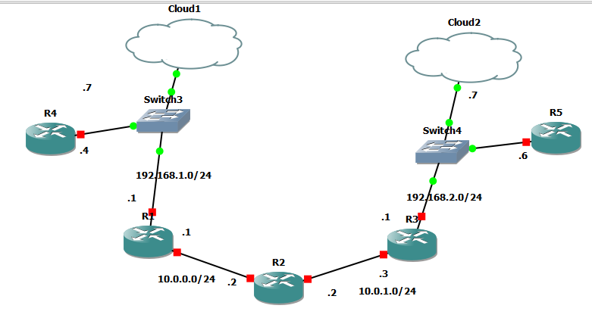
Open GNS 3 Win10_1 is cloud 1 Win10_4 is cloud 2 > select all the switches right click > start
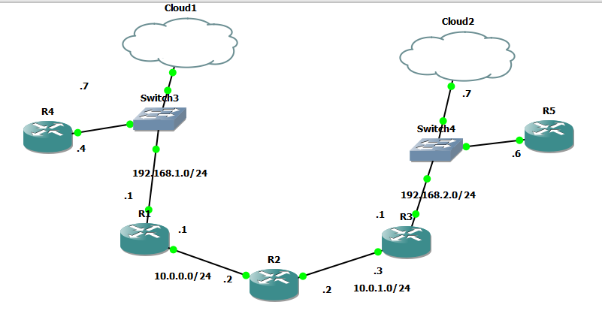
Devices should all now be up this will take approx. 5 minutes to sort out routes etc between eachother.
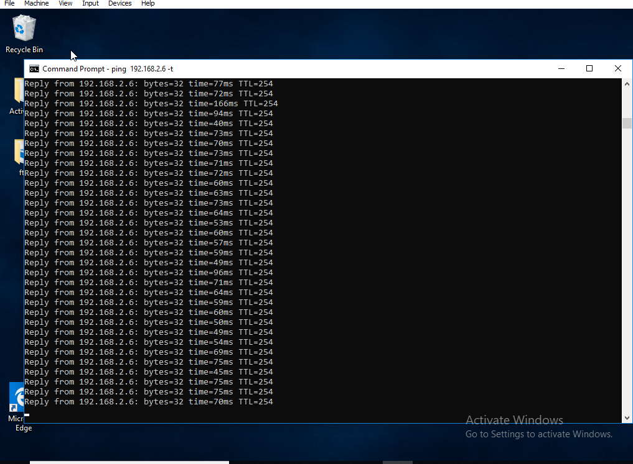
Try a ping test from 192.1.68.1.7 to 192.168.2.6 (this should succeed)

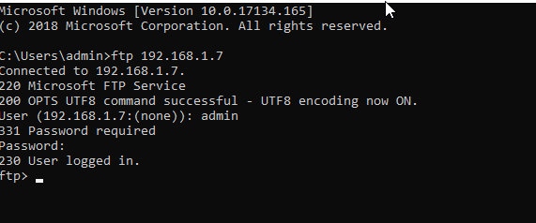
From the command prompt on win10_4 type in:
ftp 192.168.1.7
username: admin
password: admin
hit ‘enter’
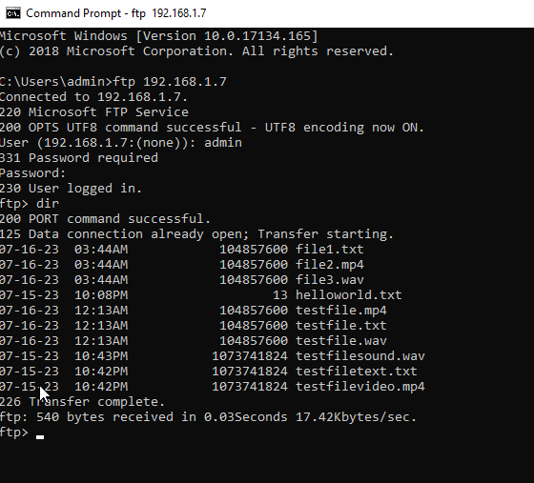
Type in ‘dir’ this will return the above files.
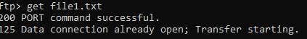
Type in ‘get file1.txt’ or ‘get file2.mp4’ or ‘get file3.wav’. (This will take approx. 4 mins depending on your system)

Appendx B

TABLE OF FIGURES
- Depciting an IP VPN L2 Tunnel encrypted and unencrypted between two sitesFigure 2 Depicting an MPLS network with ingress and egress LSR’s
- Figure 3 Image of the encapsulation of the IP Packet by ESP
- The Research Onion
- Depicture of an MPLS network
- an example of Voice data traversing a VPN with QoS in place
- Image of setup of MPLS and IP VPN setup.
- VPN/MPLS Tunnel and Internet Framework.
- Data tables of transfer times per file type by method of priority
- individual and combined text file transfer via differing methods
- individual and combined video file transfer via differing methods
- individual and combined audio file transfer via differing methods
- Combined file types via individual methods and combined via different methods of file transfer
- Wireshark Graph of MPLS transfer of data (speed in black) against the errors (in red).
- Image of a Wireshark capture of data being transmitted from one side of the MPLS network against the other.

