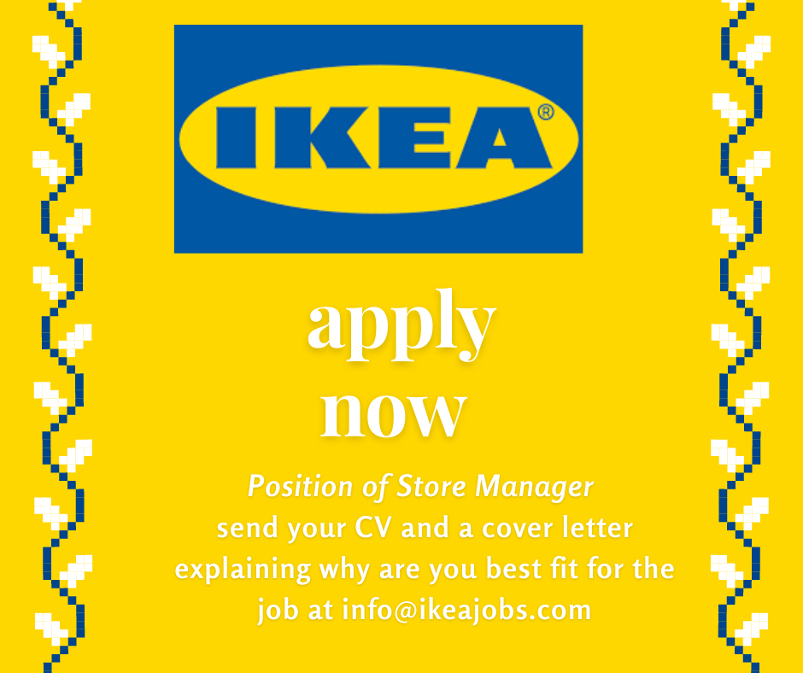

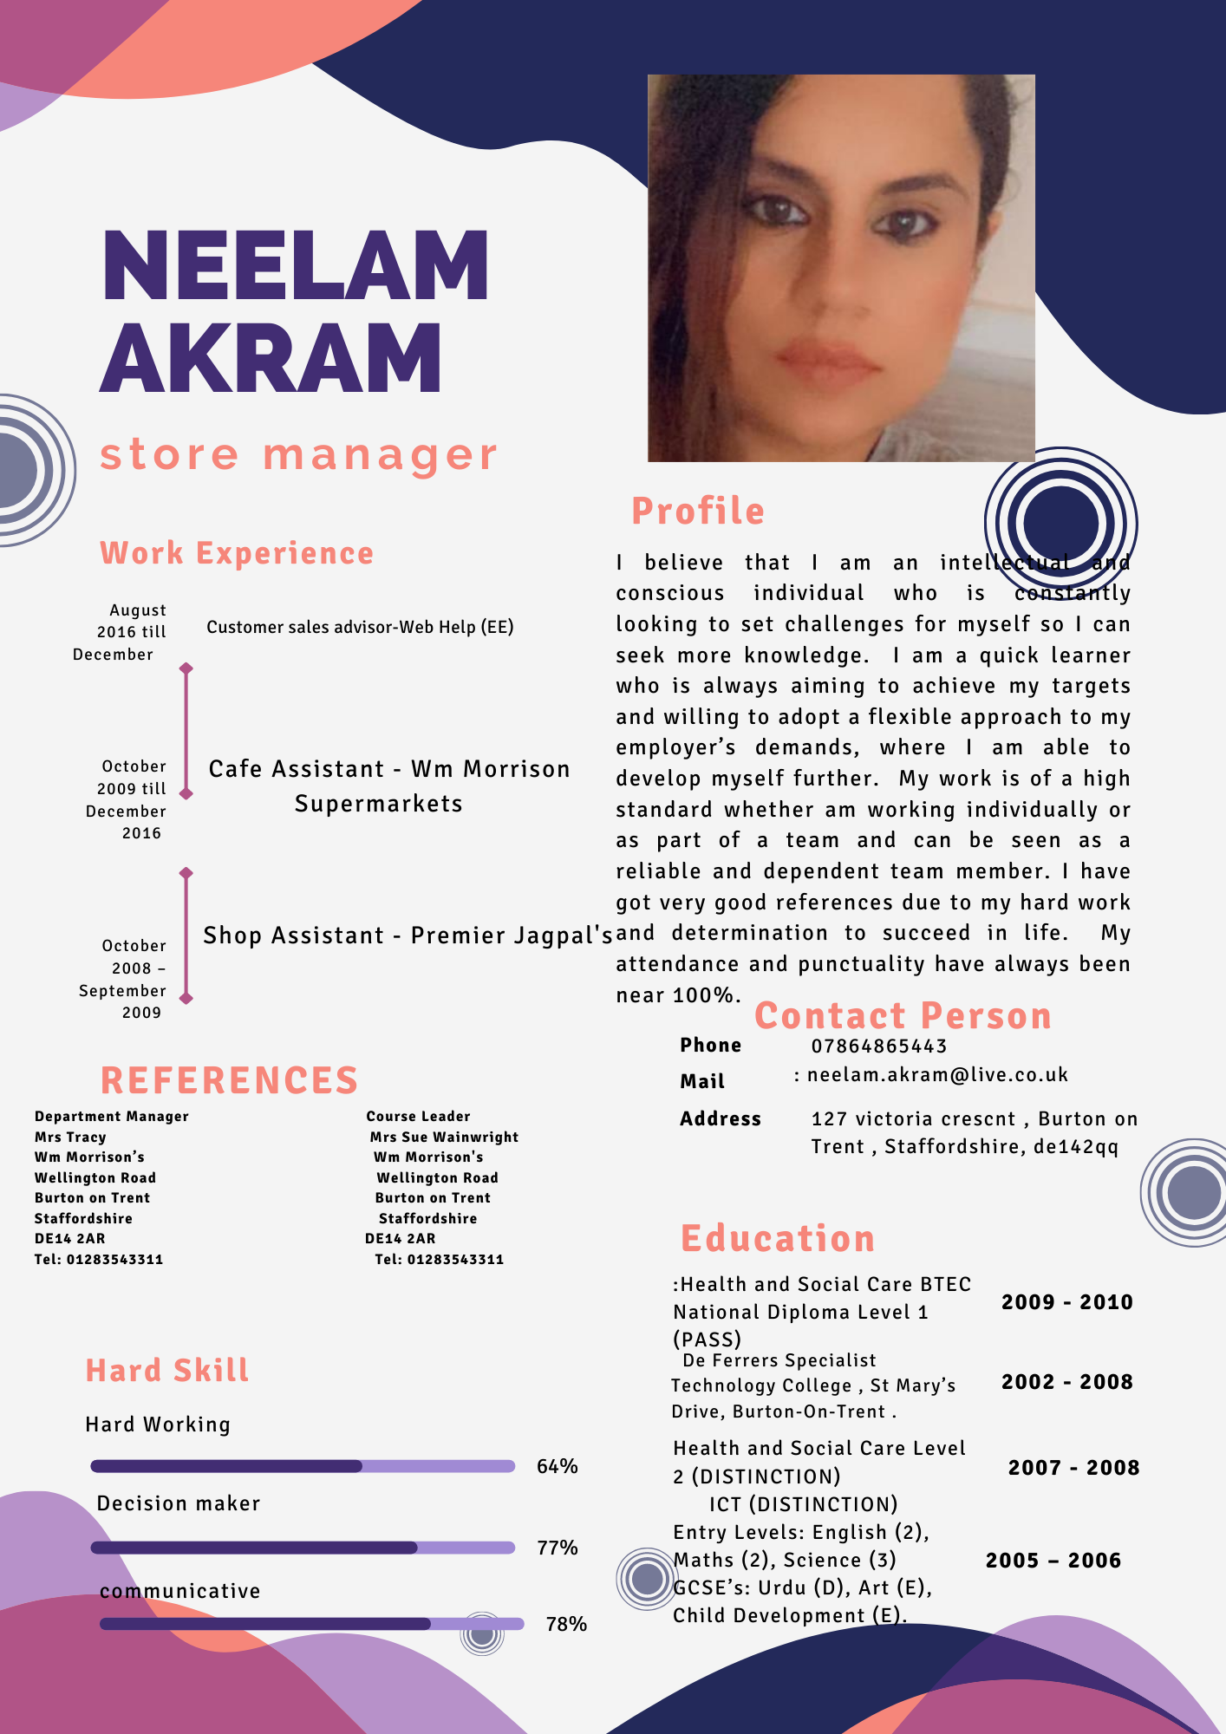
Neelam Akram
07846865443
To,
The HR Ikea UK
Getting along with clients and staff is something I am good at and have developed further by working at Morrison’s. I am a friendly and approachable person who works towards the highest standard. I am more than competent in using various Microsoft Office packages and can work on my own initiative when needed as well as part of a team. I have very good communication, numeracy and IT skills and most importantly I am of a caring nature and see myself in this field of work.
When working as a Customer Sales Advisor the main skill for this job role is being able to work well within a team and being able to multitask, also bringing a positive, friendly character in the working environment, I ensure I have great organization skills and time keeping as this is key. Meeting targets and objectives at set time scales is something I am working hardly to achieve. My statistics are currently good and I am making good sales for the company.

In the absence of the cafe manager, it have been my duty to ensure that the cafe is running smoothly. By ensuring that all staff are aware of their job roles and duties. I am also first aid trained so were there may be a case of first aid treatment required in the whole store, I will be called were I am needed. I have also done the appropriate training for the pharmacy so if they need back up staff I will be called as and when needed.
Ordering stock and filling the shop, dealing with damaged and expired stock, cleaning and date checking as well as maintaining the shop, receiving telephone calls, dealing with customer complaints and refunding products. The above mentioned qualities assures that I will be better option for the designation advertised. I’d be looking forward for the reply. I can be easily reached at 07846865443. Looking forward for the reply.
Neelam Akram

