Appendix 1
APPLICATION FOR ETHICAL APPROVAL

In order for research to result in benefit and minimise risk of harm, it must be conducted ethically. A researcher may not be covered by the University’s insurance if ethical approval has not been obtained prior to commencement.

The University follows the OECD Frascati manual definition of research activity: “creative work undertaken on a systematic basis in order to increase the stock of knowledge, including knowledge of man, culture and society, and the use of this stock of knowledge to devise new applications”. As such this covers activities undertaken by members of staff, postgraduate research students, and both taught postgraduate and undergraduate students working on dissertations/projects.

The individual undertaking the research activity is known as the “principal researcher”.

Ethical approval is not required for routine audits, performance reviews, quality assurance studies, testing within normal educational requirements, and literary or artistic criticism.

Please read the notes for guidance before completing ALL sections of the form.

This form must be completed and approved prior to undertaking any research activity. Please see Checklist for details of process for different categories of application.

SECTION A: About You (Principal Researcher)

Full Name: |  |  | Sasha Williams
Tick all boxes which apply:
Member of staff: | ☐ | Student: |  |  | Honorary research fellow: | ☐

Faculty/School/Centre: | SWWCTE: YR ATHROFA
Campus: | Carmarthen
E-mail address: | 1600234@student.uwtsd.ac.uk
Contact Telephone Number: | 07956670627
For students:
Student Number: | 1600234 | Undergraduate
Programme of Study: | BA Primary education with QTS | Taught Postgraduate | ☐
Director of Studies/Supervisor: | Dr Sioned V Hughes | Research | ☐

SECTION B: Approval for Research Activity

Has the research activity received approval in principle?  (please check the Guidance Notes as to the appropriate approval process for different levels of research by different categories of individual) |  | YES |  | NO | ☐
 |  |  |  | Date
If Yes, please indicate source of approval (and date where known): | Research Degrees Committee |  | ☐
 | Faculty Research Committee |  | ☐
 | Other (write in) |  |  | 08/02/19
Approval in principle must be obtained from the relevant source prior to seeking ethical approval.

SECTION C: External Ethical Guidance Materials

Please list the core ethical guidance documents that have been referred to during the completion of this form (including any discipline-specific codes of research ethics, and also any specific ethical guidance relating to the proposed methodology). Please tick to confirm that your research proposal adheres to these codes and guidelines.
The research follows the bounds of the normal classroom and in accordance with the SWWCTE school guidelines for parental consent as per SWWCTE letter.
The research will be conducted within BERA (British Educational Research Association) guidelines- Ethical Guidelines for Educational Research, (2018)
The research will adhere to the university research guidelines
Research will also follow the guidelines from the EWC such as ethics in education, conducting research with young people and colleagues and consent and assent.

SECTION D: External Collaborative Research Activity

Does the research activity involve collaborators outside of the University? |  | YES | ☐ | NO
If Yes, please provide the name of the external organisation and name and contact details for the main contact person:
Institution
Contact person name
Contact person e-mail address

Where research activity is carried out in collaboration with an external organisation
Does this organisation have its own ethics approval system? | YES | ☐ | NO
If Yes, please attach a copy of any final approval (or interim approval) from the organisation

SECTION E: Details of Research Activity

Indicative title: | A critical analysis on whether outdoor learning have a positive effect on a child’s wellbeing and development of learning.
Proposed start date: | 11/02/19 | Proposed end date: | 29/04/19
Purpose of research activity (including aims and objectives)
Outline the purpose, aims and objectives of the research activity, including key research questions. Show briefly how existing research has informed the proposed activity and explain what the research activity will add and how it addresses an area of importance. (Maximum 300 words)
The main purpose of the research activity is to analysis the impact outdoor learning has on pupils learning and wellbeing, including an analysis on the difference on attainment, wellbeing and pupil participation in their work. The aim of the research is to touch upon teacher’s interaction and engagement in outdoor learning. Is there a significant difference in attainment/ motivation/ engagement/ wellbeing in pupils who work out of the classroom? As a teacher, how confident do you feel teaching outside of the classroom/ outdoors? Do you find it easier to teach certain subjects outside? Researchers, such as Gardner (1999) explain the importance of different learning environments and how it effects a pupil’s wellbeing and aspirations. Bilton, states in his research that children need to experience to understand and develop their emotions. The research that I will undertake will provide an insight to the importance of outdoor learning and how it enhances a pupils well being and work ethics.

(this box should expand as you type)
Proposed methods
Provide a brief summary of all the methods that may be used in the research activity, making it clear what specific techniques may be used. If methods other than those listed in this section are deemed appropriate later, additional ethical approval for those methods will be needed. (Maximum 600 words)
Interviews- A group of children from the class will be involved in a semi- structured interview where they will be invited to respond to key questions. For example, do you enjoy having lessons outside? Do you think outdoor learning is enjoyable? Why? Do you think you participate more in activities outdoors? The group of children will be in an informal setting and I will make notes of their responses. The children will not be forced into participating into these interviews and children have the choice to stop this interview when they please. If the child decides to leave this interview, they will show this through exit cards that I will provide. The exit cards will be emojis and they can show whether they are happy or sad through these emoji cards. No names will be used through my notes. I will interview the class teacher and teacher assistances on the impact they see on pupils through learning outdoors. I will also ask how often they work outdoors through the year.

Observations- I will observe different groups participating in outdoor learning with their class teacher, this will provide me with the opportunity to observe good practice and the difference it has on a pupil compared to learning in the classroom. I will make notes on pupils’ engagement and the different activities taking place. The notes made during observations will be recorded in a book which will be available for the teacher to read. Children can also have access to these notes, and they can state whether they want certain information written down.

Questionnaire- Depending on the age of the class I will create a questionnaire for pupils to reply to about whether they enjoy outdoor learning, find it beneficial and how it makes them feel. The questionnaire may focus on qualitive or quantitative data, or both, depending on its focus. The questionnaire may also be adapted for teachers, depending on the amount of data received from the interview. If a questionnaire is required, then it will be anonymous. The questionnaire will be distributed only by physical copies. Once the questionnaire has been gathered back, the answers will be used for analysis. The final question will be for pupils to state their own personal opinion or experience of learning outdoors. Exit- If pupils decide they do not want their questionnaire to be used for analysis they are able to retain their response.

Learning walk- To support my research I will conduct a learning walk through the school if this is appropriate to observe displays and their outdoor learning environment. These learning walks can be either self-directed or directed by a learner or member of staff. Before the learning walk I will ask for consent to be able to collect evidence (written, photographic) for my research by staff.

(this box should expand as you type)

Location of research activity
Identify all locations where research activity will take place.
The proposed research activity will be conducted in a school that situated on the outskirts of Swansea with 385 pupils on roll, including 52 in nursery and 8 pupils in the special teaching facility. Along with a partnership primary school.
(this box should expand as you type)
Research activity outside of the UK
If research activity will take place overseas, you are responsible for ensuring that local ethical considerations are complied with and that the relevant permissions are sought. Specify any local guidelines (e.g. from local professional associations/learned societies/universities) that exist and whether these involve any ethical stipulations beyond those usual in the UK (provide details of any licenses or permissions required). Also specify whether there are any specific ethical issues raised by the local context in which the research activity is taking place, for example, particular cultural sensitivities or vulnerabilities of participants.
(this box should expand as you type)

SECTION F: Scope of Research Activity

Will the research activity include: | YES | NO
Use of a questionnaire or similar research instrument? |  | ☐
Use of interviews? |  | ☐
Use of diaries? |  | ☐
Participant observation with their knowledge? |  | ☐
Participant observation without their knowledge? | ☐
Use of video or audio recording? | ☐
Access to personal or confidential information without the participants’ specific consent? | ☐
Administration of any questions, test stimuli, presentation that may be experienced as physically, mentally or emotionally harmful / offensive? | ☐
Performance of any acts which may cause embarrassment or affect self-esteem? | ☐
Investigation of participants involved in illegal activities? | ☐
Use of procedures that involve deception? | ☐
Administration of any substance, agent or placebo? | ☐
Working with live vertebrate animals? | ☐
Other primary data collection methods, please explain in this box | ☐

If NO to every question, then the research activity is (ethically) low risk and may be exempt from some of the following sections (please refer to Guidance Notes).

If YES to any question, then no research activity should be undertaken until full ethical approval has been obtained.

SECTION G: Intended Participants

Who are the intended participants: | YES | NO
Students or staff at the University? | ☐
Adults (over the age of 18 and competent to give consent)? |  | ☐
Vulnerable adults? | ☐
Children under 18? |  | ☐
Prisoners? | ☐
Young offenders? | ☐
Those who could be considered to have a particularly dependent relationship with the investigator or a gatekeeper? | ☐
People engaged in illegal activities? | ☐
Others (please identify): | ☐

Participant numbers and source
Provide an estimate of the expected number of participants. How will you identify participants and how will they be recruited?
The estimate expected number of participates will be 30 children from one-year group, 1 head teacher, the classroom teacher and teacher assistants. Prior to conducting the research, I will obtain consent from the head teacher or senior mentor in the school setting.

this box should expand as you type)

Information for participants: | YES | NO | N/A
Will you describe the main research procedures to participants in advance, so that they are informed about what to expect? |  | ☐ | ☐
Will you tell participants that their participation is voluntary? |  | ☐ | ☐
Will you obtain written consent for participation? |  | ☐ | ☐
Will you explain to participants that refusal to participate in the research will not affect their treatment or education (if relevant)? |  | ☐ | ☐
If the research is observational, will you ask participants for their consent to being observed? |  | ☐ | ☐
Will you tell participants that they may withdraw from the research at any time and for any reason? |  | ☐ | ☐
With questionnaires, will you give participants the option of omitting questions they do not want to answer? |  | ☐ | ☐
Will you tell participants that their data will be treated with full confidentiality and that, if published, it will not be identifiable as theirs? |  | ☐ | ☐
Will you debrief participants at the end of their participation, in a way appropriate to the type of research undertaken? |  | ☐ | ☐
If NO to any of above questions, please give an explanation
(this box should expand as you type)

Information for participants: | YES | NO | N/A
Will participants be paid? | ☐ |  | ☐
Is specialist electrical or other equipment to be used with participants? | ☐ |  | ☐
Are there any financial or other interests to the investigator or University arising from this study? | ☐ |  | ☐
Will the research activity involve deliberately misleading participants in any way, or the partial or full concealment of the specific study aims? | ☐ |  | ☐
If YES to any question, please provide full details
(this box should expand as you type)

SECTION H: Anticipated Risks

Outline any anticipated risks that may adversely affect any of the participants, the researchers and/or the University, and the steps that will be taken to address them.

If you have completed a full risk assessment (for example as required by a laboratory, or external research collaborator) you may append that to this form.

Full risk assessment completed and appended?

Yes ☐
No

Risks to participants
For example: emotional distress, financial disclosure, physical harm, transfer of personal data, sensitive organisational information
The risk to participants is that they be involved in the research without consent. Therefore, I will ensure that all consent procedures are in place by informing the children and staff of my research. I will explain to the children and staff that they have the right to withdraw and can leave the research, or express that they do not wish any data to be used, at any time. For example, I will ask the children if I can use their answers from the interviews in my research and share my notes. I will also monitor the children’s wellbeing and stop any activity if any child is becoming upset/uncomfortable

(this box should expand as you type)
If research activity may include sensitive, embarrassing or upsetting topics (e.g. sexual activity, drug use) or issues likely to disclose information requiring further action (e.g. criminal activity), give details of the procedures to deal with these issues, including any support/advice (e.g. helpline numbers) to be offered to participants. Note that where applicable, consent procedures should make it clear that if something potentially or actually illegal is discovered in the course of a project, it may need to be disclosed to the proper authorities
N/A
(this box should expand as you type)
Risks to investigator
For example: personal safety, physical harm, emotional distress, risk of accusation of harm/impropriety, conflict of interest
The risk to the researcher is that I may be accused of unprofessional practice. I will manage the risk by adhering to the BERA guidelines and following my plan of ethical practice.

(this box should expand as you type)
University/institutional risks
For example: adverse publicity, financial loss, data protection
There should be no risk to the University if I manage the risk to the participant and the researcher as detailed above. I will conduct the research and represent the results honestly.
I will always comply with ethical, legal and professional frameworks, obligations and standards as required by the statutory and regulatory authorities, as well as with the university’s Research Integrity and Ethics Code of Practice.

(this box should expand as you type)
Adverse outcomes
List measures put in place to limit any adverse effects or outcomes of research activity where appropriate. Include any emergency protocols.
I will manage the risk by adhering to the BERA guidelines and EWC guidelines, following my plan of ethical practice. I will always comply with ethical, legal and professional frameworks, obligations and standards as required by the statutory and regulatory authorities, as well as with the University’s Research Integrity and Ethics Code of Practice.

(this box should expand as you type)

Disclosure and Barring Service
If the research activity involves children or vulnerable adults, a Disclosure and Barring Service (DBS) certificate must be obtained before any contact with such participants. | YES | NO | N/A
Has a DBS certificate been obtained? |  | ☐ | ☐

SECTION I: Feedback, Consent and Confidentiality

Feedback
What feedback will be provided to participants, how will this be done and when?
Feedback will not be returned to participants as it is not relevant for the research. If the participants request feedback from the response then I, as the author, will provide a summary of the data collected.

(this box should expand as you type)
Informed consent
Describe the arrangements to inform potential participants, before providing consent, of what is involved in participating. Describe the arrangements for participants to provide full consent before data collection begins. If gaining consent in this way is inappropriate, explain how consent will be obtained and recorded.
Participation consent- children
I will converse with my class teacher and senior mentor inform them of the research I will be undertaking, providing reason and rationale behind the research. However, I will verbally ask children identified to participate whether they wish to participate, e.g. use traffic light fans to support the children. If they show the green face, then I know they are happy to take part. If they show the red face, then I know they are not willing. This will be an individual exercise so that children are encouraged to respond honestly with their interest and wellbeing in mind. Children will also be informed that they can approach me at any time and discuss their contribution to the research project and explain whether they wish to participate.

Participation consent- teachers
For the class teachers, I will ask them to sign a document if they agree to take part in the research. If they are not willing to sign this document, then I shall not use them in my research. The consent form will include a box for the participant to tick if they agree with the statements, e.g. I confirm that I have read and understand the information sheet dated 11/02/19 for the above study. I have had the opportunity to consider the information, ask questions and had these answered satisfactorily. I understand that my participation is voluntary and that I am free to withdraw at any time, without giving any reason. I understand that any information given by me may be used in future report, articles or presentations by the research team. I understand that my name will not appear in any report, articles or presentations. I agree to participate in the above study.

(this box should expand as you type)
Confidentiality / Anonymity
Set out how anonymity of participants and confidentiality will be ensured in any outputs. If anonymity is not being offered, explain why this is the case.
I will ensure that no individual data (raw scores, individual identifiable performance outcomes) are made available to Schools/Parents, etc. Only non-identifiable summary/aggregate data can be provided in this way.

I will also place a statement on the consent form indicating that ‘if you decide to remain anonymous, maintaining your anonymity will be a priority and every practical precaution will be taken to disguise your identity. If you prefer anonymity, there will not be any identifying information on audiotapes and transcripts without your prior consent. All materials generated from this or any interview will remain confidential.’

(this box should expand as you type)

SECTION J: Data Protection and Storage

In completing this section refer to the University’s Research Data Management Policy and the extensive resources on the University’s Research Data Management web pages (http://uwtsd.ac.uk/library/research-data-management/).
 | YES | NO
Does the research activity involve personal data (as defined by the Data Protection Act)?  “personal data” means data which relate to a living individual who can be identified—  (a) from those data, or  (b) from those data and other information which is in the possession of, or is likely to come into the possession of, the data controller, and includes any expression of opinion about the individual and any indication of the intentions of the data controller or any other person in respect of the individual. | ☐
If YES, provide a description of the data and explain why this data needs to be collected:
(this box should expand as you type)
Does it involve sensitive personal data (as defined by the Data Protection Act)?  “Sensitive personal data” means personal data consisting of information as to –  (a) the racial or ethnic origin of the data subject,  (b) his political opinions,  (c ) his religious beliefs or other beliefs of a similar nature,  (d) whether he is a member of a trade union (within the meaning of the Trade Union and Labour Relations (Consolidation) Act 1992),  (e) his physical or mental health or condition,  (f) his sexual life,  (g) the commission or alleged commission by him of any offence, or  (h) any proceedings for any offence committed or alleged to have been committed by him, the disposal of such proceedings or the sentence of any court in such proceedings. | ☐
If YES, provide a description of the data and explain why this data needs to be collected:
(this box should expand as you type)

Will the research activity involve storing personal data on one of the following: | YES | NO
Manual files (i.e. in paper form)? |  | ☐
University computers? | ☐
Private company computers? | ☐
Home or other personal computers? |  | ☐
Laptop computers/ CDs/ Portable disk-drives/ memory sticks? |  | ☐
“Cloud” storage or websites? | ☐
Other – specify: | ☐
For all stored data, explain the measures in place to ensure data confidentiality, including details of password protection, encryption and anonymisation:
Confidentiality will be upheld by not requesting participant names on any piece of data collected. Data will be stored in a locked cupboard and password protected computer. Any correspondence between my tutor and myself will be through a password protected e-mail account.
(this box should expand as you type)

Will the research activity involve any of the following activities: | YES | NO
Electronic transfer of data in any form? | ☐
Sharing of data with others at the University? | ☐
Sharing of data with other organisations? | ☐
Export of data outside the European Union or importing of data from outside the UK? | ☐
Use of personal addresses, postcodes, faxes, emails or telephone numbers? | ☐
Publication of data that might allow identification of individuals? | ☐ | ☐
Use of data management system? | ☐ | ☐
Data archiving? | ☐ | ☐
If YES to any question, please provide full details, explaining how this will be conducted in accordance with the Data Protection Act (and/or any international equivalent):
(this box should expand as you type)

List all who will have access to the data generated by the research activity:
(this box should expand as you type)
List who will have control of, and act as custodian(s) for, data generated by the research activity:
(this box should expand as you type)
Give details of data storage arrangements, including where data will be stored, how long for, and in what form. Will data be archived – if so how and if not why not.
(this box should expand as you type)

SECTION K: Declaration

The information which I have provided is correct and complete to the best of my knowledge. I have attempted to identify any risks and issues related to the research activity and acknowledge my obligations and the rights of the participants.

In submitting this application I hereby confirm that I undertake to ensure that the above named research activity will meet the University’s Research Ethics and Integrity Code of Practice
Signature of applicant: |  | Date:

For students:
Teacher / Senior Mentor / Headteacher:
Signature:
Date:

Supervisor:
Signature:
Date:

Checklist: Please complete the checklist below to ensure that you have completed the form according to the guidelines and attached any required documentation:
☐ | I have read the guidance notes supplied before completing the form.
☐ | I have completed ALL RELEVANT sections of the form in full.
☐ | I confirm that the research activity has received approval in principle
☐ | I have attached a copy of final/interim approval from external organisation (where appropriate)
☐ | I have attached a full risk assessment (and have NOT completed Section H of this form) (where appropriate)
☐ | I understand that it is my responsibility to ensure that the above named research activity will meet the University’s Research Ethics and Integrity Code of Practice.
☐ | I understand that before commencing data collection all documents aimed at respondents (including information sheets, consent forms, questionnaires, interview schedules etc.) must be confirmed by the DoS/Supervisor, module tutor or Head of School.

RESEARCH STUDENTS AND STAFF ONLY
All communications relating to this application during its processing must be in writing and emailed to pgresearch@uwtsd.ac.uk , with the title ‘Ethical Approval’ followed by your name.
You will be informed of the outcome of your claim by email; therefore it is important that you check your University and personal email accounts regularly.

STUDENTS ON UNDERGRADUATE OR TAUGHT MASTERS PROGRAMMES should submit this form (and receive the outcome) via systems explained to you by the supervisor/module leader.

This form is available electronically from the Academic Office web pages: http://www.uwtsd.ac.uk/academic-office/

Application Process

All staff research projects and all research students must submit the Ethical Approval Form to the University Ethics Committee via the Academic Office (pgresearch@uwtsd.ac.uk). Staff research directly in relation to personal study for taught undergraduate or Masters programmes should be submitted via the Faculty procedures explained below.

Taught masters and taught undergraduate research Ethical Approval Forms are considered within Faculties. Faculties will provide details of the specific processes for this. Where the Ethical issues within any single ethical application are of particular concern the Faculty will refer these to the University Ethics Committee. Any student activity that involves the collection of primary data needs to undergo Ethical approval, this includes assignment work as well as dissertations.

Notes for guidance in completion of this form

Section A: About You
Please complete all relevant sections

Section B: Approval for research activity
Research proposals must be approved in principle before applying for Ethical Approval. The proposal approval only becomes final when the ethical approval is received.

The process for proposal approval varies according the individual and programme of study:
- Research students, by application on form PG1 to the Research Degrees Committee
- Taught students by review of research proposal within Faculties (Faculties provide specific details of these processes)
- Staff, by agreement by the Head of School/Assistant Dean

Section C: External Ethical Guidance materials
Many discipline areas are required to operate with the discipline specific codes of research ethics (for example health, psychology, education etc.), any such codes must be listed and you must tick to confirm that you have consulted with these.

Section D: External Collaborative Research Activity
Provide details of the external collaborative partners, where appropriate you might want to submit a copy of the external collaboration agreement with the Ethical Approval Form. If the partner requires the research to be subject to its own internal Ethical approval process then please provide details of that process and a copy of any final (or interim) approvals received from the organisation.

Section E: Details of Research Activity
Remember that the individuals reviewing this Ethical Approval Form may not have seen your research proposal, and also may not be experts in the specific area of your research. The information provided should therefore be jargon free and clearly stated.
Indicative Title: please use the same title as used on the research proposal.
Purpose: the Ethical approval process will want to ensure that the methods you propose are adequate and appropriate to address the research aims and objectives. Excessive additional data collection can be seen as unethical.
Proposed Methods: the Ethical approval process seeks to ensure that you understand the methods that are intended, and that the implementation of those methods will be appropriate and without unnecessary impact on respondents. Please be specific.
Location: this needs to mention geographical location and also local situation (for example, within Local Authority Offices in Cardiff, using a private room but close to other individuals). If you are collecting data within an organisational setting then you need to explain the permissions that you have obtained to do this.
Research Activity outside of the UK: please complete this section in detail, and note any guidance you have received. Also describe your own familiarity (or not) with the location that you will be utilising.

Section F: Scope of Research Activity
Please tick ALL of the research activities that might be undertaken. If any additional types of activity are intended then please add an extra box and describe these.
If you have answered no to all questions in F then sections G and J do not need to be completed. Section H should be considered, and may be completed. Signatures are still required in section K.

Section G: Intended Participants
Please tick all categories that might apply.
Numbers & Source: if you are using a series of different methods or research activities please list numbers for each stage/phase. Be clear about how you will find respondents. Will you use intermediaries, and if so how? How will you ensure compliance with your sampling strategy?
Information for participants: all participants should be appropriately informed about the research, what is expected of them and what will happen to the information that they provide. The Ethical review process does not ask to see this documentation, but requires this to be reviewed and approved by the Director of Studies in the case of research students, the supervisor/module tutor in relation to students on taught programmes and the Head of School/Assistant Dean in relation to staff research.

Section H: Anticipate Risks
All research carries some level of risk. The answers you provide to questions in this section will be reviewed to ensure that you have an appropriate understanding of the type of risks involved and how you can mitigate against these risks. If you have completed a full risk assessment, as required for example for laboratory work, field work, clinical tests, diving operations, or by a collaborative partner, you may append that to this form. In that case, please tick the box indicating this has been provided. You will not then be required to complete Section H.
Risk to participants Think very carefully about how your actions/questions/discussions might affect the people you are involving as participants. You might identify the risk as small but it would still be a risk. Many types of question have the potential to make respondents less content with their life / job; you need to recognise and try to ameliorate any such effects
If these are business owners, time with you may reduce profit.
In some locations physical risk is very real to both participants and yourself, please consider this.
Risk to you, the researcher Think about where you will meet people, if there are any dangers involved in the location. If you are meeting people as individuals think about using a public place. In general do not visit people in their own homes or remote locations. If you are talking to individuals about certain issues think about how their responses might affect you emotionally. What about the risk of collecting insufficient data?
Risk to the University When undertaking your research, you are acting as a member of the University (student or staff). Professionalism is important, so it is important to be well organised and well prepared. Punctuality, clarity etc. are all part of this. What will you do to ensure this? You must ensure you do not harm the good name of the University in any way and do nothing to undermine the reputation of the research it conducts and sponsors. Upholding high standards of conduct and integrity are vital in this regard. You must also conduct the research in such a way to minimise the potential for claims of negligence made against the University, its researchers and any collaborating individual or organisation. In this respect you should always comply with ethical, legal and professional frameworks, obligations and standards as required by statutory and regulatory authorities, as well as the university’s Research Integrity and Ethics Code of Practice. Research misconduct in this respect can take many forms, including:
- fabrication: making up results or other outputs (eg, artefacts) and presenting them as if they were real
- falsification: manipulating research processes or changing or omitting data without good cause
- plagiarism: using other people’s material without giving proper credit
- failure to meet ethical, legal and professional obligations: for example failure to declare competing interests; misrepresentation of involvement or authorship; misrepresentation of interests; breach of confidentiality; lack of informed consent; misuse of personal data; and abuse of research subjects or material
- improper dealing with allegations of misconduct: failing to address possible infringements such as attempts to cover up misconduct and reprisals against whistle-blowers

Adverse Outcomes. Think carefully about the possibilities, and cover here

Section I: Feedback, Consent and Confidentiality
Feedback to participants: outline your approach. Will interview transcripts be shared with respondents to check accuracy? Will summaries of questionnaire analysis be made available to respondents in some way? Will an overview report be provided? How and when?
Informed consent: Draft letter / e-mail / or heading (or footer) section of questionnaire must be approved by DoS/supervisor (if research student), supervisor/module tutor if taught student, or Head of School / Assistant Dean if a member of staff.
Confidentiality/Anonymity. Explain clearly how you will ensure confidentiality and anonymity.

Section J: Data Protection and Storage
Before completing this section it is necessary to read the University’s Research Data Management information. The questions that follow are designed to ensure compliance with the Data Protection Act as well as established research protocols.

Many research activities will involve electronic transfer of data and use of data management systems in the summarisation and analysis of data. You will need to explain these in relation to compliance with the Data Protection Act.
Think carefully about who will have access to your data, this will include supervisors and examiners. Also that a thesis will be made available via the University library and the British Library system. If you are seeking an access bar for a period of time after completion then mention it here. If you will provide a copy of your findings, or intend to give a presentation, to a facilitating/ supporting/accessing organisation then explain that in this section. But also think about the general principle of data sharing, as explained in the Research Data Management information.
In terms of storage of data please ensure security, and also mitigate against loss of data.

Section K: Declaration
Ensure the appropriate countersignatures have been provided
Look carefully at the checklist and ensure that you comply with and tick all that are relevant to your research.

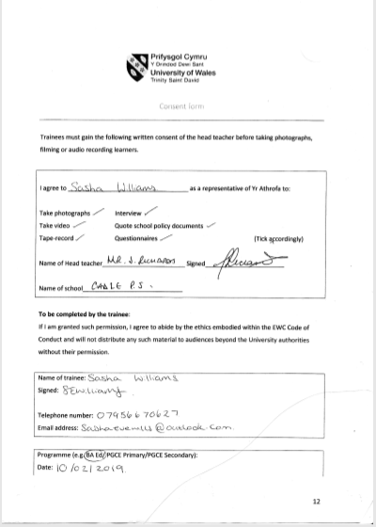
Appendix 2

Appendix 3
Appendix 3.1
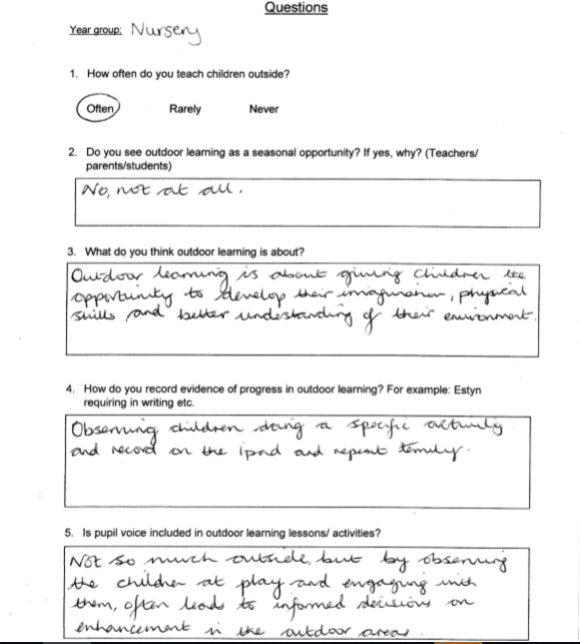

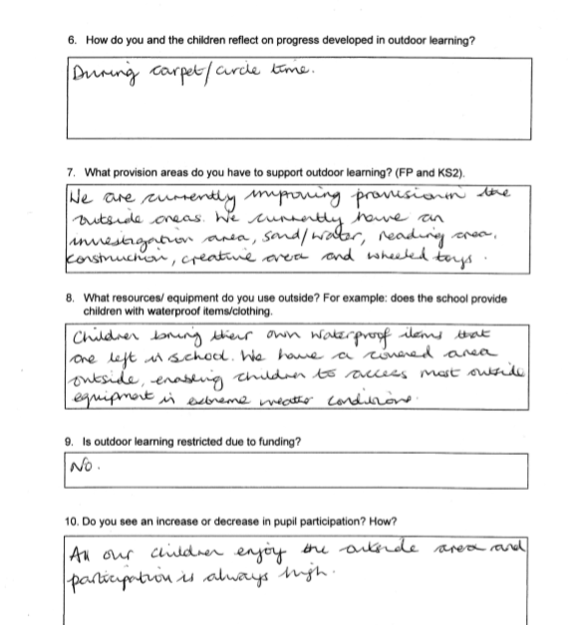

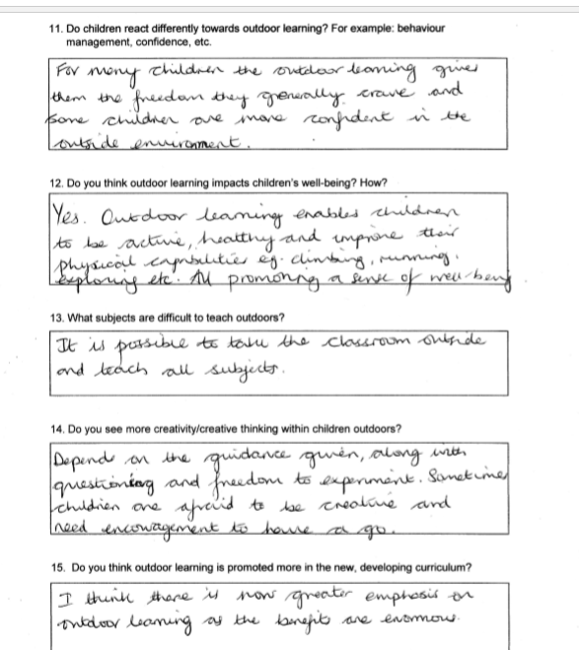

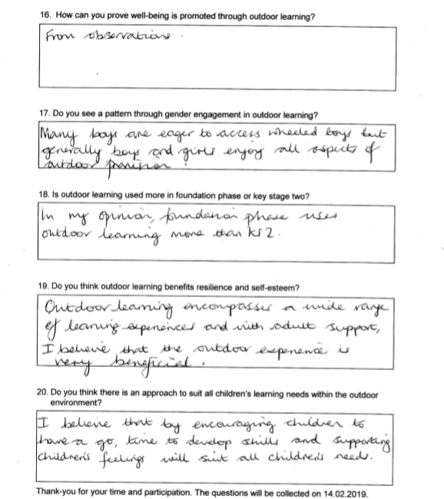

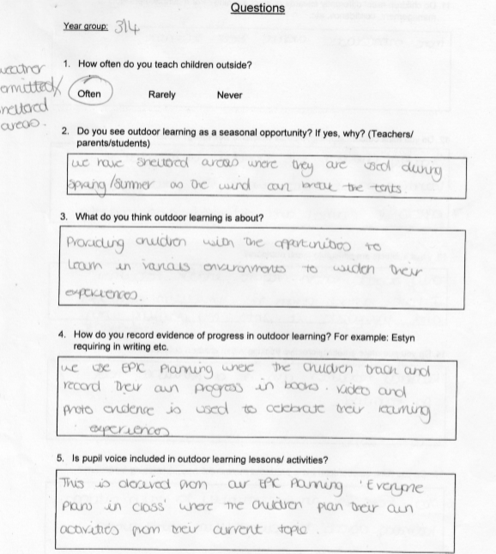
Appendix 3.2

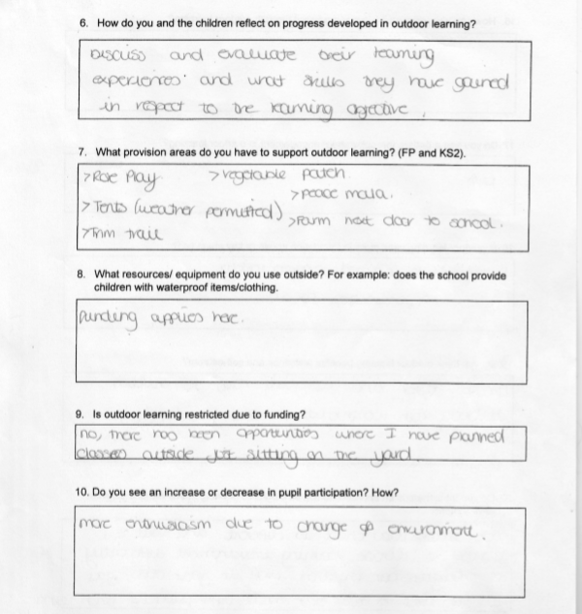

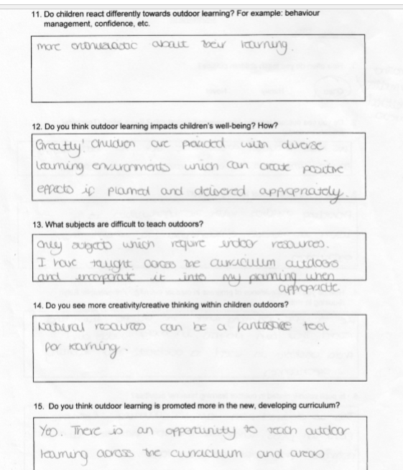

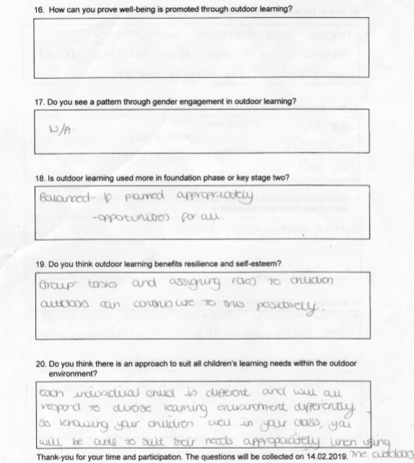

Appendix 3.3

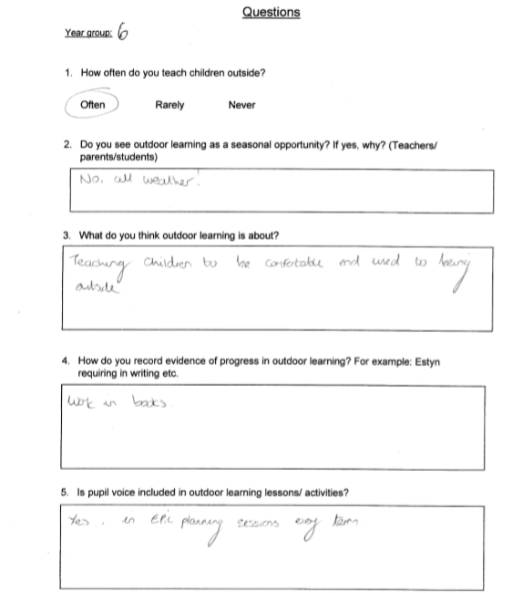

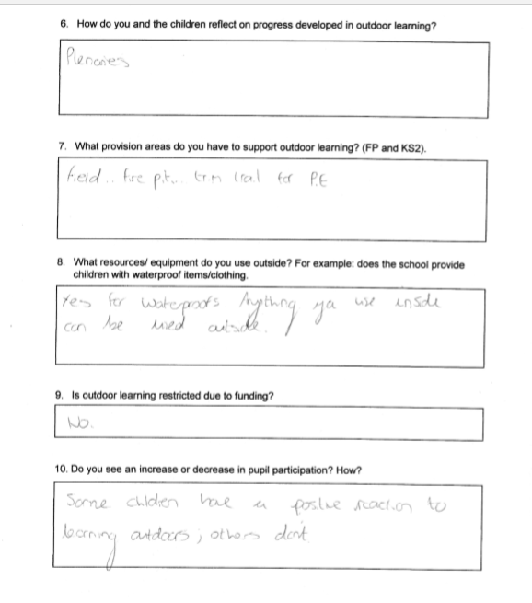

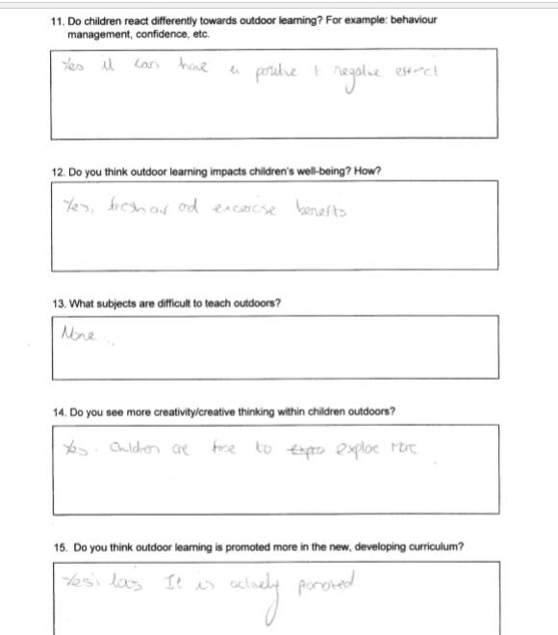

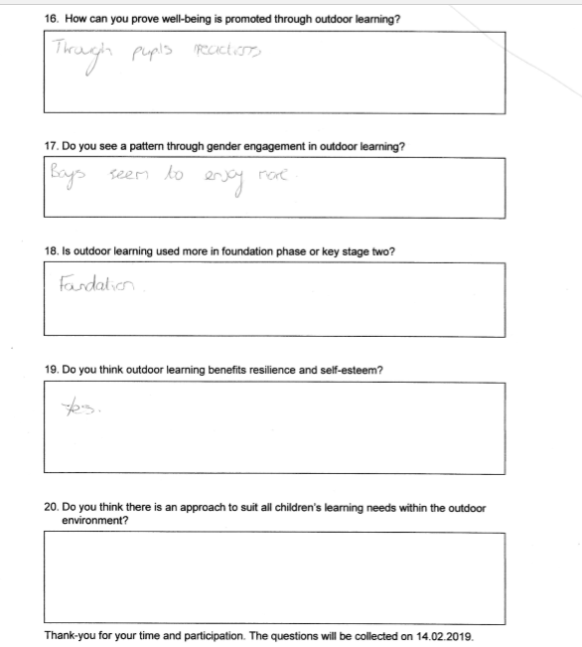

Appendix 3.4

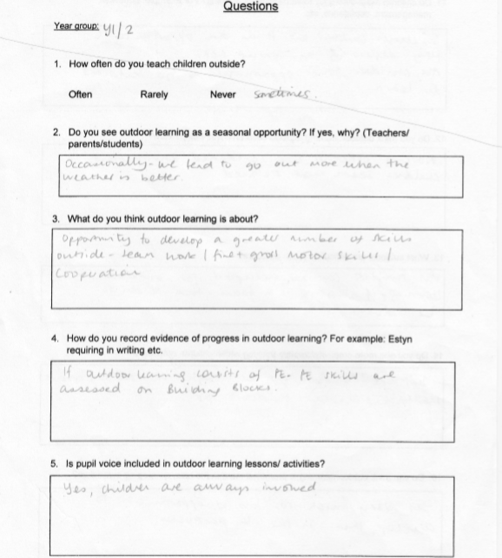

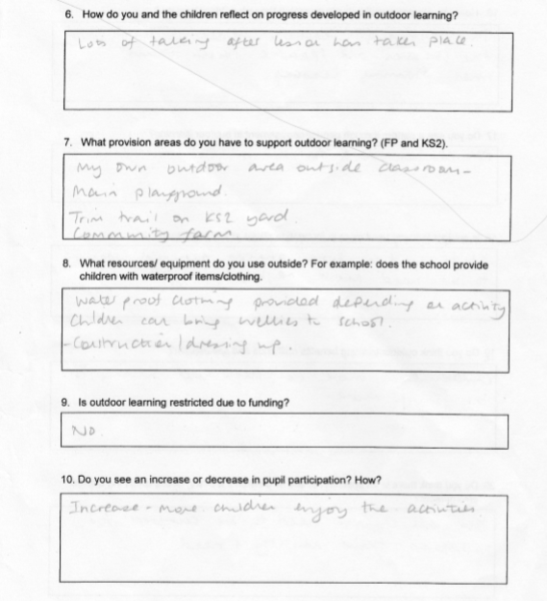

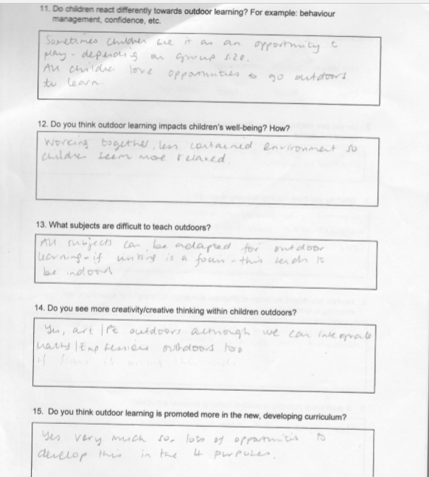

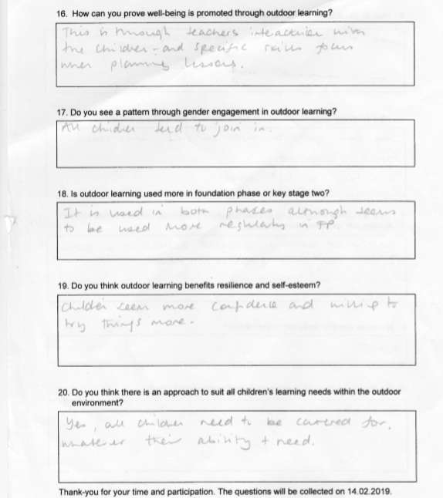

Appendix 3.5
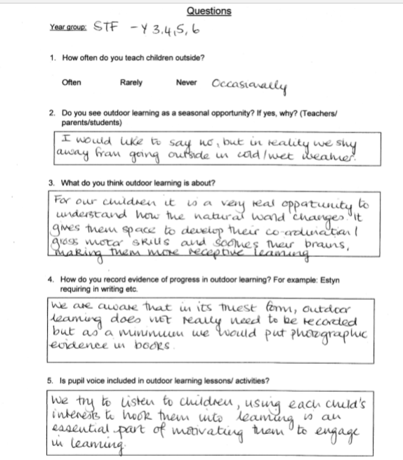

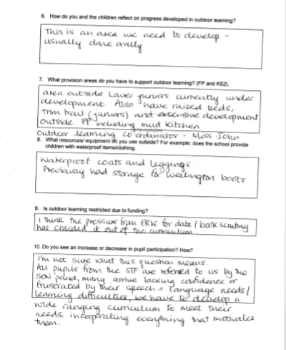

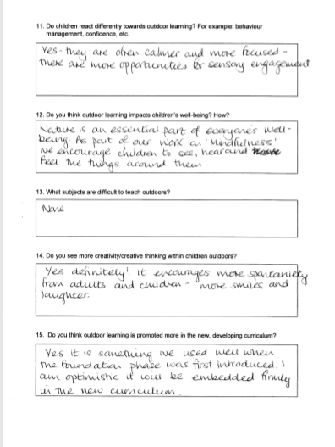

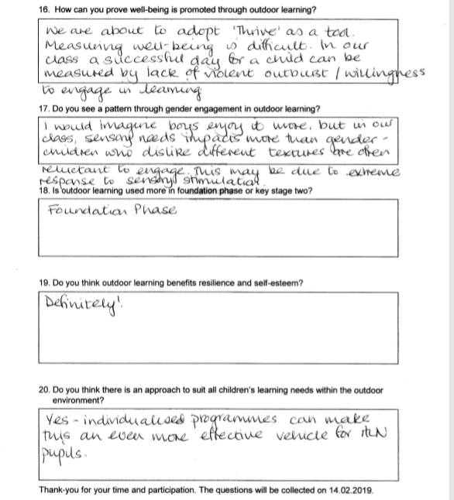

Appendix 3.6
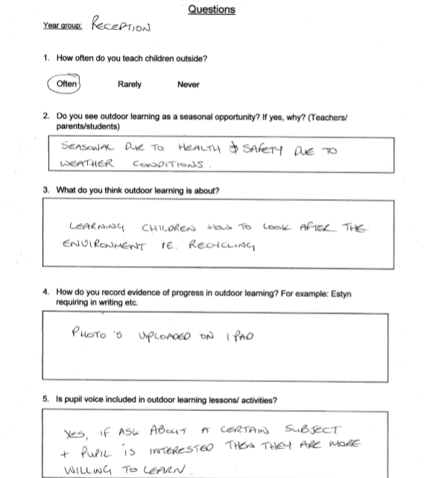

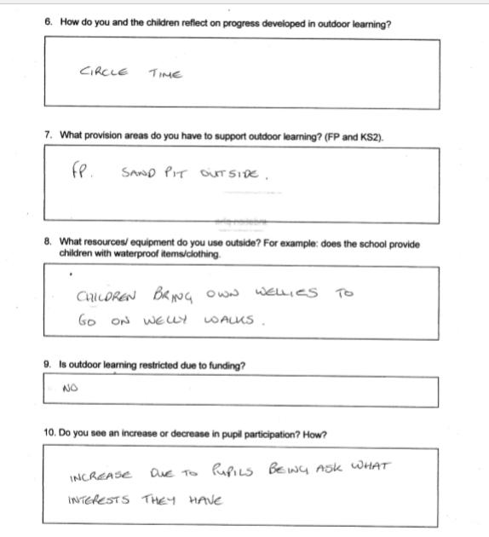

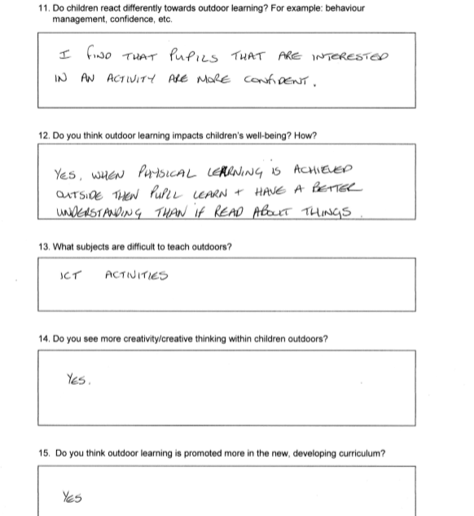

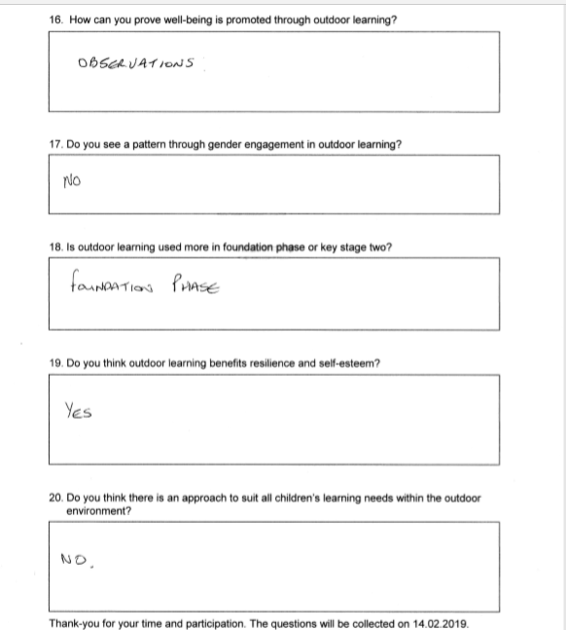

Appendix 4
Interview with Year 6

Do you enjoy outdoor learning?
Yes, we all like outdoor lessons except one of us. We remember the lesson more and enjoy it more because we have better engagement to the activities. The fresh air helps us to think more creative because we think of more ideas.
I don’t like it because it’s too cold in the winter and then it’s too warm in the summer. I don’t like bugs, bees or flies either.
How often do you go outside to learn?
Not very often, more in the summer. We mainly go outside to do P.E. because there is more room to run around. We also do gardening, which is an outside activity, but we do this in groups. The groups are made up of each class.
What do you do in gardening?
We have an afterschool gardening club and we grow plants in our pods. Soon we want to start planning fruit and vegetables that we can eat in school.
What would you like to learn about outside?
Lessons about wildlife, bugs and the environment would be really good. I would also like to learn about the weather and different habitats.
Do you think you learn better outside?
Yes!
Why?
We are more active and readier to learn. Being outside is more interesting than sitting in the classroom. Everyone is more energised, happy, ready to learn, and it breaks up the day.
Do you know what pupil voice is?
Yes.
Do you think pupil voice is heard in this school when it comes to outdoors?
Our voice was heard. All of year 6 had their voice heard because we have been able to decide what happens to the field outside.
What are you planning on doing outside?
We are creating a nature reserve outside because at the moment it is not very school friendly, not safe and overgrown at the moment. It is all muddy and not attractive to look at or go to.
How have you planned this?
We took turns looking at the B&Q catalogue and we all decided what we would like to buy or use to make our area outside. We made a list and we asked our headmaster if we could afford these things and he looked at different building companies too.

You have a lot of different areas outside, What else would you like outside?
We would wat trampolines in the playground so we can be more active, and some more seating. More patio to sit on if grass is wet. Shaded area for different weather types, outside library.
What lessons would you like outside?
I would like to do Art so we can paint scenery. And English because I think we would have more ideas for Story writing. Us boys would like to do Maths outside for topics like area and perimeter to see it more realistic.
What can’t you do outside?
Rather be inside (boys) because it is easier to concentrate because we have less distractions. We prefer to work on a table because they are comfier to write on than the clip boards.
What if you could take a table outside?
Yes, I think that would be better. (Other boys) I agree, we don’t like the clip boards they are hard to hold and write on.
Girls, what about you?
We can’t do ICT or go on the computers outside.
Couldn’t you take the iPads outside?
Oh yeah! That would be a good idea.
Did you go outside more in the infants than the juniors?
Yes, in the infants we went to the Community Farm a lot, we use to learn about the animals. It was really fun, we wish we could go there more in the juniors.

Appendix 5
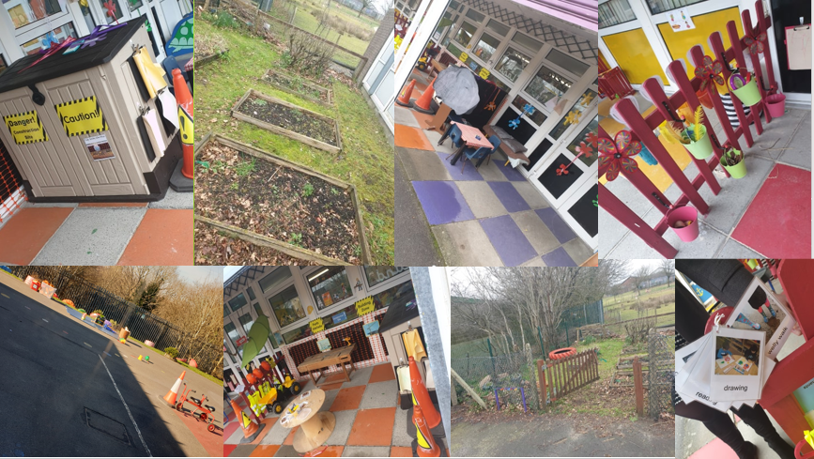

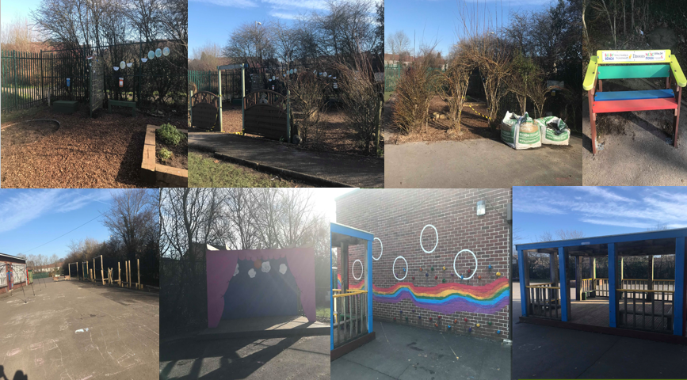

Appendix 6
Electives report
Aims and objectives
The aim of this electives is to gather primary data and information for a dissertation about outdoor learning and how it has an impact on well-being and development of learning for pupils through the primary school sector. I was intrigued in this topic because I wanted an insight and to develop my understanding of outdoor learning and how to effectively teach and use the outdoor environment and resources efficiently. Along with enhancing my own confidence in the new environment.
With the new upcoming curriculum Donaldson (2015) implements the 4 purposes: Ambitious, capable learners, creative contributors, ethnical & informed citizens, healthy, confident individuals. The outdoors can be spread across these purposes. He mentions implementing foundation phase style of learning and embedding this through key stage 2 such as learning through play and enhancing creativity. Outdoor learning promotes these areas and work can be differentiated easily for fun, enriched learning activities and to promote independence.

Observations
Throughout the school it is evident that there are a variety of outdoor learning resources for every key stage and there are opportunities to use outdoor learning effectively. The school grounds provide plenty of space for effective outdoor learning and teaching, they also have the farm to explore for better learning experiences and in new environments.
Pupils have fed back suggesting they are enthusiastic about having more opportunities to learning outside, especially creative subjects where more space is needed. Pupils also suggested creative thinking was broadened outside due to inspiration, motivation and engagement.

Findings through teachers
The teachers here have stated that:
Majority of teachers see outdoor learning as seasonal, except some of the foundation phase teachers who disagree as they have sheltered areas.
Teachers seem to believe outdoor learning is P.E. and don’t seem to see other aspects of outdoor learning such as more challenging subjects, e.g. LNF. However, they do believe it could be possible to teach every subject outdoors.
Majority of teachers agree pupil voice is thoroughly included in outdoor learning, especially through ‘Epic planning’.
All teachers have noted that all pupils become more motivated, engaged and participate more in learning outdoors.
It is widely agreed wellbeing is impacted through outdoor learning as the environment is more relaxed, positive and it includes improving mindfulness.
Through our finding’s teachers believe boys enjoy outdoor learning more than girls. However, through discussing outdoor learning with pupils we discovered the girls were more eager than the boys to take learning outside. Whereas the boys preferred classroom learning and structure.

Through the time in school
Throughout my time here in Cadle Primary School I have thoroughly enjoyed my experiences, especially through seeing well-being interventions which I wouldn’t have the opportunity to experience through placement. For this I am sincerely thankful for this enriching experience.
Unfortunately, I was unable to witness any outdoor learning through our time here which would have been beneficial for my dissertations, except for a short activity on my last day. However, staff were more than happy to explain how they incorporate outdoors in their teaching throughout the year. Teachers from different classes participated in the questionnaire that provided detailed answers to help and support to understand this style of learning. In Year 3/4 the classroom teacher took time to explain how the different provisions were used throughout the school which is very beneficial.

What Estyn have said
I have noted that your Estyn report is from 2014 and therefore these changes have already been made and embedded throughout the school. However, I have seen areas where I could provide you with some suggestions to consider for the future. I now know the school has improved and become a green school this year!
In your Estyn report from 2014 it states pupils make decisions about what they would like to learn and improves pupils’ outcomes and support wellbeing, this has been evident throughout the school.
Pupils suggested to us that they would prefer more maths lessons to be taken outside due to more space, better thinking and skills could be enhanced. Looking at your Estyn report your recommendations were to raise standards in Numeracy therefore this could be one technique to improve on this recommendation.
Estyn acknowledged that your educational visits such as the community farm enhance and enrich the learning experience for pupils. Your extra curricular activities also raise attendance throughout the school, such as gardening clubs.

Recommendations
Taking on board the opinions of staff and pupils it is evident that outdoor learning is enjoyed by the majority of pupils. They have suggested more creative learning to be taken outdoors but also some challenging subjects, for example Maths. This could be a recommendation for teachers to include in their planning, especially for topics that carry on over a series of lessons as it is incorporated in different contexts.
Through observations, analysing the questionnaires and discussing outdoor learning with pupils it was made clear that Key Stage 2 want more areas outdoors that are sheltered so they are able to go outside in different types of weather. This seems to be an issue through Key Stage 2.
My personal recommendations that I have witnessed through other placements for outdoor learning is for each class or key stage to have a set of wellies and waterproof clothing for each pupil so outdoor learning is more accessible in every weather conditions. This has already been implemented in nursery.

