ACADEMIC
AND
EMPLOYABILITY SKILLS

ANA GROSU-2129789
Thru my last five years in the company that I am working by the moment I had the chance to learn and improve my working skills.
In this assessment, I want to describe the skills that my workplace provides me and reflect on them using Gibbs' Reflective Cycle as shown in figure one below.

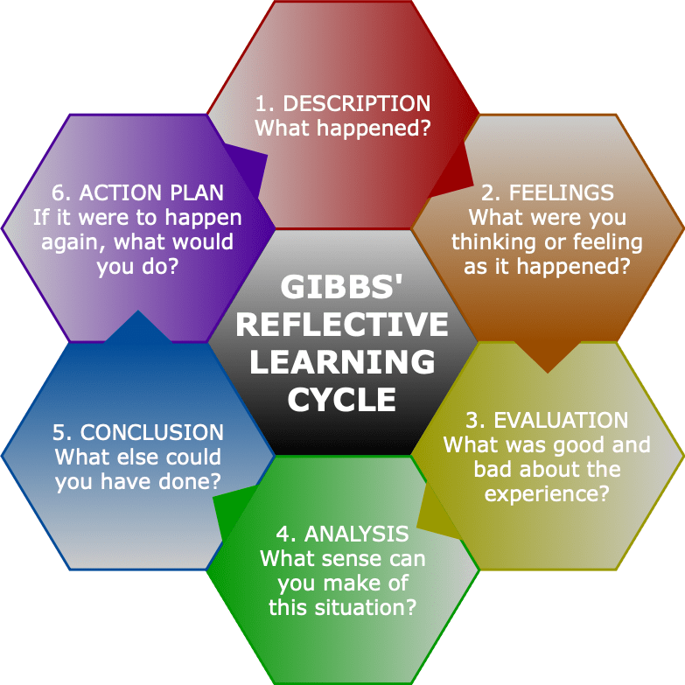
FIG 1.

DESCRIPTION

First of all, I want to add that Gibbs's reflective cycle was developed in 1988 to give you a chance to learn from experiences.
As is been shown in figure 1, a framework is presented as examining experiences, that allow you to learn and plan from negative or positive things that you or I have been thru.

As shown in figure one, six stages cover this reflection, now if I will apply those with the workplace skills that I developed in the last five years those will combine perfectly.
I want to add that as a person I am looking to develop as many skills as I can.
The first step in this cycle is the description, so if I can talk about this will be a resume about my work in the past, just to give an idea I have been working on a retail company that is been doing stocktakes around the United Kingdom and the world as well, I had the privilege to travel around the work, being a multilingual person that was an opportunity for me to practice my skill

So I can start with the question “what happened “?
I will present a past figure from my life, being in a company that works with stocktakes we are working in big teams like 40-50 people sometimes, having experience and being promoted to the supervisor position I had many opportunities to run stores with that amount of people.
A big challenge for me was that from 40 people sometimes 10 were missing, being out of target we had to solve the problem with the time and also with the breaks, every single person coming and complaining about break it was a problem for me.
In my last store, I have been more anxious about it because somebody from the head office came to examine me and to see if I could get a further level of supervisor and not be just a level 1 supervisor.
I consider that if you do not give your best of you in your workplace, then that work will become a nightmare for you, if I have a positive work attitude then I will have a smile every single time when I am going to work.

Going back to my skills, like I was saying in the first part of this assessment, I want to reflect on the skills that I developed with the time, one is the digital skill and another one is communication skills.

I want to add that the main subject in this assessment is about work, about one experience when I was tested for a new position in work, where my skills were tested.
The qualification was given from a manager from our head office, being like a test I had to get a form of duty around the day that I had to check them as a list and make them in the best way possible like this I can past the test.

I consider that practising is the key in work and life, the second skill that I presented was the communication skills that I have.
During my time in the United Kingdom, I studied a customer service course that made me realise that I do have communication skills.
I guess every single person wants that everything will be easy for them, but you need to work hard to have everything that you want, life is a lottery sometimes you have luck, sometimes you have not.

FEELINGS

The second stage from Gibb's Reflective Cycle is feelings.
The human body is made from a lot of components, with the time I have been interested in psychology, reading about this domain I realise that the brain controls your body and feelings, most people are saying that the heart is doing that, but unfortunately, I do not believe that.

Coming back to my workplace, with the time I had a lot of feelings, anxiety was first, I was thinking "how can I make my life easier in this workplace? " or "how can I solve the problems"?

I started as an auditor, with the time I did showed my manager that I can be the best employer that he had, so I started working harder and doing extra hours, indeed that helped me with the time I became a team leader, after that a supervisor and now a manager, I did work with recruitment as well with the time, again many feeling they may hit you in the face because if you are an anxious person you will need to solve those by your own.
The feeling that I had during all my time being a supervisor was not the best feeling ever, being stressed about your team and targets is not easy for everybody so you need to focus a lot.

At this moment I think that that problem was not a problem, the only problem was that I did not have enough experience and I could handle it easier with more patience.

EVALUATION

The third stage will be evaluation, like I said working hard you will be seen and you will be evaluated before taking the next step, I have been promoted with the time, but nothing was done day after day, is been more than 2 years on every single position, you need to prove them that you deserve that position.

I was scared with the time because with a better position is coming to a bigger responsibility, and more fears as well.
I had a lot of negative comments about me, being the youngest in the company many threats may come on your way.
Everything went well with the time because the experience helped me a lot.

ANALYSIS

The main question at this stage will be :
-"What did I learn from all of this"?(Gibb’s reflective cycle 1988)
In the test that I mentioned in description, many feelings were challenged me around the time.
Maybe with time, I will be an employer that will learn faster and take every opportunity.
Gibb’s Cycle is useful is you want to reflect in your work experience using the help of the people and work place like this you can make a difference between what have you done well in work and what you can do better in the future.(Gibb’s reflective cycle University of Edinburgh)
As well I want to add that from all those situations that I have struggled thru the time in this job, I learn that I need to work hard for something that I want to accomplish in the future, and I learn that there are a lot of types of persons in any workplace and you need to respect everybody and learn to respect everybody in any situation and to not confuse work with social life.

I realise from all those situations that all that matters is experience and effective work.

CONCLUSION

The fifth stage is the conclusion.
My conclusion at the time was that for every single vacancy is that I need to prove that I deserve the place that you received.
In the end of the test day I was approved and qualified as a level 2 supervisor named and HCP2.

The conclusion that I have now is completely different from the one that I had a few years ago, situations are changing your personality and also your way to act in situations that are coming in

ACTION PLAN

The sixth stage is the action plan, I want to add the main question:
"What do you want to do in the future"?
In the future with this degree I am hoping to open a personal business that is based on the same domain, I hope that this certificate will give me all the information that I do need in the future for start and grow a business that will be profitable in the United Kingdom and why not around the world as well.

I want to add that future is more important than the present, because you can change everything that you want as an opportunity and enjoy every single thing that is happening in your life.
(Gibbs, G. (1998) Learning by Doing: A Guide to Teaching and Learning Methods. Oxford Brooks University, Oxford)

Taking a qualification like the one that I was a student I will take with this course is helping you a lot in the future, will define your future if you are interested in that.

If you Check the figure one that I added on the top of the page, you will see the figure that is going on a cycle, everything is spinning in an only way, is just going forward, I want to think that this cycle is going as the same way as life, everything will go forward, you cannot look back, you just need to go forward and make the best of it, make everything to be better for your life in the future.

What I could change to make all this better?
I think that I could change most of my attitude during the time, and most of my types of work, getting more trust in my team and making the best of it.

The last thing that I want to add is that this assessment was based on Gibb's reflective cycle.

All the information that I have taken as a base was from
The University of Edinburgh website.

Reference:
1. Gibb’s reflective cycle 1988
2. Gibbs, G. (1998) Learning by Doing: A Guide to Teaching and Learning Methods. Oxford Brooks University, Oxford.
3. University of Edinburgh official online site

