

Assignment 1

MARKETING MANAGEMENT
SUBJECT CODE: LCMB7001
LECTURER: TUSHARA BALENDRAN
COURSE: MBA GENERAL MANAGEMENT
STUDENT NAME: SANJAY PRAKASH SUGUMARAN
STUDENT NUMBER: 2128846

Contents
1. Introduction 4
2. Company Background of Louis Vuitton 4
3. Communication 4
3.1 Communication Model 4
3.1.1 Shannon-Weaver Model 4
3.1.2 Strength and weakness of Shannon-Weaver model 5
4. Integrated Marketing Communications 6
4.1 Stages in an IMC Campaign 6
5. Promotion 7
5.1 Offline Promotional Strategies 7
5.2 New Promotional Strategies on Print Media 7
5.3 New Promotional Strategies on Non-Print Media 8
5.4 New Online Promotional Strategies 8
5.5 New Multi-Channel Promotional Techniques 8
5.6 New Sales Promotion Strategies 8
5.7 New Public Relations Strategies 9
6. Branding and Brand Equity 9
6.1 Branding 9
6.2 Brand Equity 9
6.3 Aaker’s Brand Equity Model 9
6.2.1 Strengths and weakness of Aaker’s Brand Equity Model 11
7. Customer Journey 11
7.1 Stages in a Customer Journey 11
8. Customer Touchpoints 12
8.1 Types of Customer Touchpoints 12
9. Customer Journey Map 13
9.1 Creating a Customer Journey Map 13
9.1.1 Strengths and weakness of the Customer Journey Map 14
10. Total Engagement Model 15
11. Recommendations to Improve the Customer Journey Map 16
12. Conclusion 16
Reference 16

Introduction
This study provides an overview of Louis Vuitton, a prominent luxury fashion business’s communication strategy and brand equity model. A detailed examination of the communication model is presented, along with an assessment of Louis Vuitton's IMC strategy. In addition, innovative promotional techniques for increasing brand recognition are proposed. Branding and brand equity ideas, such as Aaker's model, are thoroughly examined, and the customer journey map is examined for possible improvement touchpoints. The set of recommendations to improve Louis Vuitton's customer experience will be provided at the end of this study.

Company Background of Louis Vuitton
Louis Vuitton has been creating luxurious and high-quality travel items for more than 160 years. Every item is crafted with care and attention to detail, ensuring that Louis Vuitton products truly represent the world of travel (Zhang, 2021). Also, its iconic LV monogram is instantly recognizable as a symbol of luxury and sophistication. This renowned French brand creates high-quality accessories that merge creative design and practicality for travellers. With attention to detail being a core principle of their brand mission, Louis Vuitton brings its exceptional craftsmanship to ready-to-wear, bags, watches, jewellery, fragrances and more. As part of the acclaimed LVMH Moët Hennessy Louis Vuitton SE, customers now have access to premium shopping experiences in fashionable locations worldwide.

Communication
Communication is essential for achieving marketing goals, as it facilitates a connection between the company and its customers. It is defined as the exchange of information, ideas, and perspectives between two or more people (Kodheli et al., 2020). For businesses, successful communication improves customer relationships and stimulates consumer engagement.

Communication Model

Shannon-Weaver Model
The Shannon-Weaver communication model was introduced by Claude Shannon and Warren Weaver in 1949 (Sharma et al., 2020). This concept is based on a linear approach to communication, which starts by the sender crafting a message. From there, the encoder converts that into a format that can be transmitted via a channel. After traveling through the channel, it's converted back into an understandable format for the receiver by the decoder. Five components make up this process: the sender, encoder, channel, decoder, and receiver. Following these steps ensures efficient communication from one party to another.
The Shannon-Weaver Communication Model is an effective tool to understand how the Louis Vuitton brand communicates with its customers. The model can shed light on how LV shares its values, influences customer behaviour, and reinforces its brand message. As the sender, they communicate their products and services through various media channels, such as television, social media, and print ads (Kai, 2021). The message is encoded by their marketing team before it's decoded by their customers to form a response. Finally, the receiver of this information is Louis Vuitton's target audience who purchases the products and services. This model helps explain how Louis Vuitton effectively communicates its messages and how those messages are interpreted by its prospective buyers.
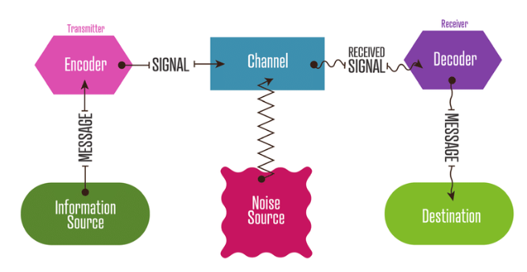
Figure 1: Shannon Waver Model
Source: Panja et al., (2023)

Strength and weakness of Shannon-Weaver model
The Shannon-Weaver model is admired for its simplicity and global usefulness. It enables us to understand the communication process and associated aspects with clarity. Noise, feedback, and other variables may be analysed in order to improve communication efficiency no matter what form it takes - written, verbal or nonverbal. Unfortunately, this linear single-way sender/recipient approach fails to consider the receiver's impression of the message or potential feedback which can prove detrimental in some cases. Also, environment factors or cultural contexts are not taken into account fully so the reliability of application deteriorates in a real-world setting involving multiple senders and recipients across different routes. Also, the Shannon-Weaver model provides intuitions about improving communication quality; it cannot be applied without considering its limitations first.

Integrated Marketing Communications
IMC (Integrated Marketing Communications) is a marketing strategy that combines all components of marketing communication to provide a consistent and engaging message for the target audience.

Stages in an IMC Campaign
An Integrated Marketing Communications (IMC) campaign consists of a succession of phases that work together to successfully market a brand or product. These are the stages:
Situation Analysis: The first stage of an IMC campaign is to undertake a thorough market and target audience study. Analysing the competition, comprehending customer behaviour, and finding major trends and possibilities are all part of this process.
Setting Objectives: The next step is to define precise, measurable, attainable, relevant, and time-bound (SMART) campaign objectives. Defining the target audience, choosing the desired objective, and establishing a budget are all part of this process.
Developing Strategies: Once the objectives have been established, the next step is to create a marketing mix that comprises the appropriate balance of advertising, public relations, personal selling, and sales promotion to fulfil the goals.
Implementation: Implementation entails carrying out the marketing mix by creating and generating promotional materials, launching the campaign, and tracking its progress.
Evaluation: The last stage is assessing the campaign's efficacy in relation to the set objectives. This involves calculating the return on investment (ROI), analysing the influence on brand recognition, and evaluating the campaign's overall performance.
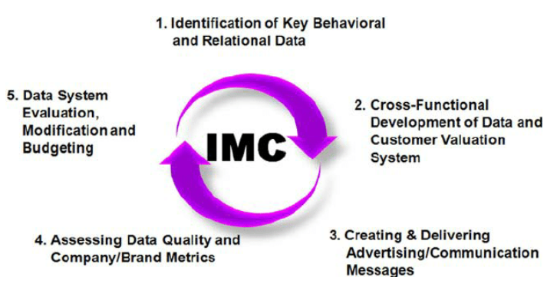
Figure 2: Stages in IMC
Source: Manoli and Hodgkinson, (2020)

Promotion
Promoting a brand or product is a key marketing tactic, aimed at raising visibility and driving sales

Offline Promotional Strategies
Louis Vuitton can increase brand visibility and reach a larger customer base through offline promotional strategies. Events such as fashion shows, product launches, and art exhibitions can showcase the company's products in an engaging way. Other luxury brands and high-end events can provide a platform for Louis Vuitton to collaborate with or sponsor (Hutabarat, 2022). Visual merchandising is also beneficial, as stylish window displays and in-store visual elements create an attractive shopping atmosphere for customers.

New Promotional Strategies on Print Media
Louis Vuitton can leverage print media to engage consumers and spread its brand's message. Advertising in fashion magazines or high-end lifestyle publications would enable the company to reach its target audience. Similarly, billboards and posters in busy areas can generated greater visibility for the brand. Additionally, creating branded content or advertorials could help Louis Vuitton establish itself as a leader in the luxury fashion industry.

New Promotional Strategies on Non-Print Media
When considering non-print media promotional strategies, Louis Vuitton can evaluate TV and radio advertisements, product placements in television programs or films, and celebrity endorsements. Leveraging social media platforms such as Instagram and YouTube could be effective to target a younger demographic, create compelling content, and widen their reach. Alternatively, sponsorship of or involvement in high-profile events and collaborating with influencers would help expand brand recognition.

New Online Promotional Strategies
Louis Vuitton can leverage online promotional strategies to increase visibility and sales. This includes creating engaging content, utilizing targeted advertising, and launching exclusives products tailored for their digital channels. These strategies help keep the company relevant in a fast-paced and digitally focused market. Furthermore, Louis Vuitton can appeal to its desired demographic by optimizing campaigns and experiences on their website and social media accounts.

New Multi-Channel Promotional Techniques
Louis Vuitton can create a unified brand experience by combining multiple promotional channels. For instance, they can utilize both brick-and-mortar and digital strategies to reach their target customers. Additionally, customer data allows Louis Vuitton to personalize experiences on every platform, from physical stores to virtual ones (Xu et al., 2021). Doing this strengthens the engagement between the company and its consumer base, contributing to the long-term success of the brand.

New Sales Promotion Strategies
Louis Vuitton can utilize numerous sales promotion tactics to boost customer engagement. Managerial levels can consider incentives such as discounts, free gifts with purchase, and limited-time offerings to stimulate purchases. Rewards programs can also be implemented to encourage repeat customers. Moreover, Louis Vuitton stores could hold trunk shows or pop-up shops to create an exclusive atmosphere that increases a sense of urgency among potential customers.

New Public Relations Strategies
Louis Vuitton can enhance its reputation in the luxury fashion industry by adopting public relations strategies. The company can partner with philanthropic organizations or launch a corporate social responsibility initiative to illustrate its values and commitment to society (Budiman, 2021). Likewise, media relationships and successful influencer partnerships will bolster positive press and brand associations.

Branding and Brand Equity

Branding
The process of generating and sustaining a distinct and memorable image, name, or symbol that distinguishes and separates a product or service from its rivals in the eyes of consumers is referred to as branding (Das, 2020).

Brand Equity
Brand equity refers to the perceived value and worth that a brand name and related products or services possess in the minds of customers (Tasci, 2021). It is the value that a brand adds to a firm that goes beyond the physical product or service itself, and it includes things like brand recognition, brand loyalty, perceived quality, brand associations, and other intellectual brand assets.

Aaker’s Brand Equity Model
Louis Vuitton has a long-standing reputation of creating luxurious products at the highest level of quality. This is one of the reasons why their brand equity is so strong, and it's important to consider this when evaluating the company's success. Applying Aaker's Brand Equity Model can help to uncover opportunities for Louis Vuitton to strengthen their brand equity. The model includes five key components: brand loyalty, brand awareness, perceived quality, brand associations, and other proprietary brand assets; these could all be examined by Louis Vuitton in order to identify potential avenues for increasing the value of their esteemed luxury identity (Çınar, 2020).
Brand Loyalty: Louis Vuitton's customers are very loyal to the brand. The company's high-quality products and distinctive designs have contributed to the creation of a devoted consumer base prepared to pay a premium for the brand's items.
Brand Awareness: Louis Vuitton has a high level of brand recognition. Because of its famous LV monogram, the brand is readily recognisable and has a prominent presence in the fashion sector thanks to its marketing efforts.
Perceived Quality: Louis Vuitton is well-known for providing high-quality items. The company employs only the finest materials and skilled artisans to create its premium products, which raises the brand's perceived quality (Pham, 2019).
Brand Associations: Louis Vuitton has strong brand associations with luxury, high-end fashion, and exclusivity. The brand is often associated with celebrities and high-profile events, which reinforces its premium image.
Other Proprietary Brand Assets: Louis Vuitton's brand is strongly associated with luxury, high-end fashion, and exclusivity. The brand's luxury image is reinforced by its association with celebrities and high-profile events.
As one of the premier brands in luxury fashion, Louis Vuitton must maintain a strong brand image. This can be achieved by investing in promotional activities and improving customer service to increase brand awareness, loyalty, and reach new markets through leveraging the brand's existing associations (Shariq, 2019). Moreover, it is essential for Louis Vuitton to take special care of key components such as chosen target markets and product lines in order to ensure continued growth and success for the company.
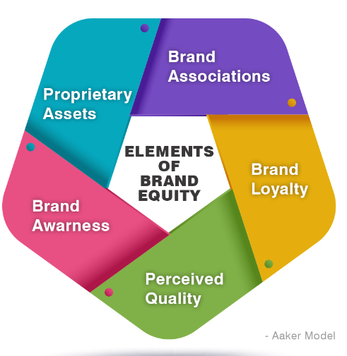
Figure 3: Aaker Model
Source: Sandhe (2020)

6.2.1 Strengths and weakness of Aaker’s Brand Equity Model
Aaker's Brand Equity Model offers a useful framework for analysing and managing brand equity. It helps to identify the functional and emotional elements of branding, as well as areas that may need improvement in order to develop comprehensive brand strategies (Chakraborty, 2019). However, when assessing its effectiveness, it is important to bear in mind certain limitations. For example, small businesses or companies with multiple brands may find Aaker’s model difficult to implement due to its complexity. Additionally, since it relies heavily on qualitative assessments rather than numerical metrics, measuring brand equity can be challenging at times. Finally, the lack of consideration of external factors such as market trends and competition restrict the utility of this model in dynamic markets.

Customer Journey
The customer journey is an incredibly important area of focus for companies and brands. It encompasses the sequence of engagements between a customer and a business from beginning to end, along with understanding their needs and preferences every step of the way. Optimizing this journey is key to creating a seamless and positive experience for customers.

Stages in a Customer Journey
The Louis Vuitton customer journey may be split into numerous stages, each of which plays an important part in the entire brand experience.
Awareness: Potential clients become aware of the Louis Vuitton brand at this stage through numerous methods such as advertising, social media, or word of mouth. For example, a person may stumble across a Louis Vuitton advertisement in a fashion magazine or a celebrity carrying a Louis Vuitton handbag on social media (Kladou, 2022).
Consideration: After being aware of the brand, buyers begin to evaluate whether or not they want to make a purchase. Before making a selection, individuals may perform research, compare costs, and read reviews. The website, social media accounts, and physical stores of Louis Vuitton are all key touchpoints that may help shoppers make educated selections.
Purchase: Once a buyer has made the decision to purchase, they can do it through a variety of channels, including the Louis Vuitton online and physical locations. Customers may engage with the items and receive personalised suggestions from sales staff when they buy in-store. Online purchases are convenient and allow you to compare items and pricing.
Post-Purchase: After a client makes a purchase, their relationship with the company continues. To ensure consumer happiness and loyalty, Louis Vuitton provides a variety of services including as after-sales assistance, maintenance services, and special events. Positive post-purchase experiences can result in repeat purchases and brand advocacy (Manlow, 2019).
Advocacy: Satisfied consumers may become brand champions by sharing their great experiences with others. They may notify others about Louis Vuitton or post about their purchases on social media. Advocacy contributes to increased brand exposure and trust, as well as the discovery of new customers.
Moreover, knowing the customer journey is crucial for Louis Vuitton to deliver a consistent and pleasurable experience for consumers at all stages.

Customer Touchpoints
Customer touchpoints are the various points of contact that customers have with a brand, product, or service throughout their customer journey. These connections may be physical or digital and range from engaging with an organisation's website, social media channels, customer service representatives, in-store experiences, product packaging, etc.

Types of Customer Touchpoints
Retail stores: Louis Vuitton's retail stores present customers with an opportunity to connect directly with the brand. As shoppers enter, they are welcomed into a luxurious shopping space, engineered to provide a memorable experience through carefully crafted displays and dedicated customer service (Massot, 2020). This primary touchpoint allows consumers to experience the brand, its values and products in person.
Social media: Louis Vuitton is committed to fostering relationships with customers on a daily basis. The luxury fashion house keeps an active presence on social media platforms while showcasing its products, conveying brand messaging, and engaging customers in an intimate manner. Through these digital touchpoints, shoppers can interact with Louis Vuitton products and values on a regular basis, furthering their understanding of the esteemed brand.
Customer service: Louis Vuitton has established multiple customer service touchpoints, both online and in-store, to support its customers. Consumers can speak to the brand with questions or complaints over social media, on the phone, or by email. Louis Vuitton is dedicated to delivering quality customer service, as seen through these touchpoints that are designed to be proactive and with a commitment to addressing customers' needs promptly (Friedman, 2019). This strategy helps establish trust with its customers while demonstrating the company's dedication in providing exceptional care.

Customer Journey Map

Creating a Customer Journey Map for Handbag
Awareness Stage: Emily, a 25-year-old fashion fanatic, has recently began exploring fashion blogs and Instagram for inspiration. She sees a post with a Louis Vuitton handbag and is captivated by the brand. When she clicks on the post, she is sent to the Louis Vuitton website.
Consideration Stage: Emily investigates several handbag collections on the internet, reads product descriptions and user reviews, and compares costs. She adds a few items to her wish list but is not yet ready to buy.
Purchase Stage: Emily receives an email from Louis Vuitton a few days later announcing a limited-time discount. She recalls the products on her wish list and chooses to use the discount. She adds the products to her shopping basket, enters her shipping and payment information, and completes the transaction.
Post-Purchase Stage: Emily is pleased to receive a confirmation email containing the estimated delivery date for her order. She tracks her package and is delighted when it arrives. After unboxing, she takes a photo of the new items and posts it to Instagram with the Louis Vuitton tag. Emily happily engages with her followers who like and comment on her purchase.
Advocacy Stage: Through regular use, Emily's friends and family make positive remarks about her Louis Vuitton items, so she shares her pleasant experience with them. Additionally, she posts a favourable review on the Louis Vuitton website and recommends their brand to others via social media. With this loyalty in place, Emily plans to purchase more products in the future.
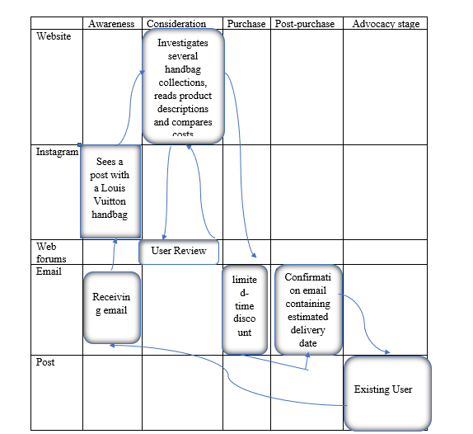
Figure 4: Customer Journey Map
Source: Created by the author

Strengths and weakness of the Customer Journey Map
Businesses can gain a better understanding of their customer's journey by utilizing a Customer Journey Map. This tool enables companies to view customer experiences from multiple touchpoints and takes into account customer needs and difficulties. Further, it allows businesses to identify areas that call for specific attention and devise ways to enhance operations to provide superior services for their customers.
Despite its advantages, the Customer Journey Map can be ineffective in certain areas such as capturing emotional or subconscious elements of an individual’s experience. Additionally, due to the fact that creating this map is resource-intensive, it may not be suitable in all cases. Thus, while a Customer Journey Map is effective in improving customer experience, additional techniques should also be applied when necessary.

Total Engagement Model
The Total Engagement Model is a marketing strategy that undertakes to coordinate all customer-brand interactions. It consists of five areas - brand awareness, consideration, conversion, loyalty and advocacy - with the aim of delivering a comprehensive experience. Louis Vuitton understands this model's importance for keeping an edge in the premium market and has deployed several techniques to always be one step ahead.
Its first goal is strengthening brand visibility, for which the luxury giant invests plenty in advertising and promotion across multiple channels such as digital media outlets, print materials or events. Secondly, as far as consideration goes, Louis Vuitton manages to remain at the forefront thanks to influencers partnerships, product placement or even experiential marketing activities (List, 2021). Louis Vuitton's Total Engagement Model provides an insightful guide for achieving customer satisfaction. This five-step approach goes beyond the traditional marketing strategy by creating holistic customer experiences that drive loyalty and advocacy. By making purchases convenient, providing incentives to dedicated customers, and leveraging the power of word-of-mouth, Louis Vuitton reinforces its position as a leader in the luxury fashion market.
The first component is awareness - increasing visibility to potential customers in an effective yet tasteful way. Second component is consideration - providing information about products that meets consumer needs on multiple channels (Jang, 2022). Third, convert customers into purchasers with simplified checkout processes across brick-and-mortar stores, e-commerce sites, and mobile apps. Fourth element is loyalty - offer benefits like personalized recommendations and exclusive access to events or product offerings so that customers become regulars who keep coming back. Lastly, encourage satisfied consumers to share their positive experiences on review sites or through influencer marketing campaigns to help spread the brand message even further. By following these steps, brands can effectively engage customers at every stage of the customer journey while maintaining a strong relationship with them over time.

Recommendations to Improve the Customer Journey Map for Handbag
It is important to conduct extensive customer research in order to acquire an accurate and effective map of consumer behaviours and motivations. Additionally, it is necessary to include all significant points of contact with the consumer; omitting minor touchpoints may result in an incomplete view of the customer journey. Lastly, collecting feedback from customers through surveys, reviews, social media channels and other avenues can be beneficial in determining areas that need improvement.
Organisations can benefit greatly from the introduction of a reliable system for tracking customer journeys. Utilising customer journey analytics software or appointing specialised staff with monitoring responsibilities can assist in recognising issues before they become difficult to resolve. In addition, the customer journey map needs continual revision and refinement if it is to remain up-to-date with the flux of internal and external factors. Considering this on an ongoing basis helps to ensure that performance goals are met and expectations exceeded.

Conclusion
The study included the communication strategies and brand equity model used by Louis Vuitton to build its luxury fashion brand. An evaluation of their IMC tactics and Aaker's model of branding have yielded insights into how customer loyalty, brand identity and awareness contribute to successful marketing campaigns. In addition, a detailed customer journey analysis outlined advantages and disadvantages of the customer experience, leading to suggestions for potential improvements. By delving into the success story of Louis Vuitton, this report serves as an invaluable resource for those wishing to enhance their techniques in marketing and branding activities as well as improve user satisfaction rates.

Reference
Manoli, A.E. and Hodgkinson, I.R. (2020) The implementation of integrated marketing communication (IMC): evidence from professional football clubs in England. Journal of Strategic Marketing, 28(6), pp.542-563.
Panja, A.K., Vasavdutta, S., Choudhary, M., Thiyagarajan, I., Shinde, A.H., Ray, S., Sahoo, T.P., Chatterjee, S., Thorat, R.B., Madhava, A.K. and Haldar, S. (2023) Interaction of physico-chemical parameters with Shannon-Weaver Diversity Index based on phytoplankton diversity in coastal water of Diu, India. Marine Pollution Bulletin, 190, p.114839.
Budiman, S. (2021) The effect of social media on brand image and brand loyalty in generation Y. The Journal of Asian Finance, Economics and Business, 8(3), pp.1339-1347.
Chakraborty, U. (2019) The impact of source credible online reviews on purchase intention: The mediating roles of brand equity dimensions. Journal of Research in Interactive Marketing, 13(2), pp.142-161.
Çınar, K. (2020) Customer Based Brand Equity Models in Hotel Industry: A Literature Review. Strategic Innovative Marketing and Tourism: 8th ICSIMAT, Northern Aegean, Greece, 2019, pp.281-288.
Das, S. (2020) Innovations in digital banking service brand equity and millennial consumerism. In Digital transformation and innovative services for business and learning, pp. 62-79.
Friedman, V. (2019) Louis Vuitton Gives Kennedy Airport a Makeover. The New York Times, pp.D5-L.
Hutabarat, Z. (2022) Effect of Product Quality, Advertisement, and Brand Image on Purchase Decision Mediated By Customer Value of Louis Vuitton at Jabodetabek. BASKARA: Journal of Business and Entrepreneurship, 4(2), pp.58-71.
Jang, S. (2022) Manipulating Frictional Performance of Wet Clutch Engagement through Material Properties and Operating Conditions. Lubricants, 10(9), p.225.
Kai, X. (2021) Research on brand alliance strategy innovation based on the big data analysis of consumers’ attitude Take Louis Vuitton and supreme as an example. In E3S Web of Conferences 23(5), p. 01075.
Kladou, S. (2022) Destination brand equity. In Encyclopedia of Tourism Management and Marketing, pp. 837-839.
Kodheli, O., Lagunas, E., Maturo, N., Sharma, S.K., Shankar, B., Montoya, J.F.M., Duncan, J.C.M., Spano, D., Chatzinotas, S., Kisseleff, S. and Querol, J. (2020) Satellite communications in the new space era: A survey and future challenges. IEEE Communications Surveys & Tutorials, 23(1), pp.70-109.
List, A. (2021) Investigating the cognitive affective engagement model of learning from multiple texts: A structural equation modeling approach. Reading Research Quarterly, 56(4), pp.781-817.
Manlow, V. (2019) The Fondation Louis Vuitton: A utopian space apart from the world of luxury retail. Journal of Design, Business & Society, 5(2), pp.149-167.
Massot, P. (2020) EU General Court ruling opens—partially—the door to the protection of the famous ‘Damier Azur’of Louis Vuitton. Journal of Intellectual Property Law & Practice, 15(11), pp.851-852.
Pham, C.H. (2019) Antecedents of consumer based brand equity of consumer goods retailers in vietnam: an empirical study. Academy of Entrepreneurship Journal, 25(2), pp.1-11.
Sandhe, A.A. (2020) A descriptive study of brand equity of india's popular online shopping sites. Independent Journal of Management & Production, 11(2), pp.324-342.
Shariq, M. (2019) A Study of Brand Equity Formation in the Fast Moving Consumer Goods Category. Jindal Journal of Business Research, 8(1), pp.36-50.
Sharma, P., Singh, M.K., Verma, K. and Prasad, S.K. (2020) Changes in the weed seed bank in long-term establishment methods trials under rice-wheat cropping system. Agronomy, 10(2), p.292.
Tasci, A.D. (2021) A critical review and reconstruction of perceptual brand equity. International Journal of Contemporary Hospitality Management, 33(1), pp.166-198.
Xu, A., Xie, Y., Su, J. and Xiao, C. (2021) Analysis of Louis Vuitton's Marketing Strategies in Chinese Luxury Fashion Market. Frontiers in Economics and Management, 2(1), pp.1-20.
Zhang, R. (2021) Analysis on Luxury’s E-commerce and Luxury Bags’ Price During the Pandemic. In 2021 International Conference on Economic Development and Business Culture (ICEDBC 2021) (pp. 154-160). Atlantis Press.

