James Cawte (2313853)

Catapult experiment
Taguchi Experimentation

Contents
Table of Tables 2
Table of Figures 2
Section 1 – Information 3
1.1 Background information 3
1.2 Example Array 3
Section 2 – Experiment 4
2.1 – Objective 4
2.2 – Method & Apparatus 4
2.2.1 – Apparatus 4
2.2.2 – Method 4
2.2.3 – Variables 4
2.3 – Experimental Data 6
2.3.1 – Populated Array 6
2.3.2 – Experiment Results 6
2.3.3 – Graphs 7
2.3.4 – Results 2 10
2.3.5 – Mid-point Calculation 10
2.3.6 – Mid-point Experiment Result 10
2.4 – Interpretation of Results 10
2.5 – Conclusion 11
2.6 – Reflection 11
References 12

Table of Tables
Table 1 – Experiment Array 3
Table 2 – Independent Variables 4
Table 3 – Dependent Variables 5
Table 4 – Control Variables 5
Table 5 – Populated Array 6
Table 6 – Results 1 6
Table 7 – Results 2 10
Table 8 – Mid-point calculation 10

Table of Figures
Figure 1 – Front Position 7
Figure 2 – Anchor Position 7
Figure 3 – Front Position to Anchor Position interaction 8
Figure 4 – Stop Position 8
Figure 5 – Pull Back 9
Figure 6 – Anchor Position to Stop Position interaction 9
Figure 7 – Operator 10

Section 1 – Information

Background information
Genichi Taguchi was a Japanese engineer and statistician concerned with the quality of manufactured goods. To aid in this, he devised the Taguchi method [1] for use in the design of experiments when finding relationships between factors to achieve a robust optimum relationship between factors.

1.2 Example Array
For an experiment involving 5 variables, the array of experiments would take the following form:
Table 1 – Experiment Array
Array
Factor | 1 | 2 | 3 | 4 | 5 | 6 | 7
Factor | A | B | AB | C | D | BC | E
Expt 1 | 1 | 1 | 1 | 1 | 1 | 1 | 1
Expt 2 | 1 | 1 | 1 | 2 | 2 | 2 | 2
Expt 3 | 1 | 2 | 2 | 1 | 1 | 2 | 2
Expt 4 | 1 | 2 | 2 | 2 | 2 | 1 | 1
Expt 5 | 2 | 1 | 2 | 1 | 2 | 1 | 2
Expt 6 | 2 | 1 | 2 | 2 | 1 | 2 | 1
Expt 7 | 2 | 2 | 1 | 1 | 2 | 2 | 1
Expt 8 | 2 | 2 | 1 | 2 | 1 | 1 | 2

The first column lists which number experiment each row is. Column A and B each represent independent variables with 2 levels each (meaning they can be 2 different values). Column AB shows whether variables A and B are at the same level or not. Column C and D represent another 2 independent variables at 2 levels. Column BC shows whether B and C are at the same level. Column E represents a fifth independent variable.
If you were to complete every possible combination of variable levels would take 16 experiments but by utilizing the relationship between variables A and B as well as B and C allows you to know if either pair of variables being different from each other makes a difference to the result. It provides a more efficient means to get meaningful data.

Section 2 – Experiment

2.1 – Objective
Carry out a practical experiment utilizing a catapult with many alterable characteristics to determine the key features to adjusting the range of the system.

2.2 – Method & Apparatus

2.2.1 – Apparatus
- Lean 6 Sigma Catapult [2]
- Projectile
- Tape measure
- Video recording device

2.2.2 – Method
- Fasten catapult to surface
- Extend tape measure from the base of catapult along firing direction
- Consult experiment table to set all variables on the catapult and decide which operator will conduct the test
- Load the projectile into the basket
- Pull the catapult to the intended angle
- Release promptly after reaching required angle
- Make note of rough impact zone along tape measure
- Begin video recording of impact zone and repeat steps 4 to 6
- View the recording in slow motion to accurately determine the distance
- Repeat steps 8 and 9 twice to gain a total of 3 results
- Take an average of the distances
- Return to step 3 for the next experiment until all intended experiments have been carried out
- Use the graphs produced in the spreadsheet to determine the key features of the system. Use this to determine the optimum settings for long distance.

2.2.3 – Variables
Independent:
Table 2 – Independent Variables
Variable | Description
Band front position | Influences how far the band stretches therefore altering the stored energy before release
Band anchor position | Where the band is held onto the catapult
Stop position | The physical obstruction which prevents the catapult moving forward thereby releasing the projectile
Pull back | How far backwards the catapult is pulled before release
Operator | Person operating the catapult

Dependant:
Table 3 – Dependent Variables
Variable | Description
Horizontal distance | The distance travelled by the projectile after release from the catapult

Control:
Table 4 – Control Variables
Variable | Description
Method of measurement | The measurements were taken from slow motion video to remove the noise of human reactions when watching the projectile impact with the tape measure
Position of catapult | The catapult was fixed to the surface in the same position for all tests
Environment | All tests were conducted in the same room
Projectile | The projectile being used in the experiment
Catapult | The catapult being used in the experiment

2.3 – Experimental Data

2.3.1 – Populated Array
Table 5 – Populated Array
Array Populated
Experiment | 1 | 2 | 3 | 4 | 5 | 6 | 7
Experiment | Band front position | Band Anchor position | AB Interaction | Stop Position | Pull back | BC Interaction | Operator
Expt 1 | 1 | 2 | 1 | 1 | 140 | 1 | A
Expt 2 | 1 | 2 | 1 | 3 | 170 | 2 | B
Expt 3 | 1 | 4 | 2 | 1 | 140 | 2 | B
Expt 4 | 1 | 4 | 2 | 3 | 170 | 1 | A
Expt 5 | 3 | 2 | 2 | 1 | 170 | 1 | B
Expt 6 | 3 | 2 | 2 | 3 | 140 | 2 | A
Expt 7 | 3 | 4 | 1 | 1 | 170 | 2 | A
Expt 8 | 3 | 4 | 1 | 3 | 140 | 1 | B

2.3.2 – Experiment Results
Table 6 – Results 1
 | Trial 1 | Trial 2 | Trial 3 | Average
Experiment 1 | 83 | 76 | 87 | 82
Experiment 2 | 239 | 248 | 183 | 223.3333
Experiment 3 | 63 | 74 | 86 | 74.33333
Experiment 4 | 174 | 174 | 179 | 175.6667
Experiment 5 | 103 | 108 | 104 | 105
Experiment 6 | 43 | 43 | 30 | 38.66667
Experiment 7 | 78 | 74 | 79 | 77
Experiment 8 | 51 | 53 | 51 | 51.66667

2.3.3 – Graphs
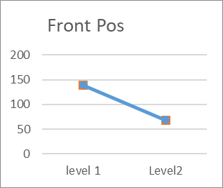
Figure 1 – Front Position

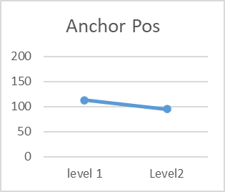
Figure 2 – Anchor Position

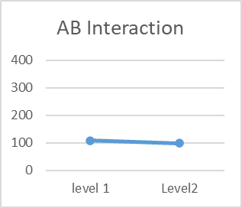
Figure 3 – Front Position to Anchor Position interaction

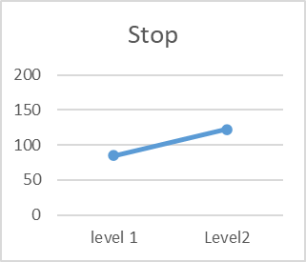
Figure 4 – Stop Position

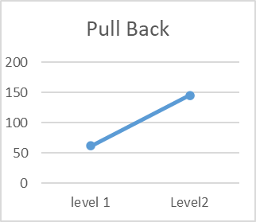
Figure 5 – Pull Back

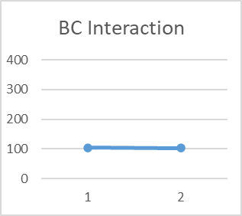
Figure 6 – Anchor Position to Stop Position interaction

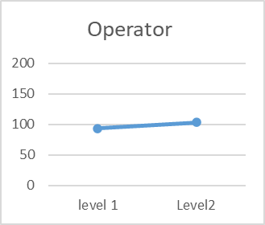
Figure 7 – Operator

2.3.4 – Results 2
Table 7 – Results 2
 | KF1 | KF2 |  | 1 | 2 | 3 | Ave
Firing 1 | 1 | 140 | range | 40 | 40 | 40 | 40
Firing 2 | 3 | 140 | range | 25 | 25 | 23 | 24.33333
Firing 3 | 1 | 170 | range | 184 | 205 | 194 | 194.3333
Firing 4 | 3 | 170 | range | 100 | 112 | 108 | 106.6667

2.3.5 – Mid-point Calculation
Table 8 – Mid-point calculation
KF 1 :1 | KF2 :1
117.1667 | 32.16667
KF 1 :2 | KF2 :2
65.5 | 150.5
mid each factor
91.33333 | 91.33333
mid combined
91.33333333

2.3.6 – Mid-point Experiment Result
Result for the final test was 90cm.

2.4 – Interpretation of Results
As seen in Figure 1 – Front Position and Figure 5 – Pull Back, the 2 critical factors in determining the range of the catapult were front position and pull back. This is visually displayed by the steep gradient between level 1 and 2 for these variables. This was then used to run a second set of tests to determine which combination of these levels would result in an optimum performance.
The next experiments were planned as seen in Table 7 – Results 2. The 2 levels for front position and pull back were to be tested in every possible combination with all other variables in the configuration that produced the better results according to the figures in 2.3.3 – Graphs. This added the following as control variables: Anchor position at 2, stop position at 3 and operator B carrying out the tests.
To ascertain if the relationship between the variables and distance was linear, a mid-point was calculated and then all variables were set to a value at the mid-point between the upper and lower level. This provided a target value, which if achieved would support a linear relationship between the variables and distance.

2.5 – Conclusion
The experiment correctly identified the critical factors in achieving a maximum distance without requiring exhaustive testing of every possible combination of settings. The calculated mid-point was very close to the measured distance in the final trial indicating that the data extracted from the experiments was accurate.
The optimum settings for the model of catapult used were as follows:
- Front Position: 1
- Anchor Position: 2
- Stop Position: 3
- Pull Back: 170°
- Operator: Operator B

2.6 – Reflection
The experiment could have been improved. One example is the use of human operators to set the pull back distance instead of using some form of mechanical release. A mechanical release would guarantee a consistent pull back distance therefore removing the noise of human inaccuracy. Though the measurements were taken via a slow-motion video, the measurements were not perfectly accurate as the projectile was fast moving and it was not always possible to ascertain the point of impact with the surface.

References

[1] | G. Taguchi, “Quality engineering in japan,” Communications in Statistics - Theory and Methods, vol. 14, 1985.
[2] | “Lean 6 Sigma Training Aids and Downloads,” Lean 6 Sigma, 03 07 2016. [Online]. Available: https://www.lean6-sigma.co.uk/training-aids/. [Accessed 10 04 2026].

Note: Band front position, anchor position and stop position were all a choice of 4 settings while the pull back was measured using a scale attached to the catapult in degrees.

