My Outcome from the Project Week
This week is project week and the week focuses on disruptive innovation. From my point of view, it is hard for me to do this without some instructions. Finally, I finish it with my teammates, my lecturers and many specialised speakers. Thanks for their help.
During this week, we heard plenty of speakers’ speeches that all of them are professional and can give us some vital points to start our business idea. Additionally, major lecturers from our MBA programme also came to Tech Hub for mentoring us. These activities helped us a lot to decide and study the subject of our project group.
We have changed our team project's subject in three times. I think it is easy to choose an industry while how to make an innovation for it is a difficult issue. We decided to analyse Domino's Pizza at first. Nevertheless it developed well in the UK market. And then, we chose the childcare industry. We wanted to make an app that can let parents feel convenient to find babysitters to take care of their children. However, after our research, we found an app had established already. That was a pity. At that time, we confused and all of us had no idea. After a few minutes' silence, our lecturer came and gave us some opinions. ‘Take the idea easy, be confident for your idea and just make something different’ were the information I learnt from the lecturer. I believed that everyone in my group can gain some useful knowledge from that. Thus, after that, one of my teammates thought a great idea about the development of hair and beauty industry. Based on the cultural factor, we thought that nowadays UK is a demographic diversity country and English is not everyone’s first language. Hence, the communication between hair dressers and their customers is difficult. If the communication has misunderstanding, both of them will receive losses. For hair dressers, they will lose many potential consumers. For clients, they will feel dissatisfied about their new hair styles. Therefore, we decided to design an app which has bilingual languages for helping them solve this problem. Actually, I'm not a good creative thinker, I just can do some followers' work. When the idea occurred, I tried my best to find some relevant documents to support our idea and the tool which one of speakers recommended called Google Trend could help me a lot to know this industry's tendency. I knew that it was an innovation action in this industry. If we can do more study on it, it will win more benefits and market share in the UK’s market.
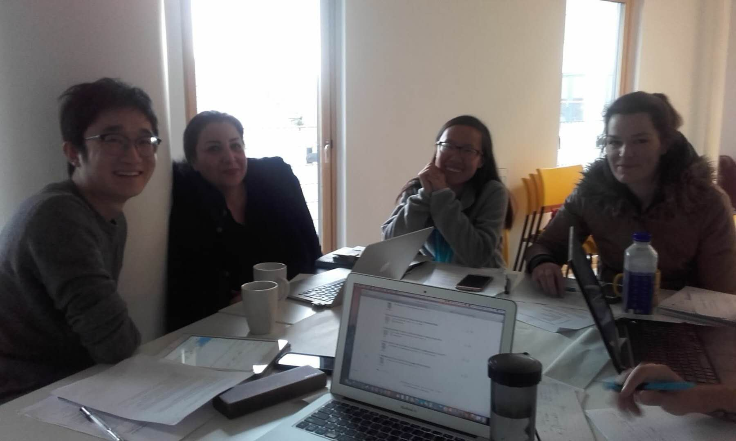
Our team created a Whatsapp’s group to discuss our ideas, notes and documents after class. Everyone used this app to present their ideas and, we discussed and decided the next step what should we do in tomorrow together. It is also a brainstorm activity to collect different opinions. Finally, through discussing in class and after class, we finished designing our app called Mi Culture. In this app, consumers can find the nearest barbers and see their qualification and rating. Both hair dressers and customers can register in this same app. There are different functions for them to have a better experience to book and check their appointments in their own languages.
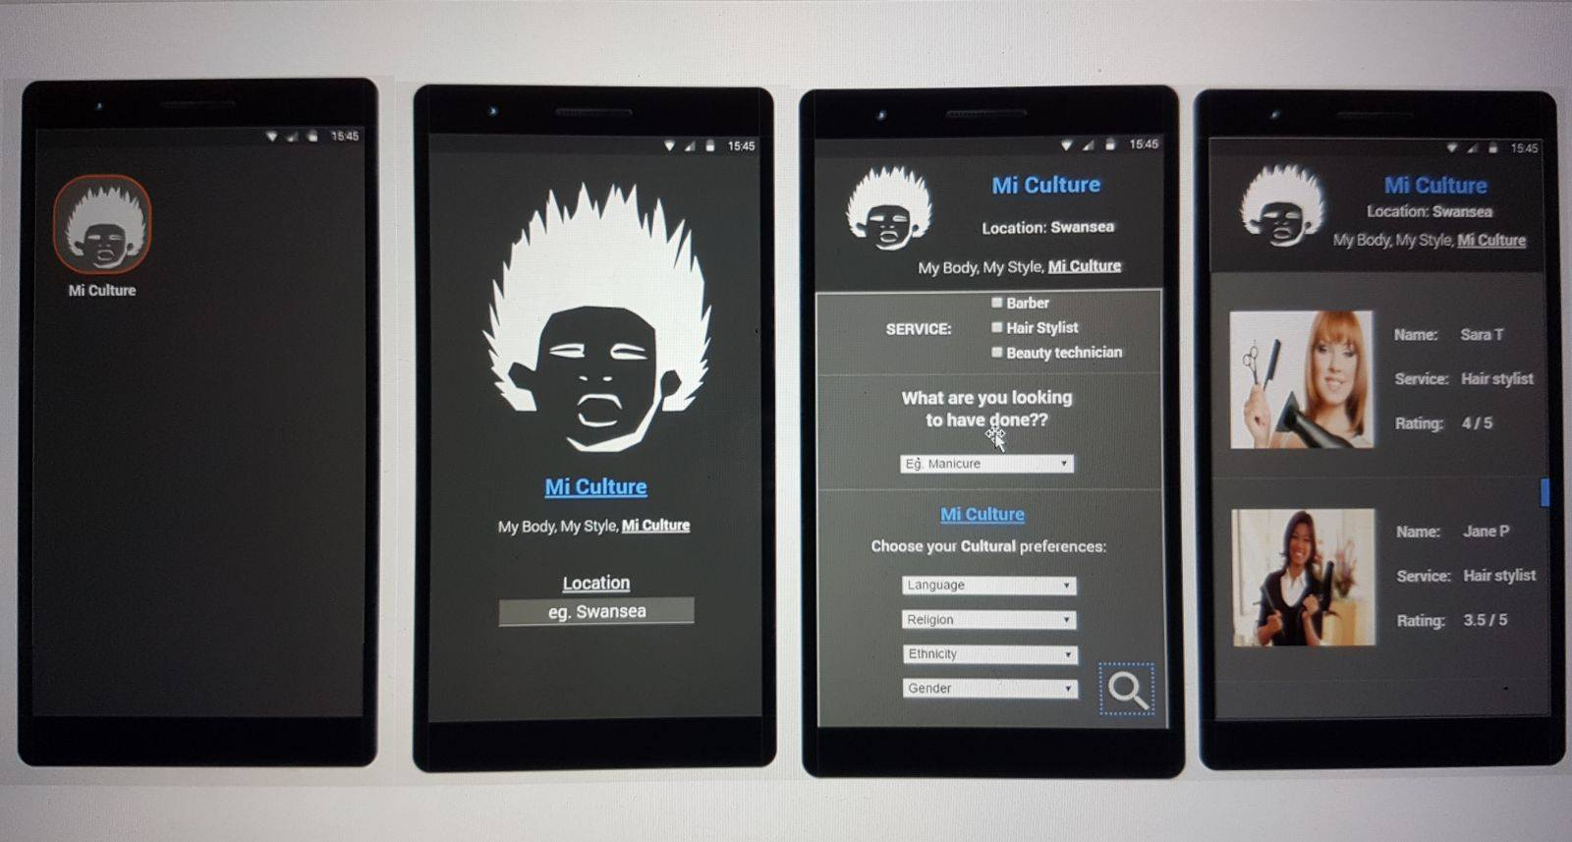
For me, the project week is a spectacular experience to talk with many local people and people from other counties. If I’m in the formal lectures, I will have chance to talk with them but I won’t, because I’m afraid about my grammar and comprehensive. I fear to have an embarrassed communication. But during this week, our tutor Sandra forced us to talk with local people to do this for giving us some different ideas. I can also learn some skills from them. The local people know a lot of information about UK market and proper nouns in the business area. During the project week, I understood the meaning of ‘Freelancer’,‘Umbrella company’ and ‘USP’. Freelancers are the people who are not controlled by time and regulation to work. Umbrella company is the corporate which usually develop in UK. It is not an employer but acts as an employer which to let contractors do the tasks under some fixed terms. ‘USP’ is the abbreviation of ‘Unique Selling Proposition’. It means one enterprise’s special selling marketing strategy. After understanding these professional words, I can do my project work better than before.
In my opinion, the project week has significant meaning. It gives me an opportunity to talk with both English speaking country and non-English speaking country’s people. It gives me a platform to learn thoughts from different cultures and, combine and collect our thoughts into a unified view. The more I communicate with them, the more I acquire from them. I believe that these points I get will support my future job and give me many ideas.

