

Programme: MBA International Business

Module: International Marketing: Principles and Practices
Module code: LCMB7026

Assignment Title: Assessment component 1: Individual report

Adidas Across Borders: A Comparative International Marketing Strategy Analysis of Germany and the United States

Lecturer: Dr Jamiu Odugbesan

Student name: Ronak Jerambhai Devani
Student ID: 2531597

Word count: 5354

Table of Contents
SECTION 1: INTERNATIONAL MARKET ENTRY STRATEGY AND MARKETING MIX 4
1. Introduction: Adidas and the Germany–United States International Marketing Context 4
2. Comparative Macro-Environmental Analysis: Germany and the United States 6
2.1 Political and Legal Environment 6
2.2 Economic Environment 6
2.3 Social and Demographic Environment 7
2.4 Technological Environment 7
2.5 Environmental and Sustainability Environment 8
2.6 PESTEL Comparative Synthesis 8
3. Comparative Cultural Analysis Using Hofstede's Framework 9
3.1 Germany and the United States: Hofstede Comparison 9
3.2 Critical Evaluation of Cultural Differences 10
4. Comparative STP Strategy: Adidas in Germany and the United States 11
4.1 Segmentation Strategy 11
4.2 Targeting Strategy 12
4.3 Positioning Strategy 13
4.4 STP Comparative Evaluation 13
Segmentation Evaluation 13
Targeting Evaluation 14
Positioning Evaluation 14
5. Comparative International Marketing Mix: Adidas's 7Ps 16
5.1 Product Strategy 16
5.2 Pricing Strategy 16
5.3 Place / Distribution Strategy 16
5.4 Promotion Strategy 17
5.5 People 17
5.6 Process 18
5.7 Physical Evidence 18
5.8 7Ps Comparative Synthesis 18
6. Adidas's Market Entry Strategy in the United States 19
6.1 Adidas's Entry into the US Market 19
6.2 Evaluation of the Entry Mode 19
6.3 Comparative Assessment 20
7. Ethical Evaluation of Adidas's Marketing Mix in the United States 21
7.1 Identification of the Ethical Issue 21
7.2 Ethical Analysis 21
7.3 Evaluation and Lessons for Adidas 22
8. Strategic Recommendations for Adidas: Germany and the United States 23
8.1 Recommendation 1: Localised Consumer Segmentation 23
8.2 Recommendation 2: Global Brand, Local Communication 23
8.3 Recommendation 3: Data-Driven Omnichannel Strategy 23
8.4 Recommendation 4: Ethical and Transparent Marketing 23
8.5 Recommendation 5: Market-Specific Competitive Differentiation 23
9. Conclusion 24
SECTION 2: REFLECTIVE ACCOUNT 25
10. Reflective Account: Researching and Developing the Adidas International Marketing Strategy 25
10.1 Concrete Experience 25
10.2 Reflective Observation 26
10.3 Abstract Conceptualisation 26
10.4 Active Experimentation 27
10.5 Conclusion on insight gained from the reflection 28
References 29

SECTION 1: INTERNATIONAL MARKET ENTRY STRATEGY AND MARKETING MIX

1. Introduction: Adidas and the Germany–United States International Marketing Context
The company is known for its innovation, sustainability efforts and global reach, with Adidas being one of the world's premier sportswear, footwear and lifestyle brands. In 2025, the company reported total net sales of €24.8 billion, driven by continued growth in all international markets, and cementing its status as one of the world's biggest sportswear companies (Adidas Group, 2025a). Germany is Adidas's home market, which offers brand heritage and reliability, while the United States is its biggest strategic overseas market, where the sportswear industry is expected to be about US$79.6 billion in 2026 (Ferrari N.V., 2026). The two contrasting markets vary in several aspects, which include the cultural values, the behaviour of consumers and the level of competition, and thus can be used as a base for comparative marketing analysis internationally. Hence, this report critically reviews the marketing strategies of Adidas in Germany as well as USA and examines the US market entry strategy and ethical marketing practices of the company and how standardisation and adaptation of the strategies in various countries in the world can help in gaining sustainable competitive advantage.

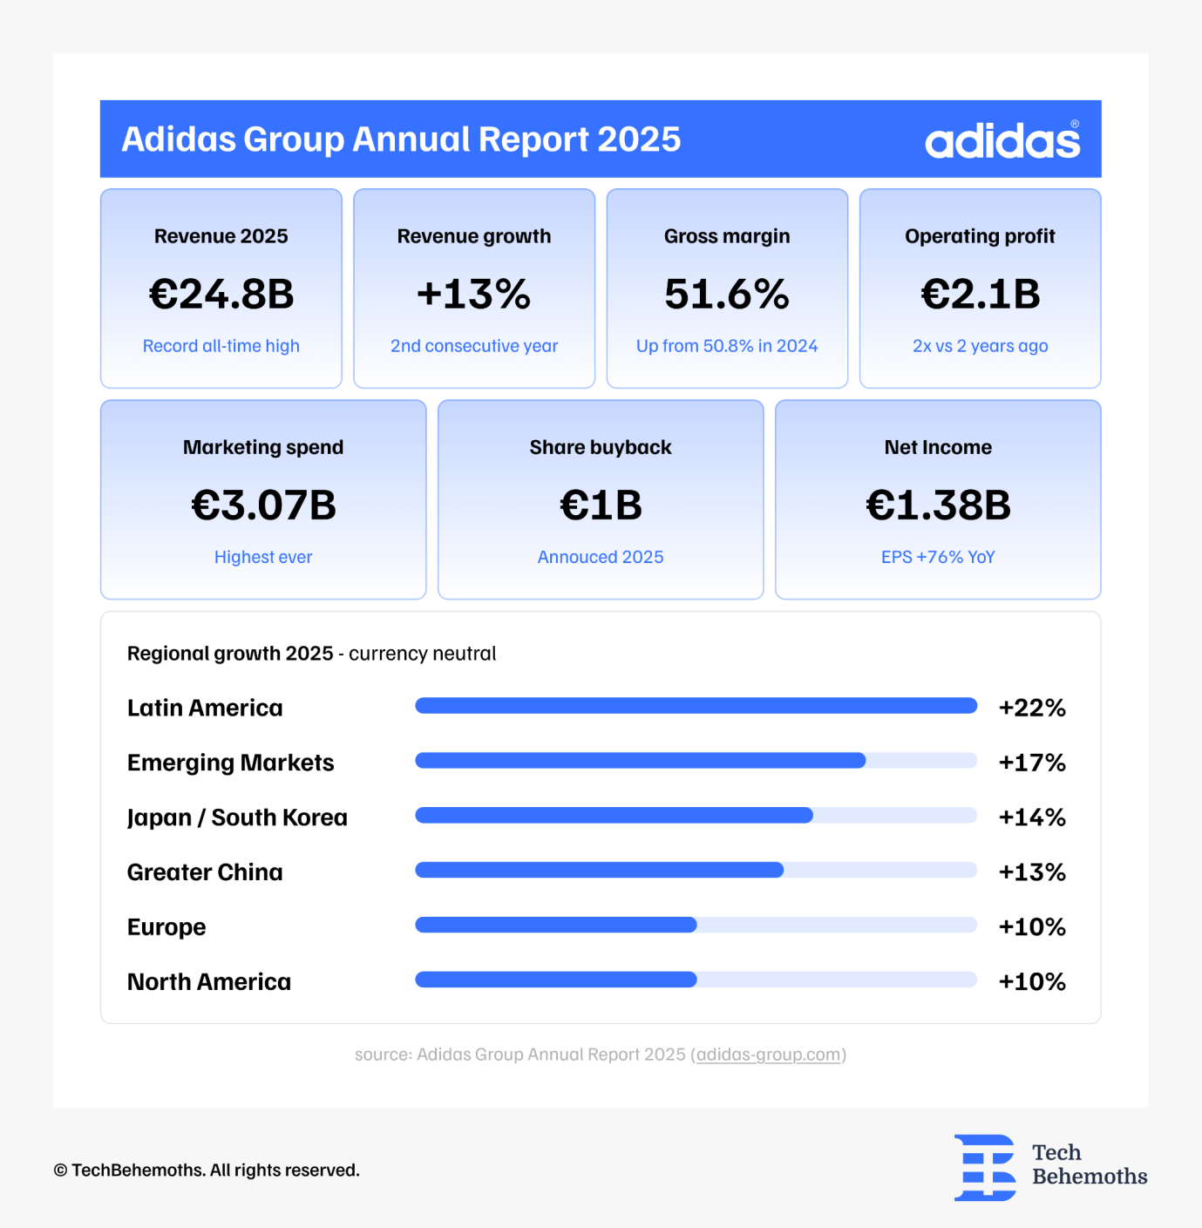
Figure 1: End of 2025, Adidas posted the best results in its history
(Source: TechBehemoths, 2026)

2. Comparative Macro-Environmental Analysis: Germany and the United States

2.1 Political and Legal Environment
Germany's comprehensive regulatory system, including the EU Digital Services Act, GDPR and Green Claims Directive, sets higher standards for Adidas' sustainability claims, use of consumer data and transparency about advertising than the more disjointed federal system in the United States.Germany's score was estimated at approximately 1.50 points (about the 92th percentile) as against the United States' score of about 90.57th percentile, signifying better institutional governance in Germany (Trading Economics, 2026). Those regulatory differences, however, call for changes in Adidas' marketing for their products as well as in their approach to the supply chain, transparency and distribution to achieve consistent global brand credibility and legal compliance.
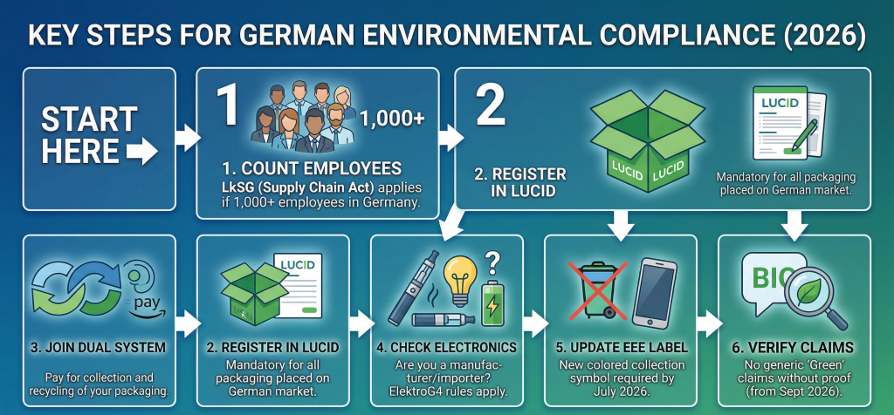
Figure 2: Key Steps for German Environmental Compliance
(Source: TechBehemoths, 2026)

2.2 Economic Environment
Germany and the U.S. are both high-mix, high margin markets that are impacted by purchasing-power disparities, inflation rates and currency variations as well as competitive levels, all of which affect how Adidas markets its products internationally. With robust demand and continued growth in global markets, the world sportswear market size estimates will attain US$ 437.3 billion in 2026, making it appealing and competitive (Grand View Research, 2026). Therefore, Adidas can't count on having a uniform global pricing structure, and needs to change its pricing, promotional discounts, product offerings (and omnichannel retail approaches) to local consumers' needs and local economies.
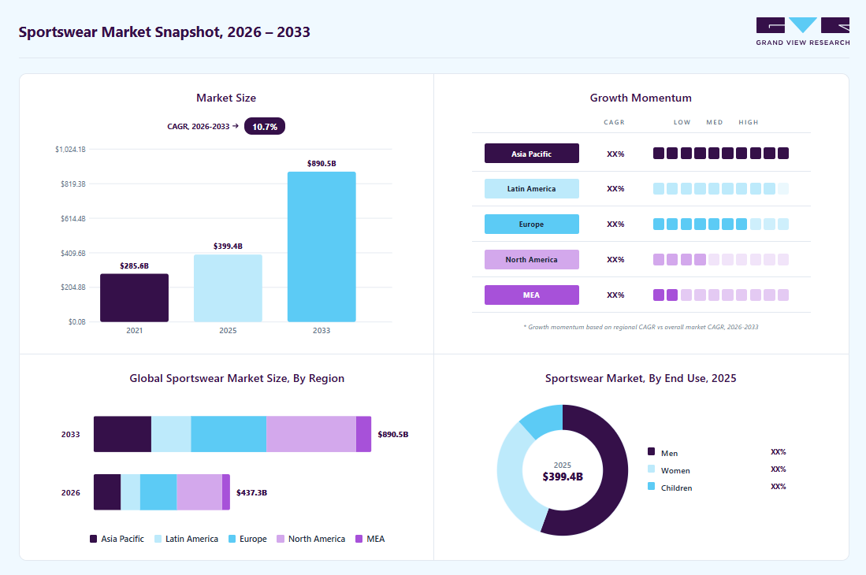
Figure 3: Sportswear Market
(Source: Grand View Research, 2026)

2.3 Social and Demographic Environment
Germany and America, respectively, handle consumers' actions and life changes so differently that they affect how Adidas markets itself in the German and American markets. American multiculturalism and an affinity for influencers fuel the desire for athleisure, limited-edition sneakers and lifestyle sneakers, and German buyers prioritise function, quality and sustainability. The U.S. activewear market is projected to amount to USD 95.1 billion and USD 100.5 billion in 2026 due to high consumer demand (Fortune Business Insights, 2026). Hence, Adidas needs to target countries with the proper product mix and marketing communications, while simultaneously keeping a unified global brand.

2.4 Technological Environment
Both Germany and the United States have high digital infrastructure development; the latter shows more use of AI for personalisation, mobile and social commerce. The significance of e-commerce channels, in particular retail, has been underlined by forecasts predicting over 2.9 billion global retail e-commerce sales in 2026 (DHL, 2026). Hence, Adidas needs to standardise its core digital platforms, AI tools and omnichannel systems across the world, and adjust customer experiences, mobile engagement and personalised marketing to mirror the specific digital habits and expectations of each target market.

2.5 Environmental and Sustainability Environment
Adidas' competitiveness both in Germany and the United States is to a great extent affected by environmental sustainability. German consumers and EU regulations emphasise circularity, carbon reduction and transparency in terms of sustainability claims, while US consumers are more concerned with innovation and product performance along with sustainability. In 2025, Adidas Group has seen significant progress in reaching its sustainability goals and reported that 99% of polyester used in its products was recycled (Adidas Group, 2026a). But sustainable products don't necessarily drive buying, and if they're more eco-friendly than their counterparts, they might actually be more susceptible to a greenwashing impression.
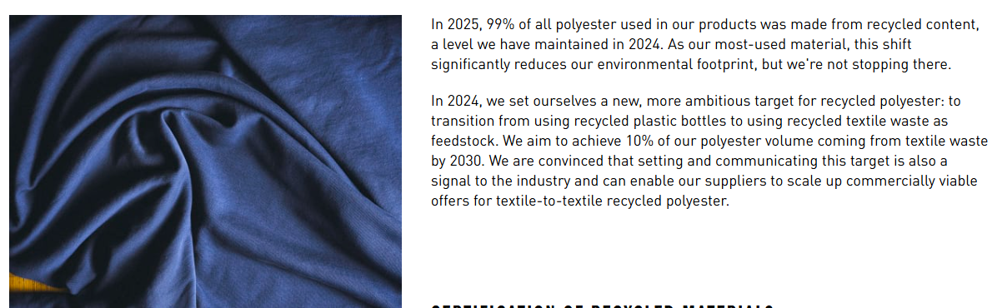
Figure 4: Adidas's Recycled Polyester Strategy
(Source: Adidas Group, 2026a)

2.6 PESTEL Comparative Synthesis
PESTEL analysis indicates that both Germany and the United States present potential market opportunities for Adidas, but the political regulation, economic conditions, consumer behaviour and legal constraints point to different approaches with regard to strategy. Germany's stricter sustainability and consumer protection standards are shining in contrast to the more extensive and innovation-focused as well as competitive, market in the USA (Delgado et al., 2026). However, both markets feed advanced digital retailing and a demand for top sportswear. So, Adidas should adjust its global brand image, but at the same time, it should consider incorporating STP strategies and the marketing mix to cater to regulatory, cultural and market conditions in different countries.

3. Comparative Cultural Analysis Using Hofstede's Framework

3.1 Germany and the United States: Hofstede Comparison
According to Hofstede's cultural dimensions, there is no doubt that Germany and the U.S. show high individualism, while at the same time, uncertainty avoidance, long-term orientation and indulgence are different, which has a potential impact on Adidas' international marketing strategy. German consumers are, in general, more UAI and have a stronger LTO, preferring quality, product reliability and sustainability (Gerlich, 2023). In conclusion, Adidas needs to draw attention to product innovation, performance and environmental friendliness via informative advertising and clear brand communication. On the other hand, with a lower score in uncertainty avoidance and a higher score in indulgence, Americans are likely to be more open to engaging ads that connect with emotions, celebrity endorsements and limited-edition products that confirm personal identity and self-expression.
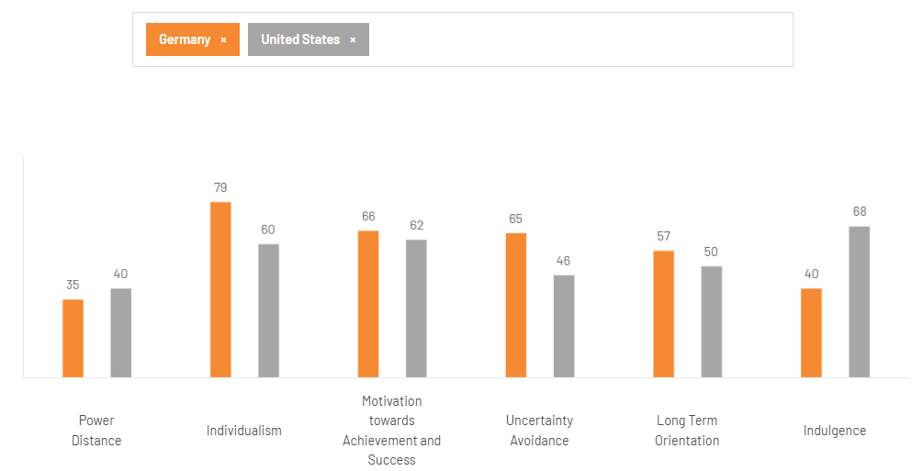
Figure 5: Hofstede's Cultural Dimensions Comparison between Germany and the United States
(Source: The Culture Factor, 2026)
These cultural differences also moderate consumer preferences and shopping experiences. German shoppers place a high level of importance on authenticity, superior product features and personalised in-store experiences, while American consumers actively embrace experiential retail, word-of-mouth marketing via social media and influencers. Hence, Adidas must have a comprehensive cross-national brand image, and message sending and communication styles must be customised on a country-by-country basis to meet the country's norms and values. In such a vein, in 2025, digital revenues accounted for around 25-30% of total revenues at Adidas, underpinning the growing role of culturally-adapted digital engagement and omnichannel communication in fostering robust customer relationships across the global landscape (FourWeekMBA, 2026).

3.2 Critical Evaluation of Cultural Differences
While Hofstede's cultural dimensions serve as a convenient model for understanding the differences between cultures, it should not be interpreted as necessarily a deterministic explanation of consumers' behaviour. National cultural scores are blind to variation within Germany and the United States in terms of individuals' preferences, generational differences and regional differences (Bartosik-Purgat et al., 2026). Younger consumers in both countries, for instance, are more affected by the values found in global digital communities, social media and international fashion than by old-fashioned national values. Similarly, in the U.S., there are multicultural populations, and in Germany, society is becoming a more diverse one, and the national average will not fully explain the size and makeup of those populations, nor will it account for the differences between their lifestyles and motivations for purchasing.
Meanwhile, globalisation and digitalisation have further blurred cultural barriers, so that consumers today have similar interests all across the world, whether in their sportswear or sustainability and streetwear. Adidas is said to be in over 160 countries, so it is crucial to go to different consumer groups and find strategies that will work globally (World Economic Forum, 2026). Hence, Adidas should take Hofstede as a diagnostic tool when making their decision-making process with behavioural, psychographic and generational segmentation as the preferred method.

4. Comparative STP Strategy: Adidas in Germany and the United States

4.1 Segmentation Strategy
In the countries of Germany and the USA, Adidas uses five segmentation strategies: demographic, geographic, psychographic and behavioural segmentation, directed at athletes, fitness enthusiasts, Gen Z, Millennials, sneaker collectors, fashion-aware and sustainability-conscious consumers. But the respective market importance of these segments varies from market to market. German consumers have a greater affinity for product quality and functionality, while US consumers value lifestyle, innovation, celebrity endorsement and limited editions. Thus, Adidas need to make some changes to its segmentation, aligning itself more with performance and sustainability in Germany and more with fashion and culture in the United States. The German sportswear market is set to generate USD 35.9 million in 2025, and by 2033, it will reach USD 80.0 million, making it a mature premium sportswear market that needs to be segmented and the marketing strategies need to be localised (Grand View Research, 2026).
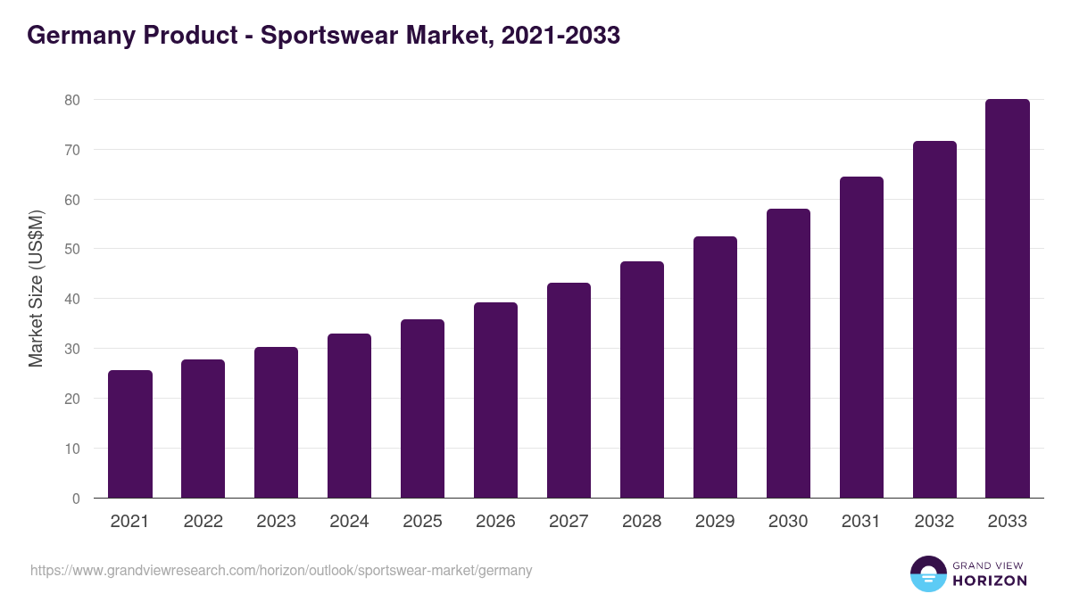
Figure 6: Germany Product - Sportswear market
(Source: Grand View Research, 2026)

4.2 Targeting Strategy
Adidas uses a differentiated targeting strategy using different consumer segments in Germany and the United States of America, with a premium image of the brand looking into the world. The company focuses on performance athletes, health-oriented professionals and consumers with high expectations of sustainability in Germany, where purchasing power and brand loyalty guarantee demand for good sportswear. The market's size, growth potential and the sports and fashion culture prevailing in the United States, Adidas targets Gen Z, Millennials, sneaker and athleisure consumers in America. There is intense rivalry in the US; however, these segments offer greater accessibility and long-term growth for the brand. Adidas North America recorded €5.94 billion in sales during 2026, highlighting the region's role in the brand’s business and the importance of implementing local targeting while maintaining the same global brand information (Staffing Industry Analysts, 2026).
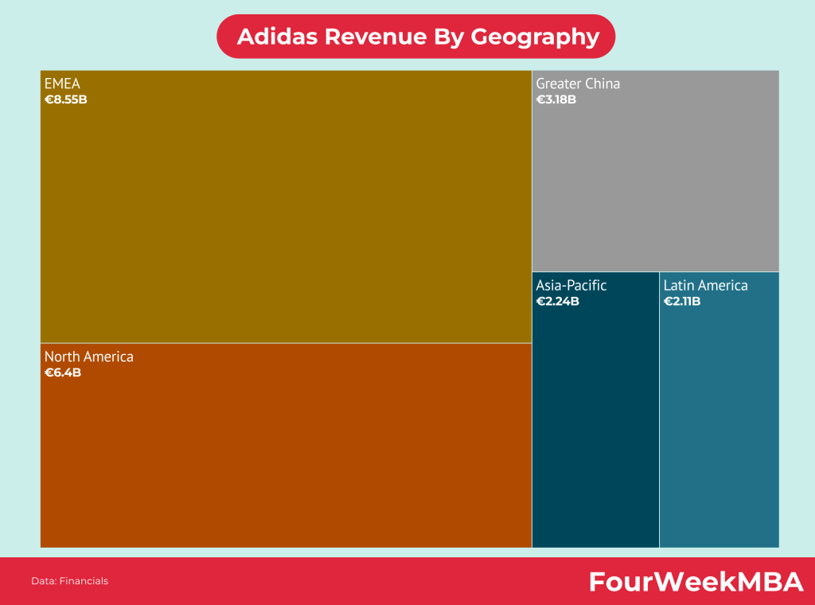
Figure 7: Adidas Revenue
(Source: FourWeekMBA, 2026)

4.3 Positioning Strategy
For Adidas, it's a worldwide company that's coming across as a blend of sport, performance, innovation, heritage, sustainability and lifestyle, albeit with a different focus in each part of the world. Given its German heritage and the quality of its products, as well as its focus on sustainability, Adidas in Germany is mainly seen as a brand that is focused on heritage and performance. Meanwhile, the United States is growing increasingly more familiar with Adidas in the fashion, street culture and lifestyle spheres as the brand begins to rope in athletes, celebrities and designers in a series of designs, launching a fierce competition to Nike, New Balance and Under Armour. Hence, Adidas should have a consistent position throughout the world with a focus on innovation and sporting success, but fine-tune the cultural messaging and lifestyle branding to fit with the local consumer. Currency-neutral growth of 13% for the “Adidas brand” leads to a record, confirming strong global brand equity and the international sportswear industry’s strong competitive position (Adidas Group, 2026b).

4.4 STP Comparative Evaluation

Segmentation Evaluation
Globally, Adidas should adopt a 'segmentation throughout' approach, which will involve adapting behavioural and psychographic segments to suit local preferences. German Consumers put a high value on sustainability, quality and performance; US Consumers value lifestyle, fashion and innovation. In 2026, revenues in the German sports apparel market are estimated at around US$6.82 billion (SourceReady, 2026). It facilitates market segmentation so as to achieve maximum relevance to the customers and a competitive advantage.
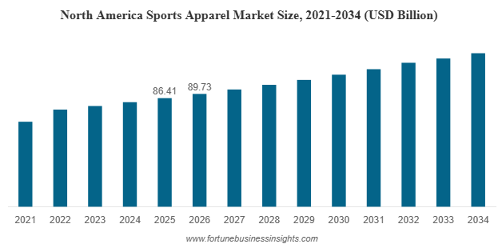
Figure 8: In 2026, North America’s Sports Apparel Market Size
(Source: Fortune Business Insights, 2026)

Targeting Evaluation
Diversification in targeting should be continued by Adidas, hence targeting high-value consumers in each individual market. Germany has a high number of performance- and sustainability-driven consumers, while the United States has more performance- and Gen Z/athleisure driven consumers. Market estimates in 2026 for Apparel in the United States show a revenue value of US$373.00bn, offering opportunities to target specific market segments to maximise growth and brand loyalty (Statista, 2026).

Positioning Evaluation
Using Adidas as a case study, the focus should be on maintaining consistency in the brand's global positioning, based on innovation, performance and sustainability, but while adapting marketing communication to local consumers. The sportswear market is projected to grow to around US$ 437.4 billion in the year 2026, further strengthening growth opportunities in the global landscape (Grand View Research, 2026). Thus, adopting a hybrid positioning approach helps Adidas find the maximum brand equity, with local relevance and sustainable competitive advantage.
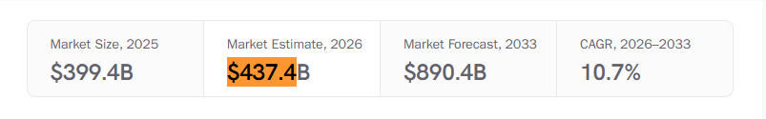
Figure 9: Sportswear Market (2026 - 2033)
(Source: Grand View Research, 2026

5. Comparative International Marketing Mix: Adidas's 7Ps

5.1 Product Strategy
Adidas produces a highly rationalised range of worldwide sports shoes, clothing and lifestyle goods and introduces selected collections by taking into account the preferences of local consumers both in Germany and the USA. German consumers prioritise performance and durability and want sustainable products, while US consumers are interested in lifestyle sneakers, limited edition collections and collaborations, and fashion collections. Adidas spent €154 million on research and development for products in 2025 to foster continued development and innovation in its products, while allowing it to tailor each market through one overall, brand-wide strategy (Adidas Group, 2025b).

5.2 Pricing Strategy
In both Germany and the United States, Adidas uses a premium pricing strategy, product-tier pricing, selective promotional discounts and has strong brand equity. However, the price needs adaptation to account for purchasing power, exchange-rate effects and competing intensity and consumer price perceptions. From the point of view of premium pricing, it has been found that in both markets this premium pricing would signal the quality of the product, however the value expectations may be different; Americans appreciate greater discounts and Germans less. In 2026, Adidas was recognized by Interbrand as the most valuable brand in the world with a value of 17.4B$ and was still able to maintain premium prices in all of its global markets (50 Pros, 2026).

5.3 Place / Distribution Strategy
Adidas deals with a multichannel distribution strategy, including Adidas-owned shops, wholesale partners, sporting goods retailers, department stores and eCommerce and direct-to-consumer (DTC) channels in Germany and the United States. Integrated omnichannel retailing is stronger in Germany, while DTC expansion and digital commerce are wider in the United States. As the model has evolved, the strategic importance of balancing physical retail, digital platforms and third-party distribution becomes clear, and the Net income from continuing operations of Adidas rises by 11% to € 484 million (Adidas Group, 2026c).

5.4 Promotion Strategy
Adidas has a digital marketing strategy that incorporates a wide range of elements, such as social media campaigns, video content, high-profile endorsements, and sports sponsorships, all aimed at enhancing its brand presence and reputation around the world. Promotional campaigns in Germany highlight performance, innovation and sustainability, while campaigns in the U.S. are more lifestyle, diversity and popular culture-oriented. Adidas' Marketing and point-of-sale expenses rose by 30%, which equates to an increase of € 212 million to an amount of € 924 million (Adidas Group, 2026d). It demonstrates significant investment in communication consistently delivered around the world and then localised for culturally diverse consumer segments.
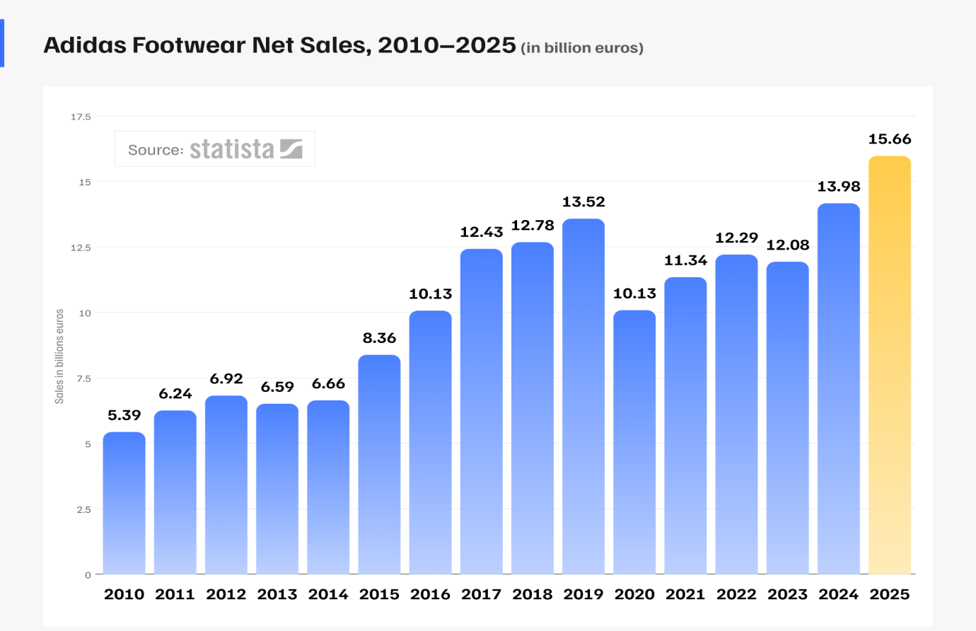
Figure 10: Adidas Footwear Net Sales
(Source: TechBehemoths, 2026)

5.5 People
Adidas' customer engagement includes shop staff who can answer questions about the merchandise, online chat features, athlete collaborations, influencers and a diversity team. Germany's technical know-how and customer service drive the brand, while the United States' athlete ambassadors and influencers drive emotional bonding and help build community. Adidas had about 62000 employees in all over the world (Phoenix United, 2026). It shows why it's critical to have an accomplished worker and brand ambassadors to provide uniform customer experiences by market.

5.6 Process
Adidas' buying, delivery, recommendations, returns and omnichannel retailing seamlessly serve the needs of the customer. Consumers in the USA value quick shipping, customisation and ease of digital interaction, while German consumers prefer secure transactions, clear procedures and data protection. The adiClub membership programme saw a global increase to more than 240 million customers, emphasising the power of loyalty initiatives and personalisation based on data in establishing deeper customer connections in varied international markets (Loyalty & Reward Co, 2026).

5.7 Physical Evidence
Modern flagship stores, coordinated visual merchandising, sustainable packaging, intuitive digital platforms to shop, and in-person brand experiences help to consolidate the adidas brand's value. Germany looks at maintaining low-cost store design and product quality, while the U.S. strives for experiential retail with interactive elements and digital engagement. In 2025, Adidas reported capital expenditure of € 477 million, which was used to enhance its retail stores, digital infrastructure and customer experience continuously (Adidas Group, 2026b). These digital and physical endorsements act as a bridge of consumers' trust and strengthen the brand in both marketplace arenas.

5.8 7Ps Comparative Synthesis
To ensure global brand consistency across Germany and the United States, Adidas carries over core elements of the marketing mix such as product quality, brand, innovation and premium positioning. But it adjusts its prices, promotion messages, distribution and delivery systems, customer interactions and retail strategies to the local economy, culture and competition. This is in line with the standardisation–adaptation view, which is oriented towards global efficiency with local responsiveness. Thus, Adidas increases its brand value and market value, customer satisfaction, and its competition in both countries (Clarisa, Ellitan and Kristiyanto, 2023).

6. Adidas's Market Entry Strategy in the United States

6.1 Adidas's Entry into the US Market
An increased presence in the market through local distribution routes, retail stores, and strategic marketing agreements with athletes, sports organisations and fashion partners enabled Adidas to break the international market barriers that were present when it first entered the United States in the 1960s, starting with sportswear. With time passing on, the company pivoted to a direct-to-consumer (DTC) model, adopting e-commerce, flagship stores and omnichannel retailing to increase customer engagement. This advancement has made Adidas more competitive with its current rivals in America and strengthened its global brand reputation. Net sales from North America bring in €5.94 billion, highlighting the strategic role the market plays (Investing.com, 2026). Further, North America generated 5087 of the total revenue of the Adidas Group in 2025, which underscores the need for ongoing investment in its North American business and the targeting of localised marketing campaigns (Adidas Group, 2026b).
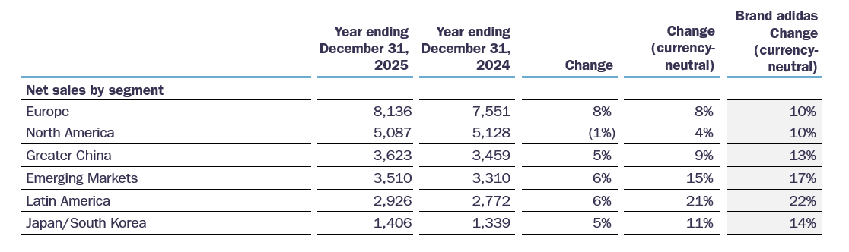
Figure 11: Year-Ending Revenue of Adidas
(Source: Adidas Group, 2026)

6.2 Evaluation of the Entry Mode
Adidas also first became famous in the U.S. by exporting, then by forming wholly owned subsidiaries that would allow them to have more control of their brands, retail, and marketing efforts. The company also established strategic partnerships with sports sales outlets, professional sports stars, and fashion partners instead of depending on franchising or joint ventures to increase market access. Wholly owned subsidiaries offer greater brand protection, direct customer contact and flexibility in operations, with increased investment levels and business risks. On the other hand, the exporting mode entailed quick market entry at the expense of low-level investment, and then the development of local operations. The strategy of high control through ownership and global market expansion is proving effective at the operating level, with Adidas's gross margin improving by 0.8pp to 51.6% and operating profit up 54% to € 2,056 million in 2025 (Adidas Group, 2026). Adidas FY2025 revenue grew in all product segments, with footwear accounting for 58% of revenue, apparel 35% and accessories 7% (Investing.com, 2026).
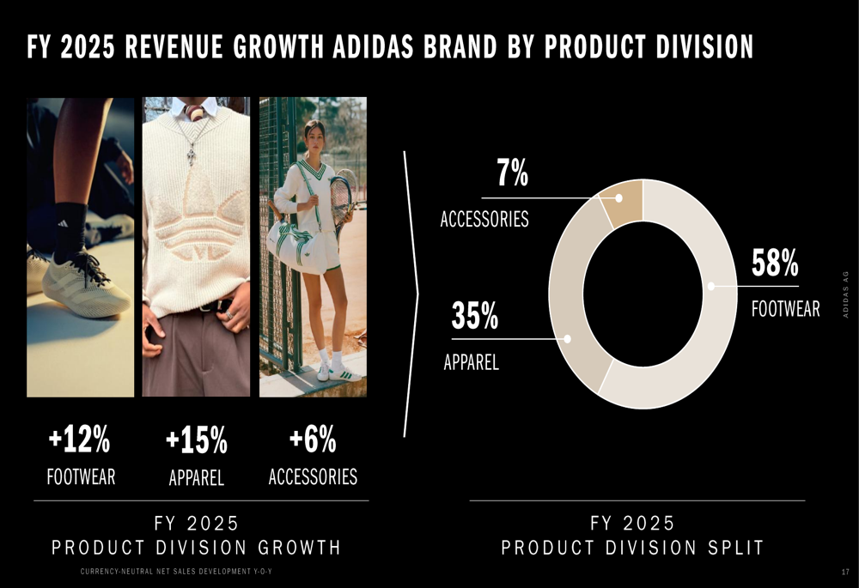
Figure 12: Adidas FY2025 Revenue Growth and Product Division Revenue Split
(Source: Investing.com, 2026)

6.3 Comparative Assessment
Adidas' move to the U.S. and its expansion have moved in the right direction from it being an export to becoming fully owned subsidiaries, leading to better control of the brand and customer engagement, as well as better retail stores. There were some strategic investments made in DTC channels, athlete endorsements and digital marketing that further increased the competitiveness (Chen, 2024). But, the market is facing sustainable pressure of Nike's market dominance and intense market competition; cultural differences and changing consumer preferences are the factors which hamper market leadership. In the future, the company's international growth strategy should focus on adapting to local markets and improving partnerships with local entities, while continuing to develop and launch new and innovative products and cultural marketing strategies, and retaining Adidas' uniform and irreplaceable global image.

7. Ethical Evaluation of Adidas's Marketing Mix in the United States

7.1 Identification of the Ethical Issue
One potential ethical concern in Adidas' marketing mix in the United States is sustainability communication and the possibility of greenwashing. With the consumer getting higher appreciation of environment-friendly products, Adidas had to make sure that all claims of sustainability were transparent, verifiable and backed by measurable facts. Exaggerated eco-claims can lead to a lack of consumer trust and brand credibility. In 2025, 60% of the materials used for the products and packaging were recycled or sustainably sourced renewable materials, contributing to Adidas future ambitions, highlighting its sustainability progress while reinforcing the need for accurate marketing communication (Adidas Group, 2026a). Meanwhile, the sustainable footwear market will grow to US$19.4 billion by 2035 at a 6.4% CAGR for 2025–2035 (Future Market Insights, 2025).
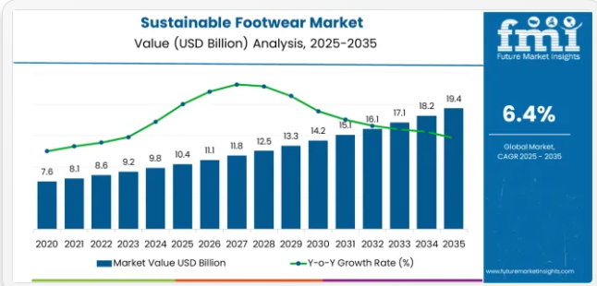
Figure 13: Global Sustainable Footwear Market Value Forecast, 2025–2035
(Source: Future Market Insights, 2023)

7.2 Ethical Analysis
According to the Stakeholder Theory, the communication of the sustainability of Adidas should have the aim of generating value for the company's various stakeholders: the customers, the employees, the suppliers, the investors, the regulators and their respective communities. Consumers not only need help with making informed purchase decisions through transparent environmental claims, but suppliers are also called on to ensure responsible sourcing and production practices (Schäfer, 2023). But over-screened and unproven sustainability claims could lead to accusations of "greenwashing," eroding consumer confidence and jeopardising the company's reputation and legal liability. Adidas thus has a responsibility to make sure the environmental performance and how its brands have been produced are truthfully communicated in marketing and communications. Ethical responsibility also involves taking care of less commercial goals along with the social and environmental factors, along with the commercial ones, other than targets of sales numbers (Rakesh and Srivatsava, 2025). In this way, it is possible to give credence to the sustainability data Adidas shares and ensure transparency regarding the engagement of stakeholders in the United States market, which can boost the long-term brand credibility, the customer's loyalty and the reputation of the company.

7.3 Evaluation and Lessons for Adidas
Adidas' sustainability communication is not necessarily unethical, but more ethically unclear: although the company has taken steps to engage in tangible environmental projects, one must also be aware that the statements in sustainability marketing need to be transparent and verifiable. The inconsistency is challenging the push for global sustainability communication, while consumers have different expectations, and countries have different regulations," a problem that murkies the communication landscape. In 2026, all cotton used by Adidas was third-party certified and either preferred or more sustainable materials (Adidas Group, 2026a). It shows progress, and it raises awareness of the need for Accountable Communication. Based upon these findings, recommendations for increased transparency and sustainability are made.

8. Strategic Recommendations for Adidas: Germany and the United States

8.1 Recommendation 1: Localised Consumer Segmentation
Problem: Varied taste preferences of consumers. Evidence: differences in behaviour in Germany and the US. Strategic action: Segmentation with behavioural, psychographic and 1st-party data locally. Expected benefit: Improved marketing relevance, engagement and loyalty. Measurements/KPIs: More conversions, customer retention, customer lifetime value (CLV), campaign engagement by target segments.

8.2 Recommendation 2: Global Brand, Local Communication
Challenge: There is a risk of losing local relevance with standardised communication. Evidence: Germany vs USA cultural preferences differ. Strategic action: Sustain Adidas brand identity on the global level but then localise their storytelling, language and influencer collaborations (Gashi, 2025). The expected value: Improved customer experience and brand authenticity. Measurement/KPI: Brand awareness, engagement rates, campaign reach and purchase intention.

8.3 Recommendation 3: Data-Driven Omnichannel Strategy
Problem: Inconsistent customer experiences across digital and physical channels. The positives: Consumers are demanding notice of seamless omnichannel interactions. Strategic action: Connect direct-to-consumer tools, stores and first-party data for individual experiences. Potential benefit: Increased satisfaction and customer loyalty. Measurements/KPIs: Omnichannel sales growth, repeat purchase rate, app engagement and customer satisfaction (CSAT).

8.4 Recommendation 4: Ethical and Transparent Marketing
The issue: Sustainability claims can drive greenwashing worries. Evidence: People are increasingly asking for information about the environment that is transparent and verifiable (Fu et al., 2023). In the interests of strategic action, reinforce the reporting of sustainability based on evidence and control the communication of influencers and ads. Expected benefit: Greater consumer trust and regulatory compliance. Milestone/metric: consumer trust scores, re: ESG ratings, reduction of complaints and adherence to sustainability audit.

8.5 Recommendation 5: Market-Specific Competitive Differentiation
Difficulty: The markets are highly competitive, and this leads to low levels of market differentiation. Evidence: Consumer preferences differ between Germany and the US. Strategic action - Ramp up in Germany: heritage and sustainability; and upgrade the US: innovation and lifestyle (Shakya and Vagnarelli, 2024). Expected benefits: Enhanced competitive strengths. KPI: Increase in market share, brand preference and customer loyalty in both markets.

9. Conclusion
The overall findings of this report indicate that the only way for Adidas to achieve success in the German and United States markets is to find the right mix of globalisation and localisation. Here, Germany has a focus on sustainability, product quality and regulatory compliance, while the U.S. takes the lead in lifestyle, innovation and cultural relevance. Develop a standardised core brand and product quality and innovation, with local segmentation, communication and pricing & distribution aligned with local expectations for Adidas. The study also shows that marketing decisions should not be taken based on culture, but rather be guided by culture. Overall, Adidas' approach to entering the U.S. market is on the right track, but more ethical transparency with regard to sustainability communication is needed. In the end, to improve and sustain the competitiveness, customers' trust and international growth of the Adidas product, the company should adopt a hybrid standardisation–adaptation strategy.

SECTION 2: REFLECTIVE ACCOUNT

10. Reflective Account: Researching and Developing the Adidas International Marketing Strategy
Use Kolb's four-stage cycle explicitly.
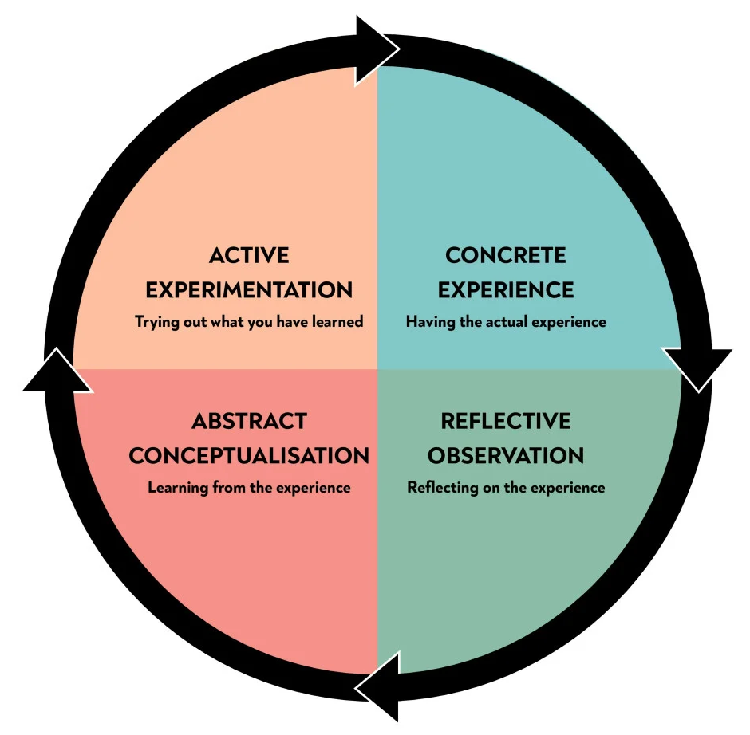
Figure 14: Kolb's Reflective Cycle
(Source: McLeod, 2025)

10.1 Concrete Experience
In this assignment, I chose to concentrate on Adidas as my focal organisation owing to its excellent presence in the world and the contrasting market characteristics in Germany and the United States. My original thought was that Adidas would adopt a standardised marketing strategy around the globe, at least to a large degree, in both countries. As part of conducting secondary research, using academic journals, company reports and industry publications. International marketing is a delicate mix of global consistency and local adaptation (Lin et al., 2023). Some of the frameworks used are PESTEL, Hofstede's Cultural Dimensions, STP and the 7Ps marketing mix, and they have been used to compare the two markets and aid in analysing the choices made by Adidas.
I also took a look at Adidas's entry in the US market, the analysis of the marketing mix and focused on one ethical issue associated with sustainability communication. Creating evidence-based recommendations was an eye-opener for me as to how theoretical models can aid in practical business decisions. The most difficult was finding information that is current and reliable to ensure company information, market evidence and academic literature correlate with the analysis. In general, it is emphasised that the research experience boosted my analytical and practical research skills in critically scrutinising international marketing strategies and subsequently connecting theory to practice.

10.2 Reflective Observation
As part of the research process, I found myself realising that my understanding of international marketing became more critical and evidence-based as I went along the assignment. At first, Hofstede's Cultural Dimensions played a significant role in helping me interpret differences between Germany and the U.S. However, subsequent readings indicated that consumer behaviour cannot be attributed only to culture, but other factors like individual preferences, digital lifestyles and demographic factors also affect consumer purchase behaviour (Hussin and Ahmed, 2025). This would certainly transform my thinking and have influenced me to make use of various different frameworks such as PESTEL, STP and the 7Ps to generate an analysis which appears more well balanced.
Peers reviewed academic papers, industry reports and Adidas's Annual Report, which provided the most valuable sources as they provided reliable strategic and financial information. By contrast, it was harder to obtain current 2026 market statistics and comparable data for both countries because various market sources sometimes produced different statistics and/or methodologies.

10.3 Abstract Conceptualisation
This assignment helped me understand international marketing in that it made me realise that successful strategies internationally must include both standardisation and adaptation. Back then, I believed that there was a possibility for a brand like Adidas to have a uniform marketing approach across countries. But differences in political, economic, cultural and technological factors indicate that firms need to make some changes in certain marketing activities while keeping the brand image consistent globally.
The application of the PESTEL framework gave better insight into the factors outside of the business that affect marketing decisions, and I realised that factors from the environment can get so complicated and change so quickly that it is possible for this framework to oversimplify the case. Similarly, the Hofstede cultural dimensions were useful in understanding cross-cultural consumer behaviour. The national cultural scores, however, do not fully account for personal tastes, regional variations and the impact of transnational digital communities (Dang and Raska, 2022). This emphasised the need to segment by behaviour and psychographics as well as culture.
The STP approach illustrated the effectiveness of segmenting, targeting and positioning in local contexts in addition to the use of national assumptions. Similarly, the application of the 7Ps marketing mix elements showed that businesses sometimes standardise their approach to core factors like brand identity and product standards and vary pricing, promotion and distribution to the local market. (San, 2025). In addition, I gained a greater understanding of the effect of exporting and wholly owned subsidiaries on control, investments and long-term competitiveness by learning about Adidas's market entry approach.

10.4 Active Experimentation
In future, if I had to undertake the same international marketing project, I would do the research earlier to enable more critical analysis and source evaluation. I would have selected a more specific research question and expanded my sources to include a wider variety of peer-reviewed journals, industry and company sources to build a deeper science of evidence. I would combine PESTEL, Hofstede, STP and the 7Ps and market-entry theories to get a more comprehensive strategic analysis, as opposed to just each in isolation. I would also cross-check information from academic research, company publications and sources of independent market research to validate, limit bias and test assumptions based upon the latest information available.
Further, I would make an effort to better manage my time by compiling a research plan and setting aside enough time to review, revise and further perfect the research analysis. I would give more weight to critical evaluation of ideas and debate opposing viewpoints and limitations in theoretical models. The knowledge and skills acquired in this assignment will be directly transferable to international business, marketing strategy, market research, strategic decision-making, consultancy projects and future managerial activities which call for analytical thought and understanding of the international business environment.

10.5 Conclusion on insight gained from the reflection
The reflective process of this has built up my understanding of International Marketing and shown me that this is an area requiring a combination of theory and business analysis. Analytical skills were developed by analysing multiple frameworks, critically assessing evidence and formulating strategic recommendations. My understanding now is that in conducting international marketing, one needs to strike a balance between standardisation and adaptation at the local level as well as between ethical and unethical situations. I'm going to have to take a more integrated and evidence-based research approach in the future. These experiences have consolidated my postgraduate knowledge and given me tools to be ready for working in international business, marketing and strategic management.

References
50 Pros (2026) The 50 Most Valuable Brands in the World. Available at: https://www.50pros.com/most-valuable-brands
Adidas Group (2025a) Group Management Report – Financial Review: Business Performance – Income Statement. Available at: https://report.adidas-group.com/2025/en/group-management-report-financial-review/business-performance/income-statement.html
Adidas Group (2025b) Notes to the Consolidated Income Statement: Other operating expenses. Available at: https://report.adidas-group.com/2025/en/consolidated-financial-statements/notes/notes-to-the-consolidated-income-statement/other-operating-expenses.html
Adidas Group (2026a) Materials. Available at: https://www.adidas-group.com/en/sustainability/planet/materials
Adidas Group (2026b) Adidas reports record revenues for 2025 and expects strong sales and profit growth to continue over the next years. Available at: https://www.adidas-group.com/en/media/press-releases/adidas-reports-record-revenues-for-2025-and-expects-strong-sales-and-profit-growth-to-continue-over-the-next-years
Adidas Group (2026c) Adidas records strong start to the year in the first quarter of 2026. Available at: https://www.adidas-group.com/en/media/press-releases/adidas-records-strong-start-to-the-year-in-the-first-quarter-of-2026
Adidas Group (2026d) adidas grows top-line 14% and achieves record sales. Available at: https://www.adidas-group.com/en/investors/statutory-publications/ad-hoc-news/adidas-grows-top-line-14percent-and-achieves-record-sales
Bartosik-Purgat, M., Rakowska, W. and Grzegorczyk, T. (2026) ‘Young consumers in cultural context: A cross-national study of Hofstede’s value dimensions’, Entrepreneurial Business and Economics Review, 14(1), pp. 155-175. Available at: https://www.ceeol.com/search/article-detail?id=1420694
Chen, T. (2024) ‘A study on Nike’s digital marketing strategy based on the 4Ps theory and analysis of competitiveness maintenance methods’, SHS Web of Conferences, 207, p. 01007. Available at: https://www.shs-conferences.org/articles/shsconf/abs/2024/27/shsconf_icdeba2024_01007/shsconf_icdeba2024_01007.html
Clarisa, M.I., Ellitan, L. and Kristiyanto, V.S. (2023) ‘The influence of brand equity on brand loyalty of Adidas shoes mediated by customer satisfaction’, Journal of Entrepreneurship & Business, 4(2), pp. 103-113. Available at: https://journal.ubaya.ac.id/index.php/jerb/article/view/5483
Dang, A. and Raska, D. (2022) ‘National cultures and their impact on electronic word of mouth: a systematic review’, International Marketing Review, 39(5), pp. 1182–1225. Available at: https://www.emerald.com/imr/article/39/5/1182/178722
Delgado, J., Triana, M.D.C. and Mangaliso, M. (2026) ‘Sustainability in the United States and China: A Cross-Country Comparison of the Literature’, Sustainability, 18(4), p. 2037. Available at: https://www.mdpi.com/2071-1050/18/4/2037
DHL (2026) What is e-commerce?. Available at: https://www.dhl.com/discover/en-ma/e-commerce-advice/e-commerce-best-practice/what-is-e-commerce
Ferrari N.V. (2026) Second Quarter 2020 Results. Available at: https://www.sec.gov/Archives/edgar/data/1625414/000110465920105475/a20-30260_2ex99d1.htm
Fortune Business Insights (2026) Sports Apparel Market Size, Share & COVID-19 Impact Analysis, By Product (Tops & T-shirts, Trousers & Tights, Shorts, and Others), By End User (Men, Women, and Children), By Distribution Channel (Online and Offline), and Regional Forecast, 2024-2032. Available at: https://www.fortunebusinessinsights.com/sports-apparel-market-107401
FourWeekMBA (2024) Adidas Revenue by Geography. Available at: https://fourweekmba.com/adidas-revenue-by-geography/
FourWeekMBA (2026) Adidas Revenue by Geography. Available at: https://fourweekmba.com/adidas-revenue-by-geography/
Fu, S., Ma, R., He, G., Chen, Z. and Liu, H. (2023) ‘A study on the influence of product environmental information transparency on online consumers’ purchasing behavior of green agricultural products’, Frontiers in Psychology, 14, p. 1168214. Available at: https://www.frontiersin.org/journals/psychology/articles/10.3389/fpsyg.2023.1168214/full
Future Market Insights (2025) Sustainable Footwear Market Outlook (2023 to 2033). Available at: https://www.futuremarketinsights.com/reports/sustainable-footwear-market
Gashi, A. (2025) ‘Sports Marketing Strategies, Navigating the Intersection of Globalization and Internationalization’, Interdisciplinary Journal of Research and Development, 12(1), p. 190. Available at: https://www.journal-uamd.org/index.php/IJRD/article/view/525
Gerlich, M. (2023) ‘How short-term orientation dominates Western businesses and the challenges they face—an example using Germany, the UK, and the USA’, Administrative Sciences, 13(1), p. 25. Available at: https://www.mdpi.com/2076-3387/13/1/25
Grand View Research (2026) Germany Sportswear Market Outlook. Available at: https://www.grandviewresearch.com/horizon/outlook/sportswear-market/germany
Grand View Research (2026) Sportswear Market Size, Share & Trends Analysis Report By Product, By End User, By Distribution Channel, By Region, And Segment Forecasts, 2024 - 2030. Available at: https://www.grandviewresearch.com/industry-analysis/sportswear-market
Hussin, N.S.N. and Ahmed, A. (2025) ‘Social and Cultural Influences on Consumer Behaviour’, Eurasian Research Institute, 36, pp. 48-57. Available at: https://www.gbppublications.com/_files/ugd/5e526c_4f968828b8d441659b44b6653c15e0c5.pdf#page=48
Investing.com (2026) Adidas FY 2025 slides: 54% profit jump masks Q4 revenue concerns. Available at: https://in.investing.com/news/company-news/adidas-fy-2025-slides-54-profit-jump-masks-q4-revenue-concerns-93CH-5272839
Investing.com (2026) Capgemini Q1 revenue beats forecasts at 11% growth; shares rise. Available at: https://www.investing.com/news/earnings/capgemini-q1-revenue-beats-forecasts-at-11-growth-shares-rise-4648156
Lin, Q., Xiaoyu, L. and Jianqiang, Z. (2023) ‘Global marketing standards and local adaptation: an analysis of the literature’, International Journal of Management and Human Science (IJMHS), 7(2), pp. 44-57. Available at: https://ejournal.lucp.net/index.php/ijmhs/article/view/2196
Loyalty & Reward Co (2026) The Ultimate Guide to Adidas adiClub. Available at: https://loyaltyrewardco.com/the-ultimate-guide-to-adidas-adiclub/
McLeod, S. (2025) Kolb's Learning Styles and Experiential Learning Cycle. Available at: https://www.simplypsychology.org/learning-kolb.html
Phoenix United (2026) Adidas. Available at: https://www.phoenixunited.in/lucknow/brand/Adiddas/1573
Rakesh, N. and Srivatsava, V. (2025) Ethical Corporate Governance: Balancing Profitability and Social Responsibility. Available at: https://www.researchgate.net/profile/Dr-Vishal-Srivastava/publication/383533666_Ethical_Corporate_Governance_Balancing_Profitability_and_Social_Responsibility_Introduction/links/66d1b335bd20173667609e7c/Ethical-Corporate-Governance-Balancing-Profitability-and-Social-Responsibility-Introduction.pdf
San, L.M.M. (2025) 7Ps marketing mix strategies and its impact on customer satisfaction of Myanma Insurance in Maubin District. Doctoral dissertation. MERAL Portal. Available at: https://meral.edu.mm/record/12224/file_preview/2MBA-037%20Ma%20Lay%20Myint%20Myint%20San%2029.7.2025.pdf?allow_aggs=True
Schäfer, N. (2023) ‘Making transparency transparent: a systematic literature review to define and frame supply chain transparency in the context of sustainability’, Management Review Quarterly, 73(2), pp. 579-604. Available at: https://link.springer.com/article/10.1007/s11301-021-00252-7
Shakya, M. and Vagnarelli, G. (2024) ‘Creating value from intangible cultural heritage—The role of innovation for sustainable tourism and regional rural development’, European Journal of Cultural Management and Policy, 14, p. 12057. Available at: https://www.frontierspartnerships.org/journals/european-journal-of-cultural-management-and-policy/articles/10.3389/ejcmp.2024.12057/full
SourceReady (2026) Germany Performance Wear Market Report 2026. Available at: https://www.sourceready.com/report/detail/germany-performance-wear-market-report-2026
Staffing Industry Analysts (2026) Capgemini Q1 revenue rises 11% on boost from acquisitions. Available at: https://www.staffingindustry.com/news/global-daily-news/capgemini-q1-revenue-rises-11-on-boost-from-acquisitions
Statista (2026) Apparel - United States. Available at: https://www.statista.com/outlook/cmo/apparel/united-states/
TechBehemoths (2026) How Adidas Makes Money? Business Model & Revenue Analysis. Available at: https://techbehemoths.com/blog/how-adidas-makes-money
TechBehemoths (2026) How Adidas Makes Money? Business Model & Revenue Analysis. Available at: https://techbehemoths.com/blog/how-adidas-makes-money
The Culture Factor (2026) Country Comparison Tool. Available at: https://www.theculturefactor.com/country-comparison-tool
Trading Economics (2026) United States - Regulatory Quality: Percentile Rank. Available at: https://tradingeconomics.com/united-states/regulatory-quality-percentile-rank-wb-data.html
Voice of Environment (2026) Environmental Regulations Germany Businesses 2026. Available at: https://voiceofenvironment.com/2026/03/30/environmental-regulations-germany-businesses-2026/
World Economic Forum (2026) Adidas. Available at: https://www.weforum.org/organizations/adidas/

