TITLE
Critically evaluate the impact of foreign footballers in the Premier League and how it has affected the development of home grown talent.
Our research is based on the decline of home grown talent in the Premier League in recent years, what has impacted on this and what Premier League clubs are trying to do at academy level in order to bring home grown players through.

TABLE OF CONTENTS

 | MATHEW | JACK | AARON | MIKE
TITLE | YES | YES | YES | YES
INTRODUCTION | YES | YES | NO | NO
TABLE OF CONTENTS | NO | NO | YES | NO
REVIEW OF LITERATURE | YES | YES | YES | NO
CONCLUSION | NO | NO | NO | YES
RECOMMENDATIONS | YES | YES | NO | NO
APENDICES | YES | YES | NO | NO
REFERENCING | YES | YES | NO | NO

Introduction
In this review, we will be discussing how foreign footballers have had an impact in the Premier League and how it has affected the development of home-grown talent.

REVIEW OF LITERATURE

Due to Brexit, Up To 100 Premier League Players Could Be Ineligible Next Season
Hesse, Javier. Behzinga Newswires; Southfield [Southfield]25 June 2016 - Jack

This article looks at the effect of Brexit on the premier league. In our review we have talked about how foreign players are impacting home-grown talent however a factor we have yet to consider is how the level of foreign players will decrease in the coming years due to Brexit, it is reported that “400 EU players registered in the Premier League, up to 100 do not meet the requisites for a work permit”(Southfield, 2016), these figures highlight not only the amount of foreign players in league which is staggering 400 players are foreign when there are only 20 teams in the league and each team is allowed 25 players for a first team squad but most importantly the implications that the league will face once we leave the EU, the main implication is that European players will now have to secure work permits and “getting a visa to work as a football player in the U.K. is not easy.”(Southfield, 2016) this will undoubtedly decrease the amount of foreign players. However, Brexit may be good for home-grown talent as they see the number of foreign players decrease these players will see their chances increase and we will see more successful talent being produced in Britain than in previous years.

http://www.ey.com/Publication/vwLUAssets/EY_-_The_economic_impact_of_the_Premier_League/$FILE/EY-The-economic-impact-of-the-Premier-League.pdf - Aaron
- The article allowed us to see how financially the premier league has changed over the last few years and how this money in football can has had a potential impact on the number of home grown players with clubs becoming more focused on financial gain and success. It also showed the impact the premier league has on the UK as a whole in terms of making contributions to employment and to national GDP.

http://www.bbc.co.uk/sport/football/34767964 - Mathew
- This article was done by the BBC. This article tells us the amount of percentage of club-trained players in the Premier League, in which is now at a record low, a study has said. The research of the percentage was found by ‘CIES Football Observatory’, in which they have stated that the percentage has gone from 13.8% to 11.7% in the past year of numbers of club-trained Players in the Premier League teams.

http://goonersphere.com/49-home/sterling-display/6308-how-has-foreign-investment-affected-the-beautiful-game - Mathew
- This article was done by Goonersphere, in which they talk about has foreign investments changed the way Premier league football is. The article goes on to talk about how different teams from past and present Premier League teams have changed with the foreign investments, for good and bad. The article gave us example of teams, such as: QPR, Manchester City, Arsenal, Chelsea and more.

http://eplindex.com/33560/foreign-owners-harming-english-football.html - Mathew
- This article was made back in 2013, asking us the question if foreign ownership is ruining English Football with the amount of money that have. The article goes on to say how the English football has changed, from working together with the communities, with clubs playing for their fans to players joining clubs who offers the more money, thanks for the foreign owners. The main example in this article is at Roman Abramovich and the amount of money he has invested into the club. Due to the amount of foreign money he has invested in the club, he has brought success to Chelsea (first Premier League title In 2004-05 and the first Champions League trophy in 2011/12), when they failed to win both before the Russian takeover back in 2003. Also, the article goes on to say that there have also been failed foreign takeovers in the Premier League, prime example being Blackburn Rovers. The team got taken over by an Indian owner, but due to the lack of quality in the team, they got relegated to the Championship.

CONCLUSION

In this research proposal, we have come to terms that youth talent is directly affected by the influx of foreign players within the Premier League, the attraction from owners to secure the top football prizes and increased money rewards has seen them ignore the wealth of British talent coming through as it is seen as a risk. Instead owners turn to players that are at the top of the game and that are from foreign leagues as they are seen as less of a risk.

RECOMMENDATIONS

During this research project our group has found many ways in how foreign players are affecting homegrown development in the Premier League. However, as a group we have designed recommendations for how they can improve youth developments of home-grown players. These are:

- Apply restrictions on how many home-grown players are in the academies.
- Invest more money into local facilities, so it can improve interest in younger children in football.
- Have the governing-body pay half the wages of youth home-grown British talent, so that would increase teams having more British players in the Premier League.
- APPENDICES

Timeline
Research | 10th of November
Identify a chosen topic | 10th of November
Identify questions & Aims | 10th of November
Research literature | 8th of December
Methodology | 10th of November
Prepare presentation | 10th of November

This is our timeline from the first assignment, it gives an indication to when we completed our work.

TABLE OF CONTENTS

 | MATHEW | JACK | AARON | MIKE
TITLE | YES | YES | YES | YES
INTRODUCTION | YES | YES | NO | NO
TABLE OF CONTENTS | NO | NO | YES | NO
REVIEW OF LITERATURE | YES | YES | YES | NO
CONCLUSION | NO | NO | NO | YES
RECOMMENDATIONS | YES | YES | NO | NO
APENDICES | YES | YES | NO | NO
REFERENCING | YES | YES | NO | NO

This is our table of contents it gives a clear indication of who in the group completed what and who contributed to the overall work.

Facts:

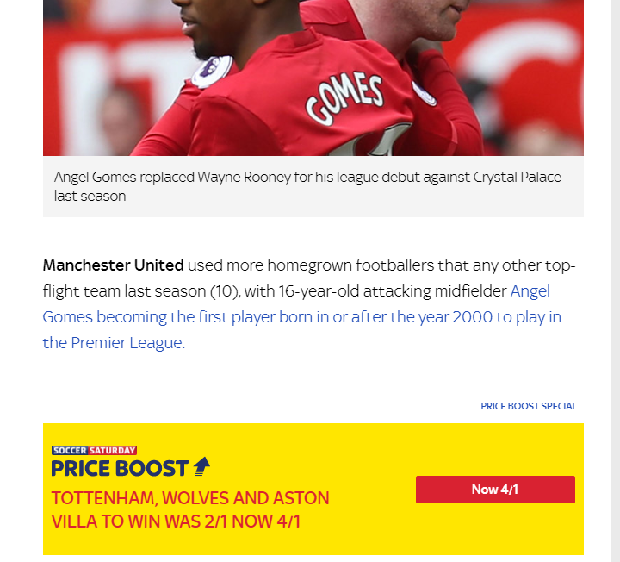

10 = Was the most used home-grown players in the Premier League last season. This was Manchester United.

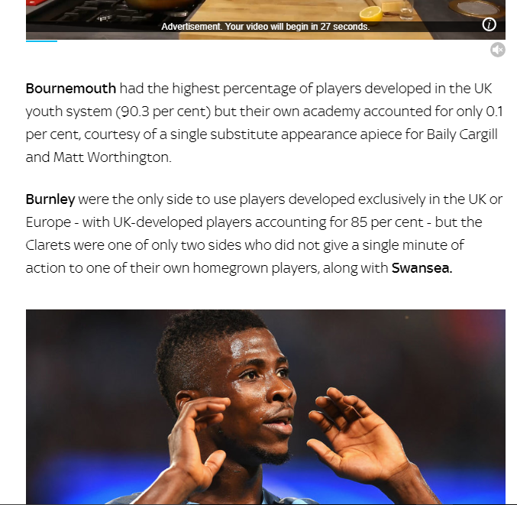

Burnley = Only team in the Premier League to use players developed within the UK and Europe. 85% of the development were British, however them and Swansea we’re the only Premier League team not to give a single minute to their home-grown players.

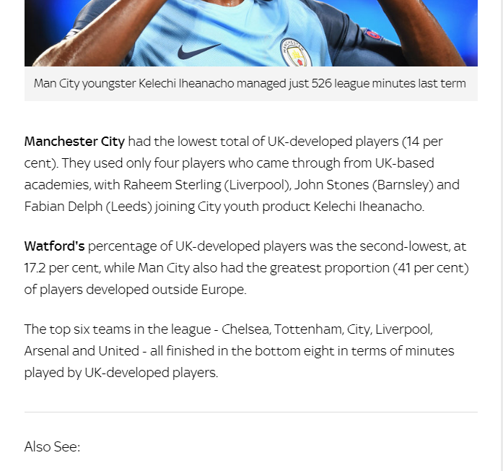

Manchester City = The have the lowest UK-development players in the Premier League. Only have 3 players in their first team starting 11.

REFERENCING

Source Type | In-text citation example | Bibliography Example
Website | Quotation: Rumsey, 2016. (Telegraph 2016) | 18th May 2016, Ben Rumsey, http://www.telegraph.co.uk/football/2016/05/18/fewer-englishmen-than-ever-on-show-in-premier-league/  Fewer Englishmen than ever on show in Premier League  ACCESSED BY 08/12/17
Website | Quotation: Ernst & Young LLP, 2015. (EY, 2015). | 11/15, Ernst & Young LLP. http://www.ey.com/Publication/vwLUAssets/EY_-_The_economic_impact_of_the_Premier_League/$FILE/EY-The-economic-impact-of-the-Premier-League.pdf  The economic impact of the Premier League  ACCESSED BY 08/12/17
Website | Quotation: Magowan, (BBC Sport, 2015) | 10th November 2015, Alistair Magowan. http://www.bbc.co.uk/sport/football/34767964  ACCESSED BY 08/12/17
Website | Quotation: Sterling, (Ionosphere, 2015) | 8th September 2015, Malcom Sterling. http://goonersphere.com/49-home/sterling-display/6308-how-has-foreign-investment-affected-the-beautiful-game  ACCESSED BY 08/12/17
Website | Quotation: Trepan, (Sky Sports, 2017). | 21st July 2017, Dev Trehan. http://www.skysports.com/football/news/11670/10955298/arsenal-top-charts-for-premier-league-minutes-given-to-homegrown-players  ACCESSED BY 08/12/17
Article | Quotation: Storey, (Football, place and migration, 2011). | 2011, D Storey.  Football, place and migration: foreign footballers in the FA Premier League. Geography, 96, pp. 86-84.  ACCESSED BY 08/12/17
Article | Quotation: Hesse, (Due to Brexit, Up To 100 Premier League Players Could Be Ineligible Next Season,2016) | 25 June 2016, Javier Hesse  Due to Brexit, Up To 100 Premier League Players Could Be Ineligible Next Season  Accessed by 08/12/17

