Alexandra Smith

1702583

Creative Research

M5XO1599

How image makers have utilized digital technology to explore the surveillance of the state.

Taken from the French word ‘surveiller’, meaning ‘to keep watch’, surveillance cameras have been used on police borders, to help war-time reconnaissance, overrule political enemies or simply to gain information on the state. From the earliest aerial photographs to satellite pictures surveillance techniques are closely linked to photography. Cameras on street corners, in shops and public buildings record our every move, while web-based technology like Google Earth use satellites to make sure there is no escape from the camera’s all-seeing eye. A famous quote by Benjamin Franklin "Those who would give up essential Liberty, to purchase a little temporary Safety, deserve neither Liberty nor Safety." (NPR,2015). This quote plays upon that if we give up liberty in favour of safety we essentially gain nothing. When people have liberty, they are not being controlled by the state, but this level of freedom may cause people to go out of control and accidently hurt others, but to be controlled for safety you lose your freedom of movement, freedom of choice, freedom of speech etc.

Johnathan Olleys “Castell of Ulster”

Firstly, I would like to discuss CCTV and its influence on photography. Johnathan Olleys work ‘castell of ulster 1981’ discusses the physical exposure of British army surveillance units in Northern Ireland before they were destroyed due to the good Friday agreement. The British army gave him permission to do so without telling him the building locations. If he happened to find them on his own he was allowed to photograph them, the work is supposed to draw attention to the constantly surveilling and monitoring of us. Thus, contrasting it by drawing the cameras back on them to highlight the level of unwilling “security” at that time before the evidence was eventually exterminated from existence due to the agreement and forgotten from history Fr. Martin Bowland (2010). The image below ‘crossmaglen ruc station and army barracks, south armach’ also known as the borucki sanger golf five zero named after James borucki who was blown up with a street bomb by the IRA in august 1976. Alleys work is trying to contrast what’s is known as the normal form of surveillance by flipping the cameras back on the watchers, he’s trying to make visible what is normal hidden from public view. The fact that the building itself is covered with a cage of mesh and CCTV shows it as a fully operational symbol that it is hated and feared by the local community. Olley describes these buildings as “being a politically invisible, part of the nonviolence resistance…”, in his photography he attempts to show the historically contingent and endow it with a significance beyond itself. Due to olleys artwork we were able to keep documented an important part of British history the would else of been lost. He shows a level of surveillance only imaginable that would have been destroyed and punches you in the face with it.

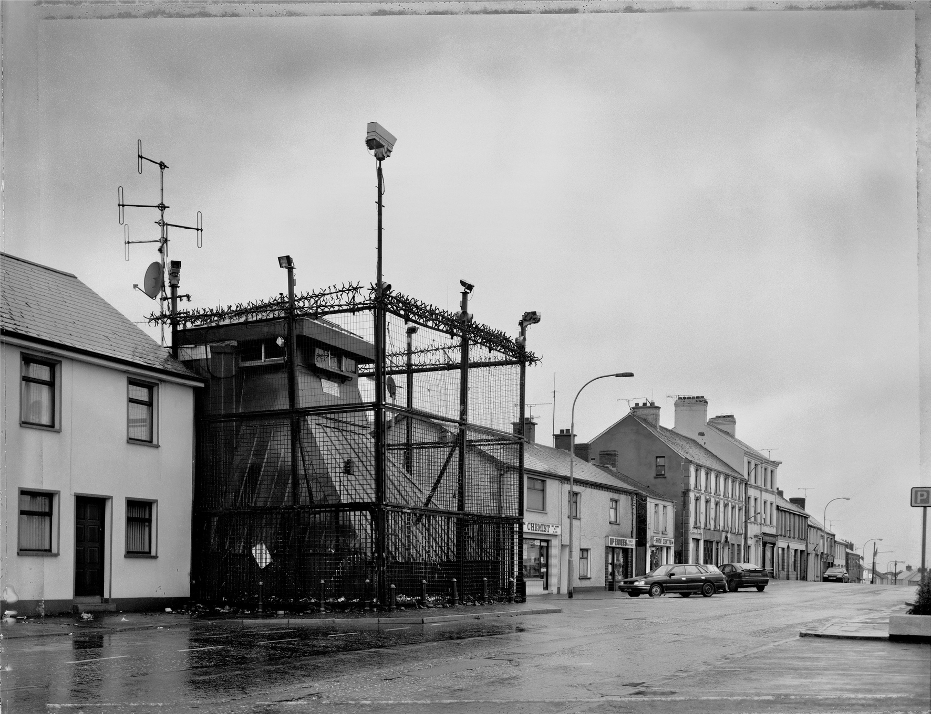
(Olley, 1999)

Trevor Paglen’s “Deep Web dive”

Paglens work is a set of photographs taken under the seas of Miami Florida, of the national security agency-tapped underwater internet cables below the Atlantic Ocean. He draws attention to the concerns of the physical struggles between reality and intangibles like privacy and network security. There are currently three hundred and forty-three of them active or under construction and they run half a million miles connected every continent except Antarctica, this I known as the most powerful surveillance means in the world. The images themselves are beautiful, powerful and equally disturbing Trevor Paglens deep web dive (Vice, 2016).
Paglen would call himself a landscape artist but his main goal is exposing the different forms of data collection unseen in our landscapes that are hidden from public view and are unknown about by the public. Paglen himself would not call himself an academic or journalist, he is not trying to make sense of the images he portrays. His ultraistic photographs ask the audience to initiate their own thoughts and conclusions and investigate furthers.
98% of the world data travels under our oceans, his work is beautiful yet creepy it takes surveillance and makes it very concrete, he shows places that are purely made just to gather your data. He destroys our false invisible perceptions on the internet created by the state such as the cloud, or cyber space and makes it something a lot more real, hard concrete buildings or copper pipes running under the world’s oceans. The NSA refers to these cables as choke points and they use them to tap into a huge amount of the world’s internet trafficking. This gives the state power to look at mass amounts of commercial data it allows the state to access everything from your Facebook searches to your google searches making them know more about you than your family does. The mass amount of internet use around the world but little understanding of it, Trevor’s work shows us insight into reality. People take thousands of photos a day of the beach or the ocean without the knowledge they are capturing a scene of mass surveillance. The cables themselves are very innocuous looking that’s what makes them so engaging they don’t look like anything. This being a true representation for what we consider the internet to be they are a physical representation of something we consider not to be a physical thing, like the hidden message behind an invisible door. Even if your privacy and surveillance isn’t a major concern to you in this very capitalist driven society the commercial cogitations of this may be of importance. The government spends more than 80 billion pound a year on surveillance just to remind us this is all very real and growing more everyday with new technologies and data being discovered as we speak. The internet is used as a tool to pray on and abuse those that use it giving google the power to initially decide our future.
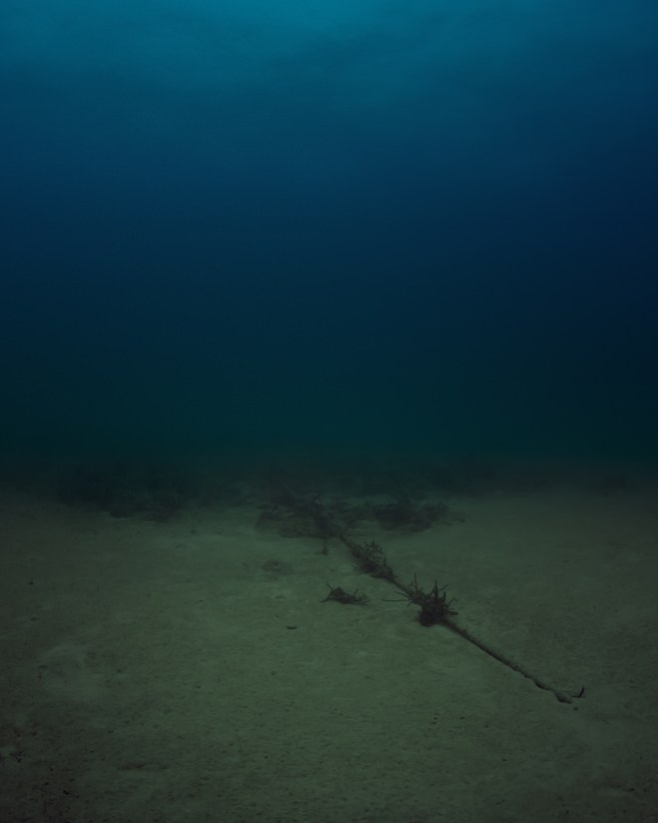

(Paglen, T. 2015)

Jill Magid “evidence locker”

Magid created this artwork with the help of the Liverpool cctv operation and its employees. The work was made over a month-long period and the art work itself is a mixture of video and email correspondence to make a “dream like diary”, the images themselves were staged and allowed Magid to act and record herself in ways that would not have been possible without the technology.
The main presumption of surveillance is that it turns us all into victims, instead of making us feel safe they turn us into potential suspects but by taking control of the cameras she’s allowing us as viewers to be the ones surveilling instead of being surveilled. Magid stated in an interview. “I could be embedded into the city’s memory for seven years; the city could be my stage; I could perform and be watched” (Magid, J. 2004) by this she means the personal relationship of it being herself interacting and being watched by the cameras allows her to become vulnerable to the system whilst still being in control of it. She excludes herself from the rest of the crowd to become center of attention, a position that scares some people away from surveillance and another that draws a desire towards it. She plays with the viewer allowing them to become the state, we observe her as they would observe us.
She used their facilitates as a mean of viewing herself in a way she has never before. She uses the system and technology as her mirror, who she sees in the reflection is unfamiliar to her and it not a true representation of her. The same way surveillance sees us as a state, she’s trying to show the world the different perspectives of yourself. The state can see and the stories that can be formed from this are example of the state’s ability to keep any action you do and hold it over you for 7 years. Whether it be a crime or not, the state dose not have any guidelines as to what is an offensive action they can decide at the time whether the action is offence and hold you accountable for it, Who’s to say what you will be held accountable for as a crime in the future.

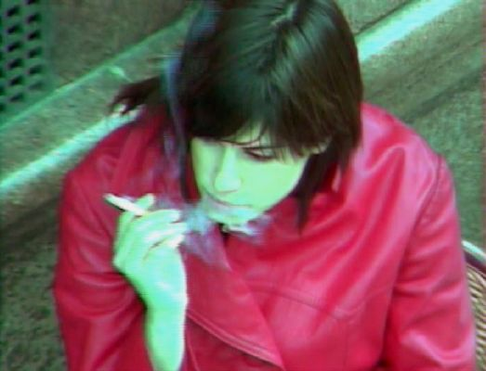

Evidence Locker (Surveillance in art, 2017)

Conclusion

Surveillance of the state is not a new phenomenon in fact its been around since 15th BC. Using census populations, we were able to be categorized and thus defined this has always proved a useful tool and it gives the state the power to appropriate taxation, divide land/ wealth and ultimately acknowledge which parts of the population could be used from military deployment. Ultimately surveillance can maintain the power of the state. (Lyndon, 1988)
The future of surveillance could become anything from miniature cameras inside insets/animals, drones, anything of any size that you will not even be aware of. There could possibly become a camera or a listening device to gather your information, your web cams, baby monitors, iPhone cameras could all become an access point to monitor you and gather information. Anyone could be watching you or taking pictures of you without your knowledge, your details will be become available to anyone, this is a danger to us stripping us of all our personal liberty’s. Commercial sales could potentially have the power access this data and know how much you earn, what you want to buy, what interests you etc., making you a much easier target. Hutson, M (2016) was a useful source of information.
Voice recognition software will evolve, and all aspects of our lives will be monitored, advances in voice recognition means no conversations will be unmonitored and we will have no privacy, key words during conversations will be triggers and used to further encroach on our privacy. Search engines such as google will breach our data to make more money and pass your personal data to commercial company’s making you easier to target. Assisted technology could possibly make our decisions for us in the future, taking away our rights and freedom leading us into decisions that we wouldn’t have necessarily made ourselves.

Bibliography

Bowland, F.M. (2010) ‘Castles of ulster’ The photos Johnathon Olley. (blog).13th June. Available at: http://theinvisibleprovince.blogspot.com/2010/06/castles-of-ulster-photos-of-jonathan.html (Accessed: 1st December).

Creators (2016) Trevor Paglen’s deep web dive HTTP://www.youtube.com/watch?v=h7guR5ei30Y (accessed:10th december2018)

Hutson, M.(2016) bugs will be bugged available at: https://www.theatlantic.com/magazine/archive/2016/11/even-bugs-will-be-bugged/501113/ (Accessed: 9th December 2018).

Lovlink, G (2004) Surveillance, Performance, Self-Surveillance Available at: http://www.evidencelocker.net/img/artistTalk.pdf Accessed: (5th December 2018)

Lyndon, D. (1988) The electronic eye. Oxford: Blackwell publishers.
NPR (2015) Benjamin Franklin’s famous/safety quote. Available at: https://www.npr.org/2015/03/02/390245038/ben-franklins-famous-liberty-safety-quote-lost-its-context-in-21st-century?t=1542376734190 (Accessed: 11 November 2018)

Olley. J. (1999) British army watchtower Available at https://fadmagazine.com/2010/06/13/review-exposed-voyeurism-surveillance-the-camera-by-ana-vukadin/golf-five-zero-borucki-sanger-british-army-watchtower-cross/ (Accessed: 14th November 2018)

Sohn, T. (2015)Trevor paglen plumbs the internet Available at: https://www.newyorker.com/tech/annals-of-technology/trevor-paglen-plumbs-the-internet-at-metro-pictures-gallery (Accessed on 4th December 2018).

Surveillance and Art (2017) evidence locker. Available at: https://sites.tufts.edu/surveillanceandart/2017/09/28/jill-magid-evidence-locker-2004/ (Accessed: 7th December 2018)

Vice (2016) Trevor Paglens Deep Web Dive. Available at: https://www.vice.com/en_uk/article/d74m8j/trevor-paglen-deep-web-dive-behind-the-scenes (Accessed: 5th December 2018).

