Contents Page:

Business Plan
Student Number: 2105630

- Section 1: Executive Summary 2
- Section 2: Operations 3
  - Supply Chain
  - Boot Collection
  - Logistics and Shipping
  - Inventory Management
- Section 3: Marketing 6
  - Marketing Mix
  - Customer Relations
  - Brand Image Promotion
- Section 4: The Market 8
  - Direct Competitors
  - Indirect Competitors
- Section 5: Finance 9
  - Sources of Funding

- Section 6: Sales 11
  - Financial Targets Year 1
    - Break Even Point
    - Cost
  - Cash Flow Statement
  - Profit and Loss Projections
- References 16

Section 1: Executive Summary
Mission
BootReNew strives to provide quality second-hand footwear at an affordable price. BootReNew believes every boot has a story, and every athlete should have the chance to write their story.
Company History and Management
BootReNew is a private limited company registered in Swansea and located in Uplands. The company is a startup founded by four individuals: Ian, Dylan, Sam, and Lewis. Each founder has a unique sporting history and discipline with over 50 years of experience in sport recreationally, and 20 years of professional sport collectively. Their continued professional development and heavy inclusion in the daily operations of BootReNew ensure the highest quality is delivered.
Products or services
BootReNew is a subscription-based platform for sports footwear that challenges contemporary markets' lack of adaptability for multi-sports consumers when purchasing footwear. BootReNew affords consumers the ability to interchange the design and size of a boot without the high-cost barrier of purchasing a new pair of sporting footwear.
The Market
Located in Swansea, a city known for its sporting pedigree, there is significant demand for sporting attire. Given the socioeconomic well-being of Swansea and its surrounding areas, BootReNew will accommodate a large proportion of the consumer population.
Competitive advantages
There are currently only two other competitors in the subscription-based market with two more indirect competitors as individual third-party retailers. Neither of the two direct competitors are within BootReNew’s region of operation. While potential consumers are high due to the sporting nature of Wales, and Swansea.
Financial Projections
Based on the size of the market, lack of direct competition, and operating area, BootReNew is forecasted to earn £18,000 in revenue the first year. By the fourth year BootReNew is forecasted to become entirely profitable.
Startup financing Requirements
To Launch, BootReNew needs £50,000 in capital. Between the four founding members, £20,000 has been invested with additional sources of finance being considered.
Section 2: Operations
The operations will follow a 3-step Operations etiquette:
1. Boot Collection/Sourcing
2. Logistics and Shipping
3. Inventory Management
Following these three steps will help build a stable and functioning supply chain for the start-up to continuously grow and keep track of the growing process and consistency. Powell, C. and Burgess, J. (2021) estimated that 1 in 12 people are employed within the logistics industry seen as it’s a fast growing industry with the world taking a step forward in technology, with everything turning to e-commerce and burst into the omnichannel fulfilment. With this being said, the operations is a crucial part in order for the business to even function properly and become successful, and with proof that for future references, this section within the business might be easier to find possible staff depending on the success and growth of the firm.

2.1 Supply Chain:
As the start-up will have a limited budget and not much staff, with a smaller quantity of stock at first, as mentioned within the Business Pitch, one warehouse will be rented with a fair amount of space to satisfy the space needed for a possible amount of 2,000 boots in case the sourcing goes better than expected. Seen as the market will be Swansea based, so will the warehouse, ultimately near a passage to the M4 and the train station, as Powell, C. and Burgess, J. (2021) mention, the accessibility and costs of the supply chain will be more gaining for the company the closer the warehouse is to the market that is targeted. If the company grows to a UK National, the Midlands is expected to be the most accessible within the Supply Chain as 90% of the population in England and Wales can be targeted who are circumference within 4 hours (Powell, C. and Burgess, J. 2021).
Making sure possible accessibility landmarks (e.g. motorways, railways) are in the area is crucial to reduce the logistics journey and helps improve the chemistry of possible distributors (Powell, C. Burgess, J. 2021). For smaller companies this is crucial as it will help reduce any costs and make it easier to make relations with larger companies Rolls Royce (2019), one of the largest and most successful Luxury Automobile manufacturers use a model which follows:
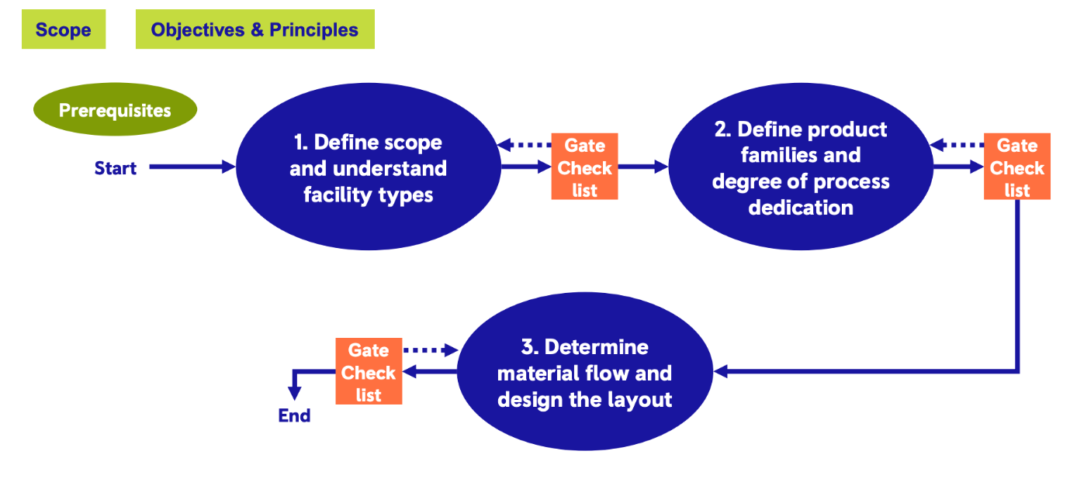

In the case of BootRenew, some aspects will need to be adapted seen as the operations will differ from a car manufacturing company, however, it’s a good base to figure what to focus on and who to target. The target audience that BootRenew is tending to target is families with younger children who are football enthusiasts. A future goal for the firm would be to start a family bundle, providing a deal with a larger number of players who are prepared to exchange the boots monthly.

2.2 Boot Collection:
The company will be sourcing high-quality second-hand boots in all sizes in from people who haven’t worn them too much or have grown out their boots faster than expected, which is where BootRenew enters the scene and plays a larger role in “recycling” the boots by cleaning them and fixing them up by sending them to the next subscriber. Partnerships with larger distributors will be a target to hit as it will mean that the available stock will be higher for the company and the quality of the boots will improved. Larger distributors tend to be American imported football boot distributors such as Football America UK LTD located in Leicester or Soccer Supplier who are based in London. Growing a partnership will grow the customer satisfaction due to better quality boots being provided to the customers and a larger stock variety with more sizes and colourways etc. Once the boots are stored within the warehouse, a thorough service will be done to the boots. This includes a deep clean with the help of washing machines and some by hand to increase the speed of the process, when being a new subscriber, a personal in-sole will be sent over to swap in-out of each pair of boots the customer receives to prevent any false ankle movements and to preserve the heals of the subscribers. Once we receive a pair of broken boots, depending on the state of the shoes, they will either be repaired or just thrown away and a new pair will be sourced. Every boot will be put through a final safety check before they are sent out to reduce the rate of unsatisfied customers.

2.3 Logistics and Shipping:
As stated in 1.2, being located near an accessibility landmark will help the shipping and logistics procedure to reduce costs, time and improve the relations with possible distributors. The return policy will allow for every subscriber to have a total of 4 boots per year that are included within the price, giving space for one free return. If anymore returns are required, these will come with an extra cost of £20 to cover the shipping costs and extra labour work. On the website, the subscribers will have to enter their details and preferences that are needed in order for them to receive the perfect boots for them. After the details are put through the system, it will be categorised through the functional label printing process within the warehouse (Powell, C. and Burgess, J. 2021). This will include the process for receiving and shipping the boots (Powell, C. and Burgess, J. 2021). Each label will be sent with the boots and will have to be returned with the boots to keep track of the orders; however, the orders will still be stored under the name and address of the subscribers.

2.4 Inventory Management:
When it comes to the inventory management, the space that Boot-Renew will have will be very limited, whilst having to store a minimum of 1,000 boots. Therefore, the boots will be palleted and stacked in order to save space and keep the working environment tidy. However, the boots will be stored in a manner where it’s easy to pick out the necessary boots for the upcoming orders. Each boot box will have an image and the boot information (i.e. size, colour, brand…) to make it an easy and quick process of picking out the boots from the storage. Every boot will be stored on the system with a marking system, providing the information whether the boot is already being utilised or if it’s in the storage unit.
Once each boot returns from a shipment, they will be analysed and will have 3 measurements of the condition, “fairly used, damaged, unrepairable”:
Fairly used means they only need a clean-up.
Damaged is a visible and repairable state which can be sorted out by the company.
Unrepairable is when the boot is in a state in which they should just be recycled.
With the whole software, it means hardware such as label printing machines and scanners are needed to scan the boots on to the system.

Section 3: Marketing
The marketing mix, represented by the 4Ps or extended to the 7Ps, provides a comprehensive framework for creating and developing marketing strategies for any business. Each element of the 7Ps is crucial when shaping the overall marketing strategy for a business (Hanlon, 2023). It is to ensure that the products or Servies correctly meet the needs or wants of the consumers while also being able to effectively achieve the businesses objectives and goals.

3.1 BootReNew’s Marketing Mix:

3.1.1 Product:
BootReNew will offer a variety of branded and high-quality second-hand football boots. Despite being secondhand boots, BootReNew will ensure the boots are thoroughly cleaned, sanitized, and in good condition. This will be to ensure there are no unhappy customers leaving any negative reviews, as possible negative reviews could result in less demand for our product. (Heyes and Kapur, 2012)
3.1.2 Price:
BootReNew will offer a £10 per month subscription-based model with the customer being able to get up to 5 new pairs of boots within a single year. As BootRenew grows as a business, there will be discounts for yearly subscriptions and loyalty offers for some of our customers that have been with BootReNew from the start. The discounts will offer the customer the chance for cheaper products and make them feel valued by the business (Paul, Bhuva and Acharya, 2020). This will also benefit the business as there will be improved cashflow and more possibilities of returning customers.
3.1.3 Place:
BootReNew will establish an online platform for easy subscription purchase and management (Taher, 2021). The easier the process to subscribe will result in more purchases as a streamlined process gives the consumer less time to change their mind but the ease in purchase will also result in happier customers. BootReNew will also look to consider partnering with local sports retailers, football clubs, or community centers to provide physical drop-off and pick-up points for local subscribers. This makes the services more accessible to more members of the public who may not like to shop online (Gibbs and Humphries, 2010).
3.1.4 Promotion:
BootReNew will also look to leverage social media platforms such as Instagram and TikTok to showcase the potential boots available and engage with our audience, encouraging our consumers to make videos of their purchases to reach more potential consumers (Tuten, 2024). Brand awareness is key in building a strong customer base as the more people aware of the brand would lead to more sales and being talked about through friendship groups, as an example leading to more potential consumers (Barreda et al, 2015). BootReNew will do this by creating unique engaging content which is likely to be shared through the social media apps providing a further reach for the brand.
BootReNew will also produce marketing content through blogs, videos, and tutorials on the importance and benefits of sustainable football boots and how we can all do our bit to ensure no boot goes to waste. BootReNew has the goal to ensure that alongside trying to grow the brand, BootReNew are also promoting the key message to ensure the world looks to a more sustainable future (Thomson, 2016).
3.1.5 People:
All staff at BootReNew will look forward to completing any available courses on how to assist subscribers and address any inquiries promptly. BootReNew will also ensure any future staff in the long term are thoroughly trained to continue offering the best service possible. As a business BootReNew wants to ensure that our customers receive the best possible service in a timely manner whether that being at one of our events, through email or our social media platforms (Sidorko and Woo, 2008).
BootReNew will also look to foster a community around our brand, encouraging subscribers to share their experiences and engage with each other through forums or social media (Humphrey, Laverie and Rinaldo, 2016). This community will be key in pushing our brand message and vision of sustainability with no boot unnecessarily going to waste.
3.1.6 Process:
One focus at BootReNew will be to streamline the ordering and subscription process for a user-friendly experience by ensuring we send out prepaid return labels for every order so there is no issues with the consumer returning the boots to ourselves. Being able to provide these return labels would result in less boots not being returned, which will have the business time in trying to change the consumers or dish out any fines which may lead to a negative look for our brand.
BootReNew will also clearly communicate the cleaning and sanitization process to assure customers of the quality and hygiene of the products. This message will be key in the initial startup of our subscription service as some potential consumer may be put off by the thought of secondhand boots, however if we ensure we encourage the population to live more sustainable our service will become more appealing (Borusiak, et al, 2020).
3.1.7 Physical Evidence:
BootReNew have developed a distinctive branding to establish a strong visual identity by incorporating the recycling theme within our slogan which will be a key part of BootReNew’s branding (Thomson, 2016). BootReNew is also launching an Instagram page where we can share our promotional material and share our brand message to be more sustainable.
3.2 Customer Relations
As a business we ensure that any customer data we have is safe to give our consumer peace of mind. Mishandling customer data could also lead to breaches, damage to reputation or even legal consequences (Henze, et al, 2013). BootReNew has put in place some key points to how we will maintain the trust of our consumers and protect their privacy.
The points are as followed:
- Customer information will be stored via a database following each order so we can find any contact details if there are any issues with any order.
- We will only collect and store the necessary data
- There will be 2 step authentications set up to access any of this data to prioritise safety for our consumers data
- To manage customer satisfaction, we will create a feedback form where we will ensure any negative feedback is responded to. This will also be the case for any social media feedback we receive, ensuring we are an open brand who engage with our consumers.

Section 4: The Market
Competitor analysis is a key aspect to running a successful business, it’s important to know the market you are entering. We spent time studying our competitors and understood the market we were entering. Upon studying the market, we identified 4 competitors. Our two direct competitors are Boot Move and Foot Source they operate very similarly to us. Boot move are our most challenging competitors with their price as low as £4.99 increasing to £9.99 after that first month and with our price sitting at pretty much the same price this creates a real challenge for us so we needed to provide more benefits for our customers so customers would choice our subscription service.
4.1 Direct Competitors:
We identified Foot Source as a direct competitor. We could clearly notice a massive gap in the price point of both of our services with Foot source being more of a premium product in oppose to a more family oriented and affordable service like our own. Being the more affordable product doesn't always benefit us as many aspiring footballers want the best flashy boots that their favourite players are wearing which we can always promising which is why Foot Source does present us with a challenge.
4.2 Indirect Competitors:
When analysing our competitors we must look at indirect competitors too, the two main ones we discovered were Fat Llama and Carousell. Fat Llama adopt a different model to us with a peer-to-peer business model where consumers buy and sell through their platform, and they take a certain amount of the profit made through seller's fees. Carousell also adopt the peer-to-peer business model but sell more than just football boots with other products also available which doesn't make them massive competitors but a company to monitor with the possibility of a big scale of the business which could see more people using a peer-to-peer platform in oppose to ours.
We decided to create a subscription service the reason behind this was that it made us similar to our competitors. All of our competitors use a simple direct to consumer model where you buy a pair of reusable boots for cheaper price which is similar to use but we changed the model so that we could provide a subscription service where customers could receive several pairs a year this was our main USP and provides us with stable revenue throughout the year and almost gives our competitors something to think about as we go an distribute the market with this subscription model.
As a business just starting their journey it's difficult to consider ourselves to massive organisations but companies such as sports direct must be considered as competitors due to the fact we are distrubiting their market as they are the top sales of football boots, and we are trying to change the way in which people buy and reuse their football boots. By introducing a business like this and with plans to scale this to a global level we would expect competitors like Sports Direct to react to this.

Section 5: Finance
5.1 Sources Of Finance:
There are four sources of finance BootReNew has considered: personal savings, investment, loans, grants, and promotional events. Altogether these sources of finance are catered specifically to BootReNew’s strengths and weaknesses.

5.1.1 Personal savings:
The personal savings of BootReNew’s founding members serve as the base to kick-start the start-up, with a total of £10,000 of money currently available. Additional funds that would be categorised as ‘personal savings’ include any financial means given by family and friends.
Personal savings are a great way to start a budding business as it does not require any interest to be paid, nor the lengthy wait for paperwork associated with alternative means of finance (Masterman, 2015). However, personal savings potentially hold great risk. The funds are coming from individuals and close relations. Should the venture fail, there is no recourse to repay the parties involved. Not only can this strain the relationships of those around you, but a failed venture can also negatively impact all parties financially.

5.1.2 Investments:
Angel investors and angel groups are one form of investment available to BootReNew. Cremades (2019) supports BootReNew’s understanding that angel investors allow for larger sums of money to start-ups. In return for the large sum of money upfront, angel investors are given a percentage of the business. Angel groups are multiple angel investors that pool together to create a package for the start-up (Cremades, 2019). Currently, BootReNew is accounting for £20,000 in exchange for 25% of the business.
The benefit of angel investors, and by extension angel groups, is the large up-front finance. Most commonly, the large up-front finance is used to procure critical components for business operations. For BootReNew, the critical business operations needed for investment include warehouse procurement, product acquisition, and market share. This investment doesn’t need to be paid back, which makes it an attractive form of finance for BootReNew.
The downside to utilising angel investors overall includes loosing control of the direction the business heads in. If an angel group procures to much of a business, then the original owners will need to consult and get approval from any shareholders. It is common for angel investors to receive a large portion of the business especially when the upfront cost is a large sum of money. This aspect of angel investment makes BootReNew sceptical of utilising this form of finance. Too benefit the most without jeopardising the businesses future position, BootReNew will make bids with relatively low up-front finance in exchange for minimal business ownership. Additionally, to cover any additional costs not identified, BootReNew will look for additional angel investors, with the maximum amount of business acquisition being capped at 40%.

5.1.3 Loans and Grants:
Loans and Grants share several similarities in terms of benefits and limitations. Business Wales (2024) highlights the opportunities for local businesses through grants, loans, and various similar schemes with the Barrier to Start-up Grant Over 25s and Start Up Loan Wales being two grants that BootReNew will aim to receive. Both grants focus on alleviating the barriers that most start-ups experience. However, the grants will not fully cover initial expenditure and the competition to receive these grants is fierce, accordingly, BootReNew must not rely on grants.
Rather than grants, bank loans are more beneficial for the financial status of BootReNew. The company is forecasted to be profitable per annum halfway through year 2, breaking even at the beginning of year 4. With a comparably short period to becoming profitable, bank loans offer secure, upfront financial support without having to cede control of the business or a portion of profits (Business Wales, 2024). Currently BootReNew is exploring the financial implications of a 10 year loan of £10,000 with a fixed interest rate of 12%. Negotiating the interest rate is of upmost importance to BootReNew. Acquiring an interest free loan for the first three years of operations allows for BootReNew to grow and maintain a community while maintaining positive cash flow. While not unprecedented, a three year interest free clause is uncommon. To overcome and ensure financing, BootReNew are willing to negotiate the interest rate up to 20% per annum.

5.1.4 Promotional Events:
Promotional events have been attributed to expanding brand image and generating profit (Masterman, 2014). Utilising promotional events, BootReNew is looking to expand it’s community of subscribers while turning a profit. The aim is to produce 2-3 large-scale events each with a budget of £3k. At these events, interactive activities, food, beverages, and other incentives to foster interactions with the community. Each event should aim for a 15% profit from on-the-day expendables, food, and beverages. Additionally, 3-4 smaller scale events will be organised throughout the year, engaging in local schools, football clubs, and charity shops. Little expenditure is expected for the smaller events with no identifiable profit being recognised.

Section 6: Sales
6.1 Financial Targets – Year 1:
Goals:
  - £1k profit off each promotional event
  - Acquire 1,000 pairs of football boots
  - Break-even
6.1.1 Break-even point = 506 annual subscriptions
  - Assuming all trades utilised for every membership
  - Fixed cost- £40,000
  - Price per unit- £120
  - Variable cost per unit - £41
    - Cost of cleaning, delivery, and insurance

6.1.2 Cost Summary:
 | Cost | Revenue
Warehouse with utilities (yearly) | £15,000
Boot acquisition | £10,000
Promotional Events & Marketing | £15,000
Loan Repayments | £1,000
Delivery (per boot) | £7
Cleaning (per 10 pairs) | £2
Subscription  (per year) |  | £120
Insurance  On boots | £1

6.2 Profit and Loss Projections
- First year goals – 150 annual subscriptions
Costs – fixed £40,000 + variable £6,150
Revenue - £18,000
Loss of £28,150 for year one
As a business we will make a loss in year one of £28,150. However, this is due to needing to purchase all the boots pre-start-up, alongside spending on a large brand and product launch.

- Second year goals – 300 annual subscriptions
Costs – fixed £25,000 + variable £9,300
Revenue - £36,000
Profit of £1,700
In our second year of operating our fixed costs will be £15,000 less as we do not need to purchase as many boots. Also, there will be less spent on promotion as our brand and product launch were a large part of the first-year budget. Furthermore, the variable cost will be less and there will be more efficient cleaning and deliver of the boots resulting in less cost per boot.

- Third year – 500 annual subscriptions
Costs – fixed £25,000 + variable £11,750
Revenue - £60,000
Profit of £23,250 end of year 3
In our third year of operating our fixed costs should remain the same. However, our sales are projected to grow further. This growth in sales will result in the business being able to utilize economies of scale to reduce the cost of delivery further working in partnership with delivery companies. This reduction in delivery costs will dramatically reduce the variable cost per unit resulting in a higher profit margin.

Finally, after 3 years we will be at a loss of £3,200 meaning that from year 4 we will look to be a completely profitable business as we will further grow sales while also working smarter to reduce our business costs.

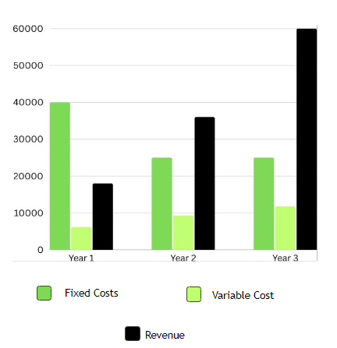
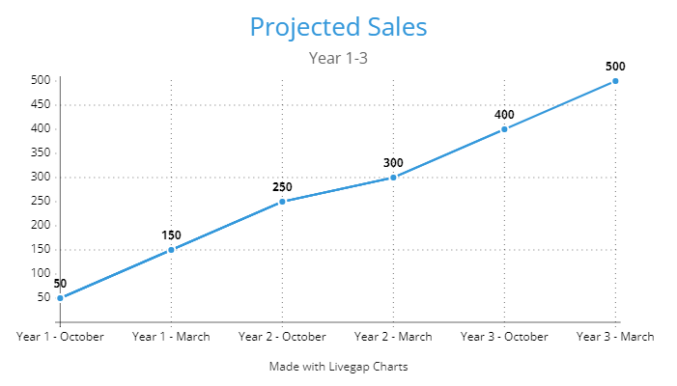

6.3 Cashflow

Loan – 10,000 – Interest free for 3 years then 12% fixed interest – annual repayments for 10 years
Warehouse and Utill - £1,250
1000 flyers £200
Major event in May and August
Smaller planned event December (buying as priority)
Subscriptions start in September small
Hit 150 by end of year cashflow
Projected sales graph

Reference list:
(2024a) Carousell. Available at: https://design-positive.com/carousell (Accessed: 01 March 2024).
(2024b) Fat Llama. Fat Llama. Available at: https://fatllama.com/uk/i/hire-test-item-for-testing-70486785 (Accessed: 29 February 2024).
(2024c) Footsource Facebook. Available at: https://m.facebook.com/people/FootSource/100063532388340/?locale=hi_IN (Accessed: 27 February 2024).
(2024d) Bootmove. Available at: https://bootmove.com/ (Accessed: 27 February 2024).
Barreda, A.A. et al. (2015) ‘Generating brand awareness in online social networks’, Computers in Human Behavior, 50, pp. 600–609. doi:10.1016/j.chb.2015.03.023.
Barriers to start-up grant for 25-year-olds and over (2024) Business Wales. Available at: https://businesswales.gov.wales/barriers-start-grant-25-year-olds-and-over#:~:text=A%20grant%20of%20up%20to,you%20and%20your%20business%20proposal. (Accessed: 26 February 2024).
Batat, W. (2022) “Why is the traditional marketing mix dead? Towards the ‘experiential marketing mix’ (7E), a strategic framework for business experience design in the phygital age,” Journal of strategic marketing, ahead-of-print(ahead-of-print), pp. 1–13. Available at: https://doi.org/10.1080/0965254X.2022.2129745.
Borusiak, B. et al. (2020) ‘Towards building sustainable consumption: A study of second-hand buying intentions’, Sustainability, 12(3), p. 875. doi:10.3390/su12030875.
Business Angels (2024) Business Wales. Available at: https://businesswales.gov.wales/businessfinance/types-finance-and-how-apply/business-angels (Accessed: 28 February 2024).
Cambridge Dictionary (2024). STAKEHOLDER | meaning in the Cambridge English Dictionary. [online] Cambridge.org.
Cremades, A. (2019) 8 types of investors for startups, Forbes. Available at: https://www.forbes.com/sites/alejandrocremades/2019/01/02/8-types-of-investors-for-startups/?sh=75beec264a3e (Accessed: 28 February 2024).
Gibbs, R. and Humphries, A. (2010) Strategic Alliances & Marketing Partnerships: Gaining competitive advantage through collaboration and partnering. London: Kogan Page.
Grants (2024) Business Wales. Available at: https://businesswales.gov.wales/businessfinance/types-finance-and-how-apply/grants (Accessed: 29 February 2024).
Hanlon, A. (2023) What is the marketing mix? London: Henry Stewart Talks Ltd.
Henze, M. et al. (2013) ‘Towards data handling requirements-aware cloud computing’, 2013 IEEE 5th International Conference on Cloud Computing Technology and Science [Preprint]. doi:10.1109/cloudcom.2013.145.
Heyes, A. and Kapur, S. (2012) ‘Angry customers, E-word-of-mouth and incentives for quality provision’, Journal of Economic Behavior &amp; Organization, 84(3), pp. 813–828. doi:10.1016/j.jebo.2012.10.002.
How long do startups take to become profitable? (2024) NineTwoThree 2023. Available at: https://www.ninetwothree.co/blog/how-long-do-startups-take-to-become-profitable#:~:text=The%20average%20successful%20startup%20takes,high%20expenses%20and%20low%20revenues. (Accessed: 29 February 2024).
How long does it take a business to be profitable? A guide (2023) FreshBooks. Available at: https://www.freshbooks.com/hub/startup/how-long-does-it-take-business-to-be-profitable (Accessed: 28 February 2024).
Humphrey, W.F., Laverie, D.A. and Rinaldo, S.B. (2016) Fostering brand community through social media. New York, NY: Business Expert Press.
Hunt & Thorne (2024) Ground Floor Office Suite , Ground Floor Office Suite. Available at: https://lc.zoocdn.com/c54b16c23be9627f0a262df6915c92e714f73f76.pdf (Accessed: 01 March 2024).
Leadley, C. (2023) Break-even analysis – what it is and how to calculate it, Forbes Burton. Available at: https://www.forbesburton.com/insights/break-even-analysis-what-it-is-and-how-to-calculate-it (Accessed: 29 February 2024).
Miele (2024) The Little Giants from Miele, The Little Giants from Miele | Miele Professional. Available at: https://www.miele.co.uk/p/the-new-little-giants-4921.htm?gad_source=1&gclid=Cj0KCQiA84CvBhCaARIsAMkAvkKr0jUMVVBFP5boS9SoFnWneT4Gh7B3jzo8ardFlR7Xl435y6285OYaAr0KEALw_wcB (Accessed: 01 March 2024).
Paul, S., Bhuva, K. and Acharya, S. (2020) ‘Providing loyalty discounts to customers in retail stores’, TRANS Asian Journal of Marketing &amp; Management Research (TAJMMR), 9(1), p. 16. doi:10.5958/2279-0667.2020.00002.4.
Piva, E., Cerutti, S., Prats, L. and Raj, R., 2017. Enhancing brand image through events and cultural festivals: The perspective of the Stresa Festival’s visitors. AlmaTourism, 8(15), pp.99-116.
Sidorko, P.E. and Woo, E. (2008) ‘Enhancing the user experience’, Library Management, 29(8/9), pp. 641–656. doi:10.1108/01435120810917279.
Taher, G. (2021) ‘E-commerce: Advantages and limitations’, International Journal of Academic Research in Accounting, Finance and Management Sciences, 11(1). doi:10.6007/ijarafms/v11-i1/8987.
Thomas, S. (2024) 63-64 Oxford St, Swansea SA1 3JA - industrial for rent: Loopnet UK, LoopNet. Available at: https://www.loopnet.co.uk/Listing/63-64-Oxford-St-Swansea/29798696/ (Accessed: 01 March 2024).
Thomson, D.M.H. (2016) ‘Sensory branding’, Multisensory Flavor Perception, pp. 313–336. doi:10.1016/b978-0-08-100350-3.00016-x.
Tuten, T.L. (2024) Social Media Marketing. Los Angeles: SAGE.

