

The Measurement of Impact Forces Relating to Medial Tibial Stress Syndrome (MTSS) in Sport

By
John Nigel James
1603327

Supervisor: Dr Stephen Mosey
Second Marker: Dr Gary Jones

Project submitted as part of the requirements for the award of
BEng (Hons) Electrical and Electronic Engineering

April 2022

DECLARATION

I, .....................................John Nigel James………………………………… declare that I am the sole author of this Project; that all references cited have been consulted; that I have conducted all work of which this is a record, and that the finished work lies within the prescribed word limits.

This work has not previously been accepted as part of any other degree submission.

Date : .................28th April 2022.....................

FORM OF CONSENT

I .................................John Nigel James………………………………… hereby consent that my Project, submitted in candidature for the BEng (Hons) Electrical and Electronic Engineering degree, if successful, may be made available for inter-library loan or photocopying (subject to the law of copyright), and that the title and abstract may be made available to outside organisations.

Date : ................28th April 2022..................

Acknowledgements

Throughout the process of writing this report I have received a great deal of support and assistance. It would be unkind of me to not acknowledge these individuals, without whose assistance I would have invariably struggled!

I would firstly like to thank my Project Supervisor Dr Stephen Mosey for his initial guidance and common-sense advice as to the approach I should take to formulate a plan.

I would like to acknowledge and thank Dr Gary Jones for his guidance, for sharing his vast knowledge and experience, and for his unconditional commitment throughout.

I would also like to acknowledge my course colleagues, Jacob Williams, Gareth Jones, Luke Anderson and Josh Hunt for their support and encouragement.

In addition, I would like to thank my family. Michele for her patience and understanding during the whole journey. Ceri for my inspiration and Elin for my motivation.

Finally thank you to my best friends Andy and Laura for providing a welcome and happy distraction and keeping me grounded.

Abstract

The adaptation of a design idea to develop a device capable of detecting and storing the number of impacts above a set threshold, experienced by an athlete during exercise and enabling the transfer of the raw data captured to an external device for further analysis and use in the prevention of Medial Tibial Stress Syndrome (MTSS).

Medial Tibial Stress Syndrome, more commonly known as shin splints, is a common condition which can be experienced by anyone who engages in an exercise involving repetitive actions i.e., running. It can affect people at any level from novice jogger to elite athlete. The effect of chronic cases of MTSS on elite athletes can result in extended periods in recovery, up to 43 weeks in some cases. [1] This can mean absence from training and potentially missing competition. Current methods of impact measurement in sport are limited to Rugby, American Football, Ice Hockey, and Soccer, and is mainly focussed on head impact measurement and its contribution to concussion.

The aim of this report is to evaluate the process of developing an initial idea into a proven physical prototype, which would have the potential to be passed forward for further development into a device suitable for production. The report includes a review of current systems and devices used for the detection and recording of impact in various sporting environments, the potential cross over of technology as well as the adaptation of ideas to fit the design requirement. The design development includes research, identification, and selection of suitable devices, including a microprocessor, based on the requirements identified in the concept development stage. Circuit design using Proteus design software, microprocessor coding in C language using CCS Compiler. Testing, evaluation, and prototyping in order to prove concept.

The rationale behind the project is the desire to further develop a concept by the authors’ daughter in a paper submitted as part of a BSc in Mathematics and Sports Science. The paper included the idea for a device comprising of multiple force sensors incorporated into an insole, each sensor allowing multiple measurements of each impact. The sensors would convert the applied force and weight into a quantifiable output which would be communicated to an app via Bluetooth [2].

Any system which can aid in the development of strategies by providing data to enable modification of training routines or physicality to prevent cases of MTSS would be of huge significance in the prevention of this type of sport associated injury.

Introduction 6
Project Planning 7
Research 9
Research Methodology 9
The Layers 10
Research Philosophy 10
Research Approach 10
Research Strategies 10
Research Methodology Choice 11
Time Horizon 11
Data Collection 11
Background Research 12
Medical Background 13
Rest and recovery 14
Prevention 14
Impact Forces 15
Feasibility 17
The Device Requirements 17
The Design Requirements 18
Accelerometers 21
Microcontroller 22
Power Supply 25
Design and Implementation 27
Programming 32
Coding 32
Functions 34
Component Costing (Simulation build only) 38
Build 38
Evaluation 40
Testing – Proteus Simulation 40
Test 1 – Baseline Test 40
Test 2 – Simulated Data Input 41
Test 3 – Dump Data Test 42
Results and Analysis – Proteus Simulation 43
Testing – Test bench Build 44
Test 1 – Channel X 44
Test 2 – Channel X and Y 45
Test 3 – Channel X and Z 45
Test 4 – Data Dump 46
Results and Analysis – Test bench Build 46
Conclusion and Improvements 47
Reflection 51
References 54

Figure 1 Saunders Research Onion 10
Figure 2 – Location of Pain Experienced Through MTSS 11
Figure 3 - Prevent Biometrics Impact Measuring Mouthguard (IMM) 13
Figure 4 Schematic Representation of Ground Reaction Force [10] 14
Figure 5 - Schematic Representation of GRF Horizontal Force 14
Figure 6 - Five small pressure sensors superimposed onto a human finger. 18
Figure 7 - MEMS Capacitive Accelerometer 19
Figure 8 PIC18F25K50 21
Figure 9 PIC18F25K50 Pinout 21
Figure 10 PIC 18F2550 22
Figure 11 PIC 18F2550 Pinout 22
Figure 12 - Component Power Ratings 23
Figure 13 Voltage Regulator 24
Figure 14 PIC18F25K50 25
Figure 15 Voltage Regulation 26
Figure 16 Accelerometer Output Simulation Network 26
Figure 17 Dump Instruction Simulation 27
Figure 18 Noise Elimination Network 27
Figure 19 Final Circuit Schematic 28
Figure 20 Operational Flow Diagram 29

Table 1 - Project Deadlines 6
Table 2 - Project Milestones 7
Table 3 GRF Vertical Parameters 14
Table 4 GRF Horizontal Parameters 15
Table 5 Power Supply Comparison 24
Table 6 CCS Compiler PIC Parameters 28

Annex A Gantt Chart Original
Annex B Gantt Chart Amendment 1
Annex C Gantt Chart Final
Annex D PIC18F25K50 Data Sheet
Annex E PIC18F2550 Data Sheet
Annex F RS Pro 3.7V Li Po Data Sheet

Introduction

Medial Tibial Stress Syndrome (MTSS), commonly known as shin splints, is a medical condition affecting the tibia in the lower leg. It is a common injury amongst participants in a wide range of sports but is more prevalent in those involved in jumping and/or running for extended periods. E.g., athletics, long distance running and basketball. Around 13% – 20% of runners are affected putting MTSS ahead of other common sports injuries such as Plantar Fasciitis (4% - 10%) or Achilles Tendinopathy (9% – 11%) [3]

MTSS is caused by excessive loading and/or overuse. This is particularly apparent where the rate of loading has been increased too rapidly, due to overtraining or competition, thus not allowing sufficient time for the development of muscle and bone strength to a level where they are able to cope with the absorption of the increase in impact forces.

Once diagnosed, the treatment and subsequent recovery from MTSS is a lengthy process which often necessitates the athlete to abstain from all exercise and training until a full recovery is made. A study of a group with MTSS found that 90% of the group took between 35 to 43 weeks to recover sufficiently to complete an 18-minute run (2). Clearly this means that athletes would have to take an enforced break from all exercise whilst in recovery. This would disrupt training schedules and delay or even prevent participation in competition.

The objective of this paper is to research current methods of measuring impact forces in sport and applying those principles to designing a device which can capture and store data representing the forces involved which contribute to the cause of injury. The device must also be capable of downloading this raw data for further analysis and use in the development of strategies to prevent and treat MTSS.
This will be achieved by carrying out research to identify the type and magnitude of forces involved during sporting activities, paying particular attention to those activities which tend to have a higher incidence of MTSS, in this case athletic track events. This information will then be used to ascertain the type and number of sensors required, their positioning and to set thresholds and ranges for the proposed measuring systems. It is intended to design and write code for microprocessor control of the process of acquiring, storing, and downloading the raw data. The circuit will be designed and along with the code, simulated and tested before building a prototype device. The physical system will be tested and evaluated. A final summary of the design process and resulting product will be carried out and any recommendations for improvement made.

Although the analysis is out of the scope of this project, it is hoped that the information collected would lead to the following:
- Reduction in the incidence of MTSS by monitoring the forces during training and competition and adjusting training intensity in accordance with the results.
- Reduction in pain experienced by the athlete due to MTSS.
- Reduction in time taken out by the athlete by production of a tailored exercise/training regime for the recovery of a MTSS injury.
- Increase in turnaround time post injury i.e., a quicker return to competition.

Project Planning

A fundamental stage of any project is planning. It became apparent that a robust project plan must be devised for the project to succeed. One such tool used in planning was a Gantt chart. To allow a Gantt chart to be constructed it was essential to detail the aims and objectives of the project and the tasks required to complete the project successfully.

Table 1 shows the major milestones and associated deadlines in chronological order, which were used to guide the construction of the Gantt chart. Table 2 details the objectives which needed to be met for successful completion.

Activity | Deadline
Introduction and Brief | Induction Week
Proposal | 18th Oct 22
Interim Viva | 19th / 20th Jan 22
Final Report | 28th Apr 22
Final Viva | 5th / 6th May 22
Exhibition | 6th May 22

Table 1 - Project Deadlines

Task | Remarks | Stage Date
Subject Research | Comprehensive research is the foundation of any project. It forms the critical thinking for the development of the initial idea into a concept capable of progression into a tangible product. Provides a framework for all other areas but importantly prevents latter stage failure due to poorly informed decision making. | 26th Nov 22
Idea Development | Guided by research, develop the idea, and define the scope of the project. | 30th Dec 22
Component Research | Investigation of existing technology and sensors to identify suitability and availability | 28th Jan 22
PIC Research | Identify requirements for PIC selection | 4th Feb 22
Component/PIC Selection | Selection of suitable/available components | 11th Feb 22
Flow Diagram | Devise framework for functional operation and coding | 3rd Dec 22
Circuit Design | Electrical design in using Proteus software | 11th March 22
PIC Programming | Writing of program code using CCS compiler software | 18th March 22
Virtual Build & Simulation | Simulation by amalgamation of Proteus and CCS | 15th April 22
Component Purchase | Identify availability and lead times. Place orders accordingly | 22nd April 22
Physical Build | Construct circuit in lab to prove concept | 22nd April 22
Test & Evaluation | Test physical prototype and evaluate | 22nd April 22

Table 2 - Project Milestones
Once identified, the project deadlines and key milestones were incorporated into a Gantt chart to set out a timetable for the project. See Annex A. As the project progressed over the Christmas break toward the Interim viva at the end of January it became apparent that there would be deviations from the original plan. This was mainly due to the increase in full time workload of the author coupled with the natural flow of a “living project” dictating the changes. It became almost common sense to concentrate on certain aspects of the project that were associated to develop an efficient and coherent style which would lead to a more accurate, concise report. Further advice was sought from the project supervisor with respect to planning and the recommendations incorporated into the changes.

These changes were notably:
- The writing up of the final report to start immediately and be updated consistently throughout the lifetime of the report.
- The block diagram to be constructed during the circuit design to aid in the development of the coding.
- Circuit design, PIC programming and to run concurrently as there was a natural overlap.

The original plan was modified and reflected in a revised Gantt chart. See Annex B.

The period between January and April 2022 transpired to be particularly challenging for the author. A consistently extremely busy full-time workload, a potential career change and a change in personal circumstances proved a distraction and cost time. This dictated further changes to the overall project plan. These changes were effectively to compress the remaining tasks into the final six weeks leading up to the completion deadline. See Annex C

Research

Research Methodology
Research for the project was fundamental to not only the success of the final submission, but also in the planning, organization, and execution of every aspect. Due to the significance of this report in respect to the final year of study towards a BEng, the step change in academic level and the level of experience of report writing held by the author, it was deemed necessary to carry out research into research methodology!
Significant use was made of the publications at the reference and in particular the resources as signposted by the SOAC Independent Project Handbook. [4] One such source is Analysis of the Saunders Research Onion [5] which provided an insight into structuring one’s research within an applicable context.
The Research Onion shows the stages used to develop a research strategy for the project. Each layer was taken in turn from outer to inner and adapted for use in the context of Engineering Research and Design. The Saunders research process can be seen as unwrapping the layers one by one; for the inner layer to be seen then the outer layer must be unwrapped. i.e. for a certain goal to be achieved then the previous steps must be completed. Figure 3

The Layers

- Research philosophy
- Research Approach
- Research strategies
- Research Choice
- Research time horizon

Research Philosophy

This is the underlying definition of the nature of the knowledge and is defined by the type of knowledge being investigated in the research. In this case the knowledge base is scientific, and the information sought is factual and can therefore be proven. This philosophical study of knowledge is called Epistemology and covers Positivism which is applicable in this case. It is advantageous as it supports scientific method in that the questions raised in this research can be tested. A simple example of this would be the development of our circuits under the presumption and belief of current flow in a conductor. We can test and prove this by analysis and evaluation through simulation and testing.

Research Approach

As the research is bases on the reviews of existing theories and technology which dictates our approach to the design then it can be considered as a Deductive approach. This is characterised by the research base being general at first but then becoming more specific as the level of knowledge gained from the general research increases. It is advantageous in that it supports the Positivism philosophy as the pre-existing factual knowledge can be tested, accepted, or rejected and the test repeated as required until a suitable result adaptable to our systems is obtained.

Research Strategies

The main method adopted here is Action research, backed up by Experimentation and Case Studies. The action research is characterised by identifying a problem by experimentation, finding a solution, and adapting that solution to solve our need. Of course, the research of that problem would be well placed in studying existing cases.

Research Methodology Choice

The choice of research methodology is dictated by the type of information being gathered. Quantative information will be researched with respect to the data on sports injuries, impact thresholds, results of trials, whilst Qualitative information in the form of data from the observations of previous impact trials, interpretations of results and analysis. Therefore, a Mixed Method of research is chosen.

Time Horizon

This describes the time required for completion of the project. As there is an established submission deadline for the project then it follows that there is a finite time to complete the research. However within the period of research there is a requirement to carry out data collection by repetitive cycles of test and evaluation. Thus both Cross Sectional and Longitudinal time horizons will be employed. There is an inherent danger that the boundaries of both could become blurred. It is important therefore that a project timeline is established and adhered to. Any deviation from this would require reassessing and a new timeline established. To this end a Gantt chart will be drawn up and used as timeline tool.

Data Collection

This is the significant “Heart” of Saunders Onion and contributes to the reliability and validity of the overall research. It defines how the information is collected and analysed, the source of the information, its size, ethics, and limitations. It is categorized into two types:
- Primary – Information collected form source
- Secondary – information derived from previous research
Saunders research Onion 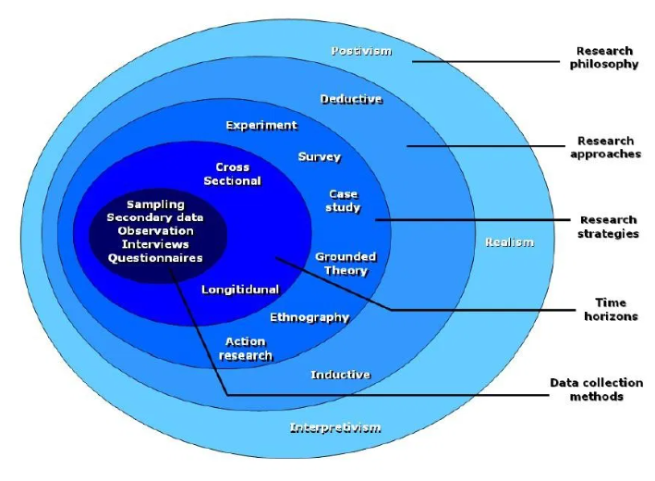
Figure 1 Saunders Research Onion

Background Research

Injuries as the result of impact occur in all walks of life, from road traffic accidents or falls to violence or even simple bumps on the head. These are considered as one off or acute traumatic injuries. An injury which is caused when too much stress is placed on a part of a body, over a sustained period, resulting in inflammation, muscle strain or tissue/bone damage is called a Repetitive Stress Injury (RSI).
Such an injury is Medial Tibial Stress Syndrome (MTSS), commonly known as shin splints. It occurs commonly amongst athletes and in particular runners, due to the repetitive nature of the running action. Many factors contribute to the onset of MTSS, but a major factor is the amount of force transmitted from the running surface, through the foot, into the lower leg. The magnitude and direction of these forces varies due to many factors including footwear, speed, physiology of the athlete, duration etc. If these forces can be measured and analysed, then action could be taken to alter the characteristics of these forces to prevent or treat MTSS.

Medical Background
Medial Tibial Stress Syndrome is a clinical condition defined as exercise-induced pain along the posteromedial tibial border caused by repetitive stress loading during running and jumping. [6] It Is common in people partaking in regular exercise and more prevalent in sectors such as elite sports, the military, long distance runners, and other active persons such as professional dancers, with a prevalence of 4% to 35% [3] [7]. The pain is felt specifically along the front inner part of the leg, between the ankle and knee. It is believed that the pain is caused by small tears in the structure of the membrane between the Tibia and Fibula, the interosseous membrane. Tiny fractures on the surface of the tibia can also result. Figure 2

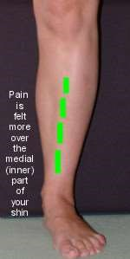

Figure 2 – Location of Pain Experienced Through MTSS

Medical opinion does not agree on a cause of MTSS. As there are several contributory factors and conditions which can lead to MTSS it is considered a symptom rather than a diagnosis. The symptoms can be treated by the application of ice, elevation, and the administration of painkillers. More severe cases may necessitate the immobilisation of the leg by use of a cast. The prognosis of MTSS is full recovery over time but the risk of re-occurrence is high if the underlying causes are not addressed.
Many things are suggested that can lead to MTSS such as:

- Sudden increase in training frequency or Intensity
- Hard running surfaces
- Running up an incline
- Previous injury
- Calcium deficiency
- Inadequate running footwear
- Poor posture

Rest and recovery

Once diagnosis is confirmed, the treatment for and recovery from MTSS is rest. A study found that 90% of participants with MTSS took between 230 and 300 days to recover sufficiently to complete an 18-minute run. [8] For a professional athlete this timescale for recovery would necessitate absence form training and competition, setting back their training schedule and potentially preventing entry to competitive events.

Prevention

In order to prescribe a prevention strategy against MTSS then it was necessary to first identify the most common risk factors. A review of current evidence regarding risk factors associated with shin splints concluded that there was little objective evidence to support the widespread use of any existing interventions in their prevention [6]. Risk factors contributing to sports injuries can be categorised as either intrinsic or personal e.g., physical fitness, anatomy, gait or extrinsic e.g., environmental factors such as running surface or type of activity being undertaken. Both these categories of risk factors can be contributory to MTSS by introducing shock to the lower leg. Body mass, running technique, gait, hard running surfaces, poor footwear, are examples of both intrinsic and extrinsic factors which can be considered contributory by their effect on the levels of shock transmission. The review concluded “The most encouraging evidence for effective prevention of shin splints involves the use of shock-absorbing insoles”. However, it went on to say that “serious flaws in study design and implementation constrain the work in this field thus far”. [6]

Investigation has shown that although impact shock is a contributory risk factor it is one amongst many variable factors. Thus, this report would concentrate only on the measurement of impact shock in the context of providing information for analysis to inform adjustments to other intrinsic or extrinsic risk factors in the prevention of MTSS.

There are studies being currently conducted into the effects of impact on injuries in sport, the majority of which are concentrating on concussion and head injury through impact. The largest study of its kind around the world is the Head Impact Detection Study being conducted by World Rugby in partnership with New Zealand Rugby, The University of Otago and Prevent Biometrics [9]. The study will underscore the continued commitment to furthering the prevention of head injury in rugby. The study will involve seven hundred male and female adults, under eighteen, under fifteen and under thirteen participants. Each participant will wear an Impact Monitoring Mouthguard (IMM) which has an impact recording accuracy of 95%. The mouthguards contain a data acquisition system that, in real-time, collects and wirelessly transmits count, load, location, direction, linear and rotational motion every time there is a collision.

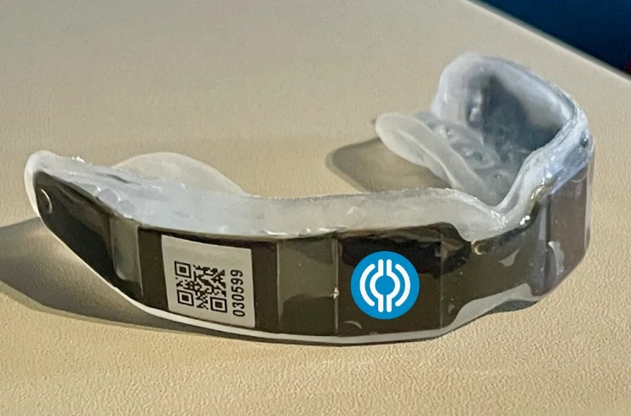
Figure 3 - Prevent Biometrics Impact Measuring Mouthguard (IMM)
Embedded with world-class hardware, the Prevent IMM is a sophisticated wearable device that accurately measures and reports head impacts in real-time. Its patented algorithm calculates the force, location, direction, and number of impacts, while effectively filtering out false-positive non-head impact events. Information on the technology involved is closely guarded by Prevent Biometrics and the registered patents [10] are currently being challenged by HitIQ, another manufacturer of smart mouthguards. There has been rapid advances in the technology within the instrumented mouth guards whereas the improved sensitivity can now distinguish between a head impact, jumping or shouting. This is important as it supports the integrity of the research study.
Although there are devices already in use in the field of impact measurement in sport the information on the technology therein is closely guarded. To this end it was difficult to analyse and assess the technology with respect to the potential overlap or adoption to this project. Consequently, the design of the device would have to rely on research of sensors currently available “off the shelf”.

Impact Forces

To be able to measure the impact loading applied to the lower leg during running it was important to understand the forces involved.
Runners strike the ground approximately 600 times per kilometre [11]. With every strike a peak vertical ground reaction force (GRF) is applied to the runner’s leg. This GRF can be 2 to 4 times the runners body weight and although soft tissue and joint structures can absorb some of this force, a proportion is transmitted through the skeletal structure of the lower leg. The accumulation of shock would become excessive in proportion to the increase in the magnitude of the load, the rate and number of loading cycles. Direct measurement of this load by surgical attachment of a strain gauge has both ethical and methodical repercussions so GRF measurement via an externally mounted device would be an indirect measure of the magnitude and rate of externally applied shock loading during running.
A schematic representation of Ground Reaction Force shows vertical (A) and horizontal (B) components. Figure 3, Figure 4 . The variables shown are peak vertical impact force (VIF_{peak}), time to peak vertical impact force (VIF_{time}), peak vertical active force (VAF_{peak}), time to peak vertical active force (VAF_{time}), peak horizontal braking force (HBF_{peak}), and time to peak horizontal braking force (HBF_{time}).
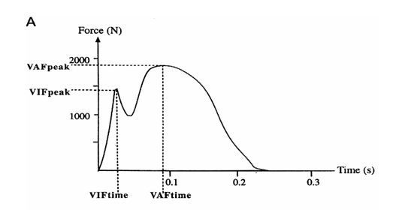
Figure 4 Schematic Representation of Ground Reaction Force [12]

The schematic shows the following:
Parameter | Measured
Peak Vertical Impact Force (VIF_{peak}) | 1400N
Time to Peak Vertical Impact Force (VIF_{Time}) | 0.025mS
Peak Vertical Active Force (VAF_{peak}) | 1900N
Time to Peak Vertical Active Force (VAF_{Time}) | 0.090mS

Table 3 GRF Vertical Parameters
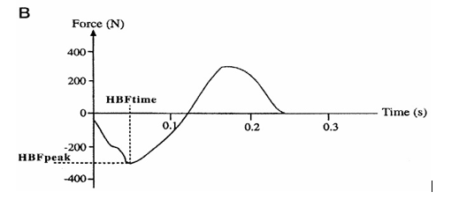
Figure 5 - Schematic Representation of GRF Horizontal Force
The schematic shows the following:

Parameter | Measured
Peak Horizontal Braking Force (HBF_{peak}) | -300N
Time to Peak Horizontal Braking Force (HBF_{Time}) | 0.120mS

Table 4 GRF Horizontal Parameters
The parameters show an initial peak for the Vertical Impact Force after approximately 0.025mS followed by a second peak to the Vertical Action Force at 0.090mS. Table 3 Figure 3. A third peak occurs at 120mS at a magnitude of -300N. This is a negative braking force acting in opposition to the vertical forces. Table 4 Figure 4 . To design a system to detect the second higher peak it was decided to initially set the read time to 100mS at a resolution of 1mS. This would require our system to read one hundred times per channel, times three channels. This would quantise the first 100mS of analogue waveform of the ground reaction force into a digital number representation at a resolution of 1mS. This would allow us to set threshold levels to count the total number of steps (step) and the impact (shock). The lower threshold (step) was needed to differentiate between an actual step and any other action taken by the wearer. The higher (shock) threshold would differentiate an actual shock reaction force over and above any other action.
The system would need to measure a combination of the vertical and horizontal forces so two sensors would be required. A third, lateral force would be present which would capture the rotational element but was considered outside the scope of this project. Should the device be developed further then expert opinion would be sought with respect to the capture of all forces acting.
To validate the measured forces acting through the leg the number of impacts would need to be measured and recorded. This required another sensor working alongside the impact sensors. To capture this step count as a parameter the use of a pedometer was considered.

Feasibility

The original design concept was to employ multiple sensors placed at various positions in the insole to capture the forces acting at various points through the foot. This would also provide an element of redundancy should any sensor fail. The requirement for multiple sensors for each axis, X, Y and Z, two pedometers plus control and power supplies was established.

In consideration, the number of components required was deemed to be not cost effective with respect to overall size constraints and for cost. It was decided at this point to consider multi-axis sensors to capture the multidirectional forces involved, reject the idea of redundancy, and consider using the multi-directional sensor output to measure the step count as well as to measure the impact forces by setting two different thresholds to be read. In keeping with the KIS mantra, “keep it simple” it was decided to use a single multi-directional sensor to provide all required signals.

The Device Requirements

Purpose – The device was aimed at measuring impact forces experienced by an individual during exercise. This meant that the device would need to be worn about the person.

Parameters to be Measured – Step count and multidirectional forces occurring repetitively over time.

Control – The type of control system for the device to carry out the instructions to capture, store and download the raw data.

Memory – Capacity for program memory, data capture and storage.

Communication – Method of data communication link to download the raw data.

Power – Power source with capacity enough to allow an adequate range of testing to be carried out.
Must be compact and lightweight with robust containment.

Size – Small enough to fit inside an insole of a training shoe with smaller shoe sizes taken into consideration. This would put limits on the physical size of the components and have a bearing on component selection.

Robust – To withstand the repetitive forces of impact experienced taking into consideration the range of body mass of the athletes.

Environmental – Ingress protection would need to be satisfied to resist moisture ingress.

Cost – If the device is to be considered for mass production then cost per unit will be a critical factor in overall production.

The Design Requirements

Purpose – The device was aimed at measuring impact forces experienced by an individual during exercise. This meant that the device would need to be worn about the person.

Hardware – Sensor and component identification and selection

Software – Proteus circuit design and simulation software.
CCS Compiler for writing the operating code for the microcontroller

Flow Chart – Construct a flowchart to aid in operational design and coding.

From the initial concept and subsequent research, a design idea was formulated for further development. The requirements were identified and a design solution idea began to emerge.

Hardware – Sensor Identification and Selection

Pedometers

To measure the number of steps taken then a device capable of registering, counting, and providing an output for each step was required. It was decided to use a device dedicated to this parameter to simplify the design and coding required.

Three methods of measuring the number of steps were considered:

- Mechanical
- Micro Electromechanical System (MEMS)
- Electronic

Accuracy of step count was desired. This can be affected by position of the sensor in relation to the direction of travel. It was decided to use a tri-axial sensor to negate these errors and reduce the false count rate. The sensor can also provide false counts from other habitual movements of the wearer other than actual steps during monitoring. This could be overcome by time stamping the data at the beginning and end of period of monitoring.

Type | Image | Advantages | Disadvantages
Mechanical | 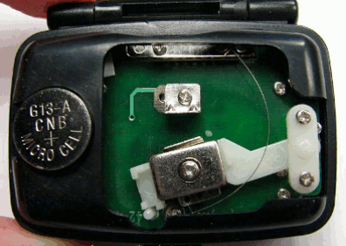 | Reliable | Cumbersome  Low accuracy  Non-integrated
Micro Electromechanical System  (MEMS) | 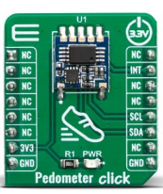 | Small  Low Cost  Accurate | Contains Moving Parts
Electronic | 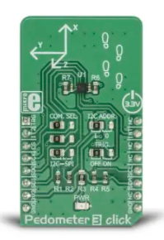 | Small  Low Power  Low Cost  Accurate | Can be expensive ($00’s for high accuracy Electrolytic)

Table 5 Methods of Measuring Steps Showing Advantages and Disadvantages

Impact Sensors

Tactile Pressure Sensor – Research identified pressure sensors that would detect the pressure forces within the range required. One such device was the Tactile Pressure Sensor.

Tactile Pressure Sensors are devices that are used to detect the pressure distribution between a sensor and a target. They are used in robot grippers as well as flat tactile arrays. In addition, flexible sensors can be moulded to curved surfaces such as the human body. Tactilus, manufactured by Sensor Products, is a state-of-the-art, tactile pressure sensor system that records and interprets pressure distribution and magnitude between any two contacting or mating surfaces. The sensing points can be spaced as close as 2 mm apart, and it can collect data as rapidly as 1,000 readings per second. Tactilus can be used to sense pressures between 0.1 psi (0.007 Kg/cm²) and 200 psi (14.1kg/cm²). Although ideally suited to pressure measurement and recording with sensors flexible and robust enough for the required application the system was deemed too bulky and bespoke to enable it to be adapted and was accordingly rejected.

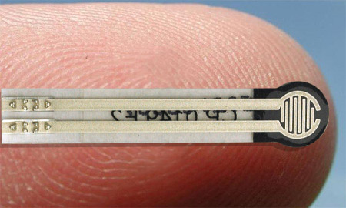

Figure 6 - Five small pressure sensors superimposed onto a human finger.

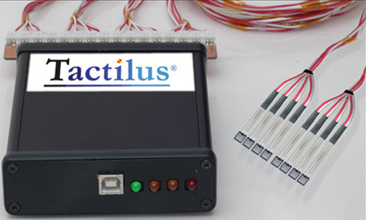

Table 6 Tactilus Tactile Pressure Sensor System

Accelerometers

An accelerometer is an electronic sensor that measures the acceleration forces acting on an object. The outputs of accelerometers can be used to determine the position and calculate the movement of an object in space.

There are three types of accelerometers: Piezoelectric, piezoresistive and capacitive.

A piezoelectric accelerometer utilizes the piezoelectric effect (piezoelectric materials produce electricity when put under physical stress) to sense change in acceleration. Piezoelectric accelerometers are most commonly used in vibration and shock measurement.
Piezoresistance accelerometers are much less sensitive than piezoelectric accelerometers, and they are better suited to vehicle crash testing. A piezoresistance accelerometer increases its resistance in proportion to the amount of pressure applied to it.

The third and most used type of accelerometer is the capacitive accelerometer. Capacitive accelerometers use change in electrical capacitance to determine an object’s acceleration. When the sensor undergoes acceleration, the distance between its capacitor plates changes as the diaphragm of the sensor moves.

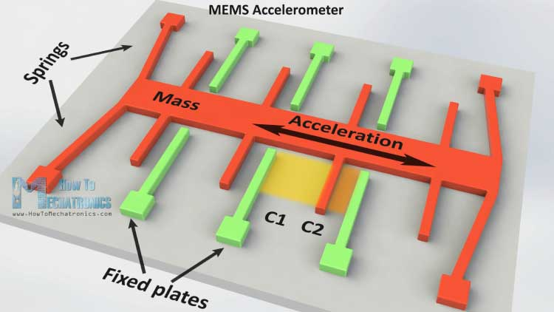

Figure 7 - MEMS Capacitive Accelerometer

Types of Accelerometers

Item Code | MPU 6050 | 820 M1 | TS-YM-310
Image | 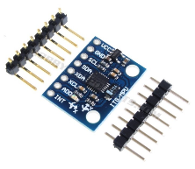 | 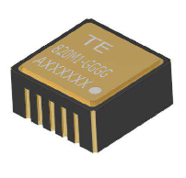 | 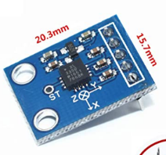
Axis | 3 Plus GPS | Single | 3
Power supply | 3 – 5 VDC | 3 – 5.5 VDC | 3 – 5 VDC
Outputs | 16bit | Analogue | 3 x Analogue
Acceleration Range | +/- 16g | +/-25g | +/-3g
Power | N/S | 310mW | 1.75mW
Connectivity | IIC | 10 Pin | 5 Pin
Construction | PCB | LCC Package | PCB
Dimensions | 2.0 x 1.6 x 0.3mm | 8.89 x 8.89mm | 4 x4 x 1.5mm
Unit cost | £3.79 | POA | £6.89

Selection – Youmile TS-YM-310 was selected due to its three analogue outputs, small size, low power consumption and easy connection.

Microcontroller
The device needs to be portable, compact, and lightweight enough to be installed in an athletic trainer. The obvious choice of system control for this application was a Programmable Interface Controller (PIC). It satisfies all the above with the added advantage that they are cheap and readily available.

From previous experience the resource of choice for PIC selection was www.microchip.com. There was a vast number of PICs available so a specification was drawn up before making use of the parametric search tool on the microchip website.

Microcontroller Specification

To develop a specification for the microcontroller PIC it is necessary to summarise the parameters required as previously identified:

Accelerometer 3 x analogue I/P

Memory 32Kb x 8bits = 256000bits 100 readings per channel = 300

From the above table and the initial brief, the required pin count for the PIC is as follows:

Type | Descriptor | Pins
Digital Input | Digital I/O | 2
Digital Input | Start Button | 1
Analogue Input (Accel) | Analogue I/O | 3
Analogue Input (Spare) | Analogue I/O | 3
RS232 | Facilitate debugging peripheral | 2
Digital Tell | Indicate operation | 1
Power and Ground | Power supply | 4
Total pin requirement |  | 16

Microcontroller specification using MICROCHIP PIC parametric search tool: The following parameters were input:

All 8 Bit PIC Microcontrollers:

ADC Inputs 8 Analogue or greater
RAM 256 bytes min
Program memory 32Kb
Pin Count 16
Speed* 16MHz* or greater
Min ADC Resolution 8 bit
Architecture C Compiler Optimised
SPI 1 min

*As a PIC has quadrative architecture i.e. every instruction takes 4 clock cycles, each reading taking 3 x 4 = 12 instructions. From our specification for the accelerometer 3 channels @ 100 readings per channel = 300, in order to capture all sensor readings then a minimum of 16Mhz would be required.

From the search the following PICs were recommended:

PIC 18F25K50

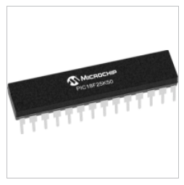
Figure 8 PIC18F25K50

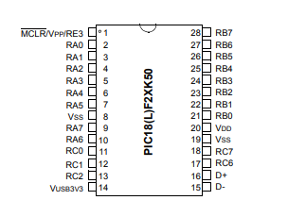

Figure 9 PIC18F25K50 Pinout

PIC18F2550

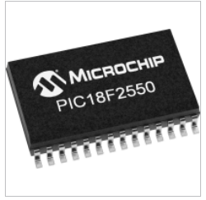
Figure 10 PIC 18F2550

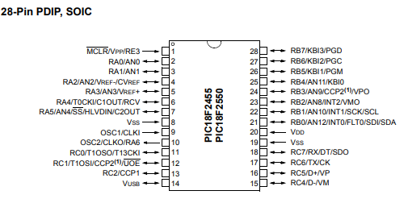
Figure 11 PIC 18F2550 Pinout

Power Supply

The requirements for the power supply were based on the total power consumption of the components as follows:

Component | Supply Voltage (V) | Load | Power(mW)
Accelerometer | 5V Max | 350uA | 1.75mW
PIC | 5V Max | 25mA | 125mW
Resistors x 5 | 5V Max | 200mA (est) | 1W
Capacitors x 5 | 5V Max | 50mA (est) | 500mW
Total | N/A | 275.35mA | 1.626W

Figure 12 - Component Power Ratings
Total requirements for the power supply were 275.35mA at 5V with an overall consumption of 1.626W
For system design, testing, and evaluation to prove concept then the device was mounted on a test bench which had its own independent power supplies.

For the prototype it was planned to carry out testing over a period long enough to allow for adequate data capture. The chosen power supply would need to be small and light enough to fit into the device but have capacity enough to power the system during testing, maintain the captured data and power the download. The power supply would need to be rechargeable for cost effectiveness. Real world operation and testing would require operation over periods of up to 30 minutes for adequate data capture, repeated multiple times during the session. To enable satisfactory operation, convenience and to provide confidence in the device it was decided to provide adequate power to enable multiple test runs up to a maximum of ten. This dictated that the power source would be required to provide a minimum of 275.3mA (Rounded up to 300mA) for 5 hours.

The following calculation was used to determine the required capacity of the battery based on the total consumption of the device and duration of operation required:

Battery Life: $\frac{Battery Capacity (mAh)}{Load Current (mAh)}= \frac{1500mAh}{300mAh} =$ 5 Hrs 14 Min

A safety margin for minimum remaining charge was adopted due to the environmental and operating conditions and to retain any RAM data. The minimum charge was 25%.

E.G. For Lithium - ion:

$$B=\frac{100×I×t}{100-Q}$$
Where: $I=Current (load)$
$t=time (Hrs)$
$Q=Req^{'}d remaining charge (\%)$

Therefore:
$B=\frac{100×0.3×5.14}{100-25}$ $B=$2.056Ah

The minimum requirements for a power supply, based on Li-ion technology were identified as:

Supply Voltage 5V
Load Current 300mA
Battery Life 2000mAh

Power Supply Selection

Item Code | RS Pro 3.7V | Eneloop AA Flat | GNB 2S 110C
Image | 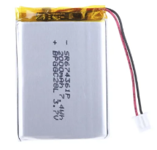 | 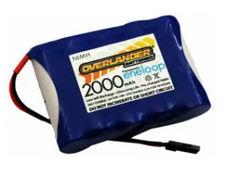 | 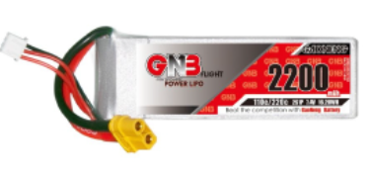
Voltage | 3.7V | 6V | 7.4V
Technology | Lithium Polymer | NiMh | LiPo
Cells | single | 5 | 2
Capacity | 2000mAh | 2000mAh | 2200mAh
Rechargeable | Yes | No | Yes
Dimensions | 62.0 x 43.3 x 7.0mm | 69 x 51 x 14mm | 17 x 34 x 105mm
Regulation req’d | Yes | Yes | Yes
Weight | 40.0g | 135g | 123g
Cost | £18.24 | £26.39 | £14.35

Table 7 Power Supply Comparison
The power supply selected was the RS Pro 3.7. All the cells considered were above or below the required 5V supply and would therefore require multiple cells and voltage regulation. An appropriate selection for voltage regulation is shown below.

Item Code | STMicro L780ACV
Image | 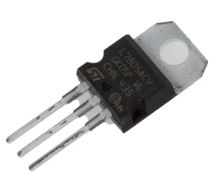
Input Voltage | Up to 35V
O/P Voltage(s) | 5,6,89,12,18,24V
Short Circuit Protection | Yes
Thermal O/L Protection | Yes
Output tolerance | 2%
Output Current | 1.5A
Dimensions | 10.4 x 4.6 x 9.15mm
Type | Linear
Cost | £0.67

Figure 13 Voltage Regulato

Design and Implementation

A summary of the research showed that the design would need to meet the following criteria to achieve the desired aim:

Single 3 channel accelerometer to provide analogue DC outputs on three channels (X, Y and Z) proportional to the forces experienced in three axes (X – lateral, Y – Horizontal and Z – Vertical).

PIC 18F2550 microcontroller configured using C compiler to read the analogue inputs and quantise them into digital representations of the detected signal, for each of the three channels. Sum the three signals and read and store two sets of signals (step) and (shock) which exceed a pre-determined threshold. Fetch these stored signals on demand from a set input (Dump).

The electronic circuit was constructed using Proteus 8 Professional simulation software. The following components were used in the construction of the Proteus circuit:

- PIC18F25K50
- Voltage Regulator 7805
- Capacitors 100uf x3

Control of the system was written in C language using CCS Compiler. Due to the authors inexperience of programming and unfamiliarity of C language and CCS Compiler, external assistance and advice was sought.

Proteus Design

A new project was opened and a firmware configuration set up with the PIC 18F25K50.

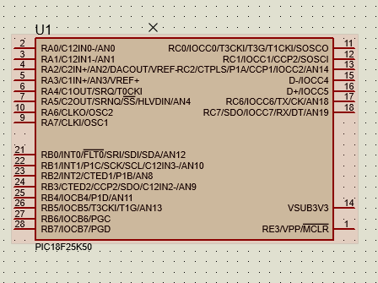

Figure 14 PIC18F25K50
A Voltage regulation network was constructed using a 7805 5V fixed 1A positive power supply regulator to provide regulated +5V DC Figure 14. A SPST latching push button was incorporated to act as the power on switch. Plug J1 was added as a connector for external 12V DC. As the device would be built and tested on a test bed which contained all the necessary power supplies the voltage regulator was excluded from the simulation.

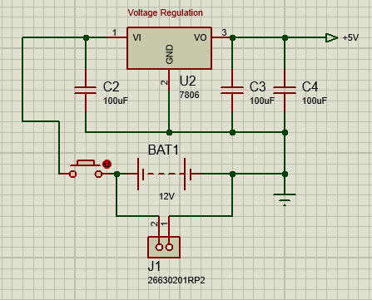

Figure 15 Voltage Regulation

There is no accelerometer in the Proteus component library so a network to simulate an analogue input was constructed. The network comprises a variable resistor RV1 with VCC applied across it to ground. The output of RV1 is applied to one pole of a dual pole switch SW1. The second pole of SW1 is terminated and the output of a signal generator is connected. The output of SW1 is applied to the PIC analogue input AN0 as channel X. SW1 is used to select which signal is applied to the PIC, the signal from either RV1 or the signal generator, for simulation purposes. The circuit was duplicated for Channel Y and Channel Z to provide three simulated accelerometer analogue outputs to the PIC.

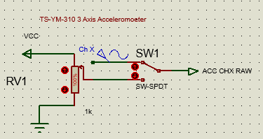

Figure 16 Accelerometer Output Simulation Network

A method of retrieving the stored data from the EEPROM was required. This was written into the program code as a Dump instruction and coded as an input to pin 21 on the PIC. To simulate this a SPST latching push button was used to allow +VCC to be applied to the pin.

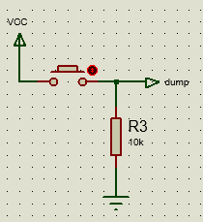

Figure 17 Dump Instruction Simulation

Microprocessors inject noise into the power supply and distribution network which can cause voltage drop, power loss and signal distortion. To eliminate this a noise elimination network was constructed. This was to be connected between VCC and ground, as physically close to the PIC as possible.

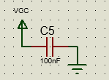

Figure 18 Noise Elimination Network

PIC18F25K50 data sheet Annex A requires that PIN 1 input only MCLR Active Low Master Clear (Device Reset) be connected to the network as required. As programming and de-bugging were not required for the end application then a direct connection to VDD sufficed. This was to reduce the risk of spurious resets due to voltage fluctuations.

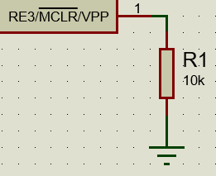

Figure 19 MCLR to VDD

A virtual terminal was connected to pins RA6/TX and RA7/RX to simulate the RS232 output and allow the data to be viewed during the simulation. A virtual oscilloscope was added and the three channels X, Y and Z connected to Channels 1, 2 and 3 respectively to allow the simulated signal generator outputs to be monitored. The final circuit was constructed as shown:

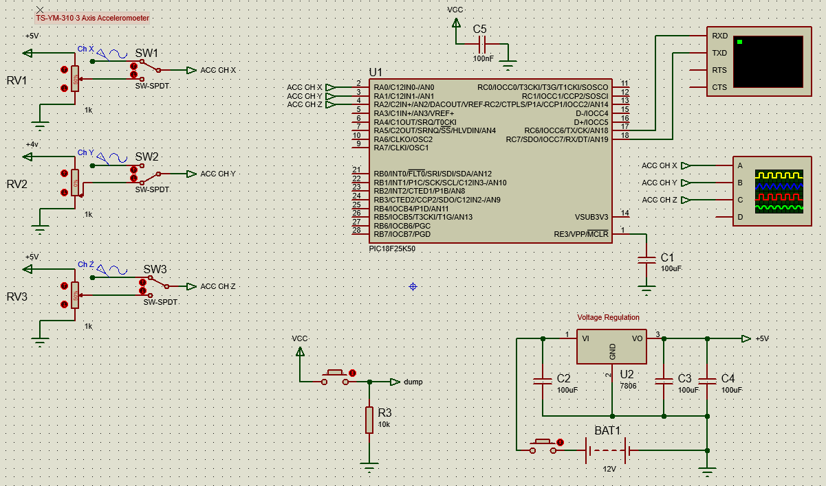

Figure 20 Final Circuit Schematic

Programming
A new project was set up in CCS Compiler using the project wizard. The device family was selected for PIC 18F and the device 18F25K50 selected. A sample code to blink an LED was selected as a check for communication. The following parameters set and the project created:

Parameter | Selection
Clock | Internal – 8Mhz
Analogue | An0, AN1 and AN2
Depth Conversion | 0 – 255
Communication | RS232 – Pins RC6 and RC7 enabled - Errors selected
Timers | Timer 2 enabled at 25mS
Options: Fuses | MCLR Pin Enabled – Off  Power Up Timer – Select  Brownout reset - Select

Table 8 CCS Compiler PIC Parameters

Once created the project files were exported to Proteus 8 Professional and the coding process commenced.

Coding

To provide a framework for coding a flow diagram was drawn up to establish a logical process for the operation of the system. The code was written in stages and tested as each section of code or function was completed. Any debugging or modifications were carried out and the function re-tested to ensure correct operation before commencing the next section of code.

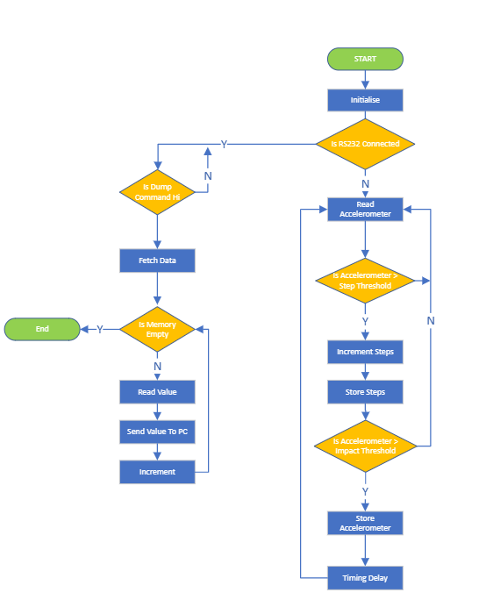

Figure 21 Operational Flow Diagram

The first stage was to define the values and routines that would be used throughout the program.

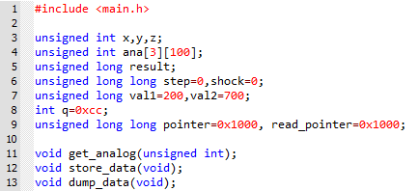

Figure 22 Initialisation

The three variables x,y and z would be the analogue signals from the accelerometer for each channel. They were defined as unsigned integers (always positive) and dimensioned as 3 analogue dual addressed arrays.

The variable “result” would be the resultant of the sum of each channel. It was defined as an unsigned long to hold a number up to 32bits.

The variables “step” and “shock” were defined as unsigned long long to hold a number up to 64bits.

“val1” and “val2” were defined as unsigned long and given values 300 and 500 respectively. These values were initial values and would be subject to change throughout the testing and evaluation.

Int q=0xcc defines q as 2 byte whole numbers

Unsigned long long pointer=0x1000, read_pointer=0x1000; defined the program memory pointers for
write and read respectively.

Functions

“get_analogue” to read the analogue inputs on pins A0 A1 and A2 defined as unsigned integer

“store_data” to store the raw data into the memory

“dump_data” to retrieve the raw data and output it on the RS232 pins

During the Proteus simulation the step and shock threshold levels “val1” and “val2” were manipulated to raise and lower the set threshold count for step and shock. The thresholds were initially too low as every result was initiating a count for both parameters. The step and shock thresholds were increased to a point where no counts were registered. The shock threshold was reduced by orders of 50 initially until an output was observed. The displayed levels were observed as being greater than 600. The shock threshold was increased by a factor of 20 and the levels were again observed and noted as being greater than 620. This process was repeated until the levels were observed to be just raising above 700. It was decided to remain at this level for the remainder of the simulation as it reflected an appropriate frequency of shocks per steps taken. The same process was carried out for the step threshold until an appropriate, readable level of step outputs were observed without swamping the system. Although these final levels did not represent real world ratios of shock/step or magnitude of impact, a decision was made to use these levels to prove concept.

Lines 22 to 25 are the initial configuration instructions imported from the Compiler setting up the ADC pins and internal clock.

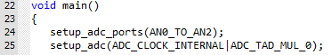

Figure 23 Initialisation set up from Compiler

Lines 29 to 60 contain the code for the routine to read the inputs and process the data dependant on the contents.

The analogue channels are read (Line 34 – 36) and summed to provide a quantity defined previously as result (38). The result is compared to val1 and if the result is greater than val1 then the count “step” is incremented by 1(38 – 41). A second comparison is carried out between result and val2 and if result is greater than val2 then the count “shock” is incremented by 1 (43 – 45). For values of q between 1 and less than 99 then q is incremented by 1 then the analogue channels are read and the data addressed and stored for each channel, X, Y and Z (46 – 55) There is a delay of 755uS to allow the data to be written before the stored data is printed to the RS232 as Step, Shock and Result. (57 – 60).

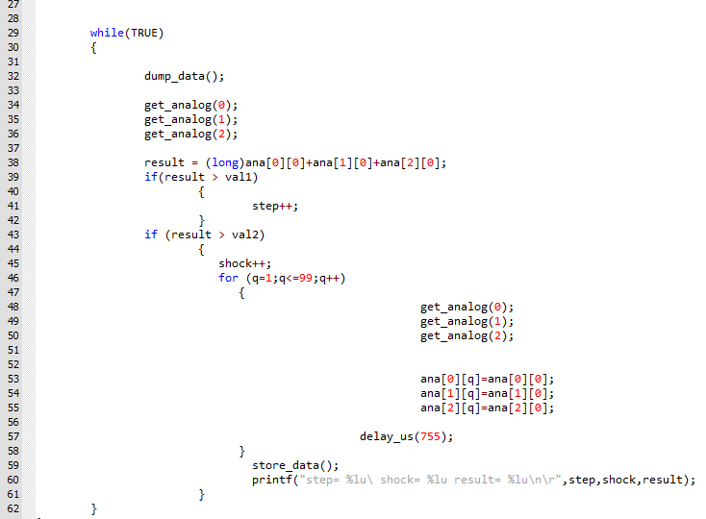
Figure 24 Routine to Read and Process Inputs

Lines 65 to 84 is the function for fetching the data from the memory locations and downloading it via the RS232 on receipt of the dump command.

The dump data pin [B0] is defined and character “g” is defined and assigned 2 bytes. This would act as a place holder to bring the information back from memory, the first for the information and the second as the end of string character. A function is set to monitor the status of the dump pin (65 – 69). If the status is set then “Memory Dump from 0x1000n” is printed to the RS232. The data is read from the memory and printed to the RS232 and the read pointer is incremented by 1. This continues while the read pointer is less than or equal to the pointer. When the read pointer reaches the pointer value then the memory dump is complete and “memory dump complete” is printed to the RS232. The read pointer is reset and the pointer is reset to overwrite the memory.

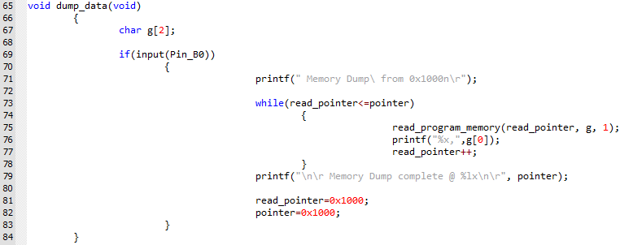

Figure 25 Dump Data Function

Lines 86 to 111 is the function to store the data. The integers x, y and z are defined and for values of q from 1 to 99 the data is written to program memory for the respective analogue channel and the pointer incremented by 1. This occurs simultaneously for each channel so 100 bytes are written per channel thus 300 bytes total are written per execution in the order X0, X1 & X2, Y0, Y1 & Y2, Z0, Z1 & Z2. “Pointer value (position)” is written to the RS232 until the pointer reaches location 1f12 when it is reset to 1dec to set an upper address limit to avoid encroaching on program memory locations.

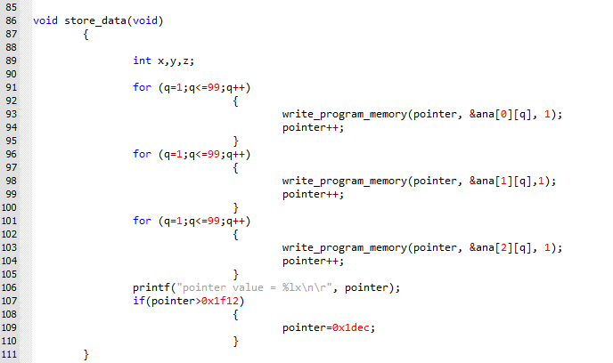

Figure 26 Store Data Function

Lines 113 to 118 is function to set then read the analogue channels with a 20us delay between setting and reading to allow the analogue channels to settle.

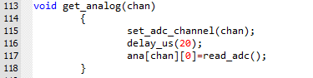

Figure 27 Read Analogue Channels Function

Component Costing (Simulation build only)

The following components were purchased online. Additional components were purchased to mitigate against inadvertent damage.

Hardware | Estimated cost | Actual Cost
PIC18F25K50 | £16.32 (2 off) | £16.32
Youmile TS-YM-310 Accelerometer | £8.79 (2 off) | £8.79
Resistors (various sizes) | £5.00 | £0.00*
Capacitors (various sizes) | £5.00 | £0.00*
* Provided by university

Table 9 Costings
Due to a global supply issue with the PIC18F25K50 with estimated lead times of up to 9 months an alternative PIC had to be sourced. The nearest alternative was identified as the PIC 18F2550. This was ordered and delivered next day. As the design had been based on the PIC18F25K50 then the Proteus schematic had to be modified. These modified schematics are included in this report.

Build
The aim of the build was to prove the concept of the system by constructing an operating circuit from the Proteus schematic, energising the system and monitoring and recording the signals where possible.

The build was carried out in the electronics lab using the Digiac Electronics Platform Breadboard Base (testbench) which contains integrated power supplies. The apparatus was controlled by the LJ Create VIP simulation software which carries integrated simulated oscilloscopes, multimeters and power supply controls.

The PIC was mounted on the centre of the breadboard and VDD (Pin 20) and VSS (19 & 8) connected. A 100nf capacitor was connected across VDD and VSS pins 20 and 19 as physically close as possible to the PIC to act as the noise elimination network. The Youmile TS-YM-310 accelerometer was assembled by soldering the pin stack to the PCB. The accelerometer was mounted on the breadboard and the three outputs X, Y and Z connected to the PIC analogue inputs A0 (2), A1 (3) and A2 (4) respectively. VDD was connected to pin 1 MCLR via a 10k resistor. VDD was connected across the push button S12 and applied to pin 21 as the active high dump command. An output to the simulated RS232 was taken from pin 17 TX and applied to LED 7.8 to act as a simulated output indicator. The operating code was exported from proteus to MPLAB IPE software and loaded onto the PIC using a PICKit3 and programmer board.

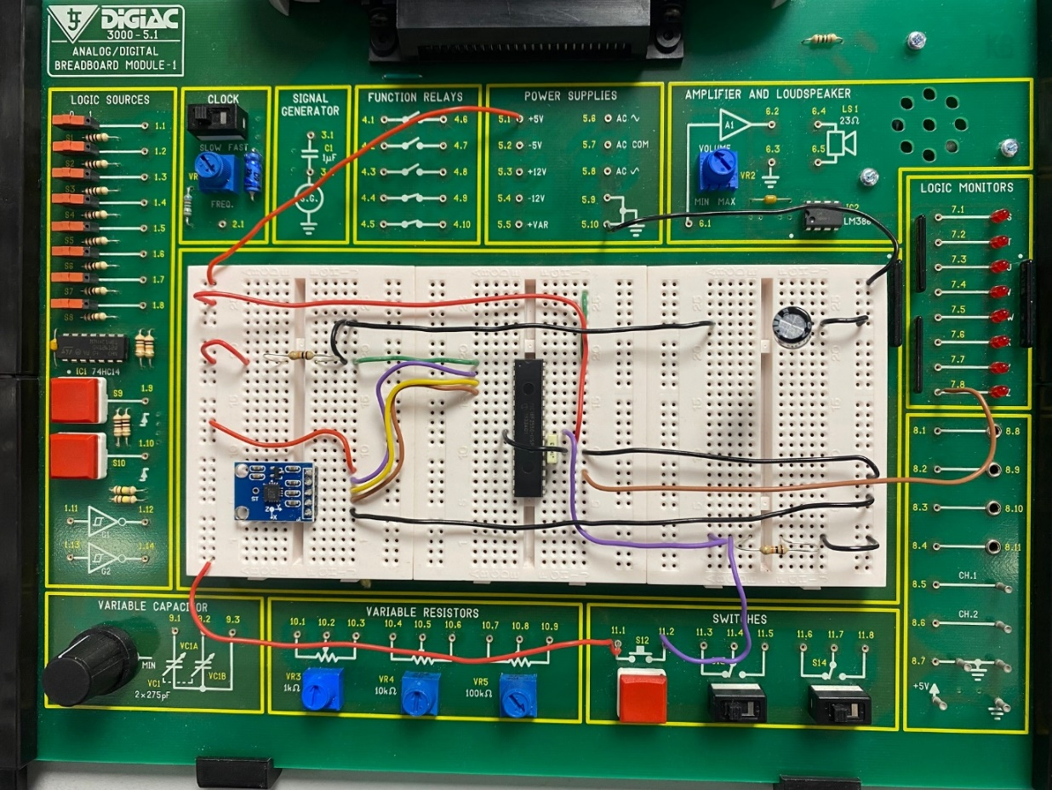

Figure 28 Breadboard Device Build

Evaluation

Testing – Proteus Simulation
The system was initially tested using Proteus to simulate the operation of the circuit. As the circuit had already been constructed and the code written and compiled then the initial testing began.

The objective of the testing was to prove concept of the device by meeting the following criteria:

- Simulation of accelerometer analogue output signals for channels X, Y and Z.
- Application of signals onto pins 2, 3 and 4 if PIC18F25K50
- Monitoring of the output of the PIC on RS232 (virtual terminal)
- Analysing inputs/outputs for the following:
- Input signals on pins 2, 3 and 4 match parameters set on signal generator
- Information displayed on virtual terminal is correct i.a.w. design parameters
- Correct response to memory dump command with correct information displayed i.a.w design parameters

Test 1 – Baseline Test

The signal generator was set up to inject the following signals as an initial test to prove signal inputs. The waveforms and virtual terminal display were observed:

Channel | Freq (Hz) | Offset (V) | Amplitude (V) (Peak)
1 | 20 | 2.5 | 5
2 | 20 | 2.5 | 5
3 | 20 | 2.5 | 5

The virtual oscilloscope was connected as follows:

Channel | Volts/Div | Time/Div | Trigger Source
A | 1 | 5mS | A
B | 1 | 5mS | A
C | 1 | 5mS | A

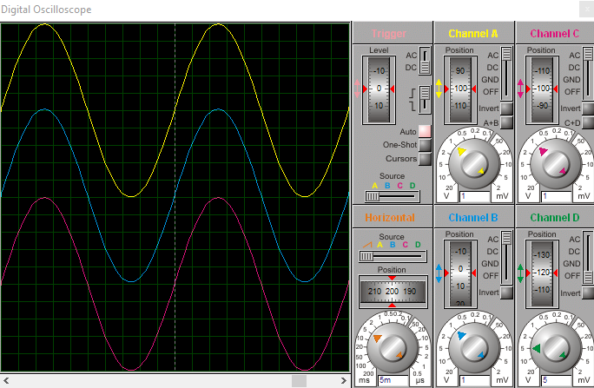
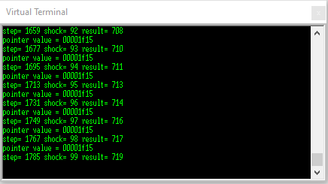

Figure 29 Test 1 Settings, Oscilloscope & Virtual Terminal

Test 2 – Simulated Data Input

The signal generator was set up to inject the following signals as an initial test to prove signal inputs. The waveforms and virtual terminal display were observed:

Channel | Freq (Hz) | Offset (V) | Amplitude (V) (Peak)
1 | 30 | 2.5 | 5
2 | 20 | 2.5 | 5
3 | 10 | 2.5 | 5

The virtual oscilloscope was connected as follows:

Channel | Volts/Div | Time/Div | Trigger Source
A | 1 | 5mS | A
B | 1 | 5mS | A
C | 1 | 5mS | A

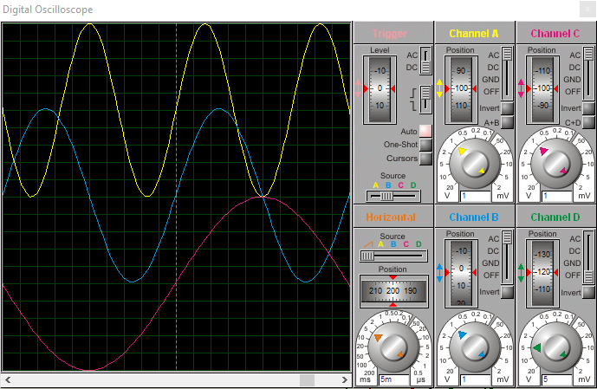
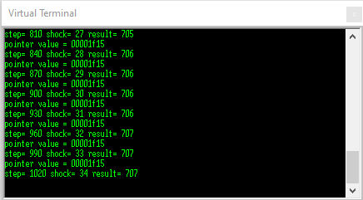

Figure 30 Test 2 Settings, Oscilloscope & Virtual Terminal

Test 3 – Dump Data Test

The system was allowed to run for 5 seconds uninterrupted to allow a quantity of data to be read and stored. The virtual terminal was monitored and the dump data function activated by the pressing the dump pushbutton. The following displays were observed:

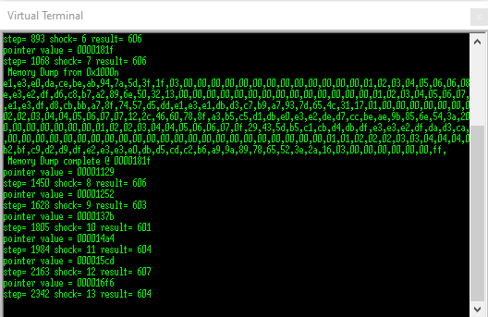

Results and Analysis – Proteus Simulation
Test 1 – Identical signals were set on the signal generator injected onto channels X, Y and Z. The oscilloscope was set up and connected to the respective channels and the waveforms were observed. The signals observed on the oscilloscope were compared with the parameters set on the signal generator and were found to match. This set a baseline and proved confidence in the apparatus. As the signals were injected into the PIC on the analogue channels an output was immediately observed on the virtual terminal. This inadvertently confirmed that the system was operating correctly.

Test 2 – The input signals were adjusted so that they were 10Hz apart between X, Y and Z respectively. The oscilloscope was set up and connected to the respective channels and the waveforms were observed. An output was immediately observed on the virtual terminal.

Test 3 – The virtual terminal display showed the last lines of the data display then advised the data dump had been activated by printing “Memory Dump from 0x1000n”. It then displayed the bits of the retrieved data. “Memory dump complete @ 0000181f” was displayed to showing the final location of the dump and that dump has completed. The data display then restarted.

Analysis of the information on the displays for test 1 showed that as the step count increased (Approximately 18 steps per display line) then the shock count increased by approximately 1 per reading. This was determined to be due to the fact that the three input signals were of the same frequency and phase so each occasion they were summed they would exceed the shock threshold every time thus incrementing the shock count accordingly. The display for test 2 showed that as the count increased (approximately 30 steps per line) then the shock count increased at a much slower rate, approximately 2 counts per line. This was due to the input signals being of differing frequencies and so out of phase. This resulted in the resultant of the summed signals not reaching the shock threshold so often. The data dump function operated correctly as detailed in the virtual display.

To summarise, the results of these tests on the simulation proved the following:

- Confidence in simulated signal generator and oscilloscope
- Correct construction of the circuit
- Correct operation of the circuit in that that the system was reading the low threshold signals and incrementing the step count consistently whilst reacting to the different input signal levels and incrementing the shock threshold accordingly
- Data Dump function executed correctly

The system simulation was successful in proving the concept.

Testing – Test bench Build
The objective of the test bench testing was to prove concept of the device by meeting the following criteria:

- Simulation of accelerometer movement by manual manipulation.
- Observation and measurement of analogue output signals from channels X, Y and Z
- Application of signals onto pins 2, 3 and 4 of PIC18F25K50
- Monitoring the output indication of the PIC on RS232 (LED 8.1)
- Analysing signals to record accelerometer output levels

Test 1 – Channel X

The LJ VIP software was initiated, and the test bench power supplies set at +5V and confirmed. The connections to VDD and VSS checked. The virtual oscilloscope was opened and channel 1 set to 50mV/div and 10mS time division. The scope was connected to accelerometer channel X output. Power was applied to the module and observed for one minute to allow the system to settle. Manual stimulation was applied to the accelerometer to simulate motion and the resulting waveform was observed. It was observed that the LED 8.1 was flickering.

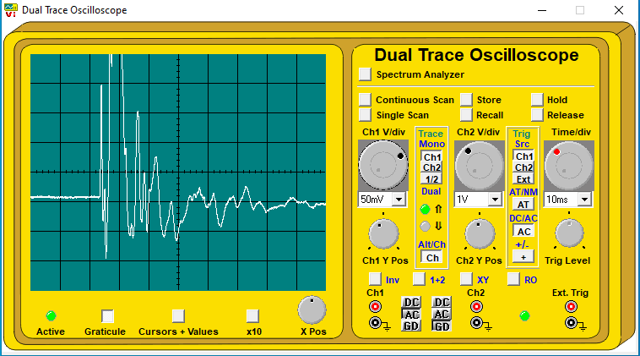

Figure 31 Test 1 - Channel X

Test 2 – Channel X and Y

Channel 2 of the oscilloscope was set up with both channels set to 50mV/div and 10mS time division. Channel 2 was connected to accelerometer output channel Y. Manual stimulation was applied to the accelerometer to simulate motion. No waveforms were observed. The manual stimulation was continued with greater manual impact applied to the accelerometer. The oscilloscope setting were adjusted process was repeated until the resulting waveforms were observed and captured.

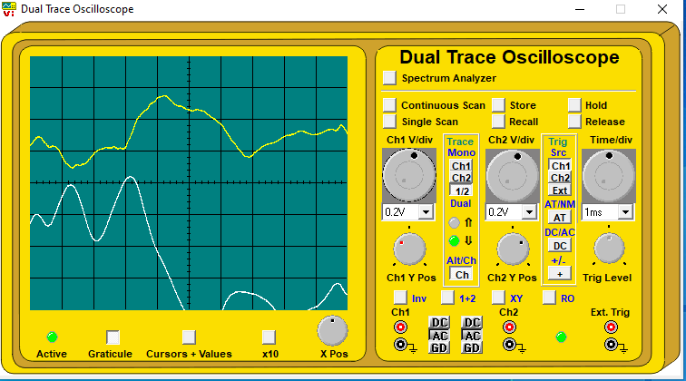

Figure 32 Test 2 - Channel X and Y

Test 3 – Channel X and Z

Channel 2 was connected to accelerometer output channel Z. The manual stimulation process was repeated and the resulting waveforms were observed and captured.

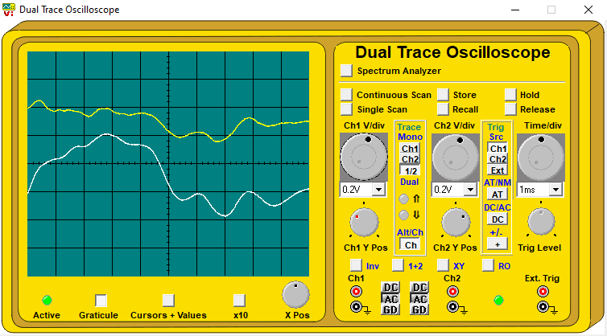

Figure 33 Test 3 - Channel X and Z

Test 4 – Data Dump

The oscilloscope channel 1 was connected to the RS232 TX pin and set to 2v/div at 1mS time division. The dump button was pressed and the output signal waveform observed.

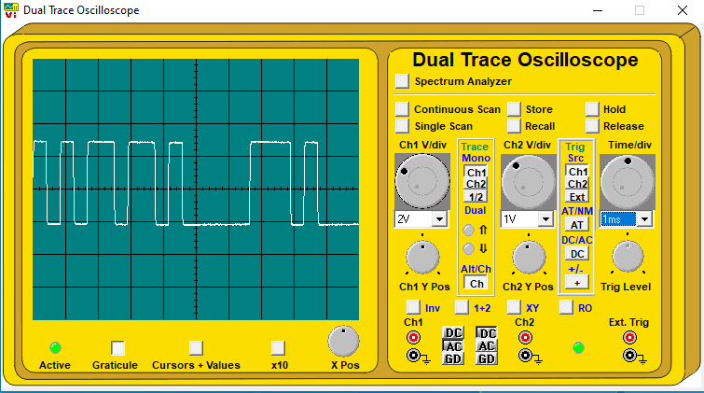

Figure 34 Data dump RS232 output

Results and Analysis – Test bench Build
Analysis of the captured signal waveform for test 1 Figure 31 showed that the output from Channel X of the accelerometer was in the region of 400mV (p-p) with the peak occurring 5mS after impact. Comparison of the outputs on channels X and Y, and X and Z Figure 32 & Figure 33 shows amplitudes of between approximately 900mV (Test 2 channel Y) and 240mV (Test 3 channel X). This showed that there was a large variation in the outputs of the accelerometer dependant on the simulated input. As the simulated shock applied to the accelerometer could not be controlled then the outputs would never be constant. The amplitudes of the output signals were very small and so there was a risk that when these signals were applied to the PIC they would not be recognised or read, thus the resultant of the summing function would fail to reach the step or shock threshold, providing false count data. The dump data function was called and a square wave of amplitude 2.5V peak was observed. This showed that there was an output to the RS232 on execution of the dump function indicating that the system was operating and collecting data and printing it to the RS232 on demand.

To summarise, the results of these tests on the test bed proved the following:

- Simulation of the accelerometer movement by manual manipulation was possible, but could not be kept constant.
- Correct construction of the circuit
- Correct operation of the circuit in that that the system was showing an output from the accelerometer on all three channels when motion was simulated. Data collection and storage was confirmed by the observation of the data being written via the RS232 on execution of the data dump function.
- The output signals from the accelerometer were very small potentially leading to missed data and incorrect step/shock counts.

The system simulation was partly successful in proving the concept.

Conclusion and Improvements

The functionality of the system was proven during the Proteus simulation to be able to recognise the analogue outputs of an accelerometer, process them and compare the resultant signal with a pre-determined threshold level, act upon the signal dependant on the outcome of the comparison, store and retrieve the signal data. The test bench also proved functionality in that stored data was exported externally to the system. When analogue signals were generated the system recognised them as inputs and processed the them and produced output signals dependant on the threshold levels. These outputs were readable as whole numbers representing steps taken and number of shock impacts above a set level. Methods of confirming the operation of the system during test bed testing would need to be designed and incorporated into the build. Indication of an output as each threshold was reached by the flashing of an LED would confirm data capture and processing. This would require the frequency of simulated input signals to be adjusted accordingly to allow observation of the LED flash.

The overall concept was proven.

The impact threshold levels used in the simulations were set to facilitate simulation and further research would be required in order to ascertain a threshold relevant to the reaction forces experienced in reality. Real time impact forces are relatively consistent with the repetitive action of an athlete. This type of impact could not be replicated during the simulations thus the data captured from the simulated impacts did not reflect that of real time inputs. The medical evidence which would be required to ascertain these levels of force is vast and, in most part, inconclusive as there are so many variables to be considered. The medical expertise required to interpret the evidence was beyond the scope of this report so a decision was made early on to use levels which would reflect the principle and still allow adequate simulation.

The hardware and sensors used for the test bench build were researched and sourced with the aim of building the system to allow test and evaluation only. Further research into miniaturisation technology and components would be required to build porotypes capable of being used as described in the design idea i.e., within an insole of an athletic trainer.

Alternative methods of measuring the shock transmitted into the lower leg could also be considered such as wearing the sensors directly on the lower leg or shin, either within a supporting apparatus or adhered directly to the skin. This would allow more space for components which would be required for a more technically advanced system.

Data download modes such as Bluetooth should be considered to facilitate real time transfer of data. This would be technically more complicated with respect to coding but would allow for a smaller device to be designed as there would be less real estate requirements without the need for a RS232 connector.

The battery specified in the research was rated at 3.7V and it was stated that two would be required to provide the +5V via a voltage regulator. Further research provided information on an alternative, considerably better method of supplying the +5V by use of a boost regulator. This would allow a much smaller battery to be used cutting down on space and overall cost.

The accelerometer analogue output signal levels were observed to be of low amplitude when measured during testing, averaging 400mV peak. These levels would prove a potential risk of not being detected as an input by the PIC resulting in impact data being missed. To overcome this a decision was taken to investigate the amplification of these signals by introducing op-amp stages between the accelerometer output and the analogue input pins.

The 741 op-amp was chosen and an amp circuit constructed in Proteus. The 741 requires independent power supplies at +VDD and -VDD so immediately alternative power supply regulation would need to be considered. Diode D1 was connected at the outputs of the amplifiers to block the negative half cycle of the waveform in order to protect the PIC. The gain of an op amp is dictated by the ratio of the feedback resistor to the input resistor:

$$Gain = \frac{RF}{Rin}$$

The values of RF and Rin were initially chosen as 5K and 1K to give a gain of 5.

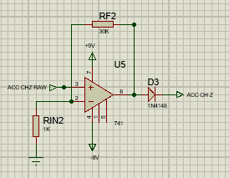

Figure 35 Op Amp circuit

The amplifier circuit was replicated for each channel and connected to the outputs of the accelerometer channels X, Y and Z. The signal generator signals were modified to 20Hz with 0V offset. An amplitude of 150mV peak was set to simulate the actual output signals observed in the test bed tests. The proteus simulation was run. The gain of 5 was deemed insufficient and so the values of RF and Rin were adjusted until an adequate signal was observed. The amplified output channels were applied to the oscilloscope channels 1, 2 and 3 respectively and the waveforms observed.

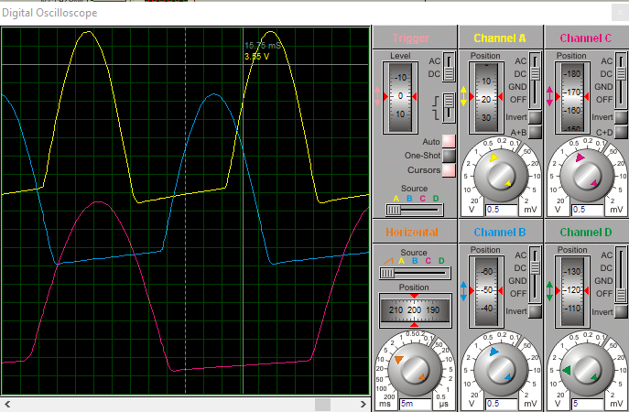

Figure 36 Post Amplification Signal Waveforms

Analysis of the amplified signals showed a peak voltage of 3.5V. This was achieved by setting the gain of the amplifiers to 30 by using an RF/Rin ration of 30K to 1K. The op amp operating voltage was set at +/- 9V to avoid clipping of the signals.

Due to time constraints and the stage in the development that the amplification requirement was identified it was decided to simulate the final system including the amplifiers on Proteus only and not rebuild the test bed system to include the amplification. Ideally the test bed build and testing would have been repeated with the amplification stages and also incorporating the step and shock output indications, to verify correct operation.

The overall proteus schematic was modified to reflect these changes (including the updated PIC 18F2550).

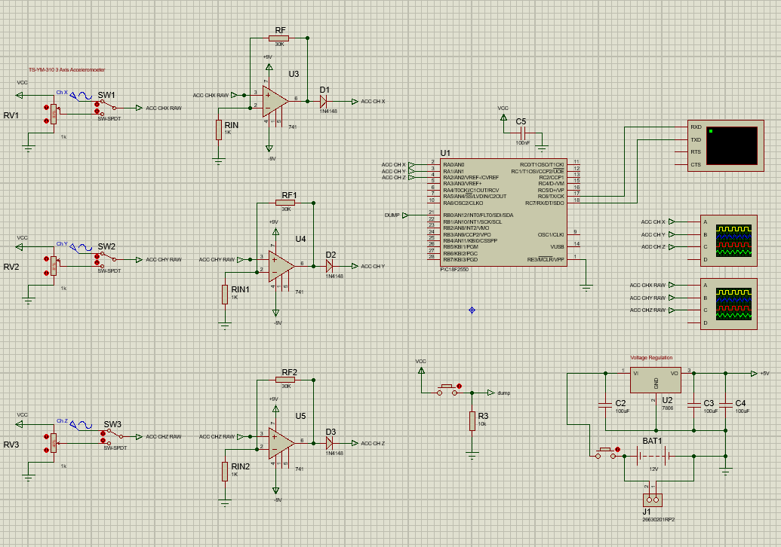

Figure 37 Final Proteus Schematic

Reflection

My journey is almost complete! Six years ago, I embarked on a part-time journey of self-improvement through learning. The rationale behind this journey was twofold: to build upon the knowledge and interest I had gained throughout my previous military career and grow the (electronics) seed planted therein, but mainly to satisfy a niggling urge to prove to myself, my dearly departed parents (and to all those school teachers) who said “could do better!”.

The culmination of this journey has been the independent project. “The Measurement of Impact Forces Relating to Medial Tibial Stress Syndrome (MTSS) in Sport” The project grew from an original idea by my daughter, who submitted the concept as part of her BSc, and in a moment of emotive madness, the basis of my project had formed! In hind sight I would probably have given it a bit more thought with respect to the knowledge and experience required to incorporate and code a microcontroller into such a system and weighed it up against a PLC controlled system, when I had recently completed, enjoyed, and had an interest in PLC’s and their application in the real world.

To formulate a plan for the project I first needed to gain some understanding of the different facets required. Medical background, current technology, similar devices or systems etc. The only way to achieve this was to carry out research. Although I have written many assignments and report in both my previous career and my academic journey, I soon came to appreciate that research at this level is a science in itself. I learned as much about researching during this process as I did about the research subject itself. It will certainly stand ne in good stead for any future journey through academia.

The design and build process was of great interest to me as it has been some time since I have had the opportunity to get hands on with a real-world solution. The use of Proteus software is a fascinating experience and something I enjoy as there is always a new aspect that reveals itself! The PIC coding process enabled me the chance to greatly expand my knowledge of C Language and re-affirmed my appreciation of the complicated simplicity of programming as a whole. I can also appreciate the test and evaluation process and its importance in the development of any system. The discovery of the small amplitude of the accelerometer output signals in my test bench is a prime example. They were so small that they were potentially lost to the system and without recognising the need for amplification then the whole system would have failed.

With respect to the overall project planning and management, the original way ahead seemed clear and feasible. As the first stages of research began then it soon became obvious that there were many more facets to be considered and which would need to be factored in. The biggest of which was the research itself. I frequently found myself so far down a particular rabbit hole that I lost sight of what I was searching for. I soon became aware that I needed to carefully define my research and recognise when I was drifting off track. The new year and post the interim viva brought what I now recognise as a false sense of security in that I assumed I was on target with the project plan. An increased workload for my business and unexpected opportunity which lead to a sudden career change during February soon brought realisation that I was way behind the curve and that I needed to take immediate corrective action to meet the target dates set. This I did and by offloading work commitments where possible and committing more time outside of work.

The overall experience of the independent project has been pleasant, stressful, enlightening, educational, satisfying and has nurtured a sense of satisfaction and achievement. An overall success in developing an idea and proving concept but also in the conduct of producing the report.

Annex A - Original Gantt Chart

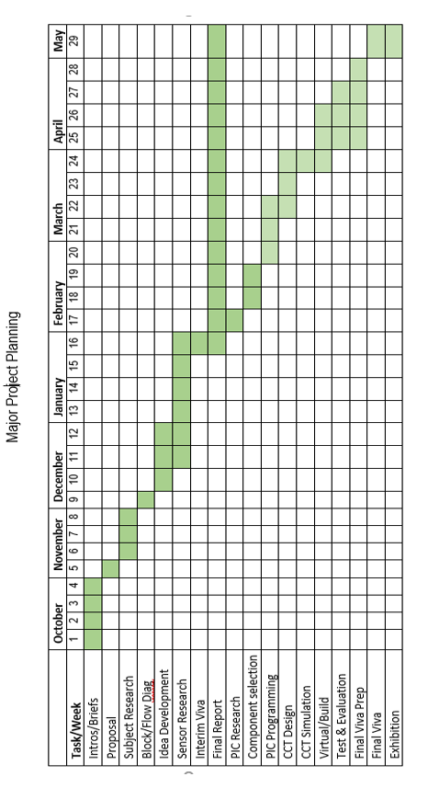

Annex B – First Amendment

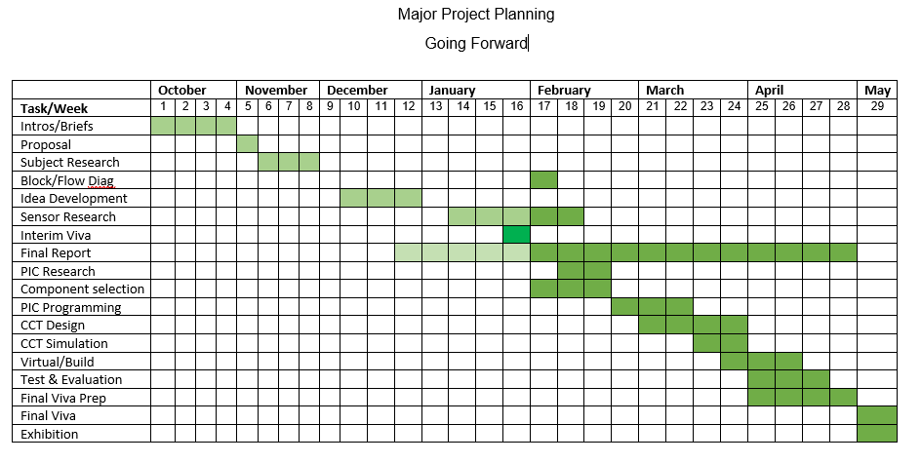

Annex C – Final Amendment

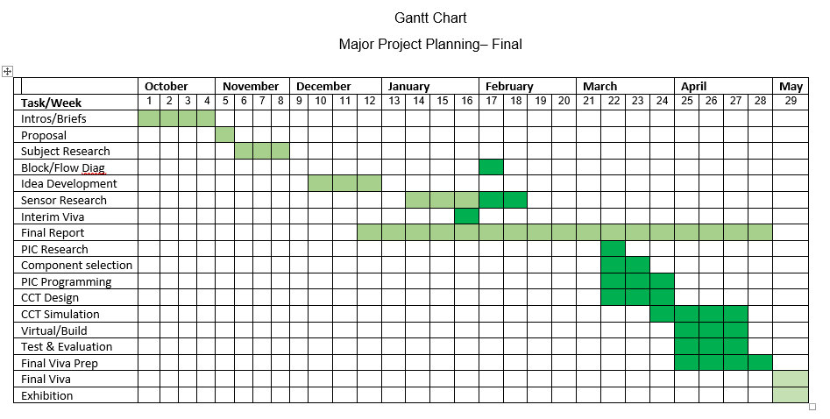

References

[1] | A. Hreljac, "Impact and overuse injuries in runners.” Medicine and science in sports and exercise," 2004.
[2] | E. James, Technology and Innovation in Injury Mechanics, Neath: Elin James, 2019.
[3] | A. D. Lopes, "What are the Main Running-Related Musculoskeletal Injuries," Sports Medicine, Auckland NZ, 2012.
[4] | U. o. W. T. S. David, SOAC Independant Project Research Handbook V2 (1), University of Wales Trinity Saint David, 2020 - 21.
[5] | "Analysis of Saunders Research Onion," 2022. [Online]. Available: https://thesismind.com/analysis-of-saunders-research-onion/. [Accessed 31 January 2022].
[6] | S. B. Thacker, J. Gilchrist, D. F. Stroup and C. D. Kimsey, "The Prevention of Shinsplints in Sport:," Medicine and Csience in Sports & Exercise, 2002.
[7] | N. Reshef and D. R. Guelich, "Medial Tibial Stress Syndrome," Clinic of Sports Medicine, 2012.
[8] | P. Newman, J. Witchalls, G. Waddington and R. Adams, "Risk Factors associated with MTSS in runners: A systematic review and meta-analysis," Open access journal of sports medicine, pp. 229 - 241, 2013.
[9] | W. Rugby, "World Rugby Head Impact Study," World Rugby, 31 March 2021. [Online]. Available: https://www.world.rugby/news/627662/world-rugby-new-zealand-rugby-the-university-of-otago-and-prevent-biometrics-to-undertake-ground-breaking-community-rugby-head-impact-study. [Accessed 6 January 2022].
[10] | T. C. C. Foundation, "Request for Opinion - Infringement of Patent EP2593015 B1". UK Patent EP2593015 B1, 7 January 2022.
[11] | P. R. Cananagh and M. A. Lafortune, "Ground Reaction Forces in Distance Running," J Biomech, pp. 397 - 406, 1980.
[12] | K. Crossley, K. Bennel, T. Wrigley and B. W. Oakes, "Ground reaction forces, bone characteristics and Tibial Stress Fracture in male runners.," Medicine and Science in Sport and Exercise, vol. 31, no. 8, pp. 1088 - 1093, 1999.
[13] | M. Saunders, A. Thornhill and P. Lewis, "Research Methods for Business Students (8th Edition)," Pearson, London, 2018.
[14] | G. D. E, Doing Real World Research, London: Sage, 2018.
[15] | D. L. Knott, "Shin Splints - Medial Tibial Stress Syndrome," 2018. [Online]. Available: https://patient.info/bones-joints-muscles/compartment-syndrome-leaflet/shin-splints-medial-tibial-stress-syndrome. [Accessed January 2022].

Bibliography

- Lopes, Alexandre Dias et al. “What are the Main Running-Related MusculoskeletInjuries?” Sports Medicine (Auckland, N.z.) 42 (2012): 891 - 905.
- Hreljac, Alan. “Impact and overuse injuries in runners.” Medicine and science in sports and exercise 36 5 (2004): 845-9 .
- https://kidshealth.org/en/teens/sm-glossary.html
- https://www.world.rugby/video/668494
- Camarillo, D.B., Shull, P.B., Mattson, J. et al. An Instrumented Mouthguard for Measuring Linear and Angular Head Impact Kinematics in American Football. Ann Biomed Eng 41, 1939–1949 (2013). https://doi.org/10.1007/s10439-013-0801-y
- Schütte, K., Seerden, S., Venter, R. and Vanwanseele, B., 2018. Influence of outdoor running fatigue and medial tibial stress syndrome on accelerometer-based loading and stability. Gait & Posture, 59, pp.222-228.
- Newman P, Witchalls J, Waddington G, Adams R. Risk factors associated with medial tibial stress syndrome in runners: a systematic review and meta-analysis. Open Access J Sports Med. 2013;4:229-241
https://doi.org/10.2147/OAJSM.S39331

