R1#show ip int brief
Any interface listed with OK? value "NO" does not have a valid configuration

Interface IP-Address OK? Method Status Protocol
GigabitEthernet0/0/0 141.240.10.1 YES manual up up
GigabitEthernet0/0/1 141.240.11.1 YES manual up up
Serial0/1/0 unassigned NO unset down down
Serial0/1/1 unassigned NO unset down down

R1#show running-config
Building configuration...

Current configuration : 3576 bytes
!
! Last configuration change at 14:28:47 UTC Tue Jan 14 2020
!
version 16.9
service timestamps debug datetime msec
service timestamps log datetime msec
service password-encryption
platform qfp utilization monitor load 80
no platform punt-keepalive disable-kernel-core
!
hostname R1
!
boot-start-marker
boot-end-marker
!
!
enable secret 5 $1$7zTu$vv6NKn4vKsresQZWWHYlh/
enable password 7 0822404F1A0A
!
no aaa new-model
!
no ip domain lookup
ip admission watch-list expiry-time 0
!
!
!
!
!
!
!
!
!
!
subscriber templating
multilink bundle-name authenticated
!
!
!
crypto pki trustpoint TP-self-signed-1562137005
enrollment selfsigned
subject-name cn=IOS-Self-Signed-Certificate-1562137005
revocation-check none
rsakeypair TP-self-signed-1562137005
!
!
crypto pki certificate chain TP-self-signed-1562137005
certificate self-signed 01
30820330 30820218 A0030201 02020101 300D0609 2A864886 F70D0101 05050030
31312F30 2D060355 04031326 494F532D 53656C66 2D536967 6E65642D 43657274
69666963 6174652D 31353632 31333730 3035301E 170D3230 30313134 31343035
34315A17 0D333030 31303130 30303030 305A3031 312F302D 06035504 03132649
4F532D53 656C662D 5369676E 65642D43 65727469 66696361 74652D31 35363231
33373030 35308201 22300D06 092A8648 86F70D01 01010500 0382010F 00308201
0A028201 0100BC9F AF8DC360 772F338A A59E7FEA CB7B4A0C 5882E87A 2563769F
68807533 6007C150 3D9E750B D8B005A7 C9CDEAA8 C82E856B 7AB50B2F 8FB5E2D2
3FA1172C 8B6D92AD A691B39B 445D6B51 FE1F0419 BAB057EE 6F6C11E0 85D0FEA3
250FCBC9 DFFCE210 BA2D31BA 87171935 366DED29 A06B8E06 4055F6D0 03AB4476
1367F440 E637FE46 1F4BE8EF 24695B11 F43FA61D 315BA529 A1D86B2B BCCDD473
59035485 9A5552ED D4D0D73C 37B46E89 AF1B4B66 267CE67F 1D6F02F4 FE51E5BC
86628F04 422F89EC B8858105 3C968F45 92727AD6 988879DE 47F0A8D9 ADFF29D9
CC48423A 1FB6668D 46C8D319 1FCE2E01 5C3877B0 0EEBEE07 B1150C5B D94AB05F
F72E525C 48730203 010001A3 53305130 0F060355 1D130101 FF040530 030101FF
301F0603 551D2304 18301680 144115F1 31BEDE46 BFB97586 1F0704B3 7C8F32A0
E6301D06 03551D0E 04160414 4115F131 BEDE46BF B975861F 0704B37C 8F32A0E6
300D0609 2A864886 F70D0101 05050003 82010100 73388EA6 889C8685 F612C0B4
970D857F D0CE05FD 3C17B4CB F398E72E F692D84B 99A15BCB F7C35BF2 59A8C64E
D2CB2FFF A8D72A79 F3496832 200D9272 E790EE2F 5ED3D69B 2156A0C3 0E71ACDC
90076C86 343E1748 1701C7A2 732C4227 13AB92CB D61BFA65 C26888E6 C0A265A1
66D9EB47 7DEA753A 8E0B63BE 5CCF9B8E 4ECA96C3 ED7C56A1 4D8883F3 CA3E8DC0
085CEAF3 B5AB89CE 2378C2E5 FEFD72E8 8CD0A5B8 1E2DB100 7C048A63 B74B3094
1616FE94 957E31F4 2BE98775 1F08EEE3 2B87D6D6 2015FB34 A8881970 512E9F54
45C7D5A7 CCD3E213 7087519F 5B768A5D 3982DCEE B9B214ED 0F678FBC 2DDCC1EA
F72F612D C8FFCF33 66970BE0 952BED90 04AED307
quit
!
license udi pid ISR4221/K9 sn FGL224190DN
no license smart enable
diagnostic bootup level minimal
!
spanning-tree extend system-id
!
!
!
!
redundancy
mode none
!
!
!
!
!
!
!
!
interface GigabitEthernet0/0/0
description PC-B
ip address 141.240.10.1 255.255.255.0
negotiation auto
!
interface GigabitEthernet0/0/1
description PC-A
ip address 141.240.11.1 255.255.255.0
negotiation auto
!
interface Serial0/1/0
!
interface Serial0/1/1
!
ip forward-protocol nd
ip http server
ip http authentication local
ip http secure-server
!
!
!
!
!
!
control-plane
!
banner motd ^C Unauthorized access is strictly prohibited! ^C
!
line con 0
password 7 094F471A1A0A
login
transport input none
stopbits 1
line vty 0 4
password 7 045802150C2E
login
line vty 5 15
password 7 045802150C2E
login
!
!
!
!
!
!
End

S1#show ip interface brief
Interface IP-Address OK? Method Status Protocol
Vlan1 141.240.11.10 YES manual up down
FastEthernet0/1 unassigned YES unset down down
FastEthernet0/2 unassigned YES unset down down
FastEthernet0/3 unassigned YES unset down down
FastEthernet0/4 unassigned YES unset down down
FastEthernet0/5 unassigned YES unset down down
FastEthernet0/6 unassigned YES unset down down
FastEthernet0/7 unassigned YES unset down down
FastEthernet0/8 unassigned YES unset down down
FastEthernet0/9 unassigned YES unset down down
FastEthernet0/10 unassigned YES unset down down
FastEthernet0/11 unassigned YES unset down down
FastEthernet0/12 unassigned YES unset down down
FastEthernet0/13 unassigned YES unset down down
FastEthernet0/14 unassigned YES unset down down
FastEthernet0/15 unassigned YES unset down down
FastEthernet0/16 unassigned YES unset down down
FastEthernet0/17 unassigned YES unset down down
FastEthernet0/18 unassigned YES unset down down
FastEthernet0/19 unassigned YES unset down down
FastEthernet0/20 unassigned YES unset down down
FastEthernet0/21 unassigned YES unset down down
FastEthernet0/22 unassigned YES unset down down
FastEthernet0/23 unassigned YES unset down down
FastEthernet0/24 unassigned YES unset down down
GigabitEthernet0/1 unassigned YES unset down down
GigabitEthernet0/2 unassigned YES unset down down

S1#show running-config
Building configuration...

Current configuration : 1588 bytes
!
! Last configuration change at 04:26:01 UTC Sun Mar 7 1993
!
version 15.2
no service pad
service timestamps debug datetime msec
service timestamps log datetime msec
no service password-encryption
!
hostname S1
!
boot-start-marker
boot-end-marker
!
enable secret 5 $1$73r/$OiEIexAAIyDPvVZ5HtUIz0
!
no aaa new-model
system mtu routing 1500
!
!
!
!
!
!
!
no ip domain-lookup
!
!
!
spanning-tree mode pvst
spanning-tree extend system-id
!
vlan internal allocation policy ascending
!
!
!
!
!
!
interface FastEthernet0/1
!
interface FastEthernet0/2
!
interface FastEthernet0/3
!
interface FastEthernet0/4
!
interface FastEthernet0/5
!
interface FastEthernet0/6
!
interface FastEthernet0/7
!
interface FastEthernet0/8
!
interface FastEthernet0/9
!
interface FastEthernet0/10
!
interface FastEthernet0/11
!
interface FastEthernet0/12
!
interface FastEthernet0/13
!
interface FastEthernet0/14
!
interface FastEthernet0/15
!
interface FastEthernet0/16
!
interface FastEthernet0/17
!
interface FastEthernet0/18
!
interface FastEthernet0/19
!
interface FastEthernet0/20
!
interface FastEthernet0/21
!
interface FastEthernet0/22
!
interface FastEthernet0/23
!
interface FastEthernet0/24
!
interface GigabitEthernet0/1
!
interface GigabitEthernet0/2
!
interface Vlan1
ip address 141.240.11.10 255.255.255.0
!
ip default-gateway 141.240.11.1
ip http server
ip http secure-server
!
ip access-list standard TELNET-ACCESS
!
no vstack
banner motd ^C Unauthorized Access is Prohibited! ^C
!
line con 0
password class
login
line vty 0 3
login
line vty 4
password cisco
login
line vty 5 15
login
!
end

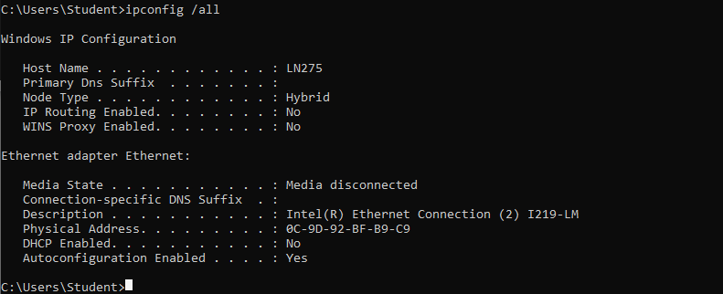
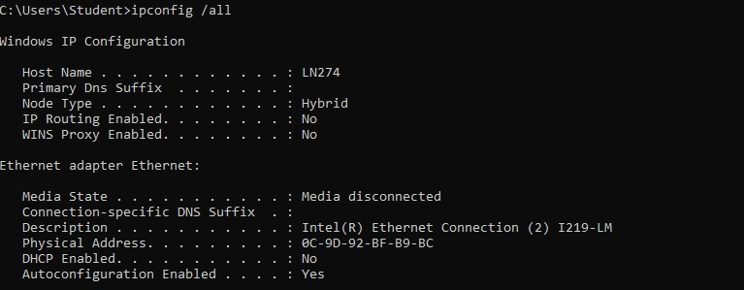

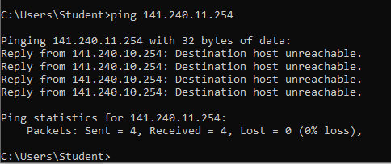

Note to Paul Wallin
You double checked everything and said that everything is alright and we couldn’t figure out why we cannot ping the other PC.

