Adventure works – North America

Student Name: Ashleigh Steel
Assignment: Business Reporting
Course: Applied Computing
Modula: Business Information Systems
Submission Date: 14/01/2019

Contents
Adventure works – North America 1
Introduction 3
Data set / Attributes 4
Accessories 4
Bike 4
Clothing 4
Components 4
Profits / Sales analysis 5
Accessories 5
Bikes 5
Clothing 5
Components 5
Grand totals 5
Trends / Forecasts 6
Accessories 6
Bikes 6
Clothing 6
Components 6
Marketing 7
SWOT 7
Strengths 7
Weaknesses 7
Opportunities 7
Threats 7
Bibliography 8
Appendix 9

Introduction
(See appendix 7 for introduction)
To carry out this task, I was provided with their database system already added to tableau’s software, I did however not use their “market basket analysis” but instead change create a calculation of the number of quantity sold by its units price to show price gain, rather than number of sales as I feel this would be not as accurate for my analysis cause some products may require multiple purchases depending on the product, for example someone will only really need one bike frame to make one, but will need two wheels to function, those analysis in profit would be more appropriate. Looking below (See appendix 1 for image) I have also used a colour system to show key areas of profit, sub totals and grand totals for each year and product and now below I will begin to analyse the data recovered to determine any acts I think will seem fitting. Last thing to mention that I was not provided with cost of items to ship it in so higher profit numbers could vary depending on manufacturing costs.

Data set / Attributes
Using images below I will be defining significant attributes and any other relevant characteristics I feel are present:

Accessories
(See appendix 2 image for accessories)
Beginning with Accessories a few key accessories need to be pointed out when attempting to predict trends and or forecast its future, some products showing in the image was not sold during 2001 and 2002 so less to analyse thus less accuracy when predicting its forecasted future. Also the stop of locks and pump sales in 2004 will negate any future analysis part from that it sold half as well during 2002 to 2003 and I wouldn’t suggest bringing back unless for increase in demand. The Key attribute here to point out is that all products, selling or not have mostly had almost half a lost in money gain over each year except helmets during 2002/2003.

Bike
(See appendix 3 image for bike)
Next speaking about the bikes, the mass increase in money in is due to the fact that bikes as a whole cost more and also perhaps be in very high demand during 2001 to 2004. We can see that touring bikes was only introduced in 2003 but keeps with its earning more than the other two in 2004, while mountain bikes and road bikes had their peak in 2002 but have seem to drop drastically in 2004. So the key attribute to state here is that touring bikes popularity from this small data gather seems to be consistent while mountain and road bikes very depending on popular of demand.

Clothing
(See appendix 4 image for Clothing)
Clothing attributes that I can conclude is that as a whole can be determent based on how the years went, from being a cold or warmer, to being more in demand, this varies a lot specially shown in this, and that’s why seeing for example bib shots only being sold in 2002 and 2003 was due to increase in demand as bikes was selling a lot more and so on. I think the key thing to note would be that especially jerseys seem to be a big selling point for their clothing.

Components
(See appendix 5 image for components)
Lastly components is a big key functionality when shipping related bike products, so looking at image we can see perhaps in 2003 an increase in demand on parts was due to 2002 (See appendix 3 image for Bikes) bike information sold the most number of bikes, so most likely more bikes means more need for components to be sold (fixing/replacements) then a slow decline in 2004. Not forgetting that 2002 may have had less components selling, but made the most amount of profit, which is certainly an attribute to keep note of. I think a key attributes here is that mountain frames and road frames certainly made the most amount of money during these years.

Profits / Sales analysis
Next I’ll be stating the profits gains and analysing its situation by using the images below, also to not profit will be subjected to me based on not knowing the manufactures cost in creating products:

Accessories
(See appendix 2 image for accessories)
First looking at accessories, first of all the point out that accessories themselves don’t cost as much as bikes and wouldn’t cost as much to manufacture, I can see a significant increase in helmet sales during 2002/2003 due to (See appendix 3 image for bike) bikes sales increase over this time period, thus more need for helmets. Also simulate with bike racks in 2003 being newly sold. So from analysing this suggests that profit may have spiked in 2003, but 2004 followed a simulate pattern in 2002 so profit should be simulated the same in 2005.

Bikes
(See appendix 3 image for bike)
Next looking at bike sales, we can see during 2002 a heavy demand for bikes began and then though till 2003 with the introduction of touring bikes. Then dropped back down again in 2003 showing that sales/demand for bikes during 2002 to 2003 was on a high and is likely to stay lower than this now till a new trend is introduced. I think the key sales analysis to point out is that there was a peak time during when bikes where selling but in 2004 it has come back to a normal standstill like 2001, so it’s possible another peak could happen in 2005 or 2006.

Clothing
(See appendix 4 image for clothing)
After looking at clothing’s profit gains its clear to me, which I would say would be recommended to stick to further increase gains in the following year, my point could be invalid as clothing trends can change suddenly and can very base on the years weather. To conclude, continuation of socks, vests, jerseys and perhaps intruding back bib shots depending on the weather conditions will be the best way to maximise profit.

Components
(See appendix 5 image for components)
From looking at both bikes and accessories we can see why components profits also very just due to number of sales on bikes so the need for such things was increase, but also to not that during 2001 not many components was on say so perhaps that’s a main reason for less profit during that year. To take an analysis to this, the profit gain is fluctuating as normal and will very depending on the amount of profit and popularity of bikes to come in the near future.

Grand totals
(See appendix 6 image for total)
Lastly looking at the grand totals for each year we can certainly see the flex for the want of bikes in 2002/2003 then drops like 2001 in 2004. So profit gains will perhaps very depending on future development main in the company, from advertisement/promotions and so on. Depending in 2001 and 2004 is considered still a good profit gain, 2005 will look to be ether a continuation of 2004 or perhaps another jump in popularity/profit depending on the steps taken in 2005.

Trends / Forecasts
[1]Next I will be discussing treads and state a forecast for 2005 with the previous year’s data:

Accessories
(See appendix 2 image for accessories)
First looking at accessories trends, I can pick up that helmets and bike racks will be the biggest increase in profit due to its trend in selling well during 2003 and 2002 for helmets, with only 2003 and 2004 data on bike racks, id still assume as its sold well in 2004 still if believe it will sell as well as helmets for 2005. Also as a side point, as more bikes have now been sold during 2002/2003 and bike racks have had a great sale then less in 2004, locks may become more in demand as those with locks may need replacement and or need one to begin with, so for 2005, sales on locks I believe will hit at least 2002 expectations. So the key trend or forecast I would say for accessories in 2005 is to keep selling all current accessories with the addition of locks again, for maximise profit gain in 2005, cause profit of accessories very based on number of bikes sales, and from analysing this, I believe a trend/increase in popularity for bikes may accrue in 2005 or 2006

Bikes
(See appendix 3 image for bike)
Next looking at bikes we can see a trend with the years 2002 and 2003 as perhaps the increase in demands for bikes increase thus the sales for them was more, and the introduction of touring bikes help keep the profit rolling into 2003 for some time. Now 2004 profits are similar to 2001, id forecast ether another spike in 2005 in demand for bikes or more/better form of advertisement could be made to achieve profits from the years 2002 and 2003, shown when intruding the new tour bikes. So I forecast that without change profit will not very but with perhaps a new trend of bike or advertisements, peeks like 2002 and 2003 would be achieved again if done correctly.

Clothing
(See appendix 4 image for clothing)
As I said in profit for clothing I feel the trends will very base on current trends, weather and so on, so take my forecast lightly, continuation of socks, vests, jerseys and perhaps intruding back bib shots depending on the weather conditions will be the best way to maximise profit gains.

Components
(See appendix 5 image for components)
Looking at components we can see a trend that during the time of sales of bikes increasing in 2002 to 2003, so do components in the same years, similar with profit too in years 2001 and 2004 but seemingly more profit from 2001 from 2004 properly due to selling more types of components. Similar to what I said in accessories, forecasting this will mostly very depending on numbers of bikes sold, it’s likely to have a similar result in 2005 as 2004 unless effort is made in advertisement or increase in popularity in bikes in 2005.

Marketing
The basic trend we can see from 2003 to 2004 for all category’s is cause of the trend/need for bikes has decrease, the need for components and accessions will also receive a similar hit. I fell from a marketing perspective, the best course of act as a whole would be to bring up more of the awareness of bikes in general and perhaps intrude more choice, this way may stretch the profits of each item again but will limit the loss with more profit in general (as long as manufacture cost are also dealt with correctly). During 2005, perhaps ether implementing more variation of bikes so components and accessions are more appealing/needed or advertise more/better on your current products to see an increase in 2005, as theirs a chance for it to peek again stated in my analysis. Also perhaps selling a few products together or multi pack options could also bring in more sales such as something popular for example sell bikes with a helmet for cheap and so on.

SWOT
[2]SWOT or Strengths, weaknesses, opportunities and threats is an organized list of business’s greatest SWOT, It’s used to basically “list”/Pinpoint a business’s flaws and or strengths, without keeping up with this, other organisations could take the lead in the market, depending on the weaknesses not being dealt with or strengths not being utilised properly. Below is my SWOT of Adventure works current status in North America

Strengths
- Bikes Selling well, especially during peeks
- Even during low peeks of bike interest, good amount of profit is gained
- For accessories, helmets are a continuing selling point, and perhaps bike racks
- Cloths such as Jerseys, shots, socks and vests seem to be a continuing gain in profit and shouldn’t be overlooked

Weaknesses
- Items such as tires and tubes gains are minimal but almost required to sell when selling bikes
- Possible weak advertisement causes products with less profit to be shown
- 2004 currently is at its lowest peak in profit but hopefully will change in 2005

Opportunities
- Increase trend or introduce new ideas will most likely benefits next year’s rise in profits
- More marketing on small earning products to increase earnings

Threats
- 2005 to not be a year of interest for cyclist, if not advertised enough
- Items like tires and tubes to earn even less next year

Bibliography

[1] | W. u. Employee, “How to Become a Trend Forecaster,” Way up, ?? ?? ????. [Online]. Available: https://www.wayup.com/guide/how-to-become-a-trend-forecaster/. [Accessed 09 01 2019].
[2] | T. Berry, “SWOT analysis,” Bplans, ?? ?? ????. [Online]. Available: https://articles.bplans.com/how-to-perform-swot-analysis/. [Accessed 09 01 2019].
[3] | Tableau, “Change the way you think about data,” tableau, ?? ?? ????. [Online]. Available: https://www.tableau.com/en-gb. [Accessed 09 01 2019].
[4] | S. b. Data, “Youtube,” Tablo, 13 10 2016. [Online]. Available: https://www.youtube.com/watch?v=9VlbYjF5_7o. [Accessed 09 01 2019].
[5] | wiki, “Tableau software,” Tableau , 10 11 2018. [Online]. Available: https://en.wikipedia.org/wiki/Tableau_Software. [Accessed 09 01 2019].

Appendix

1.
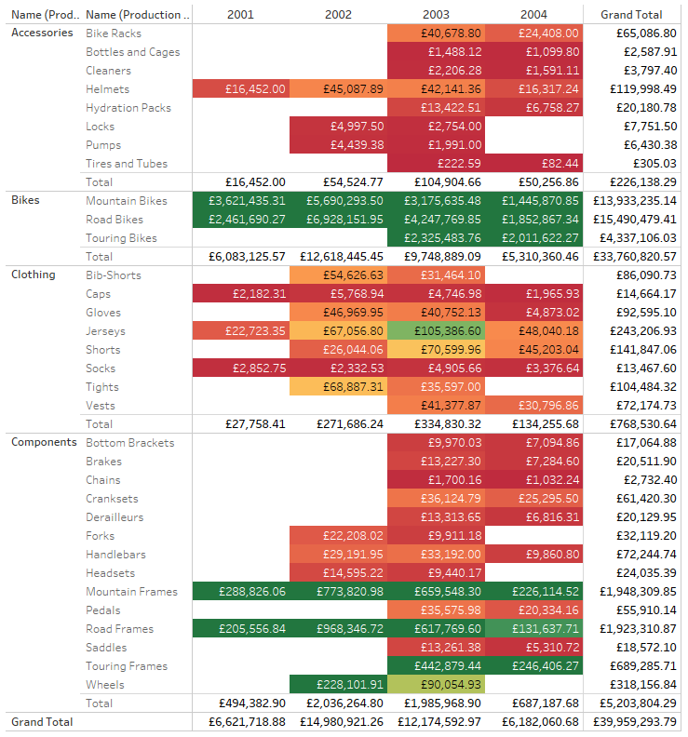
Illustrates all the products sold in NA from 2001 to 2004 using a “heat” method to show great profit

2.
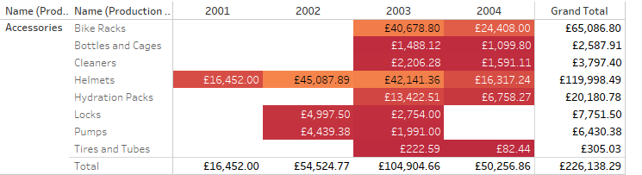
Shows all accessories items profit gains

3.
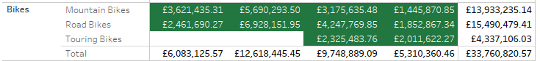
Shows all Bike items profit gains

4.
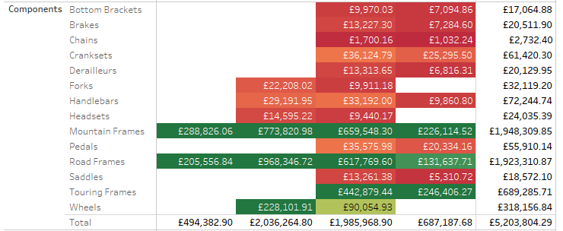
Shows all component related item gains

5.
Shows all clothing sales
6.
Shows each year’s grant total money earned
7.
I have been task to illustrate the company’s sales over 2001 to 2004 and forecast sales over the following 12 months. I will be captivating and analysing this data using a software called [3]“Tableau” which allows for me to geographically see all the values, and specifically for me, all North America and determine my findings with this report.
[4]Tableau is a graph building software using mapping functionality and data to plot and connect to create graphs out of. [5] It also has built in geocoding which allows for see for example countries, states, districts and so on, to use for plotting and perhaps showing data via say a “heat map” for example. The number of useful tools that tableau provides (as long as you present it a database) is astronomical, and it uses to show results is without question useful to say the least.

