MBA- Master of Business Administration
Module: LCMB7000- Human Resource Management
Name: Disha Nareshkumar Jain
Student ID: 2241838
Title: Human Resource Management Assignment 1
Date: 23/08/2023
Lecturer Name: Dr. Gladius Kulothungan

Contents
1. Introduction 2
2. Current Employment Situation in the UK 2
3. Emerging Changes in Human Resource Management Techniques 4
4. Challenges and factors to think about 5
5. Future Prospects 6
6. Conclusion 7
References 8

1. Introduction
This research analyses the UK labour market and Human Resourcing initiatives after the COVID-19 epidemic and Brexit. These two historic events have transformed UK employment and talent management. This paper examines how Covid-19 and Brexit have affected the labour market and human resource practises, including trends, problems, and strategic shifts. The UK labour market was forever changed by the COVID-19 pandemic and Brexit. Employment trends, skills demand, and labour dynamics have changed dramatically due to these occurrences. The employment market changed rapidly as firms faced unanticipated changes and uncertainties, forcing them to rethink workforce acquisition, retention, and development. Brexit and immigration and regulatory reforms have affected international talent, while the COVID-19 pandemic spurred remote work and digitalization. This requires a thorough review of the labour market and an examination of the innovative solutions organisations are using to solve the issues. We examine UK labour market trends in unemployment, skills demand, remote work, and automation in the following sections. We also discuss Human Resourcing Strategies' dramatic improvements, including remote work policies, reskilling programmes, talent acquisition shifts, diversity and inclusion efforts, agile HR practises, and employee well-being. This research examines all of these components to give a complete picture of the UK labour market and the strategic responses affecting human resource management.
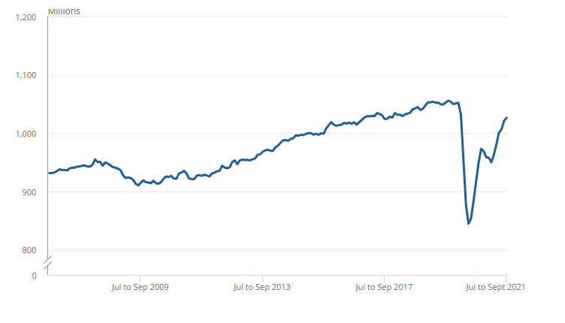
Total actual weekly hours worked increased on the quarter, reflecting the relaxation of coronavirus (COVID-19) restrictions
Source: Office for National Statistics – Labour Force Survey

2. Current Employment Situation in the UK
Due to the confluence of the Covid-19 pandemic and the Brexit transition, the labour market in the United Kingdom has seen significant changes. These incidents combined have changed the job landscape, posing problems and opportunities for employers, employees, and politicians alike.

Statistics on Unemployment
The early and severe effects of the Covid-19 outbreak on the labour market caused a spike in unemployment rates as firms closed or reduced their operations. The UK had an extraordinary rise in unemployment rates at the height of the pandemic. While government assistance programmes like the furlough programme gave many workers a chance at survival, the general economic unrest resulted in job losses across many industries. Unemployment rates started to decline steadily as constraints loosened and the vaccination programme gained steam. However, because of continuing restrictions and modifications in consumer behaviour, several industries, particularly those in the hospitality, travel, and entertainment, have recovered more slowly. This has highlighted the need for focused interventions and support systems to help these sectors recover and their employees reintegrate.

Mismatched skills and workforce adaptation
The ongoing problem of a skills mismatch has been brought to light by the changing labour market. The need for some skills has changed as a result of quick technical improvements and shifting consumer tastes. The skills needed to fulfil the changing needs of industries are often inadequate among workers. Brexit-related restrictions on the free movement of labour have made the issue worse by restricting access to overseas talent that might have helped close the skills gap. Businesses are investing more in projects to reskill and upskill people as a result, giving them the skills they will need in the future. These initiatives cover a wide range of fields, including soft skills like flexibility and critical thinking as well as IT and digital abilities. Additionally, educational institutions and training providers are working with companies to offer specialised programmes that match industry needs, resulting in a workforce that is more adaptable and resilient.

Remote employment with the digital revolution
The broad acceptance of remote work and the digital transition were sped up by the Covid-19 epidemic. Remote work options were immediately used by businesses to maintain continuity during lockdowns and social seclusion measures. This revolution has fundamentally altered how work is done and modified long-held ideas about the workplace. Benefits of remote work include increased talent pools, better work-life balance, and lower overhead expenses for companies. However, it also presents issues with worker engagement, teamwork, and mental wellness. Organisations are now faced with improving their policies on remote work, putting in place efficient communication systems, and encouraging a sense of community among remote workers.

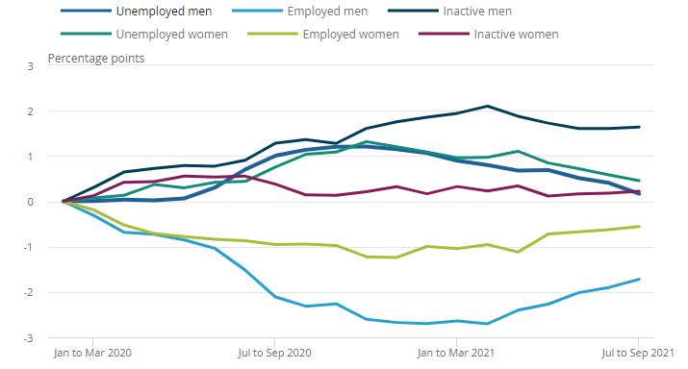
Following large falls over the pandemic, the employment rates for men and women continue to show signs of recovery
Source: Office for National Statistics – Labour Force Survey

3. Emerging Changes in Human Resource Management Techniques

Human resource management strategies are going through substantial changes to be in line with the changing dynamics of the UK labour market in the wake of the Covid-19 pandemic and the post-Brexit landscape. The need to adjust to remote work, close the skills gap, overcome difficulties in finding talent, advance diversity and inclusion, and guarantee employee well-being are the driving forces behind these changes. The adoption of rules for remote work is one of the most obvious changes in human resource management strategies. Organisations had to quickly adapt to remote work due to the pandemic, which forced them to reconsider the usual office layout. Beyond the limitations of geography, working remotely has advantages in terms of flexibility and access to a larger talent pool. However, for it to be implemented effectively, performance evaluation must be approached differently, open channels of communication must be encouraged, and technology must be used to enable virtual cooperation. The development of thorough remote work policies that strike a balance between productivity and employee wellbeing is now the responsibility of HR departments.
Upskilling and reskilling employees have become crucial tactics to solve the skills gap that the epidemic and Brexit have exacerbated. To stay relevant in the continuously evolving technology landscape, personnel must develop new competencies. In order to provide their staff with the skills necessary to fulfil changing job needs, organisations are investing in specialised training programmes, collaborations with educational institutions, and internal mobility initiatives. Employee job security is improved, and they are given the tools they need to effectively contribute to the expansion of their company. The difficulties of finding talent in the post-Brexit environment have caused recruitment techniques to be reevaluated. Exploring indigenous talent pools is necessary due to the difficulty in accessing talent from abroad. Advanced digital recruiting platforms, data analytics, and AI-driven tools are being used by businesses to more effectively find and connect with prospects. In order to recruit and keep top personnel, businesses are now concentrating on building engaging employer brands, providing competitive remuneration packages, and emphasising chances for growth.

4. Challenges and factors to think about
When reshaping their human resource strategies to fit the shifting environment, organisations must traverse a number of problems and issues brought on by the transformational transformations caused by the convergence of the Covid-19 pandemic and Brexit. These difficulties include the digital divide, difficulties with change management, complex legal and regulatory issues, and the best use of a global talent pool.
1. Changes in the law and regulations: A number of significant legal and regulatory developments brought about by the post-Brexit climate have an impact on personnel management. Immigration regulations, work permits, and other compliance issues pertaining to international employees must be managed by organisations. It takes careful preparation, legal knowledge, and a strong system for recording and maintaining work-related documentation to ensure compliance with these new regulations. If you don't follow these rules, you risk getting in trouble with the law and damaging your reputation.
2. The Digital Divide: A stable internet connection and equitable access to digital tools are prerequisites for the widespread adoption of remote work. However, in practise, there are differences in employees' access to technology. To guarantee that all employees have the tools they need to operate productively from remote locations, organisations must address this digital gap. To prevent unequal access to opportunities and information, it becomes essential to provide the required technology and training.
3. Management of Change: To achieve a seamless acceptance and reduce opposition, the deployment of new human resource management strategies requires effective change management. Changes in team structures, new skill development efforts, or changes in work arrangements may be met with resistance from employees. To ensure a smooth transition, HR departments must clearly explain the reasoning behind these changes, involve workers in the decision-making process, and offer extensive training and assistance.
4. Optimisation of the global talent pool: Organisations' reliance on access to global talent pools has been hampered by Brexit. Businesses must find creative ways to draw in and keep skilled workers from a variety of backgrounds from the domestic talent pool in order to overcome this constraint. To establish the company as an employer of choice, it is necessary to provide competitive pay, foster enticing workplace cultures, and implement effective talent development strategies.
5. Management of Hybrid Work Models: Organisations are challenged to keep team cohesion and communication open as they adopt hybrid work models that include remote and on-site work. A thoughtful approach to collaboration technologies, regular team meetings, and cultivating a sense of togetherness among geographically scattered team members are necessary to strike a balance between the needs of remote and in-office workers.
6. Execution of reskilling and upskilling: Initiatives to reskill and upskill workers are crucial for closing the skills gap, but they must be well planned and carried out to be successful. To guarantee that newly acquired skills are successfully used in the workplace, organisations must identify the skills that are most important to their future success, create training programmes that accommodate diverse learning styles, and offer continuous support.
7. Health when Working Remotely: While working remotely allows for flexibility, it also puts employee safety at risk. Potential difficulties include loneliness, exhaustion, and a blurring of the lines between work and personal life. By encouraging mental health support, encouraging frequent breaks, and outlining clear expectations for work hours and communication, organisations need to take proactive measures to address these challenges.
Organisations should take a proactive and adaptable stance in addressing these issues. Important tactics include working with legal professionals, making investments in IT infrastructure, promoting open communication, and supporting a culture of continual learning and growth. Additionally, by proactively addressing these issues, organisations can not only reduce risks but also seize chances for expansion, innovation, and improved worker wellbeing in the context of a changing labour market.

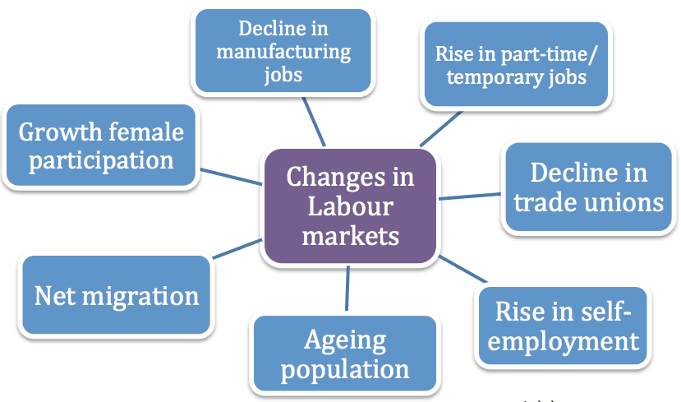
Recent Changes in UK Market Labour
Source: economicshelp.org

5. Future Prospects
In the upcoming years, as the labour market in the UK adjusts to the demands of the post-Covid, post-Brexit external environment, there will likely be considerable changes. The future of work is likely to be shaped by these shifts, which will affect everything from how people work to the methods used by organisations to recruit, retain, and grow their staff. The adoption of hybrid work patterns is one of the most obvious changes that will soon take place. The Covid-19 outbreak hastened the acceptance of remote employment, and it is anticipated that this tendency will continue after the crisis. Flexible work options are valued by organisations for enhancing work-life balance and extending access to talent beyond geographical limits. In order to allow seamless cooperation and preserve a sense of belonging among both on-site and remote employees, changes must be made to HR regulations, IT infrastructure, and communication channels in the workplace of the future. Another factor that will be crucial in determining how the labour market will develop in the future is the emphasis on reskilling and upskilling. To be relevant, individuals' abilities must change along with the continually evolving sectors. Companies are likely to foster a culture of lifelong learning by funding training initiatives that enable staff to continue to grow professionally. This dedication to skill development will be crucial in closing the skills gap and ensuring a workforce that can succeed in a changing labour market.
It is also projected that creative talent sourcing techniques would develop. Organisations are looking into new methods of hiring people as a result of the Brexit restrictions. It's expected that cross-industry hiring, educational alliances, apprenticeships, and internships will gain popularity. Such tactics not only give people the chance to enter new industries but also give corporations access to a variety of skill sets and new viewpoints. It is anticipated that the data-driven approach to human resource management would play a bigger role. Data analytics will be used by HR departments to make educated choices about hiring, performance review, and employee engagement. Organisations can adapt their strategies to better suit the requirements of their employees and increase organisational efficiency by using data-driven insights to find patterns, preferences, and areas for development. To successfully traverse unpredictable times, organisations will continue to need agility and adaptation. The Covid-19 pandemic experience showed how crucial it is to react rapidly to evolving situations. Agile approaches will be used by HR departments to quickly handle problems, update plans, and match the workforce with altering corporate priorities.

6. Conclusion
In conclusion, the Covid-19 pandemic and the effects of Brexit have combined to create the conditions for a significant change in the UK labour market and human resource strategies. The adoption of hybrid work arrangements, increased attempts to reskill and upskill employees, and creative talent procurement techniques are anticipated to define the new standard as we look to the future. Businesses will rely on data-driven insights to inform their HR choices, promoting flexibility and resilience. Furthermore, a more thoughtful approach to talent management and acquisition will result from the emphasis on sustainability and social responsibility. Even though Brexit restricts the movement of international talent, the UK's search for new ways to engage the globe shows that it is committed to maintaining its competitiveness on the global arena. It takes strategic insight, agility, and a consistent commitment to employee well-being to successfully navigate this changing market. Organisations will be better able to attract, retain, and grow a talented staff if they match their human resource strategies with these new trends. This will ensure their success and longevity in the fast-paced post-Covid and post-Brexit future. The UK is working to create the labour market of the future with the knowledge that innovation and adaptation are essential components of both a strong workforce and a booming economy.

References

1. Anderson, D., & Konrad, A. M. (2020). Redesigning the post-COVID-19 workplace. Organizational Dynamics, 49(2), 100800.

2. CIPD. (2021). Labour market overview, UK: February 2021. Chartered Institute of Personnel and Development.

3. Deloitte. (2020). The UK's future skills-based immigration system. Deloitte UK.

4. European Commission. (2020). The impact of the coronavirus on migration and asylum in the EU. European Commission.

5. Gartner. (2021). Future of work post-COVID-19: Implications for HR leaders. Gartner.

6. Green, F., & Mayhew, K. (2020). The impacts of the Coronavirus Job Retention Scheme: Evidence from firm and employee surveys. National Institute of Economic and Social Research.

7. McKinsey & Company. (2020). The future of work after COVID-19. McKinsey Global Institute.

8. Office for National Statistics. (2021). Employment in the UK: May 2021. Office for National Statistics.

9. PwC. (2021). HR's role in the future of work: 11 takeaways from our report. PricewaterhouseCoopers LLP.

10. Society for Human Resource Management (SHRM). (2020). The post-pandemic workplace: Adapting to the new normal. SHRM Research.

11. Taylor, S., & Harris, R. (2020). Reskilling in the post-pandemic era: A literature review. Journal of Vocational Education & Training, 72(4), 499-523.

12. The Guardian. (2021). Employers face skill shortages after Brexit and Covid, says CBI. The Guardian.

13. UK Government. (2021). The UK's points-based immigration system: An introduction for employers. GOV.UK.

14. World Economic Forum. (2020). The future of jobs report 2020. World Economic Forum.

15. Zhu, H., Liu, D., & Wang, C. (2021). Impact of the COVID-19 pandemic on firm productivity. Review of Economics and Statistics, 103(4), 690-702.

