

Report

Sustainability and Waste Reduction Strategy at InterContinental London – The O2



Module: Organisational Consultancy

Module code: BMIH6005

Lecturer Name: Natalie Brailsford

Student name: Elena Stenic

Student ID: 2246472

I acknowledge the use of Grammarly (https://www.grammarly.com/) on 17 June 2025 to check my work using the prompt(s):
- Please check the following text for readability, grammar and syntax.

I confirm that I have not presented any AI generated text as my own work. I confirm I have copies of my drafts, notes, and other resources I used before, and after the use of AI tools which I may be asked to provide in evidence.

Executive Summary
This consultancy report aims to tackle the sustainability and waste reduction issues of InterContinental London – The O2, a high-profile 5-star hotel in Greenwich, London. Situated near the O2 Arena, the hotel hosts a wide variety of guests such as business travellers, leisure tourists, and event participants. Though it has been highly successful and associated with luxury, the hotel has major problems involving waste management, energy use, and over-dependence on disposable plastics, raising operating expenses, hurting the hotel's environmental footprint, and diminishing its brand name.
This is a consultancy report produced by, which is a sustainability and operational efficiency consultancy specifically focused on the hospitality sector. This report aims to deliver InterContinental London – The O2 with actionable, real-world recommendations to tackle its sustainability problems and adopt successful waste reduction measures that meet current environmental and consumer demands.
The major conclusions of the report note some of the areas where the hotel is not doing well as far as sustainability is concerned. First, the waste management process in the hotel is ineffective, with high waste sent to landfills, rather than being diverted using recycling or waste-to-energy technology. This inefficiency is translating into the high cost of disposal and high environmental impact. Second, the energy use of the hotel is disproportionately excessive, with excessive use of non-renewable sources of energy, resulting in higher energy expenditures and a heavier carbon footprint. Third, single-use plastics used for water, packaging, and straws throughout the hotel have caused plastic contamination and detracted from the reputation of the hotel as an ecologically friendly brand.
Research Methodology
To evaluate the sustainability issues of the hotel and propose solutions, an in-depth analysis was conducted utilising different strategic frameworks. STEEPLED analysis was utilised to analyse the external factors—social, technological, economic, environmental, political, legal, ethical, and demographic—impacting the hospitality industry's strategy towards sustainability. This identified the major external drivers that could either be opportunities or threats to the hotel in its sustainability initiative.
Also, a SWOT analysis was undertaken to determine the internal strengths, weaknesses, opportunities, and threats of the hotel with regard to sustainability. Through the SWOT analysis, it was identified that although the hotel has good brand recall and an excellent location, it has several internal weaknesses, like inefficient waste and energy consumption methods.
The TOWS analysis was employed to develop strategic suggestions by aligning the hotel's internal strengths with external opportunities and determining the strategy to counter its weaknesses and overcome threats. This strategic framework assisted in informing the generation of feasible solutions to the hotel's sustainability issues.
Key Findings
Waste Management Inefficiency: The hotel's existing waste management system is not efficient, and a high percentage of waste ends up in the landfill instead of being recycled or used as energy. This is resulting in increased disposal expenses, an expanding environmental impact, and lost opportunities for recycling and waste reduction. Use of single-use plastics is making this situation even worse, resulting in plastic contamination and weakening the hotel's initiatives to brand itself as environmentally friendly.
Excessive Energy Consumption: The energy consumption of the hotel is high, driven mainly by its use of non-renewable sources of energy. This translates into excessive energy expenses, high carbon footprints, and negative branding, as consumers become more environmentally conscious about the carbon footprint of businesses they patronise. The hotel can save a lot of energy by adopting renewable sources of energy and energy-saving technology.
Single-Use Plastics: Problems arise from the hotel’s use of single-use plastics in guest rooms, dining facilities, and event spaces. It complicates the waste issue and leads to bad environmental impacts. The more plastic the hotel uses, makes less appealing it is to guests who are eco-conscious and want green alternatives, hence affecting its competitiveness and market share.
Environmental Awareness and Consumer Demand: The demand for environmental practices by consumers is rising. A large percentage of travellers place sustainability at the top of their criteria for accommodation choices. Such a trend provides an avenue and simultaneously a challenge for the establishment to push further its sustainability measures, improve guest satisfaction, and make itself stand out amidst the competitive environment.
Recommendations
From the findings, key recommendations are made to help InterContinental London – The O2 address its sustainability challenges.
Improve Waste Management Systems: The hotel needs to adopt modern recycling systems, plus waste-to-energy systems, along with composting for organic waste. This will help reduce the volume of waste going to the landfill site, plus also help in reducing disposal costs. Besides, the hotel needs to implement a stronger segregation of waste so that recyclable materials are removed from general waste.
Take up Renewable Energy Sources: The hotel should buy renewable energy solutions like solar panels and switch to renewable energy suppliers. By reducing its use of non-renewable energy, the hotel can lower energy costs, reduce its carbon footprint show commitment to sustainability.
Eliminate Single-Use Plastics. Water bottles, straws, and other packaging should be replaced by the hotel with biodegradable and reusable alternatives. This will reduce plastic waste on such single-use items and place the hotel on the side of a growing consumer trend for eco-friendly places to stay.
Implementation and Change Management
Implementation of these recommendations would require careful planning and change management. An action plan, spelt out, with timelines, budgets, and responsibilities assigned, will be necessary to ensure smooth execution. Change management should focus on engaging employees and communicating and training them while also ensuring guests are aware of the hotel’s sustainability initiatives.

Table of Contents
Executive Summary 1
Introduction 7
Analysis 10
Consultancy Report: Sustainability and Waste Reduction Strategy at InterContinental London – The O2 10
Reviews of InterContinental London- The O2 10
Identified Problems and Their Effects 11
Reasons Behind the Issues 12
Existing Sustainability Activities 12
Structured Root Cause Analysis: 5 Whys Framework 12
STEEPLED Analysis 13
SWOT Analysis 16
TOWS Analysis 18
Recommendations and Change Management 20
Suggestions regarding Sustainability and Waste Reduction 21
Change Management Practices 23
Measuring Success and Impact 25
Possible Advantages and Disadvantages of the Implementation of the Recommendations 26
Action plan 28
Conclusion 31
References 33

Introduction
In this report, the hospitality industry puts great emphasis on sustainability as the major factor behind the efficiency of operation and customer satisfaction. Specifically, sustainability and waste reduction have become a vital aspect for hotels as a result of increased awareness by both consumers and regulators concerning the effect large-scale hospitality has on the environment. These issues are expounded in the following consultancy report based on InterContinental London – The O2, which is one of the most prestigious hotels in the UK and is situated in Greenwich, London. The report aims to define the sustainability issues that the hotel is facing, state the reasons and effects of these issues and suggest viable solutions and strategic measures to enhance waste management, lower consumption of energy, and advance sustainability in the hotel’s operations.
InterContinental London – The O2 is a top 5-star hotel, located near the famous O2 Arena in the lively Greenwich area. The hotel that opened in 2015 has 453 large rooms and suites, many fine dining restaurants, a huge consultative meeting and event facilities, and a world-class spa. With its ideal location, the hotel caters to a vast assortment of guests, such as business travellers, leisure tourists, and event attendees. Having played a key role as one of the primary contributors to the local tourism and hospitality industry, with its multitude of guests the hotel accommodates annually, there are many sustainability challenges it faces, especially in the disposal of waste, utilisation of energy, and use of single-use plastics. Such issues not only influence the operating expenses of the hotel but also the brand image, too, as the current consumers are more likely to be attracted by businesses demonstrating a concern towards environmental responsibilities.
As the world adopts environmentally friendly practices for businesses, it is important that hotels such as InterContinental London – The O2 follow suit. The impacts of failing to implement the challenges vary from greater operational costs, a ruined reputation, to losing the market share to more eco-friendly competitors. Additionally, the growing attention towards environmental regulations as well as corporate social responsibility (CSR) in the hospitality industry leads to certain pressure for hotels to implement sustainable practices to achieve a competitive advantage. That is why the hotel has to address the issues related to sustainability and waste reduction on a proactive basis, using successful strategies.
This consultancy report is based on various degrees of research and analysis to come up with viable solutions to these sustainability issues is a top-tier consultancy firm that specialises in the sustainability strategies of the hospitality industry. Over the years, servicing the big hotel chains and hospitality organisations, our firm is capable of delivering practical, results-oriented recommendations that can help the hotels perform better in their sustainability and minimise waste and increase their environmental footprint.
Several established frameworks for analysis shall be used in the report for undertaking a comprehensive understanding of the issues at hand and to propose recommendations. First, the STEEPLED analysis will be used to examine the external factors that affect the sustainability in the hotel industry, i.e, Social, Technological, Economic, Environmental, Political, Legal, Ethical, and Demographic factors. In reviewing some of these external drivers, the report will determine critical opportunities and challenges which might preclude the implementation of sustainable practices at InterContinental London – the O2.
As well, SWOT analysis (Strengths, Weaknesses, Opportunities and Threats) will offer a comprehensive evaluation of the hotel's internal environment, thus making it possible to identify the current strengths of sustainability and its areas that need strengthening. The external opportunities that the hotel can exploit, such as the growing consumer demand for eco-friendly practices and external threats, including the high cost of energy and stiff regulatory practices, will come to light through the SWOT analysis.

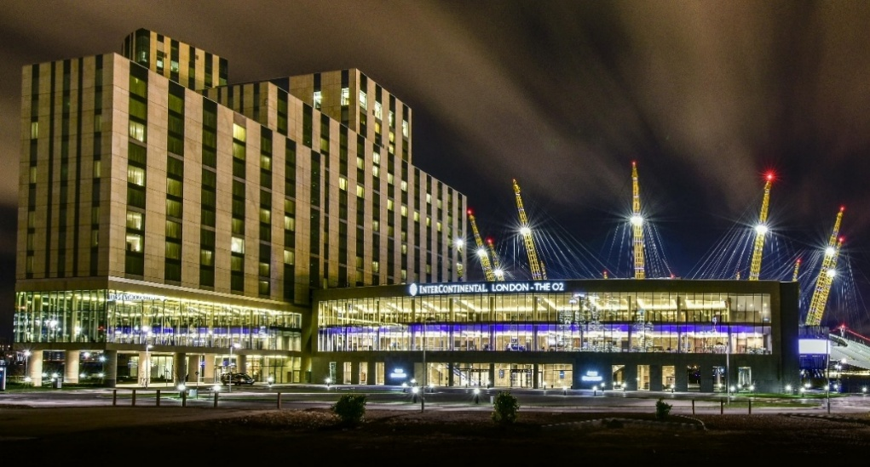
Figure 1InterContinental London - The O2
(Source: iclondon-theo2.com)

Analysis

Consultancy Report: Sustainability and Waste Reduction Strategy at InterContinental London – The O2
InterContinental London – The O2, a flagship hotel of the InterContinental Hotels Group (IHG), is strategically located near The O2 Arena in Greenwich, London. As a high-end luxury hotel, it serves many customers, including business visitors, tourists, and event visitors. Over the past few years, the hotel has seen the need to address sustainability and waste minimisation, keeping pace with global environmental issues and customer expectations (Buttrick, 2009).

Reviews of InterContinental London- The O2
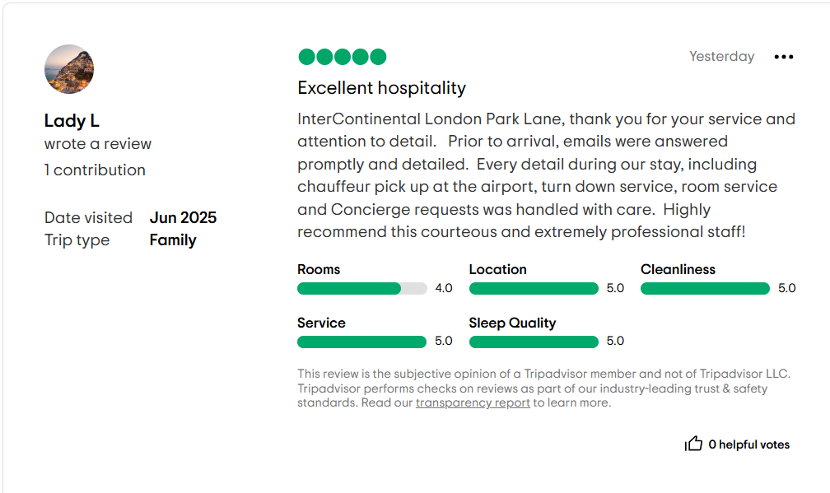
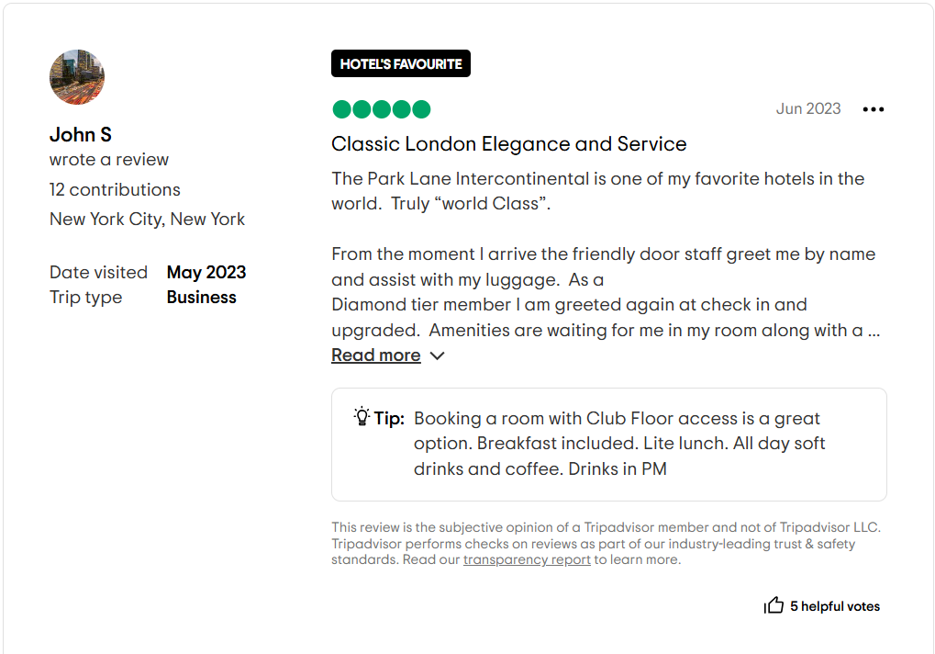

Identified Problems and Their Effects
- Environmental Impact: The hospitality sector plays a major role in environmental degradation due to energy use, water consumption, and waste production. InterContinental London – The O2 has difficulties in reducing its carbon footprint, particularly considering its size and the number of visitors it hosts (Ben Youssef and Zeqiri, 2022).
- Waste Management: Despite efforts, managing waste, particularly food waste and single-use plastics. Poor segregation and disposal of waste can result in more landfill contributions and increased operational expenses (Abd Rahim et al, 2024).
- Guest Feedback and Reputation: Guest feedback has sometimes pointed to sustainability practices issues, including inefficient appliances and wastage of water. Such feedback can negatively impact the reputation and guest satisfaction of the hotel (Scholz, Linderová, and Konečná, 2020).
- Financial Implications: Sustainability programs involve a high initial investment. Balancing the costs against long-term savings and yield is a tricky task for the management of the hotel (Burnes, 2014).

Reasons Behind the Issues
- Scale of Operations: The size of the hotel and its high occupancy result in heavy usage of resources (Noordzife, 2014).
- Limitations of Infrastructure: Outdated systems and equipment can be less efficient and thus use more and waste more.
- Training of Staff: Lack of training in sustainable practices can cause inconsistent application across departments (Mavridopoulou and O’Mahoney, 2020).
- Guest Behaviour: Guest unawareness or participation in sustainability efforts can undermine their success (Whittington et al,2020).

Existing Sustainability Activities
- Energy Conservation: The hotel incorporated solar panels and energy-efficient elevators to decrease electricity usage. MEIKO dishwashing machines have also been installed, utilising 33% less water and detergent than normal systems. London Convention Bureau (O’Mahoney, 2021).
- Minimisation of Waste: Efforts also involve the banning of single-use plastics and the utilisation of compostables. The hotel further engages with The O2 Arena's sustainability initiatives, which have diverted considerable waste from landfilling (Kipping and Clark, 2012).
- Sustainable Amenities: Collaborations with suppliers such as The Fine Bedding Company guarantee ethically sourced and long-lasting materials, ensuring both guest comfort and sustainability (Subramaniam et al, 2011).

Structured Root Cause Analysis: 5 Whys Framework
To get a clearer picture of the reasons behind sustainability issues at InterContinental London The O2, the 5 Whys of root cause analysis was implemented. This is a very effective and simple tool that can be used to dig deep into the issue/problem causing problems at a surface level by constantly asking why, usually five times but till the root cause of the issue is known.
Problem Statement: Wastes in very large amounts are being discharged to landfills in spite of the available recycling programs.
- Why is a large amount of waste going to landfills? As a reason, it is not being properly segregated at the source (i.e. guest rooms, kitchens, events).
- Why is the waste not being segregated properly? It should be because proper waste disposal methods among the guests and some of the staff are not educated, and there is a lack of signage.
- Why is there insufficient signage and awareness? Since the hotel has not provided periodic training and a guest interaction policy to manage waste.
- Why hasn’t a consistent training program been implemented? Since the sustainability activity is not incorporated into the culture of functioning of the hotel, and involves personnel recruitment.
- Why is sustainability not integrated into the operational culture? The reason is that sustainability is not regarded as a principal strategic focus in all of the departments.
Inefficiency in waste management is, therefore, a by-product of the main problem: an insufficient inclusion of sustainability into the culture of the hotel and its working practices. This is best solved by institutionalising sustainability in the employee education and interaction with guests, and operation within the hotel. The insights of this analysis directly feed into the section of recommendations, in particular, those that pertain to the issues of staff training, the education of the guests, as well as the role of leadership in sustainability strategy.

STEEPLED Analysis
STEEPLED is a tool of great importance for examining external factors that affect the strategies of an organisation. For InterContinental London – The O2, sustainability and waste reduction must be understood under social, technological, economic, environmental, political, legal, ethical, and demographic contexts of the hospitality industry. In the following, there is a detailed examination of every factor concerning the sustainability efforts of the hotel (Richter et al, 2022).
Social Factors
Social forces are the core force in determining the sustainability strategy of InterContinental London – The O2. Today, in the socially aware world, guests are closing in on eco-friendly accommodations to correspond with the value system (Hashmi, 2024). Consumer expectations continue to change, and the traveller must now have a very high priority on environmental responsibility, ethical procurement, and green certifications. Hotels that do not show any authentic sustainability effort are bound to lose market share to their competitors who market eco-friendly activities (Kuo, Fang, and LePage, 2022).
Technological Factors
Technological developments can give great opportunities to InterContinental London – The O2 for enhancing its environmental performance. New solutions to more energy-efficient systems and waste management, as well as smart buildings technology, can slash the hotel’s use of resources and the costs of its operations (He, Mushtaq, and Jan, 2024). For example, the hotel has implemented the MEIKO dishwashing systems that require 33% less water and detergent, which demonstrates how technology could be directly involved in waste reduction. In addition, there are automations in energy management systems, such that a motion-sensor lighting system and smart HVAC system can be used for optimised resource utilisation (Han and Zhang, 2020).
Economic Factors
Economic factors are critical to the feasibility and sustainability of sustainability programmes. Although investing in eco-friendly technologies and upgrading infrastructure may require a significant initial outlay, long-term savings in the form of energy and water bills make up for these expenses (Doszhan et al, 2022). Also, hotels that are more focused on sustainability can win the attention of the expanding community of environmentally concerned travellers, which will increase occupancy rates and revenues (Guo and Li, 2024).
Environmental Factors
The environmental concerns lie at the core of sustainability and the reduction of waste. The hospitality industry is faced with scrutiny in terms of carbon emissions, wastage of water and landfill overflows. As a luxury hotel, InterContinental London – The O2 is a large-scale one, and with that comes great environmental pains to curb its footprint (Redlingshöfer, Barles, and Weisz, 2020).
Political Factors
Political forces play a great role in sustainability practices in the hospitality sector. Both government policies, regulations of local councils, and international agreements dictate the necessity for hotels to embrace green practices (Webster and Cain, 2025).

Legal Factors
The legal environment related to the issues of environmental sustainability is getting more rigid. Hospitality businesses have no choice but to comply with local, national and international laws regarding waste disposal, usage of energy and reporting of the environment (Lazarus, 2023). To InterContinental London – The O2, compliance with government requirements from the UK, such as the UK Environment Act 2021 and the Waste (England and Wales) Regulations 2011, is a necessity.
Ethical Factors
The consideration of ethical issues is crucial to the sustainable strategy of the hotel. InterContinental London – The O2, as part of a well-known worldwide brand, has a corporate responsibility to exercise ethics towards the environment and the people it serves (Stoimenov, 2023).
Demographic Factors
Demographic trends have important determinants in terms of demand for sustainable hospitality services. The younger generations, especially millennials and Gen-Z tourists, have shown tremendous propensities for environmentally responsible brands.
Factor | Impact on Hotel
Social | Growing guest preference for eco-friendly accommodations necessitates enhanced sustainability efforts.
Technological | Advancements in energy-efficient appliances and waste management systems offer opportunities for improvement.
Economic | Initial investments in sustainable infrastructure can be offset by long-term savings and increased patronage.
Environmental | Regulatory pressures and environmental concerns drive the need for reduced emissions and waste.
Political | Government incentives and policies support sustainable practices in the hospitality sector.
Legal | Compliance with environmental regulations is essential to avoid penalties and maintain operations.
Ethical | Upholding corporate social responsibility enhances brand image and stakeholder trust.
Demographic | Younger travellers often prioritise sustainability, influencing market strategies.

SWOT Analysis
SWOT analysis is a systematised review of internal strengths and weaknesses of InterContinental London – The O2 and external opportunities and threats for its sustainability and waste reduction strategy (Hashmi, 2024).
The hotel’s most important advantage is its location near The O2 Arena, which helps it to attract a large flow of its guests – business travellers, event participants and tourists. This constant foot flow provides a very consequential platform to promote its sustainability endeavours to a large number of people (Kalgi and Hire, 2024). Also, being a part of the InterContinental Hotels Group allows the hotel to enjoy the IHG Green Engage programme that is well known worldwide, which gives an exhaustive set of rules for energy efficiency, waste reduction, and environmental management. Its current associations with sustainable suppliers – MEIKO in energy-efficient dishwashing appliances and The Fine Bedding Company in responsibly sourced materials – add to the hotel’s green credentials. Such powers of strength will see the hotel stand as a responsible luxury brand focusing on an ever more eco-conscious marketplace (Chong, 2023).
Lack of consistent implementation of green practices in various departments, whereby it is usually caused by improper staff training, undermines the organisation’s efforts to be green (Khalil et al, 2024). Additionally, the guest involvement in the sustainability programmes is still low, and eco-friendly policies have a limited effect, and fewer chances for positive feedback on the side of guests as well (Abdou et al, 2022).

Strengths | Weaknesses
Strategic location near The O2 Arena | High operational costs are associated with sustainability initiatives.
Affiliation with IHG's Green Engage program | Inconsistent implementation of sustainable practices across departments
Opportunities | Threats
Leverage technology for enhanced sustainability (Ahmed, 2023). | Negative guest reviews are impacting the reputation.
Collaborate with local communities for sustainability initiatives | Regulatory changes are increasing compliance costs

An effective SWOT analysis needs to be directly formatted against the sustainability issues raised in the report, namely waste management flaws, energy inefficiency, and plastics problems, so that strengths, weaknesses, opportunities, and threats pertain to and/or address them. In essence, do not mix the language of the SWOT proposition outside of each situational challenge.
- Strengths: One strength is the hotel's membership in IHG's Green Engage Programme, which is a strength because the hotel is a member of an organisation that provides standards and tools around sustainability at the global level. This provides a path towards improvements, for example, energy efficiency and waste minimisation.
- Weaknesses: Similar to identifying strengths, weaknesses have to relate to the operational issues identified. For example, "Different levels of sustainability action across campus" would directly speak to the operational issues of waste segregation and training that were found in the report.
- Opportunities: Opportunities should be the solution. The desire for eco-friendly tourism is an opportunity for the hotel to further position itself as a green leader.
- Threats: Threats can include an increase in compliance costs or negative reviews from customers based on the environmental standards of the product being reviewed.

TOWS Analysis
The TOWS matrix is a way to translate the SWOT items into actions:
- SO Strategy: Use the strengths (for example, membership in Green Engage) to capitalise on the opportunities (for example, attract new guests who are eco-conscious), such as environmental campaigns that draw attention and showcasing solutions that have been implemented, like water-efficient systems.
- WO Strategy: Turn weaknesses into strengths (for example, inconsistencies in employee training), or utilise a connection between opportunities (for example, interest from guests who travel with an eco-friendly mindset) and your weaknesses. Develop sustainability and responsibility workshops led by employees, and utilise brochures telling guests about conservation programs they can be involved in.
- ST Strategy: Look for ways to turn your strengths (such as supplier partnerships) into situations that mitigate a threat (for example, negative feedback). For example, showcase your sustainable farm sourcing in marketing and communications.
- WT Strategy: Against approach the weaknesses and mitigate the threats, through internal audits, internal reviews, employee evaluations, mechanisms to hold staff accountable for their compliance with sustainability and responsibility issues, to improve both compliance with sustainability measures and increase guest satisfaction.
The SWOT points align with the hotel’s major sustainability issues, and the TOWS strategies logically flow from this analysis will help demonstrate to your operational manager that the consultancy report is strategic and will provide better justification for your recommended practices.
TOWS analysis strategically relates the internal strengths and weaknesses of the firm with the opportunities and threats in the external environment, for the creation of usable strategies for enhancing sustainability and waste reduction actions (Wang and Wang, 2020).
With its advantages, including its opportune location and membership in IHG’s Green Engage programme, the hotel can target the emerging market of eco-concerned travellers and corporate clients who are on the lookout for environmentally friendly hotels. For instance, the hotel can promote its existing green initiatives, i.e. water-efficient MEIKO systems and relations with ethical suppliers, via specific marketing campaigns. Such efforts would not only attract environmentally responsible guests but also boost the hotel's competitive advantage in the context of the luxury hospitality market (Kuo, Fang, and LePage, 2022).
To correct the weaknesses, especially when referring to inconsistency in the implementation of the sustainability practices and lack of guest engagement, the hotel can focus on extensive training of the staff (Khatter, 2023). Training the employees in all departments on sustainable operations will standardise matters and increase the effectiveness of green programmes. Also, engaging with the guests through interacting with guest engagement platforms, like digital apps or in-room sustainability challenges, can help engage guest participation in environmentally-friendly behaviours during their stay, turning a weakness into an opportunity for increased guest satisfaction and positive reviews (Gull and Idrees, 2022).
Strategy Type | Strategies
SO | Promote existing sustainability initiatives to attract eco-conscious travellers.
 | Utilise IHG's global platform to share best practices and innovations.
WO | Invest in staff training programs to ensure consistent implementation of sustainable practices.
 | Engage guests through interactive sustainability programs and feedback mechanisms.
ST | Monitor and address guest feedback promptly to mitigate reputational risks.
 | Stay ahead of regulatory changes by proactively adapting policies and practices.
WT | Conduct regular audits to identify and rectify inefficiencies in sustainability efforts.
 | Benchmark against competitors to ensure competitiveness in sustainability initiatives.

Recommendations and Change Management
The InterContinental London – The O2 is determined to enhance its sustainability and waste minimisation practices. Based on the SWOT and TOWS analysis done on the strengths, weaknesses, opportunities and threats for the hotel before, CVS and key recommendations have been identified to improve the hotel's sustainability strategy (Prakash et al, 2023). In this section, the above recommendations will be explored in detail with particular focus on how they can be implemented effectively and the change management practices that will help bring the change and the method of measuring their success. In addition, the potential gains to the hotel will be reviewed, and the costs that will be involved in the whole process of decision-making (Pappas et al, 2021).
A consultancy report is more impactful and credible when all recommendations are grounded in analysis, i.e., each recommendation should have specific reasons, outlined in the SWOT, TOWS, STEEPLED, or root cause analysis. For example, if an analysis indicates poor waste segregation was a prominent issue as a result of ineffective training staff, then the recommendation should include structured training and effective signage; or if a client is found to be using excessive energy due to systems being out of date (she was generating too much waste energy as a result of the 5 Whys analysis), then the proposal to invest in solar panels or efficient appliances is reasonably grounded and justified.
Grounding recommendations in analysis guarantees that the response shows the problem, and then offers a reasonable action to the solution, and therefore that the recommendations do not just appear arbitrary, but rather are derived from data, and are specific to the context. Grounding the recommendations also enhances the feasibility of the action plan as it allows all stakeholders to acknowledge the reasoning and anticipated effects. Again, separately linking the action plans or recommendations to the relevant framework of analysis (i.e., STEEPLED or TOWS) also provides some strategic credence in terms of considering internal capacity and external opportunities. Structured, logical linkages reinforce overall quality, coherence and persuasiveness of the consultancy report.

Suggestions regarding Sustainability and Waste Reduction
Waste Reduction through Better Recycling Programmes
Waste management is one of the major aspects of sustainability at InterContinental London – The O2. Even though the hotel already has implemented several programmes for recycling, there is a significant space for improvement. The hotel should consider improving its waste segregation system in a way that the guests and staff will be more involved in the process. This can be achieved by (Hashmi, 2024).
- Installation of clear signage in all areas that include guest rooms, public spaces, and staff areas to direct the right disposal of waste.
- Utilising investments in waste-to-energy systems that use the organic waste to create energy, which may be used to fuel non-essential lighting or heating systems in the hotel.
- Collaborating with the local recycling companies to make sure that the waste, and specifically the plastics and paper, is recycled properly adds to the hotel’s environmental impact (Adelekan and Sharmina, 2024).
More use of renewable sources of energy
The hotel should preferably switch to renewable sources of energy, like solar or wind energy. The initial costs are high, but the long-term savings on energy will compensate for the investment (Alghassab, 2022). This can be achieved by:
- The installation of the solar panels on the roof or any other places that are not being used in the property of the hotel (Taghipour et al, 2024).
- Moving over to green energy suppliers and effectively ensuring that the hotel’s energy consumption is coming from renewable resources.
- Purchasing energy-efficient lighting and HVAC systems that could be installed to work with the hotel’s existing ones to minimise energy spending (Barbara et al, 2024).
Reducing Single-Use Plastics and Packaging
The hotel needs to do more to reduce dependence on single-use plastics and packaging, which are major contributors to landfill waste (Al-Shihabi et al, 2024). This can be done by:
- Instead of using plastic water bottles, use refillable bottles made of glass or stainless steel for both the staff and the guests.
- A specific example of how to engage in the use of biodegradable packaging in food and beverage services is the case of in-room dining (Adama, 2021).
- Promoting the use of reusable items by the guests, such as shopping bags or water bottles, by providing incentives such as discounts in future visits or loyalty points.
Improvement of staff training on sustainability practices.
For the sustainability efforts of the hotel to be successful, workers must know about the hotel’s green initiatives and be active executors of them. Training, therefore, should be one of the top priorities (Khalil et al, 2024). This could involve:
- Periodic sustainability workshop for all employees to make them understand the need to reduce waste, harness less energy and engage in eco-friendly activities.
- Providing incentives for ecological behaviour in the form of rewards for the hotel staff who help drive the hotel’s green programmes.
- Formulating certain roles in the hotel or teams, which have the specific mandate of addressing sustainability, in a way that green actions are maintained in all departments (Ahmed et al, 2021).
Guest Engagement and Education
Incorporating the guests in sustainability efforts is an important step towards developing a culture of environmental responsibility. The hotel needs to have more guest-centred sustainability programmes (Achmad and Yulianah, 2022). such as:
- Integrating sustainability information into the communications given to each guest, like welcome letters, digital information packs, or through the use of mobile phones.
- Providing guests with the possibility to engage in sustainability programmes, such as changing towels and linens, recycling, or excluding daily housekeeping to save resources.
- Offering incentives for guests who would like to engage in sustainability efforts, like providing discounts, earning loyalty points, or donating to environmental charities.
Sustainable resource procurement and food waste management
Food wastage is a major aspect that hotels can use to minimise their environmental footprint. InterContinental London – The O2 can enhance the food waste management plan by;
- Incorporating a zero-waste kitchen approach whereby extra food is distributed to the local charities or composted.
- Procurement of locally grown and organic produce to minimise the carbon footprint that comes with food imports.
- Teaching guests about food waste via digital displays and signage, asking them to take only what they need.

Change Management Practices
The organisational changes that come with these sustainability and waste reduction strategies will need to be well monitored for them to be successfully implemented. Change management is important so that the staff and the organisation will adapt to the new sustainability objectives and the change will be incorporated without creating ripples in the line of Hotel operations (Klein, Ramos, and Deutz, 2022).
Communication and Stakeholder Engagement
Proper communication will be important to ensure that all stakeholders, i.e. staff, guests, suppliers and the management, are on the same page with the changes that are to be implemented. There should be clear, transparent communication from the start (Ozdemir et al, 2023). This can be done by:
- Organising information sessions or a workshop with the employees to explain the logic behind the sustainability initiatives and the advantages of the same.
- Making sure that the updates on the progress towards sustainability goals are done regularly through internal newsletters or meetings, a sense of ownership is established among the staff (Ekblad and Ljungvall, 2020).
Training and Skill Development
As mentioned earlier, the training of the staff will play a central role in the success of these changes. There should be an establishment of a comprehensive training programme that will teach the employees the skills needed to sustain the initiatives (Blanchard and Thacker, 2023). This can include:
- Onboarding the new employees with sustainability training incorporated in their induction process.
- Ongoing professional training to ensure that employees are up to date with the current trends and technology concerning sustainability in the hospitality business (Hussain et al, 2023).
- Sustainability champions in the hotel who can mentor others and set examples.
Employee Involvement and Incentives
Staff participation is essential to a successful transition. The provision of incentives to employees to ensure that they are actively involved in their contributions to sustainability will result in their commitment to the cause (Gu et al, 2023). This could involve:
- Recognition programmes that recognise the employees for their extra efforts towards promoting sustainability.
- Incentives in the form of bonuses or prizes for the departments that perform optimally in minimising waste, saving energy, or purchasing sustainable materials.
Phased Implementation
Not all the changes should be tried to implement at a time; instead phased approach should be adopted. This will help in dealing with the transition and will be adjustable if needed. For instance, the hotel can begin with the introduction of some waste management improvement in a few of its departments, i.e. kitchen and housekeeping, first and then implement it in the whole hotel.
Using Kotter’s 8-step model
Using a structured methodology such as Kotter's 8-Step Change methodology to improve the Change Management Strategy offers InterContinental London – The O2 a clear, workable framework for putting sustainability objectives into practice. This paradigm guarantees that change is accepted by all parties involved, in addition to being presented successfully.
- Step 1: Establish Urgency. To raise awareness of the need for sustainable change, provide data on waste, energy consumption, and visitor comments.
- Step 2: Form an Overarching Alliance. Create a sustainability team of frontline employees and supervisors.
- Step 3: Create a Change Vision: List objectives like cutting plastic waste and utilising sustainable energy sources.
- Step 4: Express the Vision. Communicate objectives and advantages through meetings, training, and signage.
- Step 5: Empower Workers: Give them the tools and power to make environmentally beneficial choices.
- Step 6: Create Short-Term Gains: Honour significant achievements such as the installation of solar panels or recycling bins.
- Step 7: Sustain Acceleration: Expand programs to all departments to build on early success.
- Step 8: Anchor the Change: Include sustainability in hotel culture, rules, and employee onboarding.
Employing Kotter's methodology guarantees methodical execution, enhances employee involvement, and makes sustainability initiatives durable and significant.

Measuring Success and Impact
To make sure that the sustainability measures made are effective, there is a need for the hotel to provide clear indicators of success. Such metrics should look at both quantitative and qualitative results. Some of the key performance indicators (KPIS) may be (Scholz, Linderová, and Konečná, 2020)
- Decrease in energy consumption as well as water usage, determined through the utility bills and sustainability reports.
- Percentage of waste reduction which are monitored using monthly waste audits and recycling rates (Slutzman et al, 2023).
- Guest participation rates in sustainability programmes, measured in surveys or monitoring guest decisions in terms of eco-friendly options.
- Employee engagement levels, determined using feedback surveys and the rate of engagement in the sustainability training (Abdou, Hassan, and El Dief, 2020).
A formal review process should be put in place to determine the hotel’s sustainability performance at regular intervals, which is best every quarter to ensure that objectives are being attained. Any lack of performance should be corrected immediately using different strategies or further investments (Panno, 2020).

Possible Advantages and Disadvantages of the Implementation of the Recommendations
The pros of introducing these sustainability strategies are huge:
- Cost savings: Lower energy and water consumption and decreased costs of waste disposal will ensure that the hotel makes long-term financial savings (Sayegh et al, 2021).
- Enhanced brand reputation: The hotel will gain the image of a sustainability leader and be chosen by eco-conscious tourists and thus benefiting from a more prominent competitive position (Alsheref et al, 2024).
- Increased guest loyalty: Guests are likely to come back to the hotels that are consistent with their values, which is good for repeat business and word of mouth marketing (Koo, Yu, and Han, 2020).
- Environmental impact: Through saving on wastage and conservation of consumes and by adopting renewable energy, the hotel will do its part in the global sustainability efforts.
However, some costs accrue in getting into these strategies. These may include:
- Early outlay in green technologies (including renewable energy systems, energy-efficient appliances.
- Dollars spent on training and development of the staff to ensure that new policies are implemented properly (Urbancová et al, 2021).
- Waste management systems might need capital outlay for the upgrades of waste-to-energy solutions and new recycling bins.
- The hotel has to pace carefully for such expense and make sure that the investment would fit its long-term objectives of minimising operational cost and reducing environmental effects (Mondok, 2023).
The Sustainability and Waste Reduction Strategy for InterContinental London – The O2 outlines the way to improve its environmental performance and enhance the brand image, satisfaction of guests, and operational efficiency. With the enactment of the recommendations and careful observance of efficient change management practices, the hotel can turn its sustainability issues into grounds for increasing the business while making a positive impact on the environment (Duric and Potočnik Topler, 2021).
For the success of sustainability and waste reduction strategies recommended at InterContinental London – The O2 to be realised, it will take more than implementing new systems; there will have to be a change in culture in the organisation. The engagement of all the staff members from the management team to frontline workers is one of the key points of this transition. The hotel should institute a culture of sustainability in which green practices should be integrated in day to day operations. This can be done by emphasising the essence of sustainability in all the operations of the hotel, including food service, housekeeping and event management. In support of this, there can be a Sustainability Manager or a Sustainability Team established that would monitor the progress of these initiatives to see if the goals are being reached and the strategies adjusted accordingly (Sustiyatik, Andjarwati, and Oktavio, 2025).
Also, communication with guests is an integral part of success in sustainability initiatives. When sustainability is incorporated into the general experience of the guest, the hotel can promote a more active participation in green initiatives. For example, the hotel can spread sustainability through digital means such as the hotel’s mobile phone app or the hotel website, which can be used to notify guests of his/her consequences of the customer choices in real-time, for instance, whether the customer chooses reduced housekeeping or chooses environmentally friendly options (Khalil et al, 2024). Moreover, the spending for the shift towards more sustainable practices —still significant initially, as any transition — should be conceived as a long-term investment (Rees, 2021).

Action plan
The action plan of the InterContinental London – The O2 should be to set forth a systematic action plan on the resolution of the issues of sustainability and waste reduction prevalent, with definite solutions, results, timings, and costs. This will give the hotel a blueprint where it will be able to establish the suggested strategies efficiently and effectively (Legrand, Chen, and Laeis, 2022).
Problem: The hotel is quite strongly affected by obstacles to waste management, energy use, and single-use plastics pollution. These factors contribute to the issues of operational inefficiencies, reputational risks, and lost opportunities to lure the eco-conscious guests.
Solution: The proposed solutions involve:
- Enhancing Waste Management: Advancing the recycling systems, adding waste-to-energy devices, and introducing composting for organic waste.
- Switching to Renewable Energy: The installation of solar panels, as well as getting the supplies of energy from renewable sources.
- Reducing Single-Use Plastics: Swapping plastic bottles and packaging with environmentally friendly options.
- Staff Training: Offering ongoing training on sustainability practices to hold the employees accountable and active.
- Guest Engagement: Starting a guest sustainability programme with incentives for environmentally friendly action.
No | Problem | Solution | Desired Outcome | Time Scale | Completion Date | Planned Budget
1 | Waste management inefficiency | Enhance recycling systems, introduce waste-to-energy, and composting for organic waste. | Reduced waste, improved recycling rates, lower disposal costs, and reduced environmental impact. | 0-6 months | 6 months | £50,000 for waste infrastructure
2 | High energy consumption | Install solar panels, switch to renewable energy suppliers. | Reduced energy costs, reliance on renewable sources, and reduced carbon footprint. | 6-12 months | 12 months | £150,000 for solar panels & energy transition
3 | Excessive single-use plastics | Replace plastic with biodegradable and reusable alternatives (water bottles, packaging). | Lower plastic waste, improved eco-friendly brand image, and higher guest satisfaction. | 0-6 months | 6 months | £20,000 for product changes
4 | Lack of staff engagement in sustainability | Provide ongoing training on sustainability and eco-friendly practices. | More sustainable practices adopted by staff, higher employee engagement and accountability. | 0-6 months | 6 months | £10,000 for training programs
5 | Low guest participation in green initiatives | Launch a guest sustainability program with incentives (eco-friendly choices, discounts). | Increased guest participation in sustainability efforts, better customer loyalty and satisfaction. | 0-6 months | 6 months | £5,000 for marketing and program setup

Conclusion
In summary, the sustainability and waste reduction issues of InterContinental London – The O2 have been thoroughly analysed in this consultancy report. It has looked at the root causes of the problems, their causes, and how the issues affect the overall business efficiency of the hotel, its brand value, and customer satisfaction. The report brought to light key areas where the hotel is suffering from inefficiencies, including waste management, energy usage, and overdependence on single-use plastics, all of which increase operational costs and environmental footprint.
The solutions proposed, outlined throughout the report, are aimed at enhancing the hotel's waste management systems, using renewable energy sources, phasing out single-use plastics, and involving staff and guests in sustainability initiatives. By implementing innovative recycling systems, waste-to-energy technology, and eco-friendly alternatives to plastic, InterContinental London – The O2 can greatly minimise its environmental impact. In addition, the hotel can reduce energy expenditures by installing solar panels and deriving energy from renewable providers, being in line with international sustainability tendencies.
It also highlighted the need to develop a sustainability culture in the hotel in which both guests and employees take an active role in these efforts. Employee training initiatives and the implementation of a guest sustainability program are instrumental in facilitating broad acceptance of the hotel's sustainability goals. By communicating these efforts effectively via online channels and providing incentives for environmentally-friendly guest options, the hotel can enhance its image among green consumers even more and create greater guest loyalty.
As clear as a roadmap, the timeframes and budgets covered in the action plan offer the implementation of the solutions in question. The upfront costs of the needed infrastructure changes are substantial, but the long-term savings and benefits from decreased costs of disposing of waste and reduced energy consumption, as well as plastic waste, should pay back. It will be important to the success of reliable, sustained improvements for the hotel to be able to put these strategies in place in the short term, with continued monitoring and evaluation of the success.

This report has included a full SWOT analysis that depicts the strengths of the hotel regarding its brand reputation and market position, as well as opportunities for improvement. Further strategic directions on how the hotel’s strengths can be exploited, as well as the weaknesses can be combated through the proposed sustainability strategies, are provided through the TOWS analysis. Finally, we would like to say thank you for the opportunity to work on this important project at InterContinental London – The O2. It has been a pleasure to help in improving the hotel’s sustainability endeavours. We hope that the recommendations and strategy offered help the hotel to effectively solve its issues of waste reduction and sustainability, making it a leader of eco-friendly luxury hospitality.

References
- Abd Rahim, M.S., Alias, A., Said, N.B., Harun, S.N. and Noor, N.M., (2024). Toward Sustainable Waste Management: Assessing factors affecting single-use plastic reduction in the Southern Region of Malaysia. Geografia, 20(4), pp.1-12.
- Abdou, A.H., Hassan, T.H. and El Dief, M.M., (2020). A description of green hotel practices and their role in achieving sustainable development. Sustainability, 12(22), p.1-14.
- Abdou, A.H., Hassan, T.H., Salem, A.E., Albakhit, A.I., Almakhayitah, M.Y. and Salama, W., (2022). The nexus between environmentally sustainable practices, green satisfaction, and customer citizenship behaviour in eco-friendly hotels: social exchange theory perspective. Sustainability, 14(19), p.1-11.
- Achmad, W. and Yulianah, Y., (2022). Corporate social responsibility of the hospitality industry in realising sustainable tourism development. Enrichment: Journal of Management, 12(2), pp.1-16.
- Adama, E., (2021). Food and beverage service-Level-I.
- Adelekan, A. and Sharmina, M., (2024). Collaborative digitally-enabled business models for a circular economy: Sustaining, managing and protecting value in the UK plastics sector. Journal of Cleaner Production, 438, p.1-10.
- Ahmed, F., (2023). Towards a sustainable era: Leveraging technology for positive impact. International Research Journal of Modernization in Engineering Technology and Science, 5(6).
- Ahmed, M.F., Mokhtar, M.B., Lim, C.K., Hooi, A.W.K. and Lee, K.E., (2021). Leadership roles for sustainable development: The case of a Malaysian green hotel. Sustainability, 13(18), p.1-16.
- Alghassab, M., (2022). Quantitative assessment of sustainable renewable energy through soft computing: Fuzzy AHP-TOPSIS method. Energy Reports, 8, pp.1-12.
- Alsheref, F.K., Khairy, H.A., Alsetoohy, O., Elsawy, O., Fayyad, S., Salama, M., Al-Romeedy, B.S. and Soliman, S.A.E.M., (2024). Catalyzing green identity and sustainable advantage in tourism and hotel businesses. Sustainability, 16(12), p.1-17.
- Al-Shihabi, S., Aydin, R., Araci, Z.C., Dweiri, F., Obeidat, M. and Al Bataineh, M.F., (2024). Abolishing Single-Use Plastic Water Bottles in Dubai Hotels as a Voluntary Act—Scenarios and Environmental Impacts. Sustainability, 16(8), p.1-11.
- Barbara, C.E., Adamo, I.D., Gastaldi, M. and Nizami, A.S., (2024). Clean energy for a sustainable future: Analysis of a PV system and LED bulbs in a hotel. Energy, 299, p.1-17.
- Ben Youssef, A. and Zeqiri, A., (2022). Hospitality industry 4.0 and climate change. Circular Economy and Sustainability, 2(3), pp.1-13.
- Blanchard, P.N. and Thacker, J.W., (2023). Effective training: Systems, strategies, and practices. SAGE Publications.
- Burnes, B. (2014) 4th Edition, Managing Change, Great Britain, Prentice Hall.
- Buttrick, R. (2009). The Project Workout, London: Prentice Hall
- Chong, K.M.M.Y., (2023). Sustainability-oriented Business Model: An analysis of sustainable practices in the context of a luxury hotel.
- Doszhan, R.D., Zhuparova, A.S., Kozhakhmetova, А.K. and Semerkova, L.N., (2022). Economic feasibility of sustainable innovations. Models, Systems, Networks in Economics, Technology, Nature and Society, 3, pp.1-19.
- Duric, Z. and Potočnik Topler, J., (2021). The role of performance and environmental sustainability indicators in hotel competitiveness. Sustainability, 13(12), p.1-14.
- Ekblad, C. and Ljungvall, L., (2020). The usage of internal communication to engage and motivate employees towards a company’s sustainability goal-A case study of Perrigo Nordic’s internal communication regarding their ‘No-plastic transport packaging’goal.
- Gu, M., Zhang, Y., Li, D. and Huo, B., (2023). The effect of high-involvement human resource management practices on supply chain resilience and operational performance. Journal of Management Science and Engineering, 8(2), pp.1-10.
- Gull, S. and Idrees, H., (2022). Green training and organizational efficiency: mediating role of green competencies. European Journal of Training and Development, 46(1/2), pp.1-19.
- Guo, Z. and Li, Y., (2024). Analysis of the Decisive Factors of Government Attracting Tourists in Public Management from the Perspective of Environmental Protection. Problemy Ekorozwoju, 19(1), pp.2-15.
- Han, K. and Zhang, J., (2020). Energy-saving building system integration with a smart and low-cost sensing/control network for sustainable and healthy living environments: Demonstration case study. Energy and buildings, 214, p.1-11.
- Hashmi, G., (2024). Lancaster London Hotel: Glamour and sustainability: thriving on a strong sustainability culture as a pioneer in hospitality. In Award-winning Case Studies 2015 (pp. 1-11). Routledge.
- He, W., Mushtaq, N. and Jan, L., (2024). Unlocking the dual black box of GHRMP & EGOC for sustainable environmental performance in developing economies: Can green workplace behavior and green passion transmit the real change?. Environment, Development and Sustainability, 26(6), pp.1-15.
- Hussain, S., Singh, A.M., Mohanty, P. and Gavinolla, M.R., (2023). Next generation employability and career sustainability in the hospitality industry 5.0. Worldwide Hospitality and Tourism Themes, 15(3), pp.2-11.
- Kalgi, D. and Hire, J., (2024). Effectiveness of Hotel Amenities and Facilities in Enriching Guest Experience. Current Scenario in Science and Technology, Environment, Agriculture, Health, Water Resources, Social Science, Literature & Industrial, p.4-17.
- Khalil, N., Che Abdullah, S.N., Haron, S.N. and Hamid, M.Y., (2024). A review of green practices and initiatives from stakeholder’s perspectives towards sustainable hotel operations and performance impact. Journal of Facilities Management, 22(4), pp.1-12.
- Khatter, A., (2023). Challenges and solutions for environmental sustainability in the hospitality sector. Sustainability, 15(15), p.1-11.
- Kipping, & Clark, T. (2012). The Oxford handbook of management consulting. Oxford University Press
- Klein, N., Ramos, T.B. and Deutz, P., (2022). Factors and strategies for circularity implementation in the public sector: An organisational change management approach for sustainability. Corporate Social Responsibility and Environmental Management, 29(3), pp.1-13.
- Koo, B., Yu, J. and Han, H., (2020). The role of loyalty programs in boosting hotel guest loyalty: Impact of switching barriers. International journal of hospitality Management, 84, p.1-18.
- Kuo, F.I., Fang, W.T. and LePage, B.A., (2022). Proactive environmental strategies in the hotel industry: Eco-innovation, green competitive advantage, and green core competence. Journal of Sustainable Tourism, 30(6), pp.1-11.
- Kuo, F.I., Fang, W.T. and LePage, B.A., (2022). Proactive environmental strategies in the hotel industry: Eco-innovation, green competitive advantage, and green core competence. Journal of Sustainable Tourism, 30(6), pp.1-11.
- Lazarus, R.J., (2023). The making of environmental law. University of Chicago Press.
- Legrand, W., Chen, J.S. and Laeis, G.C., (2022). Sustainability in the hospitality industry: Principles of sustainable operations. Routledge.
- Mavridopoulou, & O’Mahoney, J. (2020). Elitism in Strategy Consulting: How Institutional Prestige Influences Recruitment. Management Consulting Journal, 3(1), 1–22.
- Mondok, A., (2023). Reducing Costs and Creating Value in the Hotel Industry-Forced Good Practices. Multidiszciplináris kihívások, sokszínű válaszok-Gazdálkodás-és Szervezéstudományi folyóirat, (3), pp.1-17.
- Noordzife, G. (2014) Project Management of Hotel Opening Processes: Exploring Better Ways to Manage New Hotel Openings, CreateSpace
- O’Mahoney, J. (2021). How Small Consultancies Grow: Challenging Problem-Based Theorising. Management Consulting Journal, 4(1), 5–20
- Ozdemir, O., Dogru, T., Kizildag, M. and Erkmen, E., (2023). A critical reflection on digitalization for the hospitality and tourism industry: value implications for stakeholders. International Journal of Contemporary Hospitality Management, 35(9), pp.1-11.
- Panno, A., (2020). Performance measurement and management in small companies of the service sector; evidence from a sample of Italian hotels. Measuring business excellence, 24(2), pp.1-10.
- Pappas, N., Caputo, A., Pellegrini, M.M., Marzi, G. and Michopoulou, E., (2021). The complexity of decision-making processes and IoT adoption in accommodation SMEs. Journal of Business Research, 131, pp.1-13.
- Prakash, S., Sharma, V.P., Singh, R. and Vijayvargy, L., (2023). Adopting green and sustainable practices in the hotel industry operations-an analysis of critical performance indicators for improved environmental quality. Management of Environmental Quality: An International Journal, 34(4), pp.1-16.
- Redlingshöfer, B., Barles, S. and Weisz, H., (2020). Are waste hierarchies effective in reducing environmental impacts from food waste? A systematic review for OECD countries. Resources, Conservation and Recycling, 156, p.1-13.
- Rees, W.E., (2021). Achieving sustainability: reform or transformation?. In The Earthscan reader in sustainable cities (pp. 1-12). Routledge.
- Richter, S., Szarka, N., Bezama, A. and Thrän, D., (2022). What drives a future German bioeconomy? A narrative and steeple analysis for explorative characterisation of scenario drivers. Sustainability, 14(5), p.1-15.
- Sayegh, M.A., Ludwińska, A., Rajski, K. and Dudkiewicz, E., (2021). Environmental and energy saving potential from greywater in hotels. Science of The Total Environment, 761, p.1-10.
- Scholz, P., Linderová, I. and Konečná, K., (2020). Green management tools as a way to sustainable behaviour in the hotel industry: Case study from Czechia. Sustainability, 12(23), p.1-17.
- Scholz, P., Linderová, I. and Konečná, K., (2020). Green management tools as a way to sustainable behaviour in the hotel industry: Case study from Czechia. Sustainability, 12(23), p.1-17.
- Slutzman, J.E., Bockius, H., Gordon, I.O., Greene, H.C., Hsu, S., Huang, Y., Lam, M.H., Roberts, T. and Thiel, C.L., (2023). Waste audits in healthcare: a systematic review and description of best practices. Waste Management & Research, 41(1), pp.3-17.
- Stoimenov, V., (2023). Good Practices in Hotel Branding–Sustainability Trends of Intercontinental Hotel Group. Предприемачество, 11(1), pp.1-11.
- Subramaniam, Collier, P., Phang, M., & Burke, G. (2011). The effects of perceived business uncertainty, external consultants and risk management on organisational outcomes. Journal of Accounting & Organizational Change, 7(2), 1–17.
- Sustiyatik, E., Andjarwati, T. and Oktavio, A., (2025). From Reflection to Sustainability: Mapping Psychological Dynamics, Collective Culture, and Supportive Leadership within Front Office Teams in Hotels. Journal of Ecohumanism, 4(1), pp.1-13.
- Taghipour, A., Padash, A., Etemadi, V., Khazaei, M. and Ebrahimi, S., (2024). Sustainable and Circular Hotels and the Water–Food–Energy Nexus: Integration of Agrivoltaics, Hydropower, Solar Cells, Water Reservoirs, and Green Roofs. Sustainability, 16(5), p.1-15.
- Urbancová, H., Vrabcová, P., Hudáková, M. and Petrů, G.J., (2021). Effective training evaluation: The role of factors influencing the evaluation of effectiveness of employee training and development. Sustainability, 13(5), p.1-11.
- Wang, J. and Wang, Z., (2020). Strengths, weaknesses, opportunities and threats (SWOT) analysis of China’s prevention and control strategy for the COVID-19 epidemic. International journal of environmental research and public health, 17(7), p.2-15.
- Webster, C. and Cain, L., (2025). Regulation, automated technologies, and competitiveness in the hospitality industry. Journal of Hospitality & Tourism Research, 49(2), pp.2-11.
- Whittington, R. et al (2020) Exploring Strategy. Harlow: Pearson Education Limited.

