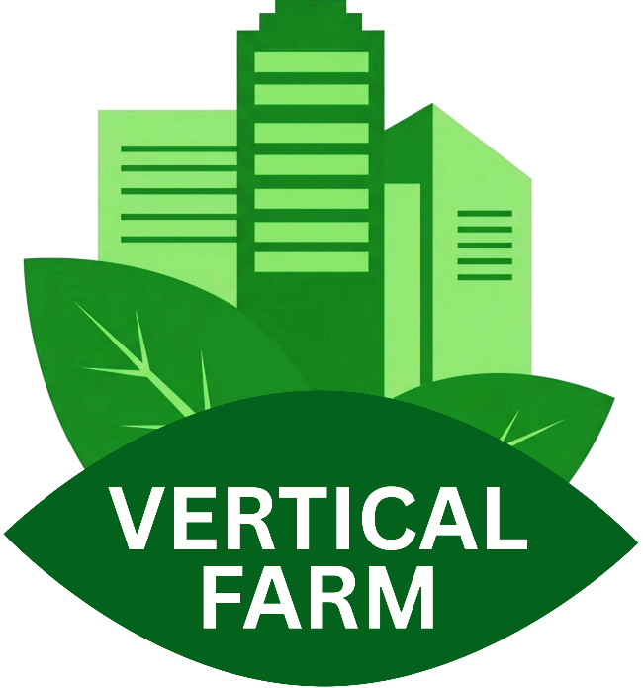  Independent Project II  “Vertical  Farming at Home” |   Module: Independent Project II  Module code: ACCA6020  Lecturer: Dr Sana Jokhio  Student name: Alexei Nica  Student ID number: 2232919  Submission deadline:  28th November 2025
Contents
ABSTRACT 4
ACKNOWLEDGEMENT 5
INTRODUCTION 6
1.1 Aim 6
1.2 Objectives 6
1.3 Motivation 7
1.4 Structure of the Report 7
2. LITERATURE REVIEW 8
2.1 Vertical Farming & Home Implementation 8
2.2 Digital Tools and Planning Systems 8
2.3 Usability, UCD and Web Interface Best Practices 9
2.4 Gaps in Current Solutions 10
2.5 How Literature Informs This Project 10
3. METHODOLOGY 11
3.1 Research Philosophy (Pragmatism) 11
3.2 Research Approach & Strategy (Mixed-method, Iterative) 11
3.3 Data Collection Methods 12
3.4 Participants 13
3.6 Validity & Reliability 13
4. ANALYSIS 14
4.1 Functional Requirements 14
4.2 Non-functional Requirements 14
4.3 Use case diagram 15
4.4 System Requirements 15
4.5 Risk Analysis 16
5. DESIGN 17
5.1 User Interface Design 17
5.2 Planner Grid & Interaction Design 19
5.3 Storyboards 21
5.4 Database Design 22
6. IMPLEMENTATION 23
6.1 Project Structure 23
6.2 Frontend Implementation (Planner, Grid, Metrics) 23
6.3 Challenges Encountered 26
7. TESTING 27
7.1 Test Plan and Cases 27
7.2 Issues Found & Fixes 28
8. EVALUATION 29
8.1 System Evaluation 29
8.2 Usability Evaluation 29
8.3 Critical Analysis of Decisions 30
9. FURTHER ENHANCEMENT 31
10. CONCLUSION 32
11. PERSONAL REFLECTION 33
12. REFERENCES 34
13. APPENDICES 37
Appendix A 37
Appendix B 49

ABSTRACT
This project starts with a very common situation: people want to grow a few herbs or vegetables at home, but they often do not know how to plan a small vertical farming system. Most information available online is technical, written for professionals, and difficult for beginners to follow. As a result, many new growers feel unsure about what equipment to choose, how much space they need, or how different systems work. This project aims to reduce that confusion by offering a clear and friendly digital starting point.
The solution developed is a lightweight web planner designed specifically for beginners. The tool allows users to place towers on a simple grid, compare basic types of vertical farming systems, and receive straightforward estimates such as the number of plants they can grow and the approximate water or energy needed. The intention was to create a calm and visual experience, where users understand each step without feeling overwhelmed.
Development followed an iterative approach, with small improvements made after each usability test. Ordinary users, with no technical or agricultural background, interacted with early versions of the tool. Their feedback shaped the final design, leading to clearer layouts, cleaner buttons, and interactions that feel direct and predictable. This process highlighted how beginners think, what confuses them, and what helps them move forward with confidence.
The final prototype is not a full product, but it successfully demonstrates the value of visual planning for home vertical farming. Testing showed that users felt more comfortable, better informed, and more capable of imagining their own setup after using the planner. The project concludes that simple guidance, clear visuals, and step-by-step interaction can make a complex topic accessible to anyone, and it opens the door for future development of more advanced features.

ACKNOWLEDGEMENT

I would like to thank my supervisor, Dr Sana Jokhio, for the support, constructive feedback, and direction provided during this project.
My appreciation also goes to the individuals who took the time to test the prototype and share their honest impressions. Their input made the planner clearer and more usable.
I am especially grateful to my family for their patience, motivation, and constant support throughout this journey.

INTRODUCTION
Urban homes often have limited space for growing fresh food. For beginners, vertical farming sounds promising, but most people quickly discover the same problem: they do not know how to plan a system, choose the right layout, or estimate what they actually need. Existing guides are scattered, complex, and mostly written for large farms, not for small households or people who simply want a small, manageable setup. There is also no simple digital tool that shows a clear layout, explains system components in a friendly way, or helps users understand what fits in their space.
Because of this, many beginners lose motivation quickly. They read long guides, get confused about terms, and have no visual way to plan. A basic question like “How many towers fit in my corner?” becomes difficult without a tool. This project addresses that gap by creating a simple, easy-to-use web planner made specifically for home users. The tool lets users design a layout, place towers, compare basic system types, and view simple metrics in a clean, guided interface. The focus is on clarity, usability, and reducing the stress that usually comes with technical gardening information.
The planner does not try to replace professional tools or advanced agriculture software. Instead, it provides a starting point for beginners who just want to see a layout, experiment, and understand the basics before buying anything. By keeping the design minimal, direct, and consistent across pages, the system supports users with limited experience, limited time, and limited space. It aims to help people make a confident first step into home vertical farming without feeling overwhelmed.

1.1 Aim
To develop a clear and accessible Vertical Farming Planner that helps beginners design and understand a home growing system without prior technical knowledge.

1.2 Objectives
- Create a simple and intuitive layout planner using HTML, CSS, and JavaScript.
- Allow users to place towers/systems on a grid and receive basic system metrics.
- Design a clean and friendly user interface suitable for beginners.
- Test the tool with users to identify usability issues and refine the design.
- Provide a functional prototype that can be expanded in future work.

1.3 Motivation
Many beginners want to grow fresh herbs or vegetables indoors but feel overwhelmed by technical information, measurements, system types, and unclear online guides. Without a visual plan, everything feels abstract and complicated. A simple planner that removes confusion, shows a clear layout, and provides instant feedback can help users start confidently, especially in small homes where every centimetre matters. This project was motivated by the need for a practical, friendly tool that makes vertical farming feel achievable, not intimidating.

1.4 Structure of the Report
The report presents the background and related work, describes the chosen methodology, explains the design and development, evaluates the prototype with users, and ends with conclusions, future improvements, and personal reflection.

2. LITERATURE REVIEW

2.1 Vertical Farming & Home Implementation
Vertical farming is usually presented as a modern and efficient way to grow plants using stacked structures and controlled environments. Many studies show its potential to reduce space, improve water efficiency, and offer predictable harvests, even in urban areas with limited land . Akintuyi (2024) notes that vertical systems can be successfully integrated into tight architectural spaces, which makes the idea attractive for small homes as well [1].
Still, most academic work looks at vertical farming at a large scale, commercial towers, automated environments, or modular farms for business use. Oh, and Lu (2023), for example, focuses on resilience and food security at the city level rather than the needs of a beginner who wants to grow herbs in a kitchen corner [2].
Mir et al. (2022) also highlight the environmental advantages of complex systems, but again, the audience is usually researchers and professionals who already understand pumps, nutrient cycles, and lighting setups [3].
When reviewing this literature as a beginner, a pattern becomes obvious: the knowledge is rich, but not accessible. There are explanations about system efficiency, modularity, or sustainability, but very few guidelines that help a home user decide, “What size tower should I pick?”, “How many plants can I realistically grow?”, or “How do I arrange things in my conservatory, so everything fits?”
In other words, the research celebrates the potential of vertical farming, but it does not translate that potential into simple, practical tools for ordinary people. This gap creates confusion for beginners who want clarity, not scientific models [4] [5]

2.2 Digital Tools and Planning Systems
When it comes to digital tools, the situation is similar. There is strong progress in agricultural technologies, professional dashboards, monitoring systems, and land-management software, yet these tools are made for trained users [6] [7].
Setiyawati et al. (2022) show that even basic land-monitoring apps require careful UX design because users get overwhelmed when too much data is shown at once [8].
This point is directly relevant to home vertical farming: if trained agricultural users struggle with visual overload, beginners will struggle even more when tools are complex.
At the same time, studies on digital farming tools lean toward mobile monitoring, automation, or large-scale dashboards. Martin and Bustamante (2021) explore modular “growing-service systems”, but the focus is on business models and urban infrastructure, not home gardens [9].
There is almost no research offering a simple, interactive planner that visualises small indoor spaces or helps users understand the shape and size of their system before buying anything.
This absence feels even stronger when looking at home-focused apps. Many provide plant care tips or reminders, but not layout planning, not system comparison, and not a visual grid that shows how a tower fits in a room. So even though digital agriculture is growing, beginners who only need a lightweight planning tool remain unsupported [10].

2.3 Usability, UCD and Web Interface Best Practices
Since beginners often rely on digital tools to learn, usability becomes central. Hertzum (2022) explains that usability testing reduces confusion and helps shape decisions based on real user reactions, not assumptions [11].
This is essential for a topic like vertical farming, where many beginners feel insecure about measurements and components. If the interface is too crowded or too technical, they simply give up.
User-centred design (UCD) principles reinforce this. According to Janstova (2025), educational agricultural tools work best when the design starts from the user’s level of knowledge, not from expert expectations [12].
This aligns with the purpose of this project: the tool must speak the beginner’s language, not replicate professional dashboards.
Usability research also highlights accessibility. Sarioğlu (2023) shows that many web modelling tools ignore keyboard users or people with basic digital skills, which makes the experience frustrating rather than supportive [13].
Other researchers reinforce the importance of simple, structured layouts, minimised cognitive load, and clear user feedback in interactive tools [14][15].
Taken together, these studies point to one clear message: a simple, structured, and friendly interface is not optional; it is necessary for beginners. This justifies the design choices in this project: clean layout, minimal wording, clear feedback, and a calm visual style instead of complex dashboards.

2.4 Gaps in Current Solutions
After comparing the literature, one thing becomes very clear:
Most academic work focuses on large-scale agriculture, while most digital tools cater to experts, not to home beginners.
When authors discuss smaller implementations, the explanations remain technical [16]. Even though they complement each other, their combined guidance still does not help a home user decide how many towers to use, how to arrange them in a room, or what the final layout might look like. So, the research moves forward, but the real beginner remains invisible [17].
Another gap is emotional: many beginners feel intimidated because information is presented with formulas, diagrams, or efficiency analyses. There are almost no tools that offer reassurance, visual clarity, and small, digestible steps. And when Gupta et al. (2021) discuss multimedia prototyping for early-stage ideas, the message is that prototypes must reduce uncertainty and help users imagine results, something that farming research rarely applies to small-scale home growers [18].
This project fills this exact gap by providing a visual, friendly planner instead of another technical guide.

2.5 How Literature Informs This Project
The literature helps shape this project in three important ways:
First, it confirms that vertical farming can work even in small spaces, but the knowledge is mainly locked in expert-level documents. Beginners are left without a simple, guided way to apply that knowledge at home [19].
Second, research on digital tools shows that complex dashboards do not help inexperienced users. A planner must be lightweight, visual, and calm. This directly supports the choice to build a minimal, browser-based tool with only essential features [20].
Finally, usability and UCD studies emphasise that early user testing and simplicity are essential for tools aimed at non-experts. This has shaped the interface of the Vertical Farming Planner: clear layout, quick feedback, and a focus on guiding rather than overwhelming.
In short, the literature offers strong foundations but leaves beginners without a bridge between theory and action [21] [22].
This project aims to become that bridge.

3. METHODOLOGY
The methodology for this project is designed around one central idea: a tool must work for beginners only if it is shaped together with them. Because the project focuses on usability and practical value, the chosen methods prioritise direct user feedback, iterative refinement, and simple forms of data collection that make sense for an early-stage digital prototype.

3.1 Research Philosophy (Pragmatism)
Pragmatism was chosen because it supports a very hands-on question: What actually helps beginners plan a vertical farming system?
Instead of analysing theories for the sake of theory, pragmatism encourages methods that bring useful, testable outcomes [23]. This aligns naturally with a development-focused project, where the value comes from improving the tool step by step, guided by what users find confusing or easy.
Other philosophies (such as positivism or interpretivism) were considered, but they did not fit the project’s practical nature. Positivism would require controlled measurements and statistical significance, while interpretivism would push the focus towards a deep interpretation of behaviours. Here, the priority was simply to understand what works and what fails in the interface. Pragmatism supports that balance.

3.2 Research Approach & Strategy (Mixed-method, Iterative)
The project uses a mixed-method approach. The qualitative side helps uncover why users struggle with certain steps, while the quantitative side helps track simple patterns such as task success or failure. By combining the two, the project avoids the risk of having feedback that is either too emotional or too statistical [24].
The development process follows a light iterative cycle:

This approach avoids building a tool based only on assumptions. Instead, each iteration responds to real feedback. For a beginner-focused tool, this is essential; what seems obvious to a developer is often confusing to a new user. The iterative strategy helps identify these gaps early.

3.3 Data Collection Methods
Usability Testing
Usability testing was the main source of data because the project focuses on interaction and clarity. Small tasks (e.g., “place a tower”, “explore system types”, “view the metrics”) were observed to understand where users slow down, click the wrong element, or hesitate.
This method is particularly effective for early prototypes, as simple user-centred evaluations reveal problems long before full development [25].

Observation
Observation was used to capture reactions that users do not verbalise, small pauses, confusion with icons, scanning behaviours, or moments when users stop reading instructions. These subtle behaviours are often more honest than answers in a questionnaire. Real behaviour is one of the most reliable ways to improve usability.

Short, Focused Questions
Instead of long surveys, the project used short questions after tasks (e.g., “Was this step easy?”, “What felt unclear?”). This reduces fatigue and encourages more honest feedback.
Together, these methods create a complete understanding of user experience: what works, what doesn’t, and why.

3.4 Participants
The participants were everyday users, friends or neighbours, who represent the intended audience: people without agricultural or technical expertise who simply want to understand how to start. This choice was deliberate. Highly experienced growers would provide feedback that is too advanced for the aim of the project.
Even though the sample was small, it was enough for early-stage usability work. A small group often uncovers most interface problems because beginners struggle in similar places. What matters is relevance, not quantity [26].

3.5 Ethical Considerations
Ethical considerations were kept simple but strict. Participation was voluntary, no personal data beyond basic interaction notes was collected, and feedback was treated anonymously. Since the testing was informal and focused solely on interaction with the interface, no sensitive information was processed.
Users were informed that they were testing a prototype and that their feedback would help refine the tool. They were also free to stop at any time. Because the project was not collecting behavioural profiles, images, or personal identifiers, the ethical risk was minimal.

3.6 Validity & Reliability
Validity was ensured by aligning every task with the actual goals of the planner. If users could not easily place a tower, understand system options, or read metrics, then the tool was objectively failing, regardless of opinion. The evaluation was designed directly around these core actions, which strengthens construct validity.
Reliability was improved by testing all users with the same interface and the same task flow. Even though individual feedback varies, repeated patterns (e.g., confusion with the metrics panel) confirm that findings are dependable. This type of reliability check is common in prototyping work, as supported by dos Santos et al., who highlight that repeated small tests provide consistent insights for iterative design [27].

4. ANALYSIS
This chapter presents the core requirements and early analysis behind the Vertical Farming Planner. Because the project focuses on usability and practical interaction rather than heavy technical engineering, the analysis remains clear, concise, and centred on what the user needs to do on the platform. Everything here supports the later design and implementation phases.

4.1 Functional Requirements
The main purpose of the tool is to help beginners plan a simple home vertical farming setup. From early sketches, the following functions were essential:
- The system must display a clear grid where users can place towers or small farming systems.
- Users must be able to add, remove, or reposition these systems on the grid.
- The planner must calculate and display basic metrics (for example: number of towers, water/energy estimates, or layout spacing).
- The interface must guide beginners without assuming any prior knowledge, no complex terms, no hidden steps.
- The system must allow basic navigation (Home, Planner, Guides), keeping the experience simple and predictable.
These functions represent the absolute minimum for testing, validating, and refining the idea [28].

4.2 Non-functional Requirements
Because the target users are beginners, non-functional requirements are as important as the core functions. The interface must feel simple, friendly, and quick to understand. It must support first-time users who may have no experience with farming or digital planners. The planner must run smoothly in a browser and respond instantly when a tower is placed or moved. The system must work on laptops and basic home devices without additional software. Visual elements, spacing, colours, and labels must support easy decision-making, not overwhelm users. The interface should avoid clutter, use clean contrast, and allow basic navigation [29].

4.3 Use case diagram
The system’s main interactions were mapped using a simple use case diagram to outline what the user can do inside the planner.
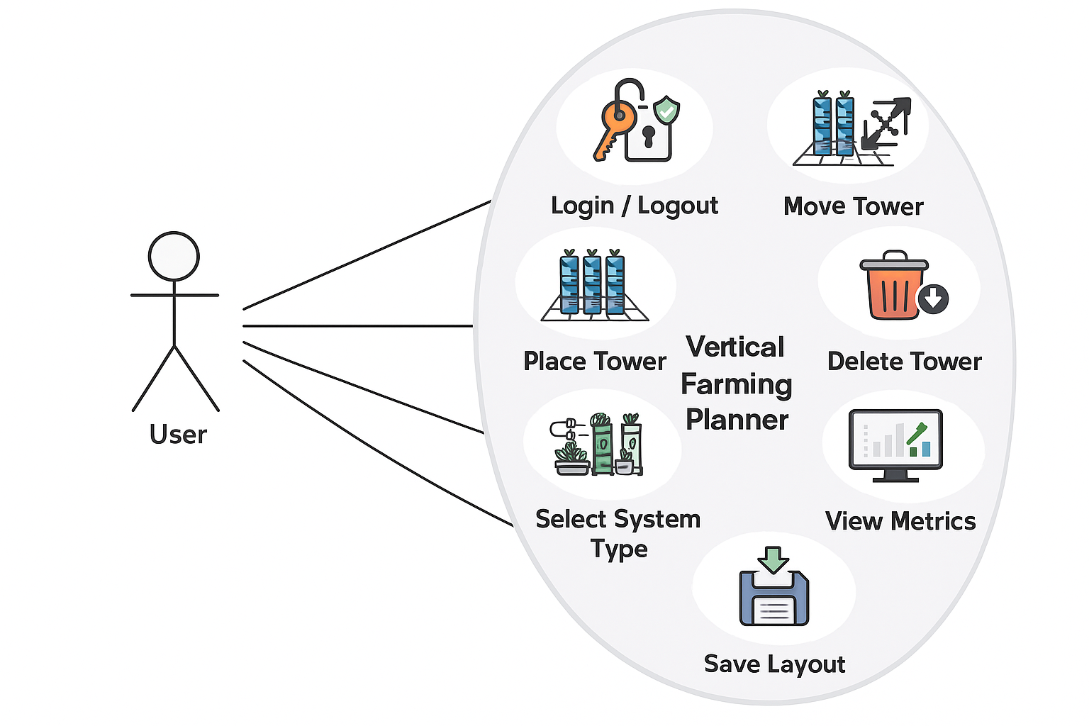
Figure 1. Use Case Diagram for the Vertical Farming Planner, showing the main actions a user can perform within the system.

4.4 System Requirements
Hardware Requirements
Because the tool is web-based, hardware requirements are minimal:
- Standard laptop or desktop computer
- Mobile phone
- Screen resolution that comfortably displays the grid

Software Requirements
- A modern web browser (Chrome, Edge, Brave, etc.)
- HTML, CSS, and JavaScript frontend
- Backend (Python + SQLite) for future versions
- Image assets for systems and UI elements
The prototype can run entirely in the browser without installation.

4.5 Risk Analysis
Managing risks was important because the project was developed by a single person with limited time and resources. Even if the system is small, poor planning or technical issues could slow down development or affect the final quality. The risk analysis helped identify what could go wrong and what actions were needed to keep the project on track.

Risk | Probability | Impact | Mitigation
Technical errors in the planner (grid bugs, drag-and-drop issues) | Medium | Medium High (affects usability) | Test features regularly, fix issues early, and simplify interactions.
Time constraints due to academic workload | High | High (delays implementation) | Break tasks into smaller steps, prioritise core features, and track weekly progress.
Limited user feedback | Medium | Medium (less accurate evaluation) | Involve real beginners early, run short usability sessions, and adjust quickly.
Database or backend failures | Low | Medium | Keep a simple schema, test connections early, and maintain backups of data.
Table 1. Risk analysis and solutions.

5. DESIGN

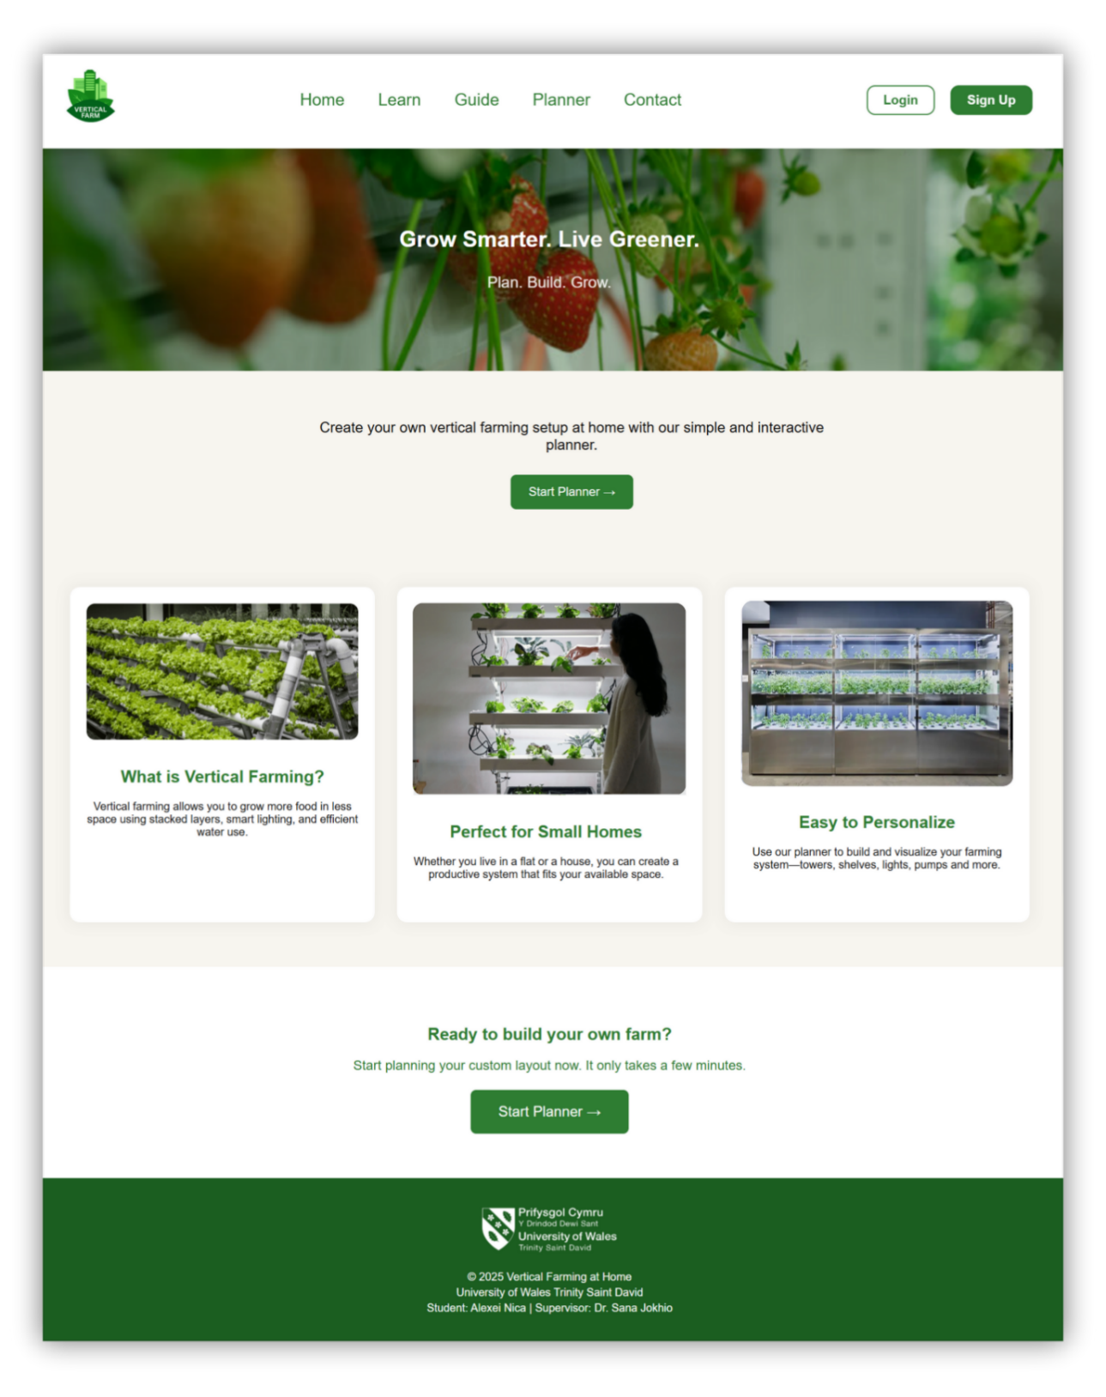
5.1 User Interface Design

Figure 2. Home page interface

The interface was designed using a clear structure that keeps all main actions easy to find. The navigation bar stays identical across pages, which helps users move between Home, Learn, Guides, Planner, and Contact without hesitation (See Figure 2). The layout follows a simple hierarchy: a visible header, a wide content area, and clearly separated sections.
The overall style uses calm green and neutral tones, which naturally fit the theme of plants and home growing. The colours were chosen not just for aesthetics, but to support readability. Buttons, highlights, and active sections use slightly darker greens to guide attention without overwhelming the user.
Wireframes were created early in the process to shape the basic structure. These wireframes helped define where each element should sit: navigation at the top, the planner in the centre, system cards on the side, and clear buttons for interaction (Figure 3).
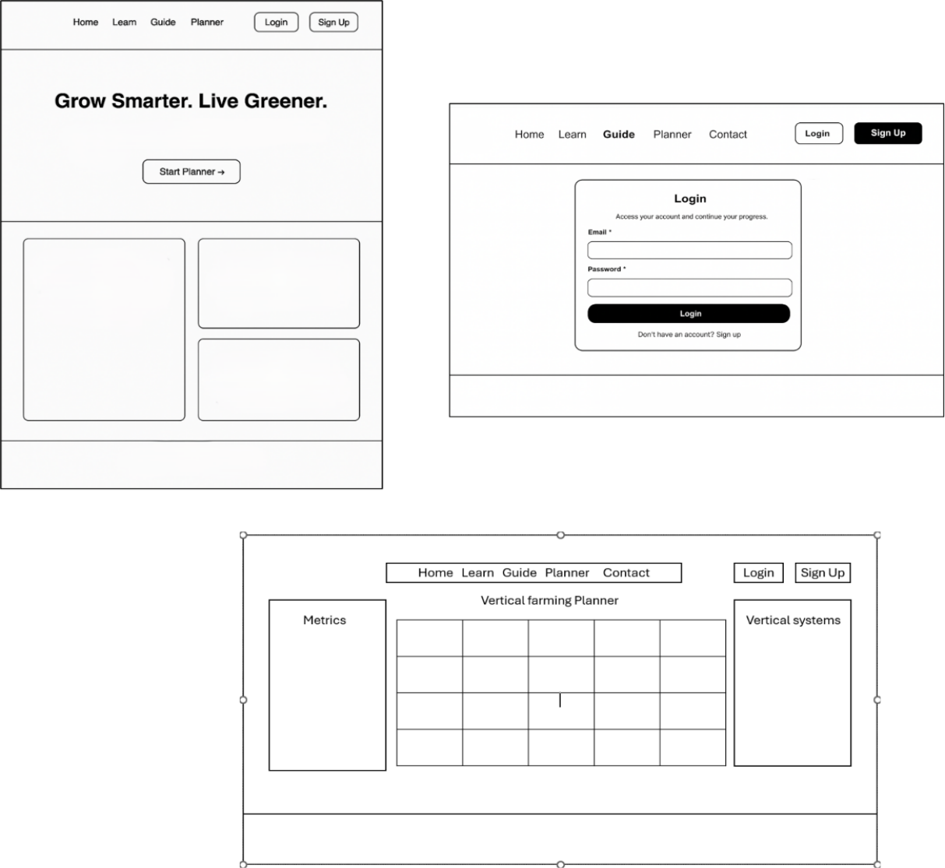

Figure 3. Low-fidelity wireframes for Home page, Planner and Login pages.

Working with wireframes made it easier to test ideas quickly and adjust layouts before any coding began. It also helped ensure that the final interface would be consistent across all pages [30].
Typography is intentionally simple. A single, readable font was used for the entire platform, with slightly larger sizes for main actions and headings. Beginners do not benefit from decorative fonts or too many weights, so the design stays minimal and calm.
Overall, every UI decision was guided by one question: “Will this help someone who has never used a farming planner understand what to do next?” If the answer was no, the element was removed or redesigned.

5.2 Planner Grid & Interaction Design

The planner is the core interactive feature of the platform, so its design required extra care. The goal was to give the user a sense of control without making the experience complex.
The grid appears visually clean, with enough spacing for placing towers while still keeping the layout realistic.

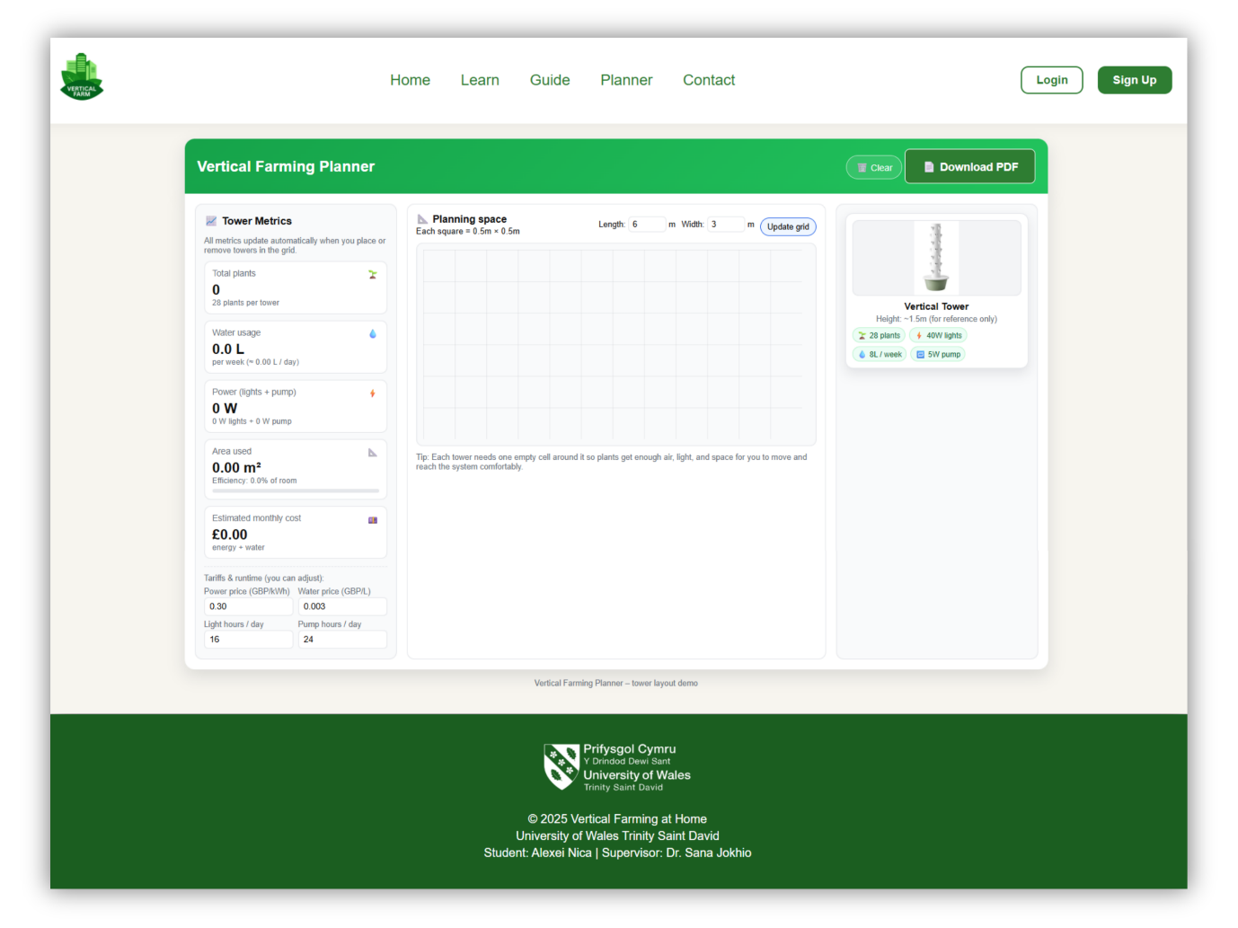

Figure 4. Planner page.

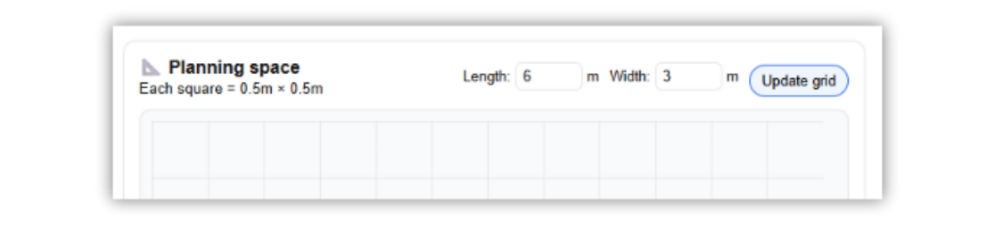
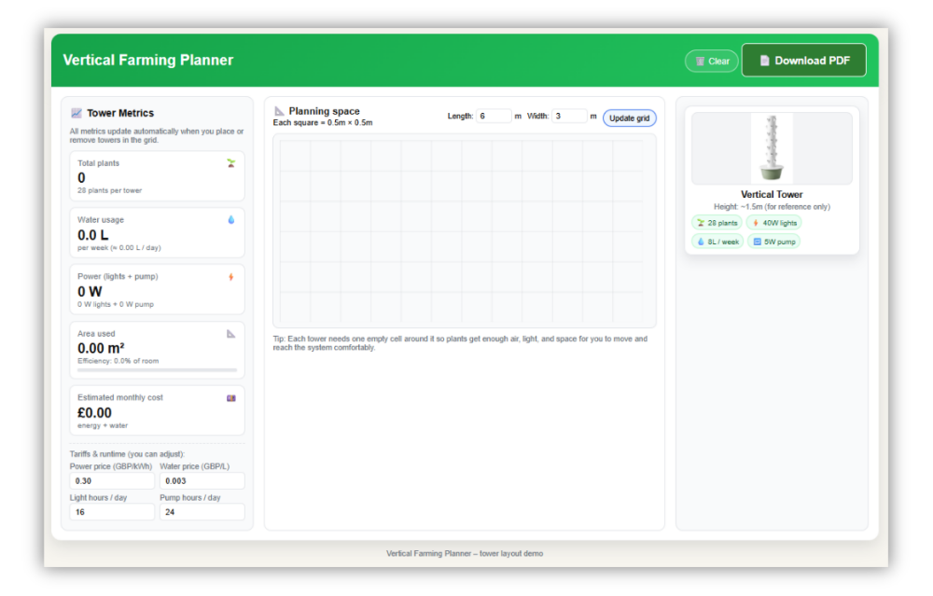


Figure 5. Adjust the planning space.

Interaction is based on very simple actions: click to add, drag to reposition, and a small delete icon to remove. This avoids the learning curve that more advanced planning tools often impose. Users do not need to rotate objects, adjust hidden settings, or manage advanced coordinates. Everything is immediate, direct, and visible (Figure 6).
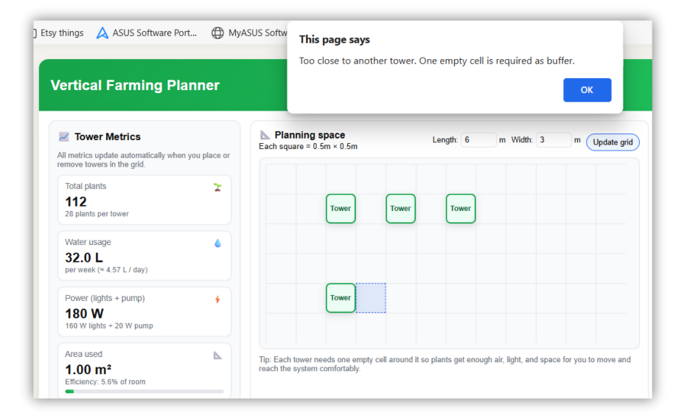
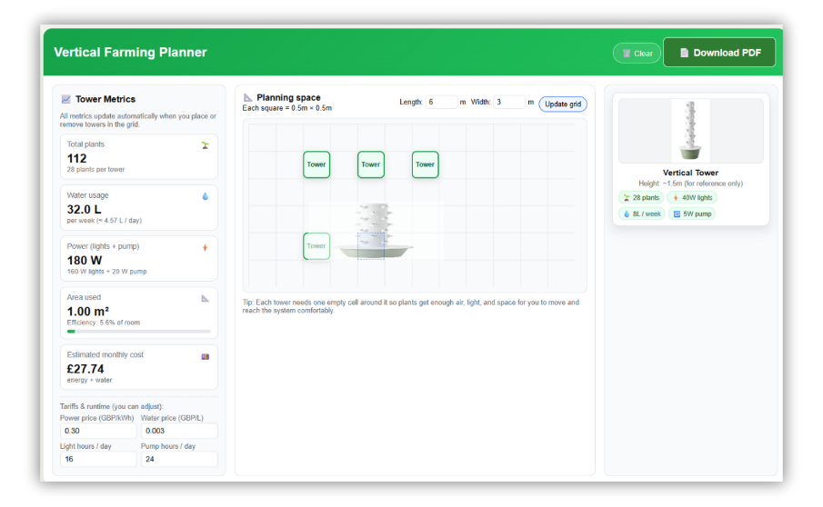

Figure 6. How the planner works.

The planner also displays basic metrics, plants, water, energy, and cost (Figure 6).
These values update dynamically based on the user’s choices. The intention is not to provide scientific precision, but to give beginners a rough sense of scale: how large the system becomes, and what it roughly requires. This helps users make informed decisions without reading long guides or technical documents. In short, the grid was designed to “feel simple,” even if a lot happens behind the scenes.
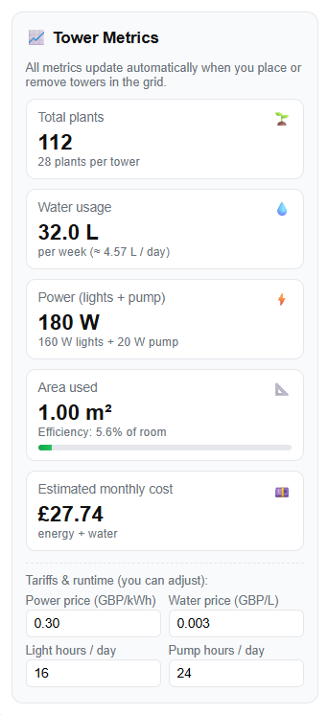
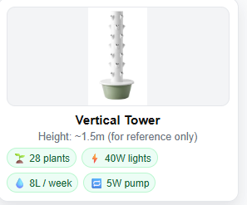
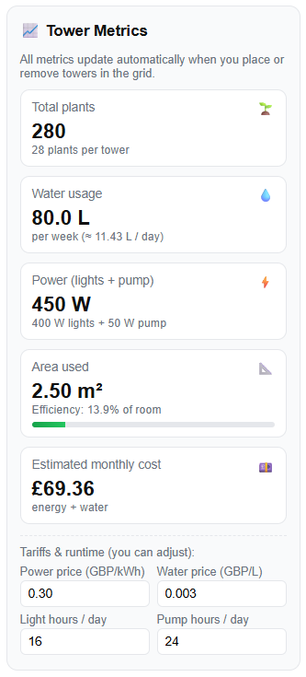

Figure 7. The updated metrics

5.3 Storyboards
Storyboards were created to visualise how a real user might interact with the planner. Instead of long technical descriptions, each storyboard captures a short scenario that reflects a simple action: a user logging in, placing a system, checking the metrics, or saving the layout. These scenarios helped keep the development process focused on the human experience rather than the technical implementation [31].
The intention behind using storyboards was to clarify the flow and predict moments of hesitation. For example, one storyboard showed a user hovering the mouse over the planner but not being sure where to click. This revealed the need for clearer tooltips and visual cues. Another storyboard highlighted confusion when removing elements, which led to the addition of a consistent “delete” icon.
Even if storyboards are simple drawings, they played a meaningful role in shaping a smoother and more intuitive interaction.

5.4 Database Design
Although the platform currently functions as a prototype, the design also includes a basic database structure intended to support login and saved layouts. The goal of including the database is not to build a complete account system, but to demonstrate that the tool can expand into a personalised experience in the future [32].
The database contains a simple “users” table with fields for username, password (hashed), and basic metadata. A second table can store layout data, allowing users to return to their farming setup later. This keeps the prototype aligned with the long-term vision of a personalised planner.
The design intentionally avoids unnecessary complexity. Only the essential fields are included, no excessive attributes or over-engineered relationships. This keeps the system lightweight and practical, matching the overall philosophy of the project.

6. IMPLEMENTATION
The implementation stage focused on building the interactive layout planner, which is the core artefact of the project. The system is composed of several small modules that work together: grid generation, component placement, drag-and-drop movement, removal logic, and a live metrics calculator. This section presents each module clearly, explains the reasoning behind the decisions, and demonstrates functionality through screenshots and code snippets [33].

6.1 Project Structure

The project was organised with a simple file structure separating HTML, CSS, JavaScript, and backend files. This keeps the code maintainable and reduces the risk of accidental conflicts between modules.

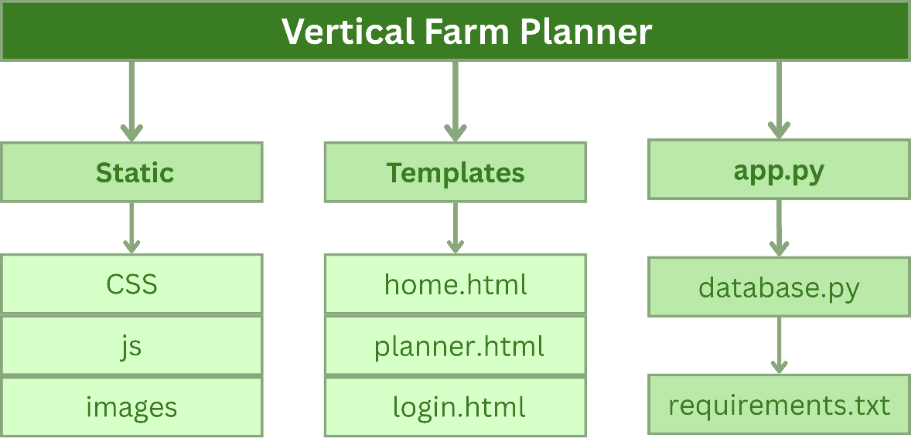

Figure 8. Structured files method for easy managment.

6.2 Frontend Implementation (Planner, Grid, Metrics)

The planner is the central feature of the application. It combines a grid area, a sidebar of system types, and a metrics panel. All interactions: adding, moving, and removing elements, happen inside this page (Figure 9).
The planner was implemented first because all other pages depend on it. It also provided the backbone for testing user interactions and adjusting the UI based on feedback.
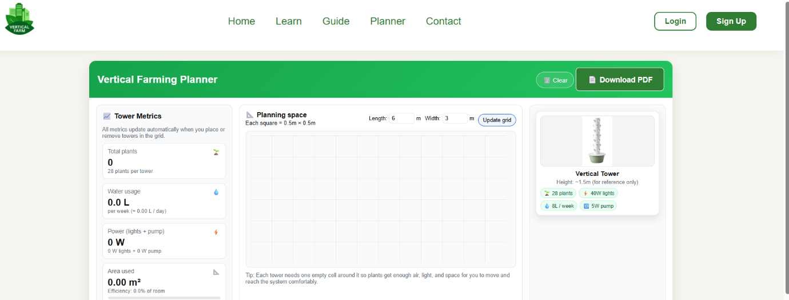
Figure 9. Planner Page – Main Interface.

The grid is generated entirely through JavaScript (Figure 10). Instead of writing static HTML cells, the grid is built programmatically so it can scale in future versions (e.g., larger grids). A dynamic grid allows flexibility without rewriting HTML. It also gave more control during testing, when users requested different grid sizes.

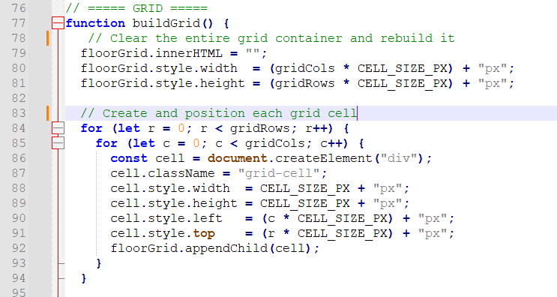

Figure 10. Empty Grid After Loading the Planner

Placing and Moving Towers
A “tower” in this prototype is represented by an image. When the user clicks a grid cell, JavaScript checks if that spot is free and then places the tower (Figure 11).
Movement was implemented by selecting the tower (single click), dragging and dropping it into a new cell, and the tower relocating with updated coordinates.
Again, nothing complex, just enough functionality to demonstrate the concept.

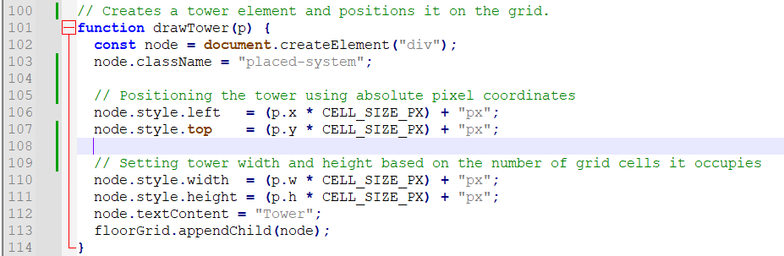
Figure 11. Creating a tower element and positioning it in the right cell.

Metric Calculations
Metrics (plants, water usage, energy usage) are estimated dynamically.
When a new tower is added, JavaScript updates the counters based on simple preset values (Figure 12). Instead of heavy algorithms, the focus was to provide quick, approximate guidance, not agricultural precision.
These values appear in a small metrics panel that updates instantly, reinforcing the idea of clarity and immediate feedback.
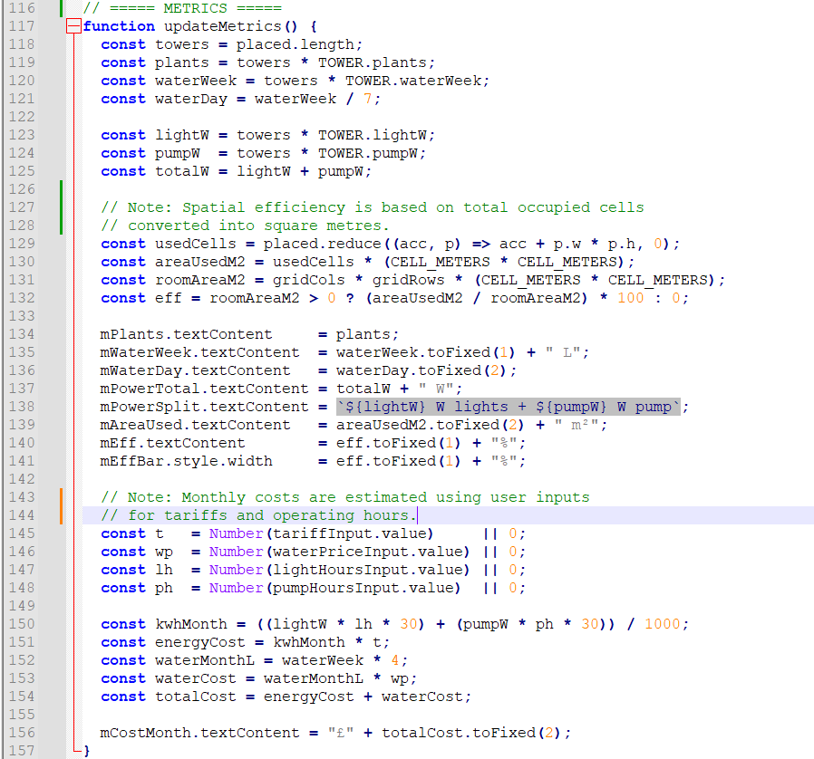
Figure 12. Live Metrics Panel Updating Based on the Current Layout

6.3 Challenges Encountered
Several challenges appeared during implementation:

Balancing simplicity with functionality
The planner needed to be intuitive yet still demonstrate meaningful interaction. Many early attempts became either too technical or too minimal. Iteration helped find a clearer middle ground.

Maintaining clean interactions
Moving towers, detecting occupied cells, and updating metrics often caused small bugs. Event listeners behaved differently than expected, especially when elements were dynamically added. Careful debugging was needed to keep interactions smooth.

Time limitations
As a solo developer, working on both design and code required constant prioritising. Some features, like rotating towers or snapping features, were postponed to avoid complexity that did not serve the main aim.

Avoiding over-engineering
It was tempting to use advanced tools or libraries, but staying close to the project’s core idea (clarity and accessibility) meant choosing simpler approaches. This kept the system understandable for beginners and aligned with the thesis aim [34].
The implementation focused on building a clean, functional, and easy-to-use prototype that demonstrates the core idea of a vertical farming planner for beginners. The combination of a straightforward grid, real-time metrics, simple tower placement, and optional backend support creates a platform that is accessible but also expandable in future work.

7. TESTING
Testing was a core part of this project because the planner was designed for people who are new to vertical farming. The goal was not to “stress-test the system,” but to see whether normal users, with zero technical background, could understand the interface, complete basic actions, and feel in control.
To keep the process realistic, each participant used the planner the way they normally navigate websites; no instructions were given beyond the starting task. This allowed the evaluation to capture genuine reactions: where users hesitated, what they clicked instinctively, and which parts of the interface felt clear or confusing [35]. The aim was to understand how the design supports the “first-time experience,” not just whether the tool functions technically.

7.1 Test Plan and Cases
The testing followed a small-scale, task-based approach:
- Use short, simple tasks that match real beginner behaviour.
- Observe interactions without interrupting the user.
- Note confusion, hesitation, or unexpected actions.
- Collect short feedback at the end.
The plan focused on usability, clarity, and task completion, not on technical performance.
Below are the selected, compact test cases relevant to this project:
Table 1. Test Case: Adding an Item to the Grid
Test Case | Description | Expected Result | Actual Result | Status
TC1 | The user attempts to add a system to the planner grid. | The item appears on the grid in the selected spot. | Successfully added in all sessions. | Pass

Table 2. Test Case: Rearranging the Layout
Test Case | Description | Expected Result | Actual Result | Status
TC2 | User attempts to reposition an existing item. | The item moves smoothly to its new location. | Some users hesitated before dragging. | Pass (minor hesitation).

Table 3. Test Case: Viewing Metrics
Test Case | Description | Expected Result | Actual Result | Status
TC3 | User checks water/energy/plant count | Metrics update instantly and are easy to notice | All users found metrics quickly | Pass

Table 4. Test Case: Saving the Layout
Test Case | Description | Expected Result | Actual Result | Status
TC4 | User tries to save their layout | Confirmation or visual feedback appears | Feedback seen, one user suggested a clearer message | Pass (with improvement suggestion)

Overall, users completed all tasks without major issues. Most actions felt intuitive, especially on the homepage and in the metric section. The grid interaction worked well, but a few users were unsure at first whether items could be dragged freely or required clicking a button first. Once they tried it, the interaction felt natural.
Participants also mentioned that the simple layout helped them focus, and they appreciated that nothing felt “too technical. This confirmed that the project’s design priorities, clarity, warmth, and minimal complexity, were appropriate for beginners.

7.2 Issues Found & Fixes
Issue | Observation | Fix Applied
Initial hesitation with dragging items. | Users were unsure if dragging was allowed. | Added a subtle hover highlight to signal interactivity.
The save confirmation is too small. | One user didn’t notice the message. | Increased contrast and added a short animation.
Metrics panel placement. | A user expected it to be closer to the grid. | Adjusted spacing so metrics feel more connected.

8. EVALUATION

8.1 System Evaluation
The system was evaluated against the main aim and objectives set in Chapter 1. The first objective was to provide a clear and accessible planner that helps beginners design a basic vertical farming layout at home. During use, all participants were able to create a simple layout, place at least one system on the grid, and see how much space it occupied. This meets the intention to turn abstract ideas from the literature about compact, modular vertical systems into a concrete planning tool for small homes, rather than for commercial farms.
The second objective was to offer basic system metrics in a way that is understandable for non-technical users. The current version calculates simple indicators such as the number of towers and the approximate growing capacity. Feedback showed that these values were easy to read and “good enough for a first plan”, even if they are not yet based on highly detailed agronomic models. This is acceptable at this stage, as the project focuses on beginner confidence rather than precise yield prediction.
A third objective was to provide a functional prototype that can be extended. The architecture, with a separated frontend, Flask backend, and database, proved stable during testing and leaves room for future modules such as saved user profiles or more advanced metrics. In this sense, the system behaves as a “base layer” that later work can build on.

8.2 Usability Evaluation
The usability evaluation focused on how easily first-time users could understand the interface, complete key tasks, and recover from mistakes. The results match many of the principles described in user-centred design and usability testing literature, which emphasise small, task-based sessions and observation of real behaviour.
Most participants quickly understood the homepage and the main call-to-action, and they described the planner page as “clean” and “not scary”. Simple labels, limited options, and a consistent layout helped them move through the tasks with little verbal guidance. This supports the decision to keep the grid and controls visually simple instead of adding complex icons or advanced features at this stage.
At the same time, the sessions revealed pain points. Some users hesitated when switching between system types and were unsure whether changes were actually saved. These findings confirm that even a minimal interface still needs clear status feedback and micro-copy. They also show the value of early prototypes: small usability problems are easier to fix before the system grows.

8.3 Critical Analysis of Decisions
Several design and technical choices can be judged more critically. Prioritising clarity over realism in the grid made the planner easier to understand, but it also limited how accurately users could represent unusual room shapes. Focusing on a web-based solution instead of a native mobile app kept development manageable; it means the current version is less optimised for small screens, even though many users may try the planner on their phones.
The mixed-method, iterative approach proved appropriate: short design test refine cycles produced visible improvements and aligned well with recommendations for UX-driven development. Still, the small sample size and informal setting mean that results should be seen as indicative rather than final evidence. A larger study with more diverse users and with tasks that include more advanced planning scenarios would be needed to fully validate the tool.

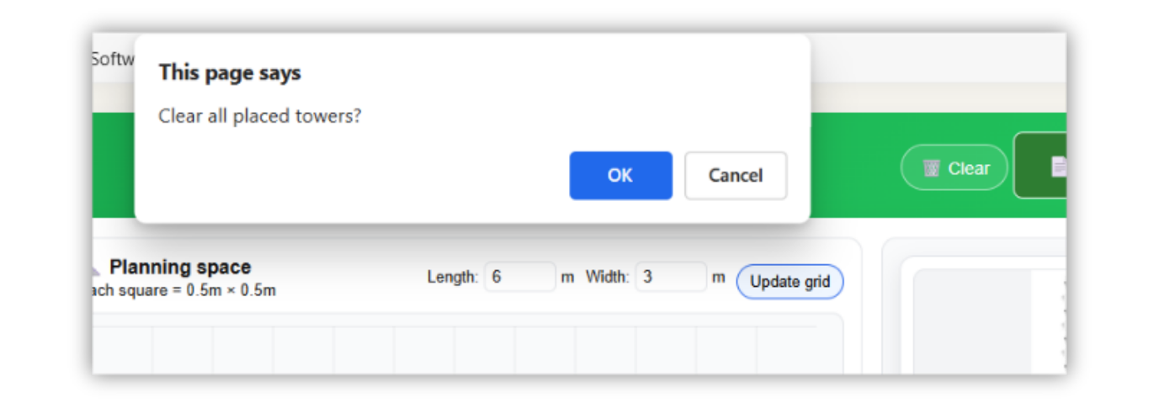
9. FURTHER ENHANCEMENT

The current version of the planner focuses on clarity and ease of use, but there is plenty of space to make it smarter and more helpful for beginners. One clear direction is automation. A future version could analyse the user's space, light level, or chosen system and offer personalised recommendations on which plants to grow or how many towers fit comfortably. AI-based plant selection would also reduce uncertainty by matching crops with the user’s conditions and goals.
Another meaningful improvement is a fully interactive 3D planning mode. A simple 3D drag-and-drop environment would let users visualise height, spacing, and room layout more realistically, especially in small apartments. This opens the door to more advanced templates, ready-made layouts that users can adjust instead of starting from scratch.
Hardware integration is another strong opportunity. Sensors for water level, temperature, or light could be connected to the platform, giving users real-time feedback about the health of their system. For people who want to keep things organised across devices, cloud-based saving would allow layouts, notes, and plans to sync automatically.
Overall, these enhancements would move the planner from a simple layout tool to a smart assistant that guides, advises, and adapts to each home environment.

10. CONCLUSION
This project set out to solve a simple but real problem: most beginners who want to grow fresh food at home do not know where to start. Vertical farming looks exciting, but the guidance available online is often too technical, too scattered, or aimed at commercial systems. The platform developed in this project offers a small but meaningful step toward making indoor growing more accessible. By giving users a clean layout, an easy grid to experiment with, and clear system options, the planner helps remove the uncertainty that usually stops beginners before they even start.
Across the design and development stages, the focus stayed on clarity and usability. The interface was built to feel familiar even to someone with no farming or technical background. Testing confirmed that this direction worked: users managed to complete the main tasks with little support, and their feedback directly shaped improvements throughout the process. Every refinement, whether in layout, interaction, or visual structure, was aimed at reducing cognitive effort and helping users feel in control.
The project also highlighted several opportunities for growth. Features such as smart recommendations, sensor integration, and more advanced templates show promising potential for future versions, especially if the platform evolves into a companion tool for real home systems.
Overall, the project achieved its aim: it delivered a working, beginner-friendly tool and demonstrated how simple digital support can make home vertical farming less intimidating and more inviting. While the prototype is modest, it lays a strong foundation for a more complete and intelligent planning tool in the future.

11. PERSONAL REFLECTION
Working on this project has been one of the clearest learning experiences I have had during my degree. I started with a simple goal: create a tool that makes vertical farming less intimidating for beginners. What looked straightforward at first quickly became a full mix of design decisions, technical choices, usability challenges, and constant iteration. Looking back, each stage pushed me to grow in areas that I had only touched briefly before.
From a technical perspective, building the planner strengthened my confidence in frontend development. Working with HTML, CSS, and JavaScript in a structured way helped me understand how each layer contributes to the final interaction. Implementing the grid, placing elements dynamically, and keeping everything lightweight and responsive required a more organised approach than I used to have. Even though my backend is simple at this stage, setting up Flask and planning the database structure gave me a clearer picture of how larger systems are built.
Design-wise, this project shaped how I think about interfaces. Creating wireframes, storyboards, and small visual sketches forced me to slow down and focus on clarity first. I learned that a clean layout with fewer distractions can make a big difference, especially for users who are new to a topic. The usability testing reinforced this. Watching how real people approached the planner, where they hesitated, what they understood instantly, and what confused them, was one of the most valuable lessons. It showed me that good design is never about what I think is “clear”, but about what users can do without effort.
Managing the project itself also taught me discipline. Working step by step, fixing issues immediately, and keeping the scope realistic helped me stay on track. I realised that a simple feature done well is more valuable than a complicated feature half-working.
If I were to start again, I would begin usability testing even earlier and keep the iterations shorter. This project gave me confidence not just in coding, but in structuring ideas, justifying design choices, and building something practical that can genuinely help people.

12. REFERENCES

[1] O. B. Akintuyi, "Vertical farming in urban environments: a review of architectural integration and food security," vol. 10, no. 2, pp.114 126, 2024.
[2] S. Oh and C. Lu, "Vertical farming-smart urban agriculture for enhancing resilience and sustainability in food security," vol. 98, no. 2, pp.133 140, 2023.
[3] M. S. Mir, et al., "Vertical farming: The future of agriculture: A review," vol. 11, no. 2, pp.1175 1195, 2022.
[4] A. C. Bunge, et al., "A systematic scoping review of the sustainability of vertical farming, plant-based alternatives, food delivery services and blockchain in food systems," vol. 3, pp.933, 2022. doi: 10.1038/s43016-022-00622-8.
[5] J. Buscher, J. Bakunowitsch and K. Specht, "Transformative Potential of Vertical Farming—An Urban Planning Investigation Using Multi-Level Perspective," Sustainability (Basel, vol. 15, no. 22, pp.15861, 2023. doi: 10.3390/su152215861.
[6] M. E. H. Chowdhury, et al., "Design, Construction and Testing of IoT Based Automated Indoor Vertical Hydroponics Farming Test-Bed in Qatar," Sensors (Basel, vol. 20, no. 19, pp.5637, 2020. doi: 10.3390/s20195637.
[7] H. T. Ng, et al., "IoT-enabled system for monitoring and controlling vertical farming operations," International Journal of Reconfigurable and Embedded Systems, vol. 12, no. 3, pp.453, 2023.
[8] N. Setiyawati, H. D. Purnomo and E. Mailoa, "User Experience Design on Visualization of Mobile-Based Land Monitoring System Using a User-Centered Design Approach," vol. 16, no. 3, pp.47 65, 2022.
[9] M. Martin and M. J. Bustamante, "Growing-service systems: new business models for modular urban-vertical farming," vol. 5, pp.787281, 2021.
[10] Advances in Agricultural Engineering Technologies and Application: Volume I, Basel: MDPI - Multidisciplinary Digital Publishing Institute, 2023. doi: 10.3390/books978-3-0365-9375-3
[11] M. Hertzum, Usability testing: A practitioner's guide to evaluating the user experience, Springer Nature, 2022.
[12] V. Janstova, "Developing an Educational Mobile App for Sustainable Agriculture: Promoting Sustainable and Ethical Farming Practices," 2025.
[13] A. Sarioğlu, "Accessibility in web modeling tools: Systematic review and conceptualization of a keyboard-only prototype," 2023.
[14] J. Š Novák, et al., "Eye Tracking, Usability, and User Experience: A Systematic Review," vol. 40, no. 17, pp.4484 4500, 2024. doi: 10.1080/10447318.2023.2221600.
[15] P. Weichbroth, "Usability testing of mobile applications: A methodological framework," vol. 14, no. 5, pp.1792, 2024.
[16] W. Goodman and J. Minner, "Will the urban agricultural revolution be vertical and soilless? A case study of controlled environment agriculture in New York City," vol. 83, pp.160 173, 2019. doi: 10.1016/j.landusepol.2018.12.038.
[17] G. Ares, B. Ha and S. R. Jaeger, "Consumer attitudes to vertical farming (indoor plant factory with artificial lighting) in China, Singapore, UK and USA: A multi-method study," vol. 150, pp.110811, 2021. doi: 10.1016/j.foodres.2021.110811.
[18] V. Gupta, L. Rubalcaba and C. Gupta, "Multimedia prototyping for early-stage startups endurance: Stage for new normal?" vol. 28, no. 4, pp.107 116, 2021.
[19] Z. Akbari, et al., "Feasibility of using vertical farming in northern Iran: A multiple necessity," vol. 354, pp.120232, 2024. doi: 10.1016/j.jenvman.2024.120232. Available: https://www.sciencedirect.com/science/article/pii/S0301479724002184
[20] J. Taylor, "Capital growth: Precision agriculture and vertical Farming in the corporate food regime," 2018.
[21] H. Tellioglu, "User-centred design as a model-based co-creation process," # PLACEHOLDER_PARENT_METADATA_VALUE#, 2022.
[22] Z. Galavi, S. Norouzi and R. Khajouei, "Heuristics used for evaluating the usability of mobile health applications: a systematic literature review," vol. 10, pp.20552076241253539, 2024.
[23] J. Berg, J. Lindholm and J. Högväg, "How do we know that it works? Designing a digital democratic innovation with the help of user-centered design," vol. 26, no. 3, pp.221 235, 2021.
[24] E. R. Oliveira, et al., "An iterative process for the evaluation of a mobile application prototype," SN Computer Science, vol. 3, no. 4, pp.262, 2022.
[25] A. Valenti, "Usability Testing Best Practices for Academic Library Websites DIY Usability Testing Toolkit," Weave (Ann Arbor, vol. 7, no. 1, 2024. doi: 10.3998/weaveux.4396.
[26] S. Ariyurek, E. Surer and A. Betin-Can, "Playtesting: What is beyond personas," vol. 15, no. 3, pp.348 359, 2022.
[27] A. I. Nur, H. B. Santoso and P. O. H. Putra, "The method and metric of user experience evaluation: a systematic literature review," 2021.
[28] S. Seinfeld, et al., "User representations in human-computer interaction," Human Computer Interaction, vol. 36, no. 5-6, pp.400 438, 2021.
[29] D. J. Dave, "Identifying Functional and non-functional software requirements from user app reviews and requirements artifacts," 2022.
[30] J. Natarajan, "From Wireframes to Interfaces: Developing a Practical Framework for UI/UX Design," 2025.
[31] T. B. d. Santos, et al., "Prototyping for user involvement activities: How to achieve major benefits," vol. 33, pp.465 472, 2021.
[32] F. Alhaidari, A. Rahman and R. Zagrouba, "Cloud of Things: architecture, applications and challenges," Journal of Ambient Intelligence and Humanized Computing, vol. 14, no. 5, pp.5957 5975, 2023.
[33] R. Bierig, et al., Essentials of Software Testing, Cambridge University Press, 2021.
[34] J. Fernández and J. A. Macías, "Heuristic-based usability evaluation support: A systematic literature review and comparative study," 2021.
[35] B. Albert and T. Tullis,Measuring the user experience: Collecting, analyzing, and presenting UX metrics, Morgan Kaufmann, 2022.

13. APPENDICES

Appendix A
This appendix contains all supporting screenshots referenced throughout the report, illustrating the interface design, planner functionality, and implementation details.
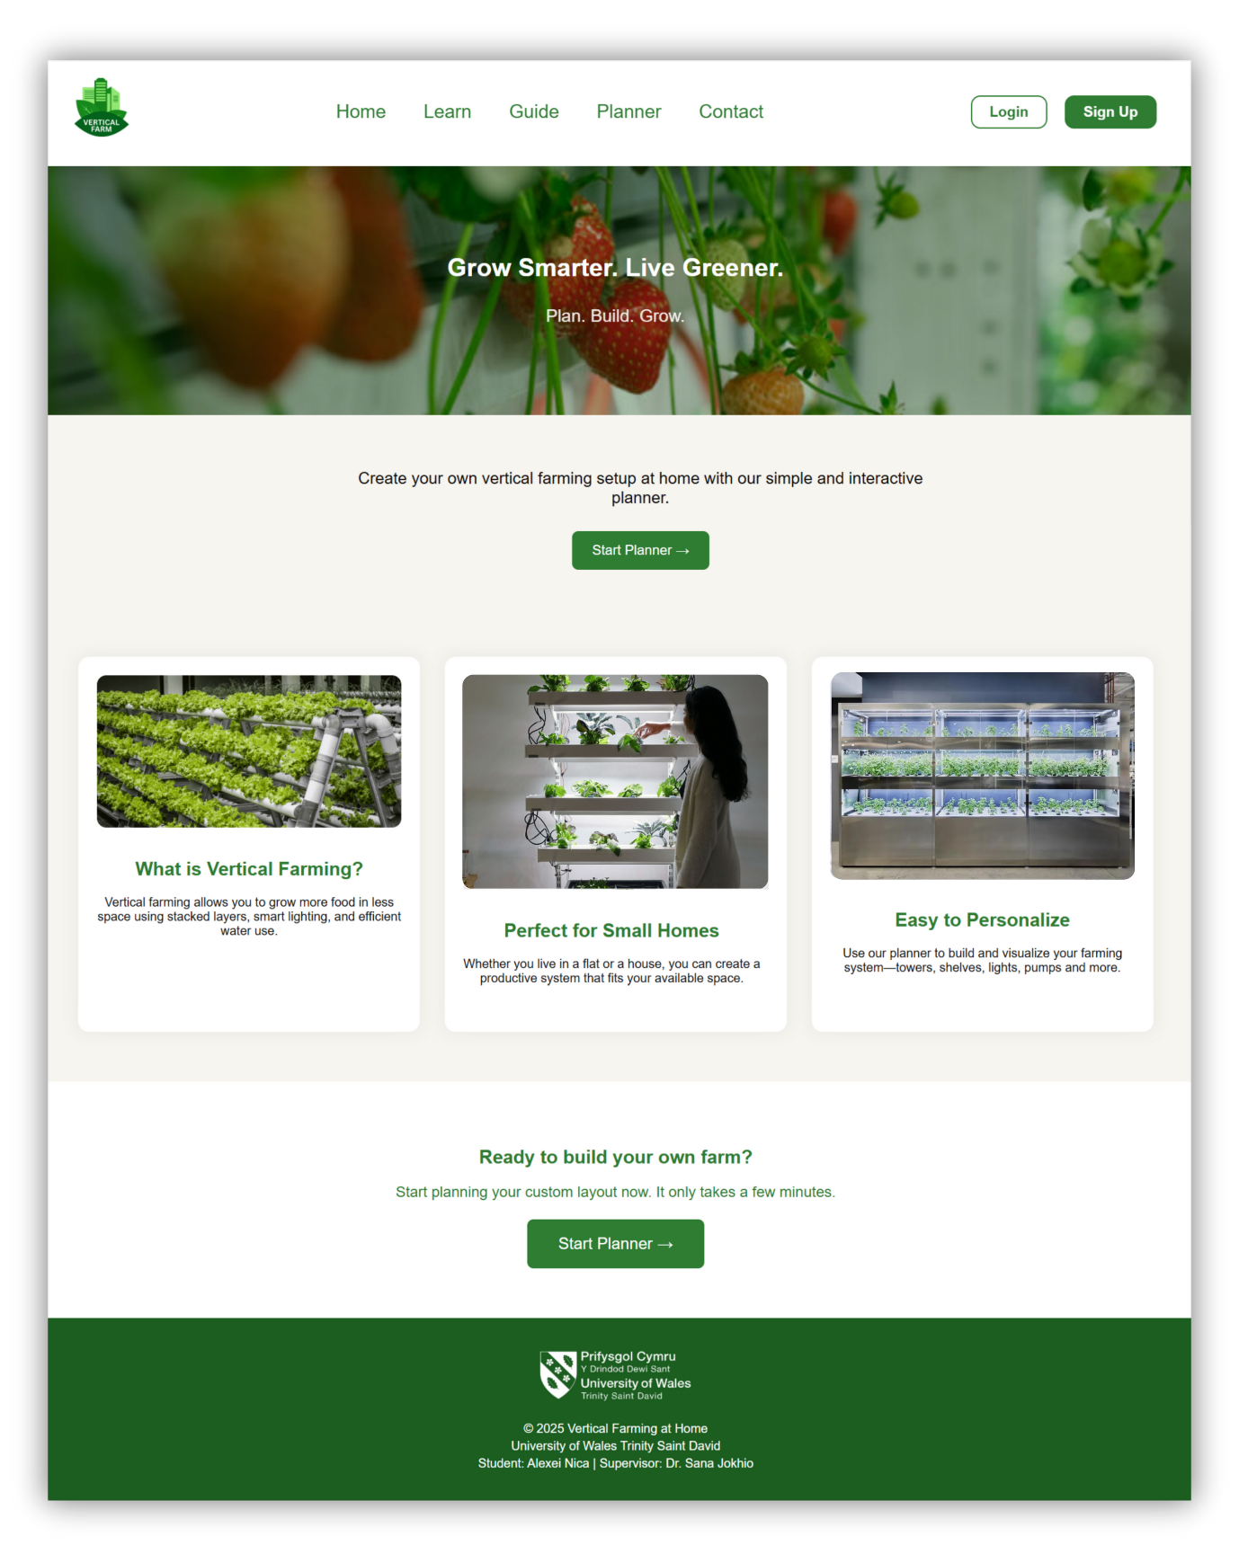

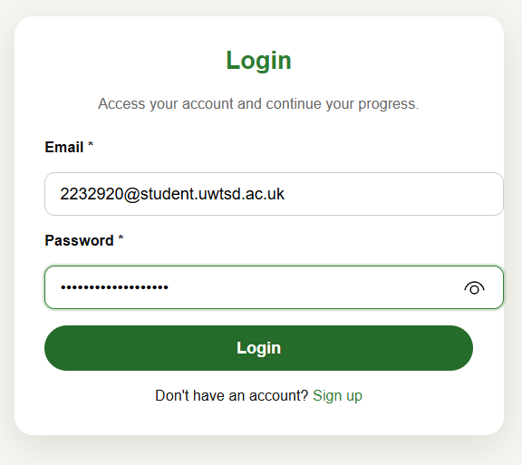

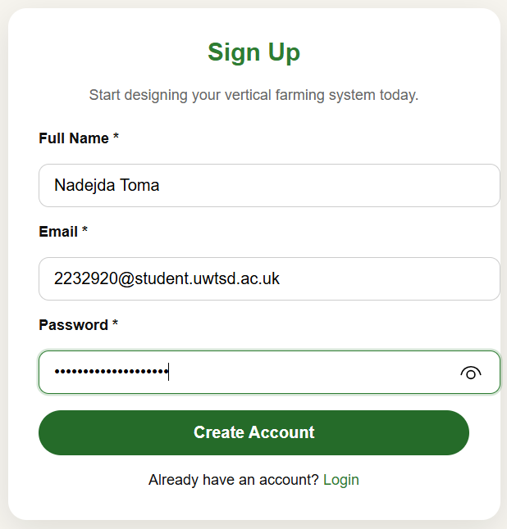

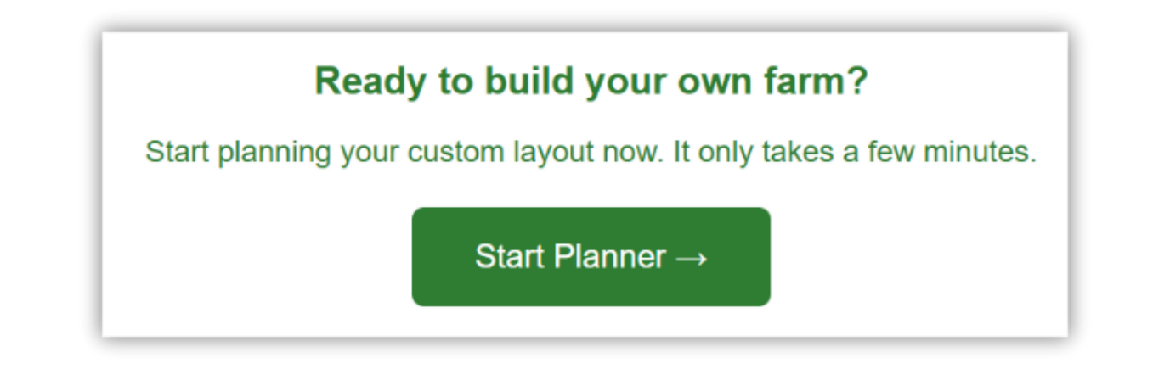

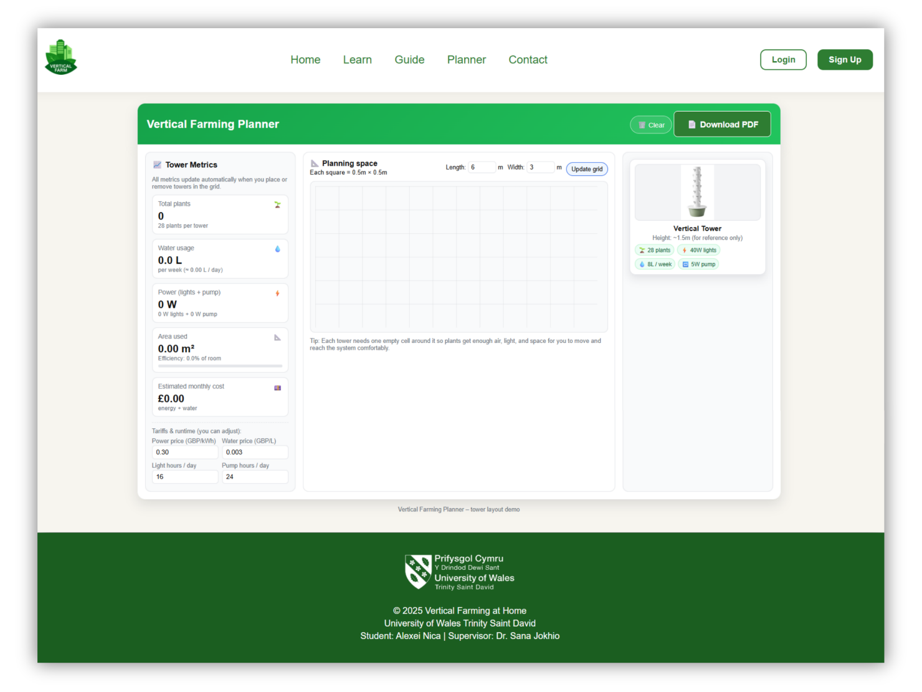

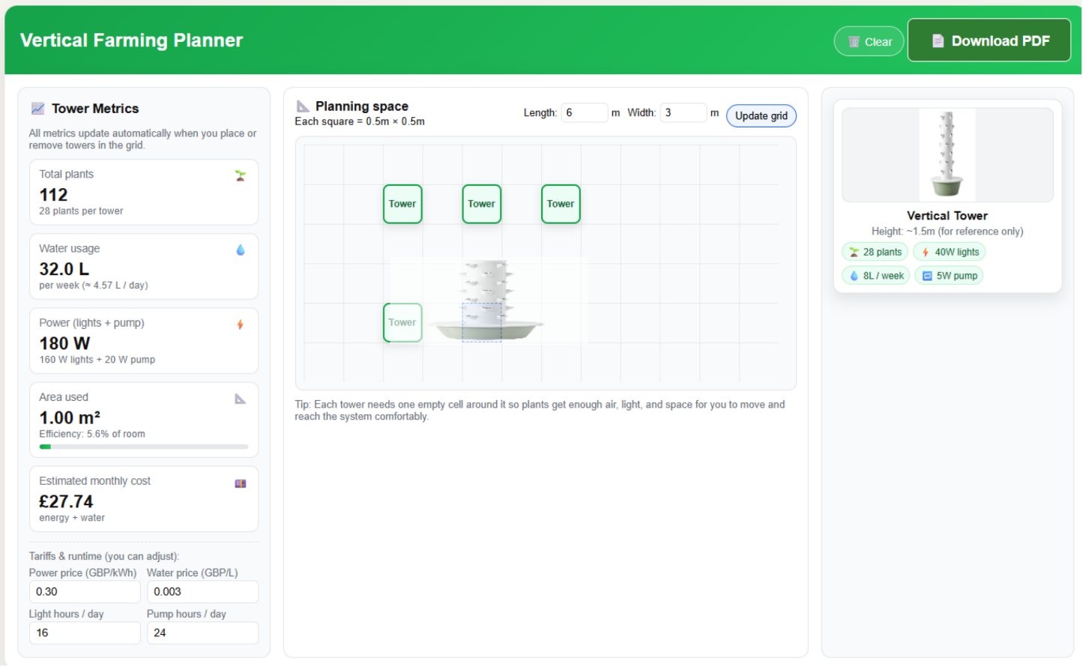

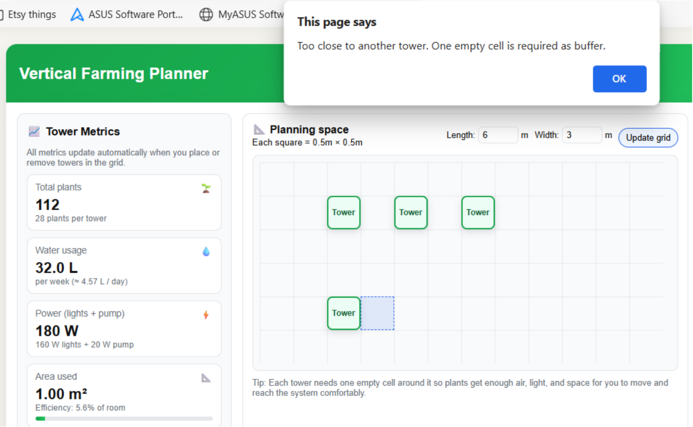

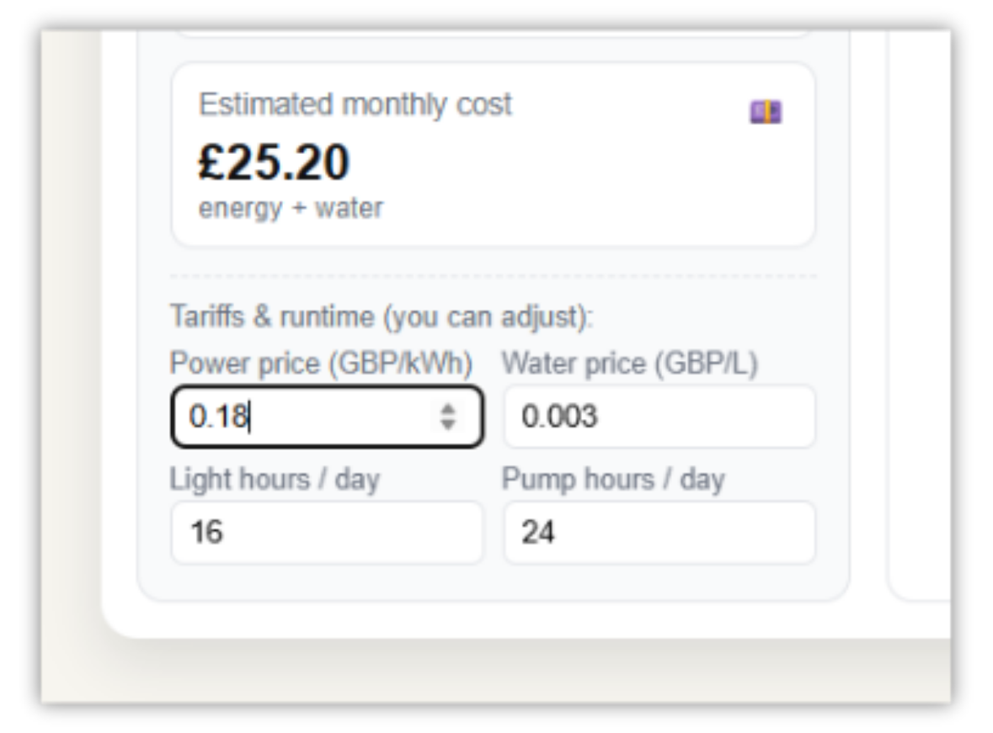

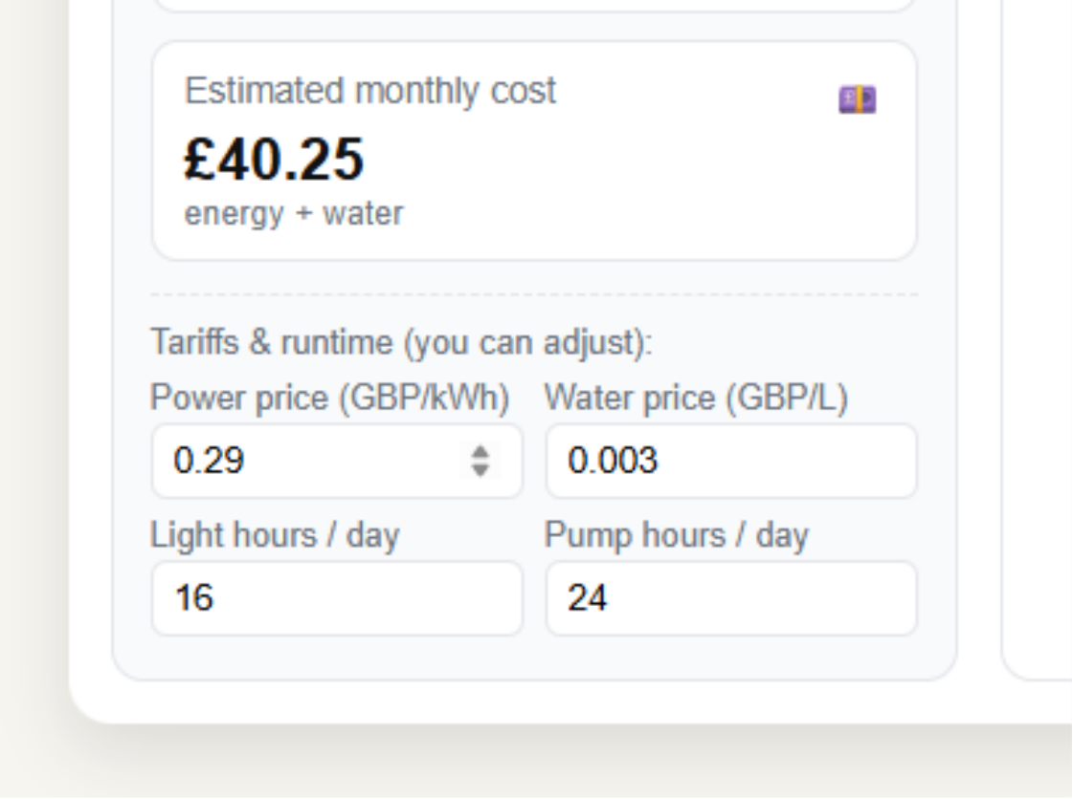

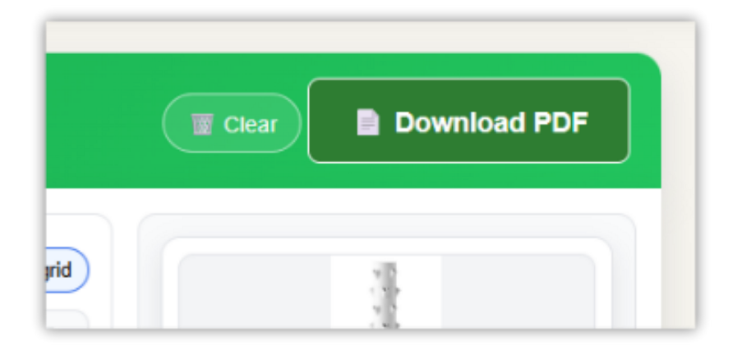

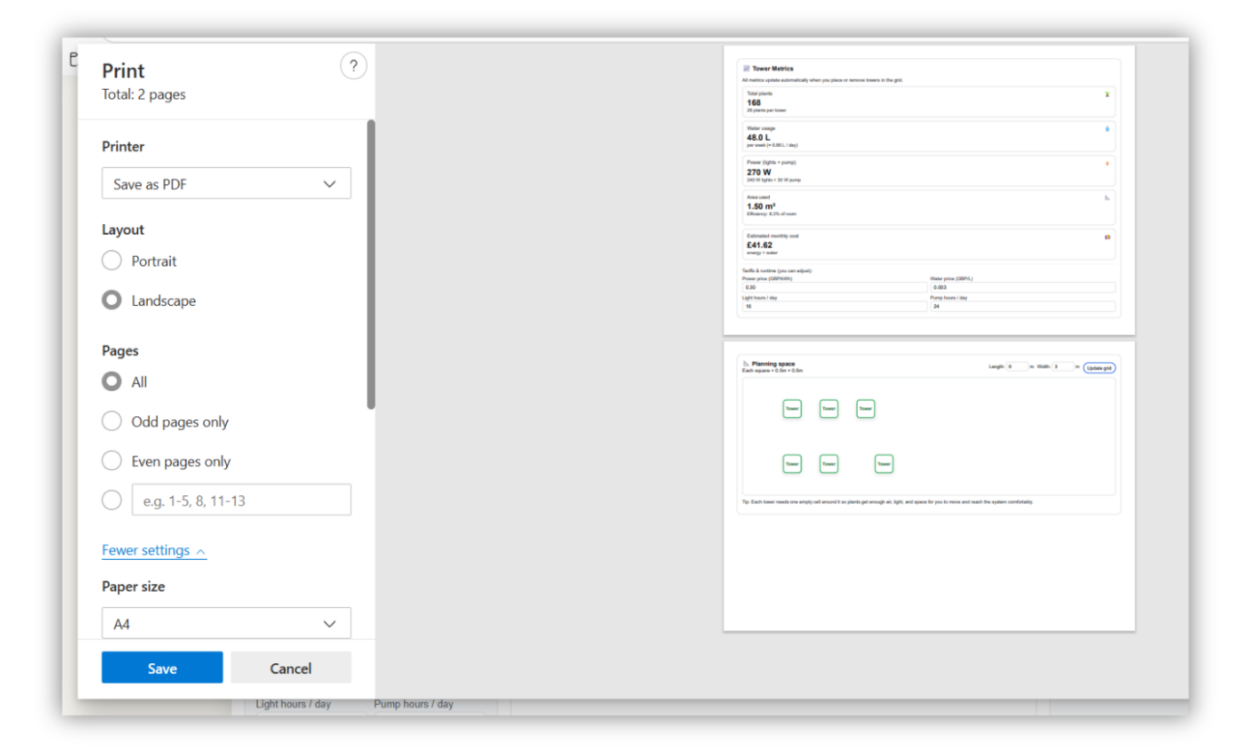

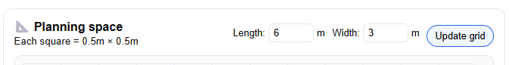

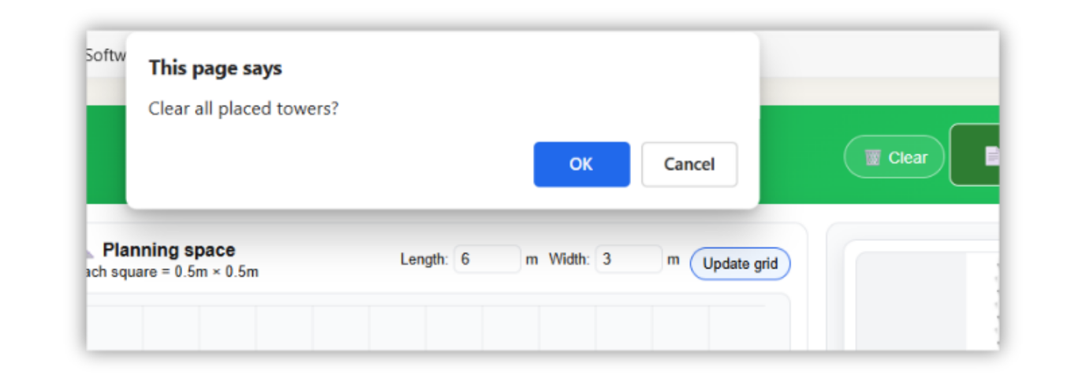

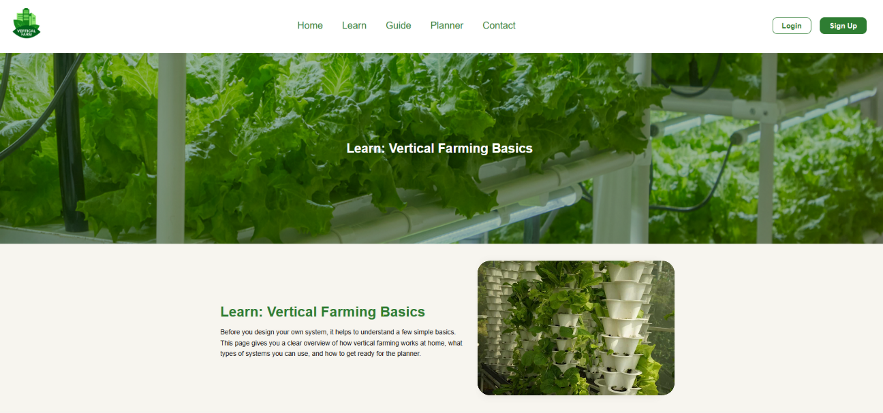

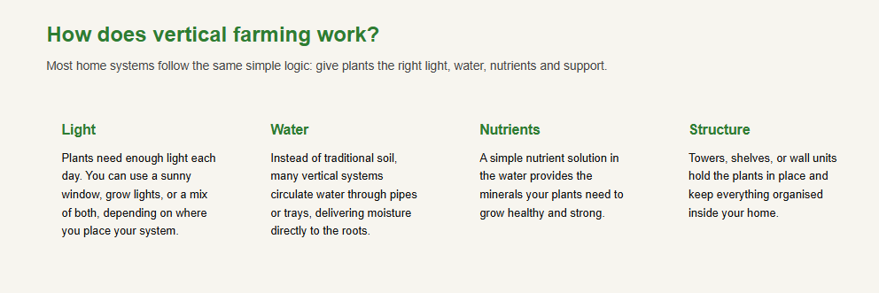

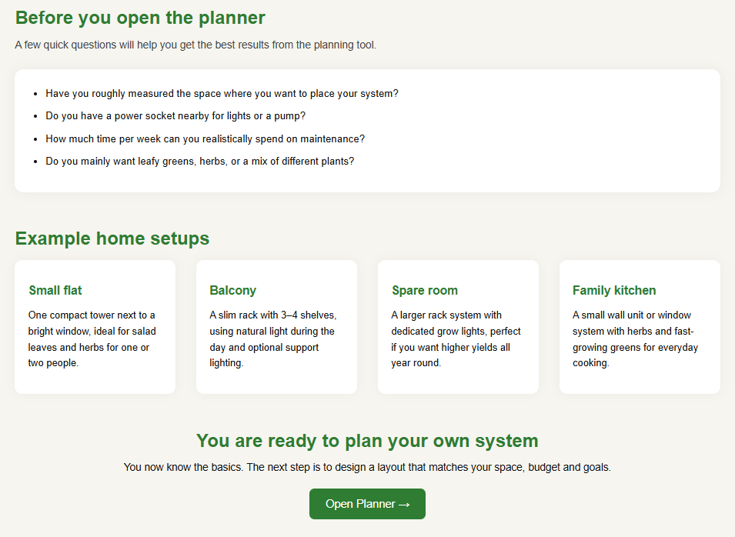

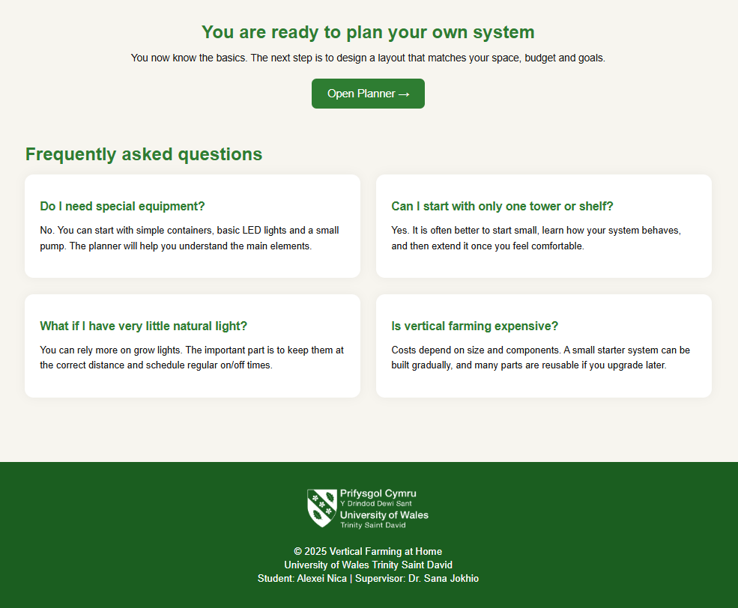

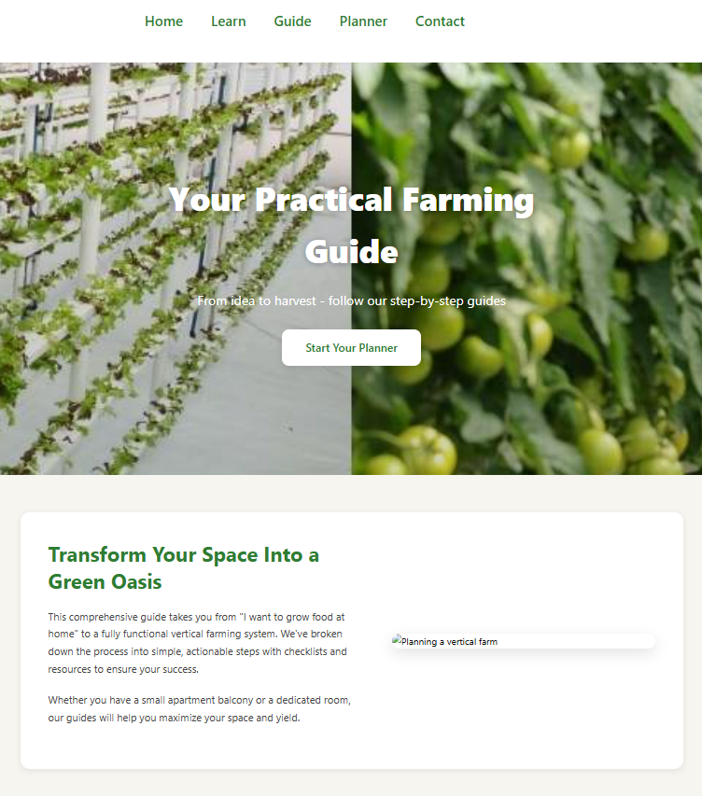

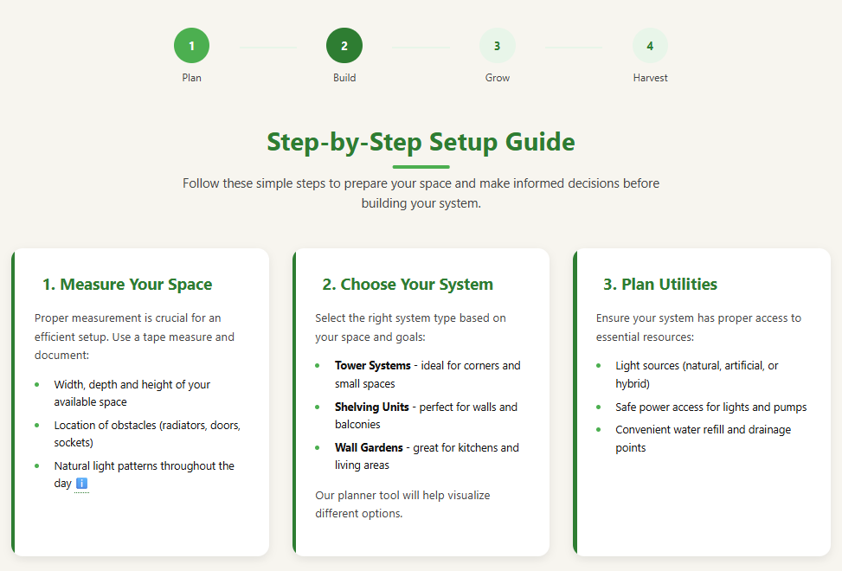

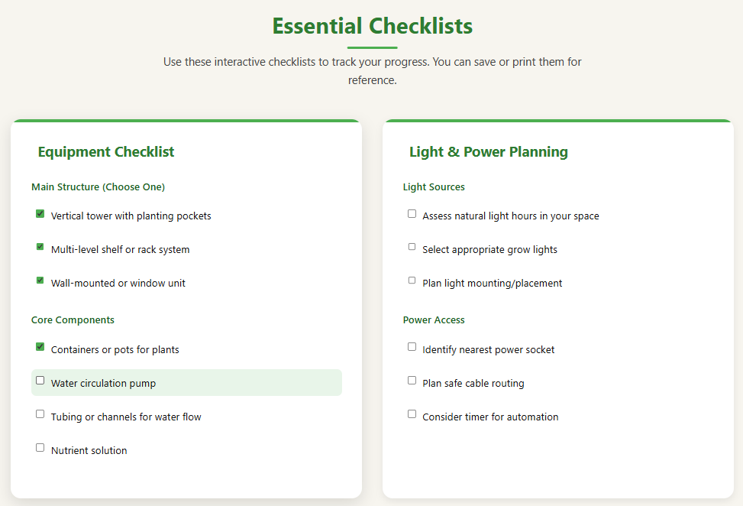

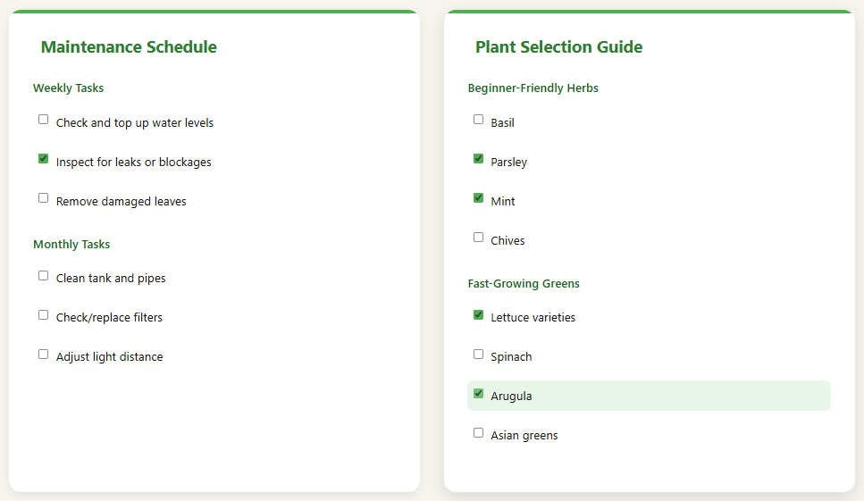

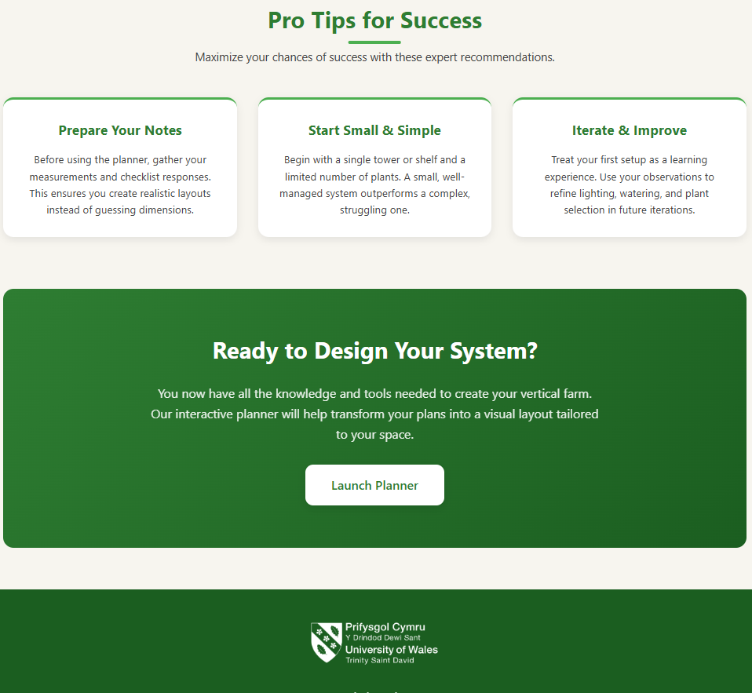

Appendix B

The following code listings in the appendix present the core HTML, CSS, and JavaScript implementation used to build the Vertical Farming at Home prototype.

HOME_PAGE
index.html

<!DOCTYPE html>
<html lang="en">
<head>
<meta charset="UTF-8">
<meta name="viewport" content="width=device-width, initial-scale=1.0">
<title>Vertical Farming at Home</title>

<!-- Styles -->
<link rel="stylesheet" href="css/style.css">
<link rel="stylesheet" href="css/learn.css">
</head>
<body>

<!-- Site header -->
<header class="header">
<div class="logo">
<img src="images/logo.png" alt="Vertical Farming Logo">
</div>

<nav class="nav">
<a href="index.html">Home</a>
<a href="learn.html">Learn</a>
<a href="guide.html">Guide</a>
<a href="planner.html">Planner</a>
<a href="contact.html">Contact</a>
</nav>

<div class="auth">
<a href="login.html" class="login-btn">Login</a>
<a href="signup.html" class="signup-btn">Sign Up</a>
</div>
</header>

<!-- Main hero banner -->
<section class="hero-banner">
<div class="banner-overlay"></div>
<h1>Grow Smarter. Live Greener.</h1>
<p class="banner-p">Plan. Build. Grow.</p>
</section>

<!-- Hero text under banner -->
<section class="hero">
<div class="hero-text">
<p>Create your own vertical farming setup at home with our simple and interactive planner.</p>
<a href="planner.html" class="btn-primary">Start Planner →</a>
</div>
</section>

<!-- Information tiles -->
<section class="info">
<div class="info-item">
<img src="images/System.png" alt="Vertical farming system">
<h2>What is Vertical Farming?</h2>
<p>Vertical farming allows you to grow more food in less space using stacked layers, smart lighting, and efficient water use.</p>
</div>

<div class="info-item">
<img src="https://images.unsplash.com/photo-1501004318641-b39e6451bec6?q=80" alt="">
<h2>Perfect for Small Homes</h2>
<p>Whether you live in a flat or a house, you can create a productive system that fits your available space.</p>
</div>

<div class="info-item">
<img src="https://images.unsplash.com/photo-1556905055-8f358a7a47b2?q=80" alt="">
<h2>Easy to Personalize</h2>
<p>Use our planner to build and visualize your farming system—towers, shelves, lights, pumps and more.</p>
</div>
</section>

<!-- Strong call to action -->
<section class="cta">
<h2>Ready to build your own farm?</h2>
<p>Start planning your custom layout now. It only takes a few minutes.</p>
<a href="#" class="btn-primary large">Start Planner →</a>
</section>

<!-- Site footer -->
<footer class="footer">
<div class="footer-content">

<div class="footer-logo">
<img src="images/uwtsd-logo.png" alt="UWTSD Logo">
</div>

<div class="footer-text">
<p>© 2025 Vertical Farming at Home</p>
<p>University of Wales Trinity Saint David</p>
<p>Student: Alexei Nica | Supervisor: Dr. Sana Jokhio</p>
</div>

</div>
</footer>

<!-- Optional homepage script -->
<script src="script.js"></script>
</body>
</html>

LEARN_PAGE
learn.html

<!DOCTYPE html>
<html lang="en">
<head>
<meta charset="UTF-8">
<meta name="viewport" content="width=device-width, initial-scale=1.0">
<title>Learn – Vertical Farming at Home</title>

<!-- Styles -->
<link rel="stylesheet" href="css/style.css">
<link rel="stylesheet" href="css/learn.css">
</head>
<body>

<!-- Site header -->
<header class="header">
<div class="logo">
<img src="images/logo.png" alt="Vertical Farming Logo">
</div>

<nav class="nav">
<a href="index.html">Home</a>
<a href="learn.html">Learn</a>
<a href="guide.html">Guide</a>
<a href="planner.html">Planner</a>
<a href="contact.html">Contact</a>
</nav>

<div class="auth">
<a href="login.html" class="login-btn">Login</a>
<a href="signup.html" class="signup-btn">Sign Up</a>
</div>
</header>

<!-- Learn page hero -->
<section class="hero-banner learn-banner">
<div class="banner-overlay"></div>
<h1>Learn: Vertical Farming Basics</h1>
</section>

<!-- Learn page main content -->
<main class="learn-page">

<!-- Intro section -->
<section class="learn-intro">
<div class="learn-intro-text">
<h1>Learn: Vertical Farming Basics</h1>
<p>
Before you design your own system, it helps to understand a few simple basics.
This page gives you a clear overview of how vertical farming works at home,
what types of systems you can use, and how to get ready for the planner.
</p>
</div>
<div class="learn-intro-image">
<img src="https://images.unsplash.com/photo-1557429287-b2e26467fc2b?q=80" alt="Vertical farm at home">
</div>
</section>

<!-- Why vertical farming at home -->
<section class="learn-section">
<h2>Why vertical farming at home?</h2>
<div class="learn-grid three">
<article class="learn-card">
<img src="https://images.unsplash.com/photo-1524592714635-3d7f9b1c8b48?q=80" alt="Small space">
<h3>Space-saving</h3>
<p>
Vertical systems allow you to grow upwards instead of outwards.
This means more plants in a small footprint, ideal for flats and compact rooms.
</p>
</article>
<article class="learn-card">
<img src="https://images.unsplash.com/photo-1512621776951-a57141f2eefd?q=80" alt="Fresh food">
<h3>Year-round harvest</h3>
<p>
With controlled light and water, you can grow fresh greens in any season,
independent of outdoor weather and soil conditions.
</p>
</article>
<article class="learn-card">
<img src="https://images.unsplash.com/photo-1524594154908-edd348f4e0bb?q=80" alt="Beginner friendly">
<h3>Beginner-friendly</h3>
<p>
You can start small with a single tower or shelf, then expand later as you gain confidence
and experience with your system.
</p>
</article>
</div>
</section>

<!-- How it works -->
<section class="learn-section">
<h2>How does vertical farming work?</h2>
<p class="section-subtitle">
Most home systems follow the same simple logic: give plants the right light, water, nutrients and support.
</p>
<div class="learn-grid four">
<article class="learn-mini">
<h3>Light</h3>
<p>
Plants need enough light each day. You can use a sunny window, grow lights, or a mix of both,
depending on where you place your system.
</p>
</article>
<article class="learn-mini">
<h3>Water</h3>
<p>
Instead of traditional soil, many vertical systems circulate water through pipes or trays,
delivering moisture directly to the roots.
</p>
</article>
<article class="learn-mini">
<h3>Nutrients</h3>
<p>
A simple nutrient solution in the water provides the minerals your plants need to grow healthy and strong.
</p>
</article>
<article class="learn-mini">
<h3>Structure</h3>
<p>
Towers, shelves, or wall units hold the plants in place and keep everything organised inside your home.
</p>
</article>
</div>
</section>

<!-- System types -->
<section class="learn-section">
<h2>System styles for home users</h2>
<div class="learn-grid three">
<article class="learn-card">
<img src="https://images.unsplash.com/photo-1582363230747-87b2f16efc90?q=80" alt="Tower system">
<h3>Tower systems</h3>
<p><strong>Best for:</strong> Corners, small rooms.</p>
<p>
Vertical towers stack planting pockets in a tall column. They are compact and can fit beside a window
or in an unused corner.
</p>
</article>
<article class="learn-card">
<img src="https://images.unsplash.com/photo-1584273143981-41c073dfe8f8?q=80" alt="Shelves and racks">
<h3>Shelves & racks</h3>
<p><strong>Best for:</strong> Spare rooms, balconies.</p>
<p>
Multi-level shelves are flexible and easy to extend. They are ideal if you have a bit more space
and want several layers of plants.
</p>
</article>
<article class="learn-card">
<img src="https://images.unsplash.com/photo-1543332164-6e82f355badc?q=80" alt="Window or wall">
<h3>Window & wall units</h3>
<p><strong>Best for:</strong> Kitchens, living rooms.</p>
<p>
Systems mounted on walls or around windows make use of existing light and turn your plants
into a green design feature.
</p>
</article>
</div>
</section>

<!-- Pre-planner checklist -->
<section class="learn-section checklist">
<h2>Before you open the planner</h2>
<p class="section-subtitle">
A few quick questions will help you get the best results from the planning tool.
</p>
<div class="checklist-box">
<ul>
<li>Have you roughly measured the space where you want to place your system?</li>
<li>Do you have a power socket nearby for lights or a pump?</li>
<li>How much time per week can you realistically spend on maintenance?</li>
<li>Do you mainly want leafy greens, herbs, or a mix of different plants?</li>
</ul>
</div>
</section>

<!-- Example setups -->
<section class="learn-section">
<h2>Example home setups</h2>
<div class="learn-grid four">
<article class="learn-mini card-bg">
<h3>Small flat</h3>
<p>
One compact tower next to a bright window, ideal for salad leaves and herbs for one or two people.
</p>
</article>
<article class="learn-mini card-bg">
<h3>Balcony</h3>
<p>
A slim rack with 3–4 shelves, using natural light during the day and optional support lighting.
</p>
</article>
<article class="learn-mini card-bg">
<h3>Spare room</h3>
<p>
A larger rack system with dedicated grow lights, perfect if you want higher yields all year round.
</p>
</article>
<article class="learn-mini card-bg">
<h3>Family kitchen</h3>
<p>
A small wall unit or window system with herbs and fast-growing greens for everyday cooking.
</p>
</article>
</div>
</section>

<!-- Soft CTA -->
<section class="learn-section learn-cta">
<h2>You are ready to plan your own system</h2>
<p>
You now know the basics. The next step is to design a layout that matches your space, budget and goals.
</p>
<a href="#" class="btn-primary">Open Planner →</a>
</section>

<!-- FAQ block -->
<section class="learn-section faq">
<h2>Frequently asked questions</h2>
<div class="faq-list">
<article class="faq-item">
<h3>Do I need special equipment?</h3>
<p>
No. You can start with simple containers, basic LED lights and a small pump.
The planner will help you understand the main elements.
</p>
</article>
<article class="faq-item">
<h3>Can I start with only one tower or shelf?</h3>
<p>
Yes. It is often better to start small, learn how your system behaves,
and then extend it once you feel comfortable.
</p>
</article>
<article class="faq-item">
<h3>What if I have very little natural light?</h3>
<p>
You can rely more on grow lights. The important part is to keep them at the correct distance
and schedule regular on/off times.
</p>
</article>
<article class="faq-item">
<h3>Is vertical farming expensive?</h3>
<p>
Costs depend on size and components. A small starter system can be built gradually,
and many parts are reusable if you upgrade later.
</p>
</article>
</div>
</section>

</main>

<!-- Site footer -->
<footer class="footer">
<div class="footer-content">

<div class="footer-logo">
<img src="images/uwtsd-logo.png" alt="UWTSD Logo">
</div>

<div class="footer-text">
<p>© 2025 Vertical Farming at Home</p>
<p>University of Wales Trinity Saint David</p>
<p>Student: Alexei Nica | Supervisor: Dr. Sana Jokhio</p>
</div>

</div>
</footer>

</body>
</html>

GUIDE_PAGE
guide.html

<!DOCTYPE html>
<html lang="en">
<head>
<meta charset="UTF-8">
<meta name="viewport" content="width=device-width, initial-scale=1.0">
<title>Guide – Vertical Farming at Home</title>

<!-- Styles -->
<link rel="stylesheet" href="css/style.css">
<link rel="stylesheet" href="css/guide.css">
</head>
<body>

<!-- Site header -->
<header class="header">
<div class="logo">
<img src="images/logo.png" alt="Vertical Farming Logo">
</div>

<nav class="nav">
<a href="index.html">Home</a>
<a href="learn.html">Learn</a>
<a href="guide.html">Guide</a>
<a href="planner.html">Planner</a>
<a href="contact.html">Contact</a>
</nav>

<div class="auth">
<a href="login.html" class="login-btn">Login</a>
<a href="signup.html" class="signup-btn">Sign Up</a>
</div>
</header>

<!-- Guide hero banner -->
<section class="guide-banner">
<div class="banner-content">
<h1>Your Practical Farming Guide</h1>
<p>From idea to harvest - follow our step-by-step guides</p>
<a href="planner.html" class="btn-primary">Start Your Planner</a>
</div>
</section>

<!-- Guide page content -->
<main class="guide-page">

<!-- Intro section -->
<section class="guide-intro">
<div class="guide-intro-text">
<h2>Transform Your Space Into a Green Oasis</h2>
<p>
This comprehensive guide takes you from "I want to grow food at home" to a fully functional vertical farming system.
We've broken down the process into simple, actionable steps with checklists and resources to ensure your success.
</p>
<p>
Whether you have a small apartment balcony or a dedicated room, our guides will help you maximize your space and yield.
</p>
</div>
<div class="guide-intro-image">
<img src="https://images.unsplash.com/photo-1584270354950-bd19c69699a9?q=80" alt="Planning a vertical farm">
</div>
</section>

<!-- Progress indicator -->
<div class="progress-container">
<div class="progress-steps">
<div class="progress-step">
<div class="step-circle completed">1</div>
<div class="step-label">Plan</div>
</div>
<div class="step-connector"></div>
<div class="progress-step">
<div class="step-circle active">2</div>
<div class="step-label">Build</div>
</div>
<div class="step-connector"></div>
<div class="progress-step">
<div class="step-circle">3</div>
<div class="step-label">Grow</div>
</div>
<div class="step-connector"></div>
<div class="progress-step">
<div class="step-circle">4</div>
<div class="step-label">Harvest</div>
</div>
</div>
</div>

<!-- Step-by-step guide -->
<section class="guide-section">
<div class="section-header">
<h2>Step-by-Step Setup Guide</h2>
<p class="section-subtitle">
Follow these simple steps to prepare your space and make informed decisions before building your system.
</p>
</div>

<div class="guide-grid three">
<article class="guide-card">
<h3><i class="fas fa-ruler-combined"></i> 1. Measure Your Space</h3>
<p>
Proper measurement is crucial for an efficient setup. Use a tape measure and document:
</p>
<ul>
<li>Width, depth and height of your available space</li>
<li>Location of obstacles (radiators, doors, sockets)</li>
<li>Natural light patterns throughout the day <span class="tooltip">ℹ️
<span class="tooltiptext">Track how sunlight moves across your space at different times</span>
</span></li>
</ul>
</article>

<article class="guide-card">
<h3><i class="fas fa-th-large"></i> 2. Choose Your System</h3>
<p>
Select the right system type based on your space and goals:
</p>
<ul>
<li><strong>Tower Systems</strong> - ideal for corners and small spaces</li>
<li><strong>Shelving Units</strong> - perfect for walls and balconies</li>
<li><strong>Wall Gardens</strong> - great for kitchens and living areas</li>
</ul>
<p>
Our planner tool will help visualize different options.
</p>
</article>

<article class="guide-card">
<h3><i class="fas fa-tint"></i> 3. Plan Utilities</h3>
<p>
Ensure your system has proper access to essential resources:
</p>
<ul>
<li>Light sources (natural, artificial, or hybrid)</li>
<li>Safe power access for lights and pumps</li>
<li>Convenient water refill and drainage points</li>
</ul>
</article>
</div>
</section>

<!-- Checklists & resources -->
<section class="guide-section">
<div class="section-header">
<h2>Essential Checklists</h2>
<p class="section-subtitle">
Use these interactive checklists to track your progress. You can save or print them for reference.
</p>
</div>

<div class="guide-grid two">
<!-- Starter equipment checklist -->
<article class="checklist-card">
<h3><i class="fas fa-tools"></i> Equipment Checklist</h3>

<div class="checklist-section">
<p>Main Structure (Choose One)</p>
<ul class="checklist-items">
<li>
<input type="checkbox" id="item1">
<label for="item1">Vertical tower with planting pockets</label>
</li>
<li>
<input type="checkbox" id="item2">
<label for="item2">Multi-level shelf or rack system</label>
</li>
<li>
<input type="checkbox" id="item3">
<label for="item3">Wall-mounted or window unit</label>
</li>
</ul>
</div>

<div class="checklist-section">
<p>Core Components</p>
<ul class="checklist-items">
<li>
<input type="checkbox" id="item4">
<label for="item4">Containers or pots for plants</label>
</li>
<li>
<input type="checkbox" id="item5">
<label for="item5">Water circulation pump</label>
</li>
<li>
<input type="checkbox" id="item6">
<label for="item6">Tubing or channels for water flow</label>
</li>
<li>
<input type="checkbox" id="item7">
<label for="item7">Nutrient solution</label>
</li>
</ul>
</div>
</article>

<!-- Light & power planning -->
<article class="checklist-card">
<h3><i class="fas fa-lightbulb"></i> Light & Power Planning</h3>

<div class="checklist-section">
<p>Light Sources</p>
<ul class="checklist-items">
<li>
<input type="checkbox" id="item8">
<label for="item8">Assess natural light hours in your space</label>
</li>
<li>
<input type="checkbox" id="item9">
<label for="item9">Select appropriate grow lights</label>
</li>
<li>
<input type="checkbox" id="item10">
<label for="item10">Plan light mounting/placement</label>
</li>
</ul>
</div>

<div class="checklist-section">
<p>Power Access</p>
<ul class="checklist-items">
<li>
<input type="checkbox" id="item11">
<label for="item11">Identify nearest power socket</label>
</li>
<li>
<input type="checkbox" id="item12">
<label for="item12">Plan safe cable routing</label>
</li>
<li>
<input type="checkbox" id="item13">
<label for="item13">Consider timer for automation</label>
</li>
</ul>
</div>
</article>

<!-- Maintenance schedule -->
<article class="checklist-card">
<h3><i class="fas fa-clipboard-check"></i> Maintenance Schedule</h3>

<div class="checklist-section">
<p>Weekly Tasks</p>
<ul class="checklist-items">
<li>
<input type="checkbox" id="item14">
<label for="item14">Check and top up water levels</label>
</li>
<li>
<input type="checkbox" id="item15">
<label for="item15">Inspect for leaks or blockages</label>
</li>
<li>
<input type="checkbox" id="item16">
<label for="item16">Remove damaged leaves</label>
</li>
</ul>
</div>

<div class="checklist-section">
<p>Monthly Tasks</p>
<ul class="checklist-items">
<li>
<input type="checkbox" id="item17">
<label for="item17">Clean tank and pipes</label>
</li>
<li>
<input type="checkbox" id="item18">
<label for="item18">Check/replace filters</label>
</li>
<li>
<input type="checkbox" id="item19">
<label for="item19">Adjust light distance</label>
</li>
</ul>
</div>
</article>

<!-- Plant selection ideas -->
<article class="checklist-card">
<h3><i class="fas fa-leaf"></i> Plant Selection Guide</h3>

<div class="checklist-section">
<p>Beginner-Friendly Herbs</p>
<ul class="checklist-items">
<li>
<input type="checkbox" id="item20">
<label for="item20">Basil</label>
</li>
<li>
<input type="checkbox" id="item21">
<label for="item21">Parsley</label>
</li>
<li>
<input type="checkbox" id="item22">
<label for="item22">Mint</label>
</li>
<li>
<input type="checkbox" id="item23">
<label for="item23">Chives</label>
</li>
</ul>
</div>

<div class="checklist-section">
<p>Fast-Growing Greens</p>
<ul class="checklist-items">
<li>
<input type="checkbox" id="item24">
<label for="item24">Lettuce varieties</label>
</li>
<li>
<input type="checkbox" id="item25">
<label for="item25">Spinach</label>
</li>
<li>
<input type="checkbox" id="item26">
<label for="item26">Arugula</label>
</li>
<li>
<input type="checkbox" id="item27">
<label for="item27">Asian greens</label>
</li>
</ul>
</div>
</article>
</div>
</section>

<!-- Practical tips -->
<section class="guide-section">
<div class="section-header">
<h2>Pro Tips for Success</h2>
<p class="section-subtitle">
Maximize your chances of success with these expert recommendations.
</p>
</div>

<div class="guide-grid three">
<article class="guide-mini">
<h3>Prepare Your Notes</h3>
<p>
Before using the planner, gather your measurements and checklist responses.
This ensures you create realistic layouts instead of guessing dimensions.
</p>
</article>
<article class="guide-mini">
<h3>Start Small & Simple</h3>
<p>
Begin with a single tower or shelf and a limited number of plants.
A small, well-managed system outperforms a complex, struggling one.
</p>
</article>
<article class="guide-mini">
<h3>Iterate & Improve</h3>
<p>
Treat your first setup as a learning experience. Use your observations to refine lighting,
watering, and plant selection in future iterations.
</p>
</article>
</div>
</section>

<!-- Call to action -->
<section class="guide-cta">
<h2>Ready to Design Your System?</h2>
<p>
You now have all the knowledge and tools needed to create your vertical farm.
Our interactive planner will help transform your plans into a visual layout tailored to your space.
</p>
<a href="#" class="btn-primary">Launch Planner <i class="fas fa-arrow-right"></i></a>
</section>

</main>

<!-- Site footer -->
<footer class="footer">
<div class="footer-content">

<div class="footer-logo">
<img src="images/uwtsd-logo.png" alt="UWTSD Logo">
</div>

<div class="footer-text">
<p>© 2025 Vertical Farming at Home</p>
<p>University of Wales Trinity Saint David</p>
<p>Student: Alexei Nica | Supervisor: Dr. Sana Jokhio</p>
</div>

</div>
</footer>

<!-- Guide page script -->
<script src="js/guide.js"></script>
</body>
</html>

PLANNER_PAGE
planner.html

<!DOCTYPE html>
<html lang="en">
<head>
<meta charset="UTF-8" />
<meta name="viewport" content="width=device-width, initial-scale=1.0" />
<title>Advanced Vertical Farming Planner – Tower Layout</title>

<!-- Styles -->
<link rel="stylesheet" href="css/planner.css">
<link rel="stylesheet" href="css/style.css">
</head>

<body>

<!-- Site header -->
<header class="header">
<div class="logo">
<img src="images/logo.png" alt="Vertical Farming Logo">
</div>

<nav class="nav">
<a href="index.html">Home</a>
<a href="learn.html">Learn</a>
<a href="guide.html">Guide</a>
<a href="planner.html">Planner</a>
<a href="contact.html">Contact</a>
</nav>

<div class="auth">
<a href="login.html" class="login-btn">Login</a>
<a href="signup.html" class="signup-btn">Sign Up</a>
</div>
</header>

<div class="app-container">
<!-- Planner header inside the app -->
<header class="app-header">
<div class="header-content">
<div class="app-title">
<h1>Vertical Farming Planner</h1>
</div>
<div>
<button class="btn" onclick="clearAll()">🗑️ Clear</button>
<button class="btn btn-primary" onclick="window.print()">📄 Download PDF</button>
</div>
</div>
</header>

<!-- Main three-column layout -->
<div class="main-shell">
<!-- Left + center area (printable content) -->
<div id="print-area">
<!-- Metrics panel -->
<section class="panel">
<h2>📈 Tower Metrics</h2>
<p class="subtext">All metrics update automatically when you place or remove towers in the grid.</p>

<div class="metric-list">
<div class="metric-card">
<div class="metric-title-row">
<span>Total plants</span>
<span>🌱</span>
</div>
<div class="metric-value" id="mPlants">0</div>
<div class="metric-caption">28 plants per tower</div>
</div>

<div class="metric-card">
<div class="metric-title-row">
<span>Water usage</span>
<span>💧</span>
</div>
<div class="metric-value" id="mWaterWeek">0 L</div>
<div class="metric-caption">
per week (≈ <span id="mWaterDay">0</span> L / day)
</div>
</div>

<div class="metric-card">
<div class="metric-title-row">
<span>Power (lights + pump)</span>
<span>⚡</span>
</div>
<div class="metric-value" id="mPowerTotal">0 W</div>
<div class="metric-caption">
<span id="mPowerSplit">0 W lights + 0 W pump</span>
</div>
</div>

<div class="metric-card">
<div class="metric-title-row">
<span>Area used</span>
<span>📐</span>
</div>
<div class="metric-value" id="mAreaUsed">0 m²</div>
<div class="metric-caption">
Efficiency: <span id="mEff">0%</span> of room
</div>
<div class="bar"><span id="mEffBar"></span></div>
</div>

<div class="metric-card">
<div class="metric-title-row">
<span>Estimated monthly cost</span>
<span>💷</span>
</div>
<div class="metric-value" id="mCostMonth">£0.00</div>
<div class="metric-caption">energy + water</div>
</div>
</div>

<!-- User-adjustable configuration -->
<div class="config-group">
<div class="field-label">Tariffs & runtime (you can adjust):</div>
<div class="config-row">
<div>
<div class="field-label">Power price (GBP/kWh)</div>
<input id="tariff" type="number" step="0.01" value="0.30" class="field-input" />
</div>
<div>
<div class="field-label">Water price (GBP/L)</div>
<input id="waterPrice" type="number" step="0.001" value="0.003" class="field-input" />
</div>
</div>
<div class="config-row">
<div>
<div class="field-label">Light hours / day</div>
<input id="lightHours" type="number" step="1" value="16" class="field-input" />
</div>
<div>
<div class="field-label">Pump hours / day</div>
<input id="pumpHours" type="number" step="1" value="24" class="field-input" />
</div>
</div>
</div>
</section>

<!-- Grid / planning area -->
<section class="planning-panel">
<div class="planning-header">
<div>
<h2>📐 Planning space</h2>
<small>Each square = 0.5m × 0.5m</small>
</div>
<div class="space-config">
<div class="space-field">
<span>Length:</span>
<input id="spaceLength" type="number" value="6" min="1" max="20" step="0.5" /> m
</div>
<div class="space-field">
<span>Width:</span>
<input id="spaceWidth" type="number" value="3" min="1" max="15" step="0.5" /> m
</div>
<button class="btn-small" onclick="updateSpace()">Update grid</button>
</div>
</div>

<div class="floor-wrapper">
<div id="floorGrid" class="floor-grid">
<!-- Cells and tower instances are rendered here -->
</div>
</div>

<small class="subtext">
Tip: Each tower needs one empty cell around it so plants get enough air, light, and space for you to move and reach the system comfortably.
</small>
</section>
</div>

<!-- Right: tower preview and drag source -->
<section class="panel">
<div id="towerCard" class="tower-card" draggable="true">
<div class="tower-photo-box">
<!-- Local tower image -->
<img src="images/tower.png" alt="Vertical tower" />
</div>
<div class="tower-details">
<h3>Vertical Tower</h3>
<p>Height: ~1.5m (for reference only)</p>
<div class="badge-line">
<span class="badge">🌱 28 plants</span>
<span class="badge">⚡ 40W lights</span>
<span class="badge">💧 8L / week</span>
<span class="badge">🔁 5W pump</span>
</div>
</div>
</div>
</section>
</div>

<!-- App footer (print-friendly) -->
<footer class="app-footer">
Vertical Farming Planner – tower layout demo
</footer>
</div>

<!-- Planner logic -->
<script src="js/planner.js"></script>
</body>
</html>

Contact_PAGE
contact.html

<!DOCTYPE html>
<html lang="en">
<head>
<meta charset="UTF-8">
<meta name="viewport" content="width=device-width, initial-scale=1.0">
<title>Contact & Feedback – Vertical Farming at Home</title>

<!-- Styles -->
<link rel="stylesheet" href="css/style.css">
<link rel="stylesheet" href="css/contact.css">
</head>
<body>

<!-- Site header -->
<header class="header">
<div class="logo">
<img src="images/logo.png" alt="Vertical Farming Logo">
</div>

<nav class="nav">
<a href="index.html">Home</a>
<a href="learn.html">Learn</a>
<a href="guide.html">Guide</a>
<a href="planner.html">Planner</a>
<a href="contact.html">Contact</a>
</nav>

<div class="auth">
<a href="login.html" class="login-btn">Login</a>
<a href="signup.html" class="signup-btn">Sign Up</a>
</div>
</header>

<!-- Short intro under header -->
<section class="hero">
<div class="hero-text">
<p>Share your feedback with us using the form below.</p>
</div>
</section>

<!-- Contact / feedback area -->
<main class="contact-wrapper">
<section class="contact-card">
<h2>Send Your Feedback</h2>

<form id="contact-form">
<div class="form-row">
<label for="name">Your Name *</label>
<input type="text" id="name" name="name" placeholder="Enter your name" required>
</div>

<div class="form-row">
<label for="email">Your Email *</label>
<input type="email" id="email" name="email" placeholder="Enter your email" required>
</div>

<div class="form-row">
<label for="subject">Subject (optional)</label>
<input type="text" id="subject" name="subject" placeholder="Short title for your feedback">
</div>

<div class="form-row">
<label for="message">Message *</label>
<textarea id="message" name="message" placeholder="Write your feedback here..." required></textarea>
</div>

<button type="submit" class="contact-btn">Send Feedback</button>
</form>
</section>

<!-- Placeholder for social links -->
<section class="social-section">
<h3>Social media</h3>
<p>Coming soon</p>
</section>
</main>

<!-- Site footer -->
<footer class="footer">
<div class="footer-content">

<div class="footer-logo">
<img src="images/uwtsd-logo.png" alt="UWTSD Logo">
</div>

<div class="footer-text">
<p>© 2025 Vertical Farming at Home</p>
<p>University of Wales Trinity Saint David</p>
<p>Student: Alexei Nica | Supervisor: Dr. Sana Jokhio</p>
</div>

</div>
</footer>

<!-- Contact page script -->
<script src="js/contact.js"></script>
</body>
</html>

Login_PAGE
login.html

<!DOCTYPE html>
<html lang="en">
<head>
<meta charset="UTF-8">
<meta name="viewport" content="width=device-width, initial-scale=1.0">
<title>Login – Vertical Farming</title>

<!-- Styles -->
<link rel="stylesheet" href="css/style.css">
<link rel="stylesheet" href="css/auth.css">
</head>
<body>

<!-- Site header -->
<header class="header">
<div class="logo">
<img src="images/logo.png" alt="Vertical Farming Logo">
</div>
<nav class="nav">
<a href="index.html">Home</a>
<a href="learn.html">Learn</a>
<a href="guide.html">Guide</a>
<a href="planner.html">Planner</a>
<a href="contact.html">Contact</a>
</nav>
<div class="auth">
<a class="login-btn" href="login.html">Login</a>
<a class="signup-btn" href="signup.html">Sign Up</a>
</div>
</header>

<!-- Auth page content -->
<main>
<div class="auth-page-wrapper">
<h2>Login</h2>
<p class="auth-desc">Access your account and continue your progress.</p>

<form class="auth-form">
<label>Email *</label>
<input type="email" required>

<label>Password *</label>
<input type="password" required>

<button class="auth-btn">Login</button>
</form>

<div class="auth-links">
Don't have an account? <a href="signup.html">Sign up</a>
</div>
</div>
</main>

<!-- Site footer -->
<footer class="footer">
<div class="footer-content">

<div class="footer-logo">
<img src="images/uwtsd-logo.png" alt="UWTSD Logo">
</div>

<div class="footer-text">
<p>© 2025 Vertical Farming at Home</p>
<p>University of Wales Trinity Saint David</p>
<p>Student: Alexei Nica | Supervisor: Dr. Sana Jokhio</p>
</div>

</div>
</footer>
</body>
</html>

SIGN-UP_PAGE
Sign-up.html

<!DOCTYPE html>
<html lang="en">
<head>
<meta charset="UTF-8">
<meta name="viewport" content="width=device-width, initial-scale=1.0">
<title>Sign Up – Vertical Farming</title>

<!-- Styles -->
<link rel="stylesheet" href="css/style.css">
<link rel="stylesheet" href="css/auth.css">
</head>
<body>

<!-- Site header -->
<header class="header">
<div class="logo">
<img src="images/logo.png" alt="Vertical Farming Logo">
</div>
<nav class="nav">
<a href="index.html">Home</a>
<a href="learn.html">Learn</a>
<a href="guide.html">Guide</a>
<a href="planner.html">Planner</a>
<a href="contact.html">Contact</a>
</nav>
<div class="auth">
<a class="login-btn" href="login.html">Login</a>
<a class="signup-btn" href="signup.html">Sign Up</a>
</div>
</header>

<!-- Auth page content -->
<main>
<div class="auth-page-wrapper">
<h2>Sign Up</h2>
<p class="auth-desc">Start designing your vertical farming system today.</p>

<form class="auth-form">
<label>Full Name *</label>
<input type="text" required>

<label>Email *</label>
<input type="email" required>

<label>Password *</label>
<input type="password" required>

<button class="auth-btn">Create Account</button>
</form>

<div class="auth-links">
Already have an account? <a href="login.html">Login</a>
</div>
</div>
</main>

<!-- Site footer -->
<footer class="footer">
<div class="footer-content">

<div class="footer-logo">
<img src="images/uwtsd-logo.png" alt="UWTSD Logo">
</div>

<div class="footer-text">
<p>© 2025 Vertical Farming at Home</p>
<p>University of Wales Trinity Saint David</p>
<p>Student: Alexei Nica | Supervisor: Dr. Sana Jokhio</p>
</div>

</div>
</footer>
</body>

STYLE_PAGE
style.

/* -----------------------------------
GLOBAL
----------------------------------- */
body {
margin: 0;
font-family: Arial, sans-serif;
background: #F7F5EF; /* ivory */
color: #111;
}

a {
text-decoration: none;
}

html, body {
width: 100%;
max-width: 100%;
overflow-x: hidden;
}

/* -----------------------------------
HEADER
----------------------------------- */
.header {
display: flex;
justify-content: space-between;
align-items: center;
padding: 1.6rem 4rem;
background: white;
position: sticky;
top: 0;
z-index: 1000;
box-shadow: 0 2px 20px rgba(0,0,0,0.06);
}

.logo {
font-size: 2.5rem;
font-weight: 800;
color: #2E7D32;
letter-spacing: 1px;
}

.logo img {
height: 75px;
width: auto;
}

/* NAV */
.nav {
display: flex;
gap: 3rem; /* generous spacing between nav links */
}

.nav a {
color: #2E7D32;
font-size: 1.5rem;
font-weight: 500;
transition: 0.3s;
}

.nav a:hover {
color: #2E7D32;
}

/* LOGIN / SIGNUP BUTTONS – MODERN PREMIUM */
.auth {
display: flex;
gap: 1.4rem;
align-items: center;
}

/* Login button */
.login-btn {
padding: 0.55rem 1.4rem;
font-size: 1.15rem;
font-weight: 600;
color: #2E7D32;
border: 2px solid #2E7D32;
background: transparent;
border-radius: 12px;
transition: all 0.25s ease;
}

.login-btn:hover {
background: #e9f7e9;
color: #1f5d24;
}

/* Sign up button */
.signup-btn {
padding: 0.55rem 1.4rem;
font-size: 1.15rem;
font-weight: 600;
color: white;
background: #2E7D32;
border: 2px solid #2E7D32;
border-radius: 12px;
transition: all 0.25s ease;
}

.signup-btn:hover {
background: #256b29;
border-color: #256b29;
}

/* -----------------------------------
HERO BANNER (IMAGE + TITLE)
----------------------------------- */
.hero-banner {
position: relative;
height: 45vh;
background-image: url("../images/baner.jpg");
background-size: cover;
background-position: center;
display: flex;
flex-direction: column;
justify-content: center;
align-items: center;
text-align: center;
}

.banner-overlay {
position: absolute;
top: 0;
left: 0;
width: 100%;
height: 100%;
background: rgba(0, 60, 0, 0.35); /* green transparent overlay */
z-index: 1;
}

.hero-banner h1,
.hero-banner .banner-p {
position: relative;
z-index: 2;
color: #ffffff;
}

.hero-banner .banner-p {
font-size: 1.4rem;
font-weight: 300;
margin-top: 10px;
opacity: 0.9;
}

/* -----------------------------------
HERO TEXT SECTION (below banner)
----------------------------------- */
.hero {
display: flex;
justify-content: center;
padding: 3rem 2rem;
text-align: center;
width: 100%;
}

.hero-text {
max-width: 800px;
}

.hero-text p {
font-size: 1.3rem;
margin-bottom: 1.8rem;
}

/* GENERAL BUTTON */
.btn-primary {
background: #2E7D32;
padding: 0.9rem 1.6rem;
color: white;
border-radius: 8px;
font-size: 1.1rem;
transition: 0.3s;
display: inline-block;
}

.btn-primary:hover {
background: #256b29;
}

/* -----------------------------------
INFO SECTIONS (CARD GRID)
----------------------------------- */
.info {
display: grid;
grid-template-columns: repeat(3, 1fr);
padding: 4rem;
gap: 2rem;
}

.info-item {
background: white;
padding: 1.5rem;
border-radius: 14px;
box-shadow: 0 0 20px rgba(0,0,0,0.05);
text-align: center;
}

.info-item img {
width: 100%;
border-radius: 12px;
margin-bottom: 1rem;
}

.info-item h2 {
color: #2E7D32;
}

/* -----------------------------------
CTA SECTION
----------------------------------- */
.cta {
text-align: center;
padding: 4rem 2rem;
background: white;
color: #2E7D32;
}

.cta p {
font-size: 1.2rem;
margin-bottom: 1.5rem;
}

.btn-primary.large {
padding: 1.2rem 2.5rem;
font-size: 1.3rem;
}

/* -----------------------------------
FOOTER
----------------------------------- */
.footer {
background: #1B5E20; /* dark professional green */
color: white;
padding: 2.5rem 2rem;
text-align: center;
}

.footer-content {
max-width: 900px;
margin: auto;
}

.footer-logo img {
height: 70px;
width: auto;
margin-bottom: 1rem;
}

.footer-text p {
margin: 4px 0;
font-size: 1rem;
}

PLANNER_PAGE
planner.css

:root {
--bg: #f5f7fa;
--panel: #ffffff;
--border: #e5e7eb;
--ink: #111827;
--muted: #6b7280;
--primary: #16a34a;
--primary-soft: #bbf7d0;
--accent: #2563eb;
--danger: #ef4444;
--shadow: 0 10px 25px rgba(15,23,42,0.12);
}

* {
box-sizing: border-box;
}

body {
margin: 0;
font-family: system-ui, -apple-system, BlinkMacSystemFont, "Segoe UI", sans-serif;
background: var(--bg);
color: var(--ink);
}

.app-container {
max-width: 1400px;
margin: 24px auto;
padding: 0 16px 24px;
}

header.app-header {
background: linear-gradient(135deg, #16a34a, #22c55e);
border-radius: 16px 16px 0 0;
padding: 16px 20px;
color: #fff;
box-shadow: var(--shadow);
}

.header-content {
display: flex;
justify-content: space-between;
align-items: center;
gap: 12px;
}

.app-title h1 {
margin: 0;
font-size: 1.5rem;
}

.app-title p {
margin: 4px 0 0;
font-size: 0.9rem;
opacity: 0.9;
}

.btn {
border-radius: 999px;
border: 1px solid rgba(255,255,255,0.6);
background: rgba(255,255,255,0.1);
padding: 8px 14px;
color: #fff;
cursor: pointer;
font-size: 0.9rem;
display: inline-flex;
align-items: center;
gap: 6px;
}

.btn-primary {
background: #fff;
color: #166534;
border-color: #fff;
font-weight: 600;
}

/* MAIN LAYOUT: left metrics – center grid – right tower */
.main-shell {
display: grid;
grid-template-columns: 320px minmax(0, 1fr) 320px;
gap: 16px;
background: var(--panel);
border-radius: 0 0 16px 16px;
box-shadow: var(--shadow);
padding: 16px;
}

@media (max-width: 1024px) {
.main-shell {
grid-template-columns: 1fr;
}
}

.panel {
background: #f9fafb;
border-radius: 12px;
border: 1px solid var(--border);
padding: 14px 14px 16px;
overflow: hidden;
}

.panel h2 {
margin: 0 0 8px;
font-size: 1.05rem;
}

.subtext {
font-size: 0.8rem;
color: var(--muted);
margin-bottom: 10px;
}

/* LEFT: METRICS */
.metric-list {
display: grid;
gap: 10px;
}

.metric-card {
background: #ffffff;
border-radius: 10px;
border: 1px solid var(--border);
padding: 10px 12px;
}

.metric-title-row {
display: flex;
justify-content: space-between;
align-items: center;
font-size: 0.85rem;
color: var(--muted);
margin-bottom: 4px;
}

.metric-value {
font-size: 1.4rem;
font-weight: 700;
}

.metric-caption {
font-size: 0.78rem;
color: var(--muted);
}

.bar {
height: 6px;
background: #e5e7eb;
border-radius: 999px;
overflow: hidden;
margin-top: 6px;
}

.bar > span {
display: block;
height: 100%;
background: linear-gradient(90deg, var(--primary), #22c55e);
width: 0%;
}

.config-group {
margin-top: 12px;
padding-top: 10px;
border-top: 1px dashed var(--border);
}

.config-row {
display: grid;
grid-template-columns: 1fr 1fr;
gap: 8px;
margin-top: 6px;
}

.field-label {
font-size: 0.8rem;
color: var(--muted);
margin-bottom: 2px;
}

.field-input {
width: 100%;
padding: 6px 8px;
font-size: 0.85rem;
border-radius: 6px;
border: 1px solid var(--border);
background: #fff;
}

/* CENTER: GRID */
.planning-panel {
display: flex;
flex-direction: column;
gap: 10px;
background: #ffffff;
border-radius: 12px;
border: 1px solid var(--border);
padding: 12px 14px 16px;
}

.planning-header {
display: flex;
justify-content: space-between;
align-items: center;
gap: 10px;
flex-wrap: wrap;
}

.planning-header h2 {
margin: 0;
font-size: 1rem;
}

.space-config {
display: flex;
gap: 10px;
flex-wrap: wrap;
align-items: center;
}

.space-config small {
font-size: 0.78rem;
color: var(--muted);
}

.space-field {
display: flex;
align-items: center;
gap: 4px;
font-size: 0.8rem;
}

.space-field input {
width: 60px;
padding: 4px 6px;
font-size: 0.8rem;
border-radius: 6px;
border: 1px solid var(--border);
}

.floor-wrapper {
border-radius: 10px;
border: 1px solid var(--border);
background: #f9fafb;
padding: 10px;
overflow: auto;
}

.floor-grid {
position: relative;
background-image:
linear-gradient(rgba(15,23,42,0.06) 1px, transparent 1px),
linear-gradient(90deg, rgba(15,23,42,0.06) 1px, transparent 1px);
background-size: 50px 50px;
width: max-content;
height: max-content;
min-width: 100px;
min-height: 100px;
}

.grid-cell {
position: absolute;
border: 1px dashed transparent;
transition: background 0.15s ease, border-color 0.15s ease;
}

.grid-cell.hover {
background: rgba(37,99,235,0.12);
border-color: var(--accent);
}

.placed-system {
position: absolute;
border-radius: 8px;
border: 2px solid var(--primary);
background: #ecfdf5;
display: flex;
align-items: center;
justify-content: center;
font-size: 0.75rem;
font-weight: 600;
color: #166534;
box-shadow: 0 4px 10px rgba(15,23,42,0.12);
cursor: move;
}

.placed-system:hover {
box-shadow: 0 8px 18px rgba(15,23,42,0.18);
transform: translateY(-1px);
}

/* RIGHT: TOWER PREVIEW */
.tower-panel-header {
display: flex;
align-items: center;
justify-content: space-between;
gap: 6px;
margin-bottom: 8px;
}

.tower-panel-header h2 {
margin: 0;
font-size: 1.05rem;
}

.tower-card {
display: grid;
grid-template-columns: 1fr;
gap: 8px;
background: #ffffff;
border-radius: 12px;
border: 1px solid var(--border);
padding: 10px;
box-shadow: 0 8px 18px rgba(15,23,42,0.10);
cursor: grab;
}

.tower-card:active {
cursor: grabbing;
}

.tower-photo-box {
width: 100%;
height: 120px;
background: #f3f4f6;
border-radius: 10px;
border: 1px solid #e5e7eb;
display: flex;
align-items: center;
justify-content: center;
overflow: hidden;
}

.tower-photo-box img {
width: 100%;
height: 100%;
object-fit: contain;
}

.tower-details {
text-align: center; /* center text under the preview */
}

.tower-details h3 {
margin: 0 0 4px;
font-size: 0.95rem;
}

.tower-details p {
margin: 2px 0;
font-size: 0.8rem;
color: var(--muted);
}

.badge-line {
display: flex;
flex-wrap: wrap;
gap: 6px;
margin-top: 6px;
}

.badge {
padding: 3px 7px;
border-radius: 999px;
font-size: 0.75rem;
background: #ecfdf5;
color: #166534;
border: 1px solid #bbf7d0;
}

.info-note {
margin-top: 8px;
font-size: 0.78rem;
color: var(--muted);
}

.btn-small {
margin-top: 8px;
padding: 6px 10px;
border-radius: 999px;
border: 1px solid var(--accent);
background: #eff6ff;
color: #accent;
font-size: 0.8rem;
cursor: pointer;
}

footer.app-footer {
margin-top: 14px;
font-size: 0.8rem;
color: var(--muted);
text-align: center;
}

/* print-area default */
#print-area {
display: contents;
}

/* PRINT */
@media print {
/* hide everything by default */
body * {
visibility: hidden !important;
}

/* show only the printable area */
#print-area,
#print-area * {
visibility: visible !important;
}

/* position printable area at top-left of the page */
#print-area {
position: absolute;
left: 0;
top: 0;
width: 100%;
display: block;
}

#print-area .planning-panel {
page-break-before: always;
page-break-inside: avoid;
}

#print-area .floor-wrapper {
page-break-inside: avoid;
}
}

LEARN_PAGE
learn.css

/* -----------------------------------
LEARN PAGE
----------------------------------- */

/* Learn banner – same structure, different image */
.learn-banner {
background-image: url("../images/learn.png");
}

/* Main container for Learn page */
.learn-page {
max-width: 1100px;
margin: 0 auto;
padding: 3rem 4rem;
}

/* INTRO */
.learn-intro {
display: grid;
grid-template-columns: 1.4fr 1fr;
gap: 2.5rem;
align-items: center;
margin-bottom: 3rem;
}

.learn-intro h1 {
font-size: 2.2rem;
color: #2E7D32;
margin-bottom: 1rem;
}

.learn-intro p {
font-size: 1.05rem;
line-height: 1.6;
}

.learn-intro-image img {
width: 100%;
border-radius: 14px;
box-shadow: 0 0 18px rgba(0,0,0,0.08);
}

/* GENERIC SECTION WRAPPER */
.learn-section {
margin-bottom: 3.5rem;
}

.learn-section h2 {
font-size: 1.8rem;
color: #2E7D32;
margin-bottom: 1rem;
}

.section-subtitle {
margin-bottom: 1.8rem;
font-size: 1.03rem;
color: #444;
}

/* GRID LAYOUTS */
.learn-grid {
display: grid;
gap: 2rem;
}

.learn-grid.three {
grid-template-columns: repeat(3, 1fr);
}

.learn-grid.four {
grid-template-columns: repeat(4, 1fr);
}

/* CARDS */
.learn-card {
background: #ffffff;
border-radius: 14px;
padding: 1.4rem;
box-shadow: 0 0 18px rgba(0,0,0,0.05);
}

.learn-card img {
width: 100%;
border-radius: 12px;
margin-bottom: 1rem;
}

.learn-card h3 {
margin-bottom: 0.5rem;
color: #2E7D32;
}

.learn-card p {
font-size: 0.98rem;
line-height: 1.6;
}

/* MINI CARDS / TEXT BLOCKS */
.learn-mini {
background: transparent;
border-radius: 12px;
padding: 1.2rem 1.3rem;
}

.learn-mini h3 {
margin-bottom: 0.4rem;
color: #2E7D32;
}

.learn-mini p {
font-size: 0.97rem;
line-height: 1.6;
}

.learn-mini.card-bg {
background: #ffffff;
box-shadow: 0 0 16px rgba(0,0,0,0.04);
}

/* CHECKLIST */
.checklist .checklist-box {
background: #ffffff;
border-radius: 14px;
padding: 1.6rem 1.8rem;
box-shadow: 0 0 18px rgba(0,0,0,0.05);
}

.checklist ul {
margin: 0;
padding-left: 1.2rem;
}

.checklist li {
margin-bottom: 0.6rem;
line-height: 1.6;
}

/* SOFT CTA */
.learn-cta {
text-align: center;
}

.learn-cta p {
margin-bottom: 1.5rem;
font-size: 1.02rem;
}

/* FAQ */
.faq-list {
display: grid;
grid-template-columns: repeat(2, 1fr);
gap: 1.6rem;
}

.faq-item {
background: #ffffff;
border-radius: 14px;
padding: 1.4rem 1.5rem;
box-shadow: 0 0 16px rgba(0,0,0,0.05);
}

.faq-item h3 {
margin-bottom: 0.4rem;
color: #2E7D32;
}

.faq-item p {
font-size: 0.97rem;
line-height: 1.6;
}

/* RESPONSIVE */
@media (max-width: 1000px) {
.learn-page {
padding: 2.5rem 1.5rem;
}

.learn-intro {
grid-template-columns: 1fr;
}

.learn-grid.three,
.learn-grid.four,
.faq-list {
grid-template-columns: 1fr 1fr;
}
}

@media (max-width: 700px) {
.learn-grid.three,
.learn-grid.four,
.faq-list {
grid-template-columns: 1fr;
}

.learn-intro {
gap: 1.5rem;
}
}

Guide_PAGE
guide.css

/* -----------------------------------
GLOBAL
----------------------------------- */
:root {
--primary-green: #2E7D32;
--dark-green: #1B5E20;
--light-green: #E8F5E9;
--accent-green: #4CAF50;
--ivory: #F7F5EF;
--white: #ffffff;
--text-dark: #111;
--text-medium: #444;
--shadow-light: 0 4px 12px rgba(0,0,0,0.08);
--shadow-medium: 0 8px 24px rgba(0,0,0,0.12);
--border-radius: 16px;
}

* {
margin: 0;
padding: 0;
box-sizing: border-box;
}

body {
font-family: 'Segoe UI', Tahoma, Geneva, Verdana, sans-serif;
background: var(--ivory);
color: var(--text-dark);
line-height: 1.6;
}

a {
text-decoration: none;
color: inherit;
}

/* -----------------------------------
HERO BANNER GUIDE
----------------------------------- */
.guide-banner {
position: relative;
height: 50vh;
background-image:
linear-gradient(rgba(0, 25, 0, 0.05), rgba(0, 25, 0, 0.20)),
url("../images/guide.jpg");
background-size: cover; /* cover the full area */
background-position: center; /* keep main subject centered */
background-repeat: no-repeat; /* prevent tiling */
display: flex;
flex-direction: column;
justify-content: center;
align-items: center;
text-align: center;
overflow: hidden;
}

.banner-content {
position: relative;
z-index: 10;
color: white;
max-width: 800px;
padding: 0 2rem;
}

.banner-content h1 {
font-size: 3.5rem;
font-weight: 800;
margin-bottom: 1.5rem;
text-shadow: 0 2px 10px rgba(0,0,0,0.3);
}

.banner-content p {
font-size: 1.4rem;
margin-bottom: 2rem;
opacity: 3;
}

/* -----------------------------------
GUIDE PAGE CONTENT
----------------------------------- */
.guide-page {
max-width: 1200px;
margin: 0 auto;
padding: 4rem 2rem;
}

/* INTRO SECTION */
.guide-intro {
display: grid;
grid-template-columns: 1.2fr 1fr;
gap: 3rem;
align-items: center;
margin-bottom: 5rem;
background: var(--white);
border-radius: var(--border-radius);
padding: 3rem;
box-shadow: var(--shadow-light);
}

.guide-intro-text h2 {
font-size: 2.2rem;
color: var(--primary-green);
margin-bottom: 1.5rem;
line-height: 1.3;
}

.guide-intro-text p {
font-size: 1.1rem;
line-height: 1.7;
color: var(--text-medium);
margin-bottom: 1.5rem;
}

.guide-intro-image {
position: relative;
border-radius: var(--border-radius);
overflow: hidden;
box-shadow: var(--shadow-medium);
}

.guide-intro-image img {
width: 100%;
height: auto;
display: block;
transition: transform 0.5s ease;
}

.guide-intro-image:hover img {
transform: scale(1.05);
}

/* SECTIONS */
.guide-section {
margin-bottom: 5rem;
}

.section-header {
text-align: center;
margin-bottom: 3rem;
}

.section-header h2 {
font-size: 2.2rem;
color: var(--primary-green);
margin-bottom: 1rem;
position: relative;
display: inline-block;
}

.section-header h2::after {
content: '';
position: absolute;
bottom: -10px;
left: 50%;
transform: translateX(-50%);
width: 80px;
height: 4px;
background: var(--accent-green);
border-radius: 2px;
}

.section-subtitle {
font-size: 1.1rem;
color: var(--text-medium);
max-width: 700px;
margin: 0 auto;
}

/* GRID LAYOUTS */
.guide-grid {
display: grid;
gap: 2rem;
}

.guide-grid.three {
grid-template-columns: repeat(3, 1fr);
}

.guide-grid.two {
grid-template-columns: repeat(2, 1fr);
}

/* CARDS */
.guide-card {
background: var(--white);
border-radius: var(--border-radius);
padding: 2rem;
box-shadow: var(--shadow-light);
transition: all 0.3s ease;
position: relative;
overflow: hidden;
}

.guide-card::before {
content: '';
position: absolute;
top: 0;
left: 0;
width: 5px;
height: 100%;
background: var(--primary-green);
transition: width 0.3s ease;
}

.guide-card:hover {
transform: translateY(-5px);
box-shadow: var(--shadow-medium);
}

.guide-card:hover::before {
width: 8px;
}

.guide-card h3 {
margin-bottom: 1rem;
color: var(--primary-green);
font-size: 1.4rem;
display: flex;
align-items: center;
gap: 10px;
}

.guide-card h3 i {
color: var(--accent-green);
}

.guide-card p {
font-size: 1rem;
line-height: 1.6;
color: var(--text-medium);
margin-bottom: 1rem;
}

.guide-card ul {
margin: 0.8rem 0 1rem 1.2rem;
padding: 0;
font-size: 0.95rem;
line-height: 1.6;
}

.guide-card ul li {
margin-bottom: 0.5rem;
position: relative;
padding-left: 0.5rem;
}

.guide-card ul li::marker {
color: var(--accent-green);
}

/* CHECKLIST CARDS */
.checklist-card {
background: var(--white);
border-radius: var(--border-radius);
padding: 2rem;
box-shadow: var(--shadow-light);
transition: all 0.3s ease;
position: relative;
overflow: hidden;
}

.checklist-card::before {
content: '';
position: absolute;
top: 0;
left: 0;
width: 100%;
height: 5px;
background: var(--accent-green);
}

.checklist-card:hover {
transform: translateY(-5px);
box-shadow: var(--shadow-medium);
}

.checklist-card h3 {
margin-bottom: 1.5rem;
color: var(--primary-green);
font-size: 1.4rem;
display: flex;
align-items: center;
gap: 10px;
}

.checklist-card h3 i {
color: var(--accent-green);
}

.checklist-section {
margin-bottom: 1.5rem;
}

.checklist-section p {
font-weight: 600;
margin-bottom: 0.8rem;
color: var(--dark-green);
}

.checklist-items {
list-style: none;
margin: 0;
padding: 0;
}

.checklist-items li {
display: flex;
align-items: flex-start;
margin-bottom: 0.7rem;
padding: 0.5rem;
border-radius: 8px;
transition: background 0.2s;
}

.checklist-items li:hover {
background: var(--light-green);
}

.checklist-items li input[type="checkbox"] {
margin-right: 10px;
margin-top: 3px;
accent-color: var(--accent-green);
}

.checklist-items li label {
flex: 1;
cursor: pointer;
}

/* MINI TEXT BLOCKS */
.guide-mini {
border-radius: var(--border-radius);
padding: 1.8rem;
background: var(--white);
box-shadow: var(--shadow-light);
transition: all 0.3s ease;
text-align: center;
border-top: 4px solid var(--accent-green);
}

.guide-mini:hover {
transform: translateY(-5px);
box-shadow: var(--shadow-medium);
}

.guide-mini h3 {
margin-bottom: 1rem;
color: var(--primary-green);
font-size: 1.3rem;
}

.guide-mini p {
font-size: 1rem;
line-height: 1.6;
color: var(--text-medium);
}

/* CTA SECTION */
.guide-cta {
text-align: center;
padding: 4rem 2rem;
background: linear-gradient(135deg, var(--primary-green), var(--dark-green));
border-radius: var(--border-radius);
color: white;
margin-top: 3rem;
}

.guide-cta h2 {
font-size: 2.2rem;
margin-bottom: 1.5rem;
}

.guide-cta p {
font-size: 1.2rem;
margin-bottom: 2rem;
max-width: 700px;
margin-left: auto;
margin-right: auto;
opacity: 0.9;
}

.btn-primary {
background: var(--white);
padding: 1rem 2.5rem;
color: var(--primary-green);
border-radius: 12px;
font-size: 1.2rem;
font-weight: 600;
transition: all 0.3s ease;
display: inline-block;
box-shadow: 0 4px 15px rgba(0,0,0,0.1);
}

.btn-primary:hover {
background: var(--light-green);
transform: translateY(-3px);
box-shadow: 0 6px 20px rgba(0,0,0,0.15);
}

/* PROGRESS INDICATOR */
.progress-container {
display: flex;
justify-content: center;
margin: 3rem 0;
}

.progress-steps {
display: flex;
align-items: center;
gap: 1rem;
}

.progress-step {
display: flex;
flex-direction: column;
align-items: center;
width: 100px;
}

.step-circle {
width: 50px;
height: 50px;
border-radius: 50%;
background: var(--light-green);
display: flex;
align-items: center;
justify-content: center;
font-weight: bold;
color: var(--primary-green);
margin-bottom: 0.5rem;
border: 3px solid var(--light-green);
transition: all 0.3s ease;
}

.step-circle.active {
background: var(--primary-green);
color: white;
border-color: var(--primary-green);
}

.step-circle.completed {
background: var(--accent-green);
color: white;
border-color: var(--accent-green);
}

.step-label {
font-size: 0.9rem;
text-align: center;
color: var(--text-medium);
}

.step-connector {
width: 80px;
height: 3px;
background: var(--light-green);
margin-top: -25px;
}

/* TOOLTIPS */
.tooltip {
position: relative;
display: inline-block;
border-bottom: 1px dotted var(--primary-green);
cursor: help;
}

.tooltip .tooltiptext {
visibility: hidden;
width: 200px;
background-color: var(--dark-green);
color: white;
text-align: center;
border-radius: 6px;
padding: 10px;
position: absolute;
z-index: 1;
bottom: 125%;
left: 50%;
margin-left: -100px;
opacity: 0;
transition: opacity 0.3s;
font-size: 0.9rem;
font-weight: normal;
}

.tooltip .tooltiptext::after {
content: "";
position: absolute;
top: 100%;
left: 50%;
margin-left: -5px;
border-width: 5px;
border-style: solid;
border-color: var(--dark-green) transparent transparent transparent;
}

.tooltip:hover .tooltiptext {
visibility: visible;
opacity: 1;
}

/* -----------------------------------
FOOTER
----------------------------------- */
.footer {
background: var(--dark-green);
color: white;
padding: 3rem 2rem;
text-align: center;
}

.footer-content {
max-width: 900px;
margin: auto;
}

.footer-logo {
font-size: 2rem;
font-weight: 800;
margin-bottom: 1rem;
display: flex;
align-items: center;
justify-content: center;
gap: 10px;
}

.footer-logo i {
color: var(--accent-green);
}

.footer-text p {
margin: 8px 0;
font-size: 1rem;
opacity: 0.9;
}

/* RESPONSIVE */
@media (max-width: 1100px) {
.guide-grid.three {
grid-template-columns: repeat(2, 1fr);
}
}

@media (max-width: 900px) {
.header {
padding: 1rem 2rem;
}

.nav {
gap: 1.5rem;
}

.guide-intro {
grid-template-columns: 1fr;
gap: 2rem;
}

.guide-page {
padding: 3rem 1.5rem;
}
}

@media (max-width: 768px) {
.guide-grid.three,
.guide-grid.two {
grid-template-columns: 1fr;
}

.banner-content h1 {
font-size: 2.5rem;
}

.banner-content p {
font-size: 1.2rem;
}

.progress-steps {
flex-wrap: wrap;
justify-content: center;
}

.step-connector {
display: none;
}
}

@media (max-width: 600px) {
.header {
flex-direction: column;
gap: 1rem;
padding: 1rem;
}

.nav {
gap: 1rem;
}

.auth {
gap: 1rem;
}
}

Contact_PAGE
contact.css

/* CONTACT PAGE SPECIFIC STYLES */

/* Layout wrapper for contact content */
.contact-wrapper {
max-width: 900px;
margin: 0 auto 4rem auto;
padding: 0 2rem 2rem;
}

/* Main card with the form */
.contact-card {
background: #ffffff;
border-radius: 16px;
padding: 2rem 2.2rem;
box-shadow: 0 8px 25px rgba(0, 0, 0, 0.06);
margin-bottom: 2rem;
}

.contact-card h2 {
margin-top: 0;
margin-bottom: 0.5rem;
font-size: 1.8rem;
color: #2E7D32;
text-align: center;
width: 100%;
}

.contact-desc {
margin-top: 0;
margin-bottom: 1.8rem;
color: #555;
font-size: 0.95rem;
}

/* Contact form */
#contact-form {
display: grid;
gap: 1rem;
}

.form-row {
display: flex;
flex-direction: column;
gap: 0.3rem;
}

.form-row label {
font-weight: 600;
font-size: 0.9rem;
color: #333;
}

.form-row input,
.form-row textarea {
border: 1px solid #ccc;
border-radius: 10px;
padding: 0.7rem 0.9rem;
font-size: 0.95rem;
font-family: inherit;
background: #fdfdfd;
}

.form-row input:focus,
.form-row textarea:focus {
outline: none;
border-color: #2E7D32;
box-shadow: 0 0 0 2px rgba(46, 125, 50, 0.15);
}

.form-row textarea {
min-height: 140px;
resize: vertical;
}

/* Small helper note under the form */
.contact-note {
font-size: 0.8rem;
color: #777;
margin: 0.5rem 0 1rem;
}

/* Submit button */
.contact-btn {
background: #2E7D32;
color: #fff;
border: none;
border-radius: 999px;
padding: 0.8rem 1.6rem;
font-size: 1rem;
font-weight: 600;
cursor: pointer;
align-self: flex-start;
box-shadow: 0 4px 14px rgba(46, 125, 50, 0.35);
transition: background 0.2s ease, transform 0.15s ease,
box-shadow 0.2s ease;
}

.contact-btn:hover {
background: #256b29;
transform: translateY(-1px);
box-shadow: 0 6px 18px rgba(46, 125, 50, 0.45);
}

/* Social media placeholder section */
.social-section {
background: #e9f5eb;
border-radius: 14px;
padding: 1.4rem 1.8rem;
text-align: center;
}

.social-section h3 {
margin: 0 0 0.5rem;
font-size: 1.2rem;
color: #2E7D32;
}

.social-section p {
margin: 0;
font-size: 0.95rem;
color: #444;
}

/* Basic responsive tweaks */
@media (max-width: 600px) {
.contact-wrapper {
padding: 0 1rem 2rem;
}

.contact-card {
padding: 1.5rem 1.4rem;
}
}
AUTH_PAGE
auth.css

/* ============ AUTH PAGES (LOGIN / SIGNUP) ============ */

.auth-page-wrapper {
max-width: 420px;
margin: 40px auto;
background: #fff;
padding: 30px;
border-radius: 18px;
box-shadow: 0 10px 35px rgba(0,0,0,0.10);
}

.auth-page-wrapper h2 {
margin-top: 0;
text-align: center;
color: #2E7D32;
}

.auth-desc {
font-size: 0.9rem;
text-align: center;
margin-bottom: 1.6rem;
color: #666;
}

.auth-form {
display: grid;
gap: 1rem;
}

.auth-form label {
font-weight: 600;
font-size: 0.9rem;
}

.auth-form input {
width: 100%;
padding: 0.7rem 0.9rem;
border-radius: 10px;
border: 1px solid #ccc;
font-size: 1rem;
}

.auth-form input:focus {
border-color: #2E7D32;
outline: none;
box-shadow: 0 0 0 2px rgba(46,125,50,0.2);
}

.auth-btn {
width: 100%;
padding: 0.8rem;
background: #2E7D32;
color: white;
border: none;
border-radius: 999px;
font-size: 1rem;
font-weight: 600;
cursor: pointer;
transition: 0.2s;
}

.auth-btn:hover {
background: #256b29;
}

/* Link text under button */
.auth-links {
margin-top: 1rem;
text-align: center;
font-size: 0.9rem;
}

.auth-links a {
color: #2E7D32;
text-decoration: none;
}

.auth-links a:hover {
text-decoration: underline;
}

/* ============ POPUP MODALS ============ */
.auth-modal-overlay {
position: fixed;
inset: 0;
background: rgba(0,0,0,0.45);
display: none;
align-items: center;
justify-content: center;
z-index: 9999;
}

.auth-modal {
background: white;
width: 360px;
padding: 24px;
border-radius: 16px;
box-shadow: 0 15px 45px rgba(0,0,0,0.3);
animation: fadeSlide 0.25s ease;
}

@keyframes fadeSlide {
from { opacity: 0; transform: translateY(-15px); }
to { opacity: 1; transform: translateY(0); }
}

.auth-modal h3 {
margin-top: 0;
text-align: center;
color: #2E7D32;
}

.auth-modal .close-modal {
display: block;
text-align: center;
margin-top: 1rem;
font-size: 0.85rem;
color: #444;
cursor: pointer;
}

.close-modal:hover {
text-decoration: underline;
}

AUTH_PAGE
auth.js

// Handle opening/closing the inline login / signup popups
document.addEventListener("DOMContentLoaded", () => {
const loginBtn = document.querySelector(".login-btn");
const signupBtn = document.querySelector(".signup-btn");

const loginModal = document.getElementById("login-modal-overlay");
const signupModal = document.getElementById("signup-modal-overlay");

// Open login popup
if (loginBtn && loginModal) {
loginBtn.addEventListener("click", (e) => {
e.preventDefault();
loginModal.style.display = "flex";
});
}

// Open signup popup
if (signupBtn && signupModal) {
signupBtn.addEventListener("click", (e) => {
e.preventDefault();
signupModal.style.display = "flex";
});
}

// Close both modals when clicking a .close-modal element
document.querySelectorAll(".close-modal").forEach(close => {
close.addEventListener("click", () => {
if (loginModal) loginModal.style.display = "none";
if (signupModal) signupModal.style.display = "none";
});
});

// Prevent clicks inside modal box from closing overlay
document.querySelectorAll(".auth-modal").forEach(modal => {
modal.addEventListener("click", e => e.stopPropagation());
});

// Close when clicking outside the modal content
document.querySelectorAll(".auth-modal-overlay").forEach(overlay => {
overlay.addEventListener("click", () => {
overlay.style.display = "none";
});
});
});

planner_PAGE
planner.js

// ===== BASIC CONFIG =====
const CELL_METERS = 0.5; // each grid square = 0.5m x 0.5m in real space
const CELL_SIZE_PX = 50; // visual size of one grid cell in pixels
const BUFFER_CELLS = 0.5; // required buffer (in cells) between towers

// Base metrics for a single tower instance
const TOWER = {
plants: 28,
lightW: 40,
pumpW: 5,
waterWeek: 8, // litres per week
widthCells: 1,
heightCells: 1
};

// Grid dimensions in cells (default 6m x 3m room)
let gridCols = 10; // 5m / 0.5
let gridRows = 6; // 3m / 0.5

// Array of placed towers
let placed = []; // [{x,y,w,h}]

// ===== DOM REFERENCES =====
const floorGrid = document.getElementById("floorGrid");
const towerCard = document.getElementById("towerCard");

const mPlants = document.getElementById("mPlants");
const mWaterWeek = document.getElementById("mWaterWeek");
const mWaterDay = document.getElementById("mWaterDay");
const mPowerTotal = document.getElementById("mPowerTotal");
const mPowerSplit = document.getElementById("mPowerSplit");
const mAreaUsed = document.getElementById("mAreaUsed");
const mEff = document.getElementById("mEff");
const mEffBar = document.getElementById("mEffBar");
const mCostMonth = document.getElementById("mCostMonth");

const spaceLengthInput = document.getElementById("spaceLength");
const spaceWidthInput = document.getElementById("spaceWidth");
const tariffInput = document.getElementById("tariff");
const waterPriceInput = document.getElementById("waterPrice");
const lightHoursInput = document.getElementById("lightHours");
const pumpHoursInput = document.getElementById("pumpHours");

// ===== HELPERS =====

// Axis-aligned rectangle overlap check
function overlaps(a, b) {
return !(
a.x + a.w <= b.x ||
b.x + b.w <= a.x ||
a.y + a.h <= b.y ||
b.y + b.h <= a.y
);
}

// Check if a candidate tower collides with others, including buffer zone
function collidesWithBuffer(candidate) {
const expandedCandidate = {
x: candidate.x - BUFFER_CELLS,
y: candidate.y - BUFFER_CELLS,
w: candidate.w + BUFFER_CELLS * 2,
h: candidate.h + BUFFER_CELLS * 2
};

for (const p of placed) {
const expandedP = {
x: p.x - BUFFER_CELLS,
y: p.y - BUFFER_CELLS,
w: p.w + BUFFER_CELLS * 2,
h: p.h + BUFFER_CELLS * 2
};
if (overlaps(expandedCandidate, expandedP)) {
return true;
}
}
return false;
}

// ===== GRID =====
function buildGrid() {
// Clear the grid container and rebuild structure
floorGrid.innerHTML = "";
floorGrid.style.width = (gridCols * CELL_SIZE_PX) + "px";
floorGrid.style.height = (gridRows * CELL_SIZE_PX) + "px";

// Create and position each grid cell
for (let r = 0; r < gridRows; r++) {
for (let c = 0; c < gridCols; c++) {
const cell = document.createElement("div");
cell.className = "grid-cell";
cell.style.width = CELL_SIZE_PX + "px";
cell.style.height = CELL_SIZE_PX + "px";
cell.style.left = (c * CELL_SIZE_PX) + "px";
cell.style.top = (r * CELL_SIZE_PX) + "px";
floorGrid.appendChild(cell);
}
}

// Redraw currently placed towers
placed.forEach(drawTower);
}

// Create a tower element and position it on the grid
function drawTower(p) {
const node = document.createElement("div");
node.className = "placed-system";

// Position tower in pixels based on grid coordinates
node.style.left = (p.x * CELL_SIZE_PX) + "px";
node.style.top = (p.y * CELL_SIZE_PX) + "px";

// Set tower footprint in pixels (depends on cell span)
node.style.width = (p.w * CELL_SIZE_PX) + "px";
node.style.height = (p.h * CELL_SIZE_PX) + "px";
node.textContent = "Tower";
floorGrid.appendChild(node);
}

// ===== METRICS =====
function updateMetrics() {
const towers = placed.length;
const plants = towers * TOWER.plants;
const waterWeek = towers * TOWER.waterWeek;
const waterDay = waterWeek / 7;

const lightW = towers * TOWER.lightW;
const pumpW = towers * TOWER.pumpW;
const totalW = lightW + pumpW;

// Spatial efficiency based on occupied cells -> m²
const usedCells = placed.reduce((acc, p) => acc + p.w * p.h, 0);
const areaUsedM2 = usedCells * (CELL_METERS * CELL_METERS);
const roomAreaM2 = gridCols * gridRows * (CELL_METERS * CELL_METERS);
const eff = roomAreaM2 > 0 ? (areaUsedM2 / roomAreaM2) * 100 : 0;

mPlants.textContent = plants;
mWaterWeek.textContent = waterWeek.toFixed(1) + " L";
mWaterDay.textContent = waterDay.toFixed(2);
mPowerTotal.textContent = totalW + " W";
mPowerSplit.textContent = `${lightW} W lights + ${pumpW} W pump`;
mAreaUsed.textContent = areaUsedM2.toFixed(2) + " m²";
mEff.textContent = eff.toFixed(1) + "%";
mEffBar.style.width = eff.toFixed(1) + "%";

// Monthly costs based on tariffs + runtime
const t = Number(tariffInput.value) || 0;
const wp = Number(waterPriceInput.value) || 0;
const lh = Number(lightHoursInput.value) || 0;
const ph = Number(pumpHoursInput.value) || 0;

const kwhMonth = ((lightW * lh * 30) + (pumpW * ph * 30)) / 1000;
const energyCost = kwhMonth * t;
const waterMonthL = waterWeek * 4;
const waterCost = waterMonthL * wp;
const totalCost = energyCost + waterCost;

mCostMonth.textContent = "£" + totalCost.toFixed(2);
}

// Recalculate metrics if tariffs / hours change
["change", "input"].forEach(evt => {
[tariffInput, waterPriceInput, lightHoursInput, pumpHoursInput].forEach(el => {
el.addEventListener(evt, updateMetrics);
});
});

// ===== TOWER PLACEMENT =====
function placeTowerAt(col, row) {
// Keep tower fully inside grid bounds
if (
col < 0 ||
row < 0 ||
col + TOWER.widthCells > gridCols ||
row + TOWER.heightCells > gridRows
) {
alert("Tower does not fit in this position.");
return;
}

const cand = {
x: col,
y: row,
w: TOWER.widthCells,
h: TOWER.heightCells
};

if (collidesWithBuffer(cand)) {
alert("Too close to another tower. One empty cell is required as buffer.");
return;
}

placed.push(cand);
buildGrid();
updateMetrics();
}

// Start drag from tower card on the right
towerCard.addEventListener("dragstart", e => {
e.dataTransfer.setData("text/plain", "tower");
});

// Highlight hovered cell while dragging over grid
floorGrid.addEventListener("dragover", e => {
e.preventDefault();
const rect = floorGrid.getBoundingClientRect();
const x = e.clientX - rect.left;
const y = e.clientY - rect.top;
const col = Math.floor(x / CELL_SIZE_PX);
const row = Math.floor(y / CELL_SIZE_PX);

const index = row * gridCols + col;

// Clear previous hover state
floorGrid.querySelectorAll(".grid-cell").forEach(c => c.classList.remove("hover"));

const cell = floorGrid.children[index];
if (cell) cell.classList.add("hover");
});

floorGrid.addEventListener("dragleave", () => {
floorGrid.querySelectorAll(".grid-cell").forEach(c => c.classList.remove("hover"));
});

floorGrid.addEventListener("drop", e => {
e.preventDefault();
floorGrid.querySelectorAll(".grid-cell").forEach(c => c.classList.remove("hover"));

const data = e.dataTransfer.getData("text/plain");
if (data !== "tower") return;

const rect = floorGrid.getBoundingClientRect();
const x = e.clientX - rect.left;
const y = e.clientY - rect.top;
const col = Math.floor(x / CELL_SIZE_PX);
const row = Math.floor(y / CELL_SIZE_PX);

placeTowerAt(col, row);
});

// ===== GRID SIZE / CLEAR / EXPORT (PUBLIC API) =====
function updateSpace() {
const lenM = Number(spaceLengthInput.value) || 1;
const widM = Number(spaceWidthInput.value) || 1;

gridCols = Math.max(1, Math.round(lenM / CELL_METERS));
gridRows = Math.max(1, Math.round(widM / CELL_METERS));

// Drop any towers that no longer fit inside new bounds
placed = placed.filter(p =>
p.x + p.w <= gridCols &&
p.y + p.h <= gridRows
);

buildGrid();
updateMetrics();
}

function clearAll() {
if (!placed.length) return;
if (!confirm("Clear all placed towers?")) return;
placed = [];
buildGrid();
updateMetrics();
}

function exportConfig() {
const data = {
cellMeters: CELL_METERS,
space: {
length: Number(spaceLengthInput.value),
width: Number(spaceWidthInput.value),
cols: gridCols,
rows: gridRows
},
towers: placed,
tariffs: {
power: Number(tariffInput.value),
water: Number(waterPriceInput.value),
lightHours: Number(lightHoursInput.value),
pumpHours: Number(pumpHoursInput.value)
}
};

const blob = new Blob([JSON.stringify(data, null, 2)], { type: "application/json" });
const a = document.createElement("a");
a.href = URL.createObjectURL(blob);
a.download = "tower_planner_config.json";
a.click();
URL.revokeObjectURL(a.href);
}

// ===== INIT =====
function init() {
// Build initial grid based on default room size and update metrics
updateSpace();
updateMetrics();
}

// Run after page is loaded
window.addEventListener("load", init);

GUIDE_PAGE
guide.js

// Simple scroll-based animation for guide cards
document.addEventListener('DOMContentLoaded', function() {
// IntersectionObserver config for fade-in effect
const observerOptions = {
threshold: 0.1,
rootMargin: '0px 0px -50px 0px'
};

const observer = new IntersectionObserver(function(entries) {
entries.forEach(entry => {
if (entry.isIntersecting) {
entry.target.style.opacity = '1';
entry.target.style.transform = 'translateY(0)';
}
});
}, observerOptions);

// Apply initial styles for animation, then observe
const cards = document.querySelectorAll('.guide-card, .checklist-card, .guide-mini');
cards.forEach(card => {
card.style.opacity = '0';
card.style.transform = 'translateY(20px)';
card.style.transition = 'opacity 0.5s ease, transform 0.5s ease';
observer.observe(card);
});

// Optional hook: stagger step-circle animations via delay
const progressSteps = document.querySelectorAll('.step-circle');
progressSteps.forEach((step, index) => {
step.style.animationDelay = `${index * 0.2}s`;
});
});

CONTACT_PAGE
contact.js

// contact.js – lightweight demo handler for the feedback form
document.addEventListener("DOMContentLoaded", () => {
const form = document.getElementById("contact-form");

if (!form) return;

form.addEventListener("submit", (event) => {
// Keep user on the page (no real backend submission in this prototype)
event.preventDefault();

const name = form.name.value.trim();
const email = form.email.value.trim();
const message = form.message.value.trim();

if (!name || !email || !message) {
alert("Please fill in the required fields: Name, Email, and Message.");
return;
}

// Prototype behaviour: simulate sending feedback
alert(
"Thank you for your feedback, " +
name +
"!\n\nThis is a prototype page, so your message is not sent as a real email."
);

form.reset();
});
});

