

Introduction to Physiology
BMHP5003
Assessment Component 2

Student Name: Johnson B. Akeju.
Student Number: 1919481
Course Name: Introduction to Physiology
Lecturer: Noura Muhamed
Table of Contents
1. Introduction 3
2.Case study 3
3. Health Assessment 4
4. Recommendations 6
5. Conclusion 7
References 9
Appendices 11

1. Introduction
A health assessment is a plan of treatment that identifies a person’s unique requirements and how they might be met. Health assessment is the process of determining one’s health state through a physical examination and a health history. The central aim of this health assessment report is to ascertain Patient A’s particular needs and determine how those needs may be effectively met by modifying his general lifestyle. The primary objective of developing this report is to gather and analyze the necessary data from the responses offered by Patient Ain answering the different questions included in the health and lifestyle questionnaire, in order to evaluate his lifestyle, and compare it with the current heath recommendations. Based on the collected data, practical recommendations would be offered to the patient, in order to help him address the heath issues of diabetes. In this process, the various needs of the patient, that is, physical, mental, emotional, nutritional, and spiritual etc. will be taken into consideration to render the recommendations holistic in the true sense of the term. The implications and suggestions of the current health campaigns will underpin the suggested set of recommendations for bringing about a dimensional shift in the patient’s lifestyle, to lead him towards health and well-being.

2.Case study
The section below presents an overview of the details derived from the responses offered by Patient A to the various questions asked to him in the health and lifestyle questionnaire. These details are important in that, they would constitute the baseline health status report of the individual being currently assessed. The name of the patient would not be revealed following the dictum of the “Data Protection Act (1998)” and the “GDPR Act (2018)”, and hence she will be referred to as “Patient A”, throughout this report for the sake of maintaining the elements anonymity and confidentiality. The present age of Patient A is 33 years. The current blood pressure (BP) of Patient A is 150/97 mmHg, the normal being120/80 mmHG(Cicero et al.,, 2019). The height of the patient is 5’6, and she presently weighs (70 kilograms). This suggests that her BMI is 16.7, which is a clear indication of being underweight, when the index of 18.5is considered the lower limit (Abana et al., 2020).
The patient has mentioned that he does smoke, and the extent of her smoking habit is 20-39 cigarettes per day, which is very high. The smoking habit of Patient A can be identified as a major cause behind his high blood pressure. she has also mentioned that she has had a heart attack in the past, and it is apparent that his smoking habits had played a major role in it.
The level of exercise in Patient A’s lifestyle is very low, as he has commented that she seldom keeps time for exercise. The unhealthy nature of her lifestyle is further indicated when she stated that she consumes frozen meals over late night television shows three to four times in a week, on an average. Patient A also states that she consumes 3-6 units of alcohol every day, and therefore, she qualifies as an alcoholic following the standard definition of the term.
It has been also stated by Patient A that she has not suffered from stroke in the past but it is evident that his family has a history raised cholesterol and facing cardiac ailments, since his father had suffered one, below the age of 60 years.
The patient has stated that she suffers from the chronic ailment of type 2 diabetes and from the facts presented above, it is clearly understandable that rather than being a hereditary issue, it is more a matter of unhealthy lifestyle and food habits which has given rise to so many health complications in Patient A. Therefore, it is apparent that the baseline health status report of Patient A suggests that her lifestyle needs to be altered radically in order to mitigate her health issues, and prevent further damage, which may otherwise become irrecoverable after a point of time.

3. Health Assessment
To begin with, Patient A is a 63-year-old lady whose height is 5’8 and who weighs about 110 pounds. Her BMI is 26.7, which suggests that she is clearly overweight. Following the international standards, a ladies of her height should weigh around 126-154 pounds for being considered to belong to a “normal” range of body weight (Linge et al., 2018). Following this, the normal blood pressure of a lady of her age should be below 140/90 mmHG, whereas that of Patient A far exceeds this, being 140/90 mmHg. Since hypertension is characterized by vascular dysfunction and damage, it is a significant risk factor for diabetes-related vascular problems. Diabetes and hypertension both correlate to cardiovascular disease via vascular mechanisms.
It appears from the responses that Patient A is a chain smoker who consumes 20-39 cigarettes per day. Smoking is particularly harmful for diabetics. Nicotine in cigarettes causes the blood arteries to constrict and narrow, therefore restricting blood flow throughout the body. Diabetes management is difficult, and smoking might make it even more difficult. Nicotine raises levels of blood sugar and makes them more difficult to control. Diabetic patients who smoke often require higher insulin doses to maintain their blood sugar around their ideal levels (Śliwińska-Mossoń and Milnerowicz, 2017). Therefore, for Patient A, her smoking habits can lead her towards much more danger than an average non-smoker.
It is noticeable that Patient A because of her high blood pressure and smoking habits. It is known that a person with diabetes is twice as likely to develop heart disease or stroke than someone without Diabetes — and at her age. The chronic status of type 2 diabetes makes things harder for her (Mancini et al., 2019). The longer one has diabetes, the more likely she is to have heart disease.
Patient A has a history of facing a stroke in the future, which might have been triggered by his diabetic tendencies, since Diabetes is a clear risk factor for stroke. Moreover, since there is a history in Patient A’s family of suffering from heart attack, she is at a greater risk. This is so because, diseases of coronary artery can lead to heart attacks, strokes, and heart failure in families, implying familial risk factors. Heart disease risk can be influenced by genetics in a variety of ways.
If a person has diabetes, being active [active exercise] helps him regulate it by increasing his body's sensitivity to insulin, the hormone that allows cells in the body to utilise blood glucose for energy. Additionally, fitness helps maintain healthy blood sugar levels and reduces the risk of heart disease and nerve damage (Liu et al., 2020). But this crucial element is virtually absent in the lifestyle of Patient A. This makes her way more vulnerable to the health issues she is currently facing and chances are that the issues will aggravate in the future, beyond recovery. Neither is she on a diet balanced one, containing optimal level of nutrition for recovery and sustenance, nor does she have the support of a proper exercise regiment for mitigating and handling the lifestyle imbalances.
Finally, diabetic patients should be very cautious in drinking alcohol, because alcohol might worsen several diabetic problems. Alcohol affects the liver first of all when it regulates blood sugar (Polsky and Akturk, 2017). Patient A, however, is a heavy drinker, and it is very easy to connect the complexities in his heath condition with her unbridled drinking habits. Therefore, it is clearly understandable that Patient A, in every case, violates all the standards set by reliable international institutions as to how to manage diabetes and maintain a healthy lifestyle.

4. Recommendations
Considering the highlighted details above, it is suggestible that Patient A should immediately bring about some effective changes in her lifestyle for managing her diabetic condition and ensuring that it does not affect her other organ systems in the future as a result of that. According to the NHS and “Diabetes UK”, a nutritious, balanced diet which is low in fat, sugar, and salt and abundant in fruits and vegetables is recommended. The NHS provides the following diet advice for people with diabetes:

- Increasing the fiber content in the diet
- Instead of frying or roasting food, grilling, baking, poaching, or steaming it.
- Consuming a variety of starchy carbohydrate-containing foods with a low glycemic index (low GI)
- Rather than saturated fats, choosing unsaturated fats such as vegetable oils, low fat spreads, oily seafood, and avocados.
- Consuming a variety of fruits and vegetables – at least five servings daily
- Reducing the reliance on fat, particularly saturated fat
- Maintaining enough hydration - try to consume between 1.6 and 2 liters of liquids each day.
- Making a point of purchasing low-fat dairy products.
- Selecting lean cuts of meat, such as skinless chicken.
- Steering clear of fatty or processed meats.
- Consuming fish at least twice per week and oily fish at least once each week.
- Choosing health sources of protein such as eggs and beans
- Reducing the intake of alcohol and replace it with snacks such as fruit, unsalted almonds, and low-fat yoghurts.
- Reducing the sugar intake
- Eating less salt –less than 6g of salt (2.4g of sodium) per day
- Avoiding foods that are high in fat or sugar, like crisps, cakes, cookies, and pastries.
- Avoiding skipping breakfast
- Keeping the body hydrated by taking in between 1.6 and 2 liters of fluid on a daily basis (Flynn and Dhatariya, 2020)
Adults aged 18–64, such as Patient A, should strive to be physically active on a regular basis to maintain their health. They should do the following actions:
- A minimum of150 minutes of mild aerobic activity each week, like cycling or brisk walking.
- Two or more days per week of strength workouts that work all the main muscles including legs, hips, back, abdomen, chest, shoulders, and arms. (Haste et al., 2018)
Smoking has been shown as an independent risk factor for diabetes, and it raises the risk of complications in diabetics. Diabetes already has consequences such as heart disease, stroke, and circulation issues. Smoking increases your chances of acquiring all of these conditions.
It is preferable if he abstains from drinking, but if he must, the following should be observed:
- Avoiding low-sugar beers and ciders, which are frequently referred to as diabetic beverages. They may contain less sugar, but they contain more alcohol.
- Certain beverages, such as beers, ales, and ciders, contain carbohydrates and will initially raise your blood sugar levels. Spirits, dry wines, and “Prosecco” are less carbohydrate-dense, making them a better option if you’re concerned about alcohol’s carbohydrate content.
- Avoiding low-alcohol wines; they frequently contain more sugar than regular wines.
- With any spirits, having diet or sugar-free mixers on hand. (Kim et al., 2020)

5. Conclusion
In conclusion it can be said that the complications in the overall health condition of Patient A has chiefly been caused due to his unbridled lifestyle, where almost everything he consumes and does violate the standards recommended by the eminent bodies like NHS. Following a thorough view of the information derived from the baseline health report, the abnormalities in the health condition and lifestyle of Patient A have been pointed out, with respect to what is officially considered normal. Finally, it can been stated that the patient is most likely to be able to mitigate further health risks and manage her existing ailments like high blood pressure, and diabetes, by making some simple changes in his food habit, sleep pattern, exercise levels, and smoking and drinking habits. The recommendations that have been presented are based on the guidelines offered on NHS and Diabetes UK for specifically assisting patients suffering from type 2 diabetes to recuperate and live a healthy life.

References
Abana, E.C., Llamelo, C., Daña, T.B., Cafugauan, R.I., Angelo, N. and Malpaya, A.C.M., 2020. BMI assessment machine with recommended ideal weight. International Journal, 9(3).
Cicero, A.F., Grassi, D., Tocci, G., Galletti, F., Borghi, C. and Ferri, C., 2019. Nutrients and nutraceuticals for the management of high normal blood pressure: an evidence-based consensus document. High Blood Pressure & Cardiovascular Prevention, 26(1), pp.9-25.
Flynn, C. and Dhatariya, K., 2020. Nutrition in older adults living with diabetes. Practical Diabetes, 37(4), pp.138-142.
Foy, C.G., Bell, R.A., Farmer, D.F., Goff, D.C. and Wagenknecht, L.E. (2005). Smoking and Incidence of Diabetes Among U.S. Adults: Findings from the Insulin Resistance Atherosclerosis Study. Diabetes Care, [online] 28(10), pp.2501–2507. Available at: https://care.diabetesjournals.org/content/28/10/2501 [Accessed 22 Jul. 2021].
Glovaci, D., Fan, W. and Wong, N.D. (2019). Epidemiology of Diabetes Mellitus and Cardiovascular Disease. Current Cardiology Reports, [online] 21(4). Available at: https://link.springer.com/article/10.1007/s11886-019-1107-y.
‌Harding, J.L., Pavkov, M.E., Magliano, D.J., Shaw, J.E. and Gregg, E.W. (2018). Global trends in diabetes complications: a review of current evidence. Diabetologia, 62(1), pp.3–16.
Haste, A., Penn, L., Rodrigues, A.M., Marques, M.M., Budig, K., Bell, R., Summerbell, C., White, M., Adamson, A.J. and Sniehotta, F.F., 2018. Using evidence-based guidelines to inform service provision: a structured mapping exercise within the National Health Service Diabetes Prevention Programme in England. BMC research notes, 11(1), pp.1-9.
Justus, N. (2018). Effects of Alcohol on Diabetes. [online] TheDiabetesCouncil.com. Available at: https://www.thediabetescouncil.com/effects-of-alcohol-on-diabetes/.
Kim, J.U., Majid, A., Judge, R., Crook, P., Nathwani, R., Selvapatt, N., Lovendoski, J., Manousou, P., Thursz, M., Dhar, A. and Lewis, H., 2020. Effect of COVID-19 lockdown on alcohol consumption in patients with pre-existing alcohol use disorder. The Lancet Gastroenterology & Hepatology, 5(10), pp.886-887.
‌

Linge, J., Borga, M., West, J., Tuthill, T., Miller, M.R., Dumitriu, A., Thomas, E.L., Romu, T., Tunón, P., Bell, J.D. and DahlqvistLeinhard, O., 2018. Body composition profiling in the UK Biobank Imaging Study. Obesity, 26(11), pp.1785-1795.
Liu, Y., Wang, Y., Ni, Y., Cheung, C.K., Lam, K.S., Wang, Y., Xia, Z., Ye, D., Guo, J., Tse, M.A. and Panagiotou, G., 2020. Gut microbiome fermentation determines the efficacy of exercise for diabetes prevention. Cell metabolism, 31(1), pp.77-91.
Mancini, G.J., Maron, D.J., Hartigan, P.M., Spertus, J.A., Kostuk, W.J., Berman, D.S., Teo, K.K., Weintraub, W.S., Boden, W.E. and COURAGE Trial Research Group, 2019. Lifestyle, glycosylated hemoglobin A1c, and survival among patients with stable ischemic heart disease and diabetes. Journal of the American College of Cardiology, 73(16), pp.2049-2058.
Polsky, S. and Akturk, H.K., 2017. Alcohol consumption, diabetes risk, and cardiovascular disease within diabetes. Current diabetes reports, 17(12), pp.1-12.
Śliwińska-Mossoń, M. and Milnerowicz, H., 2017. The impact of smoking on the development of diabetes and its complications. Diabetes and Vascular Disease Research, 14(4), pp.265-276.
Yuan, S., Li, X., Jin, Y. and Lu, J., 2017. Chocolate consumption and risk of coronary heart disease, stroke, and diabetes: a meta-analysis of prospective studies. Nutrients, 9(7), p.688

Appendices
Appendix 1: Lifestyle questionnaire
Introduction:

In order to help us focus our Health Promotion activities in the practice, we would be grateful if you could fill in this short questionnaire. If you have already completed one on a previous visit, please return this questionnaire to the receptionist.

Name Patient A Date of Birth 08/06/1988
Do you smoke? |  | Yes | [ | ✔] No []
If Yes, do you –
smoke less than 1 | cigarette/day |  | [ | ]
1 – 9 | cigarettes/day |  | [ | ]
10-19 | cigarettes/day |  | [ | ]
20-39 | cigarettes/day |  | [ | ✔ ]
more than 40 | cigarettes/day |  | [ | ]
smoke a pipe |  |  | [ | ]
smoke cigars |  |  | [ | ]

If No, have you –

never ever smoked  given up smoking in the last year not smoked for more than 1 year |  | [  [  [ | ]  ]  ]
Do you have high blood pressure? | Yes | [ | ✔] | No | [ | ]
Have you ever had a heart attack or suffered from angina? | Yes | [ | ✔] | No | [ | ]

Have you ever had a stroke, “shock”
or any weakness down one side? Yes[✔] No [ ]Have any of the following – mother, father,
brothers or sisters had –
a heart attack below the age of 60 | Yes | [ | ] | No | [ | ]
a heart attack above the age of 60 | Yes | [ | ] | No | [ | ]
a stroke | Yes | [ | ✔ ] | No | [ | ]
trouble with very high cholesterol | Yes | [ | ] | No | [ | ]

(hyperlipidemia)

………………………………………………………………………………………

Practice Use Only
Health Education Smoking ………….

BP 150 /97

Height 5’8

Weight 110 pound
EXERCISE
Healthy exercise usually involves activity that lasts for at least 20 minutes, raises your pulse and produces hard breathing. In younger people this might be running, cycling or sport, or brisk walking for older people.

Do you take this type of exercise –

daily []
3timesweekly []
once weekly []
once monthly []
seldom [✔]

I cannot take exercise because of disability []

DIET
Please tick the one category which is closest to your usual eating pattern.

I eat no meat, fish, or dairy produce []
I eat no meat [ ]
I eat a mixture including daily fruit and vegetables [ ] I eat a mixture including regular chips and fries [ ] I eat frozen meals (eg TV dinners) 3 or 4 times/week [✔ ] I eatmainlysnacks [ ]
I eat a special medical diet []

Please specify ………………………………………………………………………

ALCOHOL
Please tick the statement which most closely describes your usual average alcohol intake. (1 unit is 1 glass wine, ½ pint beer or a single measure of spirit.)

I never drink alcohol []
I drink less than 1 unit per day []
I drink between 1 and 2 units a day []
I drink between 3 and 6 units a day [✔]
I drink between 7 and 9 units a day [ ]I drink more than 9 units a day on average []

……………………………………………………………………………………….

Practice Use Only

Health Education Alcohol []
Alcohol Brief Interventions []

Appendix 2: International Statistics of Diabetes Incidence Rate
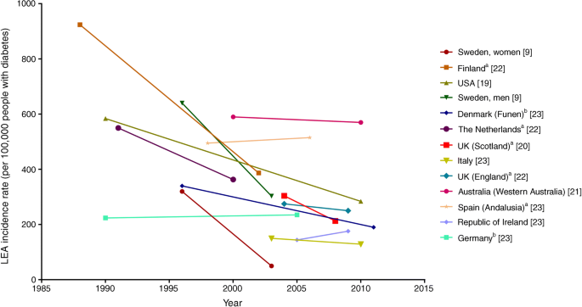
(Source: ‌ Harding et al., 2018)
Appendix 3: Prevalence of Complications in Type 2 Diabetes and Non--diabetics
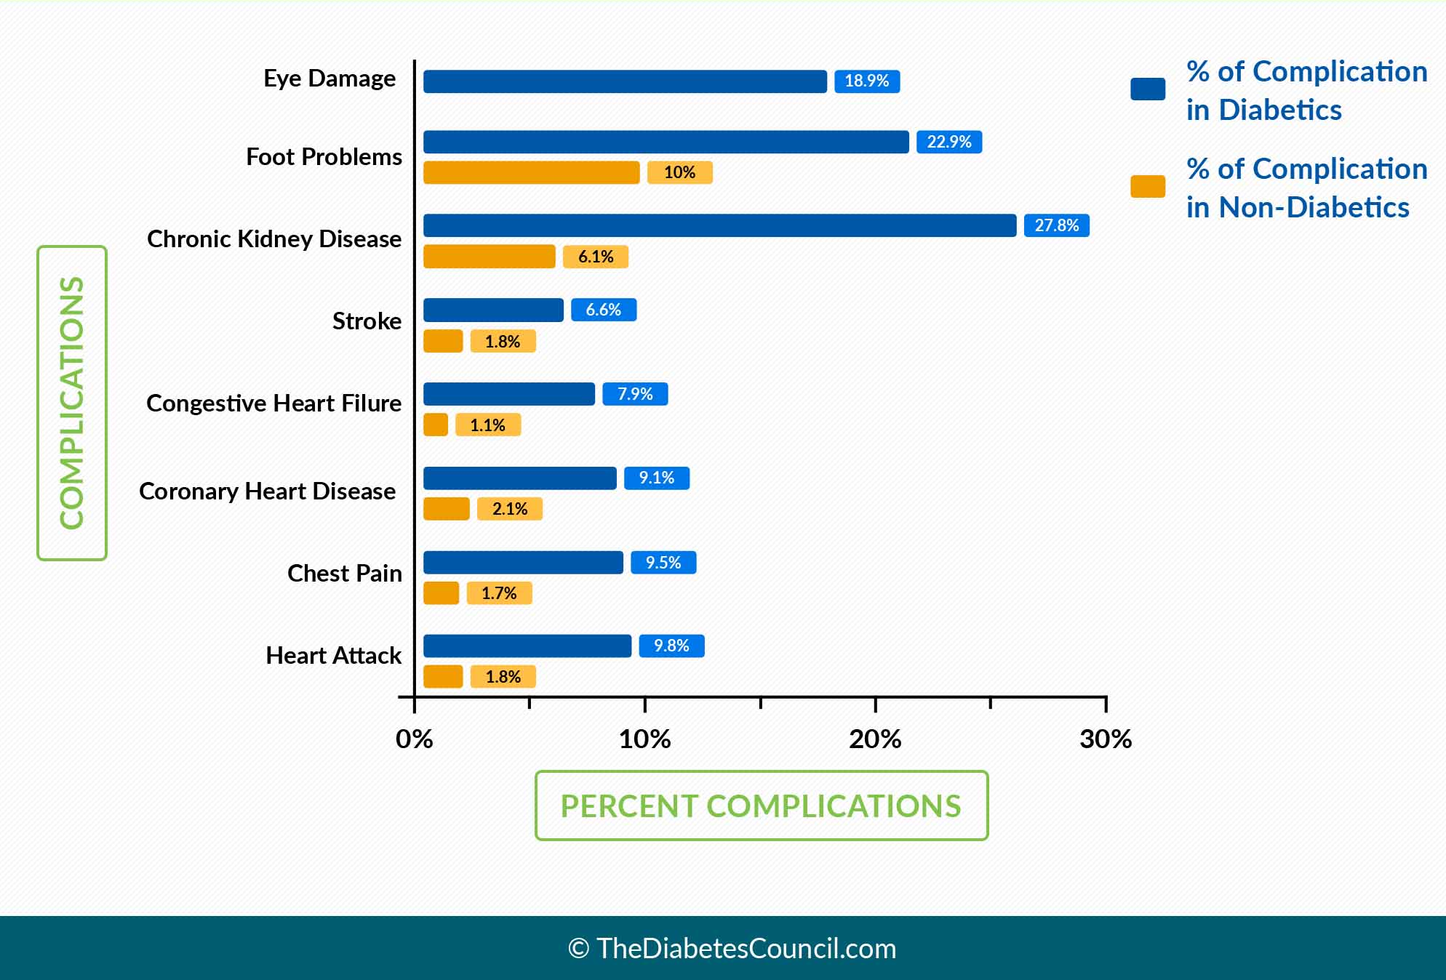

(Source:Justus, 2018)
Appendix 4: Stroke patterns in Diabetics
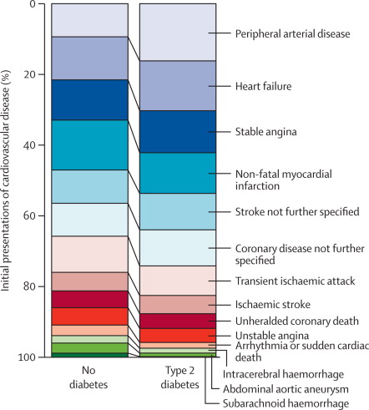
(Source: Glovaci, Fan and Wong, 2019)
Appendix 5: Smoking and Incidence of Diabetes
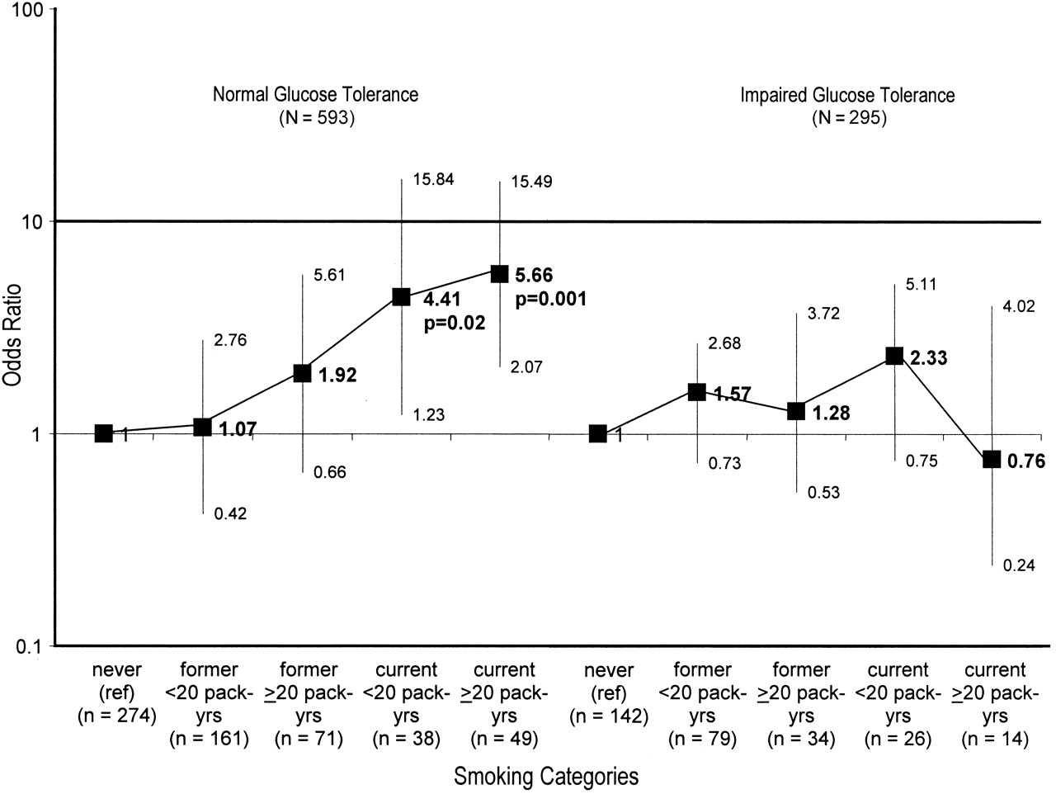
(Source: Foy et al., 2005)

End

