Student name | Colin Preston
Student number | 2534133
Module number | BMSK 4014
Module title | Problem solving and decision making
Contents
poor Organization and Storage of Building Materials on a Construction Site 3
Definition of a Complex Problem in the Workplace, Including its Scope and Impact 3
What the problem is 3
Who Is Affected? 3
How Are They Affected? 3
Analysis of Information on the Identified Problem, to Help Inform the Decision-Making Process 4
Mind Mapping 5
Five Whys Analysis 5
Fishbone (Ishikawa) Analysis 6
Solution 1 – Clearly Marked and Labelled Storage Areas 6
Solution 2 – Allocate a Person to Check Storage Areas 7
Solution 3 – Improve Delivery Planning 7
Solution 4 – End-of-Day Storage Checks 7
Solution 5 – Storage Areas and Staff Guidance 7
Evaluate a Range of Solutions to Identify the Most Appropriate Option, Using a Decision-Making Technique 7
Grid Analysis 7
Cost-Benefit Analysis and Ratios 8
Identify the Most Appropriate Option 8
Development of a Detailed Plan for Implementing the Solution 9
Action Plan 9
Communication of the Plan to Relevant Stakeholders 9
Communication Plan 9
Assessment of Appropriate Monitoring and Review Techniques to Ensure Successful Implementation of Solution 10
Monitoring and Review 10
References 11

poor Organization and Storage of Building Materials on a Construction Site

Definition of a Complex Problem in the Workplace, Including its Scope and Impact

What the problem is
Construction sites can be busy workplaces where different trades, subcontractors and delivery drivers work at the same time. Materials such as timber, bricks, plasterboard, pipes and cement are regularly delivered, moved and used. Good organisation is important so workers can find the materials they need and work safely.
The workplace problem identified is poor organisation and storage of building materials on a small construction site. Materials may be placed in different areas depending on where space is available or where they were last used. Workers may also move materials closer to their work area but not return unused materials afterwards.
The Health and Safety Executive (HSE, n.d.-b) states that construction sites should have designated storage areas and materials should not be allowed to spread onto walkways or block access routes. Storage areas should also be kept tidy.
Although the problem may appear simple, there are several possible causes. These include limited space, poor communication, frequent deliveries, different subcontractors using the same areas and a lack of clearly marked storage locations. This makes the problem complex because there is not one single cause or solution.

Who Is Affected?
Poor organisation and storage can affect site managers, supervisors, workers, subcontractors, delivery drivers and visitors.
Site managers and supervisors may spend extra time finding missing materials, dealing with storage problems and asking workers to move items. This reduces the time available for other site duties.
Workers and subcontractors may experience delays when they cannot find the materials they need. They may also have to move heavy or awkward materials unnecessarily. HSE (n.d.-a) recommends avoiding unnecessary lifting and planning where loads should be placed to reduce manual-handling risks.
Delivery drivers may be affected if there is no suitable space to unload materials. Poorly planned deliveries can result in materials being left in unsuitable areas. HSE (n.d.-b) recommends planning deliveries so that the amount of material kept on site is controlled.
Visitors and members of the public may also be affected. Poorly positioned materials near entrances or boundaries can create additional risks. HSE (n.d.-d) explains that construction work should be managed so risks to visitors and members of the public are controlled.
The investigation will focus on the organisation, delivery, movement and storage of materials on one small construction site. It will not examine wider issues such as the design of the building or the overall performance of individual workers.

How Are They Affected?

Poor material storage can affect safety, productivity, costs and the progress of the project. Workers may waste time searching for materials or moving items before they can start their work. Repeated delays can reduce productivity and make deadlines harder to meet. Research has found that effective construction materials management practices can improve labor productivity, particularly through better planning of materials and delivery schedules (Dixit et al., 2020).
Health and safety can also be affected. Materials left in walkways can increase the risk of slips, trips and falls. HSE (2006) recommends designated storage areas and states that materials should not block access routes or emergency exits.
There can also be a financial impact. Materials that are stored incorrectly may become wet, damaged or unusable and need replacing. Lost working time can also increase labour costs.
Overall, poor storage can lead to wasted time, higher costs, safety risks and delays. Improving the organisation of materials could therefore benefit both workers and the construction project.

The wider impact of the problem
Poor organization and storage of building materials can also have a wider impact on the overall construction project. When materials are not kept in clearly identified areas, workers may spend additional time looking for items they need. Although this may only take a couple of minutes each time, these small delays can mount throughout the working day. This can reduce productivity and make it more difficult for the work to be finalized according to the planned schedule. Effective materials management can therefore contribute to improved productivity and better project performance (Dixit et al., 20
There may also be a financial impact on the business. Materials that are stored incorrectly can either become damaged because of the weather or materials being placed on top of them. For example, plasterboard can become unusable if its wet, while timber may become damaged if not kept in the correct location. The business may then have to purchase replacement materials, which will create unnecessary costs.
Poor storage can also affect communication between the workers. If there is no clear system showing or explaining where materials should be kept, different workers may place the items in different areas. This can cause some confusion, particularly when several trades are working on the site at the same time. A simple storage system would make it easier for all the workers and for everyone to understand where the materials belong.
Improving the organization of materials could therefore provide several benefits. Clearly labelled storage areas, regular checks with clear responsibilities could help the workers find the materials a lot more quickly and reduce the unnecessary movement around the site. It could help reduce waste, improve housekeeping and help the site to operate in a more organized way. These small improvements would support both the day-to-day work of employees and the successful completion of the construction project.

Analysis of Information on the Identified Problem, to Help Inform the Decision-Making Process

Brainstorming was used to identify possible causes of the problem. This allowed different ideas to be considered before looking more closely at the main causes.
Possible causes included limited storage space, unclear storage areas, poor labelling, workers not returning materials, frequent deliveries, poor communication, unclear responsibility and changes to available space as the building work progresses.
Different trades may also move materials to make their own work easier. Without an agreed system, other workers may not know where those materials have been moved.
Deliveries can also contribute to the problem. If materials arrive when the site is busy or storage areas are full, they may be placed somewhere unsuitable. HSE (n.d.-b) recommends planning deliveries and using designated storage areas.
Brainstorming therefore showed that the problem is connected to people, communication, space, deliveries and working practices.

Mind Mapping
A mind map was used to organise the causes into five main areas: people, storage space, deliveries, communication and site organisation.
People may move materials and fail to return them. Storage space may be limited or poorly labelled. Deliveries may arrive at unsuitable times. Communication problems may mean workers do not know where materials belong. Finally, there may be no clear person responsible for checking storage areas.
HSE (n.d.-b) states that safe and efficient material storage requires cooperation and coordination between the different people involved in a construction project.
The mind map shows that several factors are connected and supports the need for a solution that is easy for everyone on the site to understand.
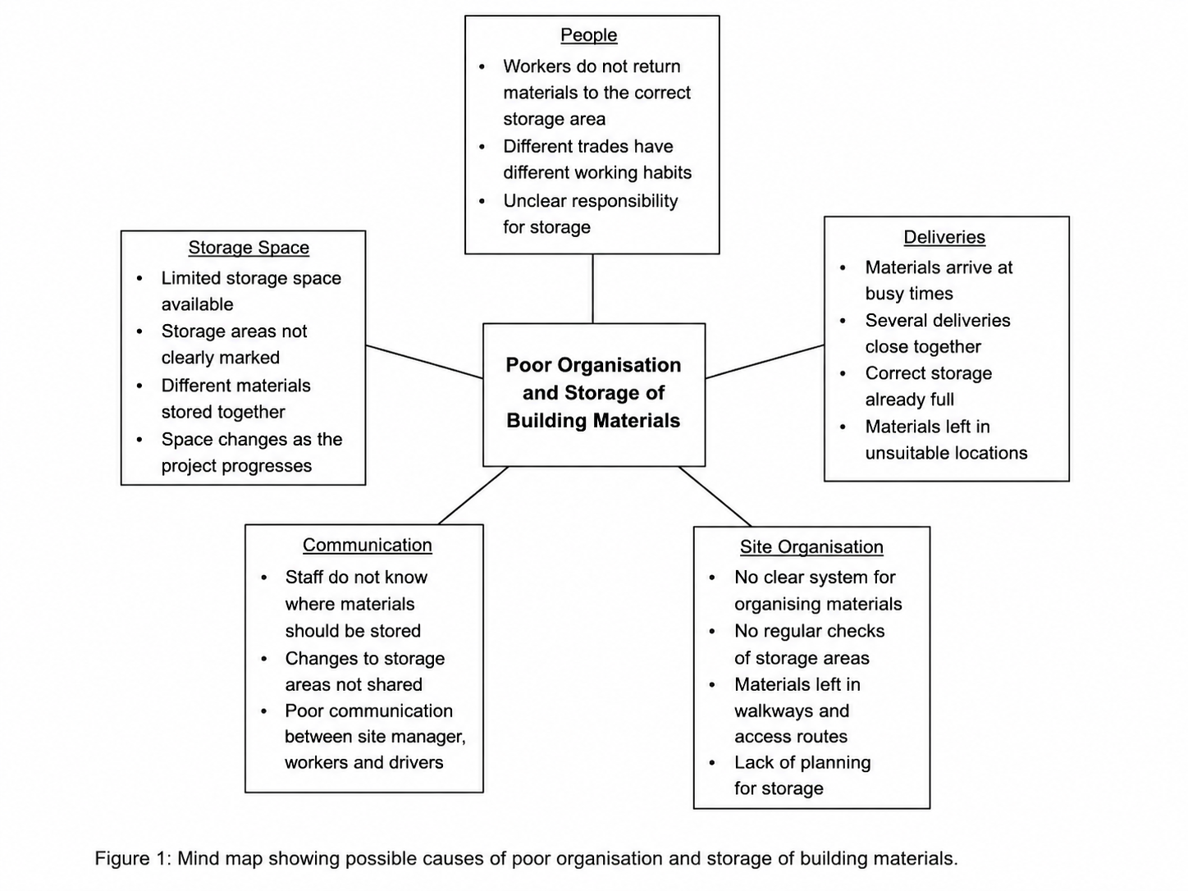

Five Whys Analysis

The Five Whys technique was used to look more closely at the main cause.
Problem: Building materials are poorly organised and stored.
Why 1: Why are materials stored in the wrong places? Because workers put them wherever there is space.
Why 2: Why do workers put them wherever there is space? Because the correct storage areas are not always clear.
Why 3: Why are the storage areas unclear? Because some areas are not labelled or clearly marked.
Why 4: Why are they not clearly marked? Because there is no standard system for organising different materials.
Why 5: Why is there no standard system? Because responsibility for planning and managing storage has not been clearly agreed.
The Five Whys suggests that the main cause is a lack of a clear and consistent storage system. Improving the storage system may therefore be more useful than simply reminding workers to keep the site tidy.

Fishbone (Ishikawa) Analysis
A Fishbone analysis was used to group the causes of the problem.
The people causes include workers moving materials and different trades having different working habits. Storage causes include limited space and poor labelling. Delivery causes include materials arriving when storage areas are full. Communication problems may mean workers and drivers do not know where materials belong. Finally, management and organisation problems include unclear responsibility for checking storage areas.
The Fishbone analysis supports the Mind Map and Five Whys findings. The main issue across the different areas is the lack of a clear and organised storage system.
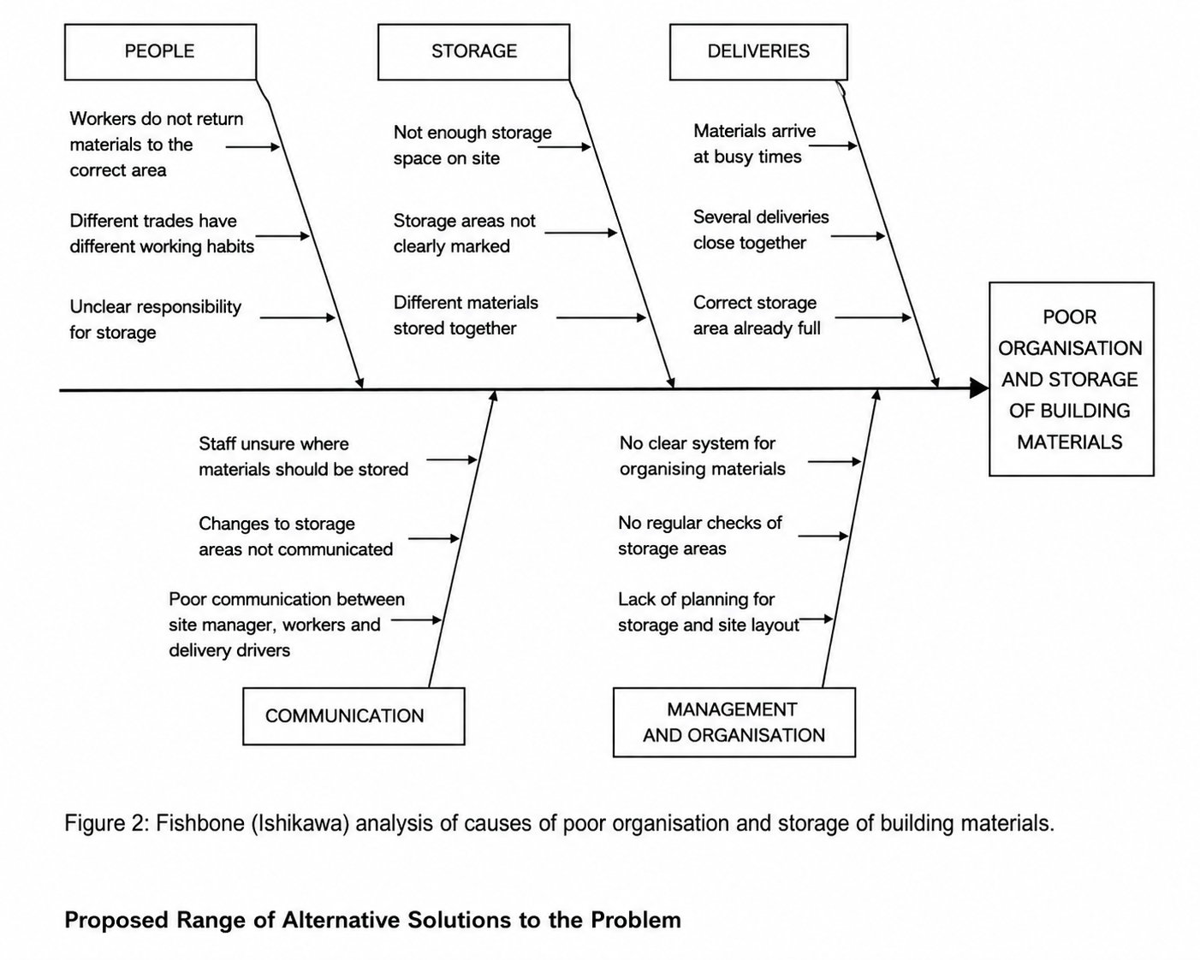

Solution 1 – Clearly Marked and Labelled Storage Areas
The first option is to create clearly marked areas for different materials. Signs and labels would show workers and delivery drivers where materials should be placed. HSE (n.d.-b) recommends designated storage areas on construction sites. This option would be fairly cheap, simple to introduce and could reduce time spent searching for materials.

Solution 2 – Allocate a Person to Check Storage Areas
A member of staff could be responsible for checking the storage areas each day. They could identify materials left in the wrong place and report problems to the supervisor. This could improve organisation but would create an extra responsibility for a worker who may already have other duties.

Solution 3 – Improve Delivery Planning
Deliveries could be planned so materials arrive when suitable storage space is available. The site manager could agree the unloading location before each delivery. HSE (n.d.-b) recommends planning deliveries to keep the amount of material stored on site to a minimum.

Solution 4 – End-of-Day Storage Checks
Workers could complete a quick check before leaving each day. Unused materials would be returned to the correct areas and walkways checked for obstructions. This would cost very little but would depend on workers consistently following the process.

Solution 5 – Storage Areas and Staff Guidance
Clearly marked storage areas could be combined with simple guidance for workers. The site manager could explain where materials belong and what workers should do with unused materials. HSE (n.d.-e) explains that site rules should be clear, easy to understand and brought to the attention of people working on the site.

Evaluate a Range of Solutions to Identify the Most Appropriate Option, Using a Decision-Making Technique

Grid Analysis
A grid analysis was used to compare the five solutions. Each option was scored against organisation, safety, cost, ease of introduction and long-term benefit. Scores ranged from 1, meaning poor, to 5, meaning very good.
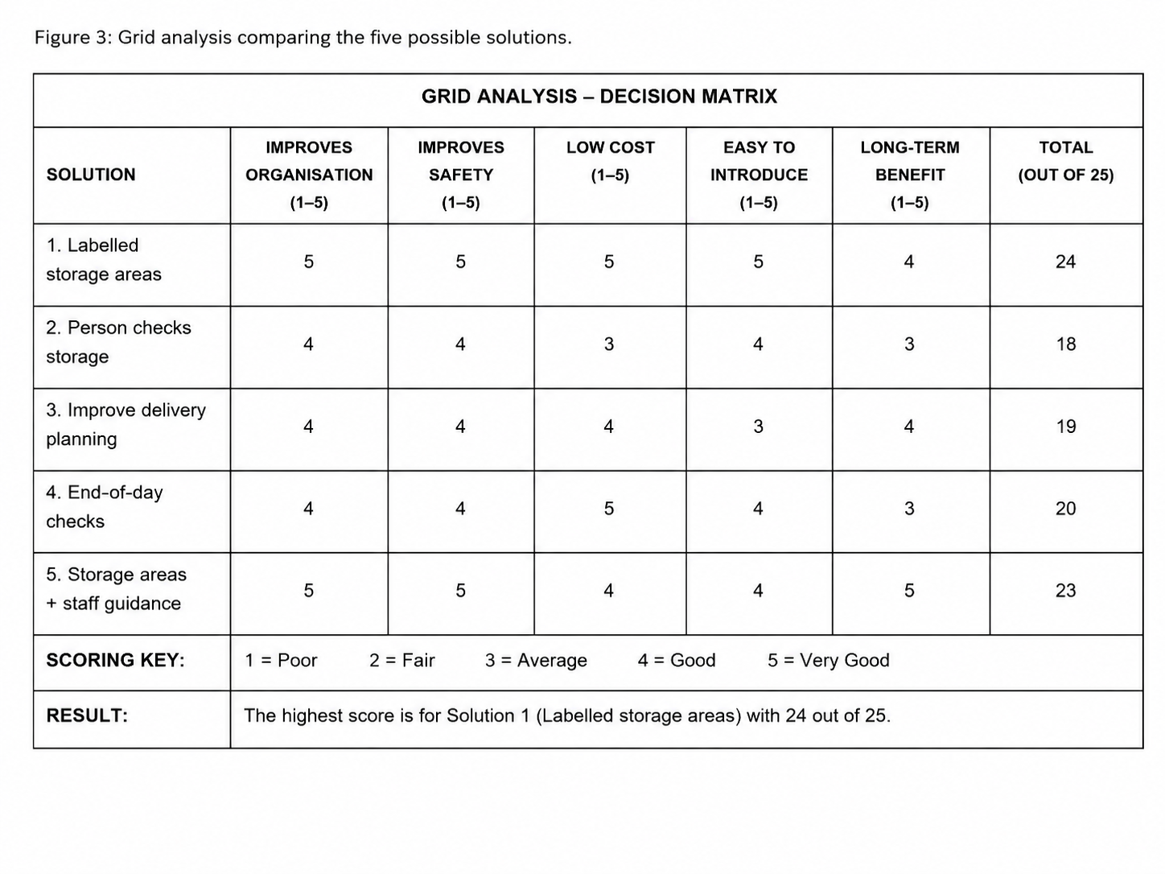
Clearly marked and labelled storage areas received the highest score of 24 out of 25. Storage areas with staff guidance scored 23, end-of-day checks scored 20, improved delivery planning scored 19 and a person checking storage scored 18.
Labelled storage areas scored highly because they are relatively cheap, easy to introduce and directly address one of the main causes identified by the Five Whys and Fishbone analysis.

Cost-Benefit Analysis and Ratios
A cost-benefit analysis was used to consider whether labelled storage areas could provide value for money. The estimated cost of signs, labels, storage equipment and staff time is £1,100. The estimated first-year benefit from reduced wasted time, damaged materials and improved productivity is £5,000.
£5,000 ÷ £1,100 = 4.55:1
The estimated benefit-cost ratio is therefore 4.55:1, with an estimated net benefit of £3,900. These figures are estimates rather than actual company figures, but they suggest that the possible benefits could be greater than the cost of introducing the solution.

Identify the Most Appropriate Option
The most appropriate option is clearly marked and labelled storage areas. It received the highest grid-analysis score and also produced a positive estimated cost-benefit result.
The solution directly addresses the lack of a clear storage system identified through the Five Whys and Fishbone analysis. It could reduce time spent searching for materials and help keep access routes clear.
HSE (2015) explains that construction work should be planned, managed and monitored so that health and safety risks are properly controlled. The proposed storage system supports this approach by introducing a clear and manageable way of organising materials.

Development of a Detailed Plan for Implementing the Solution

Action Plan
The labelled storage system will be introduced over four weeks.
During Week 1, the site manager will review the current storage areas and decide where different materials should be kept. Signs, labels and any required storage equipment will be ordered.
During Week 2, the areas will be cleared, organised and labelled. Workers and subcontractors will be shown where different materials should be stored.
During Week 3, the new system will be fully introduced. The supervisor will check that materials are being placed in the correct areas.
During Week 4, feedback will be collected and the system reviewed. Any problems will be identified and changes made if required.
HSE (n.d.-c) states that planning, managing, monitoring and coordinating health and safety are important parts of managing construction work.
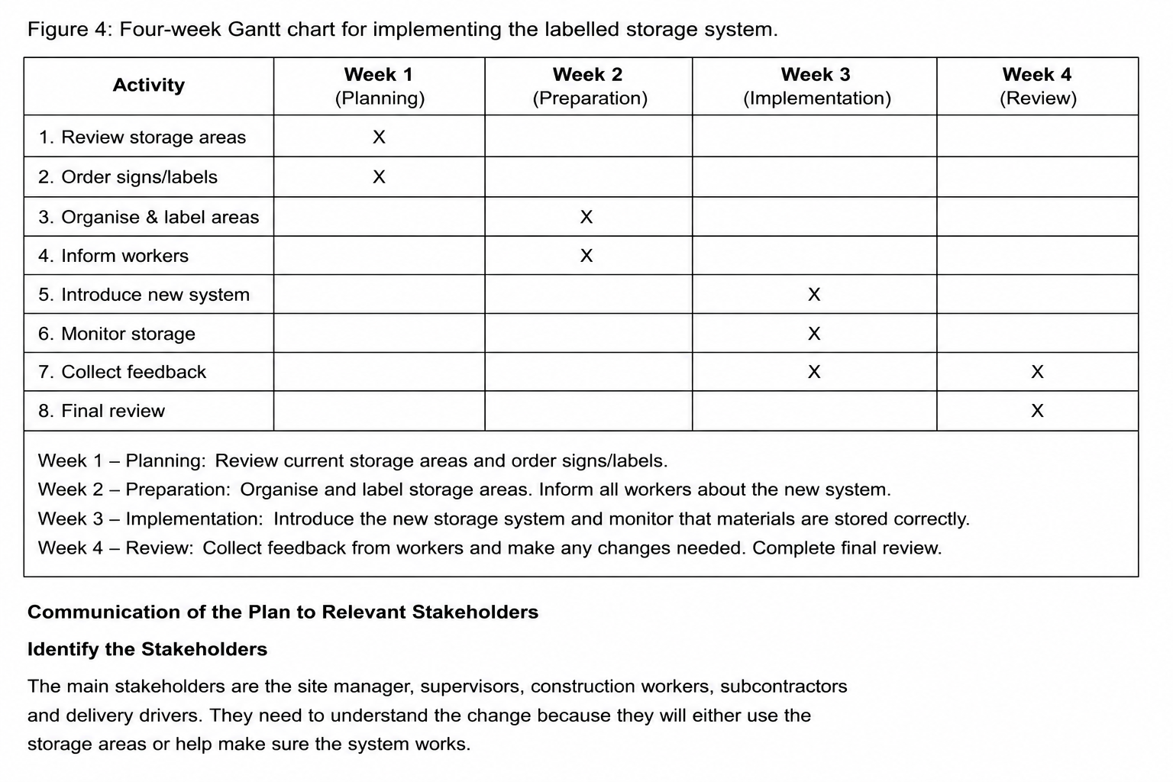

Communication of the Plan to Relevant Stakeholders

Communication Plan
The plan will be explained through a short site briefing, signs and verbal instructions. The site manager will explain the new system to workers and subcontractors before it starts.
HSE (n.d.-e) states that site rules should be clear and understood by everyone expected to follow them. HSE (n.d.-f) also describes toolbox talks as short presentations to workers about a particular health and safety issue. A short toolbox talk could therefore be used to explain the new storage arrangements.
Delivery drivers will be told where materials should be unloaded when they arrive. Workers will also be encouraged to tell the supervisor about any problems during the four-week trial.

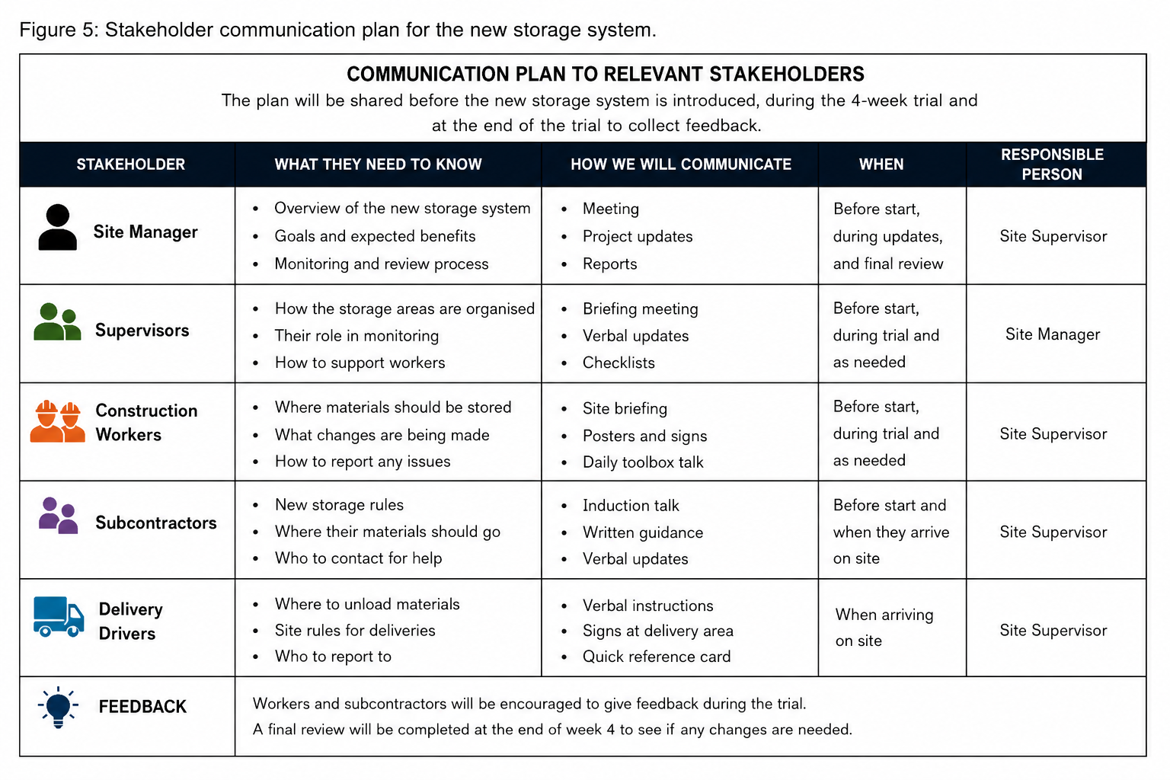

Assessment of Appropriate Monitoring and Review Techniques to Ensure Successful Implementation of Solution

Monitoring and Review
The new storage system will be checked throughout the four-week trial. The Gantt chart and action plan will be used to make sure each task is completed on time.
The supervisor will regularly check whether materials are being stored correctly and whether walkways remain clear. Regular monitoring is important because storage arrangements should prevent materials from obstructing pedestrian routes and emergency access (HSE, n.d.-b).
There will also be a milestone at the end of each week. By the end of Week 1, the storage areas should be planned. By Week 2, the signs and labels should be in place. During Week 3, workers should be using the system. During Week 4, feedback and final checks will be completed.
Workers and subcontractors will be asked whether the system is easy to use and whether materials are easier to find. HSE (2015) also highlights the importance of consulting and engaging workers when managing construction health and safety.
If the system is working well, it can continue. If problems remain, the site manager can make changes. Regular checks and feedback will help find problems early and keep the improvement on track.

References

American Society for Quality. (n.d.-a). Fishbone diagram. ASQ.
https://asq.org/quality-resources/fishbone⁠
American Society for Quality. (n.d.-b). Five whys and five hows. ASQ.
https://asq.org/quality-resources/five-whys⁠
Health and Safety Executive. (2006). Health and safety in construction (HSG150). HSE.
https://www.hse.gov.uk/pubns/books/hsg150.htm⁠
Health and Safety Executive. (2015). Managing health and safety in construction: Construction (Design and Management) Regulations 2015. Guidance on Regulations (L153). HSE.
https://www.hse.gov.uk/pubns/books/l153.htm⁠
Health and Safety Executive. (n.d.-a). Manual handling: What you need to know as a busy builder (CIS61). HSE.
https://www.hse.gov.uk/pubns/cis61.pdf⁠
Health and Safety Executive. (n.d.-b). Materials storage and waste management. HSE.
https://www.hse.gov.uk/construction/safetytopics/storage.htm⁠
Health and Safety Executive. (n.d.-c). Planning for construction work. HSE.
https://www.hse.gov.uk/construction/safetytopics/planning.htm⁠
Health and Safety Executive. (n.d.-d). Protecting the public. HSE.
https://www.hse.gov.uk/construction/safetytopics/publicprotection.htm⁠
Health and Safety Executive. (n.d.-e). Site rules and induction. HSE.
https://www.hse.gov.uk/construction/safetytopics/site-rules-induction.htm⁠
Health and Safety Executive. (2022). Toolbox talks. HSE.
https://www.hse.gov.uk/construction/resources/toolboxtalks.htm⁠
The Construction (Design and Management) Regulations 2015, SI 2015/51.
https://www.legislation.gov.uk/uksi/2015/51/contents⁠

