Welsh Language Framework: Portfolio

Film evidence:
Uploaded by the University

Lesson plan for filmed lesson:
Lesson objectives: To create food webs, to identify food chains from food webs
Introduction: Welcome pupils into the classroom (Dewch I mewn), ask the pupils how they are? (Shwmai?) (Bore Da, Prynhawn Da)
Main activity – creating a food chain
All pupils to be given cards with a description on each. Pupils to create food chains from cards.
Try to praise in welsh were possible
Next activity – picture of food web on slide, pupils to identify food chains from the food web.

Written reflection on use of welsh:
Prior to this course, my exposure of the welsh language was very limited, I only moved to Wales in 2018 and lived with non welsh speakers so I did not have much experience with the Welsh language prior to starting this course although I did understand the need to learn the language. The main issue for me using Welsh in my lessons is my confidence in my pronunciation of words, I feel that the pupils will not understand what I am saying as I could be pronouncing it incorrectly, however working with my mentor through PTE1, we started to look at ways for me to gain confidence and use welsh in my lessons. I started to try to include it in my lesson planning, planning for me to speak welsh at certain times during my lessons, I also started focusing on certain words and commands to use during my lessons, focusing on 5 words per lesson until I become more confident using them. Speaking with my mentor, they were able to help me to identify opportunities in the lessons to use welsh throughout.
During the latter part of my placement, I have started to become more confident using commands such as eisteddwych, dim siarad and dwch I mewn.
Below is a picture of a ‘cheat sheet’ that I used at the start of my 2nd placement to encourage me to use more welsh, this sheet was on my desk and gave me reminders of opportunities to use welsh, as my level of welsh increase I will aim to increase the complexity of the commands to further improve my use of welsh in the classroom.
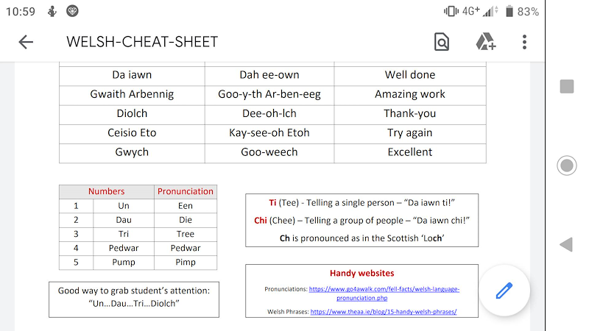

Tutor notes about use of welsh:
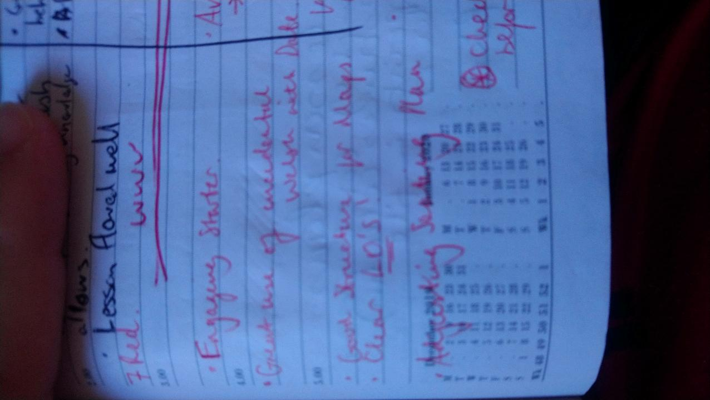

Picture from my learning journal, where the teacher praised my use of incidental welsh, in making sure the learners had the correct date in welsh, whilst working on their pronunciation.

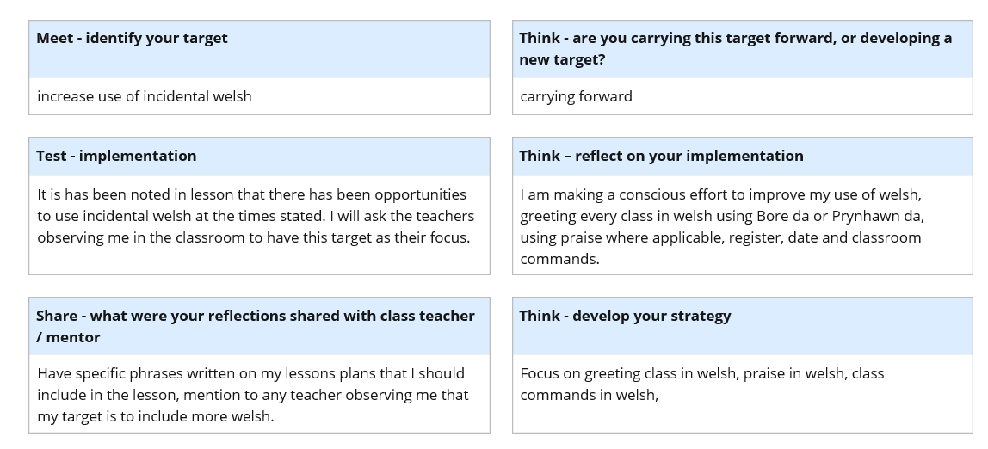

Picture above is a weekly reflection of a target I made with my mentor to try and increase my use of incidental welsh, with comments and advice from my tutor listed in the bottom left section.
Lesson plans containing welsh:
None available

Learning welsh:
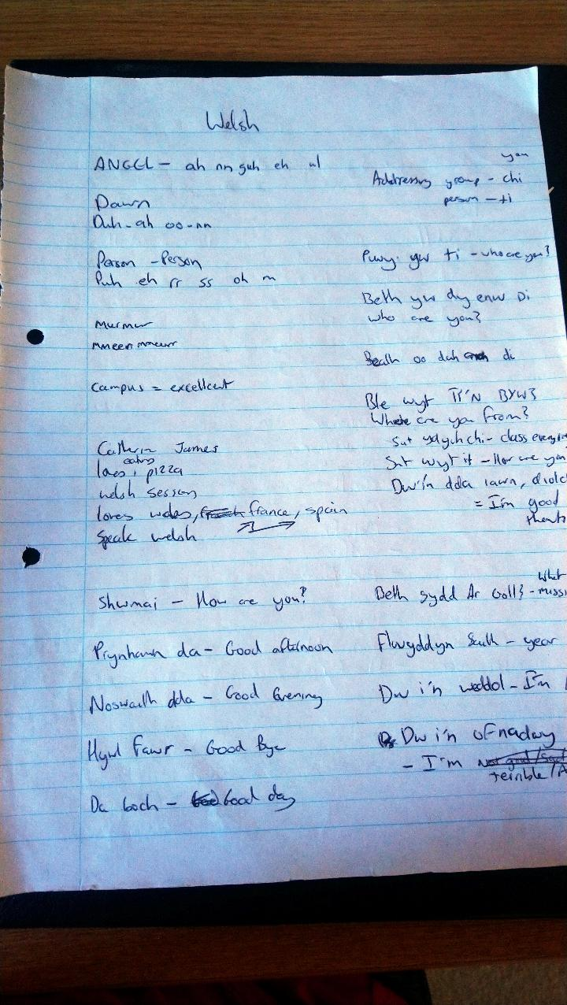
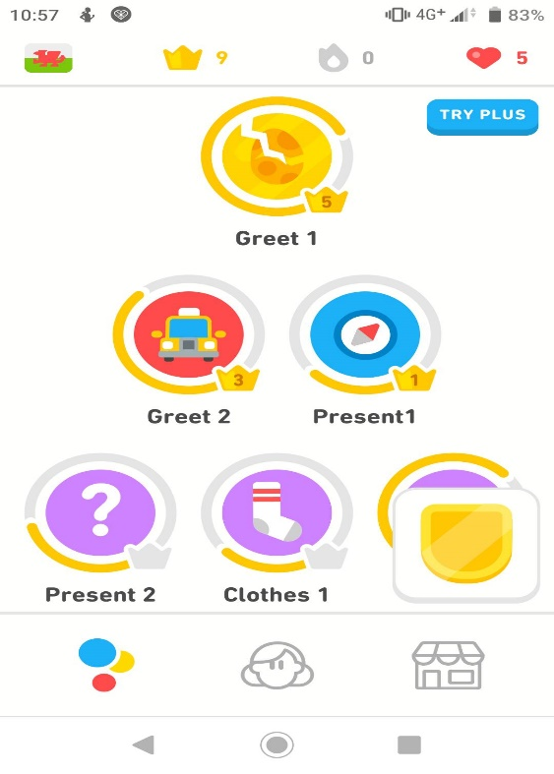

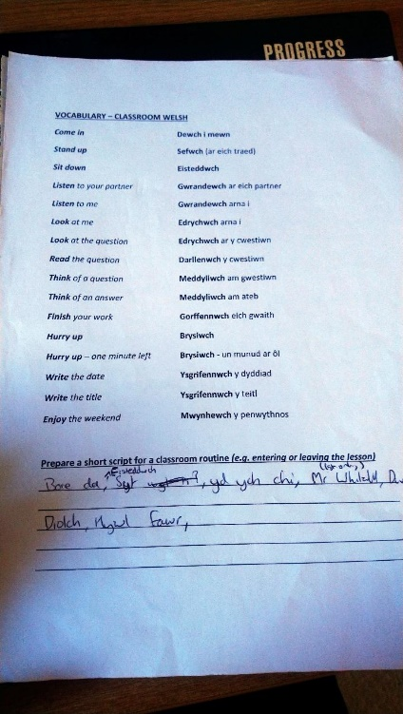

I have been learning welsh through 2 main avenues, my welsh lessons provided by the university with the main focus on incidental welsh that should be used in the classroom, and Duolingo language app, where the focus is a more broad understanding of the welsh language.

Evidence of correcting a learner’s work:
Whilst I have no picture evidence of this, I frequently used the date as a method to work on welsh with my classes, ensuring they had the full date in welsh and also got the class to say the date to ensure that their and my own pronunciation of the date was correct.
When marking books, I had to ensure that the pupils had ‘Gwaith Dosbarth’ and ‘Gwaith Cartref’ at the top of their page with the correct date in welsh.

