Case study – John Deere

Student name: Ionut Dobrescu
Student id: 1906349
Module name: Knowledge and Information Management Skills for the Workplace
Module code: BMSW5106
Lecturer name: Seyed Naveed

Executive Summary

The purpose of the report is to demonstrate the technical information system of John Deere which is the largest agricultural firm that provides a variety of services of fertilizers and manures. The report has examined that technology plays an effective role in improving the process of irrigation, fertilizers, and launched new machines. Thus, it helps in attracting more farmers towards itself. On the other hand, the report has illustrated the data analytics and the internet of things is an effective component that improves the functions of CRM system of the company.

Table of Contents
Introduction 4
1. Information System applied by John Deere 4
2. Significance of Customer Relationship Management 5
3. How John Deere can apply IT 8
4. Implications of Big Data Analytics and Internet of Things 10
5. Recommendations on John Deere for improving knowledge management practices …………………………………………………………………………………………….. 13
Conclusion 14
Reference List 15

Introduction
The report shows a depth analysis of John Deere which is a multinational organization that manufactures agricultural products, machinery, and equipment. On the other hand, it demonstrates the various information system used by the chosen organization for gaining customer satisfaction levels. Apart from that, it illustrated the positive and negative implications of the company's CRM system. Apart from that, it evaluates the concept of how John Deere adopts data analytics and IoT to manage knowledge.
Company Background (John Deere)
John Deere is a company that manufactures agricultural, construction, diesel engine, lawn cares equipment, and forestry machinery (Ahmad et al., 2020). The objective of the company is to create a solution that sustains the livelihood of customers and the committee. In the year 2020, the company has more than 69634 working employees. On the other hand, John Deere generates a profit revenue of 35.54 billion dollars every year.
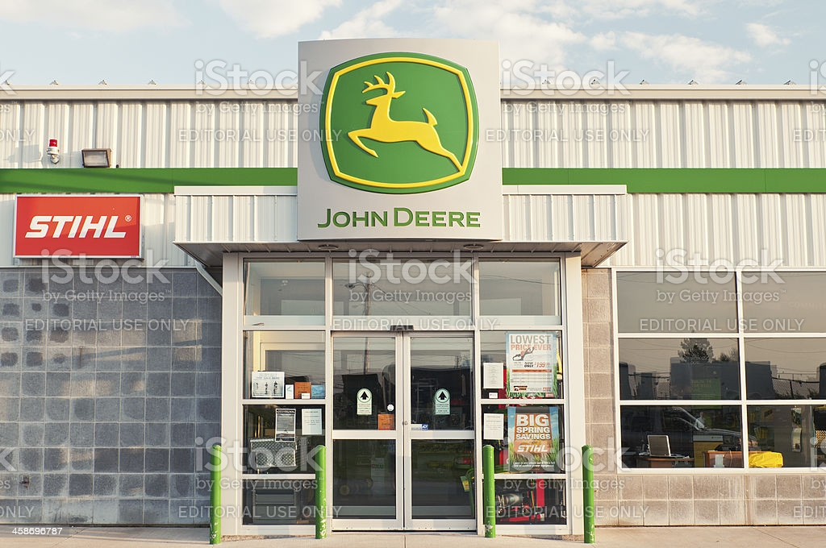
Source: Forster, 2017

Information System applied by John Deere
The company mainly developed online technology for collecting the relevant information and data about the agricultural machinery or equipment (Byström et al., 2019). It is depicted that, the information system of the company mainly helps in reducing operational cost, directing the fieldwork, and significance of higher yields.

On the other hand, it is recognized that John Deere mainly adopts the FMIS system for making effective decisions related to operational planning, documentation and stay with advanced or innovative technology. Therefore, these technologies help the organization to pay much attention to spatial distribution maps, develop appropriate productivity maps for future periods and data achievements. With the help of this information, the company can take effective decisions related to land, crops, and fertilizer.
John Deere also used remote sensor technology for collecting relevant information about the geographical and topographic data. It is identified that the company also adopts wireless sensor and context allocator sensor for gathering or collecting a large amount of data and information about agricultural processes and activities. Apart from that, John Deere used the remote sensor for measuring various aptitudes like the concentration of potassium, crop properties, and electrical conductivity. It is mainly demonstrated that the company developed its operational center on their official website for providing accurate information to the farmers and other customers. The company also takes benefit of their web online portal for knowing relevant information about the setting of machine and equipment. It provides various career development and growth to their farmers. Therefore, the company depends upon the firm management system for improving job equality and boost productivity. During the global pandemic, the company adapts to certain changes in its technology system by presenting the JD link connection (Stofberg et al., 2021). Thus, it helps the company to maintain a strong relationship with different stakeholders.
It is identified that John Deere mainly focused on cloud computing and storage for improving their logistics operations and system. Furthermore, the company has established a robust partnership with different advisors for storing and securing the customer's data. The company also maintained its data management system for storing the financial statement and scheduling the work before the given deadline.

Significance of Customer Relationship Management
Customer relationship management is the technological process for managing the company’s information and data (He et al., 2021). For the past few years, John Deere mainly takes the help of CRM for storing and maintaining separation between the documents of customers and the company's information, schedule task, and handling customer requests on daily basis. It is stated that CRM works as a backbone for the success of the organization in a challenging environment. This program helps John Deere for exploring wider sales opportunities and increase its customer base.
With the help of the CRM program, the company can collect relevant information from different sources including emails, customer phone calls, and internet traffic from official websites. Thus, John Deere can coordinate with different dealers and database analytical for tracking the customer behavior regarding the buying process.
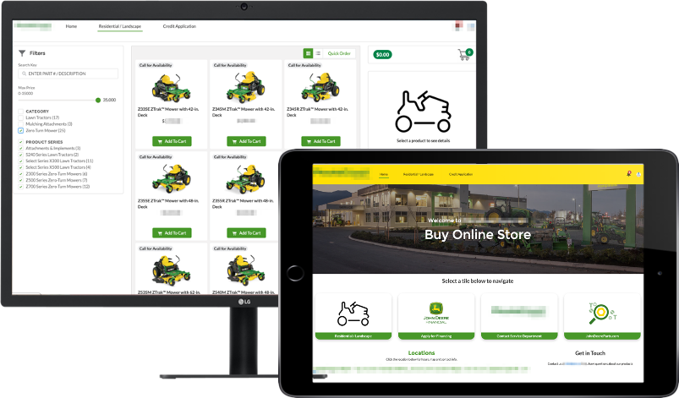
Source: Singh et al., 2020
CRM system allows John Deere to control the inventory system and expand the product supply chain. The company mainly focused on CRM systems for determining the product cycle and increase operational efficiency. In this way, the company builds a strong sales team and gains competitive advantages.
John Deere can adopt various tools like email marketing, social media platform, and live chat with the CRM system (Amevor et al., 2020). For instance, John Deere used Anvil CRM which mainly holds the effective dealership details including customer accounts, tasks, requests, and necessary information. Furthermore, some of the long-term advantages of CRM are elaborated below which makes John Deere successful. These benefits are:
Knowing customer preference: It is the biggest benefit of the CRM system for John Deere. The CRM system mainly helps in gathering a large amount of data and information about the farmers and customers (Chatterjee et al., 2020). From the research, it is stated that 61% of distribution has suggested that CRM system is an essential system for acquiring customer attention towards the products or services. For instance, the CRM system helps John Deere to have a 360-degree view of their potential customers. On the other hand, CRM software helps the organization in increasing the sales and customer base.
Customer marketing: The CRM system help John Deere to stay updated with the latest trend used in agricultural practices. With the help of personalized messaging, John Deere can promote their product among a huge target audience at once (Pedron et al., 2018). On the other hand, the company creates automated content for promoting their product or brands. Thus, it leads to gain a competitive advantage in the competitive environment. It also helps in reducing the chance of misguiding and confusion among staff members.
Sales automation: A good CRM system helps John Deere in automating the sales process. Thus, it leads to an increase in the productivity as well profitability of the organization in the competitive atmosphere (Pohludka and Štverková, 2019). Due to the online process, the product is available for customers across the global range. Therefore, it automatically increases the sales of John Deere.
Future Planning: By incorporation of CRM system in the business model of John Deere, the company can predicate the future sale and suggest the appropriate value of profit margin (Chatterjee et al., 2020). Thus, the CRM system helps in forecasting the sale and leveraging the data & information of the company.

Challenges in CRM system
The company faced various challenges while implementing the CRM system for business operations. John Deere has struggled for managing a large amount of data of customers. Apart from that, a lack of communication and training contributes to the failure of the CRM system within the organization (He et al., 2021). Small businesses are unable to access the CRM system because of huge operational costs and budgeting problems. On the other hand, competitors are also copycat different strategic applications of CRM for attracting customers. Therefore, John Deere mainly faced different challenges in managing the CRM system. These challenges are described below:
Lack of appropriate training: It is depicted that, educating or provide proper training to their staff members plays a crucial role in operating the CRM system of the organization. On the other hand, improper training harms the growth and development of John Deere (Pedron et al., 2018). Thus, the company focused on developing the contingency plan regarding the CRM implementation system.
High operational cost: It is observed that companies require more capital and fund resource for implementing an effective CRM system for the smooth functioning of the business operations (Amevor et al., 2020). Without the proper budgeting plan, John Deere is unable to implement good CRM software for their customers.
Thus, the company should demonstrate a proper budget for various techniques and procedures of CRM solutions. Apart from that, the company must focus on examining the total cost of IT resources, hardware, and operating software.
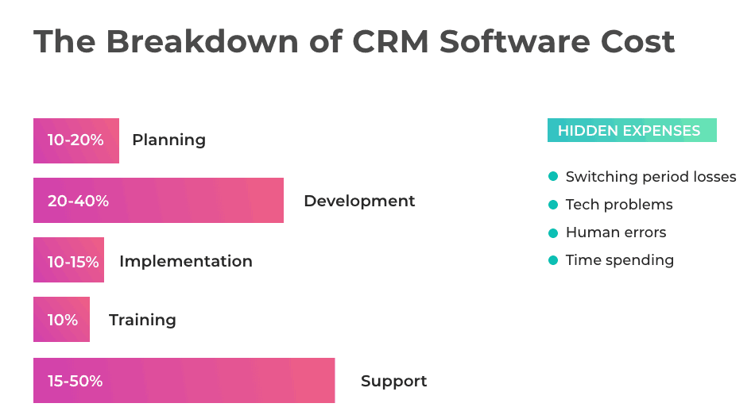
Source: He et al., 2021
Lack of clear goal: From the research, it is identified that 50% of CRM software fails due to unclear corporate goals. Therefore, the company should determine the goal before implementing the CRM system in the process (Chatterjee et al., 2020).
It is depicted that real good help in determining the success and failure of the customer relationship management system.
Difficulty in finding an appropriate CRM provider: It is the most challenging issue for implementing CRM software. For instance, John Deere often struggles in finding the right CRM provider which helps in accomplishing the goal of the organization (Amevor et al., 2020). If a company is unable to do this then the management team faced huge risks related to data security and storage of their customers. Thus, John Deere does not increase their sale and customer base.

How John Deere can apply IT
John Deere can take the help of information technology for collecting or gathering relevant information related to crop husbandry, quality standard, and harvesting. With the help of information technology, John Deere can set different pricing structures of fertilizers and seeds to gain competitive advantages (Pohludka and Štverková, 2019). On the other hand, porter’s five force strategy is applied for determining the competitive advantage of John Deere.
The five forces are demonstrated below:
Supplier power (Low): It is evaluated that suppliers have low control over the operational activities of John Deere due to its strong brand reputation in the competitive environment. In this stage, the company adopts advanced farming practices for acquiring a good position in the market (Caruso, 2017). In this way, John Deere can take advantage of automated farm machines or operations for handling day-to-day activities. Therefore, information technology can help John Deere in reducing production costs and increase productivity which leads to gain customer satisfaction.
Buyer power (Low): It is demonstrated that the company has maintained a strong presence in the emerging market. Therefore, the buyer has low power over the pricing strategy of the company (Singh et al., 2020). In the recent year, John Deere is continuously expanding on electric drivetrain for attracting their potential customers. On the other hand, the IT system helps the company in inventing new tractors and machinery equipment. Thus, John Deere deploys an IT system to achieve customer loyalty.
Threats of substitute entry (High): In the competitive environment, there are several substitutes for the agricultural machinery market containing biofuels, energy subsidies, and agreement on resource sharing (Amevor et al., 2020).

For instance, John Deere constantly focuses on implementing IT by launching innovative and advanced machinery for reducing the threats of a substitute. Thus, it helps the company to gain competitive advantages and maintain a strong presence in the emerging market.
Threats of new entry (Low): The Company faces fewer threats from the new organization because of its customer loyalty (Caruso, 2017). For instance, John Deere mainly put a strong emphasis on technological innovation and customer experience to gain a competitive advantage. It is depicted that, the company implements an IT system for increasing the customer value proportion for loyal customers. On the other hand, the company may use an IT process for guiding farmers related to storing and post harvested techniques. Thus, the IT system can help John Deere to distinguish it from other brands.

Competitor’s rivalry (High): It is demonstrated that UK agricultural machinery services faced intense competition from the existing market. In the challenging atmosphere, John Deere faced high competition from AGCO, Kubota, and CNH industries (Byström et al., 2019).
These competitive industries have maintained a strong position in the international market for gaining competitive advantages. Thus, John Deere can implement an IT system for gaining a competitive environment. On the other hand, the company maintains absolute control on tractor cabs with the help of an IT system. It also helps in managing the logistics business operations of John Deere. Therefore, it is stated that John Deere can use information technology for maximizing crop yields.

Implications of Big Data Analytics and Internet of Things
Influence of Big Data Analytics
Business data analysis is the process by which a set of techniques, procedures, and competencies are applied for investing in the past or future aspects of the business (Ahmad et al., 2020). It is recognized that John Deere used data analytics knowing the effective information and knowledge about the verities of crop and condition of the soil. On the other hand, the company also used data analytics for improving the profit revenue and provides a wider opportunity to their local farmers. John Deere is completely dependent upon data analytics for transforming the way of food production. With the help of data analytics, John Deere can support the farmer in managing fleets. Thus, the company can launch new data analytics for their customer which leads to an increase the production. It is identified that farmers can utilize the data for making an effective decision regarding crop production and fertilization.
Apart from that, John Deere can use data analytics for determining the production level and climatic condition. With this support, the company can access new machinery parts for better products for future growth.
On the other hand, John Deere has established its data platform “My John Deere.com” for helping farmers regarding crop harvesting and other agricultural practices. Thus, data analytics help the company for predicting accurate details related to crop yielding (Stofberg et al., 2021). Apart from that, John Deere utilizes the data for examining the demand of production in the competitive environment. It is also identified that the company used an open-door database system to collect data from multiple resources. Therefore, data analytics helps acquire the long-term sustainability of the business.

Some of the benefits of data analytics are demonstrated below:
Mitigating risk and fraud: The main aim of data analytics is to provide absolute control over financial and intellectual property rights (Amevor et al., 2020). Data analytics can help John Deere from preventing fraud and external threats. The company is data analytics for determining the risk in operating the business. Thus, data analytics immediately provide notification or alert to the business regarding unethical accounting practices.
Personalization and services: With the help of data analytics, John Deere can communicate with their customer and take feedback about the quality of the product (Byström et al., 2019). Data analytics is the biggest opportunity for interaction according to the personality of the customers. It helps in understanding the customer's attitude, behavior, or values.
Optimizing customer experience: The Company mainly used advanced data analytics techniques for enhancing customer experience and gain competitive advantages (Caruso, 2017). It helps businesses in managing the inventory cost and provides good customer services for resolving queries. In this way, John Deere shows multichannel abilities among different stakeholders.
Challenges in Data Analytics
Lack of appropriate data: The Company faces difficulty in research the right data or information for managing the business functions (Ahmad et al., 2020). Thus, John Deere mainly contributes to the shortage of appropriate data which leads to reduce production as well as profitability.
Privacy and security disputes: It is identified that John Deere faced several issues in managing the privacy of data (Forster, 2017).
It mainly includes hacking, cybercrime, and fake emails. Therefore, Data analytics is the biggest threat to maintaining the privacy of the data.
The problem in handling large data: It is difficult for John Deere to incorporate a large amount of data into a particular platform (Stofberg et al., 2021). In certain cases, it can lead to convey of wrong information and create confusion among their potential customers

Impact of Internet of Things
Internet of things is mainly referred to as the integration of hardware, remote sensor, and software for accomplishing the business objectives (Forster, 2017). The company mainly using IoT for implementing smart farming practices for gaining customer experience and generate more profitable revenue. Apart from that, the IoT system mainly helps John Deere in making constant improvements in the supply chain. At present, the company also focused on a cloud solution and IOT sensor to track field action and growth opportunities for future development. On the other hand, the company mainly focuses on improving the IoT for increasing fertilization, irrigation, and other agricultural resources. The company mainly helps their farmers in identifying the geographical location and adjusting the supply of water for irrigation purposes. Therefore, It mainly helps John Deere to improve the standards of their equipment and machinery. There are various advantages of IoT are elaborated below:
Gain competitive advantages: It is identified that John Deere improves their hardware processor for collecting the relevant data and information. On the other hand, IOT mainly helps businesses to determine the potential gaps within data collection and gain valuable feedbacks or reviews from their customers. Thus, it also helps John Deere to improve its logistics analysis and boost the sale collections.
New revenue stream: It mainly provides an opportunity to come up with new and advanced equipment for agricultural practices. On the other hand, the company can easily integrate with other historical data the improving the particular area.
Promote advanced agricultural practices: The Company mainly focused on advanced technology which includes a remote sensor and advanced technology for tracking the customer behavior and demand of their product in the emerging market.

Challenges in IoT
Technical problem: The Company faces various technical problems with integrating IoT from other devices (Amevor et al., 2020). Thus, John Deere is unable to upgrade their internet of things as per the needs of future development.
Privacy issues: The IOT system of John Deere is mainly suffered from several cyber-attack which leads to damage to the data and information of their potential customers (He et al., 2021). Therefore, customer loyalty and trust are affected and decrease the profitability of the company.
Software weakness: It is depicted that most of the software has low quality that affects the performance of the CRM system of John Deere (Stofberg et al., 2021). In certain situations, the IOT system has authentication failure which damages the reputation of the company.

Recommendations on John Deere for improving knowledge management practices
During the time of the global pandemic, John Deere faced several challenges such as sudden job cuts, financial loss, and problems in managing agricultural plants. At the time of strict lockdown, the company finds difficulty in manufacturing plants in the emerging market. In the situation of a global pandemic, the company encloses its manufacturing plant in most of the countries (Forster, 2017). During Covid-19, John Deere finds difficulty in attracting talented workforces and customers. It is depicted that, the profit revenue of the company is declined by 13% at the time of the global pandemic. Therefore, John Deere may adopt the following strategies to nourish their knowledge management system during the global outbreak. Some of the strategies are evaluated below:
Motivated their employees: John Deere must be focused on motivating their employees for creating realistic content. Thus, it helps to improve the knowledge management system. During the global outbreak, the company should conduct a questioning round for resolving the problems of their employees (Caruso, 2017). It can also help in maintaining effective relationships with their employees and share effective information regarding smart technology and the latest industry trends.
Develop monthly benchmark: The Company must develop a monthly benchmark for gaining competitive advantages and boos the sale volume of the products (Byström et al., 2019). John Deere must ensure that each staff members perform their function according to the well-determined objectives. Thus, the benchmark may build a strong brand identity among their competitors.
Appoint a qualified knowledge manager: The Company must focus on appointing highly qualified knowledge managers so that they can easily handle the operations of the business during the global outbreak (Ahmad et al., 2020). An effective manager used different metrics for accomplishing the desired goal of the organization.

Conclusion

The report concluded that John Deere established a strong brand reputation in the challenging environment that leads to gain competitive advantages. On the other hand, it highlighted the significance of data analytics which helps in gathering relevant information about agricultural practices. Apart from that, it also evaluates the advantages and limitations of the internet of things that help in improving the performance of John Deere. Furthermore, it illustrates the drawbacks of databases such as privacy issues and lack of appropriate data. At last, it provides suitable recommendations for improving the business performance of John Deere.

Reference List
Ahmad, F., Widen, G. and Huvila, I., 2020. The impact of workplace information literacy on organizational innovation: An empirical study. International Journal of Information Management, 51, p.102041.
Byström, K., Heinström, J. and Ruthven, I. eds., 2019. Information at work: information management in the workplace. Facet Publishing.
Caruso, S.J., 2017. A foundation for understanding knowledge sharing: Organizational culture, informal workplace learning, performance support, and knowledge management. Contemporary Issues in Education Research, 10(1), p.45.
Forster, M. ed., 2017. Information literacy in the workplace. Facet Publishing.
Stofberg, L., Strasheim, A. and Koekemoer, E., 2021. Digitalisation in the Workplace: The Role of Technology on Employee Engagement and Creativity Teams. In Agile Coping in the Digital Workplace (pp. 231-257). Springer, Cham.
He, W., Zhang, Z.J. and Li, W., 2021. Information technology solutions, challenges, and suggestions for tackling the COVID-19 pandemic. International journal of information management, 57, p.102287.
Amevor, J., Schmidt, B.R., Lyu, J. and Patterson, T.V., 2020. In-Database Analytics (Doctoral dissertation, WORCESTER POLYTECHNIC INSTITUTE).
Singh, R.P., Javaid, M., Haleem, A. and Suman, R., 2020. Internet of things (IoT) applications to fight against COVID-19 pandemic. Diabetes & Metabolic Syndrome: Clinical Research & Reviews, 14(4), pp.521-524.
Chatterjee, S., Ghosh, S.K., Chaudhuri, R. and Chaudhuri, S., 2020. Adoption of AI-integrated CRM system by Indian industry: from security and privacy perspective. Information & Computer Security.
Pedron, C.D., Picoto, W.N., Colaco, M. and Araújo, C.C., 2018. CRM System: The role of dynamic capabilities in creating innovation capability. BBR. Brazilian Business Review, 15(5), pp.494-511.
Pohludka, M. and Štverková, H., 2019. The best practice of CRM implementation for small-and medium-sized enterprises. Administrative Sciences, 9(1), p.22.

