ECAD4015

Abigail Cox 2403870

Cross curriculum

AI Acknowledgement

I confirm that I have not used any AI tools in the research and creation of this assignment.
I confirm that I have not presented any AI generated materials as my own work.
I confirm that I have copies of my drafts, notes, and other resources I used, which I may be asked to provide in evidence.

Donaldson was assigned to review the Welsh curriculum, the recommendations called for the implementation of four central purposes to guide future policy decisions and inform all teaching in Wales, alongside six Areas of Learning and Experience with progression steps to replace the previous phases and key stages (Donaldson, 2015). These recommendations were accepted and became the foundation of the new Curriculum for Wales (CFW), which became mandatory in September 2022 (Welsh Government, 2022). The 'Four Purposes' now serve as the overarching aspirations of the new curriculum and the starting point for each school's interpretation.
CFW is designed to provide a holistic approach to education, aiming to equip students with a broad range of skills and knowledge. The CFW identifies three essential cross-curricular skills for all learners: Literacy, Numeracy, and Digital Competence. These skills are mandatory and considered crucial as they provide students with the foundation to engage with the full scope of the curriculum and its opportunities, while also preparing them with lifelong abilities that support the four purposes. The three cross-curricular frameworks in the CFW are embedded throughout all subjects and areas of learning. These frameworks are crucial for the overall development of learners, from Foundation Phase (ages 3-7) to Key Stage 2 (ages 7-11). Donaldson’s suggests cross-curricular skills form the foundation for nearly all learning and are crucial for successfully and confidently participating in the modern world and that all teachers should be responsible for enforcing them (Donaldson, 2015).
Although the cross curricular skills are said to be critical for the overall success of a child’s development, there are challenges for school and practitioners to ensure this success. Digital competency framework (DCF) which is part of the cross-curricula framework, is highlighted as an important skill to ensure young people are evolving into creative, enterprising and critical thinkers (Welsh Government , 2018). Estyn state that professional learning is not being utilized effectively to enhance teachers' skills and knowledge, this can lead to digital leaders do not have a clear understanding of the expectations for their roles (Estyn, 2019). Estyn go on to say the best approaches they have seen implemented are from schools with strong leadership and a clear vision of the digital competency framework. The Association of School and College Leaders say it needs to be a ‘top priority’ to address the retention and recruitment of high-quality leaders and teachers to improve the current education standards (ASCL, 2024). NAHT Cymru is the ‘definitive voice of school leaders’ in Wales and their reports say this could be due to the lack of funding (NAHT, 2024). Which is causing schools are implementing significant budget cuts, with more than half (59%) not filling staff vacancies and reducing the number of teaching assistants.

Estyn’s report on ’effective foundation phase practice in delivering literacy and numeracy’ found some flaws in some teaching practices (Estyn, 2017). Many classrooms feature a more formal layout, with literacy and numeracy instruction often being overly structured and adult led. In these settings, students typically spend a significant portion of their day seated at a desk and aren't engaged enough in active, hands-on learning experiences. This is why I have tried to make my enhanced provision a hands-on and engaging learning experience - it is my belief that play is an essential part of the foundation phase of learning, this is backed up by the Welsh Government (Welsh Government, 2008).
However, Wales Institute of Social and Economic Research and Data (WISERD) argue that a student-centred curriculum is expensive (WISERD, 2020). That delivering syllabus-driven subjects to children sat in rows behind desks is much cheaper than experiential approaches which need new classroom resources. In addition to new resource expenses the WISERD mention the extra cost of out of school enrichment learning opportunities as well as digital devices needed. This will either come through school funding or parents/carers of the children, which would undoubtedly widen the attainment gap even further between disadvantaged pupils and their peers (EEF, 2023).

To exhibit my understanding of what an enhanced provision lesson would involve, I have devised a lesson plan which can be found in Appendix 1. This highlights the importance of cross-curricular skills as well aligning with the four purposes. When writing my lesson plan, I have followed Estyn’s guidelines of the Enhanced provision, which is to provoke children to learn in new ways, practise new skills and to think more deeply (Estyn, 2017). Enhanced provisions are a way to integrate essential knowledge while also supporting the development and practice of skills. Ways in which the learner Practitioners can scaffold learning effectively is by working alongside an individual or small group of children, observing, participating and intervening if necessary (Welsh Government, 2012). The adult’s role in the enhanced provision is to support the children to become independent learners by providing guidance through scaffolding. Scaffolding, a term created by Bruner, refers child to learn a new cognitive skill, a More Knowledgeable Other (MKO) must model and guide the child’s learning experience (Bee, 2006). Scaffolding builds on Vygotsky’s theory of Zone of proximal development (ZPD), a theory which encompasses tasks students can complete with assistance from others. In my enhanced provision, a Learning Support Assistant (LSA) will be the MKO, which will help build upon prior knowledge from the teacher-led Focus Task. I have documented this in my lesson plan, in the exclusive strategies section, where I describe the different type of scaffolding desired in this task.

The Resources I have made, ‘swamp rescue’, follows on the concept from the book the children are reading currently in class, ‘Buddy’s rainforest rescue’ by Wild Tribe Heroes. This series are gentle stories to teach children about environmental issues, plastic pollution, climate change and habitat loss (Wild Tribe Heroes, 2025). These stories harvest the opportunity of developing ethically informed citizens, in educating the class about the world and human actions and responsibilities. Knowing the importance of the four purposes for the curriculum, I incorporated as many as I could. The challenging aspects of the session, including the mathematics equations and English and Welsh vocabulary, contributes to Ambitious, capable learners. The team work as well as the fine motor skills needed to complete the session (Appendix 4 and 6), shows healthy and confident individuals. The overall story line of habitat loss due to deforestation are teaching children to be ethical informed citizens (appendix 9). My enhanced provision includes problem solving and open-ended questions to engage critical thinking, which are centred around structured play ‘swamp rescue’ resource. The structed play aspect of my resource was based around the Welsh governments statement that an enhanced provision should consistently align with children's needs and interests (Welsh Government, 2021). ‘The right to play’ is significant to enable children to make sense and explore the word around them (Unicef, 2018). Research around play-based learning approaches have a positive impact to learning outcomes, in literacy, language and numeracy, however evidence is very limited (EEF, 2023). Estyn say the inclusion of motor function development, from gross to fine motor skills, in the curriculum is valuable and accurately reflection on the progression during this phase of learning (Estyn, 2021). For many learners, delays in the development of these skills can slow the progression of other abilities (Estyn, 2021). Many agree with this, as they state that there are strong links between fine manipulative movements and hand eye co-ordination as most tasks involve both types of skill which children will be required to use once they are in school (Tassoni, 2000).

Understanding learner progression is crucial for curriculum design, classroom planning, and assessment. Although the four purposes don’t explicitly mention progression, they should guide the planning of learning within the Curriculum for Wales, integrating content, pedagogy, and assessment to challenge and support learners. Progression in learning involves developing skills and knowledge over time, deepening and broadening learners' understanding, abilities, and attributes. Progression, central to the Curriculum for Wales, is reflected in the statements of what matters and is key to assessment. In the meaningful links to the curriculum section of my lesson plan, I have outlined what progression the class will be working towards. Due to the ages and capability of some of this reception class, the progression steps will be a mixture of the Welsh Curriculum Description of learning and the Routes of learning ABC steps.
The Welsh government state that pedagogy should be at the heart of the curriculum, so that the twelve pedagogical principles should be incorporated into in every lesson (Welsh Government, 2023). Estyn agree with the importance of utilising the 12 pedagogical principles; by expressing by doing this it will support schools to improve learning and teaching standards (Estyn, 2020). The enhanced session I have created embodies many of the principles, in particular, Pupils take responsibility of their own learning supports social development and positive relationships through collaborative work. My session has been designed to build on previous knowledge across all the Area of Learning and experience in the curriculum and can easily be adapted to challenge all learners. One roll of the LSA is to adjust the level of difficulty depending on the individual children, more challenging sums and/or expanding on the use of Welsh in the session (appendix 2). The correct grouping of the pupils will help support children that may need a MKO within the group work. It may not have to be limited to colours, the sum could also be done in Welsh as well as the animal vocabulary. The provision focuses on two of the three cross-curricular responsibilities, literacy and numeracy, but it is lacking that of digital competency. Documenting the outcome of the activity using a stock motion app, would be one way to incorporate development of digital competency. It would also allow for teacher assessment of the session as well as self-assessment as the children could review their own work through this means. As shown in the section of ‘meaningful curriculum links’ I have highlight my area focus on literacy and numeracy, covering many of the elements of the frameworks. However, although I have incorporated the use of some Welsh vocabulary my lesson plan could be amended to include more variety of Welsh, for example asking the children to count the number of animal counters in Welsh.

In conclusion, the cross-curricular framework offers valuable opportunities to deepen students' skills and understanding, particularly when aligned with the four central purposes of the Curriculum for Wales. By integrating literacy, numeracy, and digital competence into a holistic approach, the curriculum fosters well-rounded learners prepared for the modern world. Despite challenges such as resource constraints, staffing shortages, and the financial pressures on schools, educators are striving to meet these challenges through innovative lesson plans and enhanced provisions, as illustrated by the "swamp rescue" enhanced provision activity. This approach not only supports academic development but also nurtures personal growth, encouraging children to become ethical, capable, and confident individuals. However, to ensure the effectiveness of cross-curricular skills, it is crucial that schools receive sufficient resources, professional development, and support. The implementation of enhanced provisions, supported by sound pedagogical principles and scaffolded learning, is essential to providing students with meaningful, engaging, and developmentally appropriate educational experiences. As the Curriculum for Wales continues to evolve, it remains vital for educators to adapt, overcome challenges, and embrace cross-curricular opportunities to ensure the best outcomes for all learners.

References
ASCL, 2024. ASCL’S MANIFESTO FOR THE 2024 GENERAL ELECTION: SUMMARY. [Online]
Available at: https://www.ascl.org.uk/ASCLManifestoSummary
[Accessed 27 02 2025].
Bee, H. B. D., 2006. The Develping Child 11th Edition. Boston: Pearson Education Inc. .
Donaldson, G., 2015. Successful Futures, Cardiff : Welsh Government.
EEF, 2023. Play-based Learning. [Online]
Available at: https://educationendowmentfoundation.org.uk/early-years/toolkit/play-based-learning
[Accessed 27 02 2025].
EEF, 2023. Research from Education Policy Institute finds attainment gap has grown. [Online]
Available at: https://educationendowmentfoundation.org.uk/news/research-from-education-policy-institute-finds-attainment-gap-has-grown
[Accessed 24 02 2025].
Estyn, 2017. Active and Experientail Learning, Cardiff: Estyn.
Estyn, 2019. Digital competence: Improving pupils’ digital skills. [Online]
Available at: https://estyn.gov.wales/blog/digital-competence-improving-pupils-digital-skills/
[Accessed 25 02 2025].
Estyn, 2020. Supporting schools to improve teaching and learning. [Online]
Available at: https://estyn.gov.wales/blog/supporting-schools-to-improve-teaching-and-learning/
[Accessed 27 02 2025].
Estyn, 2021. Cross-curricular skills frameworks, Cardiff: Estyn.
Jackson, E. C. L., 2019. Buddy's Rainforest Rescue. s.l.:Under Pressure Media Ltd.
NAHT, 2024. Falling short. [Online]
Available at: https://www.naht.org.uk/Portals/0/PDF's/Wales/NAHT%20Wales%20funding%20report_single-page-view.pdf?ver=2024-09-20-082120-060
[Accessed 27 02 25].
Tassoni, P. H. K., 2000. Planning Play and the Early Years. Oxford: Heinemann Educational Publishers.
Unicef, 2018. Learning through Play. [Online]
Available at: https://www.unicef.org/sites/default/files/2018-12/UNICEF-Lego-Foundation-Learning-through-Play.pdf
[Accessed 27 02 2025].
Welsh Government , 2018. Digital Competence Framework. [Online]
Available at: https://hwb.gov.wales/storage/85f69bca-0134-426d-bff1-c46b4c1d067b/digital-competence-framework-your#:~:text=Why%20do%20we%20need%20a,enterprising%2C%20creative%20and%20critical%20thinkers.&text=important%20in%20the%20twenty%2Dfirst%20century%20as%20liter
[Accessed 24 02 2025].
Welsh Government, 2008. Play/Active Learning. [Online]
Available at: https://hwb.gov.wales/storage/52aae98d-65ed-4065-9222-1a7876e150de/play-active-learning-overview-for-3-to-7-year-olds.pdf
Welsh Government, 2012. Learning and Teaching Pedegogy. [Online]
Available at: https://hwb.gov.wales/api/storage/8f0b360f-f1f6-4bec-b11a-df88168007f9/learning-and-teaching-pedagogy.pdf
[Accessed 27 02 2025].
Welsh Government, 2021. The Curriculum for Wales – Progression Code. [Online]
Available at: https://www.cscjes-cronfa.co.uk/api/storage/1311793c-ed3a-49a6-b790-7a15af80e5ea/Module-4-%E2%80%93-Play-and-Active-Learning-%E2%80%93-PowerPoint.pdf
[Accessed 27 02 2025].
Welsh Government, 2022. Developing a vision for curriculum design. [Online]
Available at: https://hwb.gov.wales/curriculum-for-wales/designing-your-curriculum/developing-a-vision-for-curriculum-design/#curriculum-design-and-the-four-purposes
Welsh Government, 2023. Pedagogy. [Online]
Available at: https://hwb.gov.wales/curriculum-for-wales/designing-your-curriculum/pedagogy
[Accessed 27 02 2025].
Wild Tribe Heroes, 2025. Wild Tribe Heroes. [Online]
Available at: https://wildtribeheroes.com/
WISERD, 2020. Curriculum reform and inequality: The challenges facing Wales. [Online]
Available at: https://wiserd.ac.uk/blog/curriculum-reform-and-inequality-the-challenges-facing-wales/
[Accessed 24 02 2025].

Appendix 1: Lesson plan
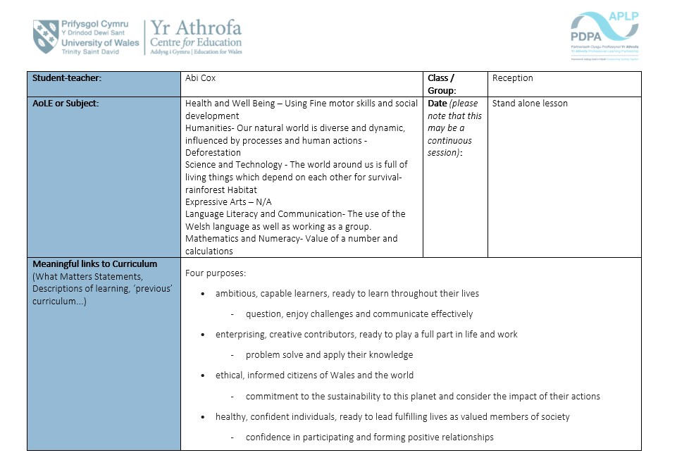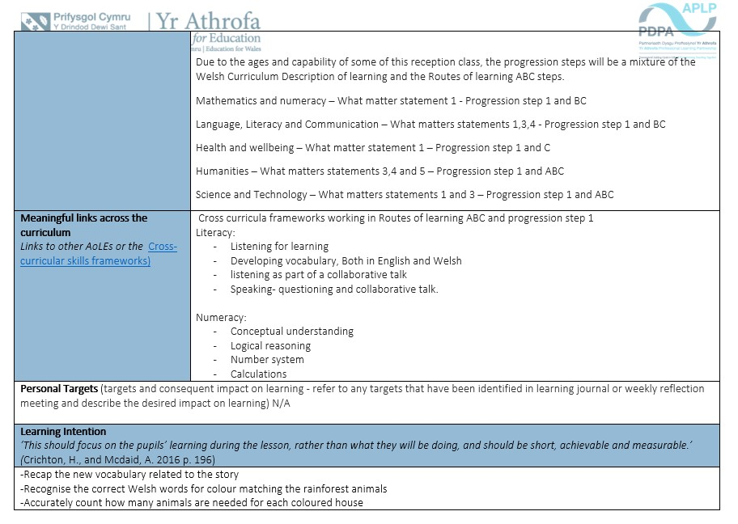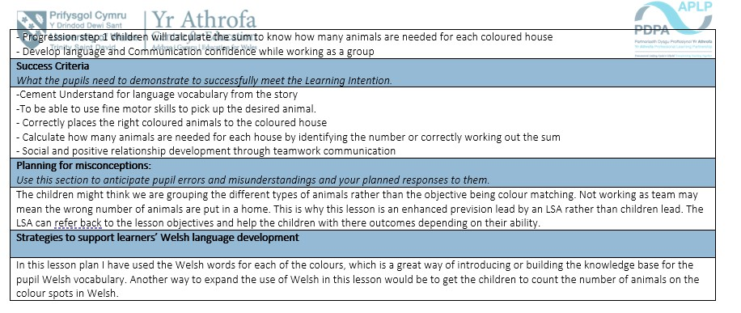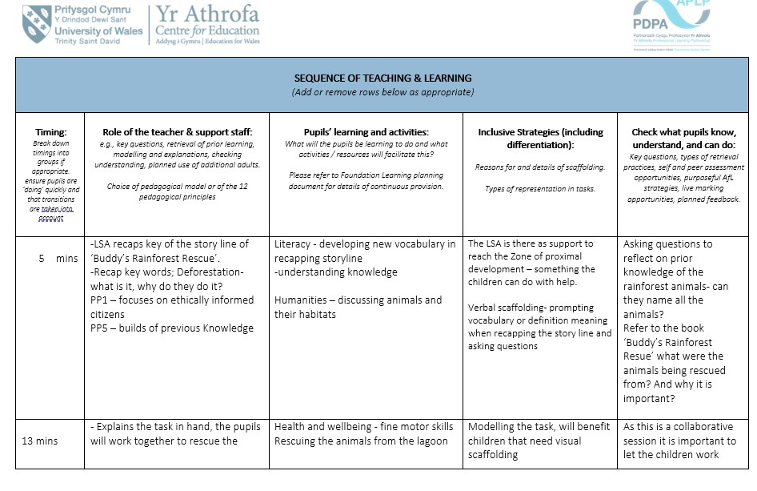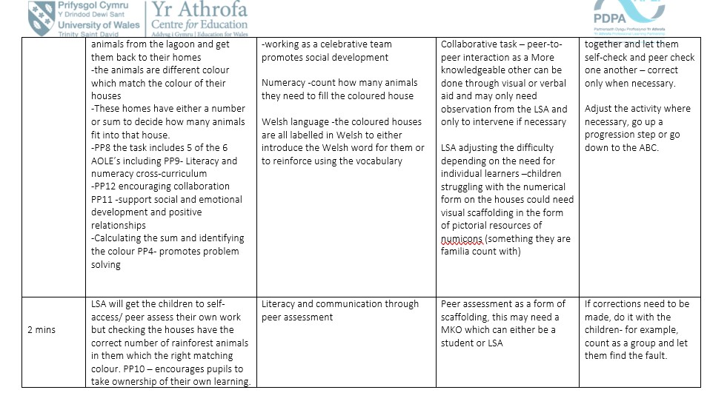

Appendix 2: Welsh Coloured Houses Resource
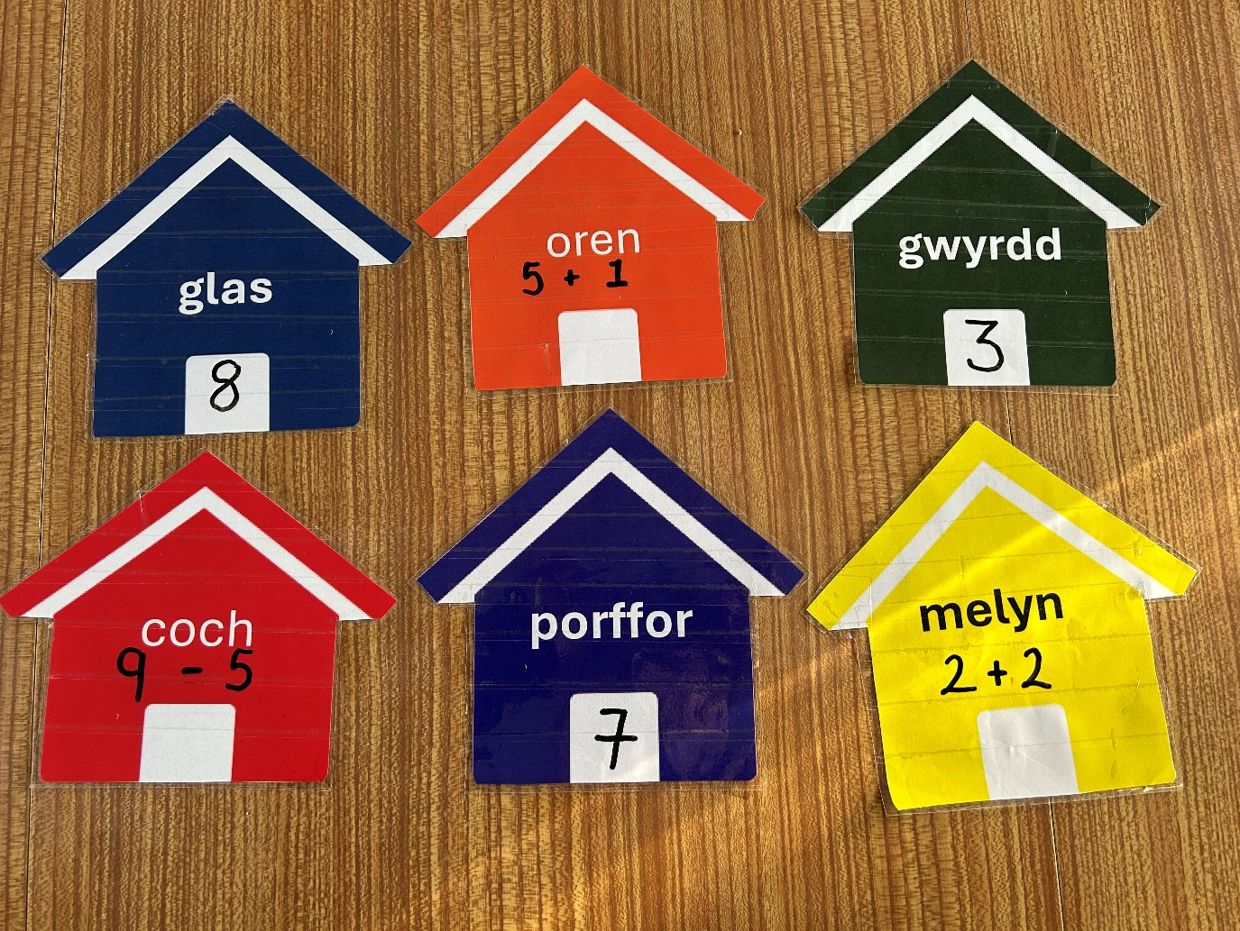

Appendix 3: Rainforest Animals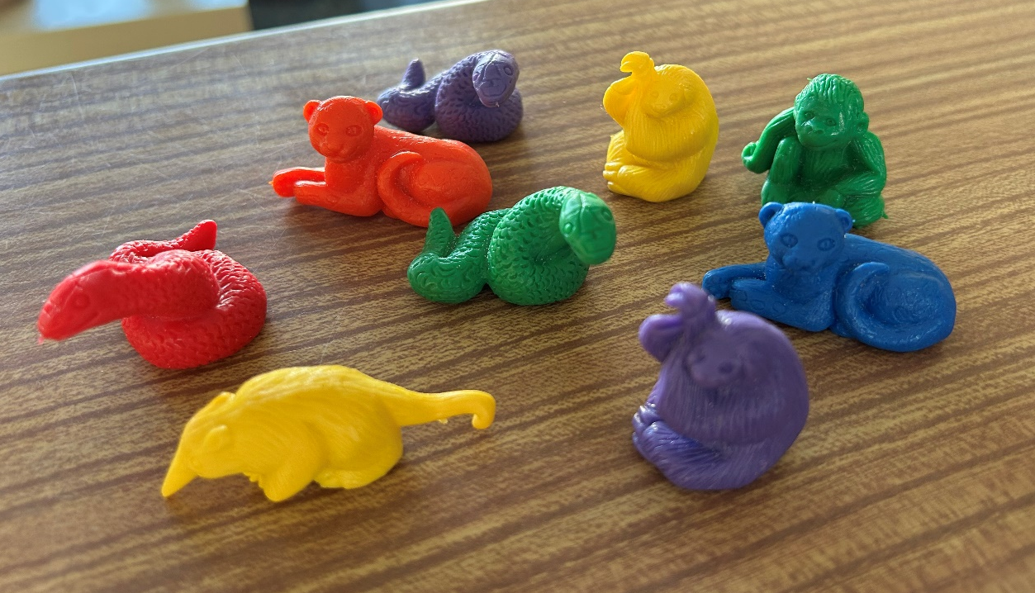

Appendix 4: Tongs used as the rescuing tool - fine motor skills
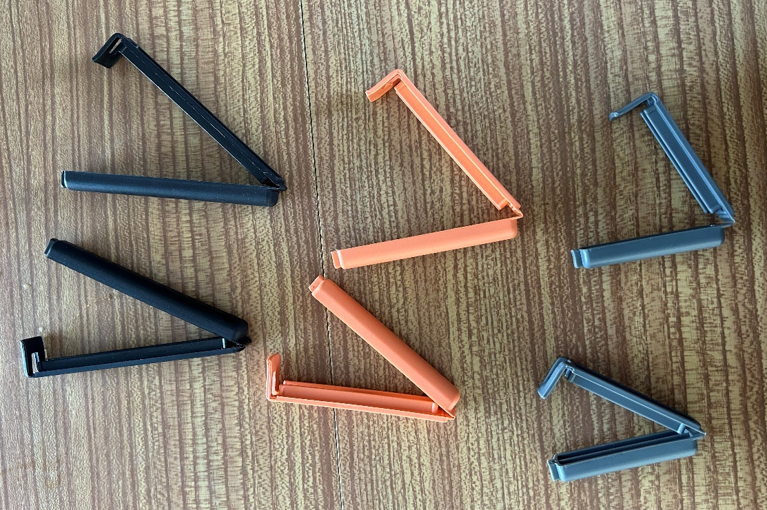

Appendix 5: Task Set out 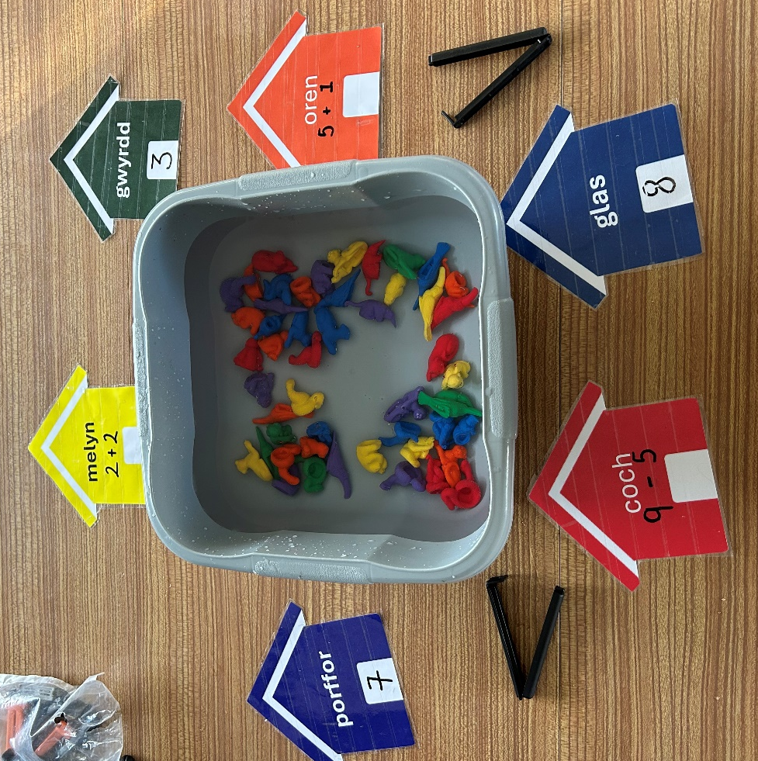

Appendix 6: Tongs Being Used To Pick Up Animals 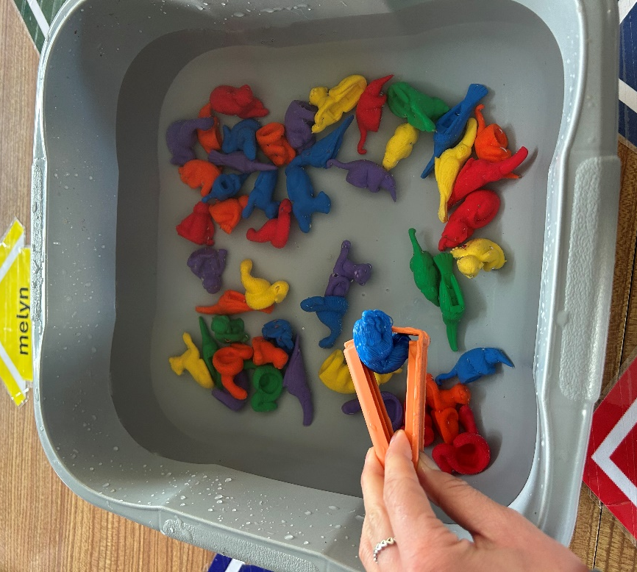

Appendix 7: Match the correct coloured animal to House

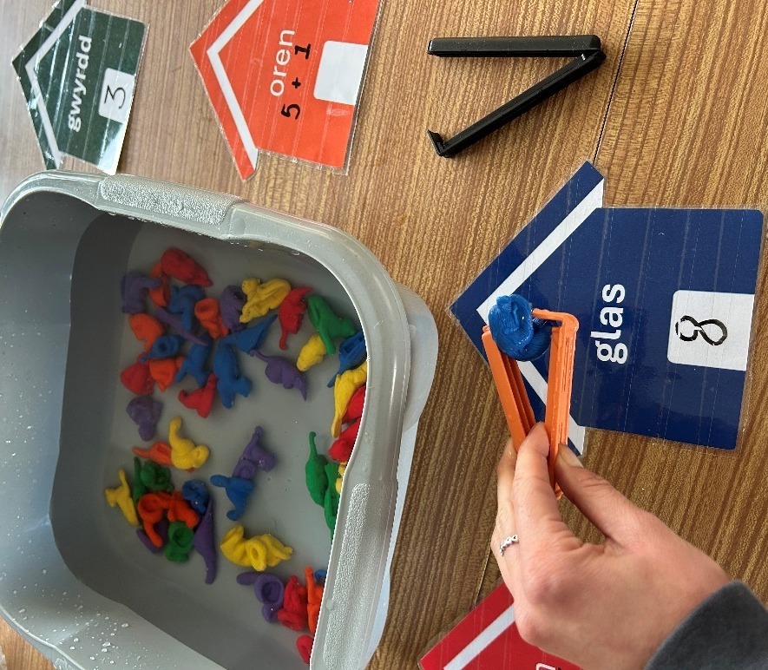

Appendix 8: Session ‘Swamp lesson’ Completed – correct number of animals with matching colour to the houses

