

Alexander Nichols

Material Science
Storage of Hydrogen in Pressure Vessels for Military Vehicles

UWTSD
ACDB 6016

BEng
Academic Year: 2024 - 2025

Supervisor: Dr Philip Holden
January 2025

Academic Integrity Declaration
I declare that:
- The thesis submitted has been written by me alone.
- The thesis submitted has not been previously submitted to this university or any other.
- That all content, including primary and/or secondary data, is true to the best of my knowledge.
- That all quotations and references have been duly acknowledged according to the requirements of academic research.
I understand that to knowingly submit work in violation of the above statement will be considered by examiners as academic misconduct.

Abstract
This report aims to investigate the suitability for the storage and use of hydrogen as a fuel source for military vehicles. To do this several existing vehicles will be researched and explained with attention being given to current fuel systems. The design of a hydrogen fuel system will then be assessed with the materials used in its construction analysed and their properties evaluated for suitability. The manufacturing techniques that could be used to build these components will then be discussed with the cost of doing so evaluated for suitability.

Table of Contents
Contents
Academic Integrity Declaration 2
Abstract 3
1 Introduction 5
1.1 Overview of Hydrogen Engines 5
1.2 Military Vehicle Fuel Systems 5
1.3 System Design 7
1.4 Considerations for Hydrogen 8
2 Task 1 Materials 8
2.1 Material Criteria 8
2.2 Unsuitable Materials 9
2.3 Appropriate Materials 9
2.4 Material Properties 10
3 Task 2 Manufacturing 11
3.1 Final Design 11
3.2 Manufacturing Considerations 12
3.3 Manufacturing Process 12
3.4 Quality Control 13
4 Task 3 Costs 14
4.1 Materials Procurement 14
4.3 Production Costs 14
5 Findings 15
5.1 Conclusion 15
References 15

Introduction

Overview of Hydrogen Engines
Hydrogen gas as a fuel has increasingly been explored as a method of powering vehicles in recent times. This has largely been explored as a replacement for traditional foil fuel-powered combustion engines due to global concerns for fossil fuel dependence, Energy Security, and Environmental impact [1]. Civil power generation and commercial automotive development have largely led the way for this change, but options for military use have also emerged. Reducing carbon footprints and moving away from fossil fuels due to pollution are concerns for military vehicles, however, the driving factor behind an alternative solution is Energy security [2]. This is due to the UK controlling less than 1% of global oil production with a large part being controlled by countries that could be hostile to the UK in the event of war [3]. Therefore, military vehicles shouldn't be dependent on foreign supply in the interest of national security.
Hydrogen fuel can be used in two different types of engines. The first of these operates similarly to traditional fossil fuel engines utilising internal combustion [4]. Unlike a typical which uses petrol or diesel for combustion, a hydrogen engine uses hydrogen gas and oxygen from the air to drive pistons [4]. The other type of engine is a hydrogen fuel cell engine, which instead of relying on combustion generates electricity through chemical reactions. Both types of engines produce no carbon emissions with water vapor being the primary emission [4].

Military Vehicle Fuel Systems
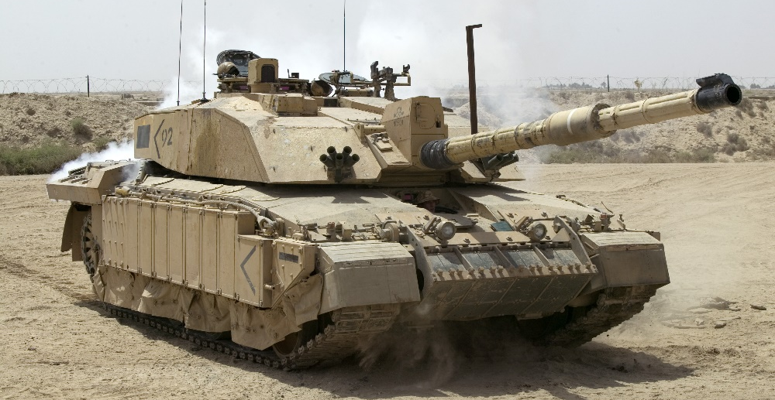
Across the British military, many different vehicles are used most of which rely on diesel fuel for propulsion. For this report, three different types of vehicles will be explored for use with hydrogen fuel systems to assess the compatibility of hydrogen fuel for different aspects of military use. The first of these vehicles is the FV54034 Challenger 2 main battle tank used by the British army shown in Figure 1. This has been selected as it is one of the heaviest and largest vehicles in use. The Challenger 2 currently uses a Perkins CV12-6A V12 26.1L diesel engine producing 1.200hp with a fuel capacity of 1,592 Liters giving the vehicle a range of 550km and a top speed of 59km/h [5]. Any engine used on this platform will need to provide a very high horsepower to compensate for the vehicle's weight and due to the frontline role must protect the crew from damage.
Figure 1
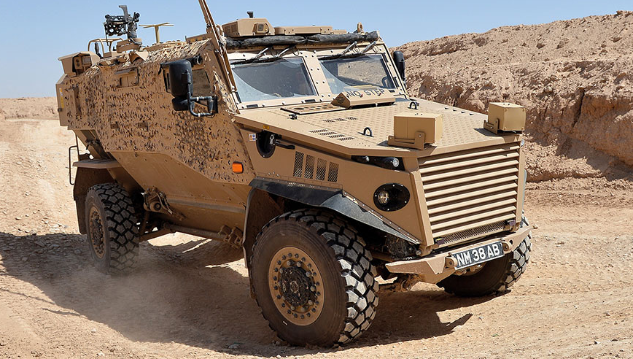
The next vehicle that will be explored in this report is the Force Protection Ocelot designated the Foxhound by the British Army shown in Figure 2. This vehicle is an example of a wheeled armoured vehicle used to transport troops on the battlefield offering armour protection and mine resistance. The vehicle is powered by a Styer 3.2L M16-Monblock 6-cylinder diesel engine providing 210hp allowing the Foxhound to travel at speeds of up to 132km/h [6]. The foxtrot has a fuel capacity of around 200 litres giving it a range of 500km. This vehicle is an example of a compact fast-moving vehicle requiring a powerful engine for high speed able to fit in a small space.
Figure 2

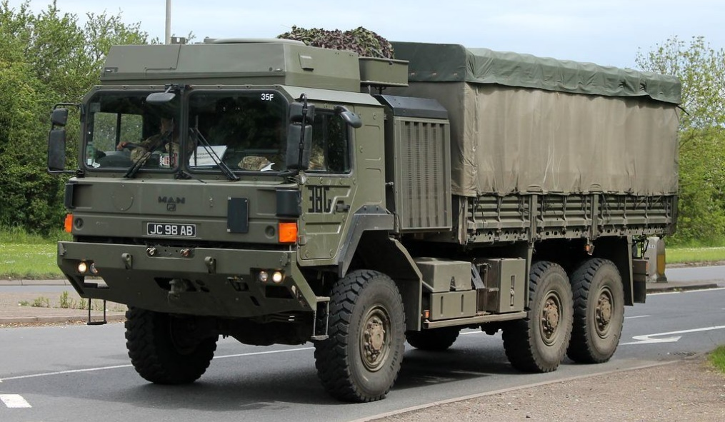
The final vehicle that will be explored in this report is the HX58 6X6 logistics Support vehicle (LSV) used by the British army shown in Figure 3. This vehicle is described as the Army’s ‘Workhorse’ and is the most numerous vehicle in use with the British armed forces. This vehicle features a MAN D2066 10.5L inline 6 engine producing 440hp. This vehicle has a fuel capacity of 400 litres with a range of 800km and can achieve a top speed of 100km/h [7]. Due to the large carrying load, this vehicle requires a high-powered engine but unlike the Challenger and Foxhound, this vehicle is designed for transport and logistics and does not feature armour protection.
Figure 3

System Design
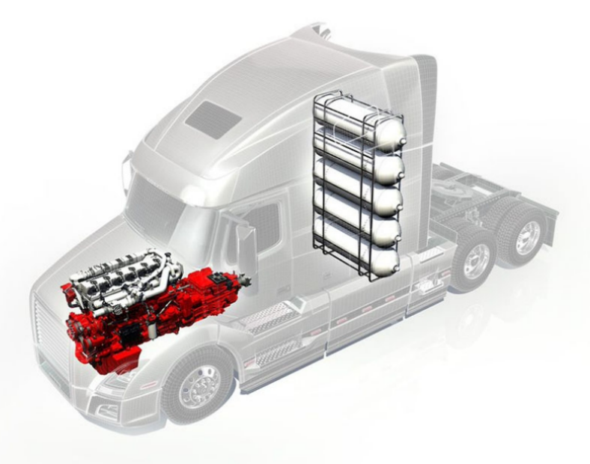
As mentioned, there are two types of hydrogen engines currently being explored for use in vehicles however for this report only hydrogen combustion engines will be explored. This is because the technology behind combustion engines is in a more mature state and relies on less complex technology [8]. Hydrogen combustion engines have several advantages such as lower costs from being a familiar technology, this also means that maintenance and development are much easier. However, hydrogen combustion engines produce nitrous oxide as an emission and are less efficient than hydrogen fuel cells [8]. An example of commercial hydrogen combustion can be seen below in Figure 4 which shows a commercially available from Cummins. For safety reasons, the use of multiple smaller fuel storage tanks is also desirable, as should one become damaged the others can still function.
Figure 4

This form of engine relies on the storage of pressurised hydrogen that is then fed into a combustion engine and mixed with oxygen from an air intake. This gaseous mixture is then injected into the engine where it is combusted and drives pistons then turning a crankshaft to propel the vehicle [4]. This design uses hydrogen gas rather than liquid hydrogen. This is because despite having the benefit of storing 75% more fuel compared to hydrogen gas storage the fuel has to be stored at -253°C [4]. These cryogenic temperatures can only be achieved with constant cooling which is not practical for a military vehicle as power would be required constantly when fuel was stored.
If the system used pure oxygen the only emissions released would be water, this can be seen with the equation 2H2 + O2 = 2H2O [9]. However, this is impractical for use in vehicles due to the space requirement. Therefore, hydrogen is reacted with air typically in an air-to-fuel ratio of 34:1 by mass, however, the air is largely made of oxygen and nitrogen which can be seen in the equation H2 + O2 + N2 = H2O + N2 + NOx [9]. This shows that when nitrogen is added to the combustion chamber nitrogen oxides are created. While not a greenhouse gas nitrogen oxides are air pollutants which can have health impacts. However, by using high-pressure hydrogen gas injection a hydrogen combustion engine can achieve up to 42% more power output than petrol engines by weight [9].

Considerations for Hydrogen
Hydrogen as a fuel source has several factors that need to be considered when designing vehicles powered by hydrogen fuel. One of the most important considerations regarding hydrogen as a fuel source is the storage of the fuel. This is a critical issue as hydrogen is the smallest element on the periodic table, which means that it is incredibly difficult to store [9]. This is due to the small size of hydrogen atoms allowing them to eventually pass through most solid materials because of this the only options to store hydrogen are to do so at very high pressure or to store liquid hydrogen which is to be stored at cryogenic temperatures. One of the other key issues with the use of hydrogen is the dangers that it poses, this has been a challenging safety issue in the civilian automotive industry so is especially important for military vehicles. This is due to hydrogen being an extremely flammable gas, a pressurised gas that can explode if heated, an oxygen displacer that can cause suffocation, forming an explosive mixture in air, and burning with an invisible flame [10].

Task 1 Materials

Material Criteria
To store hydrogen several key material properties must be met. This includes resistance to low temperatures, high tensile strength, low permeability, and resistance to hydrogen-induced corrosion. Additionally, because of the application of hydrogen for use in military vehicles, the storage vessel must be lightweight, resistant to high temperatures, and have a high toughness. Due to the nature in which military vehicles are exposed to a wide range of environments, the material must be able to cope with low and high temperatures. To understand the temperature requirements for this new system previous environments that equipment has been used in can be explored. Using Challenger 2 as an example the tank was previously used in Iraq and is currently in use in Ukraine, using these locations as temperature extremes a temperature criterion can be set. For a minimum operating temperature, Ukraine has seen temperatures drop regularly to -30°C [11]. In the case of Iraq temperature can reach above 50°C [12]. Using these two extremes as bounding cases with a tolerance of ±10°C any material used must remain viable in climates from -40°C to 60°C.
Additionally due to the likelihood of use of vehicles in proximity to water including salt water a material that is resistant to water-initiated corrosion is essential. Other environmental factors such as the use of vehicles in tropical and desert environments must also be considered so abrasion and humidity resistance are desirable. In the case of the Foxhound and Challenger 2 as armour-protected combat vehicles a high-strength material is essential as there is a high likelihood of the vehicle being attacked with projectiles or explosion. Because of this, the fuel storage tanks should be designed in a way that prevents fire and explosion from impacting other fuel tanks or harming crew. The containment vessel which stores the hydrogen gas must also be able to safely store the gas at a pressure of 700 bar [9]. Due to typical hydrogen gas being stored at around 25°C materials with insulative properties are also required this is only an issue for high temperatures, risk can also be managed with the use of pressure relief valves [9].

Unsuitable Materials
From the material criteria set out, several common materials can be discounted for use in the storage containers. Because of the high reactivity of hydrogen, it is prone to react with metals which can cause hydrogen embrittlement. This is due to hydrogen being absorbed into a metal causing them to become brittle and fracture. This is especially common in materials such as steel, iron, nickel, titanium and cobalt therefore they cannot be used for the pressure vessel [13].
Additionally, types of materials such as ceramics and plastics can be ruled out of forming the body of the containment vessel. For ceramics, this is because of the inherent material properties not being suitable for high-pressure gas storage. This can be seen in the high brittleness, lack of ductility, sensitivity to thermal shock, and permeability to gases for many ceramics. Plastics similarly have unsuitable material properties such as brittleness, thermal sensitivity, and poor strength. Plastics such as polypropylene, PVC and elastomers such as natural rubber are also permeable to hydrogen gas with certain synthetic rubbers also absorbing hydrogen.

Appropriate Materials
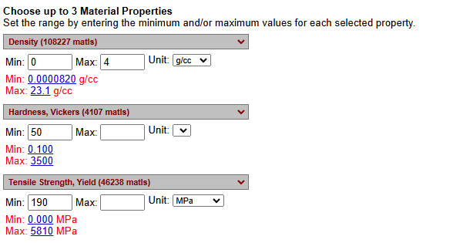
From the research conducted into material selection, it is apparent that the most suitable materials are metal alloys and composite materials. For metal alloys, the inherent benefits are the material strength and toughness with many alloys able to withstand the high pressures of up to 700 bar required for hydrogen storage without fracturing [9]. Additionally, many metal alloys are resistant to corrosion, which is essential for preventing deterioration over time, especially in environments with moisture and other corrosive elements. Alloys also typically have low permeability to hydrogen, minimising leaks and ensuring safe storage. Finally, certain alloys, such as specific grades of stainless steel and nickel-based alloys, are resistant to hydrogen embrittlement [14]. To narrow down the search for materials a database was used to search and compare material properties as shown in Figure 5.
Figure 5

Composites, such as glass or carbon fibre-reinforced polymers, offer exceptional strength while being much lighter than metals [15]. This is particularly beneficial for military vehicles where weight needs to be kept low to allow for thicker armour to be used. Composites can also withstand cyclic loading and high-stress conditions well without significant degradation, which is important for maintaining integrity with dynamic pressure as tanks are filled and emptied. Composites can also maintain their mechanical properties across a range of temperatures, ensuring consistent performance even in extreme conditions. The material is also very versatile so can be moulded into complex shapes and sizes, allowing for the design of efficient and compact storage solutions that maximize available space. Because of these composite materials are commonly used in vehicle design, aerospace applications, and industrial gas storage due to their combination of strength, and resistance to environmental factors [15].

Material Properties
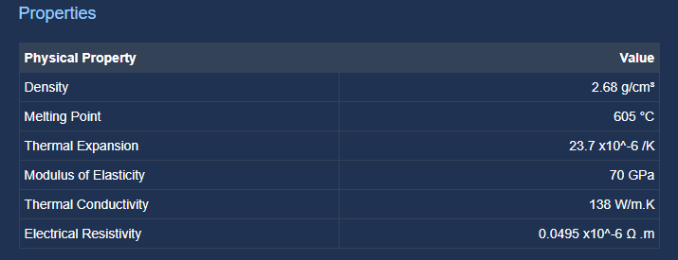
After using the material database to compare several different types of alloy aluminium-magnesium alloy was selected as the best for use in the containment vessel. This is due to the benefits 5000 series aluminium alloy has specifically regarding corrosion resistance [16]. This is because adding magnesium to aluminium provides significant corrosion protection specifically from water-induced corrosion. Aluminium alloy 5052 was then specifically selected as the alloy features hydrogen embrittlement resistance solving the main issue with aluminium. Additionally, this alloy features a high strength-to-weight ratio as the alloy is lightweight the material properties of this alloy can be seen in figure 6.
Figure 6

The aluminium alloy will be wrapped in a Carbon Fiber Reinforced Epoxy (CFRE) to provide extra strength to the pressure vessel. This will allow for increased strength to contain the high-pressure gas and provide additional protection from external threats. This is possible because of the durability of carbon fibre composite and surface hardness. This will allow fuel tanks to retain structural integrity and maintain their shape when stressed.

Task 2 Manufacturing

Final Design
After researching the current designs of military vehicles currently in use with the British military and commercially available hydrogen-powered vehicles a final design can be created. For this report, the engines used are taken to be the hydrogen internal combustion engines designed by Cummins. For the military vehicles selected two engines can be used to meet the requirements. The first of which is the H2 15L hydrogen internal combustion engine capable of producing 530hp [17]. This engine runs on hydrogen gas pressurised to 700 bar but can also use natural gas. This engine is designed for use in heavy goods vehicles as shown in Figure 4, this means that it could be easily incorporated into a vehicle such as the Logistics Support Vehicle. Due to the similar purposes for both vehicles, this engine could easily be incorporated into the Logistics Support Vehicle and would provide 90 hp more than the current engine.
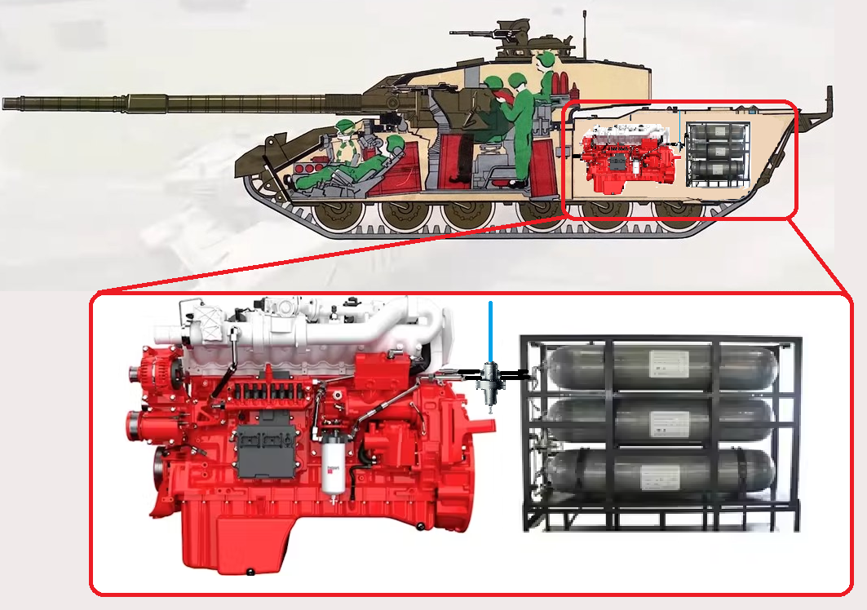
For Challenger 2 the same 15L H2 can be used however only using one engine would make the vehicle severely underpowered despite the H2 being one of the largest commercially available engines [17]. To solve this issue two engines could be used being capable of providing 1,060hp combined however this will still result in a drop in performance being less powerful than the original engine. The hydrogen tanks could then be located behind the engine to provide a large standoff distance from the crew for better safety. An example of this setup can be seen in Figure 7 which shows the engine and fuel tank position with a pressure relief valve in a Challenger 2. The concept for this design could also be applied to the Foxhound vehicle with both designs requiring additional armour to protect the fuel tanks. However, as the Foxhound is a smaller vehicle the X15 6.7L hydrogen engine from Cummins could be used instead providing 290hp while fitting in the smaller space.
Figure 7

Manufacturing Considerations
Retrofitting a new propulsion system into a range of preexisting military vehicles would come with several challenges. The most apparent of these issues is the complexity of fitting this new system in a preexisting space without vehicle modification. This is where using hydrogen combustion engines is useful as unlike a fuel cell they function in the same way as traditional engines allowing parts to be reused. For optimal performance, these vehicles would likely have to undergo a thorough re-design process.
The logistics of the modification of these vehicles would also have to be considered. This is due to the extensive facilities and resources that would be required to perform the upgrade. As there are currently 398 Foxhound, 227 Challenger 2, and 6606 Support vehicles in use the storage space, components, and effect of removing these vehicles from use must also be reviewed.

Manufacturing Process
To convert these vehicles to hydrogen power several steps are needed each with different manufacturing criteria. For the purposes of this report, it is assumed that the Engine and associated components such as pressure relief valves will be manufactured externally as they are commercially available. To manufacture the fuel tanks the first stage is to prepare the Aluminium Alloy liner and CFRE wrap. To do this sheet of aluminium must be cut to shape and then formed using a roller. The stands of carbon fibre must then be weaved into sheets to ensure strength in both the x and y directions.
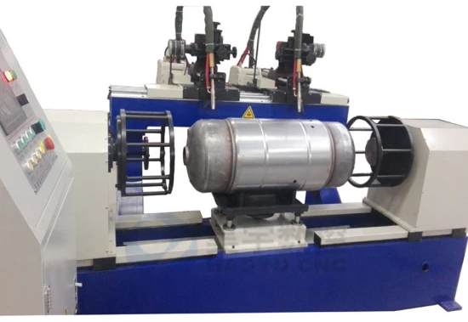
Once the alloy has been formed into a cylinder shape it can then be welded but first must undergo a cleaning process to ensure no contamination, for this an acetone bath and wash can be used before thoroughly drying the material. The cylinder can then be sealed and capped by Tungsten Inert Gas (TIG) welding as this is best suited for thin materials requiring high precision [18]. To ensure consistency over the large quantities of manufacture this could be done via computer numerical control (CNC) welding machines as shown in Figure 8.
Figure 8
To further protect the aluminium alloy liner the material will then be anodized, this will require the cylinder to be cleaned again using a degreaser. This can then be placed in an electrolyte bath such as sulfuric acid and a current is applied; this causes an oxide layer to form providing protection from corrosion and increased hardness [19].
Once the liner is complete the CFRE wrap can then be formed. This requires the surface to be coated with the epoxy and the sheet then wrapped around the liner and coated in epoxy. To ensure a consistent curing the cylinder will then be placed in a vacuum bag to remove all air and uniform pressure as the resin cures. Any Excess material can then be removed and the surface sanded to ensure that it is smooth. This will then allow for final assembly which will involve removing the old engine and fuel tanks. The new engine can then be bolted into the frame and individual fuel tanks inserted in a welded steel cage. Armour plating can then be attached to this cage to protect the vehicle and crew in the event of insult to the fuel tanks, additionally, this could be arranged so in the event of an explosion the force is directed up and out of the vehicle via a blow-out panel.

Quality Control
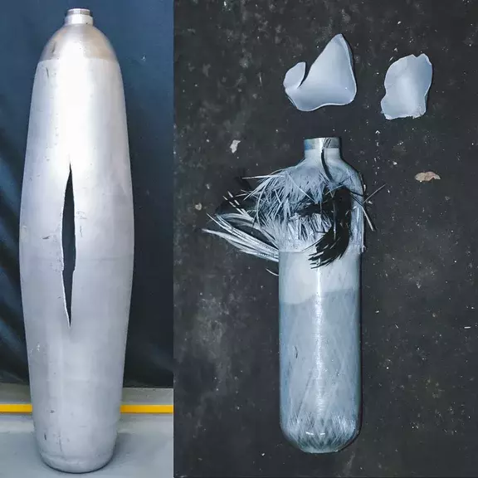
To ensure quality and consistency in the manufacturing process and final product, several quality control measures should be used. The first of these is the inspection and testing of the materials before use. To ensure good quality materials tests such as the Vickers hardness, ultimate tensile strength, and salt spray tests should be conducted on the materials [20]. This will ensure that the materials meet the criteria and tolerance created by the manufacturer. Additionally, thickness tests should be completed for the walls of the pressure container. Once the final assembly is complete the pressure vessels should undergo non-destructive testing such as ultrasonic or x-ray tests to detect any defects. Pressure and leak tests should also be completed for the storage tanks and all pipe fittings as a hydrogen leak could be catastrophic. Destructive tests could also be completed to determine the maximum pressure the tank can hold and ensure the correct functioning of the pressure relief valve. This test would also show how the tank fails so that if needed reinforcement can be added, the results of a similar test can be seen in Figure 9.
Figure 9

Task 3 Costs

Materials Procurement
To calculate the costs associated with these changes the quantities must first be known. Using the logistics support vehicle as an example the range was stated as 800km on a 400L fuel tank. The Cummins 15L H2 engine is stated to have a range of 965 km using 80kg of hydrogen gas with a consumption rate of 12.87 km/kg of fuel. To maintain the same range as the current system the vehicle would therefore have to contain over 62kg of hydrogen. Using 65kg of gas to allow for a margin of error this can be divided by the molar mass of hydrogen of 65,000g divided by 2g / mol a molar mass of 32,500 is achieved. Using the ideal gas law shown in figure 11 32,500 mols of hydrogen at 25°C and 700 bar the volume can be worked out as 1,150.9 Liters. As this is the minimum amount of fuel needed to achieve the same range the hydrogen tanks will contain 385L with a total of three used to give 1,155L of fuel. This means that roughly 3 times more hydrogen is needed by volume when compared to diesel, applying this logic to the other vehicles means a Challenger 2 would require 12 cylinders and a Foxhound 2. Applying this across all current vehicles would mean a minimum of 23,361 fuel tanks would need to be manufactured to convert all current models of these three vehicles to hydrogen power, not including spares.
To produce the 385L cylinder it is assumed to require 3.12m^2 of aluminium alloy and CFRE each. Using the figure of 23,361 units produced this would require around 72,886m^2 of each material for production. Current prices of 1.3mm Aluminium alloy 5052 are £11.78 per square meter [21] and CFRE manufacturing typically costing £26 per square meter [22]. This gives an overall cost on materials alone at over £2,753,633.

4.3 Production Costs
For a project of this scale an appropriate timeline would be a minimum of 10 years. Using this as an assumption to meet the goal of 23,361 units 7 units would have to be produced every day for 10 years. To allow for set-up time and maintenance periods assuming a throughput of 1 unit per day 10 production lines would realistically have to be set up. Each would require metal rolling and forming equipment, degreasing baths, galvanising bath, TIG welding machine, epoxy vacuum curing machine, pressure testing equipment, and a final assembly line. Using average costs from industry as an example this would likely cost £1,000,000 per line [23]. Therefore, setup costs would likely range as high as £10,000,000 in initial investment. With the average salary cost of a production line worker in the UK being £24,009 a year assuming 3 workers across each line also totals £7,202,700 across a 10-year manufacturing plan [24]. This gives a total cost of manufacturing of just under £20 million which does not factor inflation. Additionally, the cost of the engine is not publicly available yet however costs are estimated at around £75,000 and with over 7,450 engines being required this would add £559,350,000 to the total costs [25].

Findings

5.1 Conclusion
This report has shown the stages that need to be considered when designing a new fuel system. The current systems used in military vehicles have been discussed with the factors and implications of switching to hydrogen also explored. From the findings discussed in this report, there are several major disadvantages to using hydrogen In military vehicles. The first clear issue is safety as storing an explosive gas near ammunition in an environment where it is likely to be shot at poses a severe threat. However, this can be mitigated with use of advanced materials such as the carbon fibre composite discussed and armour protection. Additionally, by using several independent smaller fuel tanks the risk is also reduced. However, when researching commercially available engines the technology is not in a mature enough state for large scale use. This can be seen in the engines discussed when using in heavier vehicles not producing suitable horsepower. As shown in the costs analysis this would also be by far the largest experience of the project, with in some instances the engine costing more money than the vehicle it would be used in.
However, the results from the material and manufacturing analysis show that while the engine technology is not sufficient, the storage capability of hydrogen is. This is possible because of the advanced materials such as the composites and alloys discussed in this report that can store hydrogen in large quantities at high pressure in a variety of environments. Therefore, the limiting factor in the use of hydrogen in military vehicles is not the materials used for the storage but rather the engine technology.

References

[1] | Y. Manoharan, “Hydrogen Fuel Cell Vehicles; Current Status and Future Prospect,” 9 11 2019. [Online]. Available: https://www.mdpi.com/2076-3417/9/11/2296.
[2] | U. D. f. Energy, “Hydrogen Benefits and Considerations,” [Online]. Available: https://afdc.energy.gov/fuels/hydrogen-benefits#:~:text=When%20used%20to%20power%20highly,for%20a%20more%20resilient%20system.. [Accessed 06 01 2025].
[3] | U. EITI, “Oil & Gas in the UK,” [Online]. Available: https://www.ukeiti.org/oil-gas#:~:text=The%20UK%20is%20still%20a,of%20gas)%20%5B3%5D. [Accessed 06 01 2025].
[4] | Volvo, “Hydrogen fuel cells and combustion engines,” [Online]. Available: https://www.volvogroup.com/en/sustainable-transportation/sustainable-solutions/hydrogen-fuel-cells.html#:~:text=While%20both%20technologies%20use%20hydrogen,to%20convert%20hydrogen%20into%20electricity.. [Accessed 7 01 2025].
[5] | A. Recognition, “Challenger 2 FV4034 MBT tank,” 19 October 2024. [Online]. Available: https://armyrecognition.com/military-products/army/main-battle-tanks/main-battle-tanks/challenger-2-united-kingdom-uk.
[6] | U. A. F. Commentary, “A closer look at the Foxhound,” 16 January 2012. [Online]. Available: https://ukarmedforcescommentary.blogspot.com/2012/01/closer-look-at-foxhound.html.
[7] | R. M. M. V. GmbH, “rheinmetall,” [Online]. Available: https://www.rheinmetall.com/en/company/subsidiaries/rheinmetall-man-military-vehicles/about-us. [Accessed 09 01 2025].
[8] | MAN, “hydrogen engine a climate friendly alternative,” [Online]. Available: https://www.man.eu/engines/en/in-focus/engines/hydrogen-engine-a-climate-friendly-alternative-127808.html. [Accessed 09 01 2025].
[9] | E. Energy, “Hydrogen use in internam combustion engines,” [Online]. Available: https://www1.eere.energy.gov/hydrogenandfuelcells/tech_validation/pdfs/fcm03r0.pdf. [Accessed 10 01 2025].
[10] | Airgas, “Safety Data Sheet,” [Online]. Available: https://www.airgas.com/msds/001026.pdf. [Accessed 11 01 2025].
[11] | P. Maps. [Online]. Available: https://www.plantmaps.com/en/ua/climate/extremes/c/ukraine-record-high-low-temperatures. [Accessed 12 01 2025].
[12] | p. maps. [Online]. Available: https://www.plantmaps.com/en/iq/climate/extremes/c/iraq-record-high-low-temperatures. [Accessed 12 01 2025].
[13] | TWI, “What is Hydrogen Embrittlement? - Causes, Effects and Prevention,” [Online]. Available: https://www.twi-global.com/technical-knowledge/faqs/what-is-hydrogen-embrittlement. [Accessed 12 01 2025].
[14] | Matweb, “Property Search,” [Online]. Available: https://matweb.com/search/PropertySearch.aspx. [Accessed 12 01 2025].
[15] | H. Sharma, “An Overview on Carbon Fiber-Reinforced Epoxy Composites,” 11 April 2022. [Online]. Available: https://pmc.ncbi.nlm.nih.gov/articles/PMC9032017/#:~:text=Introduction,to%20marine%20industries%20%5B1%5D..
[16] | AALCO, “5052,” [Online]. Available: https://www.aalco.co.uk/datasheets/Aluminium-Alloy-5052-H32-Sheet-and-Treadplate_138.ashx. [Accessed 12 01 2025].
[17] | Cummins, “Cummins,” [Online]. Available: https://cleancities.energy.gov/files/u/news_events/document/749/file/Cummins%20Heavy%20Duty%20Hydrogen%20Engine%20Update.pdf?c25ee9cae5#:~:text=A%20new%2015%2Dliter%20platform,heavy%20duty%20long%2Dhaul%20trucks.&text=energy%20with%201%20gallon%20diesel,7. [Accessed 12 01 2025].
[18] | Sunbelt, “TIG Welding Applications: Advantages and Disadvantages,” [Online]. Available: https://www.sunbeltrentals.com/resources/blog/industrial-tool/tig-welding-applications/. [Accessed 13 01 2025].
[19] | u. Anodisers, “Key Advantages of Anodising,” [Online]. Available: https://www.unitedanodisers.com/about-anodising/key-advantages-of-anodising.html. [Accessed 13 01 2025].
[20] | Britannica, “materials testing,” [Online]. Available: https://www.britannica.com/technology/materials-testing. [Accessed 13 12 2025].
[21] | o. metals. [Online]. Available: https://www.onlinemetals.com/en/buy/aluminum-sheet-plate-5052. [Accessed 13 01 2025].
[22] | A. lab, “Carbon Fiber: Building Uses, Attributes, Price and Design Trends,” [Online]. Available: https://www.architecturelab.net/building/material/carbon-fiber/. [Accessed 13 01 2025].
[23] | Upmetrics, “How Much Does It Cost to Start Manufacturing?,” [Online]. Available: https://upmetrics.co/startup-costs/manufacturing.
[24] | talent.com, “Production Line average salary in United Kingdom, 2025,” [Online]. Available: https://uk.talent.com/salary?job=Production+Line. [Accessed 13 01 2025].
[25] | MES, “Cummins Unveils Powerful New 15-Liter Hydrogen Engine,” 26 May 2024. [Online]. Available: https://myelectricsparks.com/cummins-15l-hydrogen-engine-290hp-heavy-duty/.

