Report on
Personal development planning

Contents
Introduction: 3
Part 1: 3
Lifeline exercise: 3
Skill audit: 4
Self-evaluation review: 6
Swot analysis: 8
Johari window 9
Research and learning 11
Part 2: 16
My own expectation from the world of employment: 16
Suitable job role review: 16
Part 3: 18
Suitability 18
Part 4: 19
Personal goals 19
Personal development plan: 22
PDP’s effectiveness for the suitable roles 23
Conclusion 25
References 26

Introduction:
Personal development plan helps to make a person focus in his/ her future goals. It is is a composed record of self-reflection and improvement, which doubles over as a definite activity plan used to satisfy academic, individual, or future career-based objectives (McMillan and Weyers, 2006). In this report I am going to show which learning model I need to accomplish my objective and my future.

Part 1:

Lifeline exercise:
A Lifeline exercise shows up the highs and lows throughout my life, regardless of whether in the family, in my educational life, in work or in a few different exercises. It tends to be made by truly drawing a line over an outline and checking it up with the key events happened in my life.

18 20 25 30 32 33 47
Finished college in ivory coast
Moved to U.K and started as a kitchen porter
Promoted to assistant chef
Jobless for two years
Started as a bus driver
Started university
High points
Low points

Skill audit:
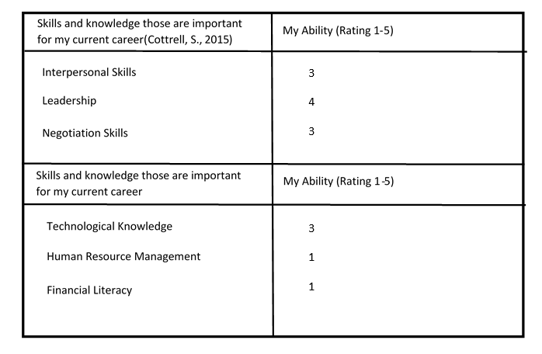
Interpersonal skills: being a bus driver, it was my duty to interact with other people, but to be better in communication I need to attend free speech seminars.

Leadership:
It is one of my strong point as I inherited this skill through years of practice.
Negotiation skill:
I’m living everyday bargaining with other people but sometimes I get nervous and through up on myself. Sometimes I loose confident in myself. As this is a weak point I need to take this matter seriously and start improving this skill through properly negotiating with my customers.
Technological knowledge:
I’m somewhat familiar with the technology of modern era and as a pass checking officer I am subjected to work in a desk with a computer.
Human resource management:
As a bus driver it is my duty to drive. So, I have no expertise in this field of hiring other people to do my job. Through proper guideline and taking short course, I may be able to improve in this field.
Financial literacy:
Currently I have poor financial literacy, but by doing financial courses from the university in the future, I may be able to improve this skill

Self-evaluation review:
Self-assessment (Blanchard, 2013) which is also known as self-review is a method to efficiently watch the system that analyzes and esteems my own proficient activity and its outcomes to balance out or improve it (Blanchard, 2013). This thing can occur on an individual or on a business’s dimension. Evaluation of myself implies that I can investigate and assess my very own professional work (Blanchard, 2013).
In self-assessment, it is the given resources that usually makes the research quality to adapt. An incredible favorable position is the emphasis on practice: the methodology (Blanchard, 2013) is straightforwardly associated with the experts' master learning and involvement in their specific area of work. This prompts high duty and higher identification with the assessment results and expands ability to reach determinations and move them into training. For me, the personal value that I have acquired are:
Achievement:
Achievement is something achieved, particularly by prevalent capacity, uncommon efforts, incredible valor, an extraordinary or courageous deed and so forth. I had always studied and worked for achieving the best from my work. Since my childhood, I have tried to focus on being the top of the position.
Honesty:
What is called honesty? Numerous kids think trustworthiness implies to "don't lie"- - and that is unquestionably part of being straightforward. In any case, trustworthiness or honesty implies more than not lying (Van Emden, & Becker, 2010). trustworthiness demonstrates that a legitimate individual doesn't do things that are ethically off-base. this is one of the things that I had achieved during the tie of being a driver. People praise me for being honest to them and being straight forward. I had never charged people with extra fare than usual.

Independence:
Basically, independence means being free from the dependency of others. Being able to do things myself and nobody will question about it. After I got the job I was able to remove myself from being a burden in the family. I was able to do things myself and earn for myself and the family.
Simplicity:
For me simplicity of life doesn’t refers to the individuals who have immense cash or people who has a lot of luxury rather people who live typical and ordinary life on their own. This isn't the effortlessness rather it is the way of life they live in this world.
Simplicity, for me, it is to pursue the standards and guidelines without being uproarious and not to be degenerate or not fix to anyone. After recovering from the effect of joblessness, I was able to lead a normal life on my own. Waking up in the morning at my very own tiny little apartment, going to the job early in the morning, work whole day and return after sunset was a typical way of leading a life. I never had cared about whether I will be a rich man, and never will I lead a life like this. I was happy with what I have
Dependability:
Reliability or dependability for people essentially implies that appearing on time in the wake of promising to do as such, doing what you guaranteed to do on schedule, and not misleading different people.

If someone is dependable and solid, at that point that person is trustworthy and that is a truly attractive good trademark to have as a part of his/ her identity for fruitful connections with different people Cottrell, S. (2010). For me, I had always appeared on time in my job and didn’t break a certain promise without a good reason.

Learning:
From my childhood, I had always been busy finding out new things and understand those fact properly. I had always tried to imply new rules from my learning into my life. I was fond of reading books magazines and journal from my school life.

Swot analysis:
SWOT analysis is the examination of a person’s circumstance by looking at Strengths, Weaknesses, Opportunities and Threats. It has been utilized by organizations for a long time as a vital instrument, since it gives them an inside and out perspective on the association. SWOT in many cases are similarly valuable on an individual dimension as an approach to distinguish regions for advancement, and as a component of profession exchanges. Its basic organization, and simple to-apply structure imply that it very well may be utilized in all respects effectively without help. SWOT stands for:
Identifying the inner strengths that will help me to achieve my goal for the future:
Strengths are those factors which will be able to help me and provide support for me. These factors include skills, vast resources, any type of experience that I have now and knowledge or wisdom in me. These things will help me to stand on my career and achieve the highest peak of my expectation. For me it is aural learning as it is the best way for me to learn. However, I can learn things quickly as I have interest in learning and I can manage my time as well as perform leadership skills.
Identifying personal weakness that will hinder me from achieving my goal for the future:
Weakness are those factors that very well relates to me personally. Overcoming those factors will help me to increase my strength and take my achievement to higher level. For me, it will be visual learning that will prevent me for achieving my goal as I like demonstration rather than simply watching it. However, I lack communication skill efficiency and I don’t have enough knowledge of accounting standards and the concepts. In addition, I lack networking skill.

Finding out any sort of opportunities that will help me to take advantage of the situation and achieve my goals:
These are totally external situation that depends upon the condition but also beneficial for me. But those situations are not just for me, rather it will be helpful for all in general. Opportunities can help me to achieve both my long term and short-term goal. This course and my enthusiasm of learning as well as the availability of the information online and the degrees on accounting courses can help me pursue my goals.
Identification of any types of threat that will prevent me from achieving my goal:
Just like opportunities, these are also totally external factor. It will affect everyone in general. These factors will either prevent me from taking benefit of an opportunity or hinder me from achieving short- and long-term objectives. Family constraints and monetary scarcity can be great threat for me and the my time management with my job life and study can create dilemma for me.

Johari window

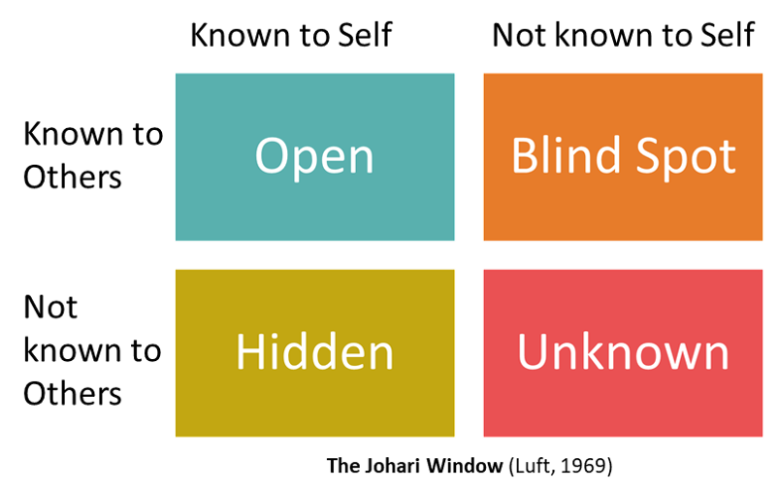
Open area: Known to both you and other people around
This Open Space is about the conducts of me that is known by me and furthermore observed and recognized by others. I can also convey about this. All things considered, some of the time happens that there is conduct of myself that is troublesome to the nature, where somebody knows that it is. It isn't in every case simple to recognize when somebody is stood up to me about this matter.
Blind Spot: Unknown to only me but Known to other people
The Blind Spot can be hard to oversee, and this is the reason they can talk about me. This is claiming to be something that other people can see that I don't. Sweat scent, the regular utilization of a similar word or ceaseless pulling of the nose are instances of this. The Blind Spot can likewise happen in the workplace. Somebody can be ignorant of the way that he works slower than his associates. Others know about this, in any case, which can cause certain disturbances. If such thing occurs and proper sentence isn’t offered appropriately to me, i will remain stuck in his old conduct and is probably going to fall outside the gathering.
Hidden Area: Known to me but Unknown to other people
In the Hidden Area, I can hush up about certain information and not let other people know about it. The Hidden Area can likewise be obscure to a predetermined number of other individuals. All things considered, my own Hidden Area will gradually move to Open Space.
Unknown Area: both unknown to myself and unknown to other people
No correspondence exists about this Unknown Area. Simply because of the way that myself and other people are unconscious of it, which implies it won't become the topic of talk.

Research and learning
Honey and Mumford’s learning styles:
ACTIVISTS
Activists (Preston, 2016) can discover Distance Learning baffling because they need to associate with different students (Preston, 2016). If they are a dissident student, they ought to truly think about going to classes, or finding an examination amigo to skip thoughts off. from my childhood, I was said to be generating new ideas in the class and sharing those ideas with other students.

REFLECTORS
Reflectors frequently appreciate Distance Learning (Preston, 2016) since they have enough energy to ingest data and different models. Their fundamental peril is getting too much busy with hypotheses, investing energy surfing the web for more data (Preston, 2016) as opposed to locking in to contemplating or composing assignments (Preston, 2016). If someone is a reflector, they need to set themselves to begin and end times for their investigation periods.

THEORISTS
These people like models and applying speculations from the learning in real life situations. They like to have an entire structure and to have the capacity to test issues. They will in general love measurements, models and applying ideas hypothetically in real life (Preston, 2016). They regularly think that its simpler to get familiar with the entire module before beginning any appraisals.

Logical thinkers
Logical thinkers (Preston, 2016) need to see a connection between what they are realizing and this present reality. On the slight chance that someone is a realist, he/ she will search for precedents, both in his/ her perusing and by going outside the learning condition (Preston, 2016). They used to learn from real life experience. It is important to know that if someone is learning for long haul benefits, so while he/ she will be unable to apply his/ her adapting now, it will be applicable later. Logical thinkers likewise need clear rules for appraisals, and to be clear what is required.

The VARK model:
The VARK (Allen, Scheve and Nieter, 2010) demonstrate shows 4 fundamental learning preferences utilized for learning data, including: Visual, Aural, Read/ write, and Kinesthetic (Allen, Scheve and Nieter, 2010).
Visual
Lean towards data in graphical structure (outlines, images, diagrams)
Aural/Auditory
Chooses data in spoken structure from others (tuning in and talking, addresses)
Read
Fulfilled by data showed as words in notes (perusing and note-taking)
Kinesthetic
Inclines toward data through encounters or experience (material and hands-on exercises)
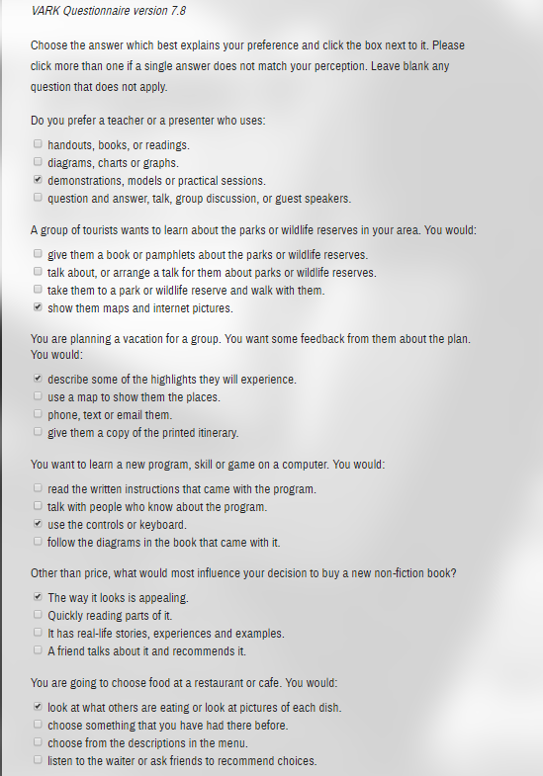

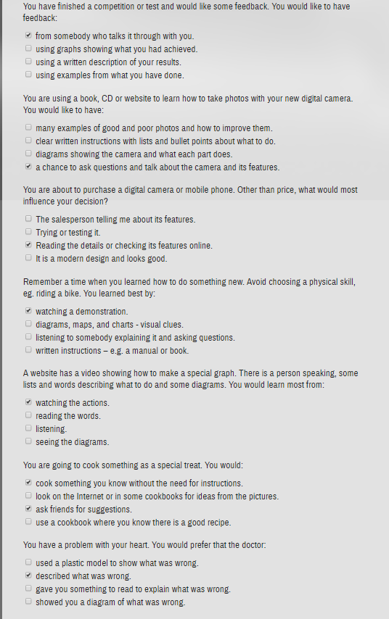

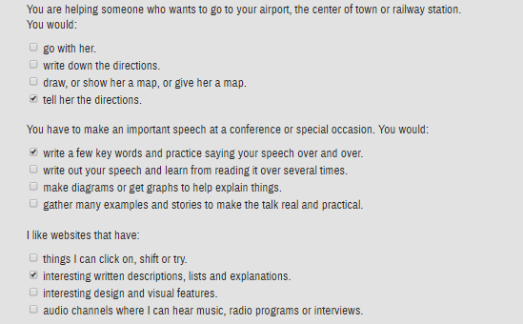

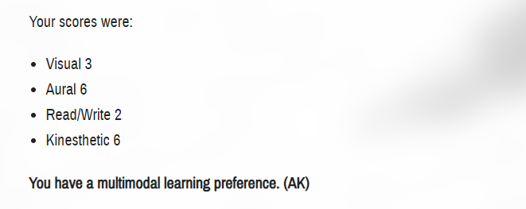
So, I am mostly an aural learner and kinesthetic learner as a medium of learning.

Part 2:

My own expectation from the world of employment:
Employment is the source of hiring the perfect candidate for the specific post within the organization. In the world full of skilled people, recruiters opt for looking new things within a prospective employee that may help them to achieve their business objective. For, most of the employers, it is:
Proper communication skills:
Employers tend to hire candidate who has better communication skill compared to others. For that reason, I will try to show my own skill in communicating across the team which as a skill I had before.
Previous work experiences:
As a driver, I have past skill. But as an accountant, I am new in this field. But, I will try to do internship in an accountant firm. It will surely help me to gain experiences that I need for working as an accountant.
Problem solving skills:
Employers like to select candidates who has this skill that can help working in a team. It is needed as the organization might try to find solution that they are facing in a desperate situation.

Suitable job role review:
Accountant in a reputed private firm: a private firm hires accountant on a regular basis. If I can complete my courses in the university, I may be able to find a suitable job in a private firm.
Assistant accountant in a govt. institution: govt. institution looks for accountant in occasional basis to hire. If I am lucky enough, I will be able to find a suitable position in a govt. institution and follow my career.
Head accountant in a small business: small business may not be profitable, but I will be able to find a job in those business organization.
Personal contribution effectiveness while working with others
Sense of commitment:
Sense of commitment make people's conduct unsurprising even with variances in their wants and interests, along these lines encouraging the arranging and coordination of joint activities. If I become a head of accountant department, I will try my best to be involve for the betterment of the organization. I will devote my time to engage the people under me to work hard by my side.
Self-confidence:
Self-confidence (Everything Is Wrong With You, 2011) is an individual's conviction or trust in their very own capacity. For me, self confidence is to have the belief on my work and try my very best to show people that I am right in my team work and leadership.
Personal initiative:
Personal initiative refers to the person's activity that starts a procedure, regularly managed without direct administrative impact. For me, it means that I will be the one to start the process. As I have background of good teamwork and effective leadership skill, I will be able to start a new or unfinished work by myself. And it will be beneficial for the organization as it will save the time of communication for getting the job done.
Improve communication system:
As a former team leader, it was my duty to properly communicate with other people. So, it will be easy for me to govern the communication process of the organization and maintain proper channel withal of the departments and make the communication between the consumer and business easier with my previous skills.
Create simultaneous learning environment:
Learning environments means that the varying physical areas, settings, and cultures in which people learn. Since the employees may learn in a wide assortment of settings, I will try to create an environment where the people working under me will try to continuously learn different things that will ultimately be beneficial for both the employee and organization.

Part 3:

Suitability
Suitability is making myself comfortable in the organization. It is something that is important to continue work the organization. Unsuitability occurs when an employee cannot cope up with the environment of the workplace. Some of reason that an employee may not be able to keep himself in pace with the work are:

Lack of motivation:
Motivation (EVANS, 2016) is a vital thing of human that drives them to accomplish what they desire or their goals or objective. If there is no motivation, then the employee might not find incentive to work for accomplishing the business objective (EVANS, 2016).

Lack of proper communication:
Keeping pace with other department is important because a business is combining effort to accomplish the end objective. And to keep pace with other department and people it is imperative to have proper communication channels. Without this, one employee might try to blame others for a work that is not completed.

Freedom of work:
Employees are not a puppet of the organization. They want independence to work for the betterment of the organization. When an employee find himself working rigorously under other people and don’t get credit for his achievement, then he might lose interest in his/ her work.

I will try my best to find job that has better independence compared to other organizations. And I will personally try to do the work in a way that not only keeps my interest but also provides help to the organizational achievement.

Part 4:

Personal goals
Personal goal (Cohen and Liverman, 2011) is the individual desires, objectives or destinations made by a person for them to concentrate on and endeavor to accomplish (Cohen and Liverman, 2011). For me, my goals for different terms will be:
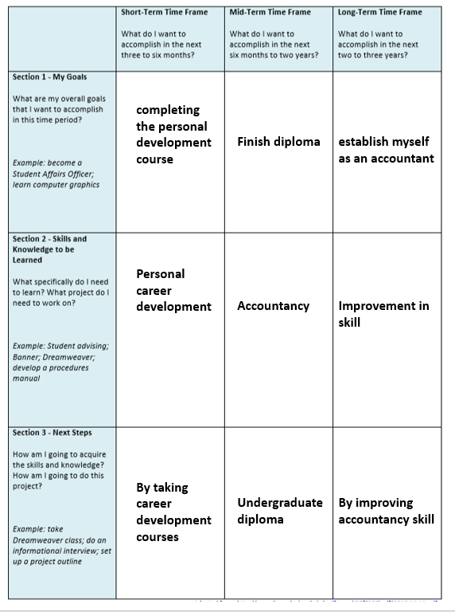

Short term goal:
Giving the best effort for completing the personal development course. Thus, improving my skills through learning different things and removing the weakness. Try to be the best in the understanding of career plan and pursue my goals or objectives.
Timeframe: 1 year.
Medium term goal:
For me, the medium-term goal will be to be finish diploma which will take 1-year worth of qualification at bachelor’s degree level.
Timeframe: 3.5-4 years.
Long term goal:
My long-term goal is to establish myself as an accountant that will provide accountancy service to my organization.
Timeframe: After 5 years of study.
Action plan
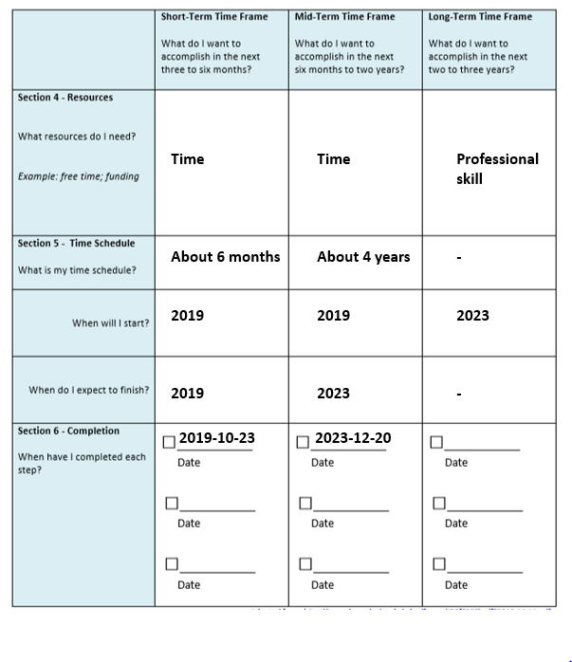

Personal development plan:
Personal development plan is an organized procedure of making an activity plan dependent on person's learning, execution and accomplishments, to get ready for his own, proficient and instructive advancement. It is also "a blend of thoughts and systems that will enable a person to deal with his/ her very own learning and development. It is helpful for improving the skills of that person. It helps an employee to turn his/ her weakness into strength that will peruse him to carry out his long-term goal.

PDP’s effectiveness for the suitable roles

Personal development plan helps me to better understand:

Identifying my professional roles:
Personal development plan helped me to better identify what I want to become in the future. For me, it was to be an accountant. Now that I have identified my professional roles, I can help my way to achieve the goal for myself.

Identifying my skills and knowledge
If I can recognize what my insight, aptitudes and capacities are, i will most likely to build up a superior profession objective. My professional objective is a basic articulation of what I need to do or achieve. It is critical to predefine my professional objective with the goal that I can center the pursuit of employment endeavors. It is additionally vital to effectively express this on my resume and proper zones of occupation applications. For this, SWOT analysis is one of the ways to determine the strength and weakness of myself.

Setting goals for future:
Goals or objective is the most important thing that drives people as like motivation. Without this, no one would have a dream of becoming someone in the future. Personal development plan helps to better help someone realizing the inner spirit and deciding what to become. PDP helped me to identify that accountancy is favorite and I want to become an accountant in the future and for that I need to work hard.

Understanding the action plan by creating one for myself:
Now that I know what to become, it is wise to take immediate action for obtaining the goal for myself. PDP has helped me to realize that I would need a professional expertise and certificate from a university to become an accountant in the future. So, it is my action plan to get a good degree, learn new things, and getting a good job and then improving my skills and position in the organization in the future.
Listing down the improvement:
The strength that I gained from the learning period and the weakness that I have discovered and removes form my life. It is imperative to identify new weaknesses and turn those into strengths.

Conclusion
Focusing alone on my individual self-improvement plan upgrades the characteristics I hold inside me and accomplishes my objective or goals in the future. My potential is boundless and putting resources into self-improvement is an approach to tackle my numerous abilities. It helps and will help me to turn my weakness into strength and assess me to continuous improvement through the future period.

References
Blanchard, J. (2013). Teaching and Targets. 2nd ed. Hoboken: Taylor and Francis.
Allen, K., Scheve, J. and Nieter, V. (2010). Understanding learning styles. 5th ed. Huntington Beach, CA: Shell Education.
Cohen, H. and Liverman, C. (2011). Certifying personal protective technologies. 6th ed. Washington, D.C.: National Academies Press.
EVANS, P. (2016). MOTIVATION. 5th ed. [Place of publication not identified]: PSYCHOLOGY Press.
Everything Is Wrong With You. (2011). 4th ed. Tow Books.
Preston, N. (2016). Learning Styles and Strategies. 3rd ed. Hauppauge: Nova Science Publishers, Inc.
Cottrell, S. (2010) Skills for Success: The Personal Development Planning Handbook (2nd edition). Hampshire: Palgrave MacMillan.
Maund, A. Schriek, M. and Tinkler, P. (2017). Certificate in Higher Education: Skills for the Workplace Student Yearbook. Sage Publications
Morgan, P. (2016). The Business Student’s Guide to Study and Employability. Sage Publications
(Palgrave Study Skills) Hampshire: Palgrave MacMillan.
Cottrell, S. (2010) Skills for Success: Personal Development and Employability
McMillan, K. and Weyers, J. (2006) The smarter student: Skills and strategies for success at university, London: Prentice Hall.
National Careers Service (2012) Preparing for an interview. [online] Available at: https://nationalcareersservice.direct.gov.uk/advice/getajob/ interviews/Pages/default.asp
Pritchards, A. M. (2008) Studying and Learning at University: Vital Skills for Success in your Degree. London: Sage Publications.
Prospects. (2016) Career advice [online] Available at https://www.prospects.ac.uk
Van Emden, J. & Becker, L. (2010) Presentation Skills for Students (2nd edition). Palgrave Macmillan.
Wilson, E A and Bedford, D (2009) Study Skills for Parttime Students Harlow: Pearson

