

Assessment 1 – Reading Task Template
PART 1: Upload your photo of your A3 in-class notes here:
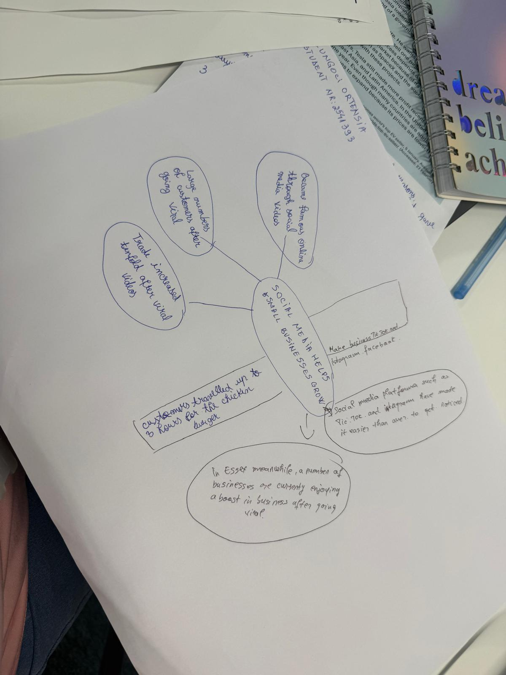

PART 2:
- Answer every question below in 1-3 full sentences.
- Use your own words. Do not use generative AI to answer these questions.
- Include a specific detail from the text when asked.
REMINDER
- The main idea is the overall message of the whole text.
- A key point helps to explain the main idea.
- A specific detail or example from the text shows that the key point is true.

- What is the main idea of the whole text?

The central concept is that social platforms can assist small enterprises in gaining recognition and drawing clients from distant locations. For certain proprietors, the visibility gained online has transformed a modest business into their primary source of income.

- What is one key point that supports the main idea, and which specific example from the text shows this?

A significant aspect is that posts that go viral can attract customers from beyond a business’s immediate vicinity. For instance, patrons journeyed for several hours to sample the chicken burger at the establishment of Murat Mutlu in Basildon.
- What is a different key point that supports the main idea, and which specific example from the text shows this?

Another important aspect is that social media has the potential to assist entrepreneurs in expanding their ventures significantly. Chloe Huggins and Ross Bliss’s event planning company garnered approximately 45 million views over the course of a year, and they currently support young individuals in celebrating almost every day.

- Which part of the text do you think is most important, and why?
I believe that the key aspect is the illustration of the chicken restaurant, as it demonstrates the tangible impact the online videos can have on a local enterprise. The fact that patrons journey for hours just to purchase a burger highlights the extensive reach of a viral message.

Reflection:
- What did you find difficult in this task (including in-class components), and why was it difficult?
I struggled to pinpoint the key pints within the text and articulate them in my own language. The content was extensive, and I was uncertain about which illustrations to incorporate.

- What helped you with this difficulty, and how did it help you?
Reviewing the material again and examining the illustrations proved beneficial for me. They simplified the process of grasping the core concepts and selecting the information that backed up my responses.

