Presentation Script - A Brief Review on the History of Victorian Era
Bo PANG 1904875
- Ceramics and Historical View
Good morning ladies and ladies. In this section, we will have 5 presenters each give a presentation in different Victorian literatures. However, it might surprise you all that this is a presentation on history rather than on literature, provided that this is indeed a presentation in literature classes.

However, from the historical view of Marxism and cultural materialism, the nature of literature is influenced by the social and political circumstances in which it is produced, which is derived from the simplest Marxist model of society constituted by a material base and a cultural superstructure. Literature as part of the cultural product must be rooted in a certain pattern of society in a certain time. That is also why literature is of research value not only in literature itself but also in politics, sociology and history. If we all agree that literature is based on social context, then before we look into Victorian literature, we need to have a review on the history of Victorian Era first. Because inevitably and necessarily we need to have a very general overview on contextual things during that period of time.

I have to reinforce again that from what aspect we view history may influence the outcomes we yield. The contents in my presentation are majorly based on the general assumptions of historical view of Marxism and cultural materialism. But, we do not discuss how we technically view history or literature from the Marxist perspective.

Instead of lecturing on the definition of Victorian era, I would like to start this general background information with a very close look at Victorian Period. There were two museums in Cardiff, one is Saint Faggan, the other is National Museum Cardiff. Besides welsh buildings and impressionist paintings, they both display ceramics. In Saint Faggan, we could find the ceramics people used here in 1200s just resembled those people used here in 1700s. Things didn’t change much over a period of five centuries here. Back in 1200s, it was Song Dynasty in China when Chinese people has already handled very sophisticated technique of making ceramics and cultivated a lot of kilns within a binary system of producing and distributing ceramics. If we compare the earthwares used here in 1200s-1700s with those of Song Dynasty in China, we may find that there are, first of all, very different, and Chinese ones are obviously better in all aspects. In the museum, there were also ceramics we referred to as blue and white porcelains in Ming/Qing dynasty, most of which could be tracked back to Qing Dynasty in China or Victorian era in Great Britain. If we compare these blue and white porcelains with those used in 1200s-1700s. We may find great changes. There is a great leap in the quality of the ceramics. If we compare these western with those used in China at the same period of time, we may surprisingly found that though very different from what we have seen in Chinese museums in shape and pattern, painting style and subjects(I would rather say that these were customized in Western style) the quality and techniques of making them are the same.

The essential Marxist view is that the cultural things (such as these ceramics) do not come out of nowhere. Instead, they are determined or shaped by the nature of economic base. If there is a change in culture over time there must be a change in economics, politics and society during that period of time. If there is a difference between two cultural things from two different countries, there must be a difference in economic and social development in these two countries. We can therefore infer from the ceramic comparison: first, there was a huge social development in Victorian era. Second, once isolated by oceans and continents, Chinese and British cultures were connected in Victorian era in a certain way, and there were some exchanges between the two cultures.

It comes to us all that there was a very huge change in Victorian era. It naturally takes us to think about and ask why there was such a period called Victorian age? What was that? When exactly was that? How things changed in different aspects? why things changed so dramatically in Victorian era? If we can figure out the answers to aforementioned questions, we may naturally understand why Victorian literature are highlightened in the history of English literature. We may also understand the content in Victorian literature in details.

- Victoria Era
The approach how we examed and compared ceramics is very useful. So I will go on with it and I put all important historical events before and after the Victorian age in a timeline.

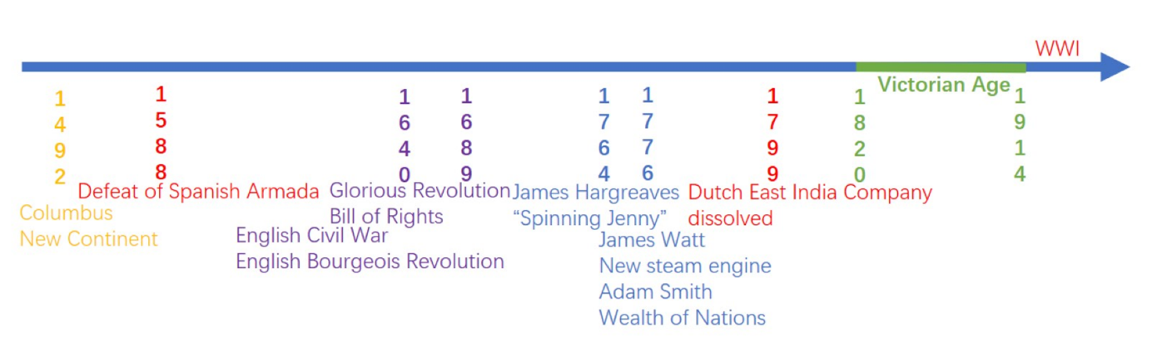

We set the year of 1492 when Columbus found the New Continent as the starting point. In 1588, the English fleet defeated Spanish Armada. In 1640, English Civil War broke out which was referred to as English Bourgeois Revolution by Marxist historians and marked the beginning of world’s modern history. The year of 1689 saw Glorious revolution followed by the issue of Bill of Rights. In 1764, James Hargreaves invented ‘Spinning Jenny’ a piece of textile machine named after his daughter, and anther James, James Watt launched new steam engine in 1776. In the same year Adam Smith published Wealth of Nations. In 1799, Dutch East India Company dissolved.

If we rearrange those events according to their influences to Victorian era, we may have a clear view on the preconditions of Victorian era. In domestic policies. English Civil War, Glorious Revolution, the launch of both Bill of Rights and Reform Act 1832 allowed a sustainable and stable political system as constitutional monarchy. Technologically, the Industrial Revolution symbolised by Spinning Jenny and new stream engine began in Britain in the 18th century guaranteed machinery, skilled workers, techniques and commodities. In international Policies, The Defeat of Spanish Armada and the collapse of Dutch East India won Britain a chance to secure and predominate international trade. The age of discovery, enlightenment and Renaissance, the development of philosophy and sociology theories all contributed to the cultural preparations in advance of Victorian Era.

There are also some significant historical events yet to be mentioned in this presentation. For example, the French Revolution in 1789, the emergence of Darwinism and Marxism in 1860s(, which I missed out from original presentations).

With these preparations, here came the Victorian Era. Here, I would like to quote the definition of Victorian era from Britannica Encyclopædia, ‘in British history, is the period between approximately 1820 and 1914, corresponding roughly but not exactly to the period of Queen Victoria’s reign (1837–1901). . .During the Victorian period, Britain was a powerful nation with a rich culture. It had a stable government, a growing state, and an expanding franchise. It also controlled a large empire, and it was wealthy, in part because of its degree of industrialization and its imperial holdings. . . The Victorian British Empire dominated the globe.

- Pax Britannica
From geopolitics we borrow an analogy of Pax Romana (We also have the term of Pax Sinica for China) to describe the situation of the United Kingdom in Victorian Era. A Pax Britannica of international trade was maintained by the country’s naval and industrial supremacy. Britain’s Royal Navy controlled most of the key maritime trade routes and enjoyed unchallenged sea power. Britain embarked on global imperial expansion, particularly in Asia and Africa, which made the British Empire the largest empire in history. Alongside the formal control exerted over its own colonies, Britain’s dominant position in world trade meant that it effectively controlled access to many regions, such as Asia and Latin America. The pound sterling became the preferred reserve currency of the world and the Bank of England the hub of international finance. British textiles, machinery, and shipping dominated the markets of Asia, South America, and much of Europe. Victoria was the only “Queen of the United Kingdom of Great Britain and Ireland and empress of India.” The country was called “the empire on which the sun never sets” or the-sun-never-sets empire. Economically, Financially and politically, the system originated from Victorian era is still working now with the proves of London now being the one of the world’s financial center, international students in campuses(service export), European and African vegetables in supermarkets and the very existence of the Common Wealth.

In case you may not have a clear picture of what Pax Britannica is like. We adopt the line of history again. And this time we put Chinese history in the line for comparison.

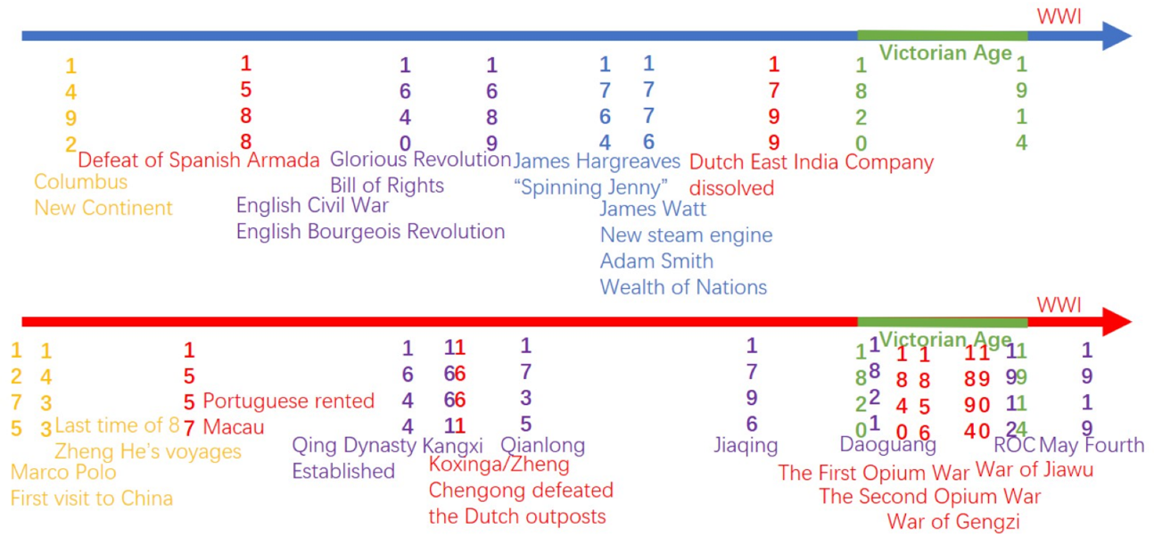
From these two paralleled lines, we can observe that nations are closely connected with each other especially after the geographic discovery. We refer to this trend as globalization. No historical events happen alone by chance. But if we pay attention to the history from Daoguang’s reign of Qing dynasty to the period of RoC and to the May Fourth Movement in 1919, we may find that the government of China were outgunned by the British one. UK acquired Hong Kong and new territories during Victorian Era/Qing Dynasty. The Victorian Harbor by its name now stands as a prove of strength and prosperity of the UK at that time and the corruption and weakness of once a great power China at the same time.

- Victorian Literature-Paradoxes
Literature as a product of history and society infrastructure, on the other hand, embodies the changes in the society in certain period of time. This dramatic change (unprecedented power and wealth and new status as the world’s first urban and industrialized society) was responsible for the extraordinary vitality, and self-confidence of the period. These energies were accompanied by sudden wealth, rapid social change and fierce intellectual controversy. The confrontation of this new industrial wealth with a new kind of urban poverty is only one of the paradoxes that characterize this long and diverse period. These paradoxes included but not limited to that between economic prosperity and poverty of working class and underworld, that between wealth and morality, that between secular social life and religious belief and that of idealism and realism philosophy. Charles Dicken was not the first nor only writer at that period of time who describe the Victorian era in a paradoxical way as:

“It was the best of times, it was the worst of times, it was the age of wisdom, it was the age of foolishness, it was the epoch of belief, it was the epoch of incredulity, it was the season of Light, it was the season of Darkness, it was the spring of hope, it was the winter of despair, we had everything before us, we had nothing before us, we were all going direct to Heaven, we were all going direct the other way—in short, the period was so far like the present period, that some of its noisiest authorities insisted on its being received, for good or for evil, in the superlative degree of comparison only.”

It is very hard to say whether Jane Austen is a romantic writer or a realistic one. But in the context where she lived, the idealism and transcendentalism of romantic thought were challenged by the growing prestige of empirical science and utilitarian moral philosophy, a process that encouraged more-objective modes in literature at that period of time. Realism would be one of the great artistic movements of the era. Maybe that’s why it is hard for us to categorise her. This collision of romanticism and realism was represented by Jane Austin’s novel Pride and Prejudice:

“It is a truth universally acknowledged, that a single man in possession of a good fortune must be in want of a wife. However little known the feelings or views of such a man may be on his first entering a neighbourhood, this truth is so well fixed in the minds of the surrounding families, that he is considered as the rightful property of some one or other of their daughters.”

Marriage as it is now all over the world (at least in China as well) converted at that period time from romantic relationship to a pure capitalist economic relationship of properties. Romanticism and realism therefore as two key features echo each other in Victorian Era. My teammates will look into the two key features from the perspective of marriage by examing Mansfield Park.

I hope we have a well-founded knowledge of historical basis from which Victorian literature is rooted. Thank you.

References
[1]Barry, P. Beginning Theory: An Introduction to literary and cultural theory(4th edition), Manchester: Manchester University Press, 2017. p.169
[2]Susie Steinbach, ‘Vicotrian era’, Britannica Encyclopædia, (https://www.britannica.com/event/Victorian-era)[accessed 18 October 2019]
[3]Darwin, John (2012). Unfinished Empire: The Global Expansion of Britain. London: Allen Lane. p.39.
[4]John Wolffe (1997). Religion in Victorian Britain: Culture and empire. Volume V. Manchester University Press. pp. 129–30.
[5]Porter, Andrew (1998). The Nineteenth Century, The Oxford History of the British Empire Volume III. Oxford University Press.
[6]Walter A. McDougall, ‘20th-century international relations’, Britannica Encyclopædia, (https://www.britannica.com/topic/20th-century-international-relations-2085155)[accessed 18 October 2019]
[7]Meredith Veldman&Edgar Trevor Williams, ‘Victoria’, Britannica Encyclopædia, (https://www.britannica.com/biography/Victoria-queen-of-United-Kingdom#ref475147)[accessed 18 October 2019]
[8]Reginald P.C. Mutter et al. ‘English Literature’, Britannica Encyclopædia, (https://www.britannica.com/art/English-literature)[accessed 18 October 2019]
[9]Charles Dickens, A Tale of Two Cities, Book the First, Chapter I.
[10]Jane Austen. Pride and Prejudice, Chapter 1.

Here attached is my ppt slides I used in the presentation.

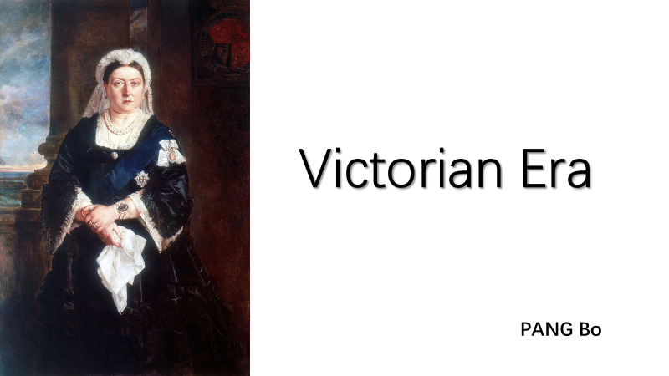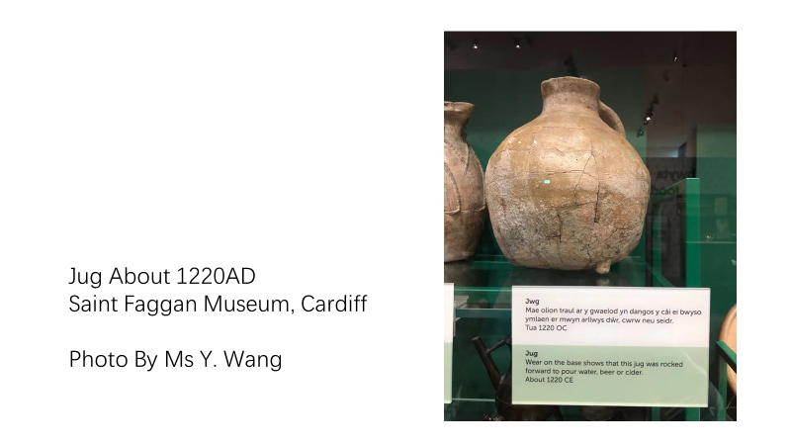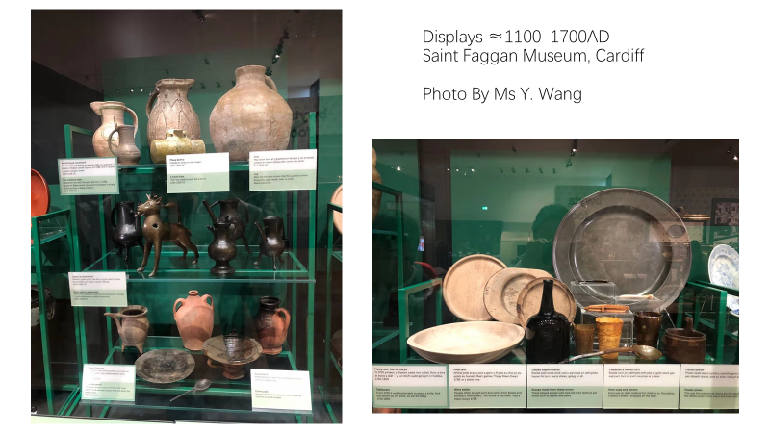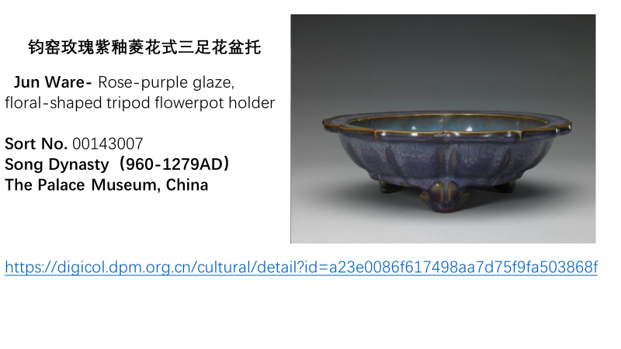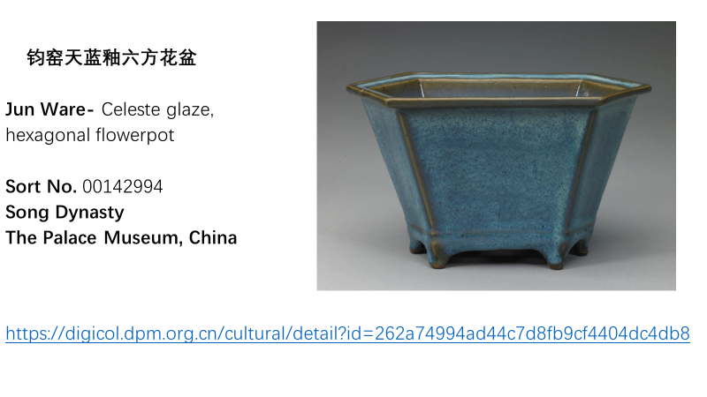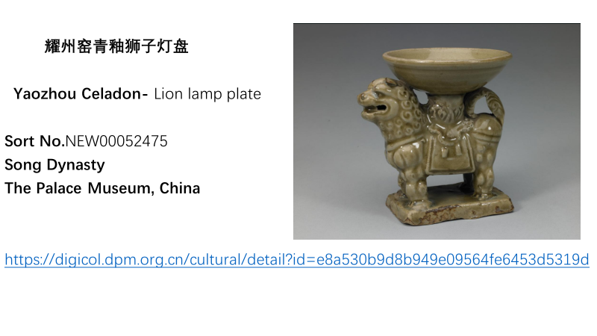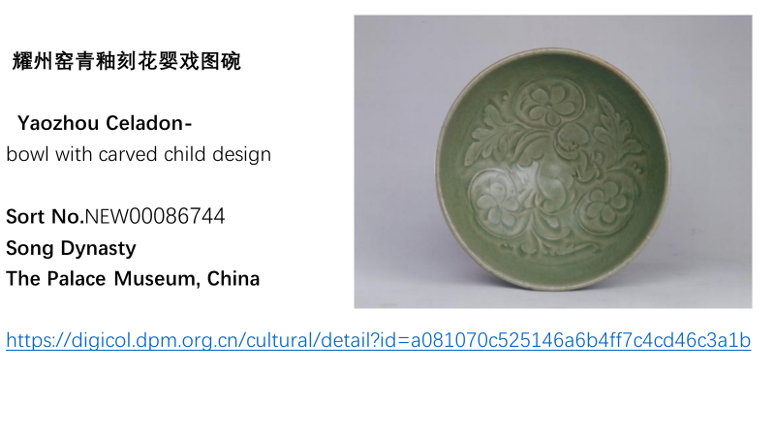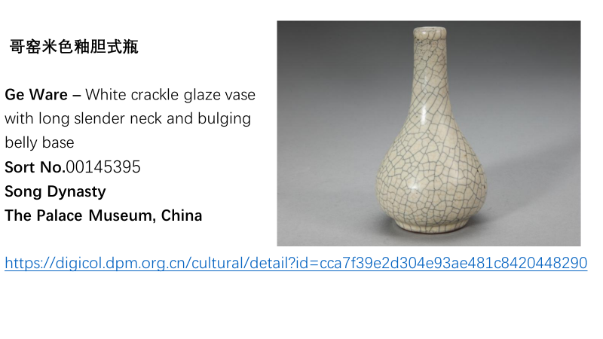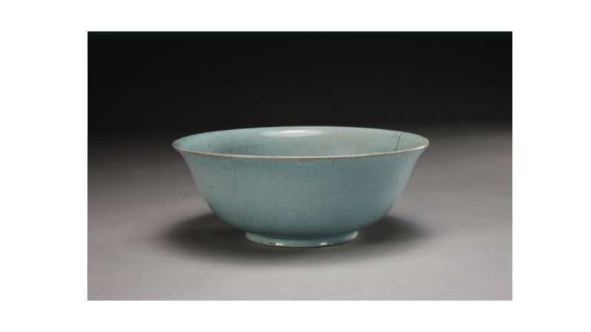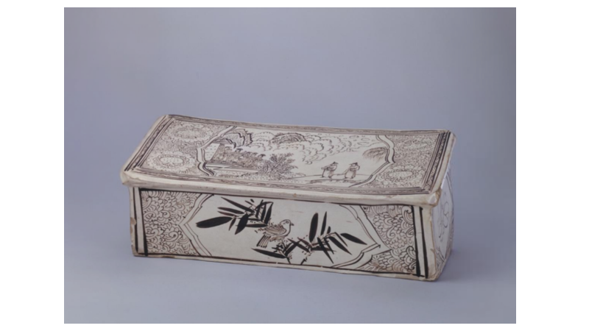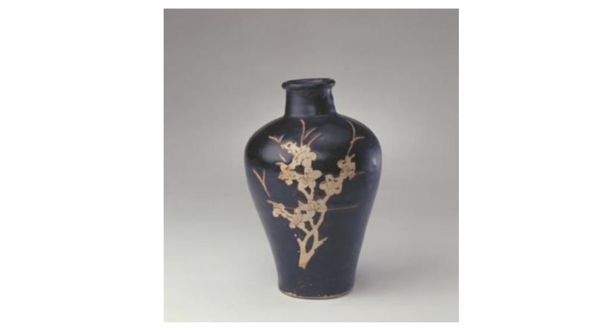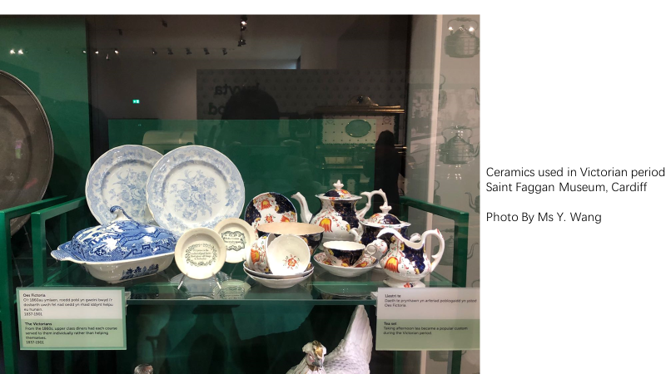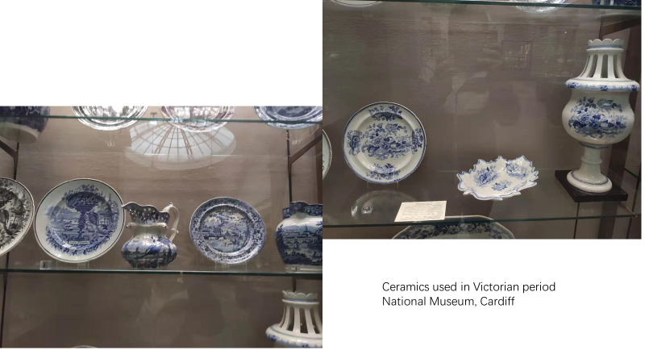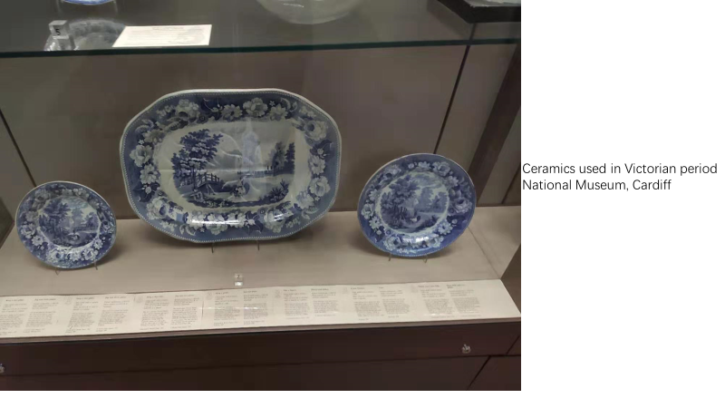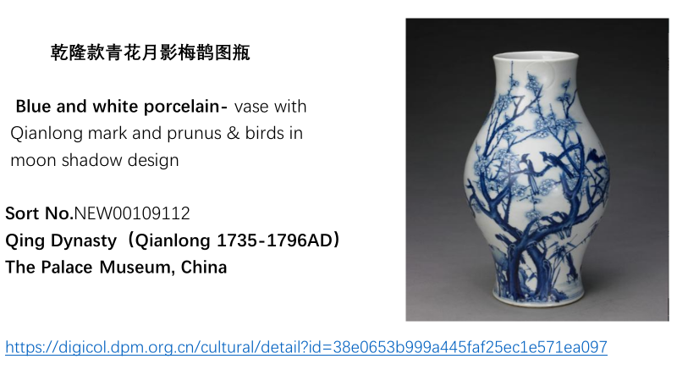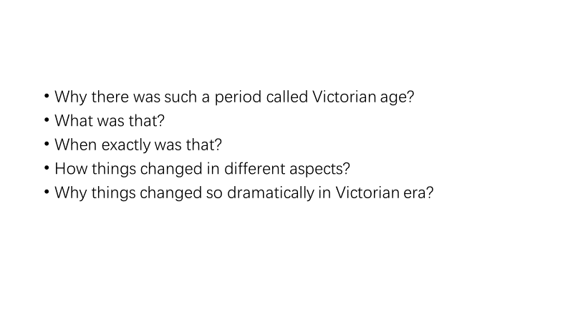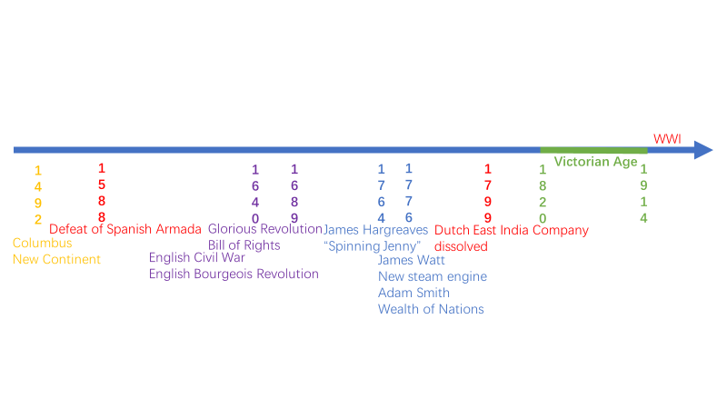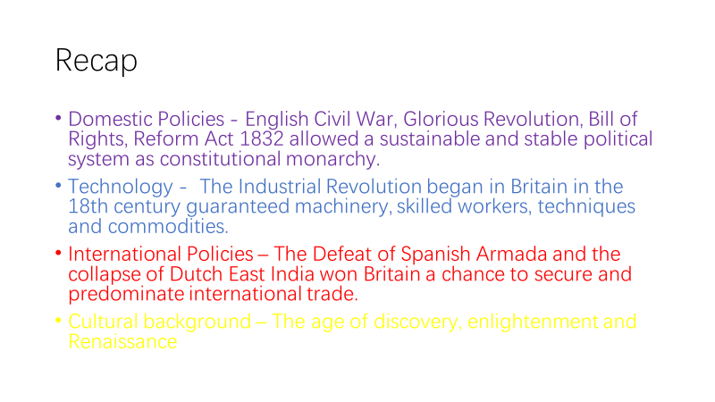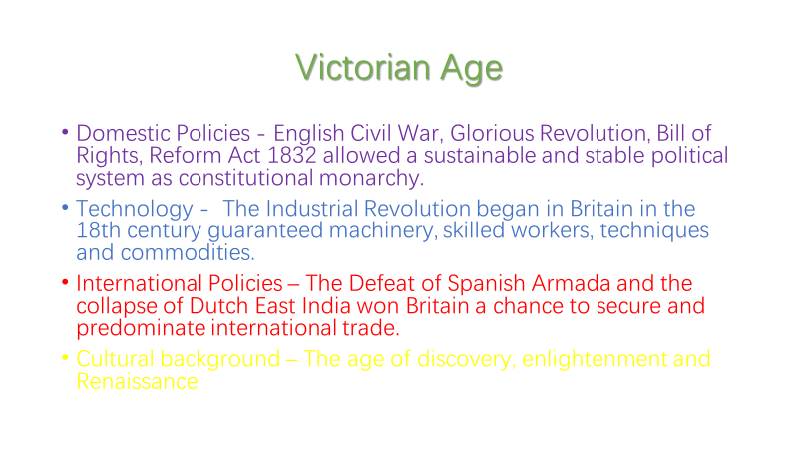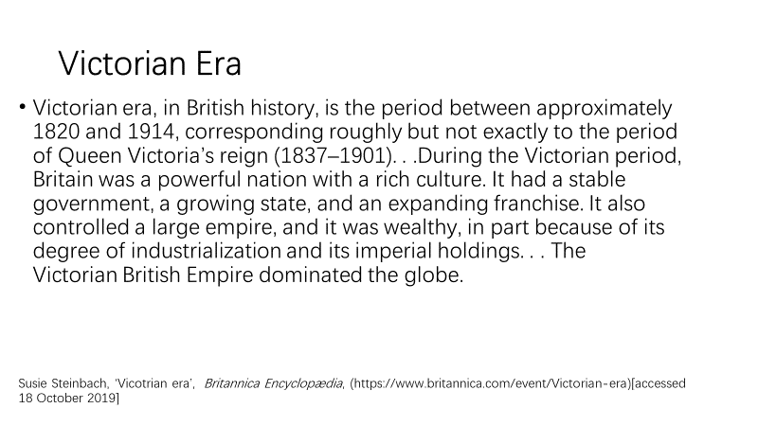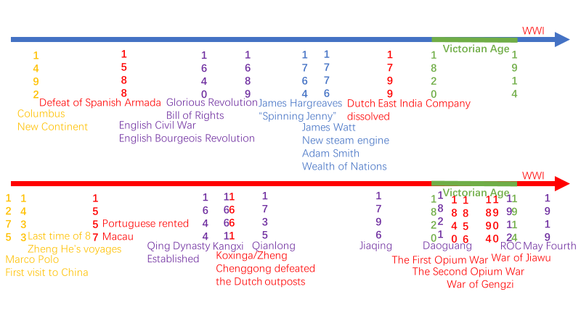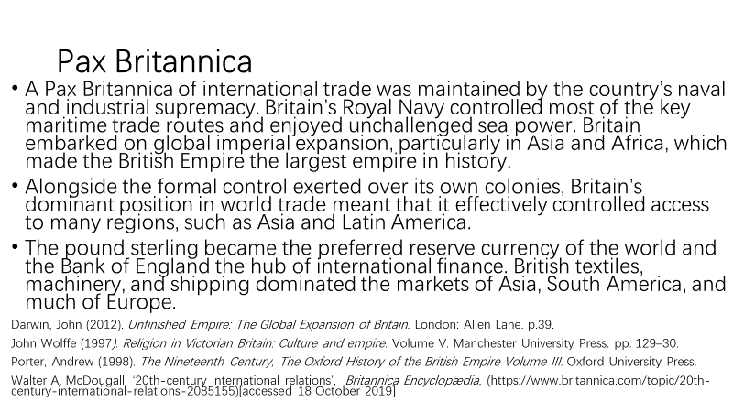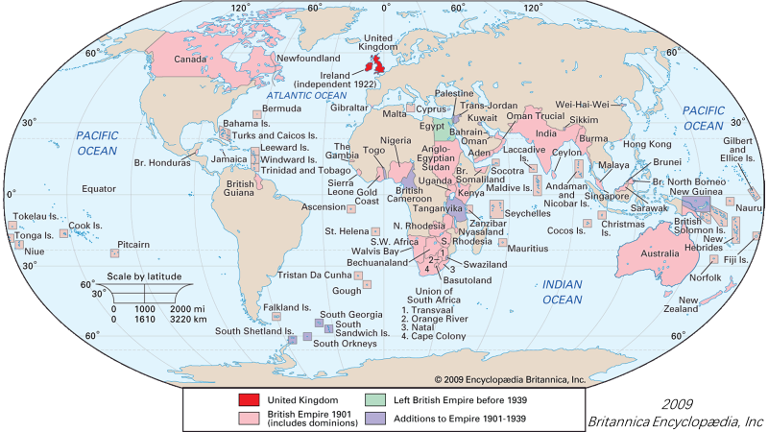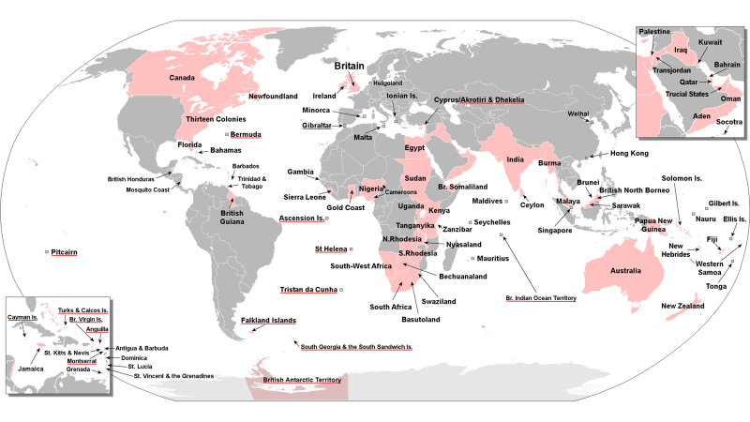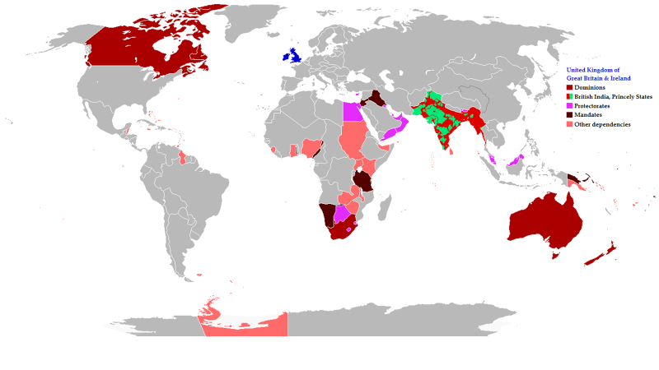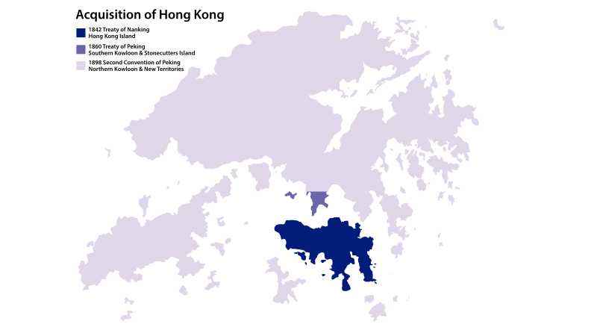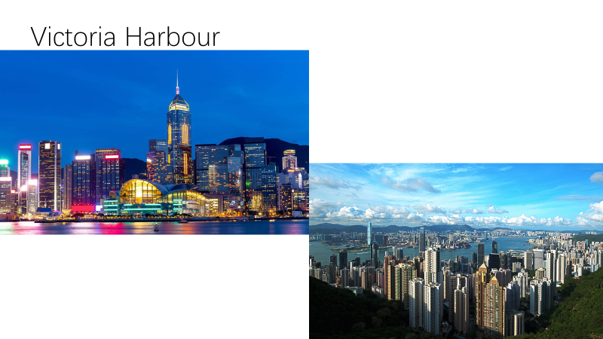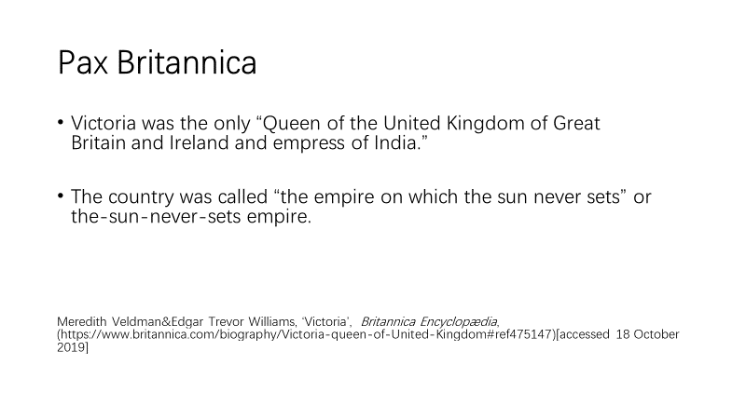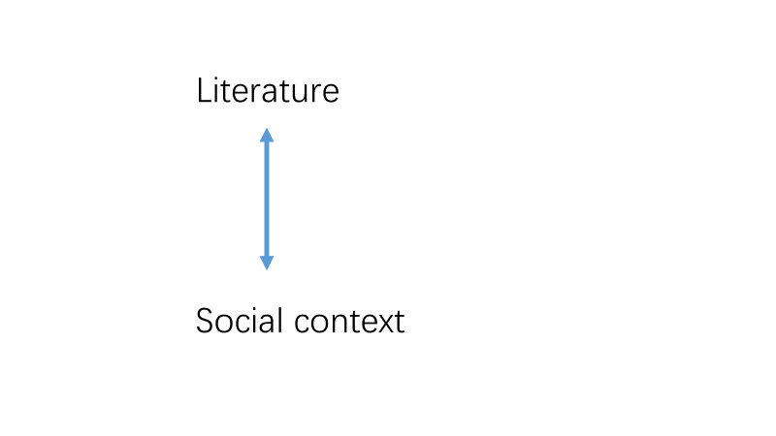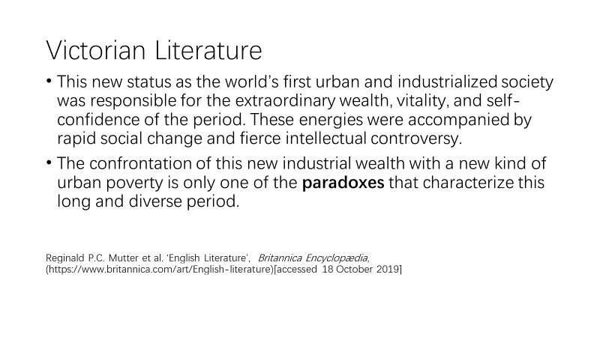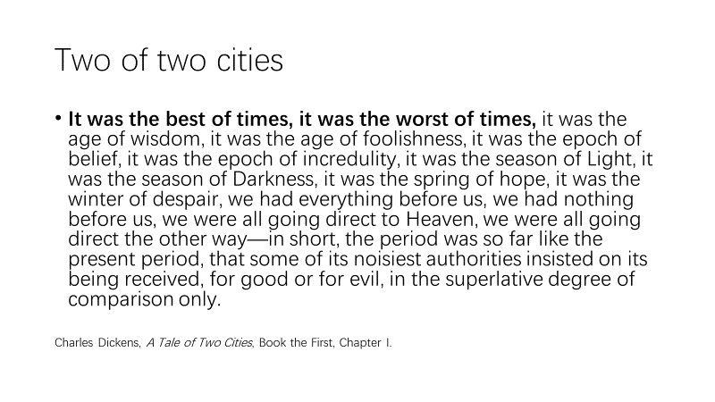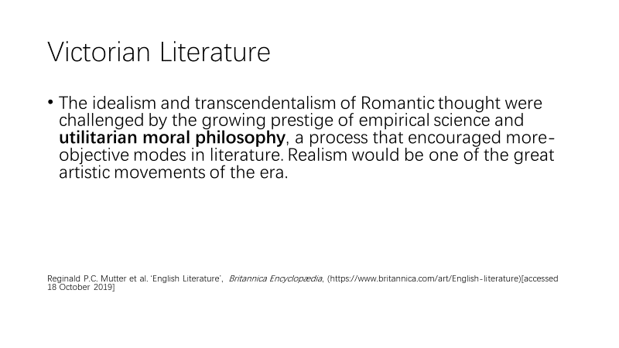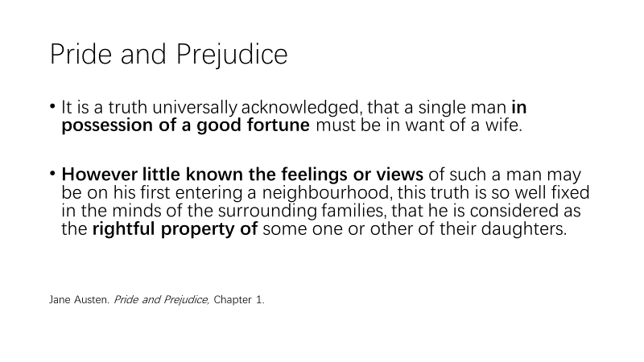

Barry, P. Beginning Theory: An Introduction to literary and cultural theory(4th edition), Manchester: Manchester University Press, 2017. p.169
Ibid, p.160
Ibid, pp.160-161
Susie Steinbach, ‘Vicotrian era’, Britannica Encyclopædia, (https://www.britannica.com/event/Victorian-era)[accessed 18 October 2019]
Darwin, John (2012). Unfinished Empire: The Global Expansion of Britain. London: Allen Lane. p.39.
John Wolffe (1997). Religion in Victorian Britain: Culture and empire. Volume V. Manchester University Press. pp. 129–30.
Porter, Andrew (1998). The Nineteenth Century, The Oxford History of the British Empire Volume III. Oxford University Press.
Walter A. McDougall, ‘20th-century international relations’, Britannica Encyclopædia, (https://www.britannica.com/topic/20th-century-international-relations-2085155)[accessed 18 October 2019]
Meredith Veldman&Edgar Trevor Williams, ‘Victoria’, Britannica Encyclopædia, (https://www.britannica.com/biography/Victoria-queen-of-United-Kingdom#ref475147)[accessed 18 October 2019]
Reginald P.C. Mutter et al. ‘English Literature’, Britannica Encyclopædia, (https://www.britannica.com/art/English-literature)[accessed 18 October 2019]
Charles Dickens, A Tale of Two Cities, Book the First, Chapter I.
Reginald P.C. Mutter et al. ‘English Literature’, Britannica Encyclopædia, (https://www.britannica.com/art/English-literature)[accessed 18 October 2019]
Jane Austen. Pride and Prejudice, Chapter 1.

