DS 1 Template

My Screenshots/Photos
- Please add 4–6 screenshots or photos of your digital life.
- You can use your phone or laptop.
- For each screenshot, write one or two sentences explaining what it shows.

Screenshot/Photo 1
WhatsApp
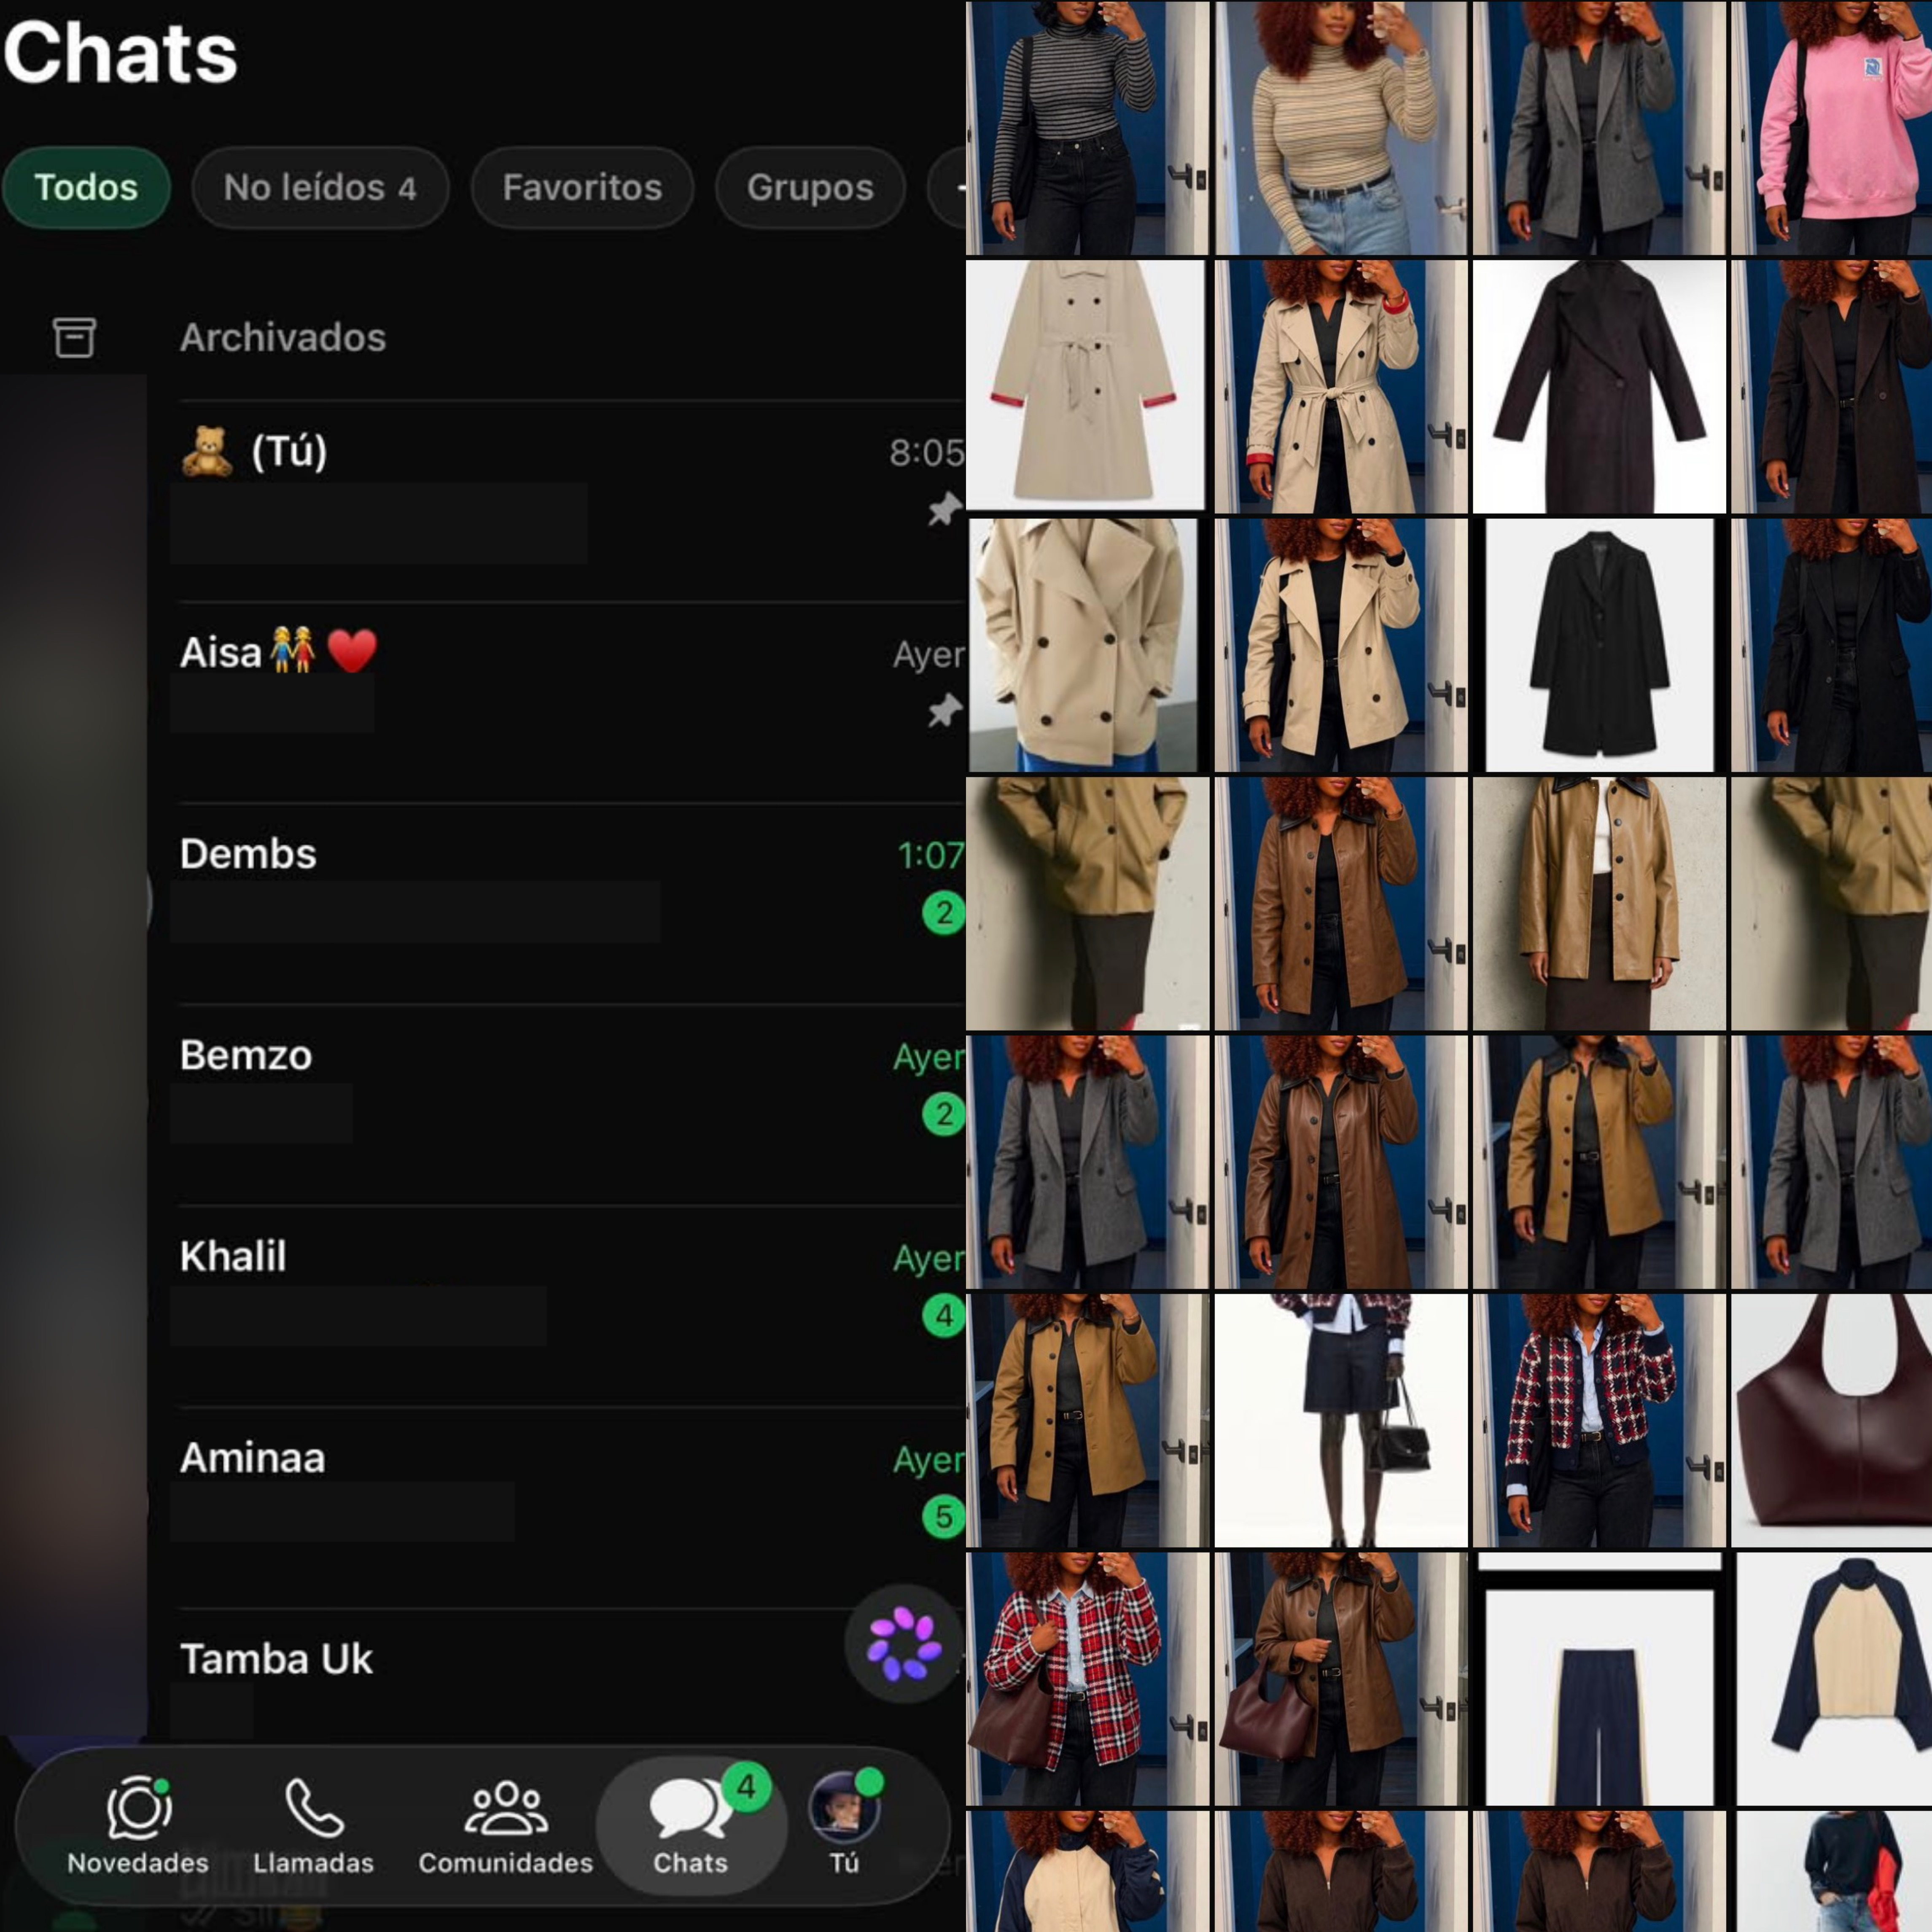
WhatsApp is where I stay in contact with my loved ones. I also use Meta AI to learn more about digital tools and edit pictures.

Screenshot/Photo 2
Pinterest
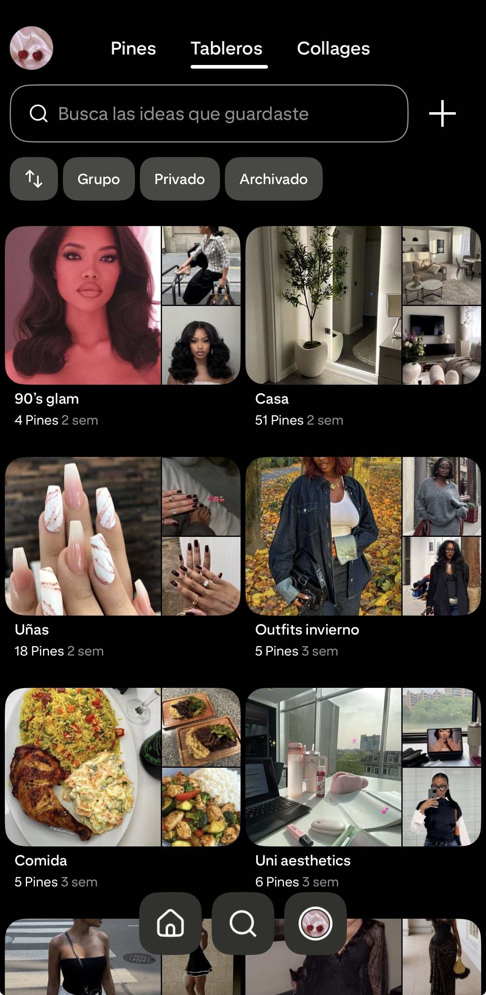
Pinterest is where I look for inspiration and ideas to stay up to date with trends. I save pictures and posts by topic into different boards, so it is all neat and easy to find.

Screenshot/Photo 3
Safari
Safari is my main browser to search for information and access the university's website and learning materials. It helps me find answers, stay organised, and support my studies.

Screenshot/Photo 4
YouTube
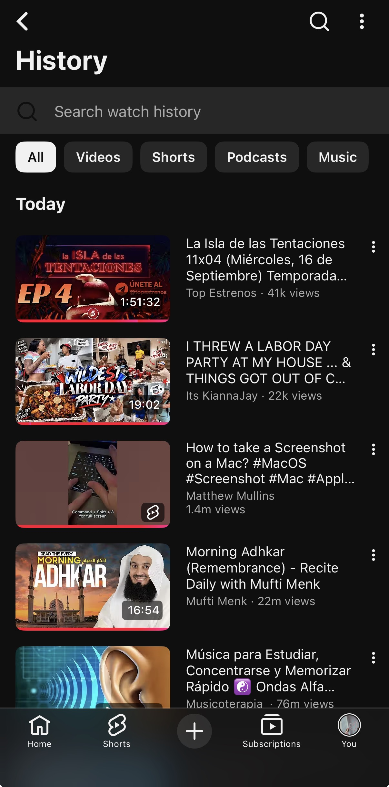
I use YouTube daily to watch short videos, vlogs, documentaries, and tutorials. It helps me learn, use digital tools, and resolve problems.

Screenshot/Photo 5
eDreams
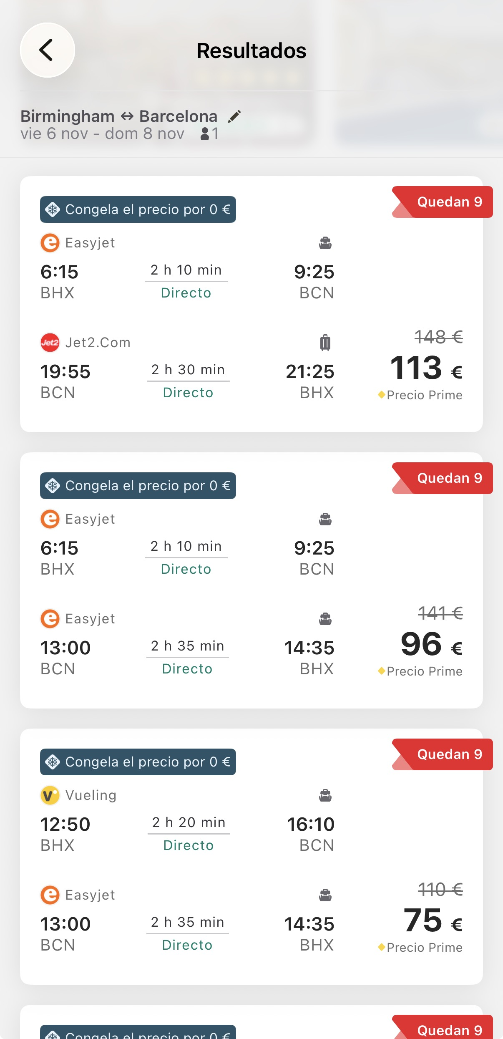
EDreams is where I search for and book flights. It helps me improve digitally with finding information online and making good decisions.

Screenshot/Photo 6
OneDrive
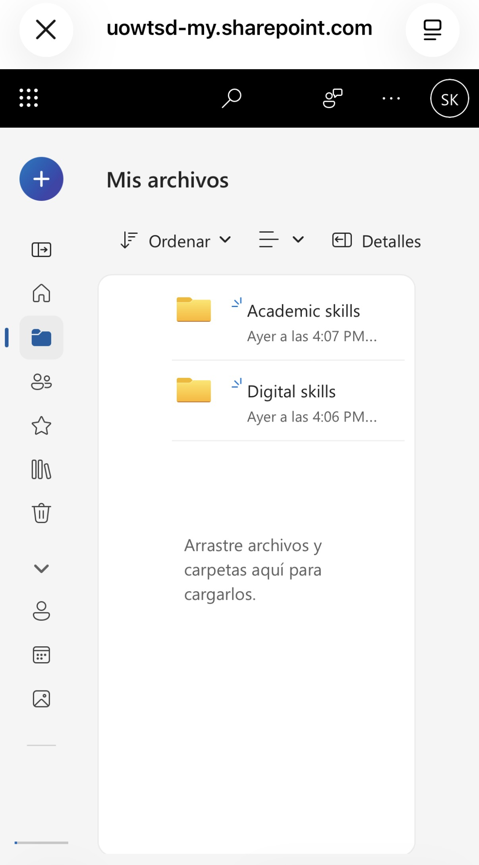
I use OneDrive to save my university notes and assignments. I organise my files with clear names and folders. I can also access my work from different devices and it keep my files safe.

My Short Reflection
- Write 5–8 simple sentences about your digital life.
- You can use the sentence starters below if helpful.
Digital tools help me stay in contact with my family, organise my university work, and save my notes and assessments. They also help me find information and inspiration for my studies, projects, and daily life.
I feel confident when I organise my files easily and find information quickly.
I want to improve at finding information accurately and feel more confident using new apps and tools.
I often use these tools to communicate, learn, browse, get ideas, and complete tasks.
I sometimes feel nervous about saving my important documents correctly. I also feel unsure when I use tools, I am not familiar with. Also, I am a bit nervous about uploading my first assessment.
I hope this module helps me develop skills that can be useful in my studies and future work. As well, I want to find better ways to do my work and feel much more confident.
Digital skills matter to me, especially at university since all my course materials are online.

Sentence starters
- I use digital tools to …
- I feel confident when I …
- I want to improve …
- I often use these tools: …
- I sometimes feel nervous about …
- I hope this module will help me …
- Digital skills are important for me because …
You can write more if you want.

Submission Checklist
Before you submit, please check:
​​​ ☐ I added 4–6 screenshots
☐ I wrote short sentences for each screenshot
☐ I wrote my short reflection
☐ My work is my own
☐ My file opens correctly
​​☐ My file opens correctly

