Reflective journal.

I choose to undertake my placement within a primary school setting due to an interest in primary teaching as a career. Upon visiting the Headteacher to discuss my options, it was decided that I would be best placed within the school’s year 5 and 6 class, as I would be able to draw upon my previous working experiences. As the school comprised of less than eighty pupils, the Headteacher also felt that my presence would aid the school’s current lack of non-teaching staff within the junior setting of the school, due to budgetary constraints. In accordance with Gibbs (1988) (Oxford Brookes University, 2020), I am going to reflect upon two of my experiences:



Mental health and wellbeing.

Description.

Whilst on placement, I observed Child A become increasingly agitated as each week progressed. During the morning session of week three, Child A participated in a numeracy lesson, where he attentively listened and completed all tasks. During the plenary activity, Child A volunteered to tell the class what he had learned from the lesson.
Following a short break, the class undertook a literacy lesson. Child A immediately appeared to be distracted and was displaying behaviour, which was non-typical when compared to others. After liaising with the class teacher, I reminded Child A of the classroom’s expectations which were clearly on display. However, Child A continued with his distractive behaviour and was off task for the remainder of the lesson. During the plenary, it became evident that he had completed very little of the work set, with no explanation given when questioned. As lunchtime was imminent, the teacher decided to take no further action. During lunchtime, I noticed how Child A was isolated from his peers in the yard.
During the afternoon session, the class continued with a literacy based topic which involved creative arts. Child A became increasingly frustrated as time progressed, and began to disrupt his fellow pupils. The class teacher advised me to repeat the classroom’s expectations to him. On this occasion, Child A displayed complete disregard for himself and others, and began flicking paint around the room. The teacher immediately intervened and explained to him that his behaviour was completely unacceptable. As the situation digressed and the teacher’s voice became increasingly louder, Child A had a meltdown and ran out of the class.
When Child A returned to the classroom he was extremely upset, but not apologetic for his behaviour. To avoid further disruptions, the teacher asked if I would work one-to-one with him. Whilst working with Child A, I noticed that he oozed a strong bodily odour, which was accompanied by a constant scratching of his hair. During the session, I overheard several pupils speaking in a derogatory manner regarding his appearance. However, Child A remained on task and appeared to be happy. At the end of the school day, I reported my concerns to the class teacher.
Upon returning to the classroom a week later, I noticed that Child A was happy and content amongst his fellow pupils. Upon discussion with the class teacher, it became evident that Child A had been suffering with some health and wellbeing issues which originated from home. Following my concerns, the school had contacted home and asked Mum to visit the school to discuss her son. During the session, Mum had shared further information which under the school’s Child Protection Policy, could not be divulged to myself. However, the school in agreement with all parties had concluded that Child A required additional support to address his needs and difficulties.

Feelings.

Regarding the incident, my emotive responses are varied. Having witnessed a positive outcome for the child, I felt relieved to hear that he was to receive support in a bid to address his wellbeing needs. In addition, I received gratification from the Headteacher for exposing the child’s difficulties, which re-affirmed my emotions that I had responded to the incident appropriately.
However, upon reflection I am questioning the timeframe regarding the reporting of my concerns. Initially, I felt nervous and unsure about voicing my concerns, fearing a negative response from the class teacher, who would undermine my role as a student on placement. As a result, I regret possibly letting the child’s difficulties digress further, causing additional distress. During the week long period from reporting the incident to re-visiting the school, I was fearful as to how the school would react to my returning role as a student on placement.
In addition, I am also bewildered as to how nobody else in the school had noticed Child A’s difficulties beforehand. Child A’s behaviour was clearly non-typical when compared to his fellow pupils, whilst his bodily odour was very prominent. However, I do understand the pressures school staff are experiencing, following budgetary deficits.

Evaluation.

As a student on a six week placement, I did not feel it appropriate to interfere with welfare issues regarding children. However, upon reflection I now recognise that an earlier response would have been in the best interests of the child. On this occasion, I feel that I chose to question the value, respect and opinions of a student, in favour of a personal negative gut feeling on a child. Should a similar incidence arise in the future, I would alter my timeframe of reaction by reporting my concerns immediately to the appropriate personnel. A pro-active approach is more productive when compared to a reactive response. I have gained an insight into the value that every member of staff holds within the school, regardless of their position.
Overall, I am pleased with my response regarding the reporting of my concerns for Child A to the school. I am assuming that my previous experiences of dealing with children who suffer from special educational needs (SEN), enabled me to handle the situation with positivity.

Analysis.

To extend my professional knowledge, I decided to research the strategies which I applied, which will allow me draw upon both my knowledge and experiences in a professional manner, should the incident ever be re-visited.
Initially, I responded to the incident by reminding the child of the the classroom’s expectations. These were displayed via a wall poster and were set out in accordance with the school’s policy on inclusion and behaviour, incorporating the United Nations Convention on the Rights of the Child (UNCRC) (unicef, 2020). Whilst researching this, it became apparent that there are many statutory duties which the school needed to adhere to.
According to the Department for Education (2016), all schools have a statutory duty in line with the Education Act 2002, to ensure that arrangements are made to safeguard and promote children’s welfare. Legislatively, the Headteacher has a duty to clearly define measures within the school’s behaviour policy, to address whole school behaviour.
To support the policy, the school had produced wall posters to add value, whilst supporting the school’s Rights Respecting School stature (Unicef, 2020). According to Unicef (2020), Rights Respecting School is an initiative that creates safe, inspiring places for children to learn and develop. The initiative embeds the values of school life, whilst nurturing children’s talents, by providing opportunities to thrive. The initiative actively supports the fifty four articles endorsed by the United Nations Convention on Rights of the Child (Unicef, 2020). This is the poster that was on display in the classroom at the time of my placement.
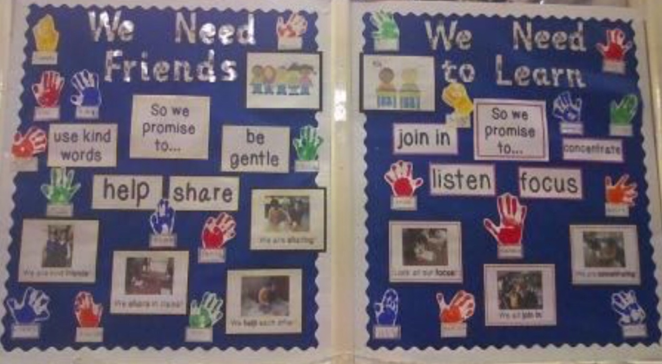

In 2004, Wales adopted the Rights, to utilise within its policy making decisions involving young persons. In 2011, Wales implemented the Rights of Children and Young Persons (Wales) Measure 2011, to legislatively support the intentions of the UNCRC (Welsh Government, 2020). Alongside the Act, the position of Children’s Commissioner was created, to promote the rights and well-being of children.
To support the promotion of children’s rights in schools, the Children’s Commissioner of Wales introduced a scheme entitled ‘Super Ambassadors’. As part of the scheme, schools are encouraged to create class charters for classrooms, which highlight children’s rights and responsibilities. The poster is tailored to suit the needs of each classroom and is signed by all class members, to ensure that everyone understands the consequences of their behavioural actions (Children’s Commissioner for Wales, 2020).
John Dewey’s theory of ‘Social Learning’ supports the notion that good management is obtained by applying practices, which result in children enduring consequences for their actions (Sikandar, 2015).
According to Williams (2017), social learning is an effective approach to promoting the engagement of children in the classroom. This notion is linked to a Responsive Classroom curriculum which delivers education in a secure, happy, learning environment.
Elements of a Responsive Classroom curriculum, appear to be evident in ‘The Right Way: A Children’s Rights Approach in Wales’, a framework developed by the Commissioner for Wales. The framework endorses the principles: participation, embedding children’s rights, accountability and empowering children. Within the framework, restorative justice programmes are utilised as a strategy for dealing with behavioural issues, whilst enhancing the school’s commitment to Article 12 of the UNCRC, which allows children the right to express an opinion (Children’s Commissioner for Wales, 2017).
According to Restorative Justice 4 Schools (2020), restorative approaches can create environments where children are held accountable for their learning and behaviour. Restorative justice encourages children to articulate their emotions and develop feelings of empathy. In addition, it can inspire children to think about their behavioural actions and consequences. (SchoolRun, 2020). The benefits of a restorative school, are reduced numbers of exclusions, alongside improvements in attendance and academic performance. When adopting a whole school approach, restorative justice has been found to be effective in improving learning and behaviour (Restorative Justice Council, 2020).

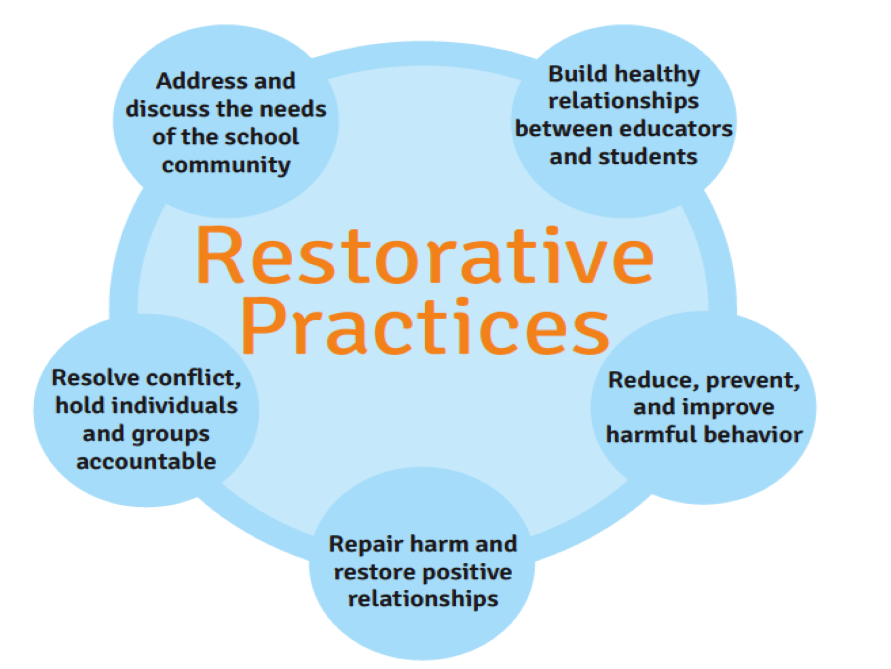

(Tes, 2020)

In 2010 the Department for Education, conducted research on the effectiveness of restorative justice, identifying a 97% success rate (Department for Education, 2010). However, the report does not evidence this statement by providing information regarding the socio-economic backgrounds of the schools and their pupils. This lack of information could impact the overall result in terms of biases, as the schools may not have been fairly selected at random. In addition, Suvall (2009) suggests that there are limitations to using restorative justice as a singular approach to managing behaviour. To overcome these concerns, schools could decide to utilise restorative justice programmes alongside other behavioural strategies, until further research confirms its effectiveness.

Conclusion.

Having acquired additional knowledge, I now foresee a different approach from a personal perspective. Firstly, drawing upon my previous professional experiences, I should have addressed my initial concerns earlier, instead of fearing the outcome for myself. Should I have reported the concerns in week one, I feel that the child would not have possibly had to endure another two weeks of sadness and despair. Subsequently, my delay in reporting the concern could have put the child’s well-being in jeopardy in accordance with the school’s Child Protection Policy.
Secondly, following a discussion with the class teacher, I now recognise that I need to develop my confidence and put the well-being of children at the forefront of my responsibilities. Whilst recognising the difficulties placed upon schools due to budgetary deficits and the resulting pressures placed upon staff, I now understand that my role was still considered to be of high importance and value within the classroom. As a result, I must ensure that I abide to all areas of good practice to ensure that no children are potentially at risk.

Action plan.

Should a similar experience arise in the future, I would alter my responses by reporting any concerns immediately to the appropriate personnel, in accordance with the school’s Child Protection Policy. I now recognise that it is important to report concerns, as no response could impact upon the child’s welfare needs. I have also gained an understanding on the role of all personnel within the school and their subsequent duty of care responsibilities to children.
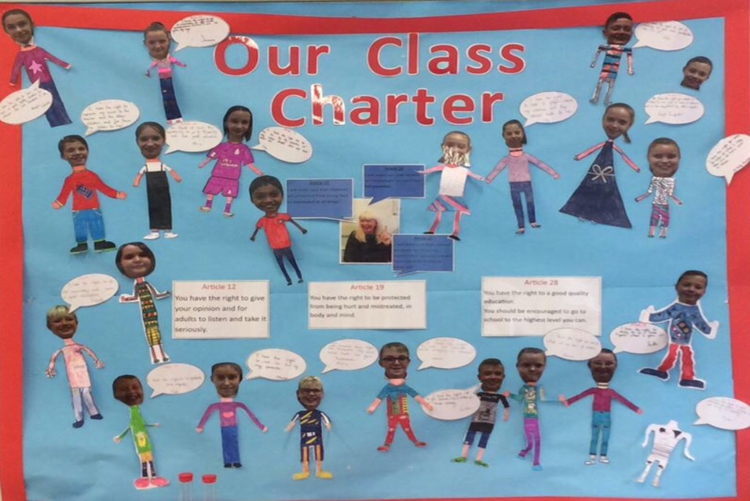
In addition, having researched information on class charter posters, I discovered the role of School Ambassadors. Following discussion with the classroom teacher, we decided to look at how other class charter posters had been produced. Upon inspection, it was evident that the other posters involved all class members:

In response, the class are going to produce a new class charter, involving all persons. This will aid the class when addressing any future behavioural issues, as the children will have a better understanding on the concept that actions have consequences.
In addition, it appears that the school are not currently adopting a whole school approach to the ‘Rights Respecting School’ initiative. Following a discussion with the school’s Headteacher, it has become apparent that this is due to the loss of non-teaching staff, following budgetary deficits. However, the Headteacher is to address the whole school approach in the next INSET training day.

Inclusion and pedagogy.

Description.

The school where I chose to undertake my placement, has a Communication and Resource unit to support children with language and communication difficulties. During the morning sessions, children in the unit undertake their own literacy and numeracy lessons. In the afternoon, the children integrate where possible into mainstream educational lessons, supported by non-teaching staff.
During the afternoon session of week five, I was asked to support a child who experienced difficulties in processing receptive language, as the usual non-teaching staff member was on long term sick leave. The class teacher advised that I should encourage good listening skills to keep them focused, utilising a multi-sensory approach.
The session began with the teacher introducing the topic ‘The Georgians’. As time progressed Child B became increasingly distracted. In response, I instructed her to sit smartly whilst paying attention to the teacher. As she did not respond initially, I repeated the instructions with success. However, the cycle of distraction reappeared within five minutes, resulting in a repeat of my instructions. Once again, Child B responded for a short period before returning to continuous episodes of cyclic disruptive behaviour, until an interlude of afternoon play ended the session.
During the break I chatted to the teacher, regarding my approach to keeping the child focused. The class teacher advised me to pause between each spoken instruction, to allow the child time to process the command instructions. Returning from break I applied this strategy with success, whilst the class undertook their next task to produce a short descriptive paragraph about the Georgian period in history.
During the task, it became evident that Child B was struggling due to her difficulties with understanding spoken language. As a result, Child B was unable to articulate her knowledge into written words. Seeking advice from the teacher, I was instructed to model sentences to the child. However, it soon became apparent that Child B’s work consisted mainly of my own spoken words.
At the end of the session, I informed the teacher of the child’s difficulties in working independently, and explained how her work was singularly a reflection of my ideas. Together, we discussed a strategy which involved utilising visual aids to record information, in the form of mind maps. The teacher suggested that I apply this strategy the following week, when the class were going to be studying the topic ‘The Victorians’.
The following week, I applied the strategy with Child B to produce a mind map. As the topic was explored, we added information to a plain piece of paper, in the form of both words and pictures. Different coloured pens were used as we digressed from the main headings, so each branch and sub-branch was clearly identifiable, by its unique colour. Child B was encouraged throughout to verbally express what she could remember, via short brainstorming sessions. The strategy was a success, with Child B utilising the mind map to produce a descriptive paragraph.

Feelings.

I was initially nervous about working independently with a child I had not met prior to the session, as I knew that children with speech and language difficulties often presented themselves as awkward in social situations. However, Child B greeted me with smiles and was happy to cooperate throughout. I felt relieved upon witnessing her responses towards me.
During the initial periods of distraction, I was experiencing increasing feelings of hopelessness as the child was unresponsive towards my instructions. In addition, I felt under pressure that I was adding to the class distractions, by continuously using my voice. However, I am proud that I possessed enough confidence to seek advice from the teacher.
Whilst modelling good sentence structure to Child B, I became increasingly frustrated to see her project my ideas onto paper word for word. In addition, I was concerned that she had learned nothing from the session as she was unable to articulate her own ideas. Seeking advice from the teacher, resulted in a new approach using ‘mind maps’.
During the week break, I gathered information on mind maps as I was initially bewildered. However, utilisation of the strategy was a great success and I was delighted to see Child B experience a period of independent learning.

Evaluation.

Having initially felt nervous about working with Child B, I am pleased with the overall outcome. Child B did not present themselves as socially awkward, but did possess difficulties with articulating knowledge into written words. Having sought advice, I acquired new strategies which I will utilise in the future. In my opinion, mind maps are a very effective strategy to aid visual learning and understanding.
However, I am disappointed that I initially allowed the child to experience episodes of distractive behaviour, which left me feeling stressed. I was fortunate that the child did not identify my weakness, as it could have led to further negative behaviour. As a result, I acknowledge that I need to be more patient in the future, to allow the child time to process all instructions.
In addition, I have gained an understanding on how children with Special Educational Needs (SEN), do not always typically present themselves. I have witnessed and appreciated the value of SEN children, integrating into mainstream education. Child B appeared to academically thrive whilst developing her social and emotional skills amongst children who modelled good practice to her. Inclusion appears to be an aspect of education which is of prime importance and value to all children.

Analysis.

To academically support the new strategies introduced, I decided to carry out some additional research. According to Elks and McLachlan (2008), there are several process involved in the understanding of receptive language, which includes the use of non-verbal communication. According to Crowley et al. (2016), non-verbal communication is an essential component in cognitive development, facilitating learning. It is also effective in identifying a student’s level of understanding (Zeki, 2008).
According to Elks and McLachlan (2008) strategies to aid non-verbal communication include focusing the attention of the child prior to giving instructions, whilst modelling good listening skills alongside the use of hand gestures and prompts.
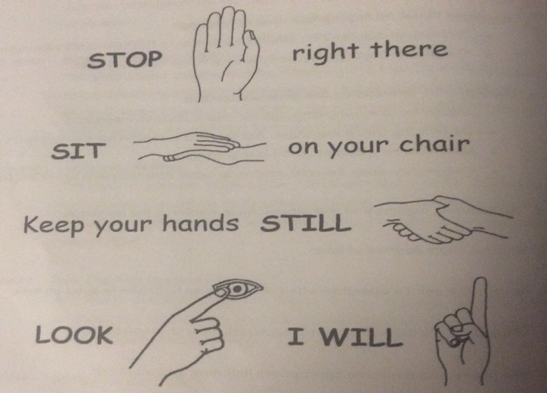
The Welsh Government (2012) supports the use of non-verbal communication to manage classroom disruptions, via its PATHS (Promoting Alternative Thinking Strategies) programme. According to Welsh Government (2012) PATHS is a highly effective and well researched programme, which has been designed to promote positive behaviour in the classroom. To reaffirm their statement of success, I analysed the document for evidence of their research, with no success. As the school do not currently adopt PATHS into their behavioural management approach, consideration regarding the implementation and success of this programme, maybe required by the school.
To address Child B’s difficulties in maintaining attention, the teacher advised that I pause between each spoken instruction to allow the child time to process the information. This approach is supported by Elks and McLachlan (2008), who recommend the strategy when delivering a sequence of commands to children who have difficulties in understanding receptive language, whilst adopting a multi-sensory approach.
A multi-sensory approach involves the use of visual aids to reinforce any information the child is learning in class. Visual support aids are considered to be a highly effective strategy, in helping the child to succeed academically, whilst developing their self confidence (Stackhouse and Wellington, 2011).
To support Child B, the teacher recommended the use of mind maps to aid visual learning. According to Elks and McLachlan (2008), mind maps are an effective strategy that strengthens the relationships between semantics. To develop semantic knowledge, appropriate pictures must be selected for vocabulary items (Chiat, 2000). Mind maps are flexible and can be utilised in several ways, to record information on any given topic that can be categorised. According to Buzan and Buzan (2006), mind maps use both hemispheres of the brain, which is essential for learning.
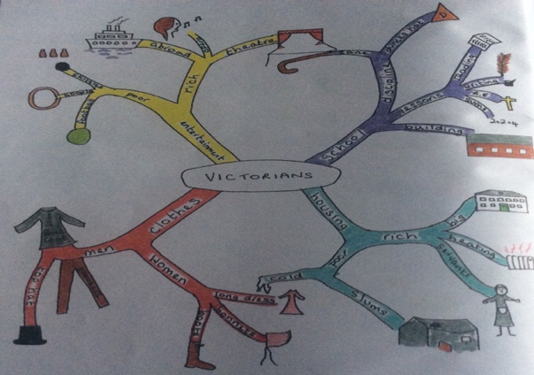
According to Kuther (2016), the left hemisphere of the brain is responsible for language development, whilst the right hemisphere controls the use of spatial skills. Children are encouraged to use both sides of the brain during cognitive development, to accentuate their active learning. Piaget’s cognitive theory supports active learning, as children physically engage with the world. However, some educational theorists disagree with Piaget’s theory, questioning the use of brain based activities to advance children’s learning. However, utilisation of the strategy with Child B proved to be effective when summarising the topic ‘The Victorians’, Therefore, having witnessed the success of mind maps, I believe that active learning supports the cognitive development of children. Example of a mind map summarising ‘The Victorians’ (Elks and McLachlan, 2008):

The strategies above actively support children who possess difficulties in understanding receptive language. This approach by the school enabled Child B to be inclusive within mainstream education. According to Welsh Government (2016), inclusion is a process where pupils in schools access opportunities relevant to their needs, to ensure they feel a sense of belonging and are not disadvantaged by their difficulties. To incorporate inclusion, it is recommended that schools need to remove barriers which could potentially hinder a pupil from participation and learning (Cheminais, 2006).
To satisfy the school’s development plan, inclusive strategies have been adopted for use to ensure SEN children are not disadvantaged, in accordance with ‘The SEN Code of Practice for Wales’ (Welsh Government, 2004) and ‘Inclusion and pupil support’ (Welsh Government, 2014). However, the current SEN systems in Wales are undergoing reform, with a new legislative, unified system due for implementation in September 2020 (Welsh Government, 2018). The new system appears to be highly beneficial for young persons with additional learning needs. In contrast, the new system has already attracted negative attention, with some questioning its financial implications. For those who disagree, there will be periods of scrutiny over the next three years.
Alongside the aforementioned documents, the school in in September 2013 adopted, ‘The National and Literacy and Numeracy Framework’, which is a statutory inclusive framework for all children (National Assembly for Wales, 2013).

Conclusion.

Having acquired additional knowledge, I envisage a different pathway of response when working with SEN children. Following my placement, I now understand that working with SEN children is complex and challenging. As a student I was not provided with in-depth information regarding Child B’s precise difficulties. Upon reflection, I recognise that I should have asked questions which would have provided me with an understanding of their needs, and how to manage them in the classroom. Staff who work with SEN children are knowledgeable and well trained in many aspects of support. Therefore, I could have sourced additional help by communicating with staff members of the Communication Resource Base.
Secondly, having witnessed the benefits of integrating SEN children into mainstream education, I now see the value of inclusion. However, inclusion requires planning and support from non-teaching staff, which equates to extra costs for schools, in increasingly difficult financial times. However, it is evident that their role is critical to ensuring SEN children receive an inclusive education.
Effective support also requires preparation time to gather resources. Initially, I was given no time to prepare and as a result I feel that the child was disadvantaged. However, when given advance notice of the topic and task, I was able to prepare for the lesson appropriately. Therefore, the sharing of good practice and communication is key to ensuring children with SEN receive an inclusive education.

Action Plan.

In accordance with the school’s commitment to the SEN Code of Practice for Wales (Welsh Government, 2004) and Inclusion and pupil support (Welsh Government, 2014), I would in future ask to view the child’s Individual Education Plan (IEP). IEPs give further insights to a child’s precise difficulties and how to manage them, utilising approved strategies. This change in approach would ensure the child receives support which is of value.
To encourage a child to sit attentively and remain focused, I would apply non-verbal communication as a strategy from the outset. Alongside this approach, I would sit next to the pupil throughout the lesson and model good practice to them. Having witnessed the benefits of visual aids, I would also adopt the use of visual cue cards to support my non-verbal hand gestures.To support children with written tasks, I will deploy the use of the mind maps strategy from the outset.
Good communication amongst staff is highly effective, when supporting children with SEN. To allow myself to be fully prepared for class lessons, I will in the future request advance notification of class topics. This will allow me to gather additional information and resources which will be highly beneficial to the child, whilst ensuring they receive an inclusive education. However, I do understand that there are limitations to this approach.

Overall conclusion.

Completing this reflective journal has given me an insight into reflective thinking. It has enabled me to reflect upon my experiences from a positive and negative perspective, with empathy. In addition, I have been able to analyse the effectiveness of my approaches and identify my strengths and weaknesses. I have learned many new strategies and gathered additional academic evidence to support their use. Alongside this, I have gained an understanding on the ethical difficulties regarding child protection and the limitations of sharing knowledge, to achieve best practice. I have positively witnessed the meaningful value of integrating SEN children into mainstream education, and how with effective support they can continue with their journey to receiving an inclusive education. However, the future roles of non-teaching staff is evidently under jeopardy, due to the financial pressures schools are facing in dealing with budgetary deficits.

References.

Buzan, B. and Buzan, T. (2006) The mind map book. 4th Ed. Essex: Educational Publishers LLP.
Chiat, S. (2000) Understanding Children with Language Problems. Cambridge: Cambridge University Press.

Children’s Commissioner for Wales (2017) THE RIGHT WAY: A Children’s Approach for Education in Wales. Available at: https://www.childcomwales.org.uk/wp-content/uploads/2017/05/The-Right-Way-Education.pdf (Accessed: 7th January 2020).

Children’s Commissioner for Wales (2020) Super Ambassadors. Available at: https://www.childcomwales.org.uk/our-schemes/primary/ (Accessed: 10th January 2020).

Children’s Commissioner for Wales (2017) The Right Way: A Children’s Rights Approach in Wales. Available at: https://www.childcomwales.org.uk/wp-content/uploads/2017/04/The-Right-Way.pdf (Accessed: 7th January 2020).

Crowley, K et al. (2016) An Introduction to Child Development. 3rd Ed. London: SAGE Publications Ltd.

Department for Education (2010) The Use and Effectiveness of Anti-Bullying Strategies in Schools. Available at: https://assets.publishing.service.gov.uk/government/uploads/system/uploads/attachment_data/file/182421/DFE-RR098.pdf (Accessed: 8th January 2020).

Department for Education (2016) Behaviour and discipline in schools: Advice for headteachers and school staff. Available at: https://assets.publishing.service.gov.uk/government/uploads/system/uploads/attachment_data/file/488034/Behaviour_and_Discipline_in_Schools_-_A_guide_for_headteachers_and_School_Staff.pdf (Accessed: 7th January 2020).

Elks, L. and McLachlan, H. (2008) Language Builders: Advice and activities to encourage children’s communication skills. Cornwall: Elklan.

Kuther, T. (2016) Lifespan Development: Lives in Context. London: SAGE Publications Ltd.

National Assembly for Wales (2013) Literacy and Numeracy in Wales. Available at: https://www.assembly.wales/Research%20Documents/Literacy%20and%20Numeracy%20in%20Wales%20-%20Research%20paper-03062013-246762/13-039-English.pdf (Accessed: 19th January 2020).

Oxford Brookes University (2020) Reflective writing: About Gibbs reflective cycle. Available at: https://www.brookes.ac.uk/students/upgrade/study-skills/reflective-writing-gibbs/ (Accessed: 1st January 2020).

Phethean, S (2016) Restorative Approaches: School Information Pack. Available at: https://www.surreycc.gov.uk/__data/assets/pdf_file/0019/101827/Introduction-to-restorative-approaches-for-schools.pdf (Accessed: 7th January 2020).

Restorative Justice Council (2020) Restorative practice in schools. Available at: https://restorativejustice.org.uk/restorative-practice-schools (Accessed: 8th January 2020).

Restorative Justice 4 Schools (2020) Restorative Justice 4 Schools. Available at: https://www.surreycc.gov.uk/__data/assets/pdf_file/0019/101827/Introduction-to-restorative-approaches-for-schools.pdf (Accessed: 7th January 2020).

SchoolRun (2020) Discipline in primary schools: restorative practices. Availability at: https://www.theschoolrun.com/restorative-practices-in-schools (Accessed: 8th January 2020).

Sikandar, A. (2015) ‘John Dewey and His Philosophy of Education’, Journal of Education and Educational Development, 2(2), pp. 191-201. Available at: https://www.researchgate.net/publication/314967156_John_Dewey_and_His_Philosophy_of_Education (Accessed: 11th January 2020).

Stackhouse, J. and Wellington, W. (2011) ‘Using visual support for language and learning in children with SLCN: A training programme for teachers and teaching assistants’, Child Language Teaching and Therapy, 27(2), pp. 183-201. Available at: https://www.researchgate.net/publication/241645300_Using_visual_support_for_language_and_learning_in_children_with_SLCN_A_training_programme_for_teachers_and_teaching_assistants (Accessed: 16th January 2020).

Suvall, C. (2009) ‘Restorative Justice in Schools: Learning from Jena High Schools’, Harvard Civil Rights-Civil Liberties Law Review, 44(2), pp.

Tes (2020) Restorative Practices [Image]. Available at: https://www.tes.com/lessons/gmSgpPMLx9Xohw/restorative-practices-for-pbis-schools (Accessed: 7th January 2020).

Unicef (2020) A SUMMARY OF THE UN CONVENTION ON THE RIGHTS OF THE CHILD. Available at: https://downloads.unicef.org.uk/wp-content/uploads/2019/10/UNCRC_summary-1_1.pdf?_ga=2.243805317.1486331736.1578238153-1968450522.1552161653 (Accessed: 7th January 2020).

Unicef (2020) ABOUT THE RIGHTS RESPECTING SCHOOLS AWARD: PUTTING CHILDREN’S RIGHTS AT THE HEART OF SCHOOLS. Available at: https://www.unicef.org.uk/rights-respecting-schools/the-rrsa/about-the-rrsa/ (Accessed: 7th January 2020).

Unicef (2020) A SUMMARY OF THE UN CONVENTION ON THE RIGHTS OF THE CHILD. Available at: https://downloads.unicef.org.uk/wp-content/uploads/2019/10/UNCRC_summary-1_1.pdf?_ga=2.56768554.1473457300.1577473692-1968450522.1552161653 (Accessed: 1st January 2020).

Welsh Government (2004) The Special Educational Needs Code of Practice for Wales. Available at: https://gov.wales/sites/default/files/publications/2018-05/guidance-inclusion-and-pupil-support_0.pdf (Accessed: 16th January 2020).

Welsh Government (2012) Practical approaches to behaviour management in the classroom: A handbook for classroom teachers in primary schools. Available at: https://dera.ioe.ac.uk/15811/7/120713primaryen_Redacted.pdf (Accessed 15th January 2020).

Welsh Government (2014) School development plans. Available at: https://gov.wales/sites/default/files/publications/2018-03/school-development-plans.pdf (Accessed: 17th January 2020).

Welsh Government (2016) Inclusion and pupil support. Available at: https://gov.wales/sites/default/files/publications/2018-05/guidance-inclusion-and-pupil-support_0.pdf (Accessed: 16th January 2020).

Welsh Government (2018) Implementing The Additional Learning Needs and Education Tribunal (Wales) Act 2018: A guide to the timeframes for implementing individual development plans for children of compulsory school age and under. Available at: https://gov.wales/sites/default/files/publications/2018-11/additional-learning-needs-and-education-tribunal-wales-act-2018-implementation-guide-for-individual-development-plans.pdf (Accessed: 17th January 2020).

Welsh Government (2020) Children’s rights in Wales. Available at: https://gov.wales/childrens-rights-in-wales (Accessed: 7th January 2020).

Williams, M. (2017) ‘John Dewey in the 21st Century’, Journal of Inquiry & Action n Education, 9(1), pp. 91-102. Available at: https://files.eric.ed.gov/fulltext/EJ1158258.pdf (Accessed: 11th January 2020).”

Zeki, C. (2009) ‘The importance of non-verbal communication in classroom management’, Procedia – Social and Behavioural Sciences, 1(2009), pp. 1443-1449. Available at: https://www.researchgate.net/publication/240448153_The_importance_of_non-verbal_communication_in_classroom_management (Accessed: 14th January 2020).

