HUMAN RESOURCE MANAGEMENT
Prepared by Emil Milanov
Student Number : 2011247
Module Title : Human Resource Management (LCMB7000)
Programme : MBA
Assignment Title : Human Resources Management–Assessment 2
Module Lecturer : Gladius Kulothungan

Table of Contents
Introduction 3
Significance of reward systems 3
Contemporary Reward Practices that can be introduced into the business to increase employee engagement 3
The need of reward management- adding value to business 5
Conclusion 8
References 10

Introduction
Human Resource Management is one of the critical aspects of a company that allows in the growth and development of a company. Every company requires a well-developed HRM system to ensure that the employees are happy and satisfied and are therefore working as per the company norms. The Human Resource Manager has to ensure that the employees' training, development, reward system, and performance appraisal happen correctly within the company. In this report, the need for reward systems will be discussed, and along with that, a detailed analysis will be provided that covers the reasoning behind the chosen HRM practices. The company under consideration is the Hanoi Hat Company in Vietnam.

Significance of reward systems
Rewards are one of the critical aspects that are required for company stability. Employees will work within a company, only if they feel that the company cares about them. It is essential to understand that the care provided by the company can be in two ways. One of them is financial support, and the other includes rewards (Ngwa et al., 2019). Bonuses play a crucial role in establishing growth and development within a company. The essential purpose of a reward system is to ensure that the employees feel that their work is critical to the company and that the company values the work done by the employees. Rewards ensure that satisfaction levels are maintained within a company, and thereby they ensure that the employees keep working with their maximum efforts within the company (Ngwa et al., 2019). Rewards systems, in short, try to enable the company on the whole and thereby create a sustainable working environment which is exceptionally crucial for the growth and development of a company.

Contemporary Reward Practices that can be introduced into the business to increase employee engagement
In order to establish a company, it is essential to create proper reward systems that will enable sustainability within the company. It is necessary to undertake certain contemporary reward practices that will help the company to undergo sustainable development. In this section, a detailed study will be done that will focus on the usage of contemporary reward practices for Hanoi Hat Company and thereby focus on employee engagement at the same time.
Rewards are primarily of two different types that can be introduced within the company. Since the employees need to learn new skills and new qualities to develop the products, they also need to possess specific strengths and individual rates, and therefore the company needs to ensure that the employees are rewarded accordingly. The company can focus on two different types of systems which are called extrinsic rewards and intrinsic rewards.
At first, it is essential to discuss extrinsic rewards. These are primary rewards that employees look forwards when they are joining a company. The critical aspect of extrinsic rewards is linked with factors related to salary and benefits. When employees are performing well, and when they are doing well within the company and at the same time when they are made to learn about new things, it becomes exceedingly important to ensure that the employees receive enough remunerations (Hahl, 2016). This has to do with the basic salary that is being provided to the employees, but it comprises other variable payments. The fixed amount includes the company's hourly and daily wage, but variable charges comprise of additional compensations that the company can provide to the employees based on their work (Lissitsa, Chachashvili-Bolotin and Bokek-Cohen, 2017). This can be linked with the work's quality; the employees are doing and the number of hours the employees have to work. When the employees have to work for extra hours, the company must provide them with additional payment for the extra hours that they work in terms of incentives.
However, it is essential to understand that when the company develops a performance-based pay reward system, it has certain advantages and disadvantages (Lissitsa, Chachashvili-Bolotin and Bokek-Cohen, 2017). The benefits of extrinsic rewards include influencing employees to work harder and work more efficiently. It also allows the company to develop targets which might look unattainable, however, with employees putting in more effort; it just might become possible (Riasat, Aslam and Nisar, 2016).
However, it is safe to say that there are certain disadvantages to this system as well. One of the prime weaknesses of this system is that it never helps to improve poor performance. If an employee is flawed from the start, just by adding a reward system does not improve the employees' performance (Riasat, Aslam and Nisar, 2016). Simultaneously, such a system requires immense creativity and innovation from the employees, and it could lead to frustration as it is not always possible to establish a creative work environment.
However, there is a second reward system that the company can approach as well. It is called the intrinsic reward system. This type of reward system primarily focuses on providing the employees with value-added services such as health insurances, providing housing, providing promotions and recommendations and providing with vehicles for travel and other services which are in general not offered to others (Phillips et al., 2016). These are services which do not involve money; however, they affect the recognition that makes the employees feel important. If the manager within the company calls an employee and provides them a few days of leave for a project that the employee worked hard on without any pay cut, then the employee definitely feels relieved and satisfied for their performance within their company. This, in turn, helps the employees to work with more enthusiasm as they understand that the company will provide them with some sort of reward if they perform well within the company (Khern-am-nuai, Kannan and Ghasemkhani, 2018). The employees get excited about the work that they subjected towards, and it helps to create a very sustainable work environment in the company.
However, every new system comes with its positives and negatives, and it essential to understand both of the sides so that the idea can be implemented without any problem.
The advantages of the intrinsic reward system involve the ease of implementing the plan. It is easy to reward people with value-added services as they do not often complain (Dhakan et al., 2018). The intrinsic rewards consist of specific recognitions which please the employees very fast. The intrinsic rewards are also easy to implement financially as not all of the rewards cost money, for instance, promoting the employees.
However, the disadvantages of the intrinsic reward system involve the difficulty in pleasing every employee. Some employees are too fixated on money, and they do not care about promotions or holidays. In the case of these employees, the dissatisfaction always remains, and it leads to significant problems (Dhakan et al., 2018). Another issue with this reward system is defining the scale of the reward. This kind of reward is usually suitable for significant achievements, and it is often quite challenging to implement in the case of smaller achievements.

The need of reward management- adding value to business
In order to increase the employee motivation for a better working approach, Hanoi Hat Company can opt for motivational theory to start e reward management policy in the company. Maslow’s Hierarchical needs theory is one of them to motivate the employees for better work management. According to the theory, there are five stages of motivation in a pyramid style. If one can achieve all the needs in one stage, want to reach the next stage (Hopper, 2019). The need to reach the next stage of the pyramid works as a motivation factor for the employees. The last stage of the pyramid is self-actualisation. Basically, it is impossible to reach that stage. Only for reaching that stage, employees work hard. The supervisors or the managers set a target or themselves are the motivational factors for the subordinates. The first stage of the motivational theory is physiological needs, then comes safety needs, then love and belonging and finally self-actualisation. This final stage keeps the cycle going and motivates everyone to perform better to reach to that stage (Fallatah and Syed, 2018) as Hanoi Hat Company can set salary, wage and some benefits as a motivational factor for the cutters. Even the job security in the higher stage of the pyramid motivates the employees to perform better and earn the reward. The reward works as a motivational factor and inspires them to push their limit and put the best effort and help the company in earning more profit.
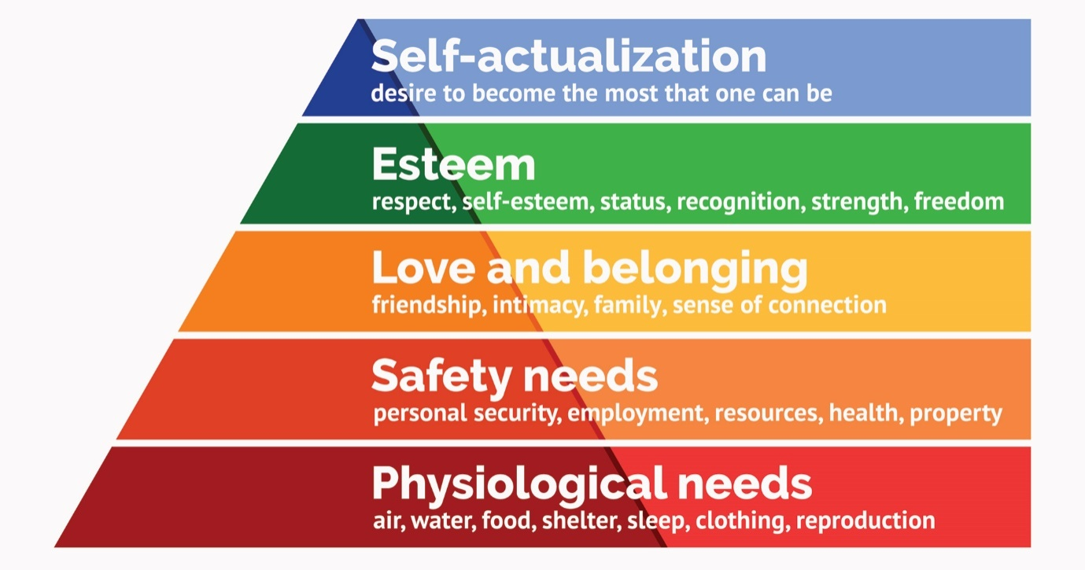
Figure 1: Maslow’s Hierarchical need
(Source: Fallatah and Syed, 2018)
Equity theory of employee motivation can also be implemented in the company. When the employees observe that they are receiving equal treatment in the company, they get motivated and respect their work. As per this theory, the input of the HRM in motivating the employees should also be equal to the output of the work and productivity. The employers also acknowledge the working culture of the employees and give them recognition by intrinsic or extrinsic reward system (Mintropand Ordenes, 2017). Hanoi Hat Company can implement extrinsic reward by increasing the wages, incentive and benefits. For an intrinsic reward, Hanoi Hat company can upgrade their working environment, implement upgraded technology that will help the workers to produce more product on a short span of time. Even for enhancing the skills of the employees, HRM can give them learning and development opportunity and career advancement facility. If all these types of reward strategy are applied, then Hanoi Hat Company can motivate the employees quickly.
The general manager can persuade the line manager for implementing reward management theory in the company. Reward management is basically motivating the employees for better work with some exclusive policies or benefits. The amount of reward must be proportional to the number of set goals in the organisation for employees (Festing and Tekieli, 2018). A proper reward management system in Hanoi Hat Company can give the employees something to work for and expect from the organisation. Even proper reward strategy can also push the employees for working out of the box. The objective of reward management is gaining control as an employer and giving motivation, recognition and compensation to the employees. In Hanoi Hat company, the HRM should persuade the line managers for different types of reward strategy. The first one if performance basis compensation. The line manager has to conduct a performance assessment for the individual team member, and as per the performance, the intrinsic and extrinsic reward is given to them (Wuet al., 2017). The second one is a membership-based reward. If the HRM if Hanoi Hat Company finds out that as a whole the company has done well and earned a lump sum revenue, it can distribute a percentage to all of the participants and stakeholders of the company. Here the organisation gives reward to the employees for contributing their talent in work, a better performance every day and helping the company to earn a competitive advantage.
The line manager of Hanoi Hat company should also understand the benefits of reward management, such as better working efficiency in every quarter, loyalty from the employees and job satisfaction. The amount of conflict and workplace tension can also be reduced by a proper reward strategy. The line manager has to set a standard of working performance and goals for the employees, and it will help the employees to chase their goal. This can also help in aligning the individual goal to the organisation's business aims and objective. Even the number of worker's strike will also be reduced (Bussin, 2018). Sometimes, monetary factors and benefits also work as a motivator for the employees. As a reward system of the company implements fair wage policy, fixed per hour rate, the employee performance can also be enhanced. The reward strategy can influence the employees by changing their approach and behaviour towards the work. If the payment system in reward is fair and consistent, the line manager can create an entrepreneurship behaviour and performance-oriented culture in the organisation. The Line manager should not overlook the monetary factor as a part of the reward system and employee motivation. If the employees of the company are unsatisfied for wages, they would indeed work more casually (Festingand Tekieli, 2018). Flexibility in the functional approach is also a part of the reward strategy. As a part of extrinsic reward, the company can invest its capital to upgradation of technology. The line manager also has to provide a clear statement of reward policy before setting any desired standard. This transparency can also motivate employees.
Hanoi Hat company has seen that training and skill development program was not able to raise the productivity of the employees. Hence, it has to look for reward management. As the rewards are exclusively designed for the benefits of employees, they feel motivated to achieve them. Reward management for the company should be reasonable and understandable (Bussin, 2018). Not only the money and bonuses, the career development program and employee benefit policies can give them a better aspect for improving the performance. It can also give job security and job satisfaction. Once the employees are loyal to the company, the employee retention rate is in the control of the HRM team. The top performer of the company even does not feel monotonous and demotivated. They also get a chance to grow in the company. Reward management theory is not only beneficial for the employees but also for the employers of Hanoi Hat company.

Conclusion
Hanoi hat Company can look for better reward management approach for a better performance by the employees. It can not only retain experienced employees but also attract talent for the market. In order to activate the outcome of training and development program, proper reward management is necessary. The reward strategy should be decided by keeping in mind all the internal and external factors and motivators of the company. The performance and behavioural approach of the employees will also depend on the reward management policy. The HRM of Hanoi Hat should link the business aims and objective with the individual goal for earning the reward. In a word, it can be said that in any workplace, reward pushes the employees to be a better version of themselves.

References
Bussin, M., 2018. Reward solutions to retention questions. In Psychology of Retention (pp. 395-413). Springer, Cham.
Dhakan, P., Merrick, K., Rañó, I. and Siddique, N., 2018. Intrinsic rewards for maintenance, approach, avoidance, and achievement goal types. Frontiers in neurorobotics, 12, p.63.
Došenović, D., 2016. Employee reward systems in organisations. Economics, 4(1), pp.107-118.
Fallatah, R.H.M. and Syed, J., 2018. A critical review of Maslow's hierarchy of needs. Employee Motivation in Saudi Arabia (pp. 19-59). Palgrave Macmillan, Cham.
Festing, M. and Tekieli, M., 2018. Global alignment or localisation? An empirical examination of global reward management in MNEs from a subsidiary perspective. The International Journal of Human Resource Management, pp.1-39.
Hahl, O., 2016. Turning back the clock in baseball: The increased prominence of extrinsic rewards and demand for authenticity. Organization Science, 27(4), pp.929-953.
Hopper, E., 2019. Maslow’s Hierarchy of Needs Explained. Viitattu, 12, p.2019.
Khern-am-nuai, W., Kannan, K. and Ghasemkhani, H., 2018. Extrinsic versus intrinsic rewards for contributing reviews in an online platform. Information Systems Research, 29(4), pp.871-892.\
Lissitsa, S., Chachashvili-Bolotin, S. and Bokek-Cohen, Y.A., 2017. Digital skills and extrinsic rewards in late career. Technology in Society, 51, pp.46-55.
Mintrop, R. and Ordenes, M., 2017. Teacher work motivation in the era of extrinsic incentives: Performance goals and pro-social commitments in the service of equity. education policy analysis archives, 25, p.44.
Ngwa, W.T., Adeleke, B.S., Agbaeze, E.K., Ghasi, N.C. and Imhanrenialena, B.O., 2019. Effect of reward system on employee performance among selected manufacturing firms in the Litoral region of Cameroon. Academy of Strategic Management Journal, 18(3), pp.1-16.
Phillips, L.A., Chamberland, P.É., Hekler, E.B., Abrams, J. and Eisenberg, M.H., 2016. Intrinsic rewards predict exercise via behavioral intentions for initiators but via habit strength for maintainers. Sport, Exercise, and Performance Psychology, 5(4), p.352.
Riasat, F., Aslam, S. and Nisar, Q.A., 2016. Do intrinsic and extrinsic rewards influence the job satisfaction and job performance? Mediating role of reward system. Journal of Management Info, 11(1), pp.16-34.
Wu, Y.E., Chang, S., Zhang, Z. and Deng, Z., 2017. Impact of social reward on the evolution of the cooperation behavior in complex networks. Scientific reports, 7, p.41076.

